# Introduction to Computer Networks

# Homework #5

# Submission by:

* Alexander Shender 328626114
* Netanel Rotschild 204937841

## Question 1.

### 

**True.**

Using the similar example from the tutorial: A and C aren’t in the same circle, thus they cannot connect with each other. Thus, probably the correct answer here would be True.

But in practice: Station A and station C have 2 others stations within their mutual reach – G and F. If any of those stations will be configured as an AP, A will be able to send data to C (and vice versa). The 802.11 MAC frame contains 4 addresses : Receiver, Transmitter, Source, Destination.

For example, if F is an AP, and A send to C, then:

1. Sending A to F. Source: A, Destination: C, Receiver: F, Transmitter: A
2. Sending F to C. Source: A, Destination: C, Receiver: C, Transmitter: F

## 

**Wrong.**

Taking the previous example, if F is an AP, and communicates with both A and C. But C doesn’t ‘hear’ transmissions from A, thus the *hidden terminal effect* exists.

## 

**True.**

Because the hidden terminal effect exists. Using the similar graphics from the lecture.

The events are the following:

1. At t=0 F wants to send to C, so it sends RTS. E hears F as well, but since RTS is not meant for E, it does not broadcast CTS. C hears RTS, sees the message is meant for C, and sends CTS.
2. At t=1, B wants to send to E, and sends RTS. But E also receives CTS from C. So a collision occurs

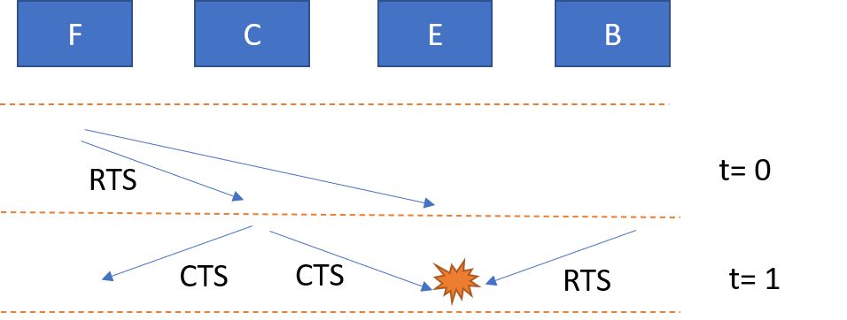

## 

**True.**

Since the RTS messages were sent at the same time, and SIFS is most likely equal for all stations, the CTS messages from the F and E stations will be transmitted at the same time, and neither E or F will sense a collision. A will receive CTS from F, and B will receive CTS from E, and will begin transmission. The transmission will be successful because E can only hear B, and F can only hear A, no collision.

## 

## 

**False.**

RTS or CTS messages contain information about the length of the transmission. The stations which receive RTS or CTS will stay silent for NAV, to allow a successful collision-free transmission between the stations willing to communicate. C doesn’t hear D. C also didn’t receive RTS from E.

On station C, between receiving CTS and sending the Data, there is a short period of time called SIFS. It is given that C is silent until the CTS is received. But C can start transmitting during the SIFS time, and station E will hear and may interrupt the transmission.

## 

**False.**

This scenario resembles the one from (e), but here it is different. Any transmission from A will not affect the transmission of Data from station F to C. First, because C doesn’t hear A. F may hear some information during the SIFS period after the CTS from A, but the Data will still be sent, since usually data packets which have to be sent after the expiration of SIFS have a higher priority.

## Question 2.

We solve this question similarly to the question in the tutorial.

Marking:

* A = reservation slots for short messages
* B = reservation slots for long messages
* Thus : 1-A-B = slots used for the data transmission

All the stations compete to reserve a slot for a short message. Probability for each station to reserve given $\frac{1}{E}$. Thus, probability for only 1 reservation:

$$p\left(1 short reversation\right)=N⋅\frac{1}{N}⋅{\left(1-\frac{1}{N}\right)}^{N-1}=\frac{1}{e}$$

Taking into account the probability for success, the total part of successful reservations for short messages is:

$$part\left(short reverations\right)=A⋅\frac{1}{e}⋅\left(1-p\right)$$

And the total transmissions for the short messages are:

$$slots\left(short transmissions\right)=T⋅\left(A⋅\frac{1}{e}⋅\left(1-p\right)\right)$$

Now, only $\frac{N}{2}$ stations want to reserve long messages, but probability to reserve stays the same.

$$p\left(1 long reversation\right)=\frac{N}{2}⋅\frac{1}{N}⋅{\left(1-\frac{1}{N}\right)}^{\frac{N}{2}-1}=\frac{1}{2\sqrt{e}}$$

Taking into account the probability for success, the total part of successful reservations for long messages is:

$$part\left(long reverations\right)=B⋅\frac{1}{2\sqrt{e}}⋅\left(1-p\right)$$

Likewise, slots for long transmissions:

$$slots\left(long transmissions\right)=2T⋅\left(B⋅\frac{1}{2\sqrt{e}}⋅\left(1-p\right)\right)$$

Given another constraint, we can express B as A and b:

It is given than only $b∈\{0,1\}$ slots from all the slots are for the short messages. Thus,

$$b⋅\left(A+B\right)=A$$

$$Ab+Bb=A$$

$$B=\frac{A\left(1-b\right)}{b}$$

Now, we can equalize the total transmissions time to the initial assumption:

$$T⋅\left(A⋅\frac{1}{e}⋅\left(1-p\right)\right)+ 2T⋅\left(B⋅\frac{1}{2\sqrt{e}}⋅\left(1-p\right)\right)=1-A-B$$

$$\frac{TA\left(1-p\right)}{e}+\frac{2T}{2\sqrt{e}}\left(1-p\right)\frac{A\left(1-b\right)}{b}= 1-A-\frac{A\left(1-b\right)}{b}$$

$$A⋅\left(\frac{T\left(1-p\right)}{e}+\frac{2T}{2\sqrt{e}}\left(1-p\right)\frac{\left(1-b\right)}{b}\right)=1-A⋅\left(1-\frac{\left(1-b\right)}{b}\right)$$

$$A⋅\left(\frac{T\left(1-p\right)}{e}+\frac{2T}{2\sqrt{e}}\left(1-p\right)\frac{\left(1-b\right)}{b}\right)=1-A⋅\left(1-\frac{\left(1-b\right)}{b}\right)$$

$$A=\frac{1}{\left(\frac{T\left(1-p\right)}{e}+\frac{2T}{2\sqrt{e}}\left(1-p\right)\frac{\left(1-b\right)}{b}+1+\frac{\left(1-b\right)}{b}\right)}$$

$$A=\frac{e}{\left(T\left(1-p\right)+T\sqrt{e}\left(1-p\right)\frac{\left(1-b\right)}{b}+e+\frac{e\left(1-b\right)}{b}\right)}$$

$$A=\frac{eb}{\left(T\left(1-p\right)b+T\sqrt{e}\left(1-p\right)\left(1-b\right)+eb+e\left(1-b\right)\right)}$$

$$A=\frac{eb}{\left(\left(1-p\right)⋅\left(Tb+T\sqrt{e}\left(1-b\right)\right)+eb-eb+e \right)}$$

$$A=\frac{eb}{T\left(1-p\right)⋅\left(b+\sqrt{e}\left(1-b\right)\right)+e}$$

Thus, the throughput is:

$$S=1-A-B=1-A-\frac{A\left(1-b\right)}{b}=1-A⋅\left(1+\frac{\left(1-b\right)}{b}\right)$$

$$S=1-\left(\frac{eb}{T\left(1-p\right)⋅\left(b+\sqrt{e}\left(1-b\right)\right)+e}\right)\left(\frac{1}{b}\right)$$

$$S=1- \left(\frac{e}{T\left(1-p\right)⋅\left(b+\sqrt{e}\left(1-b\right)\right)+e}\right)$$

### 

Inserting the values: $T = 8 , p =$ ${10}^{-5}$ $b∈\left[\frac{1}{5},\frac{4}{5}\right]$

We receive that for the minimal value of $b$, the throughput is the biggest.

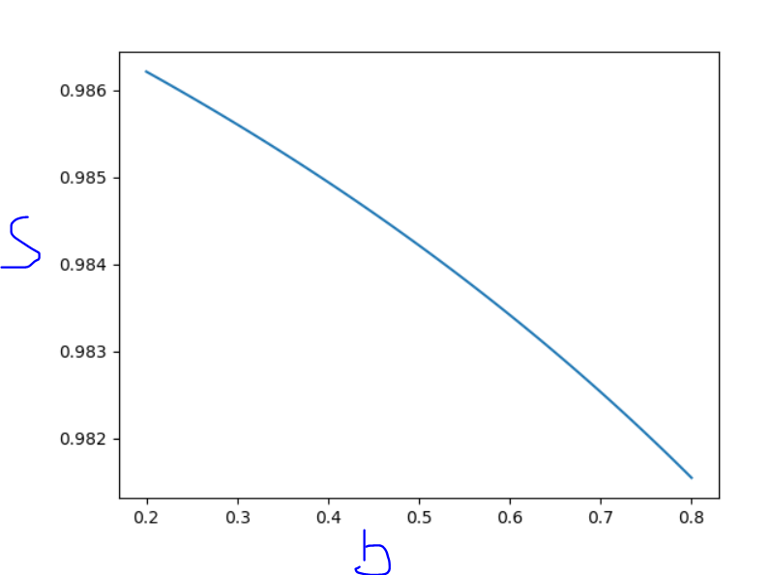

### 

Now only $\frac{1}{3}$ of the stations reserve long messages. Going back to calculation:

$$p\left(1 long reversation\right)=\frac{N}{3}⋅\frac{1}{N}⋅{\left(1-\frac{1}{N}\right)}^{\frac{N}{3}-1}=\frac{1}{3\sqrt[3]{e}}$$

$$part\left(long reverations\right)=B⋅\frac{1}{3\sqrt[3]{e}}⋅\left(1-p\right)$$

$$slots\left(long transmissions\right)=2T⋅\left(B⋅\frac{1}{3\sqrt[3]{e}}⋅\left(1-p\right)\right)$$

The equation for the transmission slots:

$$T⋅\left(A⋅\frac{1}{e}⋅\left(1-p\right)\right)+ 2T⋅\left(B⋅\frac{1}{3\sqrt[3]{e}}⋅\left(1-p\right)\right)=1-A-B$$

$$…$$

$$A=\frac{1}{\left(\frac{T\left(1-p\right)}{e}+\frac{2T}{3\sqrt[3]{e}}\left(1-p\right)\frac{\left(1-b\right)}{b}+1+\frac{\left(1-b\right)}{b}\right)}$$

$$A=\frac{e}{\left(T\left(1-p\right)+\frac{2Te}{\sqrt[3]{e}}\left(1-p\right)\frac{\left(1-b\right)}{b}+e+\frac{e\left(1-b\right)}{b}\right)}$$

$$A=\frac{eb}{\left(T\left(1-p\right)b+\frac{2Te}{\sqrt[3]{e}}\left(1-p\right)\left(1-b\right)+eb+e\left(1-b\right)\right)}$$

$$A=\frac{eb}{\left(\left(1-p\right)⋅\left(Tb+\frac{2Te}{\sqrt[3]{e}}\left(1-b\right)\right)+eb-eb+e \right)}$$

$$A=\frac{eb}{T\left(1-p\right)⋅\left(b+\frac{2e}{\sqrt[3]{e}}\left(1-b\right)\right)+e}$$

And the throughput is:

$$S=1-\left(\frac{e}{T\left(1-p\right)⋅\left(b+\frac{2e}{\sqrt[3]{e}}\left(1-b\right)\right)+e}\right)$$

Making the graph again to find out the best $b$ value:

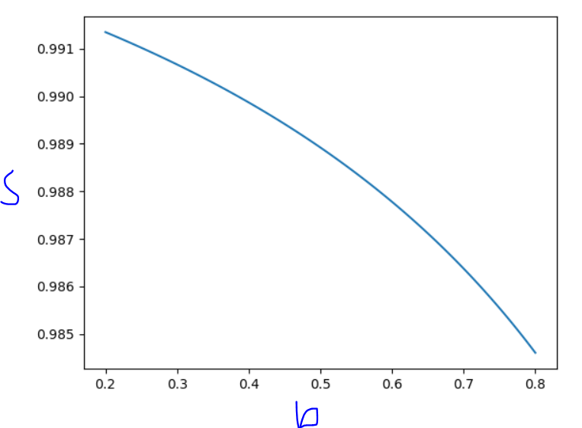

We can see again that the best value is the smallest b, which is 0.2

## Question 3 - RPR

1. The average distance $(\overline{d})$ for a message from a station chosen at random, uniformly from stations 1,2,…,x. Is no different than the average distance from any station to any station, and remains: $\overline{d}=\frac{N-1}{2}$
2. Divide the stations into two groups $U=\{u|2,3,…,x\}$ any station $u$ which is required to go through all the stations to reach station $u-1$. Group $V=\{v|x+1,…,N,1\}$ any station $v$ which is not required to go through all stations to reach $v-1$.

For a messages $U→U or U→V$:

Average distance is the same as found in a.

$$\overline{d}(U→N)=\frac{N-1}{2}\overset{→}{for large N}\frac{N}{2}$$

Probability is the likelihood of selecting a station from group $U$ multiplied by the likelihood of selecting a *different* station from $N$

$$P\left(U→N\right)=\frac{x-1}{N}∙\frac{1}{N} \overset{→}{for large x}\frac{x}{N}∙\frac{1}{N}$$

For messages $V→V$:

Average distance is farthest distance to travel $\left(N+1-\left(x+1\right)\right)=N-x$ minus shortest distance to travel $(1)$ divided by 2.

$$\overline{d}\left(V→V\right)=\frac{N-x-1}{2}\overset{→}{for large x \& N}\frac{N-x}{2}$$

Probability is the likelihood of selecting a station from group $V$ multiplied by the likelihood of selecting a station within $V$.

$$P\left(V→V\right)=\frac{N-x}{N}∙\frac{N-x-1}{N}\overset{→}{for large x \& N}\frac{N-x}{N}∙\frac{N-x}{N}$$

For messages $V→U$:

Average distance is farthest distance to travel $(N-1)$ minus shortest distance to travel $\left(x+1-2\right)=(x-1)$ divided by 2.

$$\overline{d}\left(U→V\right)=\frac{N-1-(x-1)}{2}=\frac{N-x}{2}$$

Probability is the likelihood of selecting a station from group $U$ multiplied by the likelihood of selecting a station within $V$.

$$P\left(U→V\right)=\frac{x-1}{N}∙\frac{N-\left(x-1\right)}{N}=\frac{x-1}{N}∙\frac{N+1-x}{N}\overset{→}{for large x \& N}\frac{x}{N}∙\frac{N-x}{N}$$

In total the average distance is:

$$\overline{d}= \overline{d}\left(U→N\right)∙P\left(U→N\right)+\overline{d}\left(V→V\right)∙P\left(V→V\right)+\overline{d}\left(U→V\right)∙P\left(U→V\right)$$

$$\overline{d}= \frac{N}{2}∙\frac{x}{N}∙\frac{1}{N}+\frac{N-x}{2}∙\frac{N-x}{N}∙\frac{N-x}{N}+\frac{N-x}{2}∙\frac{x}{N}∙\frac{N-x}{N}=\frac{x}{2N}+\frac{{\left(N-x\right)}^{3}}{2N^{2}}+\frac{x{\left(N-x\right)}^{2}}{2N^{2}}$$

$$\overline{d}=\frac{{xN}^{2}+{\left(N-x\right)}^{3}+x{\left(N-x\right)}^{2}}{2N^{2}}$$

1. The efficiency $S$ is $\frac{N}{\overline{d}}$

$$S=\frac{N}{\overline{d}}=\frac{N}{\frac{{xN}^{2}+{\left(N-x\right)}^{3}+x{\left(N-x\right)}^{2}}{2N^{2}}}=\frac{2N^{3}}{{xN}^{2}+{\left(N-x\right)}^{3}+x{\left(N-x\right)}^{2}}$$

$$\frac{dS}{dx}=2N^{3}∙\frac{N^{2}-3{\left(N-x\right)}^{2}+{\left(N-x\right)}^{2}-2x\left(N-x\right)}{x+{\left(N-x\right)}^{3}+x{\left(N-x\right)}^{2}}=0$$

$$→N^{2}-3{\left(N-x\right)}^{2}+{\left(N-x\right)}^{2}-2x\left(N-x\right)=0$$

$$→N^{2}-3N^{2}+6xN-3x^{2}+N^{2}-2xN+x^{2}-2xN+2x^{2}=0$$

$$→1-N^{2}+2xN=0→x=\frac{N^{2}-1}{2N}=\frac{N}{3}-\frac{1}{2N}\overset{→}{for large N}x=\frac{N}{3}$$

The efficiency $S$ for this $x$ is:

$$S=\frac{2N^{3}}{{\frac{N}{3}N}^{2}+{\left(N-\frac{N}{3}\right)}^{3}+\frac{N}{3}{\left(N-\frac{N}{3}\right)}^{2}}=\frac{2N^{3}}{\frac{N^{3}}{3}+\frac{8}{27}N^{3}+\frac{N}{3}∙\frac{4}{9}N^{2}}=\frac{2}{\frac{9}{27}+\frac{8}{27}+\frac{4}{27}}=\frac{54}{23}$$

1. This question now is very similar to the one we saw in the recitation, we can put a “mock” station which will not be counted on cross line and it becomes very similar

For messages $U→U$ we get an average distance of $\overline{d}=\frac{x}{2}$, with probability of $P={\left(\frac{x}{N}\right)}^{2}$

For messages $V→V$ we get an average distance of $\overline{d}=\frac{N-x}{2}$, with probability of $P={\left(\frac{N-x}{N}\right)}^{2}$

For messages $U→V$ we get an average distance of $\overline{d}=\frac{N}{2}$, with probability of $P=\left(\frac{N-x}{N}\right)∙\frac{x}{N}$

For messages $V→U$ we get an average distance of $\overline{d}=\frac{N}{2}$, with probability of $P=\left(\frac{N-x}{N}\right)∙\frac{x}{N}$

Overall average distance is $\overline{d}=\frac{x}{2}∙{\left(\frac{x}{N}\right)}^{2}+\frac{N-x}{2}∙{\left(\frac{N-x}{N}\right)}^{2}+2∙\frac{N}{2}∙{\left(\frac{N-x}{N}\right)}^{2}$

$$\overline{d}=\frac{x^{3}+{\left(N-x\right)}^{3}+2N\left(N-x\right)x}{2N^{2}}$$

1. The utilization therefore is:

$$S=\frac{N}{\overline{d}}=\frac{2N^{2}}{x^{3}+{\left(N-x\right)}^{3}+2N\left(N-x\right)x}$$

$$\frac{dS}{dx}=2N^{3}∙\frac{3x^{2}-3{\left(N-x\right)}^{2}+2N\left(N-2x\right)}{{\left(x^{3}+{\left(N-x\right)}^{3}+2N\left(N-x\right)x\right)}^{2}}=0$$

$$→3x^{2}-3{\left(N-x\right)}^{2}+2N\left(N-2x\right)=0→3x^{2}-3N^{2}+6xN-3x^{2}+2N^{2}-4xN=0$$

$$→2xN=N^{2}→x=\frac{N}{2}$$

$$S=\frac{2N^{3}}{{\left(\frac{N}{2}\right)}^{3}+{\left(N-\frac{N}{2}\right)}^{3}+2N\left(N-\frac{N}{2}\right)\left(\frac{N}{2}\right)}=\frac{2}{\frac{1}{8}+\frac{1}{8}+\frac{1}{2}}=\frac{8}{3}$$

## Question 4 – Bitmap

1. The time to transmit a message is given by the equation $p∙N∙\frac{d}{R}=\frac{\left(N∙d\right)}{4R}$

Bitmap transmit time is $N∙(T_{p}+\frac{1}{R})$ as shown in the recitation

In average $\frac{1}{4}$ of the stations wants to transmit. The propagation time for all windows is the number of windows desired to transmit multiplied transmission time, with the propagation time added for a single window. In total we get that time to send a window of data is:

$$p∙N∙\left(T_{p}+\frac{1}{R}\right)=\frac{1}{4}∙N∙(\frac{d}{R}+T_{p})$$

Utilization is:

$$\frac{\frac{N∙d}{4R}}{\frac{1}{4}∙N∙\left(\frac{d}{R}+T_{p}\right)+N∙\left(\frac{1}{R}+T_{p}\right)}=\frac{Nd}{Nd+NT_{p}R+4N+4RNT_{p}}=\frac{d}{d+4+5RT_{p}}$$

1. As we can see if the rate increase by 2 the overall utilization will decrease! This is due to the fact that the denominator will increase causing the overall fractions to decrease.
2. If a station transmits $0$ and another station registers a $1$ for that station, it will wait for the transmission to complete, causing overall utilization to decrease. This is caused by adding the probability multiplied by the stations and wait time.

$$\frac{\frac{N∙d}{4R}}{\frac{1}{4}∙N∙\left(\frac{d}{R}+T_{p}\right)+N∙\left(\frac{1}{R}+T_{p}\right)+\frac{3N}{4}∙\left(\frac{1}{R}+T_{p}\right)\left(1-p\right)}→$$

$$→\frac{\frac{Nd}{4R}}{\frac{Nd+NT_{p}R+4N+4RNT_{p}+(3Nd+3NT_{p}R)(1-p)}{4R}}=\frac{d}{d+4+5RT_{p}}$$