## Question 7.

This statement is **FALSE**.

The proof:

Let’s suppose we have 3 examples in our sets:

* Examples 1, 2, 3 appear in BOTH $DS1$ and $DS2$

Thus, they appear in both of the sets: $DS1 ∪DS2$ and $DS1 ∩DS2$ ( once in each of those sets).

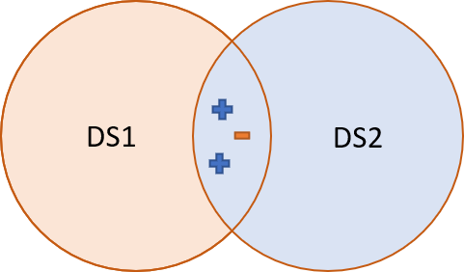

Let’s say for simplicity it’s 2D. The new test example is marked with “?” sign and we use the 3NN to classify it:

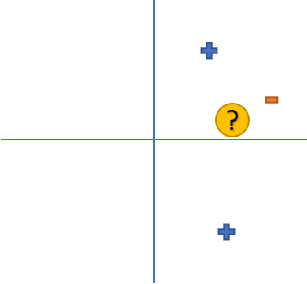

Using the 3NN method, it will be classified as TRUE for both : $DS1 ∪DS2$ and $DS1 ∩DS2$

But when we classify it with the $DS1+DS2$ group, we receive the following:

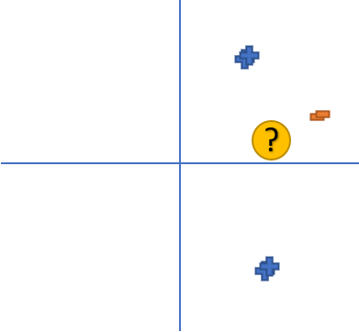

(In this example the points are in the SAME location, but are slightly moved to show that they appear twice).

Now, the 3 closest points include two FALSE classifications, which means, the 3NN classification will be FALSE. Thus, this proves the statement is wrong.