# Wet section

To succeed in the classification task in the best possible way, we first had to go back into feature imputation stage.

## Code Review

As before, our code is fully automatic, and performs the model selection automatically.

To the existing model we have added new models, which are AdaBoost, and the MLP.

The same actions on features are later done on the unseen data, and the output is given.

## Features imputation

### Discipline score

The discipline score had outliers, but it was noticed that they are simply multiplications of existing discipline scores by 10. Those outliers were divided by 10. The other missing were replaced with a mean.

### Social Activities

There is a big correlation between the TimeOnSocialActivities and the AvgHouseholdExpenseOnPresents graphs:

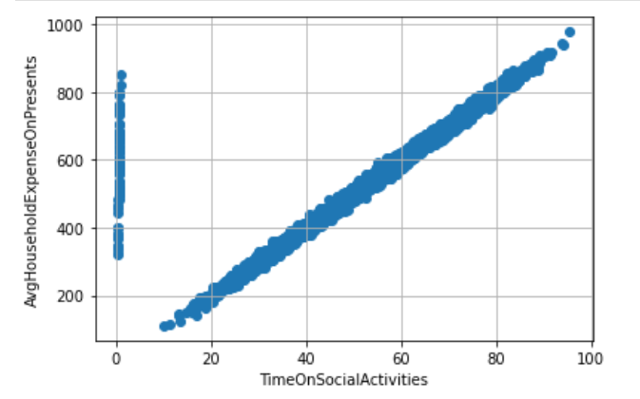

The following imputations are done:

* The outliers (TimeOnSocialActivities < 5) was replaced according to AvgHouseholdExpenseOnPresents
* The non-existing values were also replaced according to AvgHouseholdExpenseOnPresents (if those existed there)
* For all the rest, replacing with the mean value of TimeOnSocialActivities

### Age Handler

To handle missing age, we have examined the AvgMinSportsPerDay and StepsPerYear parameters, and this is the distribution (with upper and lower boundaries)

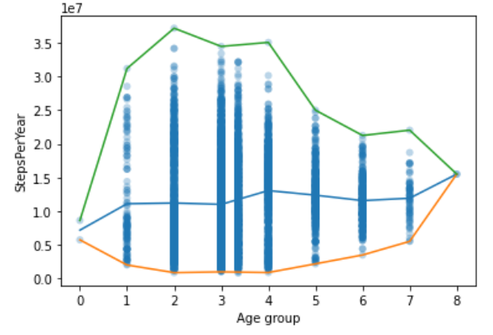

Same for AvgMinSportsPerDay:

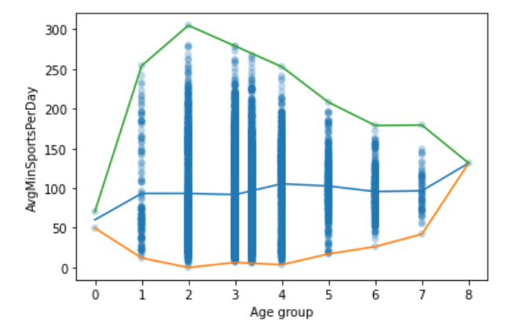

We can see some correlation (which is logical).

### Steps Per Year

There is a strong correlation between AvgMinSportsPerDay and StepsPerYear:

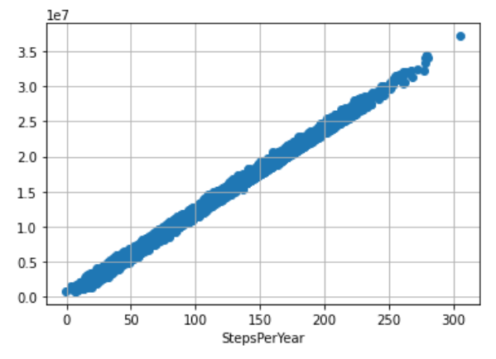

So if the value for StepsPerYear is missing, but is existing in AvgMinSportsPerDay, we calculate this value. Other values are replaced by the mean value.

### PCR Results

Like with the case with clustering (homework no. 4) we try both the mean and the KNN imputer. For each PCR result, we use the z-value to discover outliers. Then calculate the mean without the outliers. Then we replace the outliers and the missing values by those means or the KNN.

### Syndrome Class

Nothing special was done so far.

## Features Scaling

StandardScaler was used on all features. The boxplot distribution of the data after the scaling:

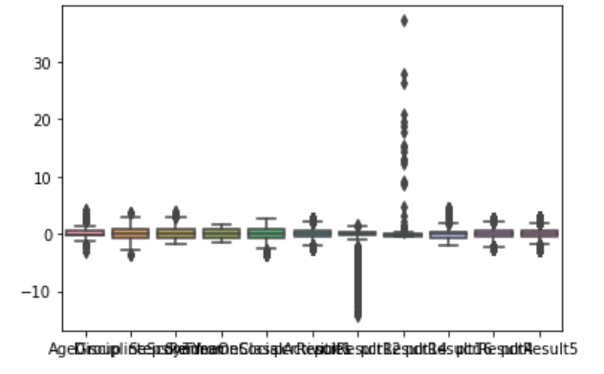

## Cluster Analysis

By learning to perform the cluster analysis, we tried to visualize the 6 clusters of the disease type. This would also help us to verify that the feature imputation procedures were indeed effective.

We use the most successful clustering model from the previous homework, which is GaussianMixture Model, since most of the features distributions resemble Gaussian distribution.

To visualize, we use the 2 PC (3d plot doesn’t add much more information).

We used the whole training set of 9000 samples.

Using the TRUE samples (from the dataset):

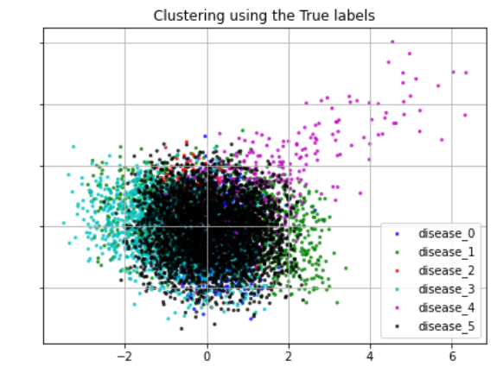

And using the Derived cluster indexes from the GMM:

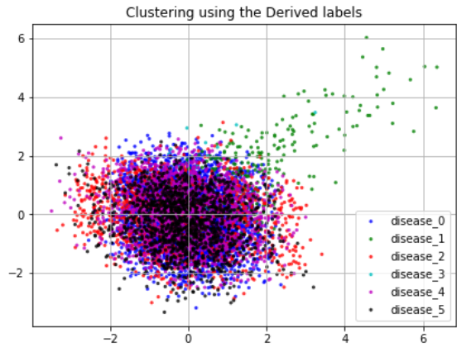

We can see that GMM succeeded to discover some clusters (like the easy one which spans through big x and y values), but in general it doesn’t correspond too much. We will later use this visualization to assert the precision of the classifier.

## Class Imbalance

For the disease type: the distribution of the classes in our dataset is not equal:

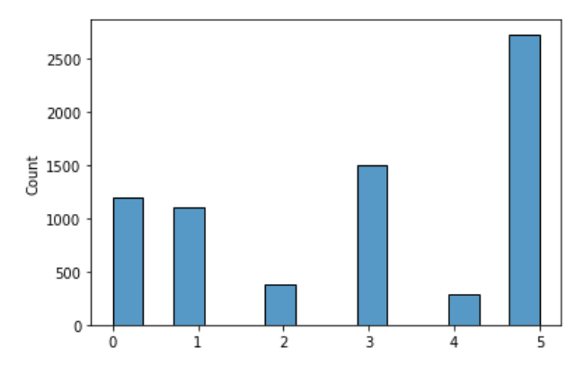

We handle the imbalanced data using SMOTE (Synthetic Minority Oversampling Technique), which created new samples for the minority classes. We use the

## Classification

We have implemented new gained knowledge to tackle the classification problem with more success that previously. We first concentrated on the Disease classification, since it was the most challenging task from the HW3.

### Adaboost

We have used the AdaBoost classifier with various parameters, experimenting with the algorithm (sklearn offers SAMME, SAMME.R), number of estimators, base estimator and its parameters. The most successful parameters were the following:

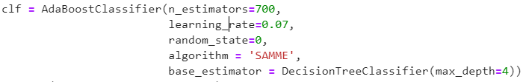

Which gave around 86% on the test set for the Disease classification.

### MLP

The sklearn library provides the MLP classifiers. We have as well examined different parameters variations, we found the following to be relatively fast converging and accurate:

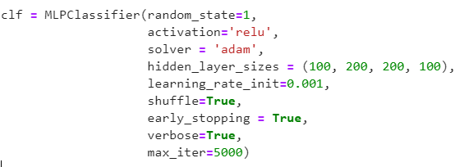

In reality it would converge already after 50 epochs (iterations), with the accuracy of 88% on the test set, thus proving superior to the Adaboost.

### MLP + Transfer Learning

In transfer learning, we used the following process:

* 1. First, train the binary classification on the Disease ( 0 = No disease, 1 = Any other disease). Use the SMOTE to fix class imbalance between classes (No disease, Disease)
  2. Build a new model based on the trained model in (a.). Add new layers (only those layers will be trained)
  3. Train the new model.

Using this process, we could achieve above 90% of accuracy on the Disease classification.

## Results

After running the automatic model selection, those are the models that were chosen by the process and their metrics.

### Risk detection

### Spreader detection

### Disease detection

The model chosen was ….