Homework No. 5

Alexander Shender 328626114

Snir Hordan 205689581

**Question 1.**

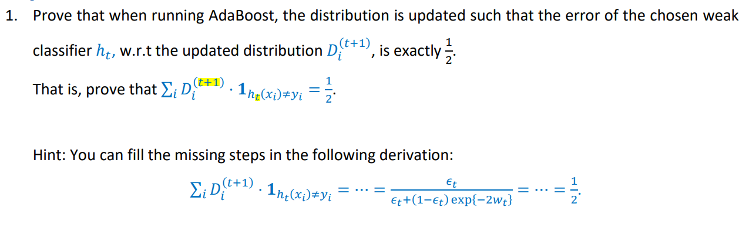

We start by indeed from writing the expression for the updated error value with the updated data weights (distribution) for the last chosen weak classifier:

By using:

Putting back:

is a normalization factor, so we can put it outside of the sum:

We divide into 2 cases:

For each case,

So we get:

The numerator contains the expression for the error value, since we have isolated for case :

Opening the denominator using same 2 cases:

Putting back:

Taking out of the sum:

The sum over weights of the correct predictions E, is 1-sum over incorrect predictions, since they sum to 1:

So we get:

Using the expression for the weight of the weak classifier:

Putting everything back: