Final Project Report

Submitted by:

Hamza Khatieb 315398933

Alexander Shender 328626114

Part A – Data Construction:

Discuss advice 2:

Indeed, the effective dictionary CA can create zero columns. If some column contains only zeros, this means that all the pixels of this atom are among the “corrupted” pixels. This is quite unlikely to happen but is still possible.

Show two clean images and their corresponding noisy and corrupted versions

From top to bottom: clean, noisy, corrupted image with p=0.4, sigma = 0.05

Part B – Inpainting by the Oracle Estimator

Insert average PSNR result of the Oracle estimator: **43.999**

Show clean, noisy, corrupted and Oracle-based reconstruction:

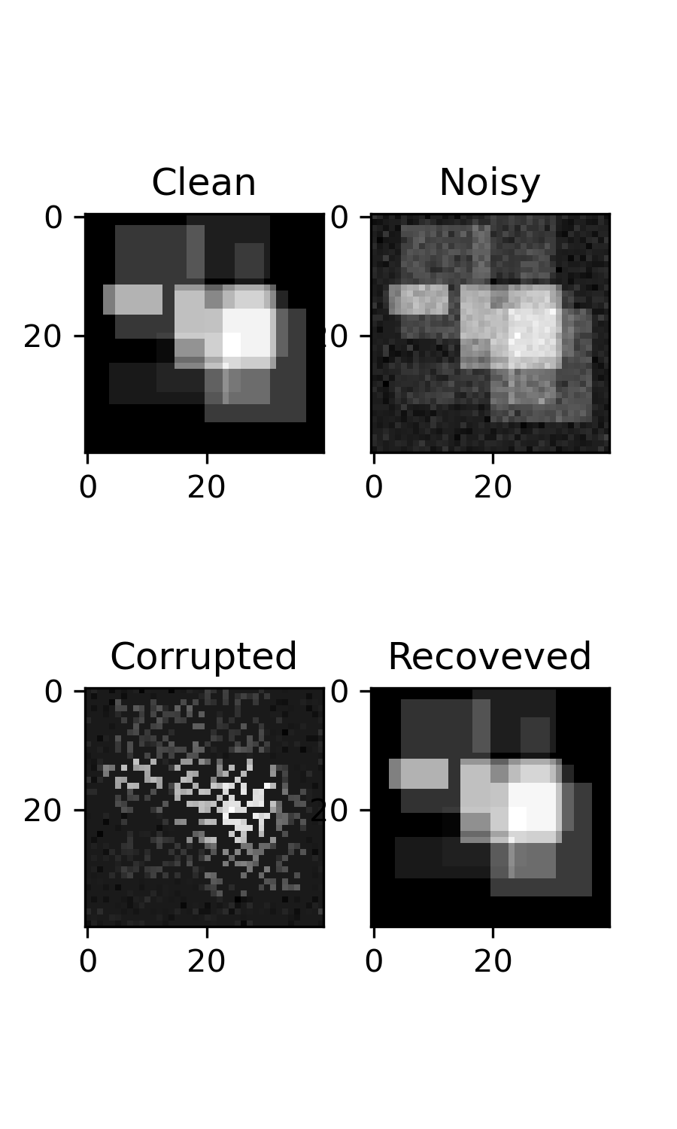

As we can see, the recovered image resembles the original “clean” image quiet well.

Part C – Inpainting by Greedy Pursuit

Insert average PSNR result of OMP: **35.178**

Show clean, noisy, corrupted, and OMP-based reconstruction:

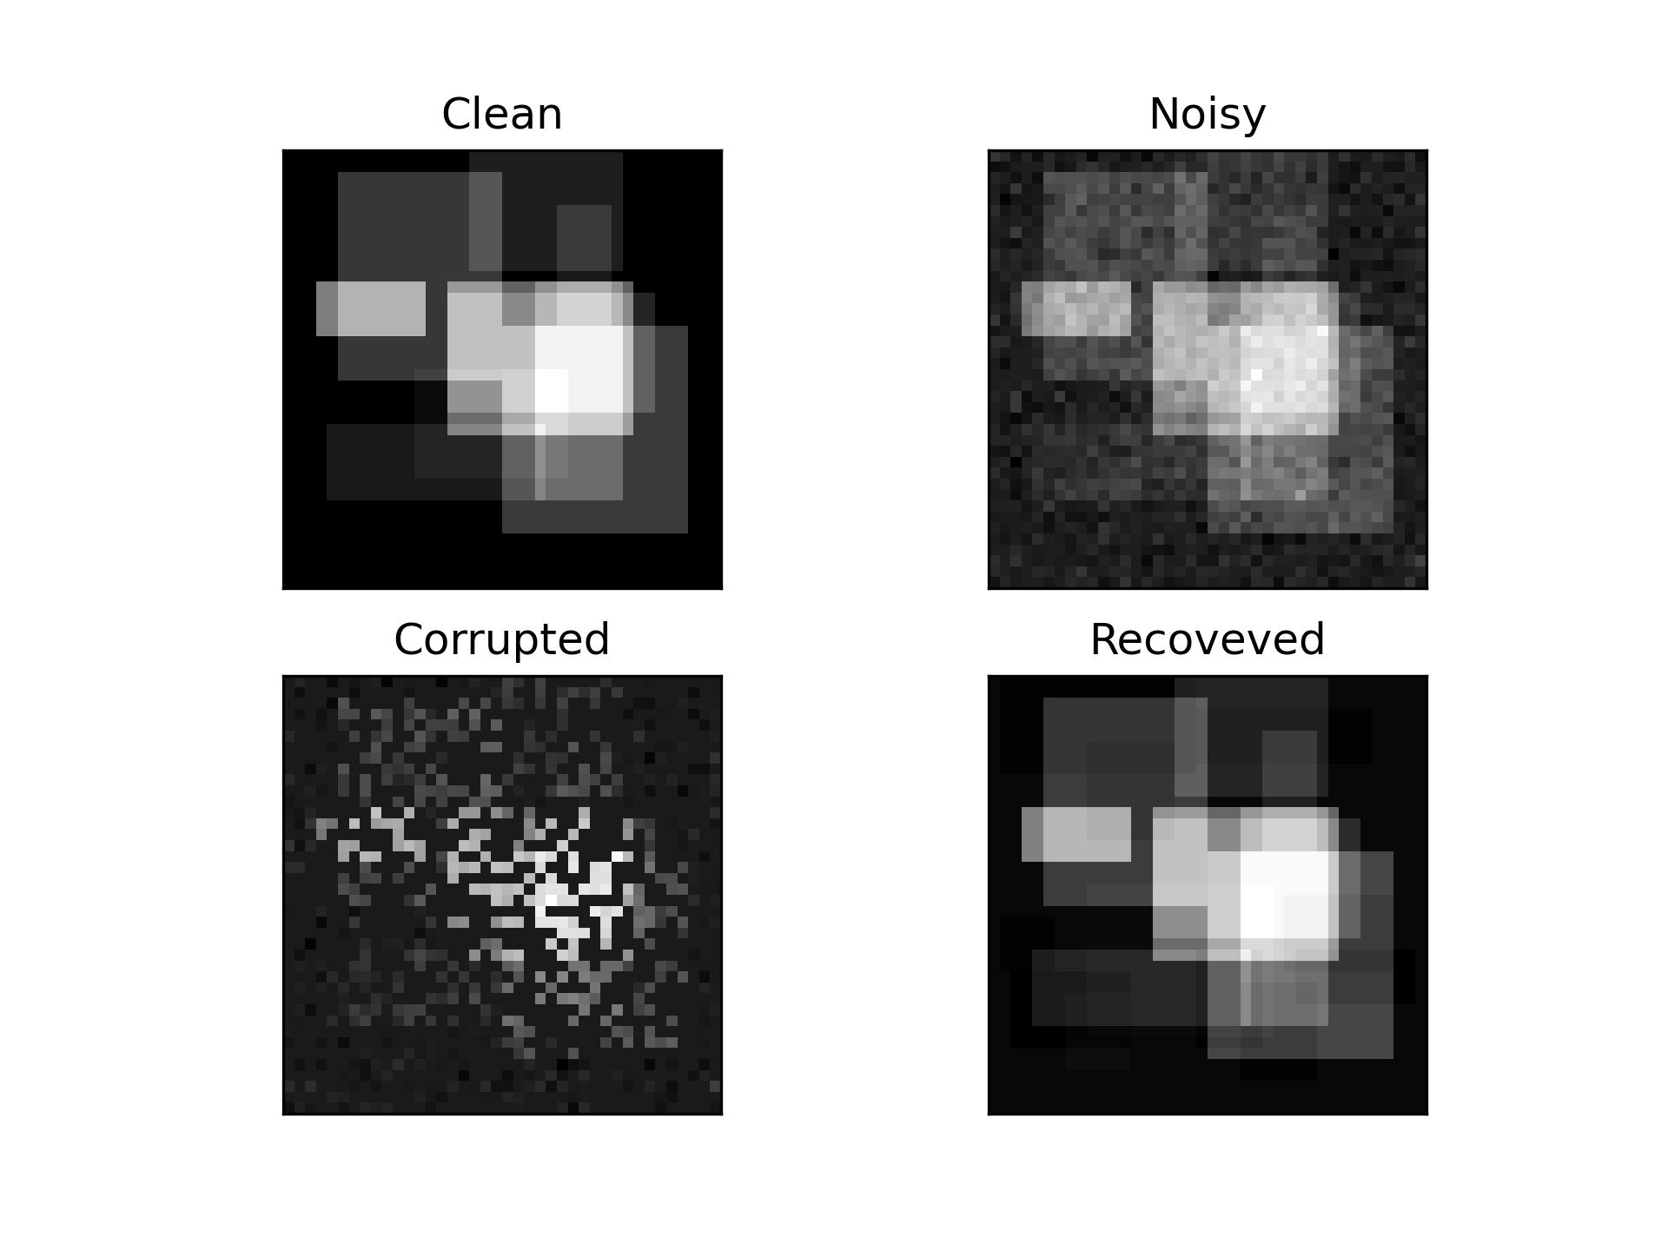

Compare between Oracle and OMP reconstructions:

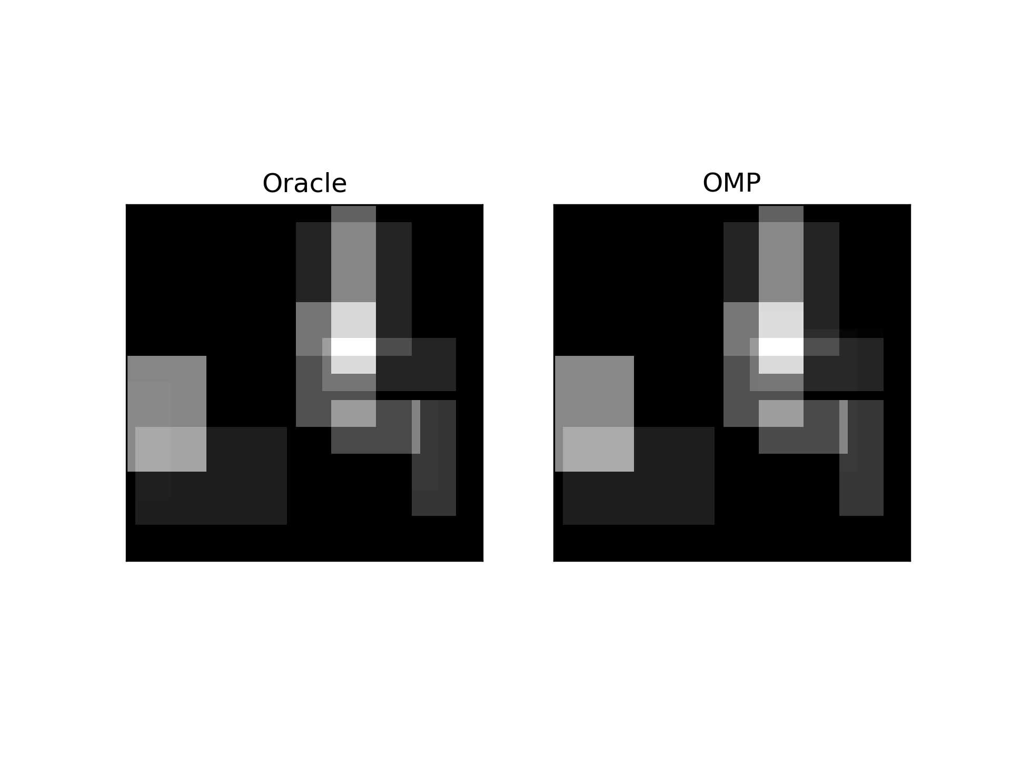

Discuss results of OMP and compare to Oracle performance:

We can observe that the PSNR of the OMP compared to the Oracle is smaller. This conclusion is quiet obvious, since Oracle has the knowledge of the original atoms in the clean image. But we can see that OMP algorithm still performed really well – at least visually it is hard to see any difference between the reconstructed images.

Show average PSNR of OMP as a function of $k$

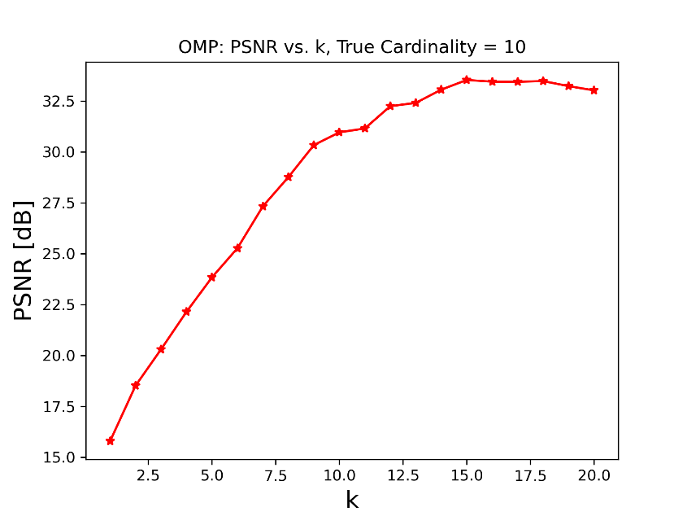

Discussion regarding the average PSNR as a function of $k$:

We can observe in the left part that there is a high tendency of PSNR to increase as k increases, which is logical. The original image was generated using k=10 atoms. We can see that we get best PSNR for even larger k, which is bigger than the original k used to generate images. This can be explained by the presence of the noise, and the corruption of part of the pixels. Apparently, OMP finds a way to “explain” some of the noise present using specific additional atoms that it chooses. After around k=13 we can see the decrease in PSNR.

Influence of noise std increase on the PSNR vs k graph:

To answer this question, the experiment was retaken using higher value of noise std.

This is the graph that was obtained for sigma=0.25:

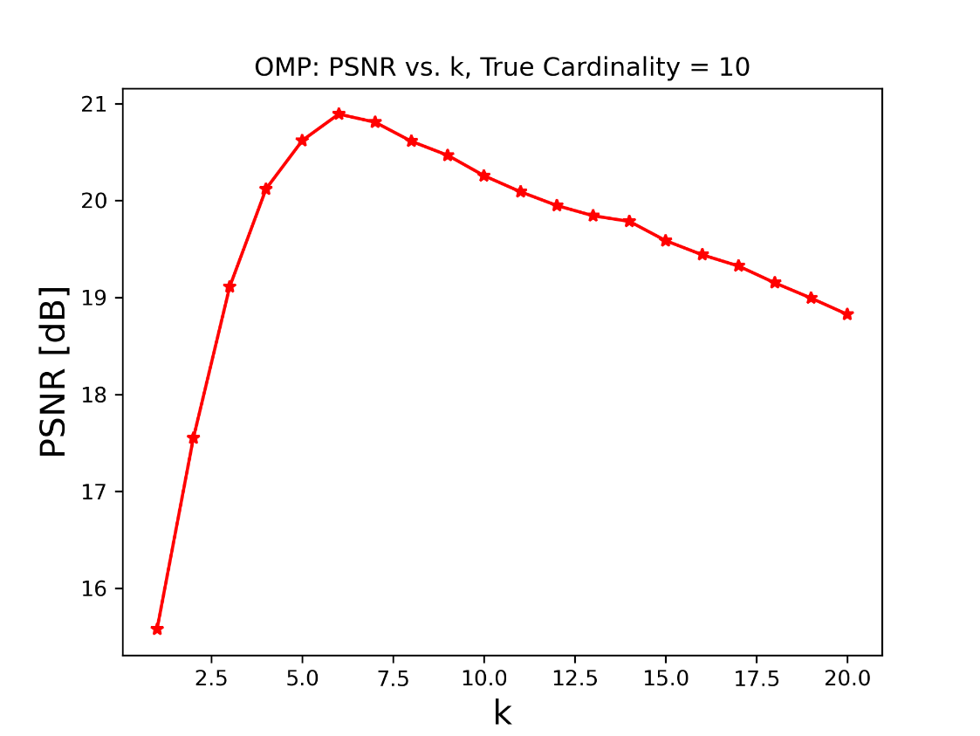

We can observe that the best PSNR was obtained for k=7, which is lower than the true cardinality! This can be explain by the fact that the presence of the noise is very big compared to the original data, and OMP tries to explain those high noise values using the dictionary atoms. OMP finds the atoms with the highest values, but the atoms with low values get “blended” among the noise, and thus are harder to find. The image below shows example of the original, noisy, corrupted, and recovered image by OMP for this scenario:

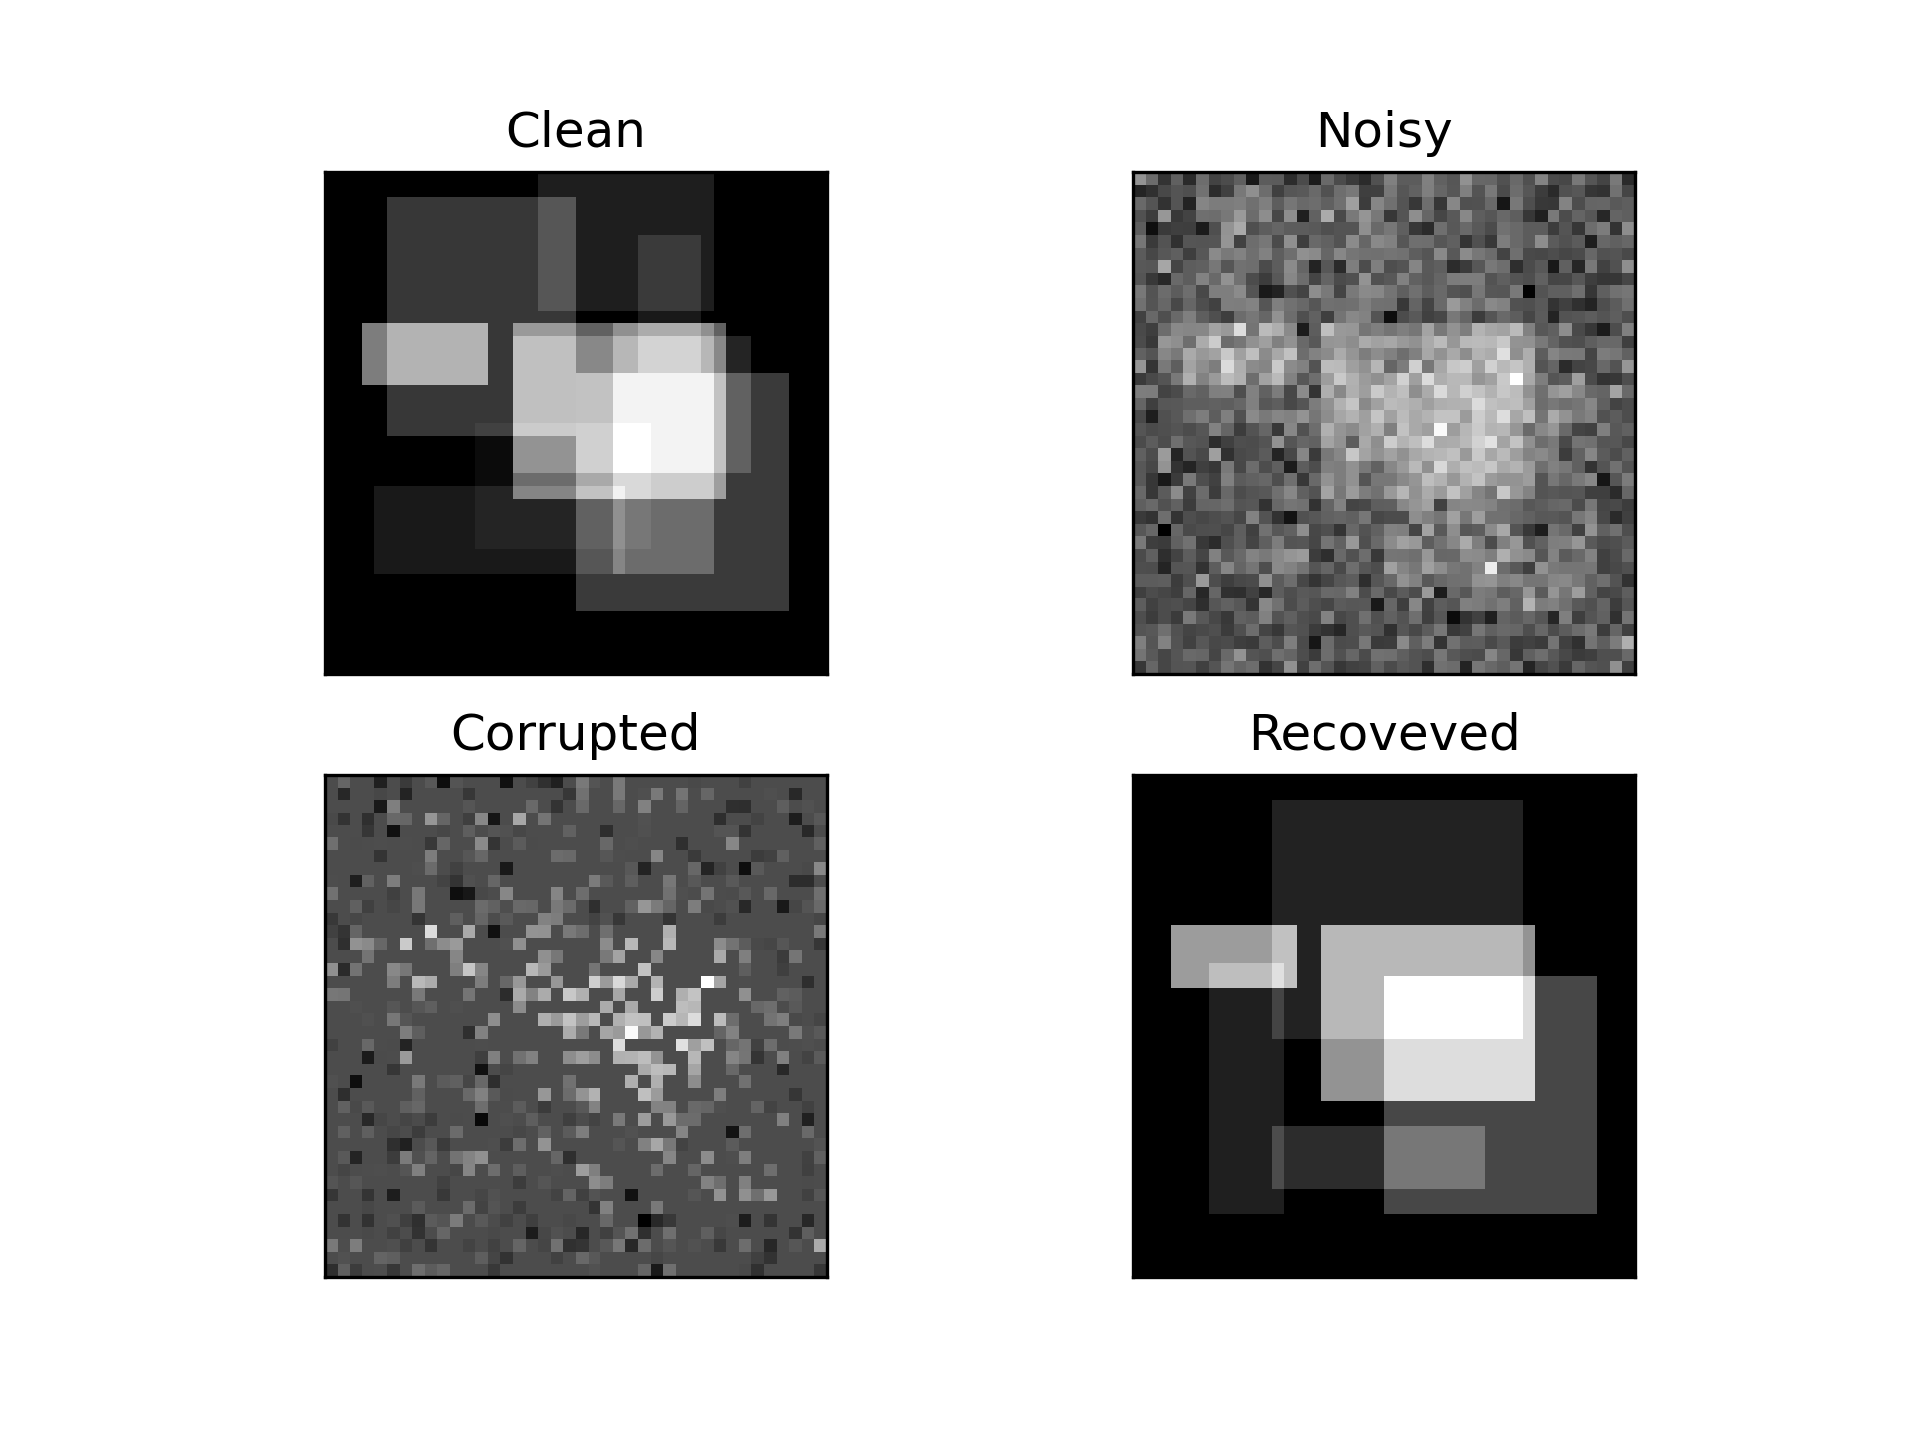

Tuning the k parameter:

We can use the method suggested in the lecture based on the comparison between the energy of the residual and the energy of the noise, when the noise level is given or can be estimated (usually we know the noise model of a sensor). When this relation is close to 1, this means the energy level of the residual is closest to the energy level of the noise, i.e. the reconstruction of the image is at the closest point, accounting for the noise, which of course doesn’t appear in atoms and cannot be reconstructed using atoms.

Part D – Inpainting by Basis Pursuit

Insert average PSNR result of Basis-Pursuit: **34.703**

Show clean, noisy, corrupted and BP-based reconstruction:

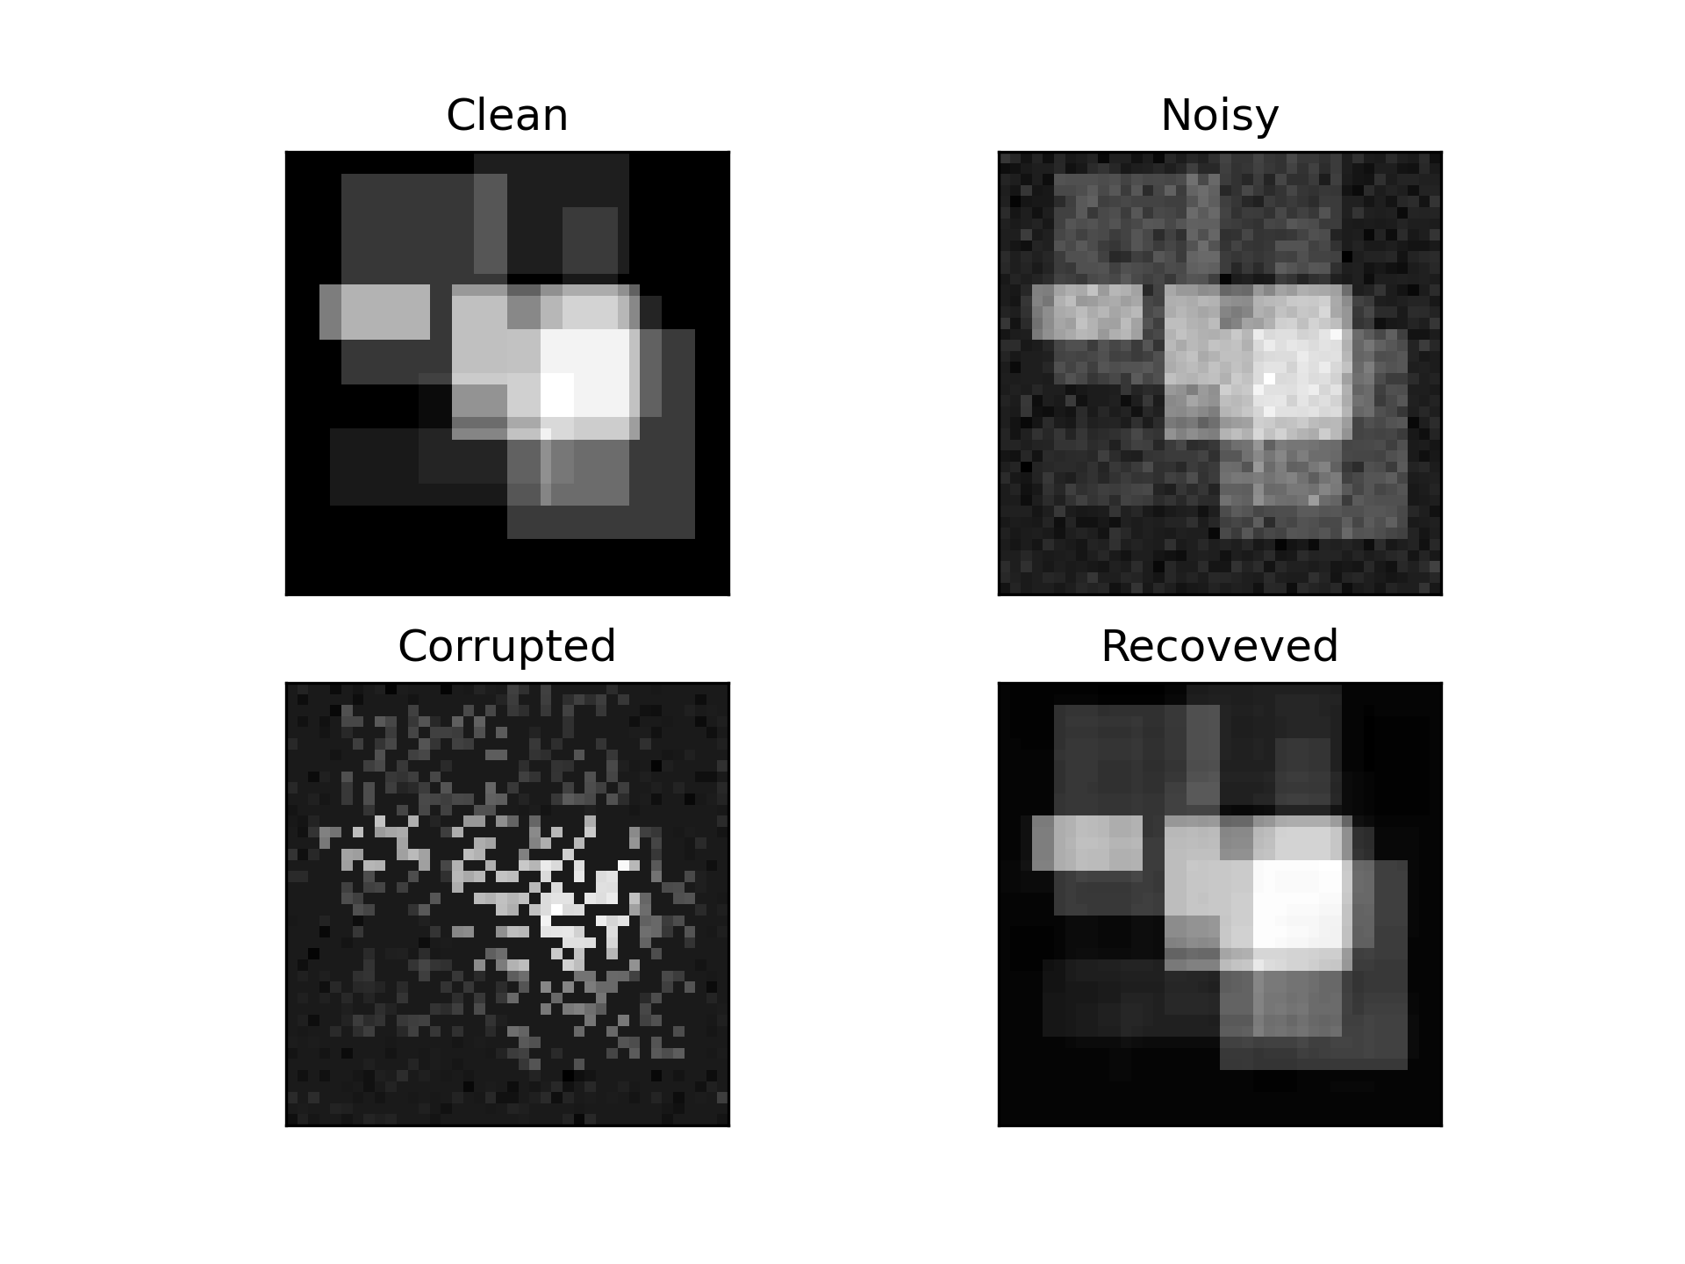

Compare between Oracle and OMP and BP reconstructions:

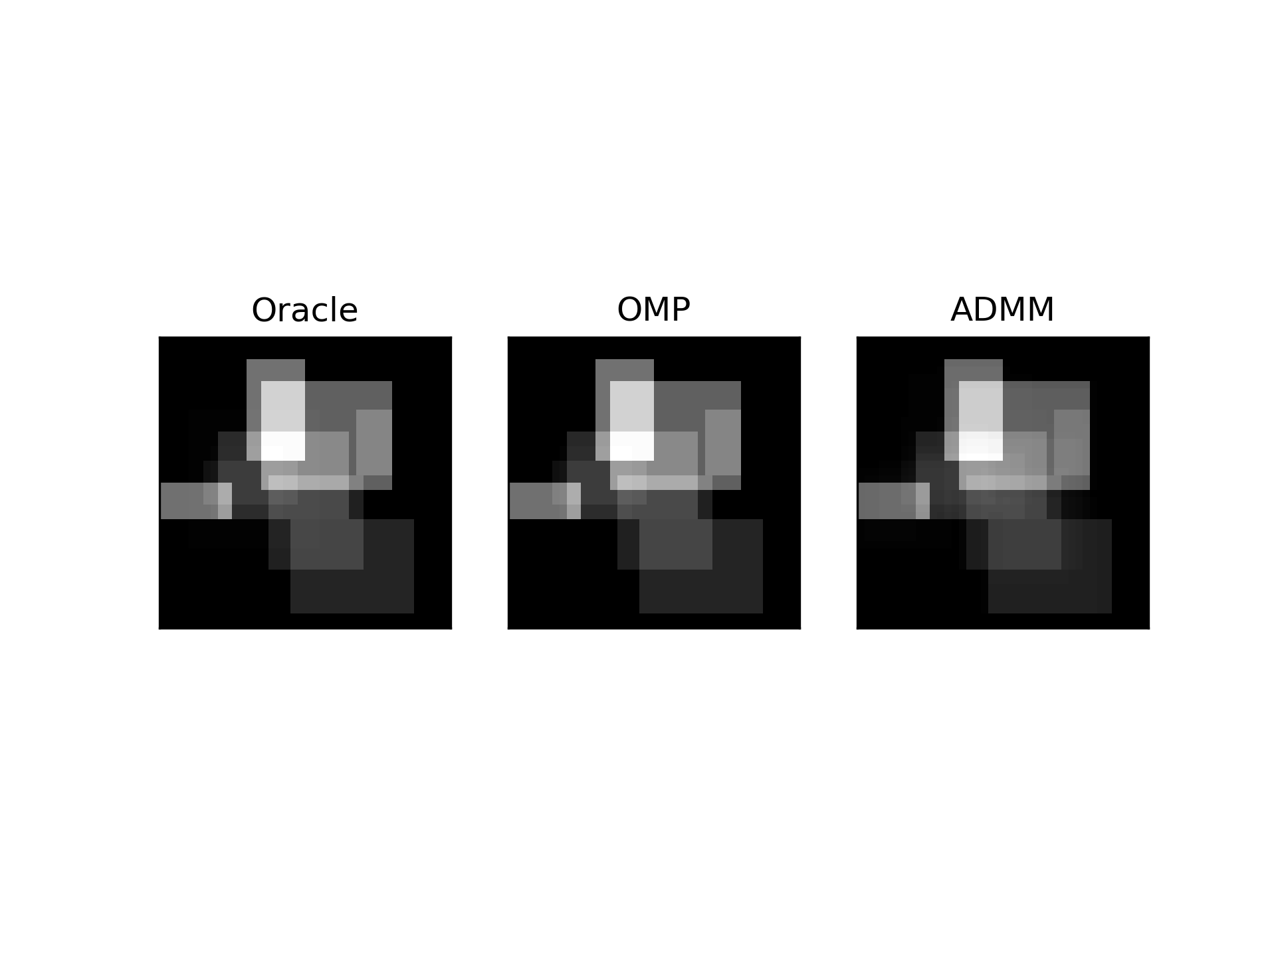

PSNR comparison:

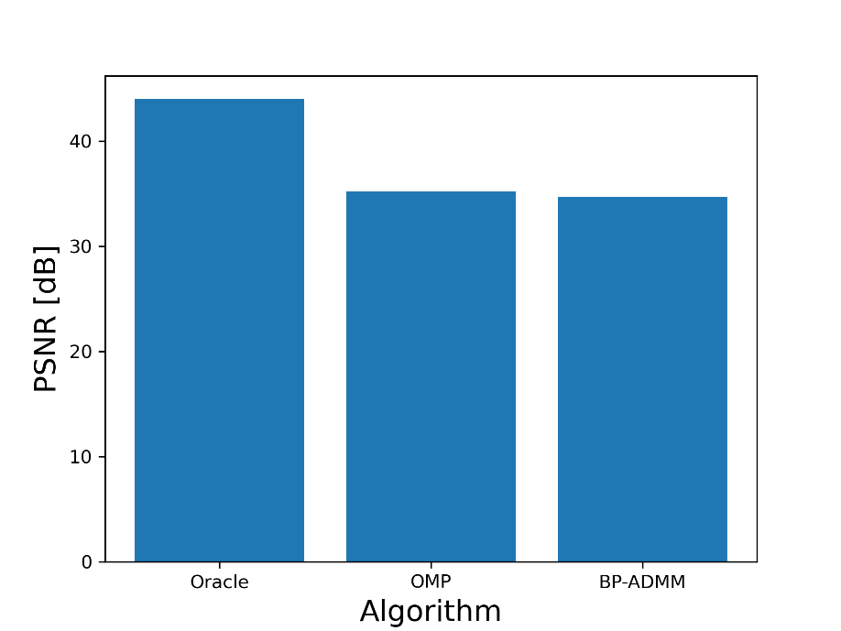

Discuss results of BP and compare to greedy methods and to the oracle performance:

* The visual reconstruction looks similar for both OMP and ADMM.
* The average PSNR between OMP and ADMM is similar
* The ADMM solution is much less “sparse”. In the reconstructed image is it visible that much more than 10 atoms were used. This means ADMM also tried to explain the noise.

Show PSNR as a function of $λ$:

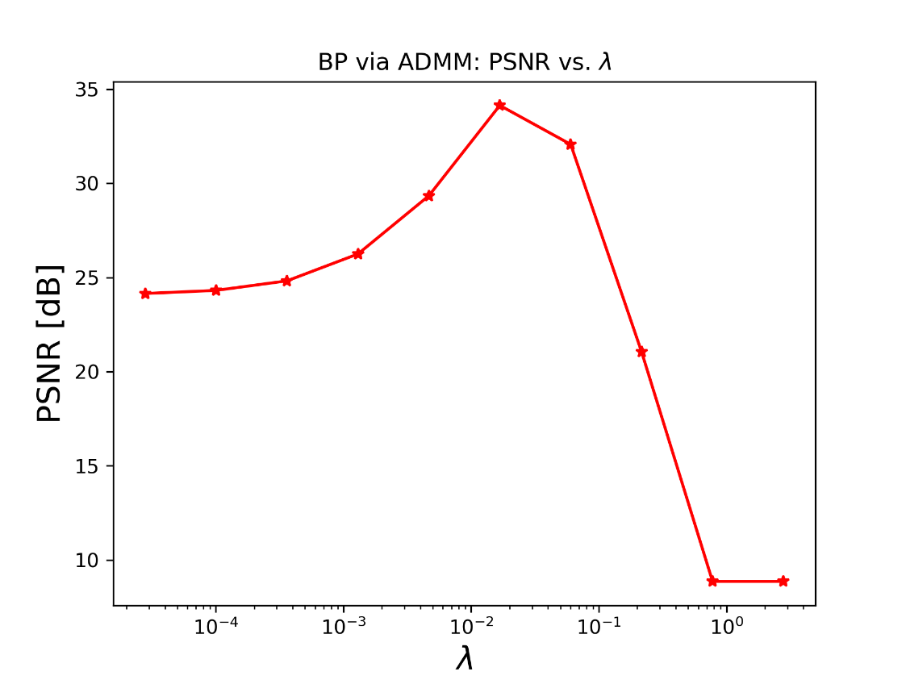

Discuss how $λ$ affects BP reconstruction:

We see that lambda has enormous effect on the reconstruction of the image, as was shown and proven in the lecture. The best lambda value that will achieve the highest PSNR will be different for each image. When the original image is not given, we cannot calculate PSNR. To tune lambda in this case, a method was suggested in the lecture, which uses the knowledge of the noise model (gaussian with a known std). It utilizes the comparison of the energy level of the residual and the energy of the noise. By using the log value of this relation, we can discover when the energy level of the residual is similar to the energy level of the noise, and deduce that this lambda is the best fit.

Part E – Effect of Parameters

Show MSE as a function of $p$ and $σ$:

To get better results, the number of experiments was increased to 1000 for this section.

This way the graphs were more representative of the true behavior, allowing for more precise conclusions.

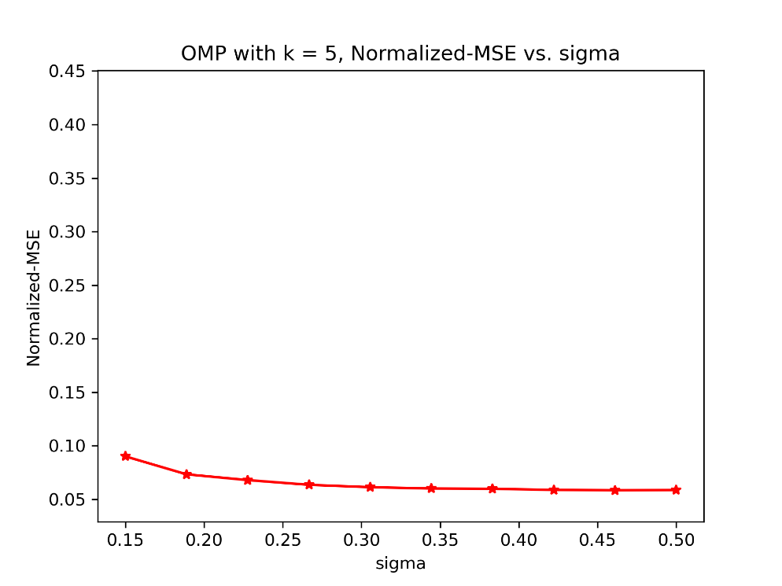

Discuss the effect of $p$:

As we can observe, there is direct relation (with some inconsistencies, due to the small number of experiments) between p and normalized MSE. The lower the number of corrupted pixels, the better is the reconstruction. This conclusion is logical and doesn’t require much explanation – the more data is available, the better we can represent the original image. Worth noting that for low values of p, the effective dictionary CA may not include some of the atoms at all, reducing altogether the probability to recover this dictionary index (by using any method).

Discuss the effect of $σ$:

First, we see that the effect of the noise std is not so pronounced. This can be explained by the fact that OMP acts as “denoising” algorithm, which finds atoms which are pronounced the most in the signal (image).

We can see the slight correlation between the effect of sigma and the normalized MSE, especially for small sigma values.

The larger the noise STD, the better is the recovery. This is a strange conclusion at the first glance.

This can be explained by the “denoising” effect that was also mentioned in the lectures. The atoms that were chosen by the OMP correlate the best with the residual.

**FILL**