Mid Project Report

Submitted by:

Hamza Khatieb 315398933

Alexander Shender 328626114

Part A: Data Construction and Parameter-Setting:

Barbara:

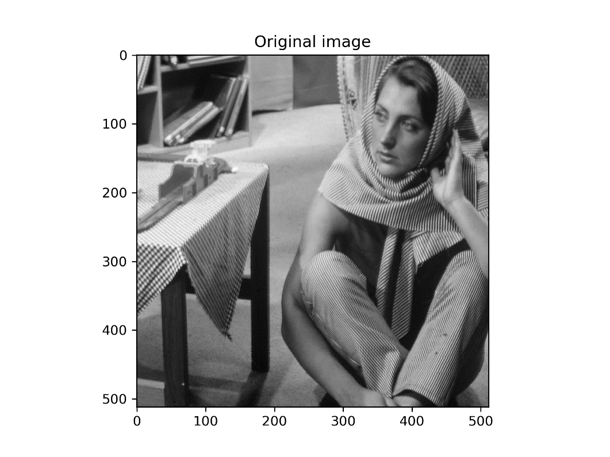

DCT Dictionary:

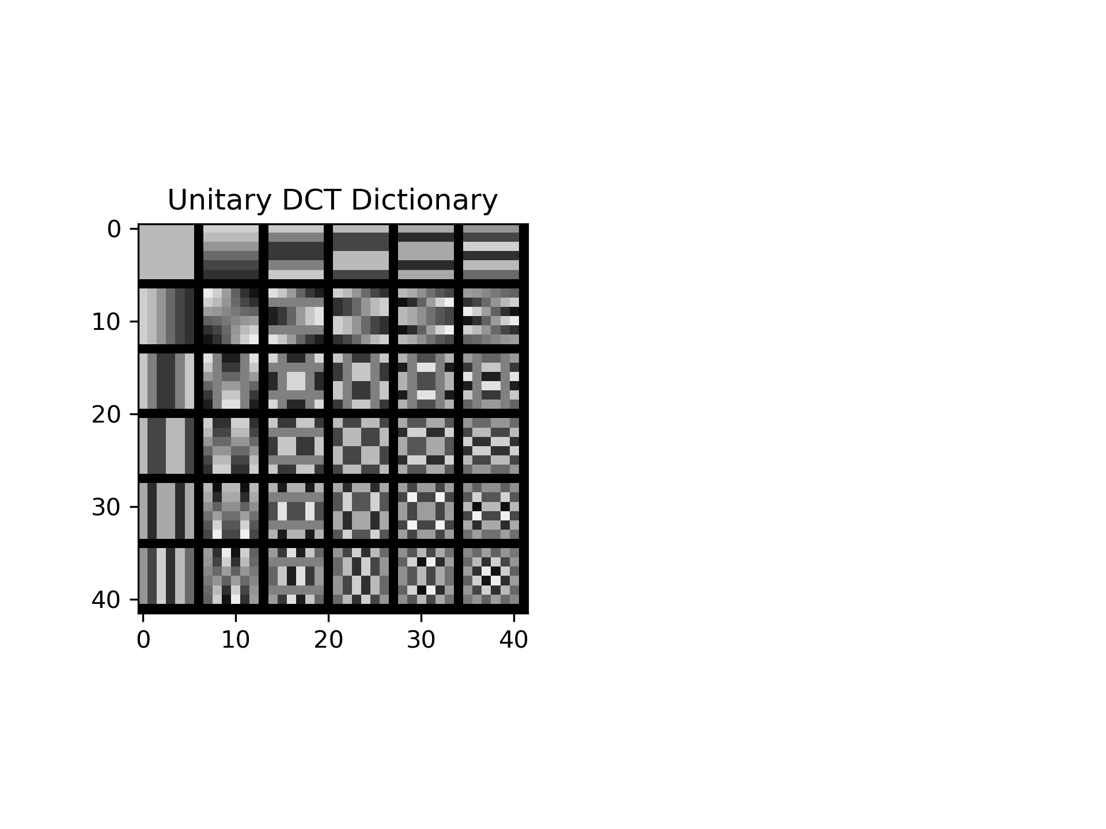

Part B: Compute the Representation Error Obtained by the DCT Dictionary

Insert average MSE for train set: 742.17

Insert average MSE for test set: 716.99

Insert average number of non-zeros for train set: 4

Insert average number of non-zeros for test set: 4

Part C: Procrustes Dictionary Learning

The obtained learned dictionary (on the right):

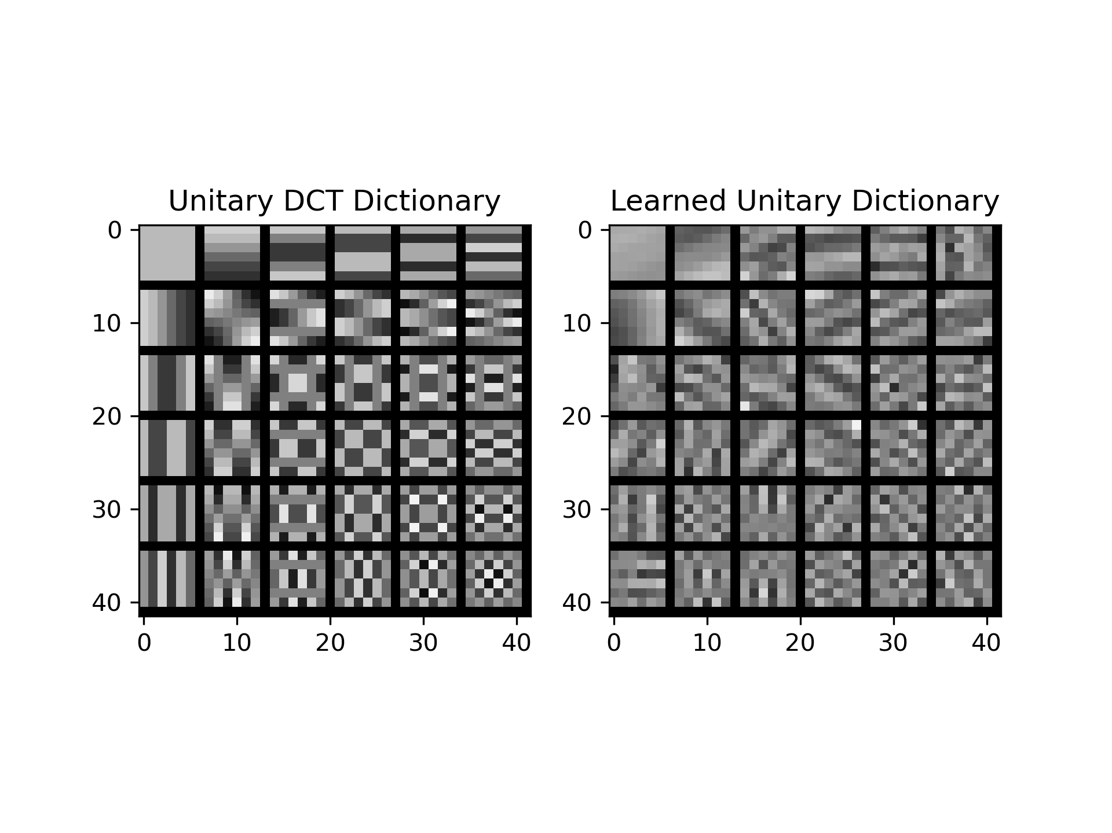

**Discuss the obtained dictionary:**

We can observe that the Learned dictionary is more domain-specific for this image that was used to generate patches. Since the image contains both patches with relatively calm regions with small gradients (e.g. carpet on the back), and patches with big gradients (e.g. textures on the clothing or the table), the dictionary had to learn to represent all of this variety sparsely.

Average MSE and number of nonzeros as a function of the iteration (train-set):

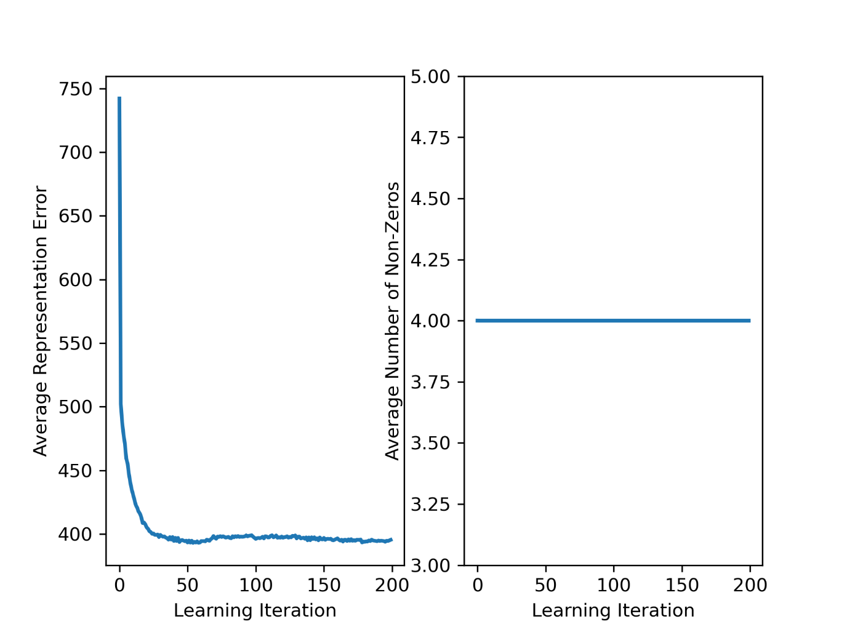

**Discuss the obtained curves:**

1. On the MSE:

We can see a sharp decline in the MSE in the first iterations, and some stagnation (even degradation) in later learning steps. This result shows the limitation of the sparse representation performance that we can reach using Unitary dictionary learned via Procrustes method.

1. On the Average number of non-zeros:

We can see a steady constant 4 number of non-zeros in the pursuit stage. This displays that there weren’t any same values in the columns of $DY^{T}$, which are equal to the threshold that was used for the hard thresholding. Although this is possible, perhaps this is a special case. In general, in the pursuit stage we have aimed to find representation consisting of only 4 non-zero atom values.

**Insert average MSE for test set:** 417.88

**Discuss the obtained MSE:**

We can see substantial improvement over the case with the DCT matrix. This shows that the learned dictionary, tailored for specific type of signals, can give a better sparse representation of this signal, than a ‘general-purpose’ dictionary.

**Compare the results of the DCT dictionary and the learned dictionary:**



By looking at the dictionaries side-by-side we can see that the Learned Dictionary is much more ‘tailored’ to the specific set of patches that we have trained it on. This dictionary may be used to give better results on deblurring and denoising images than ‘generic’ dictionary such as DCT dictionary.