Bonus Project Report

Submitted by:

Hamza Khatieb 315398933

Alexander Shender 328626114

Part A: Data Construction

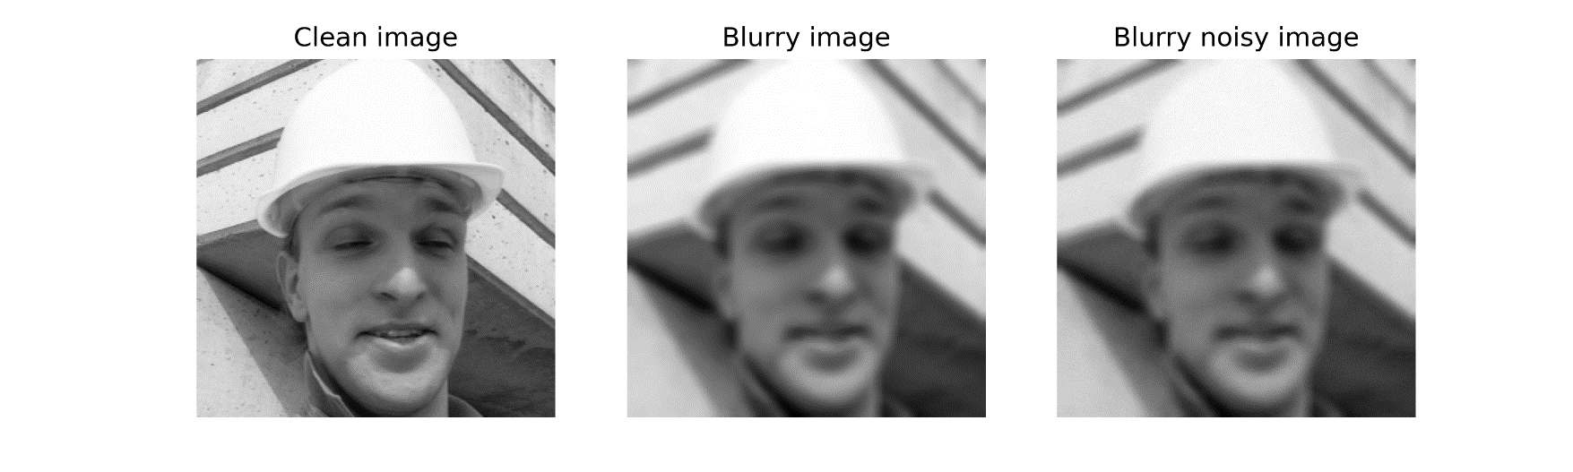

Insert PSNR value of final degraded image: 28.08

Part B: Deblurring via Regularization by Denoising (RED)

RED reconstructed image:

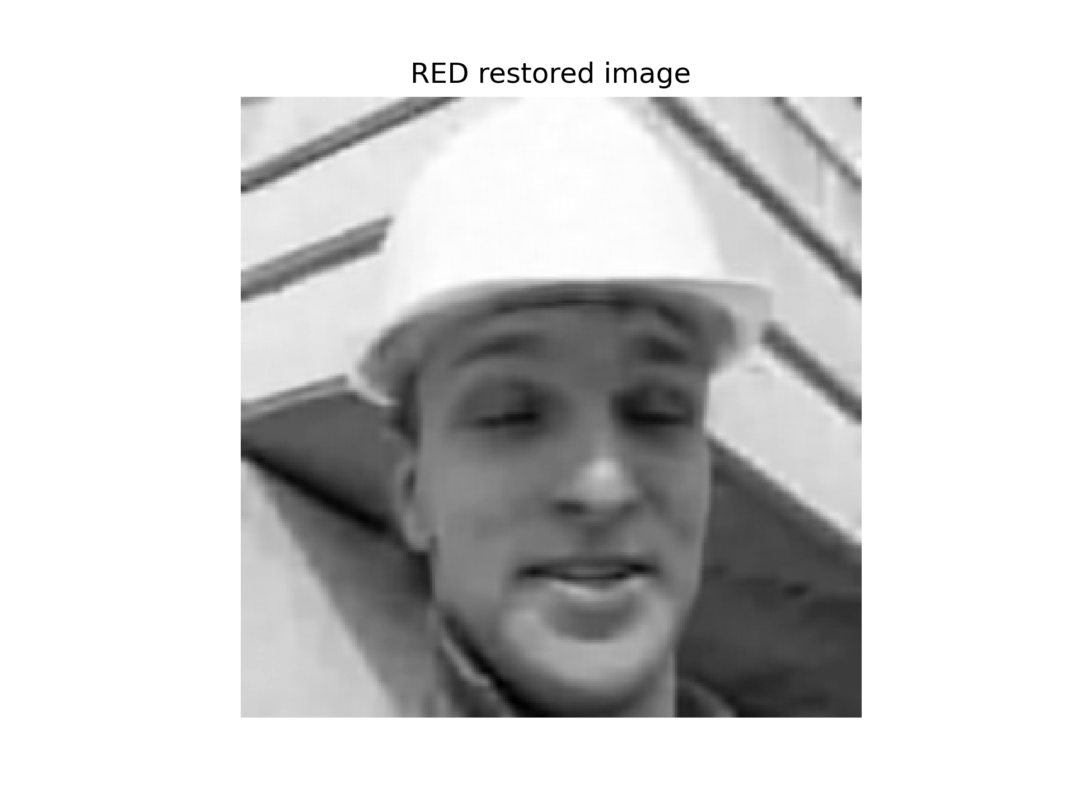

Enter PSNR of reconstruction: 31.992

Discuss the obtained results below:

We can observe that the RED restoration visually has produced great results. The image is less blurry and less noisy that the input image, and the PSNR was increased significantly. What is surprising is that even the teeth texture was restored and we can see the gap between the teeth. Of course there are still undesired artifacts that can be seen and the result can be improved further.

PSNR as a function of FP iterations:

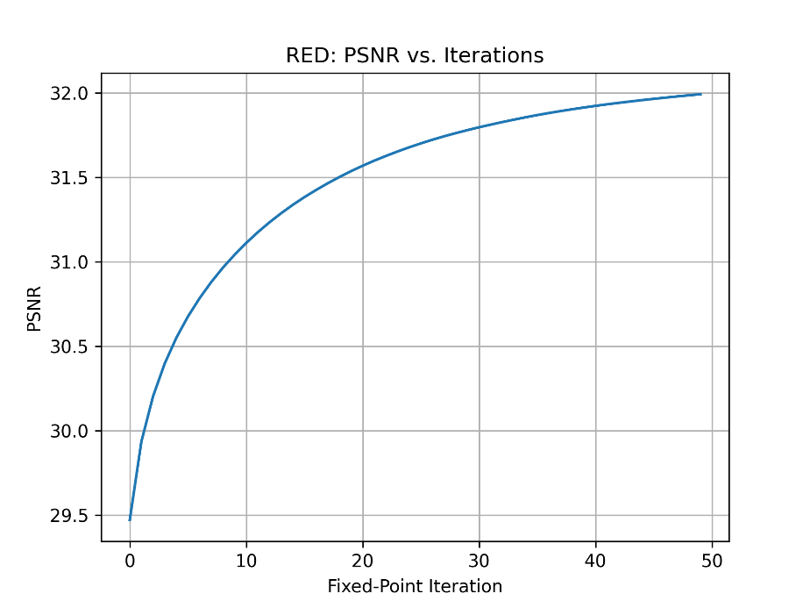

Discuss the obtained results below:

We can witness that the PSNR is getting increased over iterations, as predicted. The logarithmic-like nature of the PSNR increase is expected as well, since there is a 'ceiling' to the PSNR that we can get using this algorithm, and the closer we are to this 'ceiling', the harder it is to improve the PSNR even more.