A

PROJECT REPORT

ON

**ONLINE HOSPITAL MANAGEMENT SYSTEM**

Towards partial fulfilment of the requirement in

**5th Semester BCA (2018-2019)**

**Submitted By: -**

Leonard HABIMANA (160510101041)

Romarick Junior AKA (170510101903)

**Submitted To: -**



**Parul Institute of Computer Application,**

**Parul University**

Under the Guidance of

Mr. JANARDAN BHARVAD,

Assistant Professor

**ACKNOWLEDGEMENT**

We take this occasion to thank God, almighty for blessing us with his grace and taking our endeavour to a successful culmination. We extend our sincere and heartfelt thanks to our esteemed guide, Prof. **Janardan bharvad** for providing us with the right guidance and advice at the crucial junctures and for showing us the right way. We extend our sincere thanks to our respected head of the division

We would like to thank the other faculty members also, at this occasion. Last but not the least, we would like to thank friends for the support and encouragement they have given us during the course of our work.



PARUL INSTITUTE OF COMPUTER APPLICATION

CERTIFICATE

This is to certify that **Leonard HABIMANA** and **AKA Romarick Junior** the student(s) of Parul Institute of Computer Application, has/have satisfactorily completed the project entitled

“**Online Hospital Management System**” as a part of course curriculum in BCA / IMCA semester - V for the academic year 2018-2019 under guidance of Prof.Janardan bharvad.

Enrolment Number: 160510101041

Enrolment Number: 170510101903

|  |  |  |
| --- | --- | --- |
| Quality of work | Grade | Sign of Internal guide |
| Poor / Average / Good /  Excellent | B /B+ / A / A+ |  |

H.O.D Principal

**Harshika Rana** Dr. **Priya Swaminarayan**

Date of submission:

**INDEX**

|  |  |  |
| --- | --- | --- |
| Title No | Title | pages |
| 1 | Title page , Acknowledgement, certificate |  |
| 2 | Research   * What is research * Types of research methodology * Why it is useful | 1 |
| 3 | Feasibility study  What is feasibility study?  Importance of feasibility study  Feasibility study of your project  SDLC | 3 |
| 4 | SRS  What is SRS  SRS of your project | 6 |
| 5 | Technology description which you are going to use  Limitations and features of your project | 9 |
| 6 | UML  Description of UML or DFD | 12 |
| 7 | Description of class diagram  Your class diagram | 16 |
| 8 | Description of activity diagram  Your activity diagram | 17 |
| 9 | Description of use case diagram  Your use case diagram | 18 |
| 10 | Description of E-R diagram  Your E-R diagram | 20 |
| 11 | Description of Data dictionary  Your data dictionary | 22 |
| 12 | Screenshots of development phase-1 | 23 |
| 13 | Screenshots of development phase-2 | 23 |
| 14 | Screenshots of development phase-3 | 24 |
| 15 | Screenshots of development phase-4 | 24 |
| 16 | What is testing  Importance and types of testing  Screenshots of testing phase | 25 |
| 17 | Future Enhancement | 28 |
| 18 | References & Bibliography | 29 |

**ABSTRACT**

The data are well protected for personal use and makes the data processing very fast. Our project Online Hospital Management system includes registration of patients, storing their details into the system, and computerized billing in the pharmacy, and labs. Our software has the facility to give a unique id for every patient and stores the details of every patient and the staff automatically. It’s includes a search facility to know the status of each room. User can search availability of a doctor and the details of a patient using the id. The Online Hospital Management System can be entered using a username and password. It is accessible either by an administrator or receptionist. Only they can add details into the database, the data can be retrieved easily. The interface is very user-friendly.

**INTRODUCTION**

Online Hospital Management System aims to develop the software that covers all the aspects of management and operations of the hospital. It enables healthcare providers to improve operational effectiveness, reduce costs, reduce medical errors, reduce time consumption and enhance delivery of quality of care.

The purpose of the project is to computerize the Front Office Management of Hospital to develop software which is user friendly, simple, fast, and cost – effective. It deals with the collection of patient’s information, diagnosis details, etc.

Traditionally, it was done manually. The main function of the system is to register and store patient details and doctor details and retrieve these details as and when required, and also to manipulate these details meaningfully System input contains patient details, diagnosis details; while system output is to get these details on to the CRT screen.

**RESEARCH**

Research is a systematic study, inquiry or investigation that collects data and information on a specific thing like a problem! It is a form of science that turns a normal thing into a question of how it was build, where did it come from and what are the other forms it can transform into.

Research is based on finding detailed information or knowledge about a specific thing.

**Types of research methodology**

There are various types of Research, but the basic ones are 6

* Basic Research
* Applied Research
* Problem Oriented Research
* Problem Solving Research
* Quantitative Research
* Qualitative Research

1. **Basic Research**

Also known as Pure or fundamental, it is based on getting knowledge on some concepts rather than creating or inventing. This research is mostly operated on human welfare, animal welfare and animal kingdom welfare.

1. **Applied Research**

This research is based on solving practical problems of the modern world, analysis and solving social and real-life problems rather than acquiring knowledge. Its goal is to improve human condition by investigating ways for using knowledge to solve practical problems life government issues.

1. **Problem Oriented Research**

This research is based on solving the problems faced by other companies by knowing the exact nature of the problem to be solved. It means if like one company faces a problem, the study looks after the cause of the problem and how to overcome it.

1. **Problem Solving Research**

This research is based on numeric figures or numbers. Quantitative research aim is to measure the quantity or amount and compares it with past records and tries to project for future period. In social sciences, “quantitative research refers to the systematic empirical investigation of quantitative properties and phenomena and their relationships”.

1. **Qualitative Research**

Qualitative research presents non-quantitative type of analysis. Qualitative research is collecting, analyzing and interpreting data by observing what people do and say. Qualitative research refers to the meanings, definitions, characteristics, symbols, metaphors, and description of things. Qualitative research is much more subjective and uses very different methods of collecting information, mainly individual, in-depth interviews and focus groups.

The nature of this type of research is exploratory and open ended. Small number of people are interviewed in depth and or a relatively small number of focus groups are conducted.

**Why is it useful?**

1. A Tool for Building Knowledge and Efficient Learning

## Means to Understand Various Issues

## An Aid to Business Success

## A Way to Prove Lies and to Support Truth

**FEASIBILITY**

**Feasibility Study**: is an assessment of the practicality of a proposed plan or method. Used to determine potential positive and negative outcomes of a project before investing a considerable amount of time and money into it.

**OHMS Feasibility**

* Hospital management system will provide a self-test to the patient, if hospitals are not available in near places. our project includes online registration of patients, storing their details into the system and computerized billing in the pharmacy
* This System will be useful to the people who are far away from the hospitals and the patients can get treatment when the doctor is not available in hospital.
* This system will be helpful to the people who are busy with their professional work, because they can get doctor suggestions through online and can share their problems with doctor

**SDLC (Software Development Life Cycle)**

 SDLC is a process used by the software industry to design, develop and test high quality software. It is also called as Software Development Process as a framework defining tasks performed at each step in the software development process.

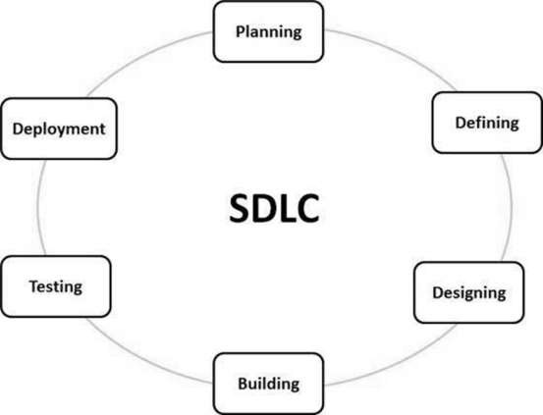

Fig1 : SDLC

**Planning:**  It involves creating of a set of plans to help guide your team through the execution and closure phases of the project. The plans created during this phase will help you to manage time, cost, quality, change, risk and issues. They will also help you manage staff and external suppliers, to ensure that you deliver the project on time and within budget.

**Defining:** After the planning has been approved, the project enters the second phase: the definition phase. In this phase, the requirements that are associated with a project result are specified as clearly as possible. This involves identifying the expectations that all of the involved parties have with regard to the project result.

**Designing:** In this third phase, the system and software design documents are prepared as per the requirement specification document. This helps define overall system architecture.

This design phase serves as input for the next phase of the model.

There are two kinds of design documents developed in this phase:

-High-Level Design (HLD)

- Low-Level Design (LLD)

**Building:** Once the system design phase is over, the next phase is coding. In this phase, developers start build the entire system by writing code using the chosen programming language. In the coding phase, tasks are divided into units or modules and assigned to the various developers. It is the longest phase of the Software Development Life Cycle process.

**Testing:** Once the system design phase is over, the next phase is coding. In this phase, developers start build the entire system by writing code using the chosen programming language. In the coding phase, tasks are divided into units or modules and assigned to the various developers. It is the longest phase of the Software Development Life Cycle process.

**Deployment:** Once the software testing phase is over and no bugs or errors left in the system then the final deployment process starts. Based on the feedback given by the project manager, the final software is released and checked for deployment issues.

# SRS DOCUMENTATION FOR HOSPITAL MANAGEMENT SYSTEM

A software requirements specification (SRS) is a comprehensive description of the intended purpose and environment for software under development. The SRS fully describes what the software will do and how it will be expected to perform.

The SRS is produced at the culmination of the analysis task. The function and performance allocated to software as part of the system engineering and refined by establishing a complete information description, a detailed functional description, a representation of system behaviour, indication of performance requirements and design constrains, appropriate validation criteria and the other information related to requirements.

The SRS is technical specification of requirement of Hospital Management system. This specification describes what the proposed system should do without describing how it will do it. It also describes complete external behaviour of proposed system.

**Purpose: -**

The main purpose of our system is to make hospital task easy and is to develop software that replaces the manual hospital system into automated hospital management system. This document serves as the unambiguous guide for the developers of this software system.

**User of online hospital management system**

* **Patient** : Patient will be using the system from home or anywhere
* **Receptionist** : Receptionist is the one who will receive queries of the patients, process them and have a look on their profiles
* **Doctor** : The doctor will have a look on patients treatment and fix the next appointment
* **Admin**: The **admin** is the person responsible for managing all or part of the system, employees, and data

**Modules of online hospital management system**

* **Appointment module:** This is the reference that allows the clinic administrator to define when resources (*doctors*, *locations*, *equipment*, etc) are available and allows clinic staff to make patient appointments.
* **Dashboard module**: This provides users with personalized **dashboard** pages and can add widgets to their pages and arrange them through the use of a drag and drop interface.
* **Billings module** : This works as a connector of financial information capture between different departments inside the hospital
* **Treatment module**: medical care given to a patient for an illness or injury so that the patient may retrieve his/her data for the appointment given by the Hospital.

**Research and compare the existing system with online hospital management system**

This system provides online diagnosis, retrieval and updating facility. It’s also provides very less paper work, and everything is stored electronically.

* **Advantages**:
  + Avoid errors and track every single detail
  + Improve data security
  + Improved clinical decision-making
  + Establish the hospital as technically advanced
* **Disadvantages**:
  + Change communication process with staff
  + Training of staff is quite time consuming
  + costly of the new system
  + The system requires Internet, it’s won’t work or success their duties.

**Requirement analysis**

**Software requirement**

* Windows 10, 8,7 and Window XP

**Hardware requirement**

* Computer
* 512MB RAM or above
* Minimum 32GB hard disk or above
* Minimum 600MHZ processor

**TOOLS AND TECHNOLOGY USED**

* **PHP:** stands for Hypertext Pre-processor. It is also an interpreted language.
* **MYSQL:** MySQL is a relational database management system, includes all topics of MySQL database such as insert record, update record, delete record, select record, create table, drop table etc…
* **JAVASCRIPT:** is used to create web application just like Servlet technology. It can be thought of as an extension to servlet because it provides more functionality than servlet such as expression language
* **HTML:** stands for Hyper Text Markup Language, it is also describes the structure of Web pages using markup.
* **CSS:** stands for **C**ascading **S**tyle **S**heets, it’s used to describe the style of HTML document and how HTML elements are to be displayed on screen, paper, or in other media, it saves a lot of work. It can control the layout of multiple web pages all at once.
* **WAMP SERVER:** WampServer is a Web development platform on Windows that allows you to create dynamic Web applications with Apache2, **PHP**, and **MySQL.**
* **BROWSER:** It’s a software application that allows you to retrieve, search for and explore information on the internet and is very helful in excuting our project work. Common **browsers** include Internet Explorer, Firefox, Safari, Google Chrome, …
* **SUBLIME TEXT (TEXT EDITOR):** is a proprietary cross-platform source code editor with different programming Languages. It natively supports many programming languages and markup languages, and functions can be added by users with plugins, typically community-built and maintained under free-software licenses

**DESCRIPTIONS AND LIMITATIONS OF ONLINE HOSPITAL MANAGEMENT SYSTEM**

**Descriptions:**

* Uses a manual system for the management and maintenance of critical information
* Requires numerous paper forms, with data stores spread throughout the hospital management infrastructure
* Multiple copies of the same information exist in the hospital and may lead to inconsistencies in data in various data stores.
* Requires a comprehensive auditing process to ensure that no vital information is lost.

**Needs for online hospital management system**

* Efficiently maintains the details about the patients
* Simultaneously updates changes made to any data, item in the entire data base
* It is faster than manual system
* More reliability
* Responsiveness
* Easier to update

**Features of online hospital management system**

* Replace existing manual paper based system
* Efficient
* Cost effective
* Automation of system
* Saves, retrieves, updates, and deletes information of patients in efficient manner.
* Appointment
* Billing

**Limitations:**

* More man powers.
* Time consuming.
* Consumes large volume of paper work.
* Needs manual calculations.
* Data redundancy
* Forms may be lost
* No direct role for the higher officials.

**DFD SYMBOLS AND DESCRIPTIONS**

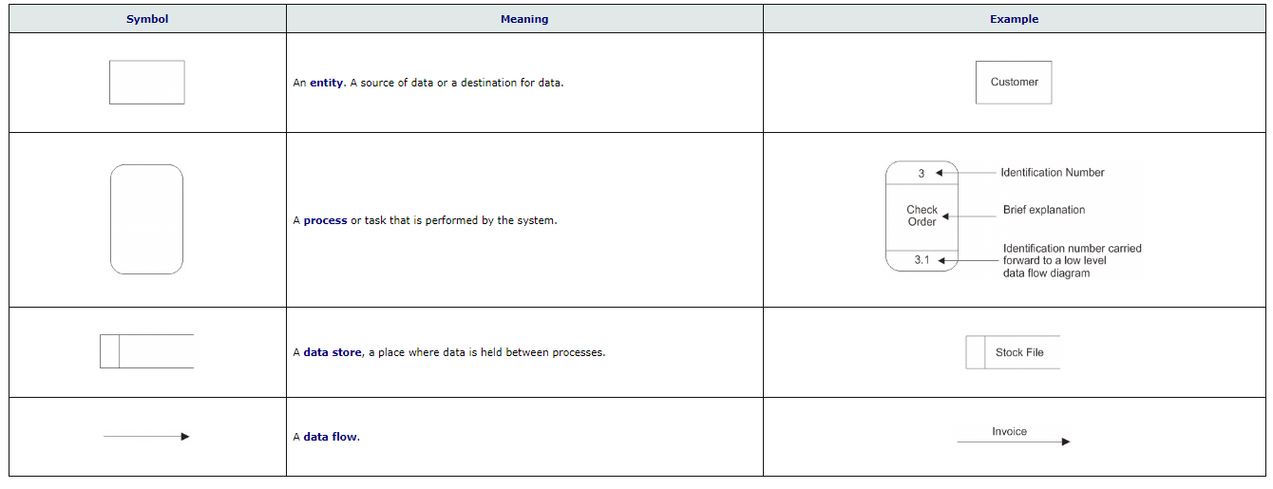

**DFD LEVEL 0**

**Level 0**:  It only contains one process node ("Process **0**") that generalizes the function of the entire system in relationship to external entities.

Doctor

System Administration

Patients

Receptionist

Fig2: DFD level 0

**DFD LEVEL 1**

**Level 1**:  is more detailed than a **level** 0 **DFD** but not as detailed as a **level** 2 **DFD**. It breaks down the main processes into sub processes that can then be analysed and improved on a more intimate **level**

1.1

Add new patient

Receptionist

Login

fail

Patient

Generating test result

1.3

Treatment process

View Patients

Doctor

1.2

Patient details

Login No

Test Results

Checking Entry

c

Lab Process

Check

1.4

Bill Calculation

Yes

Billing

Fig3: DFD level 1

**DFD LEVEL 2**

**Level 2:** offers a more detailed look at the processes that make up an information system than a **level** 1 **DFD** does. It can be used to plan or record the specific makeup of a system; therefore, you can input the particular of your own system.

Patient(Client)

Login after being registered

Patient ID

Doctors

Login

Invalid

Valid Get new id

Receptionist

Request

Generating a test result feedback

Treatment process Check if Doctor is available

give treat add new

# Fig4: DFD level 2

# ACTIVITY DIAGRAM

No No

Yes

Yes



No

Yes

Fig5: Activity diagram

**USE CASE DIAGRAM**

This is the methodology used in system analysis to identify, clarify, and organize

system requirement

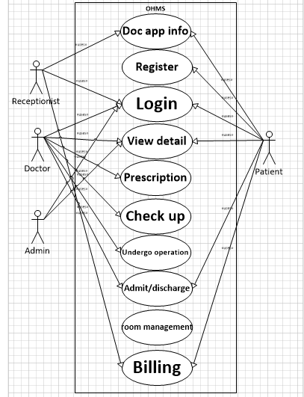

Fig6: Use case diagram

**CLASS DIAGRAM**

**Description**

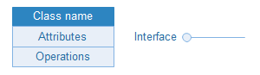

**Classes** and **interfaces** in UML show architecture and features of the designed system.



**Aggregation** is a special type of association in which objects are assembled or configured together to create a more complex object. An aggregation describes a group of objects and how you interact with them.

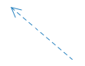

**Dependency** relationship is a relationship in which one element, the client, uses or depends on another element, the supplier.



**Composition** represents whole-part relationships and is a form of aggregation.



**Generalization** is a relationship in which one model element (the child) is based on another model element (the parent).

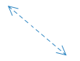

**Association** is a relationship between two classifiers, such as classes or use cases, that describes the reasons for the relationship and the rules that govern the relationship.

Constraint

**Constraint** is an extension mechanism that enables you to refine the semantics of a UML model element.

Note

**Note** contains comments or textual information.

This is illustration of relationship and source code dependencies among classes

in the Unified Modelling Language(UML). It defines as the method of and variables in an Objects which specific entity in program or the unity of representing that entity.

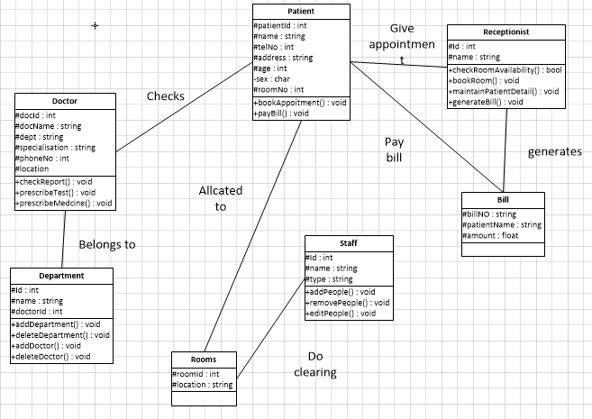

Fig7: Class diagram

**ENTITY RELATIONSHIP DIAGRAM**

**Description**

Activity

**Activity** in Unified Modeling Language (UML) is a major task that must take

place in order to fulfill an operation contract.

State

**State** defines current condition of an event or activity. State diagram is often used to describe state changes triggered by events.



**Decision activity** is introduced in UML to support conditionals in activities. A decision activity is modeled as a diamond on a UML Activity diagram.

Control flow

**Control flow** in computer science refers to the order in which the individual statements, instructions or function calls of an imperative or a declarative program are executed or evaluated.

Object flow

**Object flow** is a path along which objects or data can pass.



**Bars** represent the start (split) or end (join) of concurrent activities.



**Initial state** shows the initial state of the workflow, meanwhile, **final state** displays the final state of the workflow.

Constraint

**Constraint** is an extension mechanism that enables you to refine the semantics of a UML model element.

Note

**Note** contains comments or textual information.

TREATMENT

MEDCINE

bill

ISA

maintains

DOCTOR

attends

RECORD

RECEPTIONIST

EMPLOYEE

ROOMS

assigned

PATIENT

Fig8: ER diagram

**A DATA DICTIONARY**

 It’s a file or a set of files that contains a database and metadata. The data dictionary contains records about other objects in the database.

|  |  |  |  |  |
| --- | --- | --- | --- | --- |
| Entity | Constraints | Attributes | Datatypes | Size |
| Patient | Primary | Patient ID  PName  Date of Birth  Phone Number  Gender  Email  Country  Address  Appoint Info  Details  Username  Password | AutoNumber  Varchar  Varchar  Date  Number  Varchar  Varchar  Varchar  Varchar  Varchar  Varchar  Varchar | Auto  100  100  20  15  100  100  10  100  100  100  10 |
| Employee | Primary | Employee Id  Name  Username  Password  Email  Gender  Salary  Address | AutoNumber  Varchar  Varchar  Varchar  varchar  Varchar  Number  Varchar | Auto  50  50  50  50  50  50  50 |
| Room | Primary | Room Id  Room type  Period | AutoNumber  Varchar  Date | Auto  50  20 |
| Medicine | Primary | Code  Price  Quantity | AutoNumber  Number  Number | Auto  50  20 |

FORM DESIGN SCREENSHOT

1. **Login Form**: this form describes how a patient or admin will access the system accordingly their password and username. 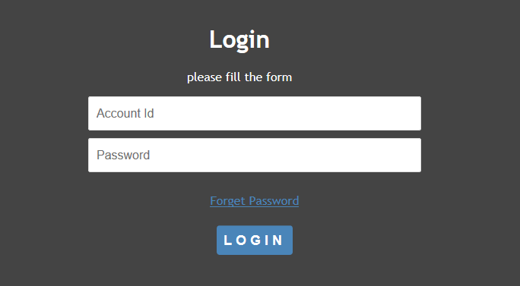
2. **Index form:** This index form work as a home page of the system that will provide a little information of our system, how it’s works and direct a new applier where to go.

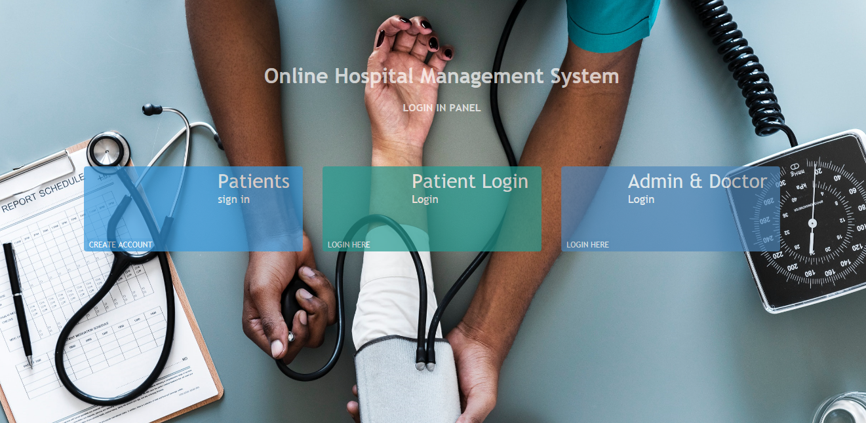

1. **Admin Profile:** This is the Dashboard of the Admin in the System who’s function as the build he can manager all the account in the system and give an access on it!

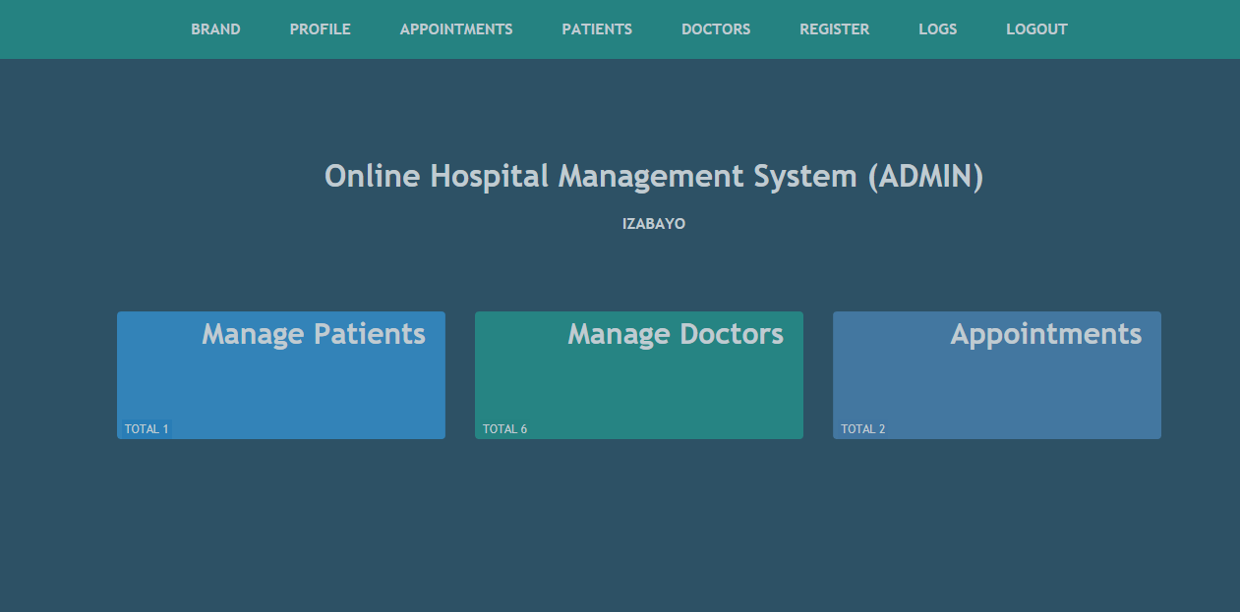

1. **Appointment Form:** This is the appointment form which is used for requesting an appointment when the patient is far away from the hospital.

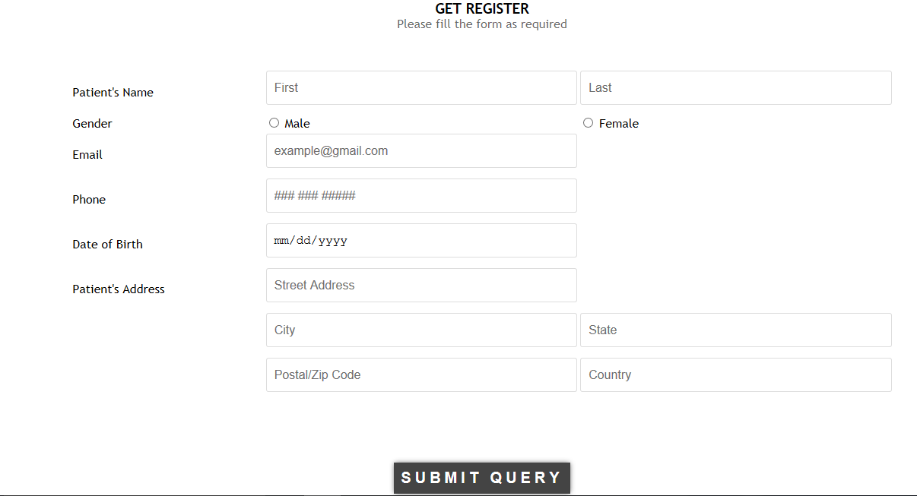

1. **Patient List:** This display the list of the Patient who are received the appointment and their regular date of treatment!

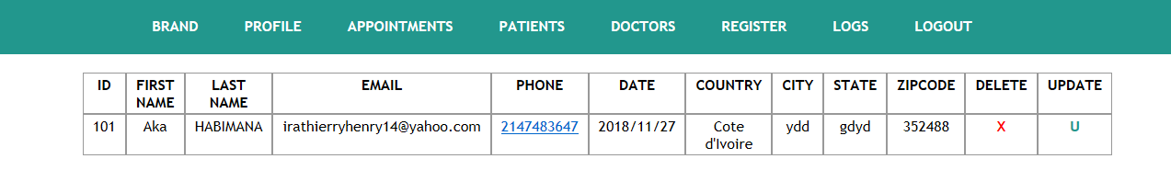

**TESTING**

**Importance of testing**

Testing should be introduce in the early stage of the SDLC, The cost of fixing the bug is larger if testing is not done in early stage & bugs found in later stages.

In the today’s competitive market only the quality product stays long time firmly, so to make sure the produce the good quality product the testing of application is key factor in SDLC.

As it not possible makes it software application is defect free but testing will be necessary.

Most important thing of testing is the development environment is different than the Testing environment and the testing done on testing environment is similar to the Production environment.

**Types of testing**

**-Functional testing**

**-Non-functional testing**

**Functional testing**

**Unit testing:** Unit Testing allows your find more bugs at code level or more refined class level. Whatever you are developing Unit testing applies there, be it a web application or mobile app development. It is a concept that is up to the discretion of the team whether to use it or not.

**Integration Testing:** In integration testing, every element is treated as an atomic unit or as a black-box, at the same time the interconnections among them are checked and modelled to conduct software testing of component interfaces and interplays.

**Interface testing:** Verify that communication between the systems are done correctly if all supported hardware/software has been tested. If all linked documents are supported/opened on all platforms the security requirements or encryption while communication happens between systems. Check if a Solution can handle network failures between a Web site and application server.

**System testing:** System testing is the testing of a complete and fully integrated software product. System testing simulates real life scenarios that occur in a simulated real life test environment. It tests all the functions of the system.

**Regression testing**: User Acceptance Testing which means agreement or approval. It is used to ensure that the software is satisfying the functional and performance requirement of the end user.

**Non-functional testing**

It is a testing to determine the performance of the system to major the measure, validate or verify quality attribute of the system.

**Documentation testing**: Documentation testing helps to estimate testing efforts required and test coverage. Software documentation includes test plan, test cases, and requirements section.

**Installations testing**: Installation testing is a type of quality assurance work in the software industry that converges on what customers will need to do to install and set up the new software successfully. The testing process may involve full, partial or upgrades install/uninstall processes.

**Reliability testing:** Reliability testing assures that the product is fault free and is reliable for its intended purpose. It is about exercising an application so that failures are discovered before the system deployed.

**Security testing:** Security word itself defines that something has to relate with technique to strengthen the security. It’s not about securing data and information. It can affect to whole functionality of the system. Security testing is a variant of software testing which ensures that system and applications in an organization are free from loopholes. Security testing is about to find all possible weaknesses of the system which might result in a loss of information at the hands of the employees.

**Screenshots of testing phase**

**Testing Phase** will check allow the users to access the system by using their correct username and password while the Password and Username is incorrect the system will produce an error message for correcting both.

Here is an Error message after entering the incorrect requirements.

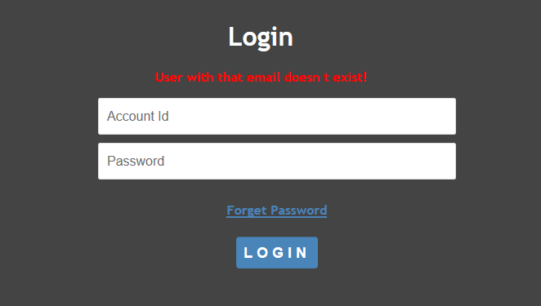

Down here, it’s happened when a user pressed the login button without entering the Use id and Password and receive the error message for required field!

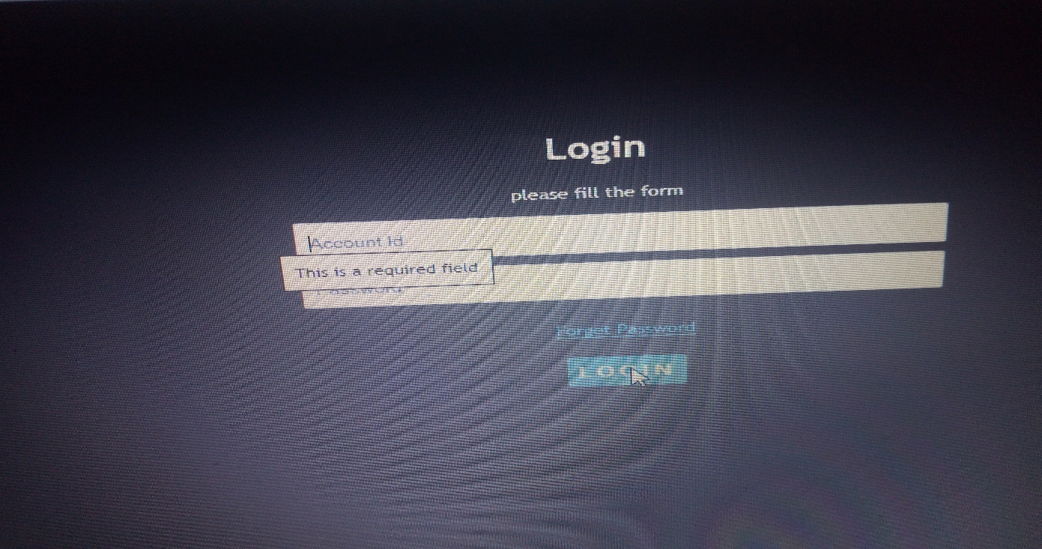

**FUTURE ENHANCEMENT**

The proposed system is Online Hospital Management System. We can enhance this system by including more facilities like inpatient room allotment for the admitted  
patients and the stock details of medicines in the pharmacy. Providing such features enable  
the users to include more comments into the system.

For the future we can add to our system:

* Prescription
* Pharmacy
* Icu
* etc.

**REFERENCES & BIBLIOGRAPHY**

##### **Website**

1. <http://www.w3schools.com/>.
2. <http://www.javatpoint.com>

##### **Books**

1. Matthew MacDonald, "Creating a Website - The Missing Manual", 3rd ed, 2011, O’Reilly.   
   (A good introductory book on HTML/CSS. A new version is expected in July 2015.)
2. Matthew MacDonald, "HTML 5 - The Missing Manual", 2nd ed, 2014, O’Reilly.
3. David Sawyer McFarland, "CSS 3 - The Missing Manual", 3rd ed, 2013, O’Reilly.