**Computer Vision**

*Homework 2: Hybrid Image.*

Hybrid Image of two images is generated by adding two images at different frequencies. The high frequency image will be visible from near distance and low frequency image will be visible from far distance. The frequencies for input images are determined empirically and it is called ***Cut of Frequency****.*

***Algorithm Description***

Step 1: Two images are selected to generate the hybrid image. Best choice of the images are of faces with different expression, time laps image or images of similar shape object.

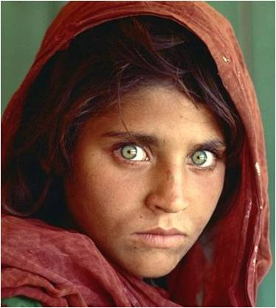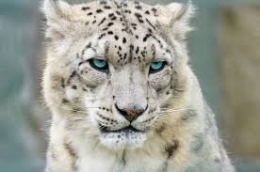

Step 2: Input Images are oriented manually to get better perceptual grouping. For example images with faces are made to overlap on eyes and oriented to look in same direction.

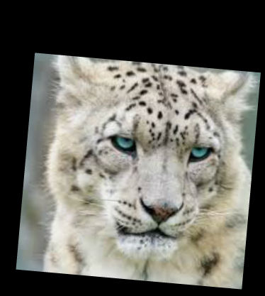

Step3: Laplacian pyramid of both images are generated. This is done by first generating Gaussian pyramid and subtracting two adjacent images in Gaussian pyramid.

Laplacian pyramid separates image into band pass frequencies in order. I.e. Each image in Laplacian pyramid will have frequencies in different band. This helps us select required bands of frequencies form each image.

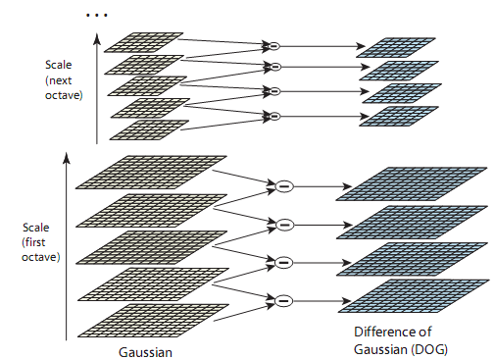

Step 4: Hybrid pyramid is generated by using empirically set cut off frequency.

The Hybrid pyramid is constructed by selecting n low frequency images from one Laplacian pyramid and high frequency image from other Laplacian pyramid, this will helps us gather required frequencies from both the images.

Since last image in Gaussian pyramid contains all the low frequency, this image is added to the base of the hybrid pyramid. Hence size of hybrid pyramid will be 1 + size of Laplacian pyramid.

Step 4: Merge all images in hybrid pyramid by up sampling and adding each pixels.

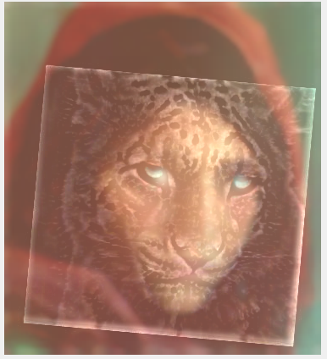

***Results***

1. ***Two Face***

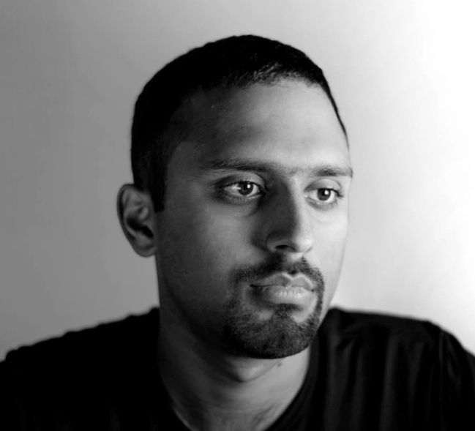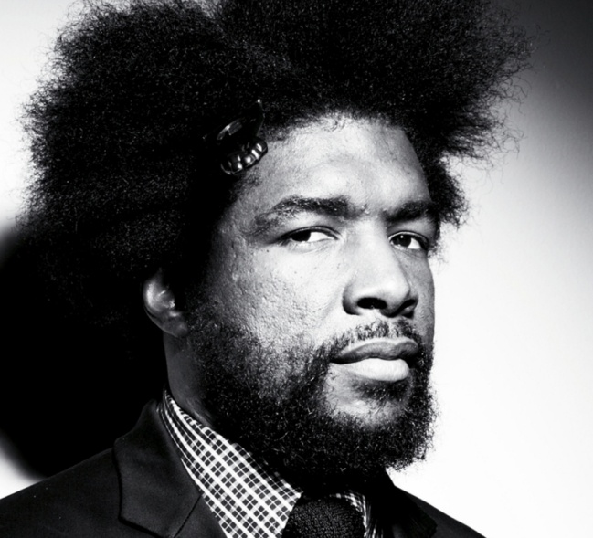

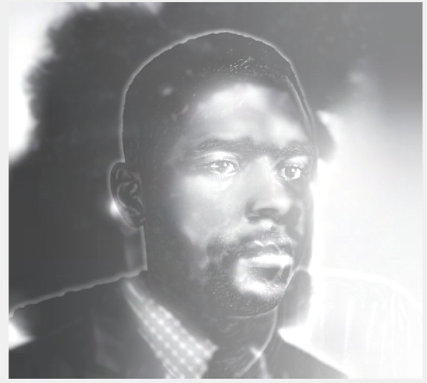

***Remark: The result is very good, since the image are oriented and aligned very well here.***

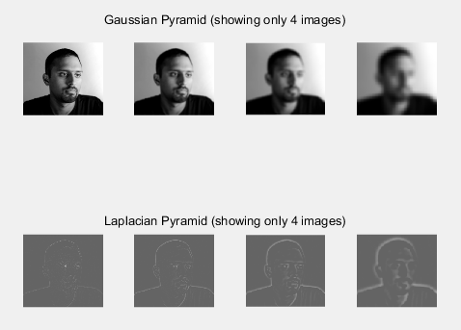

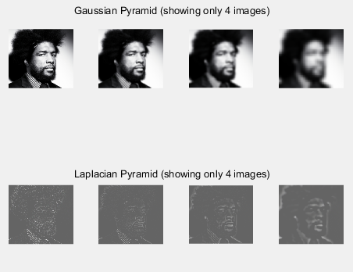

***2. Lady and the Leopard (Texture Superposition).***



***Remark: Light color of snow leopard and skin color of lady *are blended very well but the strong boundary edges of tiger causes the artifact.***

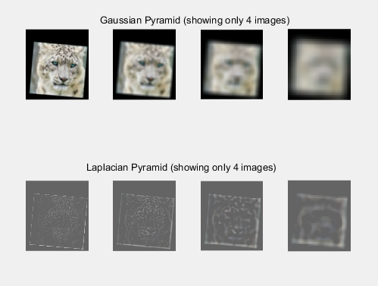

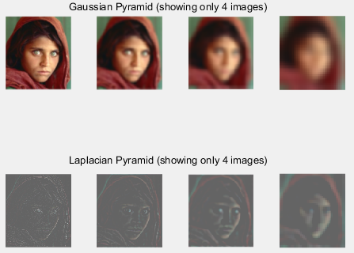

***3. Expressions***

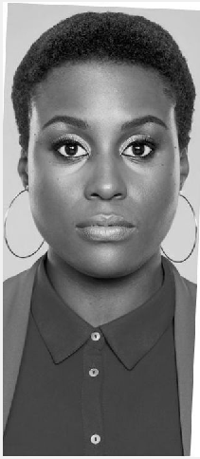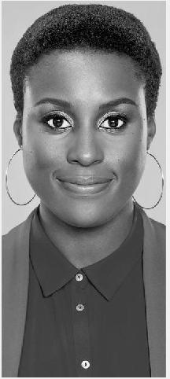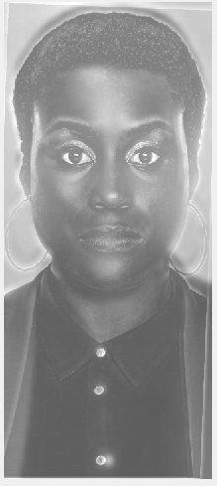

***Remark: The result is very good, since the image are oriented and aligned very well here.***

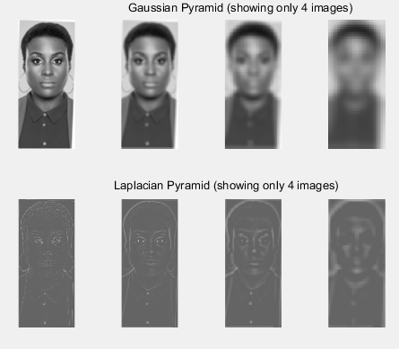

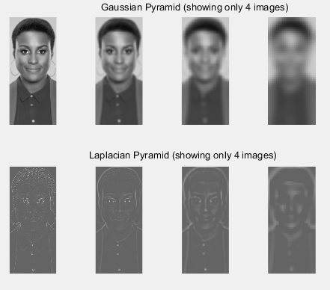

***4. Batsy vs. Joker***

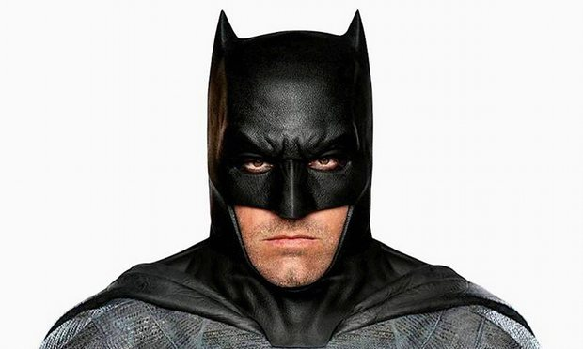

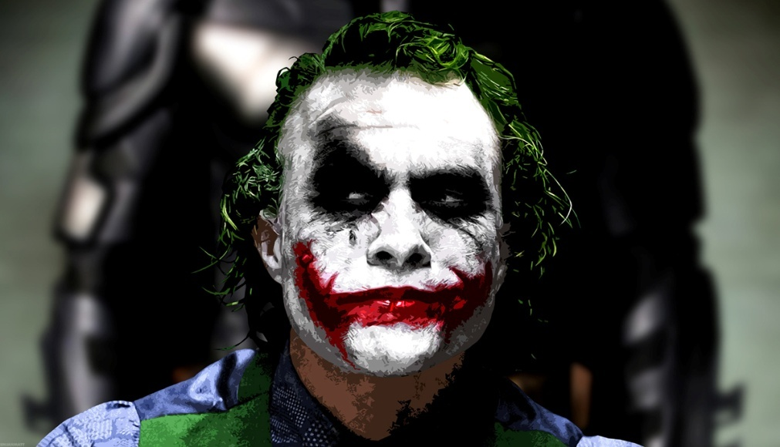

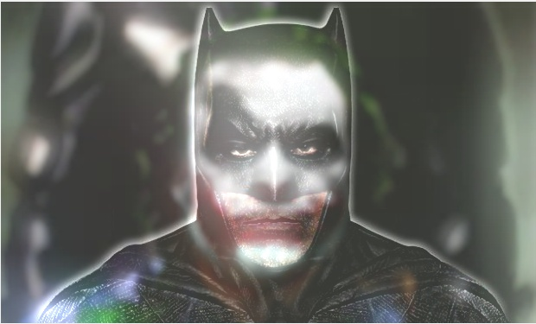

***Remark: Even though the superposition is good, the white color from joker image is overwhelming and it is still visible in batman image.***

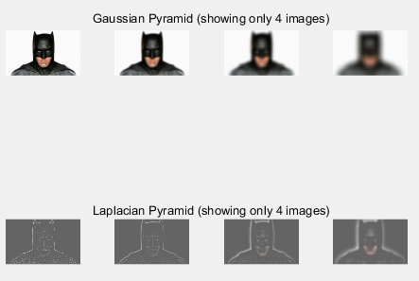

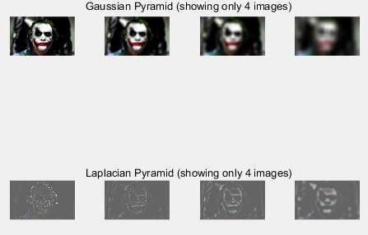

***5. Double the Joke***

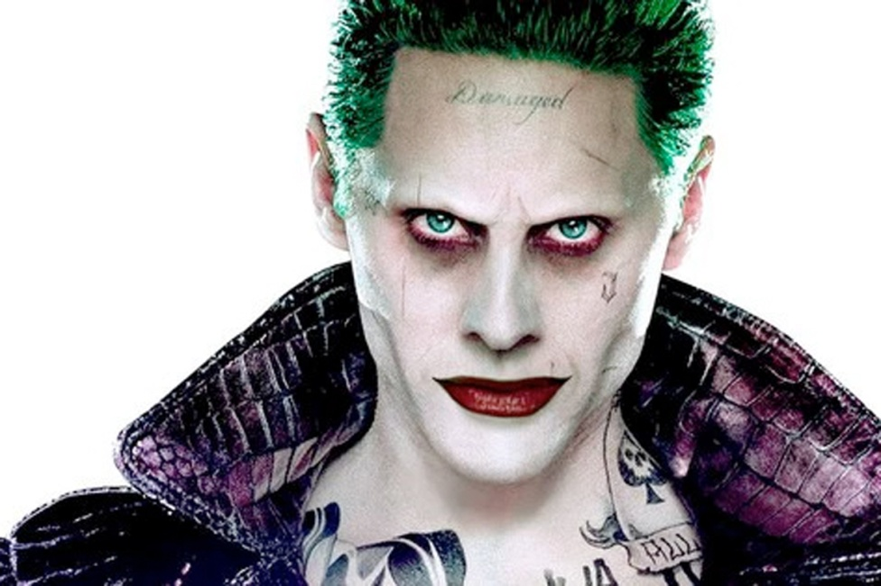

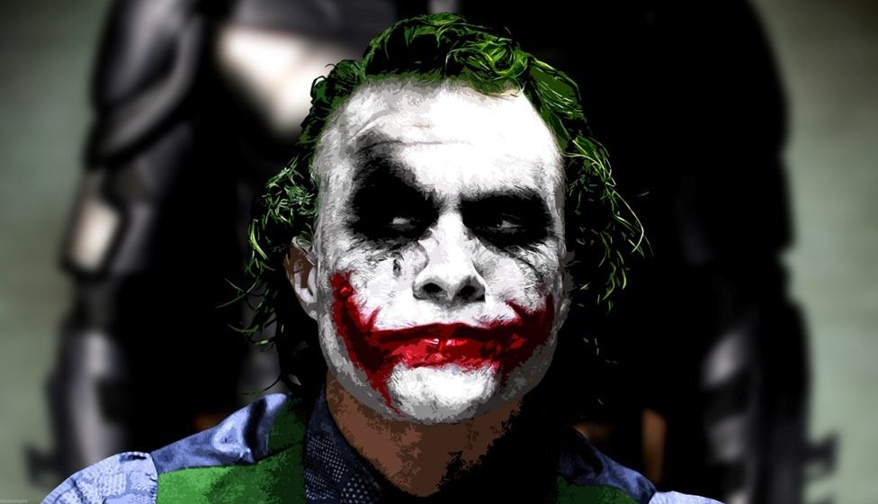

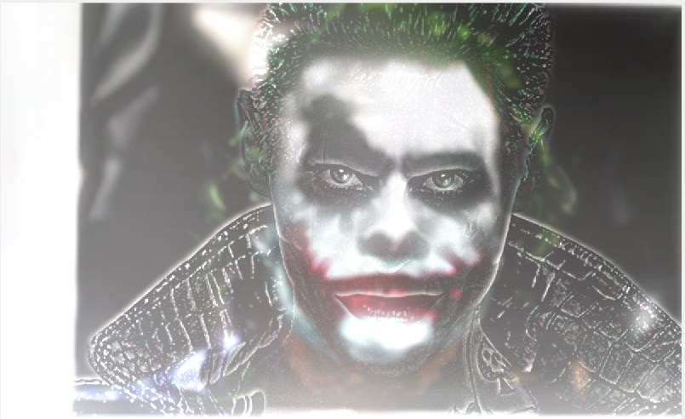

***Remark: The result is very good, since the image are oriented and aligned very well here.***

