**Final Project – Pokémon Pocket Monster**

The goal of the project is to find best Pokémon (ID) by finding CP, HP, Stardust and Level of the Pokémon.

I have implemented template matching to find CP, HP and Stardust, Which I found very efficient since all texts are of the same format. I have used Hough Transform to detect circle to find Level and used Bag of words to find Pokémon ID, which is trained by SVM.

Below are the detailed descriptions on how each attributes are obtained.

**Template Matching**

I have manually cropped all required templates in binary format so that computation will be efficient. Below are few templates I have collected.

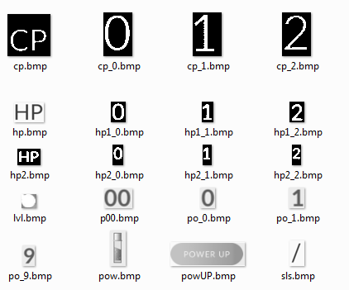

Key method I used for template matching is normxcorr2 which computes the normalized cross-correlation between template and Image and the most matching template will have maximum value of normalize cross correlation. This proved to be very convenient and efficient.

**Finding CP**

First narrow down the search by locating the location of CP in image by using normxcorr2.

Once the pixel coordinates of ‘CP’ are found the cp numbers are found by template matching

each digit individually.



**Finding HP**

Similar to CP, HP is found by locating the template first and narrow down the search. Problem is that there are two different kinds of representations of HP as below.

 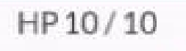

The solution here is to locate both ‘HP’ template and ‘/’ template and find the digits between these two.

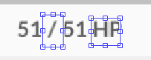

**Finding Stardust**

The same logic is applied here .First narrow down the search by finding ‘Power Up’ logo.



One advantage which I have used is that the Stardust value always ends with “00”.So next step is to locate test tube logo and ’00’ and determine the digits between those two templates.

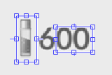

**Finding Level**

I have used Hough Transform to find Circles

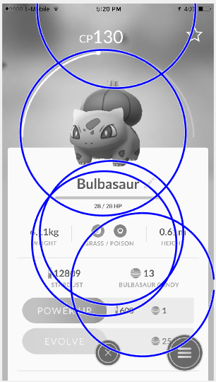

Hough transforms gives many circles. I have selected best circle required by applying the know information. We know that our circle of interest is always in above half of the image and its X coordinate (Coolum) is almost center of the image , also the radius of this circle is few pixels less the half the number of columns in the image. Using this information I have eliminated the redundant circles.

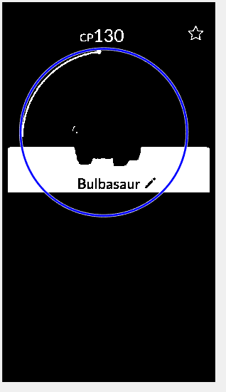

Once the circle of interest is found, I clean out unwanted information by performing binary operations (logical AND) with below two Masks one in succession. These masks are generated by using the radius and center of circle found.



The output of binary operation is as below.

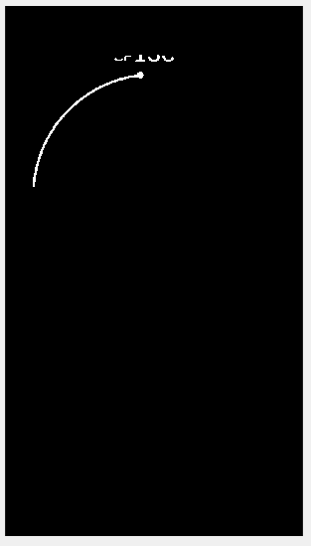

On this image I apply template search to find the level.



**Finding ID**

The ID is obtained by using Bag of words for Image classification.

I have extracted the SURF features of each image and formed visual words by applying K-Means for quantization. These Visual words are used to obtain feature descriptors of each image, these descriptors are used to used to train the model, which I have achieved by using Matlab’s SVM.

**Results**

The result on given validation data is as fallow

accuracy_CP = 55.71%

accuracy_CP = 80.00%

accuracy_HP = 87.14%

accuracy_stardust = 88.57%

**Challenges Faced**

The only challenge I encountered is that few images are of very low resolution, as a result I could not apply correct threshold on these these images, and those are predicted incorrectly.