**Solar System using OpenGL**

This is one my demo projects which I wish to send you .I have rendered simple Solar System using fallowing

* OpenGL 4 and GLSL for Rendering
* GLFW for Windows
* AntTweakBar for Menus and
* GLM for Vectors and Matrices

**Tessellation of Icosahedron.**

Here I have rendered Spheres for planet by tessellating Icosahedron on GPU using Tessellation Control Shader and Tessellation Evolution shader.

Below Image shows the tessellation of Icosahedron in two different stages.

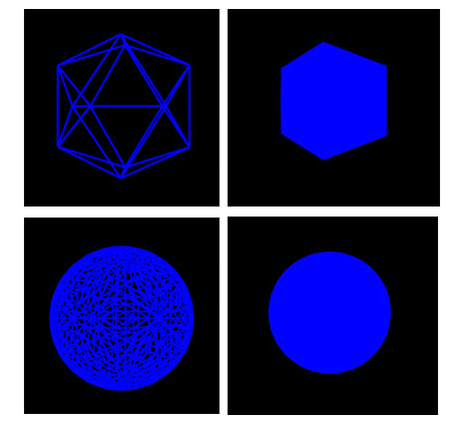

**Normal.**

Below images shows the two types of normals

a) Normal at each vertices are just vertex positions

b) Face normal calculated on fly at Geometry Shader obtained by cross product of two edges of triangles

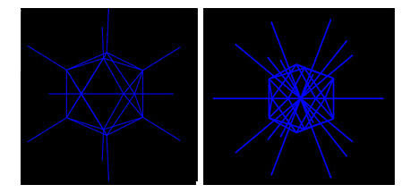

**Texture Coordinates.**

The texture coordinates for sphere are calculated in Geometry Shader by using below calculations

float tx = atan(Normal.x, Normal.z) / (2. * M_PI) + 0.5;

float ty = asin(Normal.y) / M_PI + 0.5;

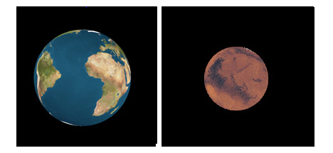

**Different Effects.**

The below figures from top left to right in that orders shows all effects shown in demo

a)Phong lighting model calculated at Fragment Shader

b)Mix of night and day textures for planet earth done at Fragment Shader

c)Gaussian Blur effect calculated at Fragment Shader

d)Bloom effect calculated at Fragment Shader

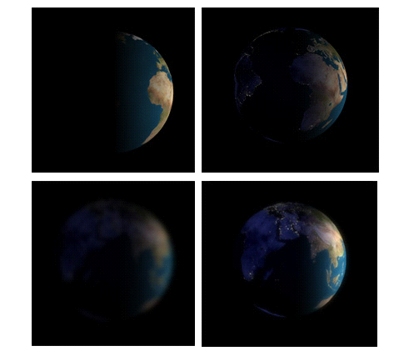

**Arc Ball**

‘Planet only’ rendering mode also has an Arc Ball implementation. This enables user to rotate planets manually with mouse motion. When Arc ball is activated, clicking down right mouse button and moving the mouse will enable user to rotate the planet at will in any direction.

**Different effects on entire Solar System.**

1)Solar System render without any Light effect

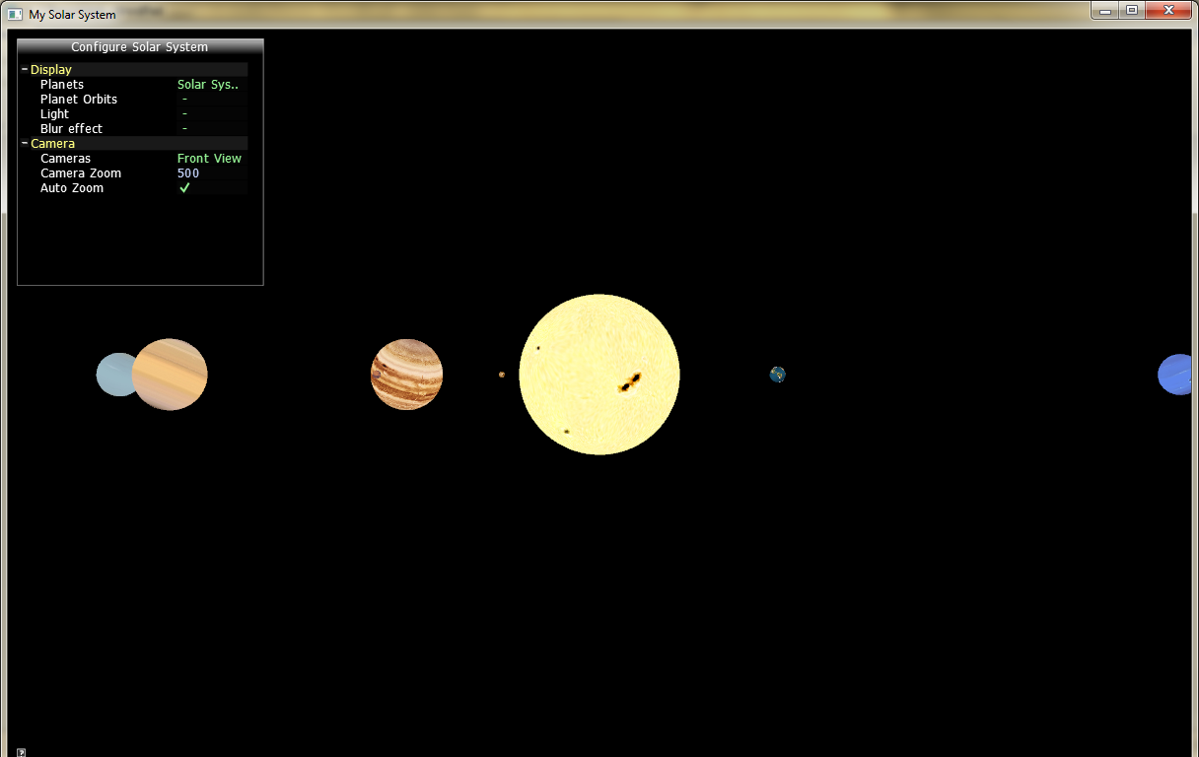

2)Solar System render with Phong Lighting

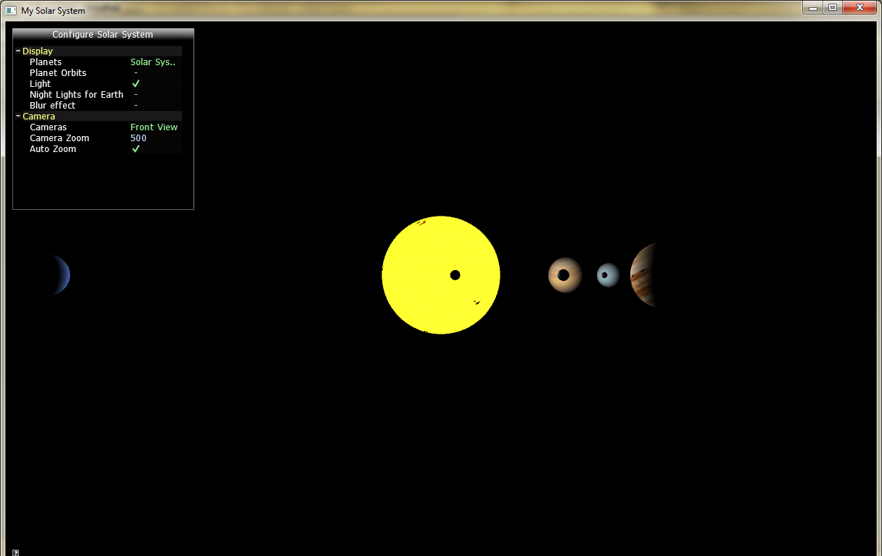

3)Solar System render with Blur effect

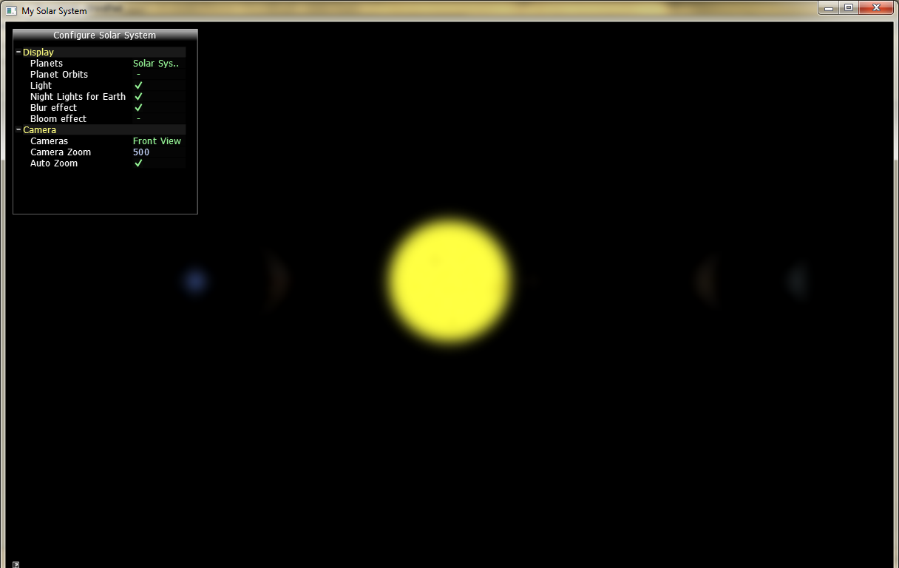

3)Solar System with Bloom effect

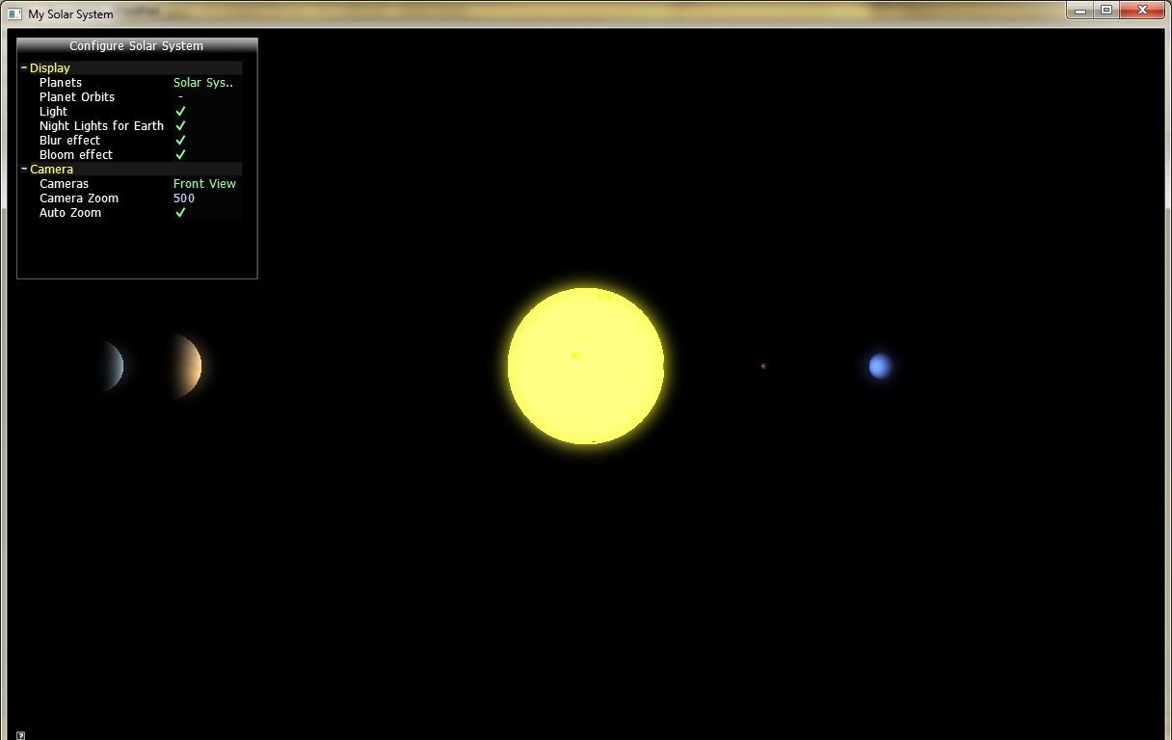

**Cameras.**

There are three different camera view implemented in demo they are as fallows

1)Front View



2)Top View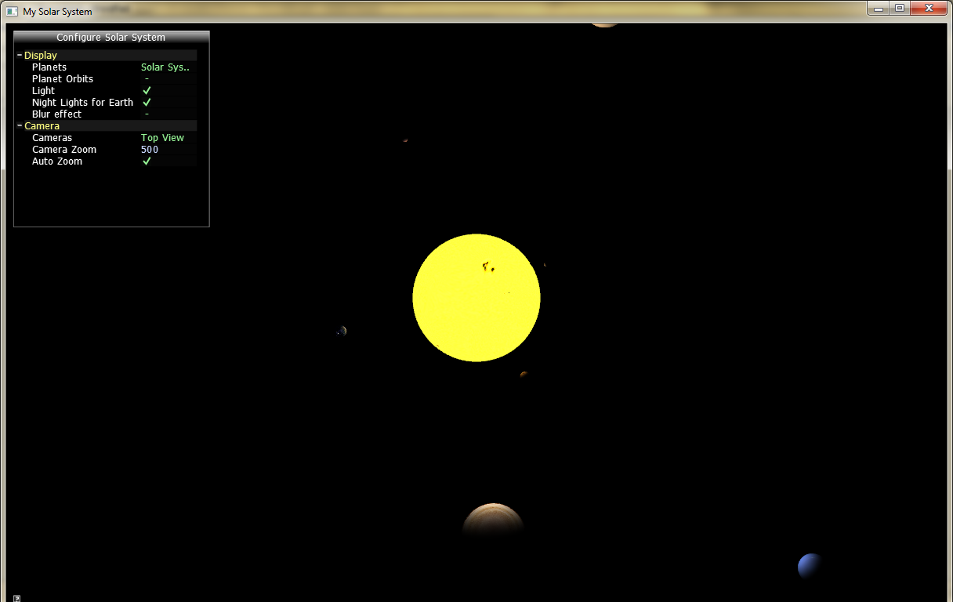

3)Orbital View

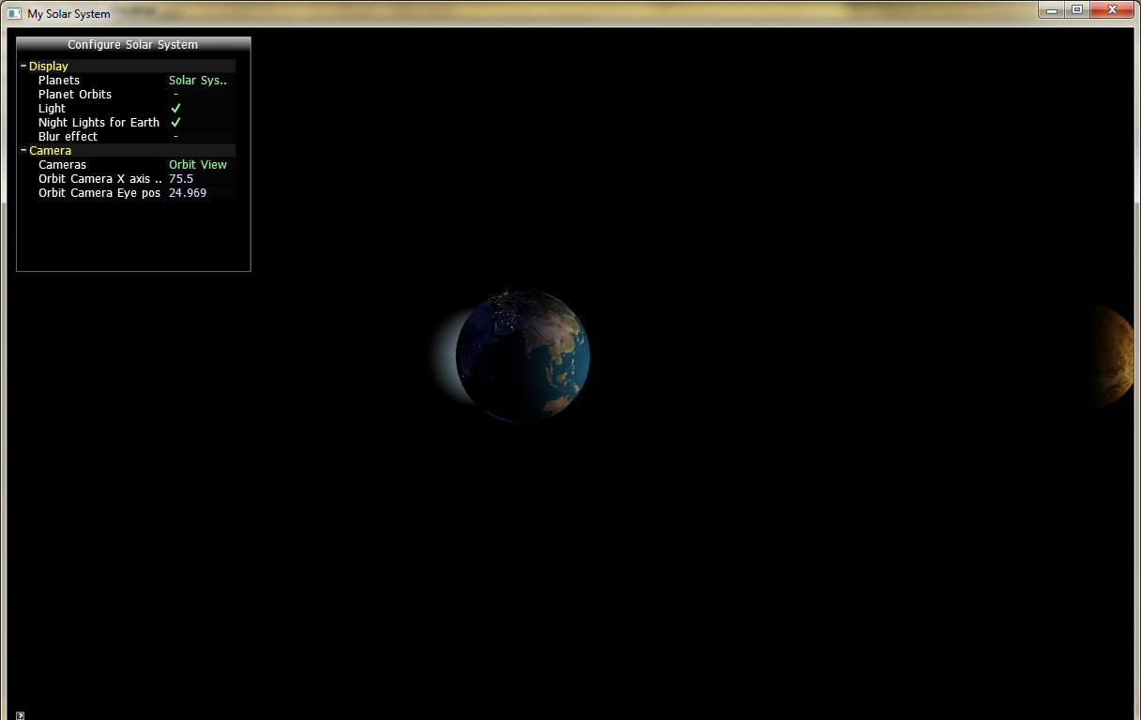

**Planets Orbits.**

Each planet can be rendered with their orbital path

1)Front view with Planet's Orbit checked on

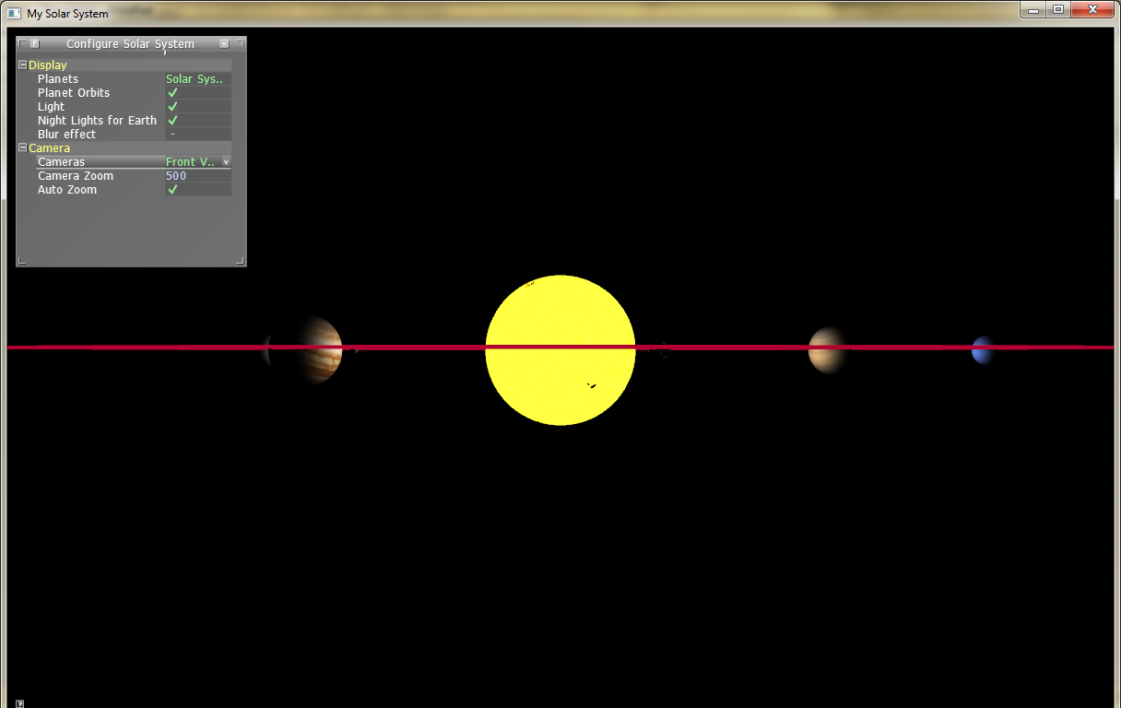

2)Top view with Planet's Orbit checked on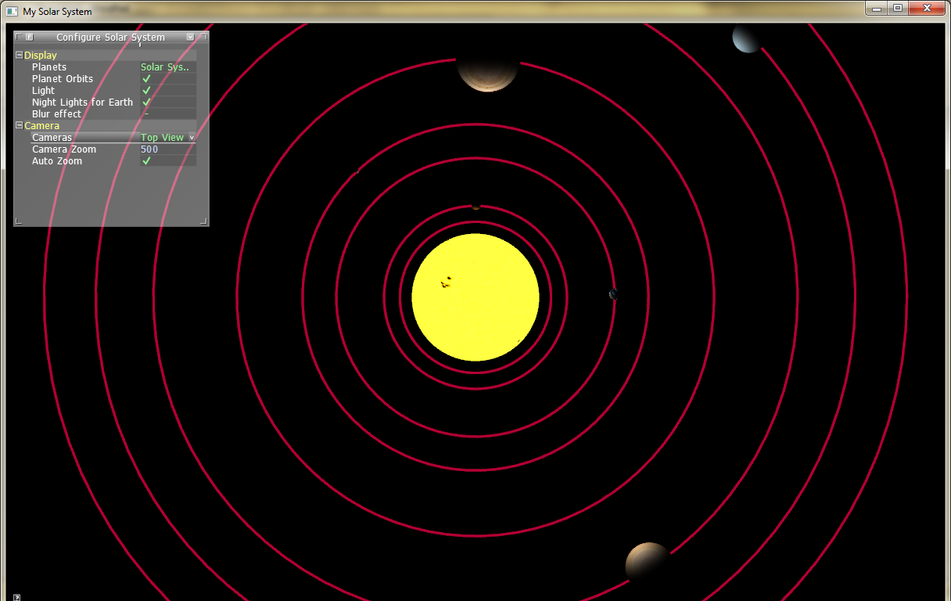

3)Orbital view with Planet's Orbit on

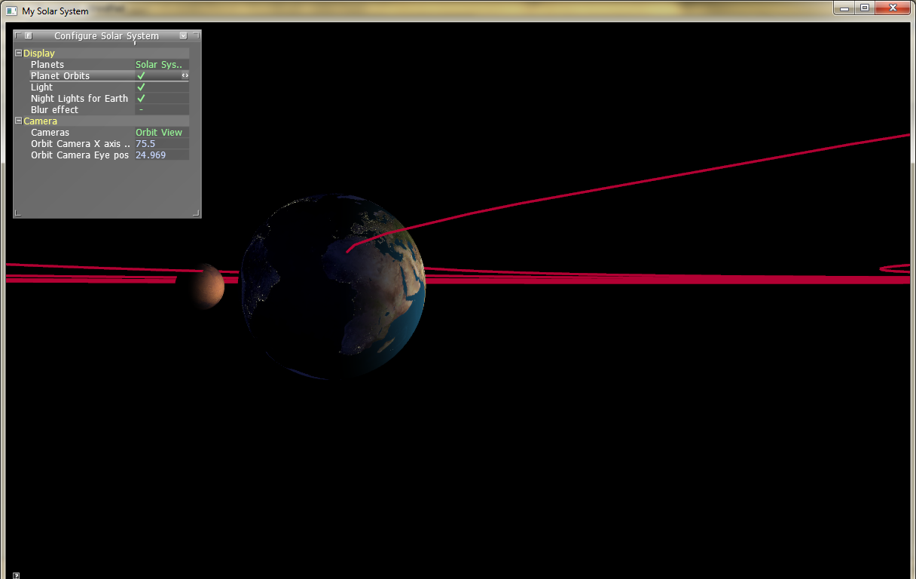

**Menu Bar.**

Menu for user interaction is rendered using AntTweakBar as GLFW has no Menus.

The Menu has Toggle buttons for each functionality.

1)Planets: Enables to switch between all 8 planets ,sun and entire Solar System.

2)Planet Orbits: Enable to turn on/off Planet Orbits.

Below effects are enabled only for Top and front view of Solar System render (not for planets render) only.

3) Light: Enable to turn on/off Phong Lighting.

4) Night Lights for Earth: Enable to turn on/off Night light Texture for Planet Earth.

5) Arc Ball on: Enable to turn on/off Arc Ball.

This is enabled only for Planet render.

Arc Ball enables to rotate Planet with Mouse motion.

6) Blur effect: Enable to turn on/off Blur effect.

Blur effect also enables user to toggle Bloom effect.

7) Bloom effect: Enable to turn on/off Bloom effect.

8) Cameras: Enable to select between different Cameras.

Enable to switch between Front view, Top view and Orbit Views.

Front and Top views has following Functionalities.

9) Camera Zoom: Enables to manually zoom in /zoom out in the range 0 to 1000.

10) Auto Zoom: Enables to zoom automatically for both 'Solar System Render ' and 'Planet only Render'.

Orbital View has fallowing Functionalities.

11) Orbit Camera X axis pos: Enables to move Orbit view camera's X axis position.

12) Orbit Camera Eye pos: Enables to move Orbit view camera’s Eye position.

Orbital View automatically switch too "Solar System Render’.’Planet only Render' is not possible in Orbital view and planets orbits are automatically disabled.

