**EXPERIMENT -1**

Aim : - To get an introduction of PROLOG

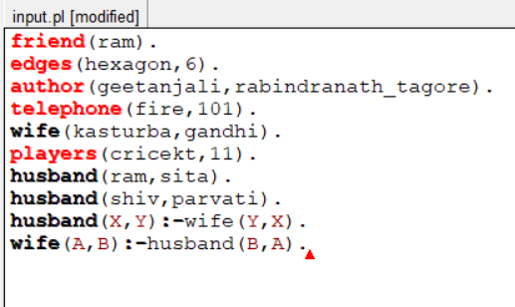

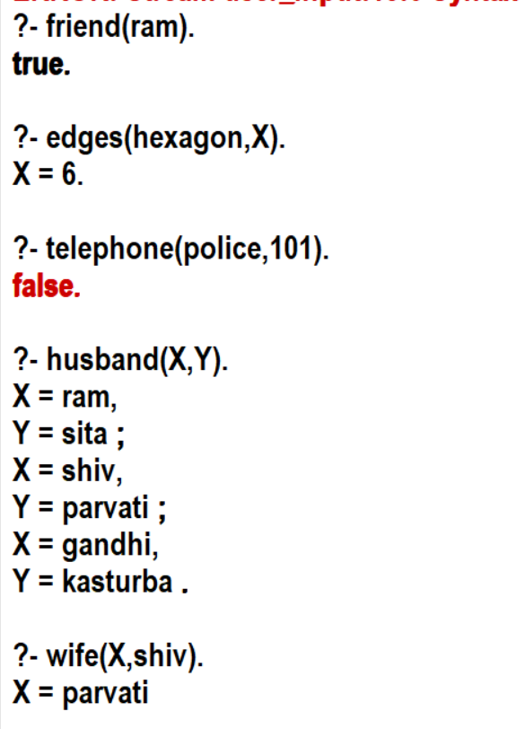

**EXPERIMENT -2**

Aim : - To implement MAHABHARATA family tree in prolog.

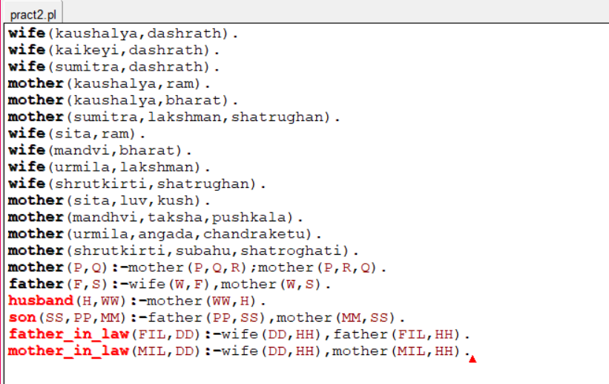

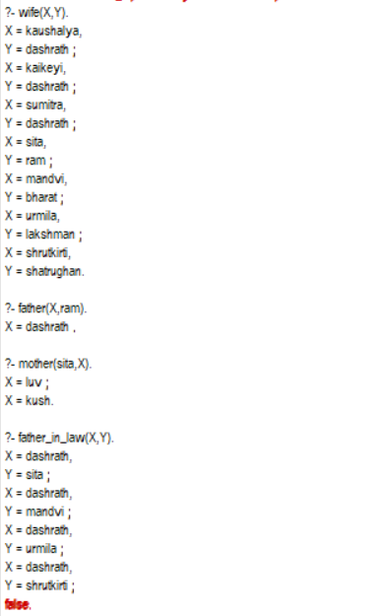

**EXPERIMENT -3**

Aim : - To implement NEHRU family tree in prolog

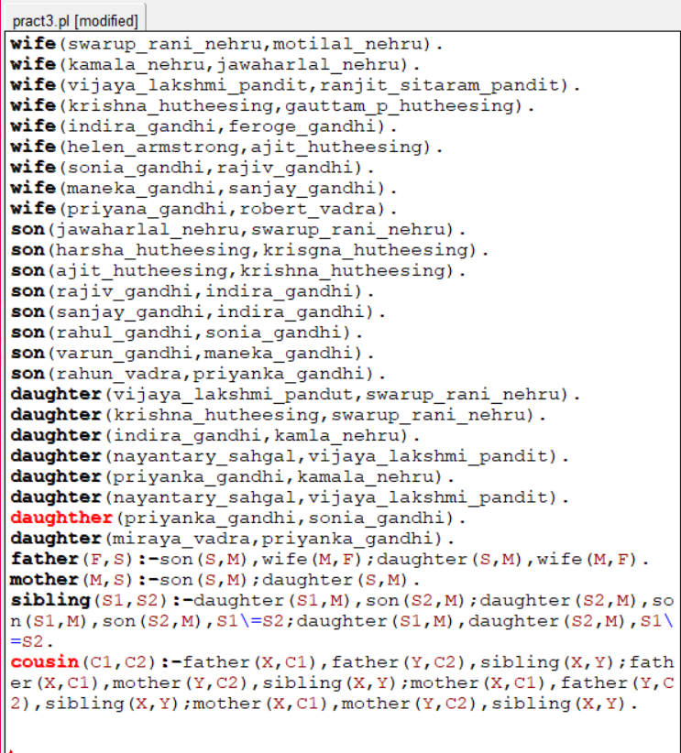

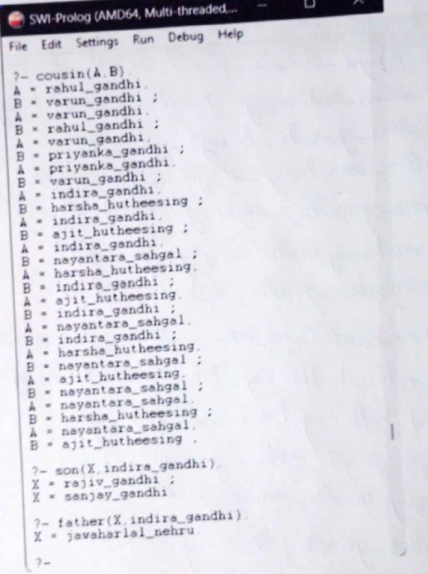

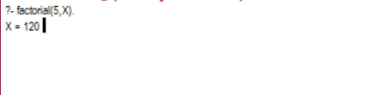

**EXPERIMENT -4**

Aim : - Find Factorial of a number

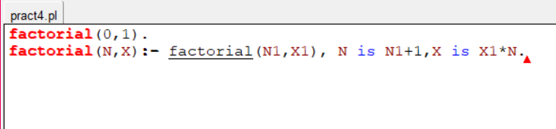

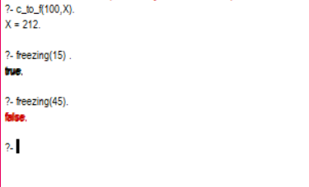

**EXPERIMENT -5**

Aim : - Program to convert temperature from Celsius to Fahrenheit and check whether temperature is below freezing point

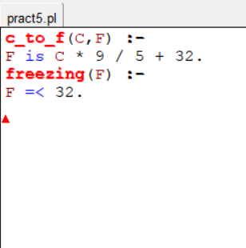

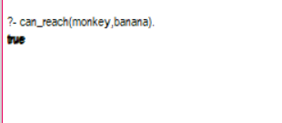

**EXPERIMENT -6**

Aim : - Monkey Banana Problem Using Prolog.

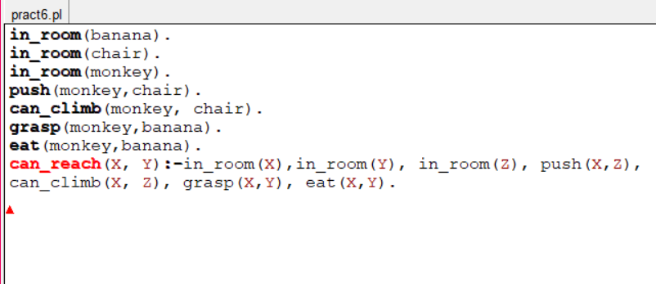

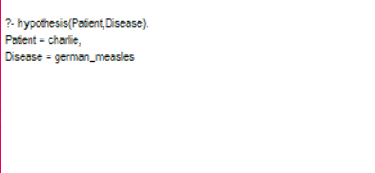

**EXPERIMENT -7**

Aim : - Medical diagnostic system in prolog.

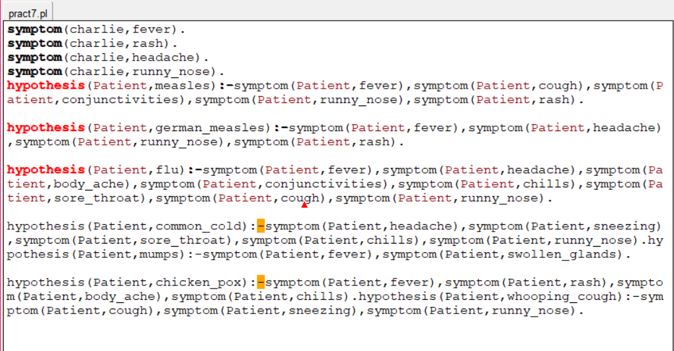

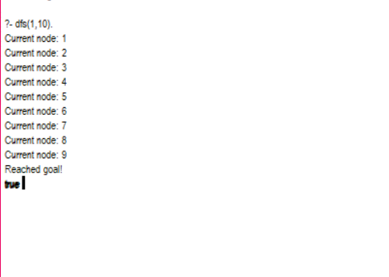

**EXPERIMENT -8**

Aim : - To solve any real life problem using DFS.

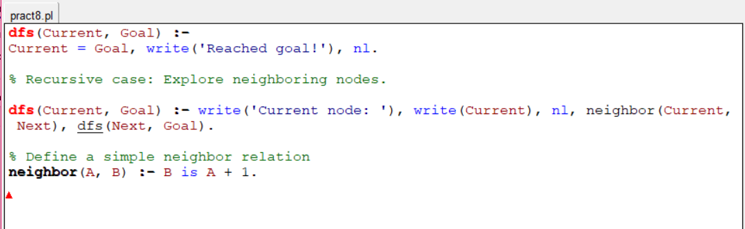

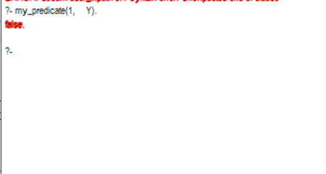

**EXPERIMENT -9**

Aim : - Implement local variables and conditional statements using prolog

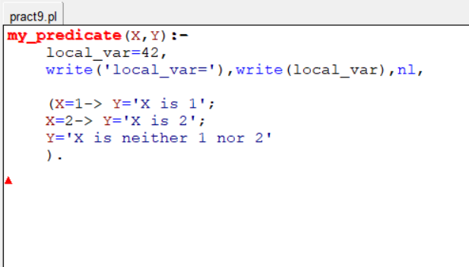

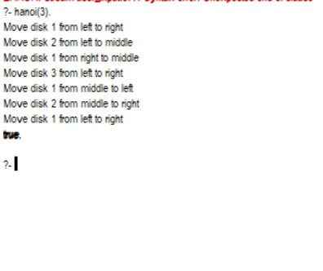

**EXPERIMENT -10**

Aim : - Define a predicate to solve the Tower of Hanoi problem.

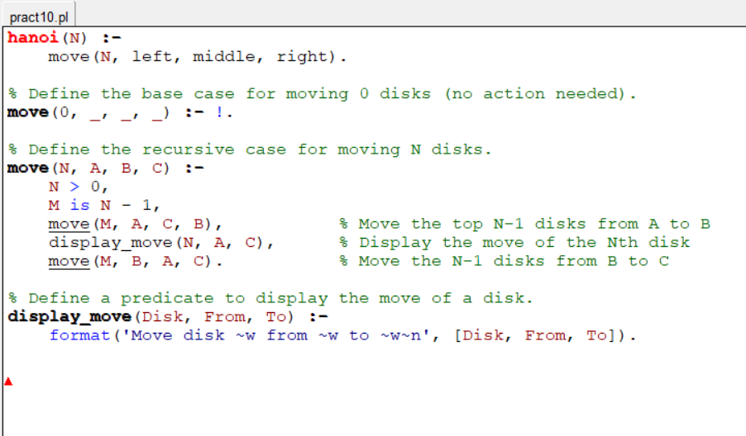

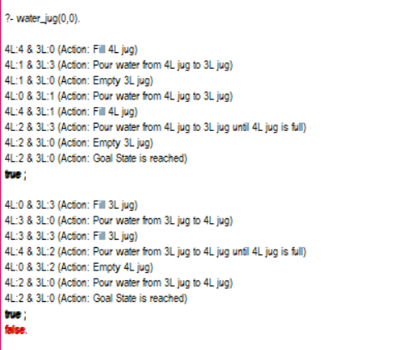

**EXPERIMENT -11**

Aim : - Write a program to solve Water Jug Problem using Prolog

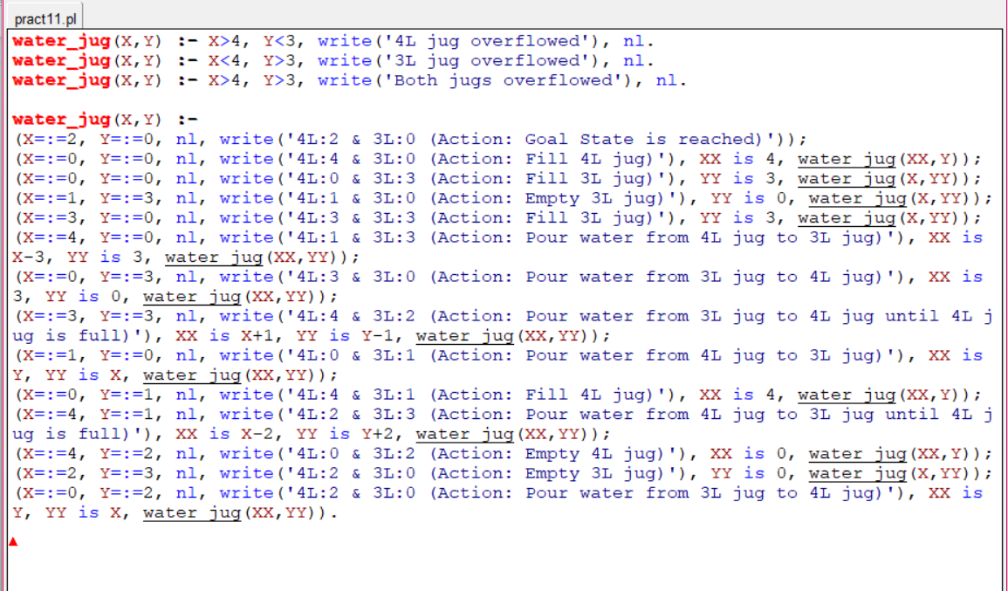

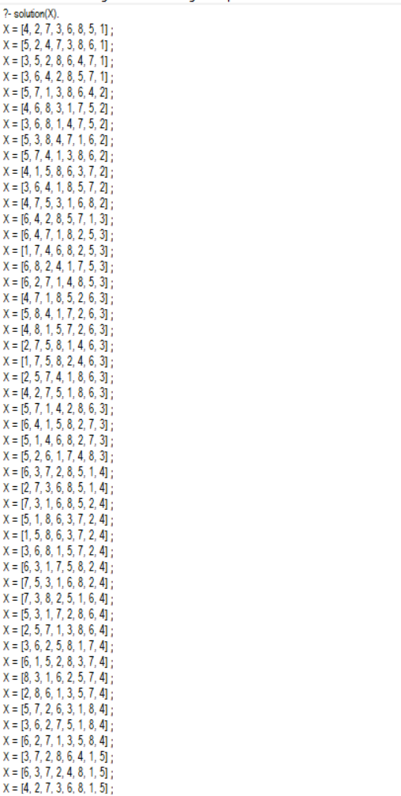 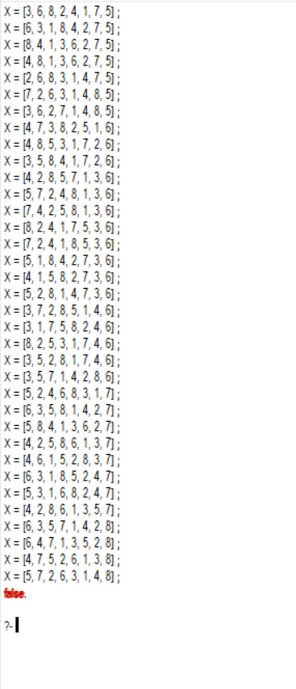

**EXPERIMENT -12**

Aim : - Write a program to solve 8-queen problem using Prolog.

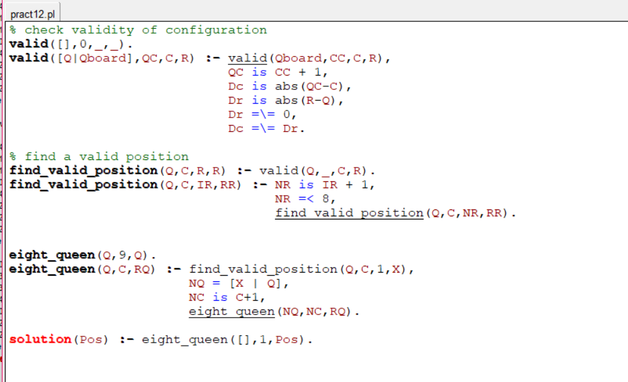

**EXPERIMENT -13**

Aim : -