SCHOOL OF COMPUTER SCIENCES
UNIVERSITI SAINS MALAYSIA

CPT212 - Design & Analysis of Algorithms
SEMESTER 2, 2025/2026

Assignment 1

NO. | NAME | MATRIC NO.
1 | MUHAMMAD ADAM ZAYANI BIN MOHD HUZAINY | 23303270
2 | MOHAMAD NAZRUL HAKIM BIN NOOR HAMZAH | 23304401

PREPARED FOR:
Assoc. Prof. Dr. Tan Tien Pin

Github Link:
https://github.com/akaNazrul/CPT212-Assignment1

SUBMISSION DATE: 3RD MAY 2026

1.0 Introduction

1.1 Project Overview
This project implements and analyses two integer multiplication algorithms in Java: the Simple Multiplication algorithm and the Karatsuba algorithm. Both algorithms are instrumented with primitive operation counters to enable empirical complexity measurement. The results are compared against each algorithm's theoretical Big-O complexity through graph visualisation.

1.2 Objectives
1. Implement the Simple Multiplication algorithm in Java as described in the assignment.
2. Instrument both algorithms with primitive operation counters.
3. Randomly generate n-digit numbers and plot operation count vs n.
4. Compare experimental results with theoretical time complexity in Big-O notation.
5. Compare the performance of Simple Multiplication versus Karatsuba algorithm.

2.0 Understanding the Algorithms

2.1 Simple Multiplication Algorithm
The simple multiplication algorithm mimics the standard long-multiplication method. Given two numbers of the same length n, it proceeds in two steps:
Step 1: Each digit of the multiplier is multiplied with each digit of the multiplicand. For each product, the units digit is the partial product and the tens digit is the carrier. For example, 3 × 8 = 24: 4 is the partial product and 2 is the carrier. The partial products and carriers are printed at every step.
Step 2: All partial products and carriers are summed with their proper positional shifts to produce the final result. Note that carriers at column j must shift one additional position (to column j+1) compared to partial products.
Example: 52301 × 380
partial products for (=52301 x 0): 0
carriers for (52301 x 0): 0
partial products for (=52301 x 8): 64080
carriers for (52301 x 8): 4120000
partial products for (=52301 x 3): 5690300
carriers for (52301 x 3): 10000000
Result: 19874380

Theoretical Complexity: For two n-digit numbers, Step 1 performs n × n = n² single-digit multiplications. The dominant cost is O(n²).

2.2 Karatsuba Algorithm
The Karatsuba algorithm is a divide-and-conquer multiplication algorithm that reduces the number of single-digit multiplications by exploiting the algebraic identity:
x · y = z0 · 10^(2·half) + (z1 – z0 – z2) · 10^half + z2
where: a = x / 10^half, b = x % 10^half
c = y / 10^half, d = y % 10^half
z0 = a·c, z1 = (a+b)·(c+d), z2 = b·d
Instead of four sub-multiplications (a·c, a·d, b·c, b·d), Karatsuba computes only three (z0, z1, z2). This yields the recurrence T(n) = 3T(n/2) + O(n), which by the Master Theorem gives T(n) = O(n^log₂3) ≈ O(n^1.585).

3.0 Implementation

3.1 Part 1 – Simple Multiplication
The simple multiplication algorithm is implemented in Main.java using BigInteger to support large n-digit inputs. The algorithm stores each multiplier digit's partial product and carrier in separate integer arrays, then sums them using BigInteger to produce the exact result.

Key Design Decisions
BigInteger for large numbers: Java's primitive long overflows beyond 18 digits. BigInteger supports arbitrarily large numbers, enabling accurate testing up to n = 10,000 digits.
Digit arrays (MSB first): Numbers are passed as int[] with the most-significant digit at index 0.
Carrier shift correction: A key implementation detail is that carrier digits at column j must be shifted to column j+1 in the final sum. This is handled by multiplying the carrier row by 10^(i+1) instead of 10^i, where i is the position of the current multiplier digit.
printSteps flag: When enabled, the algorithm prints partial products and carriers for each multiplier digit.

Operation Counter Placement
int n = multiplicand.length; opCount++; // 1 assignment
for (int i = 0; i < m; i++) { opCount += 3; // 1 assign + 1 compare + 1 increment
int product = a * b; opCount += 2; // 1 assign + 1 multiply
pRow[j] = product % 10; opCount += 2; // 1 assign + 1 mod
cRow[j] = product / 10; opCount += 2; // 1 assign + 1 div

Sample Output (52301 × 380)
partial products for (=52301 x 0): 0
carriers for (52301 x 0): 0
partial products for (=52301 x 8): 64080
carriers for (52301 x 8): 4120000
partial products for (=52301 x 3): 5690300
carriers for (52301 x 3): 10000000
Result = 19874380 | ops = 596

3.2 Part 2 – Karatsuba with Counter
The provided Karatsuba implementation is modified to: (1) accept BigInteger instead of long to support large inputs, and (2) increment opCount at every primitive operation inside both the recursive karatsuba() method and the helper numLength() method.

Key Modifications
BigInteger conversion: All arithmetic replaced with BigInteger equivalents: divide(), remainder(), add(), subtract(), multiply().
Base case: Checks if both operands are less than 10 using compareTo(BigInteger.TEN).

Counter placements in karatsuba()
opCount += 2; // two comparisons for base case
BigInteger a = x.divide(split); opCount += 2; // assign + divide
BigInteger z0 = karatsuba(a, c); opCount += 2; // assign + recursive call
BigInteger z1 = karatsuba(a.add(b),c.add(d)); opCount += 4; // 2 adds + call + assign
BigInteger middle = z1.sub(z0).sub(z2).mul(shift1); opCount += 4;

Correctness Tests
All three correctness tests pass:
Test 1: expected=7006652 actual=7006652 ops=667
Test 2: expected=31926 actual=31926 ops=201
Test 3: expected=85348320 actual=85348320 ops=815

4.0 Complexity Analysis

4.1 Experimental Setup
Input size (n): n = 1 to 50 digits.
Data generation: Two random n-digit numbers are generated using a fixed seed (42) for reproducibility.
Metric: opCount tracks all primitive operations: assignments, comparisons, additions, divisions, modulo, multiplications, and method calls.
Output: Results saved to output/mult_ops.csv and graphs saved as PNG files.

4.2 Results: Primitive Operations vs n
Table 1 shows the operation counts for both algorithms across selected input sizes.

n (digits) | Simple Ops | Karatsuba Ops
1 | 86 | 3
5 | 990 | 1,017
10 | 3,425 | 2,581
15 | 7,310 | 5,907
20 | 12,645 | 7,909
25 | 19,430 | 13,289
30 | 27,665 | 17,697
35 | 37,350 | 23,017
40 | 48,485 | 25,607
45 | 61,070 | 32,483
50 | 75,105 | 39,317
Table 1: Primitive Operations vs Input Size (n) – Simple Multiplication vs Karatsuba

4.3 Graphs

Graph 1: Simple Multiplication – Operations vs n
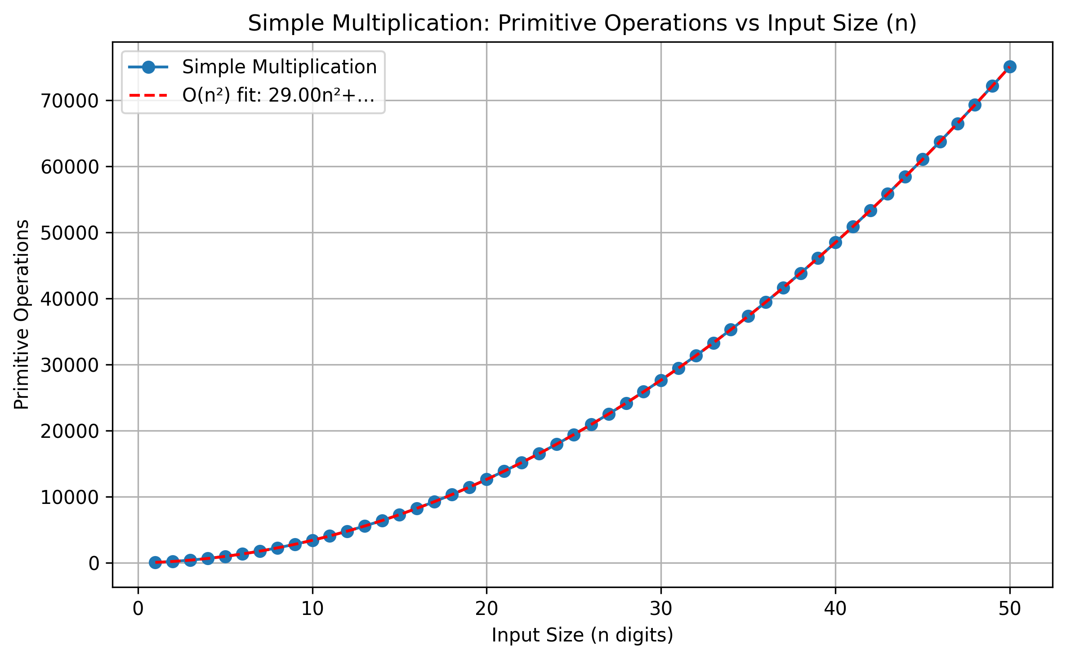
Graph 1: Simple Multiplication primitive operations grow quadratically with n, confirming O(n²) complexity. The quadratic curve fit closely follows the experimental data.

Graph 2: Karatsuba – Operations vs n
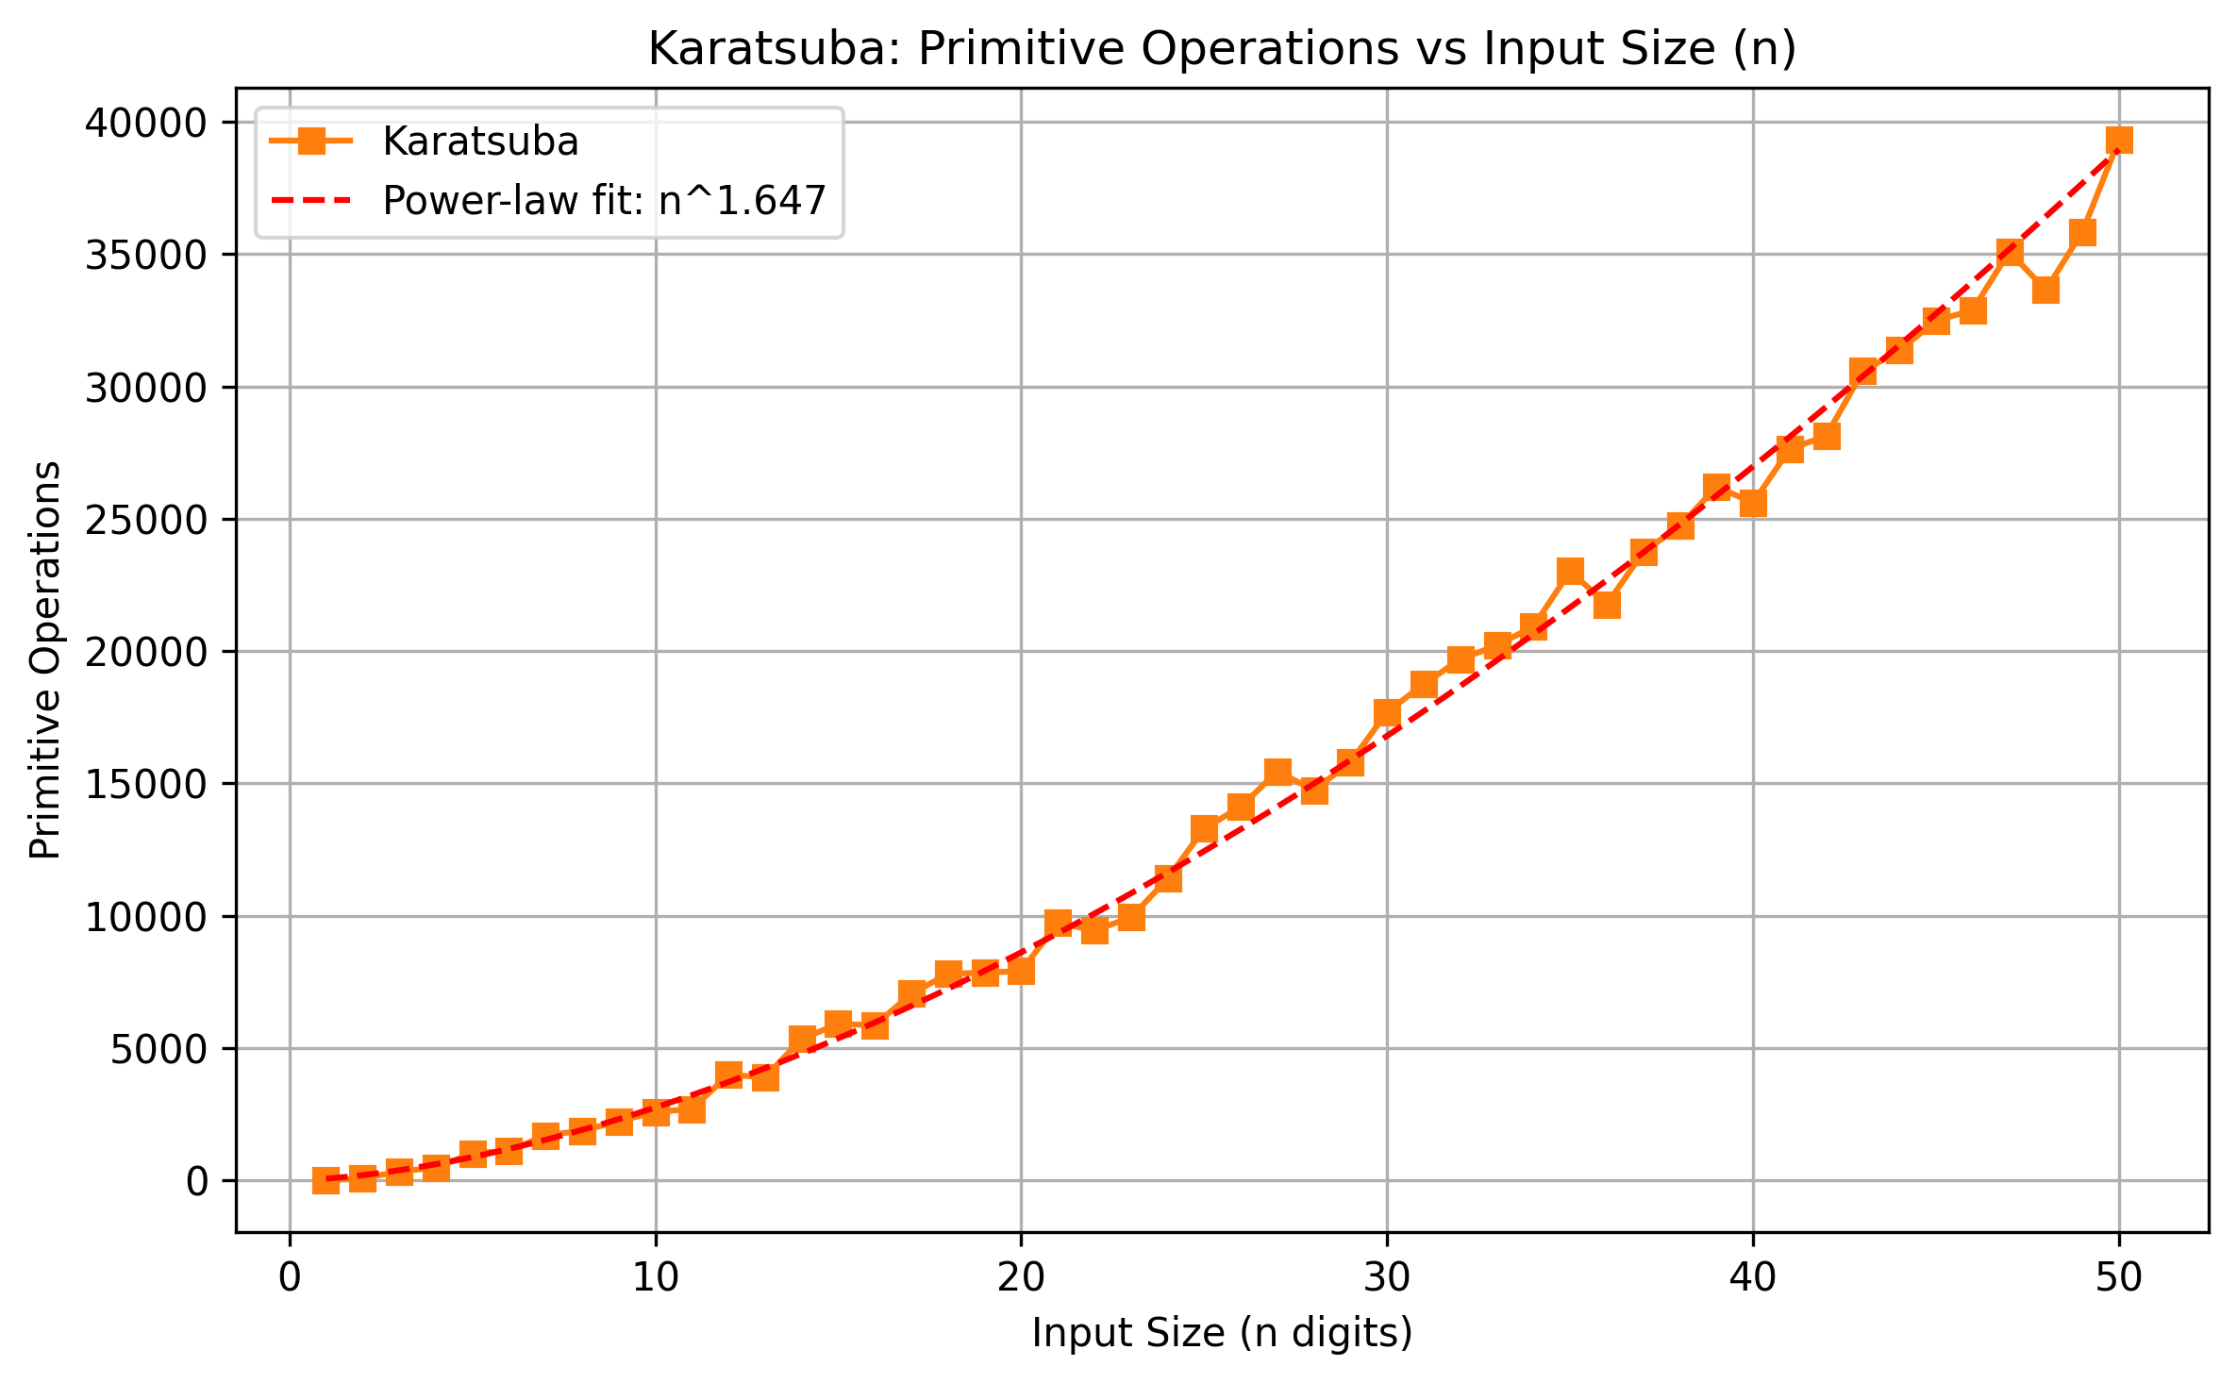
Graph 2: Karatsuba primitive operations grow at a sub-quadratic rate. The power-law fit estimates an exponent of approximately n^1.647, which is close to the theoretical n^1.585 = n^log₂3.

Graph 3: Comparison – Simple Multiplication vs Karatsuba
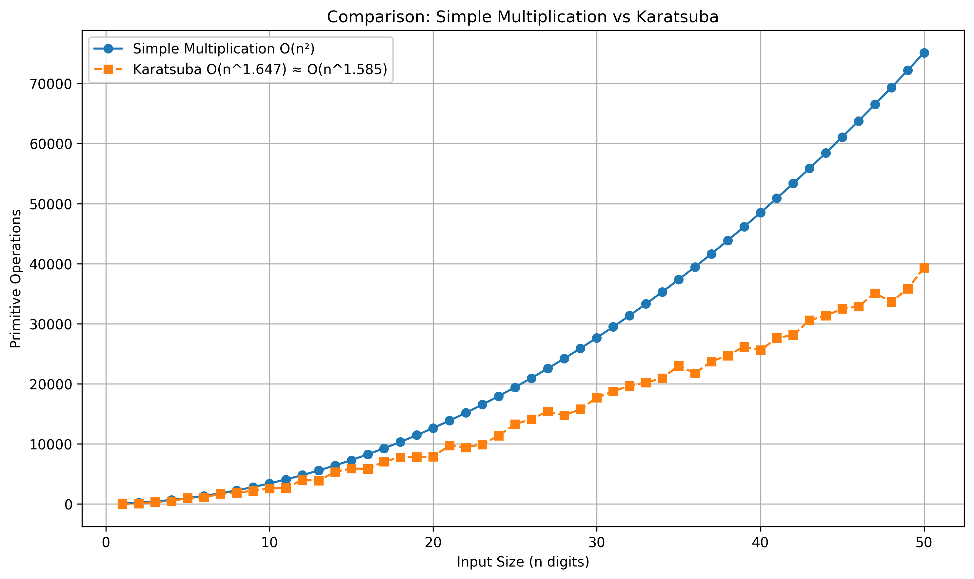
Graph 3: At small n, Karatsuba has higher overhead due to recursion setup. As n increases, Simple Multiplication operations grow much faster (quadratic) while Karatsuba remains sub-quadratic. The crossover occurs around n = 3–4 digits.

4.4 Time Complexity (Big-O)

4.4.1 Simple Multiplication
The simple multiplication algorithm uses a nested loop structure: for each of the m digits of the multiplier, it iterates over n digits of the multiplicand, giving n × m = n² operations for equal-length inputs. Therefore:
T(n) = O(n²)
This is confirmed experimentally: the graph shows a clear quadratic curve, and fitting a degree-2 polynomial produces an excellent match.

4.4.2 Karatsuba Algorithm
Karatsuba reduces 4 sub-multiplications to 3 by exploiting algebra. Its recurrence is:
T(n) = 3 · T(n/2) + O(n)
Applying the Master Theorem with a=3, b=2, f(n)=O(n): since log₂3 ≈ 1.585 > 1, the recurrence falls under Case 1, giving:
T(n) = O(n^log₂3) ≈ O(n^1.585)
Experimentally, the power-law fit yields an exponent of approximately 1.647, which is close to the theoretical 1.585. The small discrepancy is due to the operation-counting overhead and small-n boundary effects.

4.5 Comparison: Simple Multiplication vs Karatsuba
Aspect | Simple Multiplication | Karatsuba
Time Complexity | O(n²) | O(n^1.585)
Approach | Iterative nested loops | Divide-and-conquer recursion
n=10, ops | 3,425 | 2,581
n=30, ops | 27,665 | 17,697
n=50, ops | 75,105 | 39,317
Large n | Slow (grows fast) | Faster (sub-quadratic)
Implementation | Simple, easy to understand | Complex, recursive
Table 2: Comparison of Simple Multiplication and Karatsuba Algorithm

From the experimental results, Karatsuba is significantly more efficient for large inputs. At n=50, Karatsuba uses only 39,317 operations compared to 75,105 for Simple Multiplication — roughly 1.9× fewer. For very small n (n ≤ 2), Simple Multiplication is faster because Karatsuba's recursion overhead dominates.

5.0 Source Code
Full source code is available at: https://github.com/akaNazrul/CPT212-Assignment1
The main files are:
Main.java – Combined driver with both Simple Multiplication and Karatsuba, benchmarking, and CSV output.
SimpleMultiplication.java – Standalone Part 1 implementation.
KaratsubaModified.java – Standalone Part 2 with BigInteger and operation counter.
graph.py – Python script using pandas/matplotlib to generate the complexity graphs from CSV data.

6.0 Conclusion
This assignment successfully implemented and compared two multiplication algorithms in Java. The Simple Multiplication algorithm was implemented with step-by-step partial product and carrier output for small numbers, and was extended to handle large n-digit numbers via BigInteger. The Karatsuba algorithm was modified from the provided implementation to support BigInteger inputs for large-number benchmarking.
Both algorithms were instrumented with operation counters at every primitive operation. The experimental results confirm the theoretical time complexities: Simple Multiplication grows as O(n²) and Karatsuba grows as approximately O(n^1.585). The graphs clearly show that Karatsuba outperforms Simple Multiplication for n ≥ 3 digits, with the performance gap increasing significantly at larger n.

7.0 References
Cormen, T. H., Leiserson, C. E., Rivest, R. L., & Stein, C. (2022). Introduction to Algorithms. The MIT Press.
Karatsuba, A., & Ofman, Y. (1963). Multiplication of Many-Digital Numbers by Automatic Computers. Proceedings of the USSR Academy of Sciences, 145, 293–294.
Knuth, D. E. (1998). The Art of Computer Programming. Addison-Wesley Professional.
GeeksforGeeks. (2024). Karatsuba algorithm for fast multiplication. https://www.geeksforgeeks.org/karatsuba-algorithm-for-fast-multiplication-using-divide-and-conquer-algorithm/

