Country
 | Student 1 | Student 2 | Student 3
Name
Code
Signature

Experiment I. Determination of the Densities of Fruit Juices
Questions  (Points) |  | Data and Answers
I-1  (1.0) |  | Length of spring (cm)
I-2  (6.0) | I-2-1  (1.0) | Masses (g) | 0
I-2  (6.0) | I-2-1  (1.0) | Lengths of spring (cm)
I-2  (6.0) | I-2-2  (1.0) | Extended lengths of spring (cm) | 0
I-2  (6.0) | I-2-3  (2.0) | 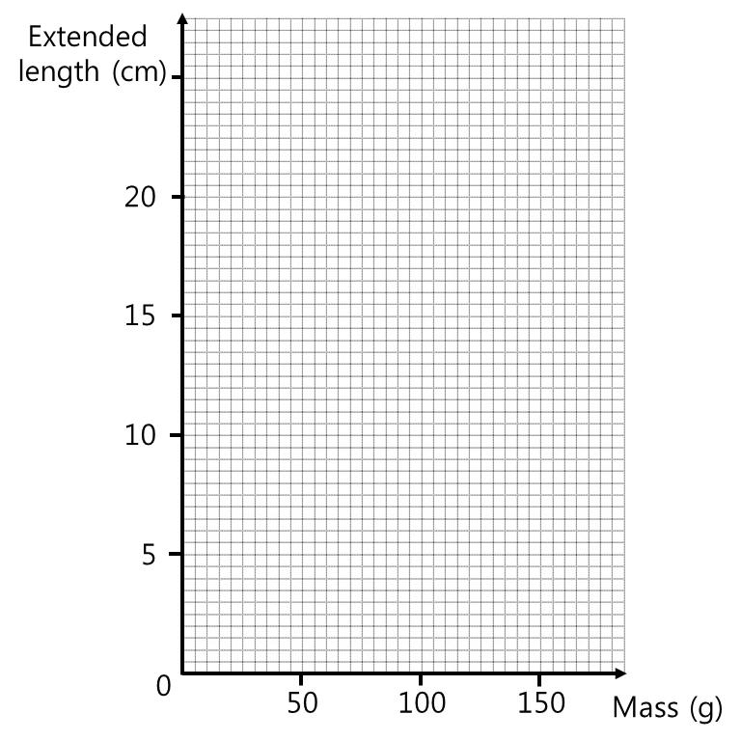

 | Student 1 | Student 2 | Student 3
Name
Code

Experiment I. Determination of the Densities of Fruit Juices (Cont’d)
I-2  (6.0) | I-2-3  (2.0) | (Show your working)
I-2  (6.0) | I-2-3  (2.0) | <x> |  | <y>
I-2  (6.0) | I-2-3  (2.0) | < x²> |  | <xy >
I-2  (6.0) | I-2-3  (2.0) | Slope, A | cm/g | Intercept, B | cm
I-2  (6.0) | I-2-4  (2.0) | Spring Constant |  | N/m

 | Student 1 | Student 2 | Student 3
Name
Code

Experiment I. Determination of the Densities of Fruit Juices (Cont’d)
Questions  (Points) |  | Data and Answers
I-3  (4.0) | I-3-1  (1.0) | Juice | Mandarin | Apple
I-3  (4.0) | I-3-1  (1.0) | Lengths of spring (cm)
I-3  (4.0) | I-3-2  (1.0) | Extended lengths of spring (cm)
I-3  (4.0) | I-3-3  (2.0) | (Show your working)
I-3  (4.0) | I-3-3  (2.0) | Juice | Mandarin | Apple
I-3  (4.0) | I-3-3  (2.0) | Buoyant forces (N)

 | Student 1 | Student 2 | Student 3
Name
Code

Experiment I. Determination of the Densities of Fruit Juices (Cont’d)
Questions  (Points) | Data and Answers
I-4  (1.0) | Volume (cm³)
I-5  (2.0) | (Show your working)
I-5  (2.0) | Juice | Mandarin | Apple
I-5  (2.0) | Densities (g/cm³)

------------------------------------ DO NOT WRITE BELOW ------------------------------------
Total points for experiment I

 | Student 1 | Student 2 | Student 3
Name
Code

Experiment II. Determination of the Citric Acid Contents in Fruit Juices
Questions  (Points) | Data and Answers
II-1  (7.0) | (Show your working)  0.5 per juice for completing all readings to two decimal places and all appropriate units  0.5 per juice for correct calculation of average values (if necessary disregarding anomalous values); 0.25 if anomalous values are included  0.5 per juice if at least two titers are no more than 0.1 mL apart  -----  Marks for accuracy compared to ideal titer  ≤ ±0.25 mL [2.0] per juice  ± 0.26 – 0.45 mL [1.5]  ± 0.46 – 0.65mL [1.0]  ± 0.66 – 0.85 mL [0.5]  ±0.85 – 0.99 mL [0.2]  ≥ 1 mL [0.0]
II-1  (7.0) |  |  | Juices
II-1  (7.0) |  |  | Mandarin |  |  |  |  | Apple
II-1  (7.0) | Trials |  | 1 | 2 |  | 3 | 4 | 5 |  | 6 | 7 | 8
II-1  (7.0) | Initial Readings (in )
II-1  (7.0) | Final Readings (in )
II-1  (7.0) | Volumes of NaOH solution consumed for titration
II-1  (7.0) |  |  | Average volume |  |  |  |  | Average volume
 |  | Student 1 |  |  | Student 2 |  |  |  | Student 3
Name
Code

Experiment II. Determination of the Citric Acid Contents in Fruit Juices (Cont’d)
Questions  (Points) | Data and Answers
II-2  (2.0) | (Show your working)  n(NaOH) = V(NaOH) * c(NaOH) [1]  Correct values for each juice [0.5]
II-2  (2.0) | Moles of NaOH | Mandarin | mol | Apple | mol
II-3  (2.0) | (Show your working)  Mole ratio: 3:1  Calculation n(acid) = n(NaOH) / 3 [0.5 per juice]  Calculation m(acid) = n(acid) * M_{r}(acid) [0.5 per juice]  0.25 if error in M_{r} or missing units
II-3  (2.0) | Moles of citric acid | Mandarin |  | Apple
II-3  (2.0) | Masses of citric acid | Mandarin |  | Apple

 | Student 1 | Student 2 | Student 3
Name
Code

Experiment II. Determination of the Citric Acid Contents in Fruit Juices (Cont’d)
Questions  (Points) | Data and Answers
II-4  (2.0) | (Show your working)  Calculation m(juice) = density * volume = 1.00 g/cm³ * 10.0 cm³ = 10.0 g [0.5]  Calculation Percent Concentration m(acid) / m(juice) * 100 [0.75 per juice]  Or value based on students’ answer of II-3
II-4  (2.0) | Percent concentration of citric acid | Mandarin | % | Apple | %
------------------------------------ DO NOT WRITE BELOW ------------------------------------
Total points for experiment II

 | Student 1 | Student 2 | Student 3
Name
Code

Experiment III. Anatomy and classification of fruits and seeds
Question  (Points) | Data and Answers
III-1  (1.0) | Location of tissues originated from A | 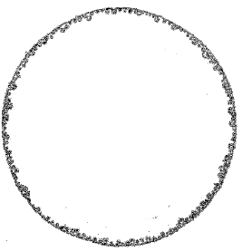
III-2  (2.0) | Location of tissues originated from A, B, C and D | 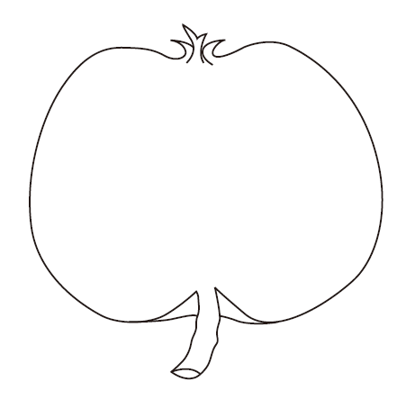

 | Student 1 | Student 2 | Student 3
Name
Code

Experiment III. Anatomy and classification of fruits and seeds (Cont’d)
Question  (Points) | Data and Answers
III-3-1  (2.0) |  | fruits
III-3-1  (2.0) | Fruits for ① and ②
III-3-2  (2.0) | Classification schemes for ‘c’ and ‘d’ | characters
III-3-2  (2.0) | Classification schemes for ‘c’ and ‘d’ | c | d
III-3-3  (6.0) | III-3-3-1  Draw branch lines to complete the diagram.  (4.0 points) | 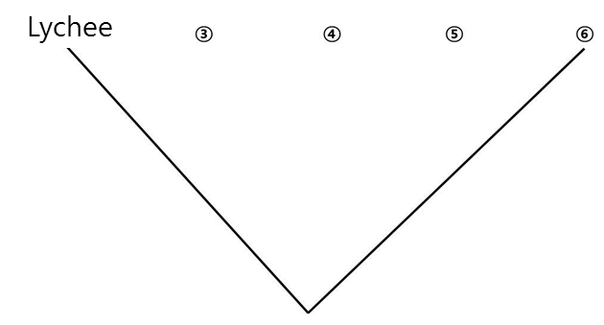
III-3-3  (6.0) | III-3-3-2  (0.5 points) | A fruit for ③
III-3-3  (6.0) | III-3-3-3  (0.5 points) | A fruit for ④
III-3-3  (6.0) | III-3-3-4  (0.5 points) | A fruit for ⑤
III-3-3  (6.0) | III-3-3-5  (0.5 points) | A fruit for ⑥
------------------------------------ DO NOT WRITE BELOW ------------------------------------
Total points for experiment III

