Assignment1

Name: Akaash Emmanuel Rayipudi

NetID: ar429

Roll no. : 2210110959

Name: Vansh Sangwan

NetID: vs554

Roll no. : 2210110642

Output1:

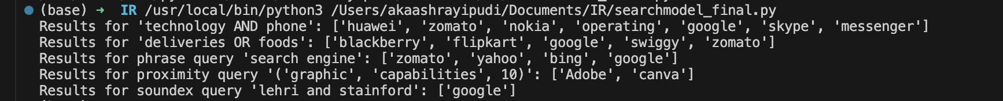

Output2:

