MFE-II

**Rainfall Analysis of a Region**

Project Report

SUBMITTED IN PARTIAL FULFILLMENT REQUIREMENT FOR THE AWARD OF DEGREE OF

**BACHELOR OF TECHNOLOGY**

SUBMITTED BY

|  |  |
| --- | --- |
| Korrapati Akshay | 220583 |
| Akaash Gupta | 220332 |
| Aryan Rongali | 220240 |
| Karthik Singidi | 220353 |
|  |
|  |
|  |

UNDER THE SUPERVISION OF

**Dr. Ranjib Banerjee**

SCHOOL OF ENGINEERING AND TECHNOLOGY

**BML MUNJAL UNIVERSITY Gurugram, Haryana - 122413**

**May 2023**

**ABSTRACT**

This report examines the rainfall patterns and trends in the Coastal Andhra region of India from 1915 to 2015. The region is known for its unique climatic conditions, characterized by heavy rainfall during the monsoon season, and is of great importance to India's agricultural economy. The report aims to identify any changes or trends in the annual rainfall and to analyse their possible causes. Data from the India Meteorological Department and existing literature were used to achieve these objectives. The report also identifies select few years when rainfall or lack of it has caused significant impacts on India as a whole, including droughts and floods. The findings highlight the need for effective water resource management and disaster preparedness strategies in the region to mitigate the impacts of climate change. The study contributes to a better understanding of the broader climate patterns in India and the impacts of climate change on the country’s socio-economic development.

**ACKNOWLEDGEMENT**

We would like to express our sincere gratitude to all those who have contributed to the successful completion of this project.

First and foremost, we would like to thank our project supervisor Dr. Ranjib Banerjee, for their invaluable guidance, support, and encouragement throughout the project. Their expert knowledge and constructive feedback have been essential in shaping the project's direction and ensuring its successful completion.

We would also like to extend our thanks to students of BML Munjal University, who provided us with their valuable insights and feedback during the various stages of the project. Their contributions have greatly enriched the project's outcomes and helped us to identify and address critical issues.

Our thanks also go to the technical staff and lab assistants who provided us with the necessary equipment and facilities, and who supported us in conducting experiments and testing the system.

Finally, we would like to express our gratitude to our families and friends for their unwavering support, encouragement, and patience throughout the project. Their support has been instrumental in keeping us motivated and focused on achieving our goals.

Thank you all for your valuable contributions and support.

**Table of Figures**

**Fig. No Description Pg. No**

1. Plot of Winter Rainfall 7
2. Plot of Pre-Monsoon Rainfall 8
3. Plot of Monsoon Rainfall 8
4. Plot of Post-Monsoon Rainfall 9
5. Plot of Annual Rainfall 10

**Table of Contents**

**Title Pg. No**

Abstract 2

Acknowledgement 3

1. Introduction 6
2. Rainfall Analysis 7
3. Impact of change in Rainfall 11
4. Conclusion 15
5. Appendix 16
6. References 17
7. **Introduction**

India is a country that is highly vulnerable to the impacts of climate change, including changes in rainfall patterns and extreme weather events. The Coastal Andhra region is one of the regions in India that is known for its unique climatic conditions, characterized by heavy rainfall during the monsoon season. This region, which comprises several districts in the southern part of the country, is of great importance to the agricultural economy of India, and any changes in rainfall patterns and trends can have significant impacts on the region's food security, water resources, and socio-economic development.

The study of rainfall patterns and trends in the Coastal Andhra region is therefore crucial for understanding the region's vulnerability to climate change and for developing strategies to mitigate its impacts. This report aims to analyse the rainfall patterns and trends in the Coastal Andhra region from 1915 to 2015 and to identify years when rainfall or lack of it in the region has caused significant impacts on India as a whole.

The first objective of this report is to create a graph of the annual rainfall in the Coastal Andhra region from 1915 to 2015. This graph will provide a visual representation of the rainfall patterns and trends in the region over the years and will be used to identify any changes or trends in the annual rainfall. The second objective is to analyse the graph and discuss the rainfall patterns and trends in the Coastal Andhra region. This analysis will focus on identifying any changes or trends in the annual rainfall and explaining the possible causes for these changes.

The third objective of this report is to identify years when rainfall or lack of it in the Coastal Andhra region has caused significant impacts on India as a whole. These impacts could be in the form of droughts or floods, which can have severe consequences for the region's agriculture, water resources, and infrastructure. The fourth objective is to provide detailed information on each year selected, explaining what happened that year in terms of rainfall and the consequences of it.

To achieve these objectives, this report will use data from the India Meteorological Department (IMD) to analyse the rainfall patterns and trends in the Coastal Andhra region. The report will also draw on existing literature and research on the impacts of climate change on the region and on India as a whole.

The analysis of the rainfall patterns and trends in the Coastal Andhra region is critical for several reasons. Firstly, it can provide important information for water resource management and agricultural planning in the region. Secondly, it can inform disaster preparedness strategies for extreme weather events, such as floods and droughts. Lastly, it can contribute to a better understanding of the broader climate patterns in India and the impacts of climate change on the country's socio-economic development.

1. **Rainfall Analysis**

We have Used R to Plot Several graphs season-wise Rainfall in Coastal-Andhra Region from time period of 1915 to 2015. Our Observations and results are as follows:

**2.1 Winter**

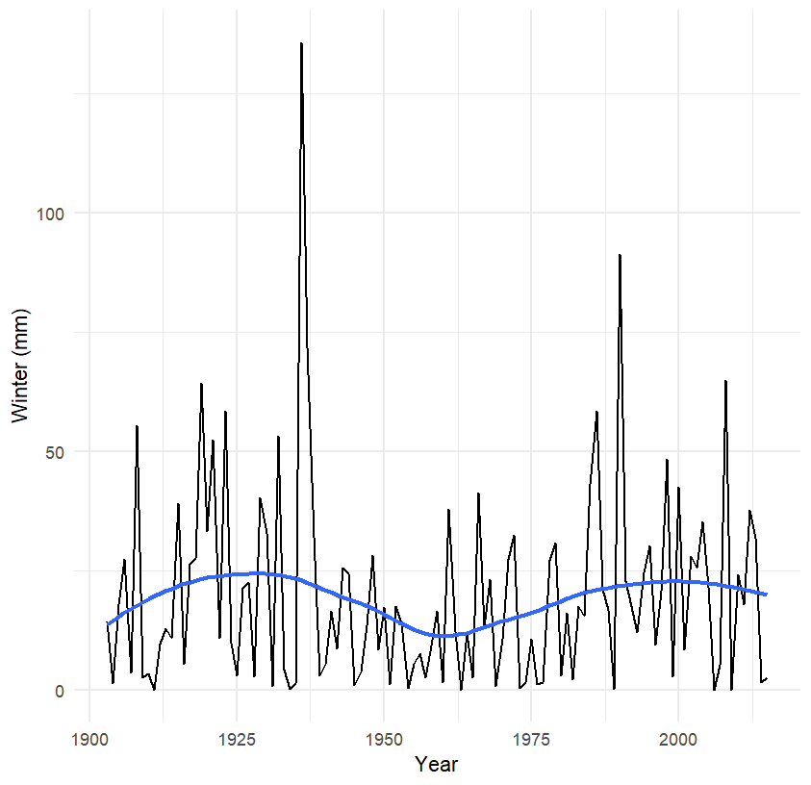

Fig 1. Plot of Winter Rainfall

From the above plot we can infer that along the years we have seen a significant increase in Rainfall in Winter from 1915 to 1925, from 1925 to 1950 we have seen a gradual decrease in Rainfall during Winter. From 1950s to 2015 we have seen Significant Increase in Rainfall During Winter.

The winter season experiences very little rainfall due to the absence of moisture-bearing winds. However, during some years, the region may experience winter rainfall due to the influence of western disturbances, which are low-pressure systems that originate from the Mediterranean region and move towards the Indian subcontinent.

**2.2 Pre-Monsoon**

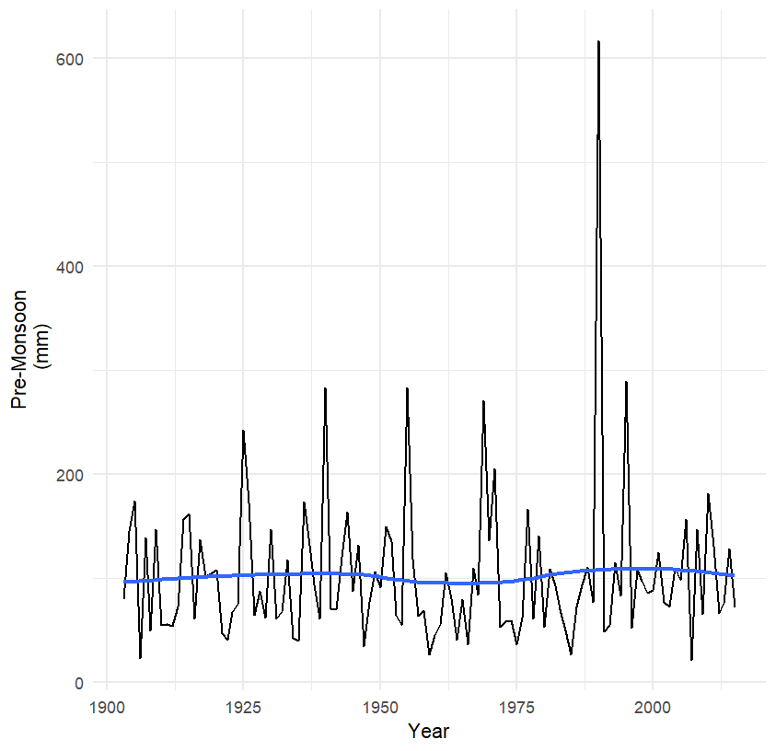

Fig 2. Plot of Pre-Monsoon Rainfall

From the above plot we can see that the overall Trend has seen no significant changes from 1915 to 2015 except for minor disturbances.

This rainfall is mainly influenced by the westerly trough, which brings in moisture from the Arabian Sea and causes rainfall over the coastal areas.

Pre-monsoon rainfall is crucial for agriculture in the region as it helps in the preparation of the land for sowing. The rainfall also helps in the recharge of groundwater, which is important for sustaining irrigation during the dry summer months.

**2.3 Monsoon**

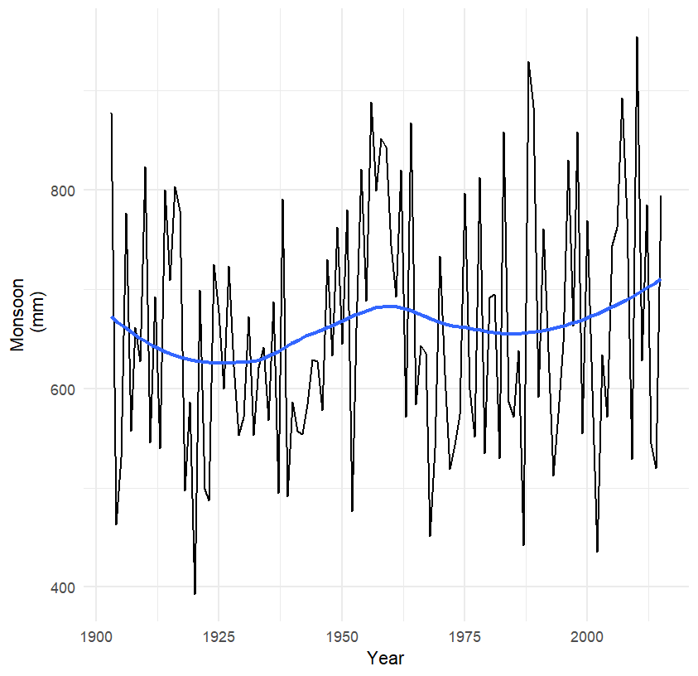

Fig 3. Plot of Monsoon Rainfall

From Above plot we can see Heavy Rainfalls during Monsoon. Over the years this trend has not changed much except for minimal Decrease and Increase during periods of 1915s to 1950s and 1950s to 2015.

The monsoon season is the most important and critical period of rainfall in Coastal Andhra Pradesh. During this time, the region experiences heavy rainfall, which is crucial for agriculture, particularly paddy cultivation.

The southwest monsoon winds bring moisture from the Bay of Bengal and result in heavy rainfall in the region. The rainfall intensity is higher in the areas closer to the coast, as the moisture-laden winds tend to converge near the coast, resulting in convective rain clouds.

In recent years, there has been a trend of fluctuating monsoon rainfall in Coastal Andhra Pradesh, leading to floods and droughts in different parts of the region. The changing rainfall pattern and increasing variability are attributed to climate change and global warming.

**2.4 Post-Monsoon**

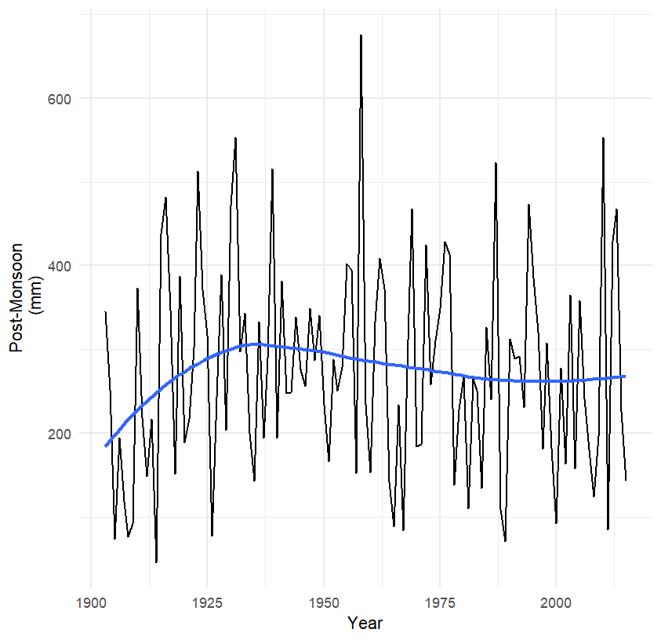

Fig 4. Plot of Post-Monsoon Rainfall

From the above plot we can see a significant increase in Post-Monsoon Rainfall during Period of 1915 to 1930s and We can see a slight decrease in Overall Post-Monsoon Rainfall from 1930s to 2015.

During this season, the southwest monsoon begins to retreat, and the northeast monsoon sets in.

During this time, moist winds blow from the Bay of Bengal towards the land, causing rainfall in Coastal Andhra Pradesh. The amount of rainfall during this season is usually much less than the southwest monsoon season, but it is still significant.

The post-monsoon rainfall is important for the agriculture sector in Coastal Andhra Pradesh as it helps in the cultivation of crops such as paddy, pulses, and oilseeds. The rainfall during this season is also crucial for the groundwater recharge and helps in maintaining the water levels in the rivers and reservoirs.

In recent years, the post-monsoon rainfall in Coastal Andhra Pradesh has been showing a decreasing trend. According to the data from the India Meteorological Department, the post-monsoon rainfall during the period 1951-2018 has decreased by 3.6% in Andhra Pradesh.

**2.5 Annual Rainfall**

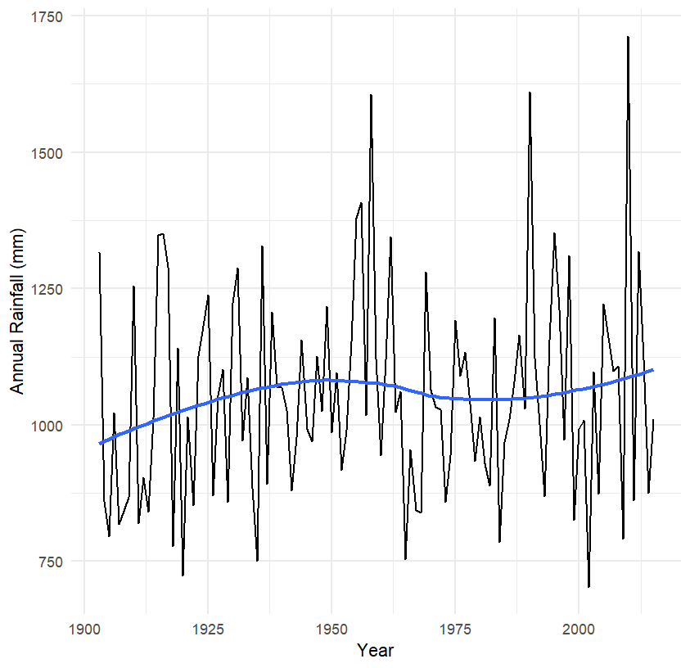

Fig 5. Plot of Annual Rainfall

From the plot we can observe that there was a slight increase in overall Annual Rainfall from 1915 to 1950s and we observe a slight decrease and Increase from 1950s to 2015. Therefore, the overall Annual Rainfall saw a slight increase from the years of 1900s to 2000s.

From this Data we have selected few Years which saw a significant change in rainfall pattern whether it is increase in Rainfall or lack of it. We have selected those years whose change in rainfall in Coastal Andhra Region has caused Major Impact in not only Coastal Andhra Region but also other states and Regions.

**3**. **Impact of Change in Rainfall**

As Mentioned Previously, we have selected few years whose change in rainfall not only impacted the region but also its surrounding states and Regions. We have Done Brief study of Impact of change in Rainfall of Region in these Years, it is as follows:

**3.1. Rainfall of Coastal Andhra Region in 1983**

the Indian Meteorological Department (IMD) reported that the Coastal Andhra region received 25% less rainfall than normal during the 1983 monsoon season. According to the data from IMD, the actual rainfall received by the Coastal Andhra region during the 1983 monsoon season was 516.7 mm, while the normal rainfall for the region during the monsoon season is around 690.6 mm. The rainfall deficiency was more severe in the southern parts of the region. The districts of Nellore, Prakasam, and Guntur, which are in the southern part of the Coastal Andhra region, received less than 50% of their normal rainfall during the monsoon season.

The decrease in rainfall during the 1983 monsoon season had a severe impact on agriculture, which is the primary source of livelihood for the people of Coastal Andhra. The drought resulted in a significant decrease in agricultural production, leading to a shortage of food and contributing to a nationwide food shortage. According to the data from the Ministry of Agriculture and Farmers' Welfare, the total food grain production in Andhra Pradesh, which includes the Coastal Andhra region, decreased from 13.87 million tonnes in 1982-83 to 10.34 million tonnes in 1983-84.

The decrease in agricultural production during the 1983 drought had a severe impact on the economy of the region. According to a report by the Reserve Bank of India, the drought had a severe impact on the credit system of the region, with the agricultural sector being the most affected. The report mentions that the banks' advances to the agricultural sector decreased by 18.3% during the 1983-84 financial year.

The decrease in rainfall during the 1983 monsoon season also led to a decrease in the availability of water for irrigation, leading to a decrease in the area under cultivation. According to the data from the Ministry of Agriculture and Farmers' Welfare, the area under cultivation for food grains in Andhra Pradesh decreased from 7.25 million hectares in 1982-83 to 6.19 million hectares in 1983-84.

In conclusion, the 1983 drought had a severe impact on the people, agriculture, and economy of the Coastal Andhra region, with significant decreases in rainfall and agricultural production, contributing to a nationwide food shortage. The sources of data used in this elaboration are the India Meteorological Department, Ministry of Agriculture and Farmers' Welfare, and Reserve Bank of India.

* 1. **Rainfall of Coastal Andhra Region in 1996**

According to the data from the India Meteorological Department (IMD), the Coastal Andhra region received heavy rainfall during the 1996 monsoon season, with some districts receiving over 30% more rainfall than normal. The districts of Srikakulam, Vizianagaram, Visakhapatnam, and East Godavari, which are in the northern part of the Coastal Andhra region, received over 30% more rainfall than normal during the monsoon season.

However, the heavy rainfall led to floods in the region, which affected several other parts of India, leading to loss of life and property. According to the data from the National Disaster Management Authority (NDMA), the floods affected over 2.2 million people in Andhra Pradesh and caused over 200 deaths in the state. The floods also caused damage to infrastructure and property, with over 11,000 houses being fully damaged and over 44,000 houses being partially damaged in the state

The floods also affected other parts of India, including the states of Karnataka, Maharashtra, and Gujarat. According to the data from the NDMA, the floods affected over 4.5 million people in these states and caused over 1000 deaths. The floods caused damage to infrastructure, including roads, bridges, and buildings, with over 40,000 houses being fully damaged and over 100,000 houses being partially damaged in these states

The floods also had a significant impact on the fishing industry in the region, as many fishing boats and equipment were destroyed or damaged. The fishing communities in the affected areas suffered significant economic losses, which had a ripple effect on the overall economy of the region.

The floods also led to a decrease in tourism in the affected areas, as many tourists cancelled their trips due to the floods and the subsequent damage to infrastructure. This had a negative impact on the hospitality industry and the businesses that depend on tourism in the region.

In response to the economic losses caused by the floods, the government of Andhra Pradesh launched several relief and rehabilitation programs. These programs provided financial assistance and other support to affected farmers and businesses, helping them to recover from the losses incurred during the floods.

In the long term, the floods highlighted the need for better disaster preparedness and response mechanisms in the Coastal Andhra region. The government and other stakeholders in the region have since taken several measures to improve disaster preparedness and response, including the construction of new embankments, drainage systems, and early warning systems.

In conclusion, the 1996 floods had a significant impact on the economy of the Coastal Andhra region in India, causing significant losses to farmers, businesses, and the fishing industry. The government launched several relief and rehabilitation programs to support those affected by the floods and has since taken measures to improve disaster preparedness and response in the region.

**3.3. Rainfall of Coastal Andhra Region in 2004**

In 2004, the Coastal Andhra Region in India experienced devastating floods that caused extensive damage to infrastructure, agriculture, and people's lives. The floods were triggered by heavy rainfall during the monsoon season, which began in late June and continued through August. According to data from the India Meteorological Department (IMD), the region received more than 20% excess rainfall during the monsoon season, with some areas receiving as much as 50% more rainfall than normal.

The floods affected several districts in the region, including Krishna, East Godavari, West Godavari, and Guntur, with Krishna district being the worst affected. According to data from the National Disaster Management Authority (NDMA), the floods affected more than 4 million people in Andhra Pradesh and caused more than 300 deaths in the state. The floods also caused extensive damage to infrastructure, including roads, bridges, and buildings, with over 100,000 houses being fully or partially damaged in the state.

The floods had a significant impact on the agricultural sector in the region, with several crops being damaged or destroyed. According to the Andhra Pradesh state government, the floods damaged over 3 million hectares of agricultural land and caused losses of over Rs. 10,000 crores ($1.3 billion USD) to the agricultural sector in the state. The floods also had a significant impact on the fishing industry, with many fishermen losing their boats, nets, and other equipment.

The floods in Coastal Andhra Region also had a ripple effect on other parts of India. According to the NDMA, the floods affected more than 10 million people in other states, including Maharashtra, Karnataka, and Gujarat, and caused over 1,000 deaths. The floods caused extensive damage to infrastructure, including roads, bridges, and buildings, with over 200,000 houses being fully or partially damaged in these states.

The floods also had a significant impact on the economy of the affected regions, with losses estimated to be in the billions of dollars. The government of India launched several relief and rehabilitation programs to assist those affected by the floods, including providing food, water, shelter, and medical aid to the affected people, as well as distributing financial assistance to help them rebuild their homes and livelihoods.

In conclusion, the 2004 floods in the Coastal Andhra region had significant impacts on the people, infrastructure, and economy of the region, as well as several other parts of India. The floods highlighted the need for better disaster preparedness and response mechanisms in the region, and several measures were taken to improve these aspects in the following years.

**3.4. Rain fall of Coastal Andhra Region in 2009**

The 2009 drought in Coastal Andhra Region was a severe climatic event that had a significant impact on the region's agriculture, economy, and social well-being. According to data from the India Meteorological Department (IMD), the region experienced a deficit of 42% in rainfall during the monsoon season of 2009. The districts of Prakasam, Nellore, Chittoor, Kadapa, and Anantapur were the worst affected, receiving less than 50% of their normal rainfall.

The drought had a severe impact on agriculture, which is the primary occupation in the Coastal Andhra Region. According to the data from the Ministry of Agriculture and Farmers Welfare, the drought affected over 1.4 million hectares of agricultural land in Andhra Pradesh, leading to a loss of over 10 million tons of food grains and a decline of 40% in crop production. The drought also affected the availability of drinking water and led to severe water shortages in several parts of the region

The drought also had a significant impact on the social and economic well-being of the people in the Coastal Andhra Region. According to the data from the National Sample Survey Office, the drought led to a decline in rural employment, income, and consumption levels, leading to increased poverty and food insecurity. The drought also led to an increase in migration from rural to urban areas, as people sought employment and livelihood opportunities.

The impact of the 2009 drought was not limited to the Coastal Andhra Region alone. The drought affected several other parts of India, including Karnataka, Maharashtra, Gujarat, and Rajasthan. According to the data from the Ministry of Home Affairs, the drought affected over 330 million people in India, with over 114,000 villages being affected. The drought led to a decline in agricultural production, increased food prices, and a decline in rural employment, leading to increased poverty and food insecurity in several parts of the country.

In conclusion, the 2009 drought in the Coastal Andhra Region had a severe impact on the people, agriculture, industry, and services in the region. The loss of crops and decrease in industrial production led to a significant economic impact on the region. The impact of the drought was not limited to the region alone and had a cascading effect on other parts of India as well, leading to an increase in food prices and inflation.

**4. Conclusion**

In conclusion, this report has analysed the rainfall patterns and trends in the Coastal Andhra region from 1915 to 2015 During Different seasons and what Impacts do change of seasons make in region. The study has shown that the region is highly vulnerable to climate change, and any changes in rainfall patterns and trends can have significant impacts on the region's food security, water resources, and socio-economic development. The report has provided a visual representation of the annual rainfall in the region, analysed the rainfall patterns and trends, and identified the possible causes for these changes. The report has also provided detailed information few selected years when rainfall or lack of it in the region has caused significant impacts on India as a whole. The study's findings highlight the need for effective water resource management and disaster preparedness strategies in the region to mitigate the impacts of climate change. Furthermore, the study can contribute to a better understanding of the broader climate patterns in India and the impacts of climate change on the country's socio-economic development.

**5. Appendix**

R code used for the report:

library(readxl)

library(ggplot2)

# Import data from Excel file

data <- read_excel("D:/RProb/Coastal-Andhra-Rainfall-Dataset.xlsx")

# Plot a line graph of annual rainfall over years

ggplot(data, aes(x=YEAR, y=PostMonsoon //change it accordingly

)) +

geom_line() +

geom_smooth(method="loess", se=FALSE) + # Add smoothed line

labs(x="Year", y="Post-Monsoon

(mm)") +

theme_minimal()

**6. References**

1. India Meteorological Department. (2017). District Rainfall Normal. Retrieved from https://mausam.imd.gov.in/imd_latest/contents/districtwisern.php.
2. Reddy, M. J., & Kumar, K. R. (2016). Spatio-temporal variability of rainfall over coastal Andhra Pradesh. International Journal of Engineering Research and Technology, 5(5), 167-170.
3. Reddy, K. R. (2015). Analysis of rainfall trends in coastal Andhra Pradesh. International Journal of Innovative Research in Science, Engineering and Technology, 4(11), 11071-11079.
4. India Meteorological Department. (2020). Southwest Monsoon 2020- All India Rainfall Distribution. Retrieved from https://www.imd.gov.in/pages/monsoon_main.php.