Project Report
Generative AI Agents – Task Automation with LLM Reasoning
[CSE3024]

Policy Navigator: A Multi-Agent AI System for Agricultural Policy Navigation, Crop Guidance, and Market Intelligence in Andhra Pradesh

By

Akaash Gupta Vandanapu
220332
Likhit Sagar Gajja
220322



Department of Computer Science and Engineering
School of Engineering and Technology
BML Munjal University

November 2025
Declaration by the Candidates

We hereby declare that the project entitled “Policy Navigator: A Multi-Agent AI System for Agricultural Policy Navigation, Crop Guidance, and Market Intelligence in Andhra Pradesh” has been carried out to fulfil the partial requirements for completion of the core-elective course Generative AI Agents – Task Automation with LLM Reasoning offered in the 7th Semester of the Bachelor of Technology (B.Tech) program in the Department of Computer Science and Engineering during AY-2025-26 (odd semester). This experimental work has been carried out by us and submitted to the course instructor Dr. Soharab Hossain Shaikh. Due acknowledgments have been made in the text of the project to all other materials used. This project has been prepared in full compliance with the requirements and constraints of the prescribed curriculum.

Akaash Gupta Vandanapu

Likhit Sagar Gajja
Place: BML Munjal University
Date: 18 November, 2025

Contents

Title | Page Number
Introduction | 4
Problem Statement | 5
Literature Review | 6 -7
Methodology | 8 – 19
Technology Stack | 20 – 21
Results | 22 -25
Conclusions | 26
References | 27
Appendix: (Include code/output etc.)

Introduction
For Indian farmers obtaining timely and accurate agricultural information is a significant challenge. Finding trustworthy answers quickly is challenging because government policies, crop guidance, pest management and market data are frequently dispersed throughout documents and websites. A single interface for agricultural data is offered by the multi-agent AI system Policy Navigator. It uses specialized AI agents to navigate policies, provide crop guidance, manage pest information and deliver market intelligence with a focus on Andhra Pradesh. The system integrates 9 specialized AI agents which are 8 CrewAI agents and 1 Google ADK agent working together to process queries, retrieve information from a curated document repository of 22 agricultural documents across 12 categories and synthesize responses. The system makes use of Agent-to-Agent (A2A) communication for framework interoperability, Model Context Protocol (MCP) for web search and PDF processing and Retrieval-Augmented Generation (RAG) with ChromaDB for document search. Using RAG for Andhra Pradesh specific information and web search for other regions it intelligently routes queries based on region detection providing structured answers with follow-up questions and source citations.

In order to produce a useful agricultural information system the architecture exhibits multi-agent orchestration, context sharing among agents, structured output generation and cross-framework integration (CrewAI and Google ADK). Coordination of multiple specialised agents accurate information retrieval from local documents and web sources along with context preservation throughout agent interactions and the provision of comprehensive and easily comprehensible structured outputs are some of the technical challenges that the system tackles. The system bridges the gap between static policy documents and dynamic market data by fusing MCP based web search for real time information with RAG for document based knowledge. This gives farmers access to a comprehensive information resource that can be tailored to their unique needs and local context. The system's intelligent query routing mechanism analyses user queries to detect regions, classify intent and determine which specialized agents should handle the request and also ensures accurate results.
Problem Statement
Accessing timely and accurate agricultural information is a major challenge for Indian farmers. It is challenging to locate trustworthy answers fast because government policies, programs, crop cultivation manuals, pest management techniques and market data are dispersed throughout a variety of sources including extension offices, PDF documents, official websites and agricultural departments. Farmers must navigate several platforms while comprehending complicated policy language and synthesise data from various sources as a result of this fragmentation which takes time and is prone to errors. Since agricultural practices, policies and market conditions differ between states and districts the issue is made worse by the requirement for region specific data. The current information infrastructure has a number of serious drawbacks. Static policy documents kept in government repositories and dynamic real time data like current market prices are not in sync.
weather predictions, recent policy announcements and Minimum Support Prices all of which call for online resources. A farmer enquiring about crop cultivation for example might need policy information about subsidies, technical guidance on varieties and practices, pest management strategies and current market prices. However the traditional systems treat these as distinct information silos. Agricultural queries frequently require information from multiple domains at the same time. Farmers who might lack the specialised knowledge to understand eligibility requirements, application processes or technical agricultural guidance are further hindered by the technical nature of policy documents and the intricacy of agricultural terminology.
In Andhra Pradesh these difficulties are especially severe since farmers must deal with state specific programs, regional crop types, local pest control methods and district level market data. They may also need to know about policies at the federal level or in nearby states. A major gap in agricultural information accessibility is caused by the lack of a unified system that can intelligently route queries, retrieve information from local document repositories and web sources maintain context across multiple information domains and present synthesised responses in an accessible format.
Literature Review
Recent studies have investigated multi agent systems in agriculture emphasising decision support, information retrieval and coordination. In order to enhance context and iteratively improve responses. [1] proposed a self reflective multi agent framework for agricultural visual question answering that uses four specialised agents like Retriever, Reflector, Answerer and Improver.
In order to demonstrate the benefits of agent specialisation in agricultural applications, Lee et al. [2] presented GeoLLM-Squad a geospatial copilot that employs a multi-agent paradigm and achieved a 17% improvement in agentic correctness. With Editor, Retriever and Validator agents Shi et al. [3] created Pest MA an LLM based multi-agent system for pest control. Evaluations showed accuracy improving from 86.8% to 92.6% after validation highlighting the importance of validation in multi-agent workflows Kumar et al. [4] presented a multi-agent expert system that monitors the agricultural production cycle and analyses data from various sources to enhance yield and support decision making. In their review of multi-agent large language models in agriculture Zhao et al. [5] talked about issues like model interpretability, hallucination and multi-modal data processing. These issues are addressed in Policy Navigator by means of guardrails and structured outputs.
Ankit [6] demonstrated how multi-agent systems can maximise resource allocation in agricultural contexts by creating a multi-agent collaborative framework that integrates UAVs and UGVs with a graph-based decision maker for task partitioning.
In their review of multi-agent system applications in precision agriculture Pérez-Pons et al. [7] emphasised how MAS can assist farmers in obtaining comprehensive information and making defensible choices. In their investigation of AI driven agent communication in smart farming systems Obeidat et al. [8] placed a strong emphasis on multi-agent integration for effective data processing. In order to show how multi-agent systems can adjust to changing agricultural conditions Seo and Lee [9] proposed a Density Driven Optimal Control framework for multi UAV coordination.
In his review of swarm robotics and multi-agent systems in agriculture Michael [10] talked about decentralised coordination for tasks like pest control, planting and monitoring.
By addressing coordination, information retrieval, decision support and resource optimisation these studies show the potential of multi-agent systems in agriculture. They back the design of Policy Navigator a unified agricultural information system that combines A2A communication ,MCP-based web search, RAG-based retrieval and specialised agents.

Methodology
System Architecture and Implementation Details
A multi-agent architecture with centralised orchestration is used by the Policy Navigator. The MainOrchestrator aggregates results controls workflow execution and initialises CrewAI crews as needed. The system consists of three layers namely infrastructure (RAG, MCP servers, monitoring), agent execution (9 specialised agents like 8 CrewAI and 1 ADK) and orchestration (workflow management and agent coordination). To avoid token limits the orchestrator disables CrewAI memory for large PDF uploads and employs lazy initialisation. A sequential task execution model with conditional branching is used in component interactions. Conditional tasks can access query analysis results thanks to the ExecutionTracker singleton which keeps track of state throughout the pipeline. CrewAI's built in memory allows agents to share context by storing intermediate outputs and making them accessible to later tasks without the need for explicit message passing.
The majority of agents in the system use CrewAI as their main framework taking advantage of its memory management, task orchestration and agent specialisation. YAML based configuration enables declarative agent definitions without requiring code changes and the @CrewBase pattern keeps agent definitions apart from execution logic. The calculator agent is integrated with Agent Development Kit for interoperability, utilising Google Generative AI models and interacting with CrewAI agents via a common A2A message protocol. This dual framework strategy preserves a single execution model while exhibiting interoperability.
For redundancy and cost flexibility the technology stack consists of CrewAI v0.80+ on Python 3.10+ with multi-provider LLM support (OpenAI GPT 4o mini as primary, Groq Llama 3.3 70b as alternative). Because of its lightweight architecture, persistent storage and metadata filtering, ChromaDB functions as the vector database. SentenceTransformers with the all-MiniLM-L6-v2 model are used to generate embeddings resulting in 384-dimensional vectors that are optimised for semantic similarity search in the agricultural domain. The system incorporates two Model Context Protocol servers like Ollama Web Search API for real time web information retrieval and FastMCP for PDF processing. Pydantic v2 is used for schema validation in structured output generation guaranteeing data consistency and type safety throughout all agent outputs.
The development environment follows a modular architecture with clear separation of concerns. The development environment follows a modular architecture with clear separation of concerns. The project structure organizes code into logical directories like configuration files in config/, custom tools in tools/, Pydantic models in models/, monitoring callbacks in callbacks/ and core orchestration logic in core/. Configuration management uses a three tier approach that is environment variables for sensitive information like API keys and model selection, YAML files for agent characteristics and task templates and runtime configuration through the LLMConfig helper class with intelligent fallback mechanisms. The system supports primary and fallback LLM configurations allowing graceful degradation when API limits are reached or services are unavailable. The configuration system automatically detects available API keys and selects appropriate models with explicit overrides available through environment variables ensuring system reliability and reducing dependency on single service providers.
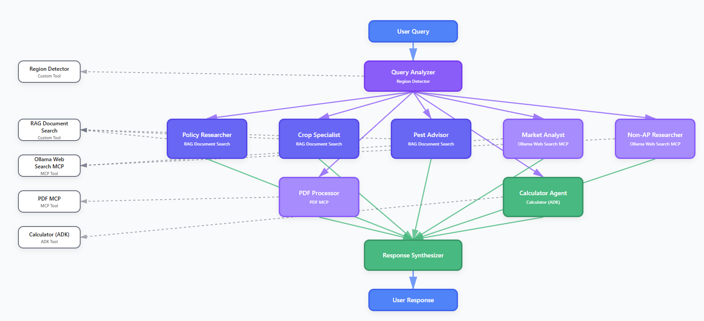
Fig 1. MindMap of the project architecture.

Agent Design and Specialization
The system uses 9 specialized agents each with a distinct role. The Query Analyzer performs intent classification, entity extraction and routing. The Policy Researcher, Crop Specialist, and Pest Advisor use RAG to access domain specific documents. The Market Analyst and Non-AP Researcher use web search for real time information. The PDF Processor handles document extraction and the Calculator Agent (ADK) performs calculations using Google Generative AI. The Response Synthesizer combines outputs from all agents into a coherent final response.
Agent Roles and Responsibilities:
- Query Analyzer: Intent classification, entity extraction, scope validation, region detection and routing decisions
- Policy Researcher: Retrieves agricultural schemes and policies from government documents using RAG
- Crop Specialist: Provides crop cultivation guidance including varieties, sowing, fertilization and irrigation
- Pest Advisor: Identifies pests and diseases recommends IPM strategies and control measures
- Market Analyst: Retrieves real time market prices and MSP using web search (never generates from memory)
- Non-AP Researcher: Handles queries about regions outside Andhra Pradesh using web search
- PDF Processor: Extracts and analyzes PDF documents with domain validation
- Calculator Agent (ADK): Performs agricultural calculations using Google Generative AI
- Response Synthesizer: Combines outputs from multiple agents into coherent final responses
Agents are configured through YAML files (agents.yaml) with role, goal, backstory, verbose settings, delegation permissions and max iterations. This declarative approach enables rapid modification without code changes, supporting iterative refinement and allowing non-programmers to adjust agent behavior.
Specialization is achieved through domain specific tools, contextual prompts and structured outputs. Each agent has access to relevant tools (RAG for policy/crop/pest, MCP servers for market/non-AP, ADK for calculations). Task descriptions include domain specific guardrails that prevent agents from operating outside their expertise. Each agent produces domain specific Pydantic models that enforce output structure and validation reducing hallucination and improving response quality.
Agent-to-agent coordination occurs through sequential task execution, CrewAI memory and the A2A protocol. Tasks execute in a predefined order with later tasks receiving outputs from earlier tasks. CrewAI's built-in memory automatically stores and retrieves intermediate outputs enabling context sharing without explicit message passing. ADK agents communicate with CrewAI agents through the StateManager, which maintains a message queue and shared state using the A2AMessage Pydantic model. The ExecutionTracker singleton provides a unified view of execution state allowing conditional tasks to access query analysis results and make routing decisions ensuring seamless coordination between agents regardless of their underlying framework.
Information Retrieval System (RAG) and MCP Integration
The document processing pipeline has four stages, document loading, text extraction, text chunking and metadata enrichment. The DocumentProcessor scans the data/ directory organized by 17 categories (Financial Schemes, Crop Cultivation Guides, Pest Disease Management etc.), supporting PDF and text files. PDFs are processed using PyPDF2, extracting text from all pages. Documents are split into chunks of 500 characters with 50-character overlap, attempting to break at sentence boundaries to preserve semantic coherence. Each chunk is tagged with source file name, category, chunk index and total chunks. The pipeline processes documents during RAG initialization (scripts/initialize_rag.py) creating a persistent vector database that can be queried at runtime without reprocessing.
ChromaDB is used as the vector store for its lightweight design, persistent storage and metadata filtering. The VectorStore class implements a singleton pattern ensuring a single database connection throughout the application lifecycle. The vector store uses a single collection (policy_documents) with cosine similarity metric. Documents are stored with embeddings, text content and metadata (source, category, chunk_index, total_chunks). Embeddings are generated using SentenceTransformers with the all-MiniLM-L6-v2 model (configurable via EMBEDDING_MODEL environment variable) producing 384 dimensional vectors optimized for semantic similarity search. The search() method accepts a query string, top_k parameter (default: 5) and optional category filter. It generates a query embedding, performs similarity search using ChromaDB's query() method and returns results with similarity scores (converted from distance: 1 - distance).
RAG Implementation Details:
- Vector Database: ChromaDB with persistent storage and metadata filtering
- Embedding Model: SentenceTransformers all-MiniLM-L6-v2 (384-dimensional vectors)
- Chunking Strategy: 500 characters per chunk with 50 character overlap, sentence boundary aware
- Search Method: Cosine similarity with configurable top_k results and category filtering
- Collection Structure: Single collection with embeddings, text and metadata (source, category, chunk_index)
The embedding model selection balances performance and computational efficiency. The all MiniLM-L6-v2 model is optimized for semantic similarity tasks and provides good results for domain specific agricultural terminology. The embedding model is configurable through environment variables allowing experimentation with alternative models (e.g., all-mpnet-base-v2 for higher accuracy at the cost of larger model size). Semantic search is performed using cosine similarity between query embeddings and document chunk embeddings. The RAG tool (rag_tool) wraps the vector store search functionality providing a CrewAI-compatible interface. Search results are formatted with source documents, categories, relevance scores and text excerpts enabling agents to cite sources and assess information reliability. The search supports category filtering allowing agents to narrow results to specific document types (e.g., "Financial Schemes" for policy queries) improving precision by reducing irrelevant results.
The system integrates Ollama Web Search MCP for real time web information retrieval. The MCP server (ollama_websearch_mcp_server.py) implements FastMCP protocol and provides a web_search tool that queries Ollama's web search API. The tool accepts a query string and max results parameter (default 10, max 20). It makes HTTP POST requests to https://ollama.com/api/web_search with retry logic (3 attempts with exponential backoff) and error handling for rate limits and server errors. Search results are formatted as JSON strings containing rank, title, URL and content preview (truncated to 500 characters). The formatted results are returned to agents who extract relevant information and cite source URLs.
PDF processing is implemented through two MCP servers that is FastMCP PDF Extractor (pdf_extractor_mcp_server.py) using pypdf library for modern PDF processing and Legacy PDF MCP Server (pdf_mcp_server.py) using PyPDF2 as a fallback. The MCP server provides a read_file tool that extracts text from PDF files, returning structured data with text content, page count, file name and character count. The system supports both implementations with FastMCP as the primary method. Uploaded PDFs undergo domain validation using a specialized validator that checks if content relates to agriculture and Andhra Pradesh policies. Invalid PDFs are rejected with clear error messages.
MCP Integration Features:
- Ollama Web Search MCP: Real time web information retrieval with retry logic and error handling
- PDF MCP Servers: Dual implementation (FastMCP primary, Legacy fallback) for document extraction
- Domain Validation: Automatic validation of uploaded PDFs for agricultural and AP policy relevance
- Tool Discovery: Automatic tool registration through CrewAI's @tool decorator pattern
Tools are integrated into CrewAI agents through the @tool decorator which makes Python functions available to agents. The system provides three custom tools that is RAG Document Search Tool (wraps VectorStore.search() for semantic document retrieval), Region Detector Tool (analyzes queries to detect Andhra Pradesh vs. non-AP regions using keyword matching) and Ollama Web Search Tool (provides web search capabilities through MCP). Tool discovery is automatic CrewAI agents can access any tool registered with the @tool decorator. Tools are assigned to agents during crew initialization based on agent roles and task requirements ensuring each agent has access to the appropriate tools for its domain expertise.
A2A Communication Protocol
The ADK agent adapter (adk_agent.py) bridges CrewAI's agent framework and Google's Agent Development Kit. It implements three classes like A2AMessage (Pydantic model defining the message format), ADKAgent (base class handling Google Generative AI model initialization and message processing) and CalculatorAgent (specialized ADK agent for agricultural calculations). The adapter enables seamless integration like CrewAI agents can invoke ADK agent capabilities through tool interfaces while ADK agents can send messages to CrewAI agents via the StateManager.The StateManager class implements a singleton pattern providing shared state and message queuing for A2A communication. It maintains a state dictionary for shared data, a message queue for asynchronous communication and methods for state management and message handling. The StateManager ensures thread safe access to shared state and provides a unified interface for cross framework communication.
A2A Message Format:
- from_agent / to_agent: Source and target agent identifiers
- message_type: 'task_delegation', 'task_complete', 'data', 'status_update', or 'capability_query'
- content: Message payload with task data, results or context
- timestamp: ISO format timestamp
- status: 'pending', 'processing', 'completed' or 'failed'
- capabilities: List of agent capabilities for discovery
- response required: Whether a response is needed
Messages follow the A2A Protocol standard enabling standardized communication between CrewAI and ADK agents. Task delegation occurs when a CrewAI agent requires calculation capabilities like the agent invokes the calculator tool which creates an A2AMessage with message_type="task_delegation" and sends it to the ADK agent through the StateManager. The ADK agent processes the message, performs the calculation and returns results through the same mechanism. This delegation is transparent to the CrewAI agent which receives results in a compatible format.
Capability discovery is implemented through the capabilities field in A2AMessage. Agents can query other agents capabilities by sending messages with message_type="capability_query". The ADK agent responds with a list of supported operations (e.g., ["cost_estimation", "yield_calculation", "subsidy_calculation", "profit_calculation"]). This mechanism enables dynamic agent composition where agents can discover available capabilities at runtime and adapt their behavior accordingly demonstrating the flexibility and extensibility of the A2A communication protocol.
Query Routing and Task Orchestration
Query analysis is performed by the Query Analyzer using a multi step process. Scope validation determines if the query is agricultural or non-agricultural queries are marked as out of scope and routed directly to the response synthesizer. For in scope queries like region detection uses the region_detector_tool to identify mentioned regions through keyword matching. If no region is detected the system defaults to Andhra Pradesh. The agent then classifies queries into types (policy, cultivation, pest, market, general or document_upload), extracts key entities (crops, schemes, locations, pests, diseases) and determines the required_agents list based on query type and region. The analysis output is structured as a QueryAnalysis Pydantic model.
Query Analysis Steps:
- Scope Validation: Determines if query is agricultural or out of scope
- Region Detection: Identifies Andhra Pradesh vs. non AP regions using keyword matching
- Query Classification: Categorizes into policy, cultivation, pest, market, general, or document_upload
- Entity Extraction: Extracts crops, schemes, locations, pests and diseases
- Agent Assignment: Determines required_agents list based on query type and region
The region detection algorithm uses keyword-based pattern matching with predefined lists of AP variants, districts, cities, and non-AP states/cities. It performs case-insensitive matching and returns is_ap_region, detected_regions, region_type ("ap", "non_ap", or "mixed"), and separate lists for AP and non-AP regions. If no region is detected, the system defaults to Andhra Pradesh.
Conditional task execution uses CrewAI's ConditionalTask class. Each specialized task checks if its agent ID is in the required_agents list from query analysis. The _check_condition_with_fallback() function retrieves query analysis from the ExecutionTracker and checks if the agent is required. If not required the task returns a minimal structured output (still tracked for monitoring) without executing expensive operations and ensuring efficient resource usage.
Context sharing occurs through three mechanisms like CrewAI memory (automatically stores task outputs and makes them available to subsequent tasks), Execution Tracker (maintains global state, storing query analysis results and agent outputs) and task dependencies (ensuring proper execution order). The response synthesizer task depends on all specialized tasks that are receiving their outputs automatically. Context is shared through structured Pydantic models ensuring type safety and validation.
Workflow orchestration is managed by the PolicyNavigatorCrew class which implements CrewAI's @CrewBase pattern. The orchestration follows crew initialization (agents and tasks loaded from YAML configurations), input processing (user query and optional PDF file path passed through the inputs dictionary), sequential execution (Query Analysis always first and then conditional specialized tasks and then Response Synthesis always last) and result aggregation (final response synthesizer combines outputs from all executed agents). The orchestration supports dynamic routing like query analysis determines which agents execute enabling efficient handling of diverse query types.
Structured Output Generation, Monitoring, and Guardrails
The system uses Pydantic v2 models for all agent outputs ensuring type safety, validation and structured data exchange. Each agent has a corresponding Pydantic model like QueryAnalysis (query classification, entity extraction, routing decisions), PolicyResponse (scheme details, eligibility, benefits, application process), CropGuidance (varieties, sowing details, fertilizer schedules, irrigation), PestManagement (pest information, control measures, prevention methods), MarketInfo (real time data with sources and timestamps), WebSearchResponse (web search results with disclaimers), PDFAnalysis (extracted text, structured data, summaries) and FinalResponse (synthesized response with markdown formatting). Models include field validators (e.g., validate_entities(), validate_markdown()), default factories for lists or dicts and type constraints (e.g., Literal types for enums, ge/le for numeric ranges) preventing invalid outputs and ensuring consistency.
Key Pydantic Models:
- QueryAnalysis: Query classification, entity extraction, routing decisions
- PolicyResponse: Scheme details, eligibility, benefits, application process
- CropGuidance: Varieties, sowing details, fertilizer schedules, irrigation
- PestManagement: Pest information, control measures, prevention methods
- MarketInfo: Real-time data with sources and timestamps
- FinalResponse: Synthesized response with markdown formatting
The response synthesizer combines outputs from multiple agents into a coherent final response. The synthesis process includes input aggregation (collects structured outputs from all executed agents), context integration (incorporates query analysis context to tailor the response), information fusion (merges related information from multiple sources, resolving conflicts and identifying complementary data), formatting (generates both plain text and markdown versions with proper headings, lists, tables and source citations) and validation (ensures minimum length requirements and includes confidence scores). The synthesizer uses guardrail context helpers (get_rag_task_context(), get_web_search_task_context()) to remind agents of data sources and prevent hallucination.
Markdown formatting follows a structured template with hierarchical headings (H1 for main topic, H2 for sections, H3 for subsections), bulleted lists for benefits and eligibility criteria, formatted tables for schedules and prices, emphasis (bold for key terms, italics for definitions), source citations (links and references to source documents or URLs) and code blocks for structured data when appropriate. The markdown is generated by the LLM with explicit instructions to use proper formatting, ensuring readability and professional presentation.
The ExecutionTracker class provides comprehensive execution tracking. It tracks executed agents (which agents actually executed vs skipped), tool usage (records tools used by each agent), agent tool mapping (maintains a dictionary of tools per agent) and query analysis storage (stores query analysis results for conditional task access). The tracker is implemented as a singleton ensuring consistent state across the execution pipeline. It is reset for each new query to prevent state leakage.
The system implements two callback functions integrated with CrewAI's callback system like step_callback() (called after each agent step, tracking agent identification, tool usage detection and step-level execution state) and task_callback() (called after each task completion, tracking task output extraction, query analysis storage, agent execution status and tool usage aggregation). Callbacks use the ExecutionTracker to maintain state enabling real time monitoring and post execution analysis. The monitoring system provides transparency into agent behavior, tool usage patterns and execution flow facilitating debugging and system optimization.

Technology Stack
The system is built on Python 3.10+ (tested with Python 3.12.4) using modular dependency management through pyproject.toml for version compatibility and reproducible builds.
Core Framework and Agent Development:
The primary agent framework is CrewAI (v0.28.0+) selected for agent specialization, task orchestration and memory management. It provides the @CrewBase pattern and YAML based configuration. The system integrates Google's Agent Development Kit (ADK) through google generative ai (v0.6.0+) enabling the calculator agent to use Google Generative AI models while maintaining A2A communication with CrewAI agents.
Language Model Providers:
The system supports multiple LLM providers for redundancy and cost flexibility. OpenAI (openai>=1.35.0) provides access to GPT models with GPT-4o-mini as the primary choice. Groq (groq>=0.9.0) offers high speed inference using Llama models. LiteLLM (litellm>=1.43.0) serves as a unified interface enabling seamless switching between providers and ensuring system reliability.
RAG and Vector Database:
ChromaDB (v0.5.0+) serves as the vector database for document storage and retrieval, selected for its lightweight design, persistent storage and metadata filtering. SentenceTransformers (v2.2.0+) provides embedding generation with the all-MiniLM-L6-v2 model producing 384-dimensional vectors optimized for semantic similarity search.
Data Processing and Structured Output:
Pydantic (v2.6.0+) is used for structured output generation and validation across all agent responses ensuring type safety and consistent data exchange. PyYAML (v6.0.0+) handles YAML configuration files for agent and task definitions. PDF processing uses PyPDF2 (v3.0.0+) and pypdf (v3.0.0+) for robust document extraction across various PDF formats.
MCP Integration and Web Services:
MCP integration is implemented through FastMCP (v0.1.0+) and the MCP library (v1.19.0+) enabling CrewAI agents to interact with external tools. HTTP client libraries include requests (v2.31.0+) and httpx (v0.24.0+) for API interactions with tenacity (v8.2.0+) providing retry mechanisms. Flask (v2.0.0+) serves as the web framework for the REST API with Flask CORS (v3.0.10+) enabling cross origin resource sharing. The python dotenv library (v1.0.0+) manages environment variables for secure configuration management.
Technology Selection Rationale:
The stack prioritizes reliability, maintainability and extensibility. The multi provider LLM approach ensures availability during service outages. The modular architecture allows independent component replacement or upgrade. Established well-documented libraries reduce development time and provide community support. The combination of CrewAI, ChromaDB and Pydantic creates a robust foundation for complex multi-agent systems.

Results
The Policy Navigator system was evaluated through testing with diverse agricultural queries. The React frontend provides a user interface for querying the system and visualizing agent execution, workflow details and responses.
System Functionality and User Interface:
The React frontend displays query processing, agent execution status, tool usage and final responses. The interface shows real time workflow visualization indicating which agents executed, which tools were used and the execution flow. Users can submit queries and view structured responses with markdown formatting, source citations and confidence scores.
Query Processing and Agent Routing:
The system handles multiple query types. Policy queries (For example What are the benefits of PM KISAN scheme?) route to the Policy Researcher agent which uses RAG to retrieve relevant information from government documents. Crop cultivation queries (for example How to grow paddy in Andhra Pradesh?) route to the Crop Specialist which provides detailed guidance on varieties, sowing schedules and best practices. Pest management queries route to the Pest Advisor which identifies pests and recommends IPM strategies. Market queries route to the Market Analyst which uses Ollama Web Search MCP to retrieve real time prices and MSP data.
RAG System Performance:
The RAG system retrieves relevant document chunks from the ChromaDB vector store. Semantic search returns results with relevance scores, source documents and categories. The system supports category filtering allowing agents to narrow results to specific document types (e.g., Financial Schemes for policy queries) improving precision by reducing irrelevant results.

MCP Integration and External Tools:
The system integrates MCP servers for external tool access. The Ollama Web Search MCP provides real time web information retrieval for market data and non AP region queries. The PDF MCP server handles document extraction and processing with domain validation ensuring only agricultural policy documents are accepted. Tool usage is tracked and displayed in the workflow visualization demonstrating the system's ability to leverage external services.
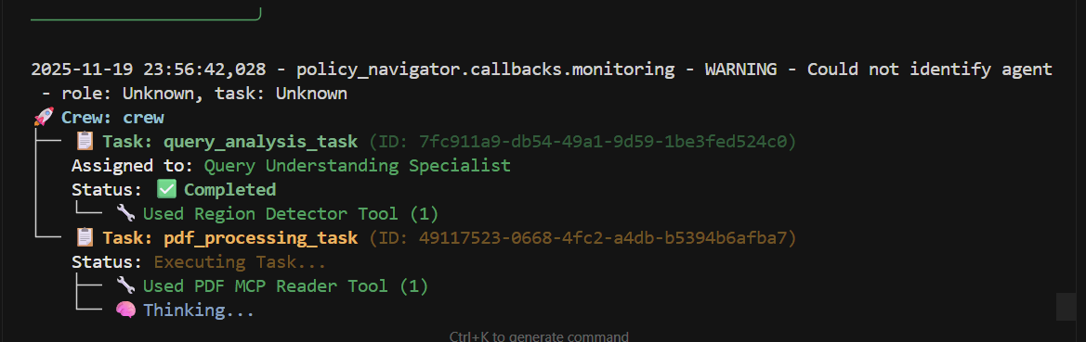
Fig 2. Execution of Pdf MCP
A2A Communication and Interoperability:
The system demonstrates interoperability between CrewAI and ADK agents through the A2A communication protocol. When calculation capabilities are required the Calculator Agent (ADK) receives task delegation messages through the StateManager, performs calculations using Google Generative AI and returns results to CrewAI agents. This cross framework communication is transparent to users with the workflow visualization showing the integration.
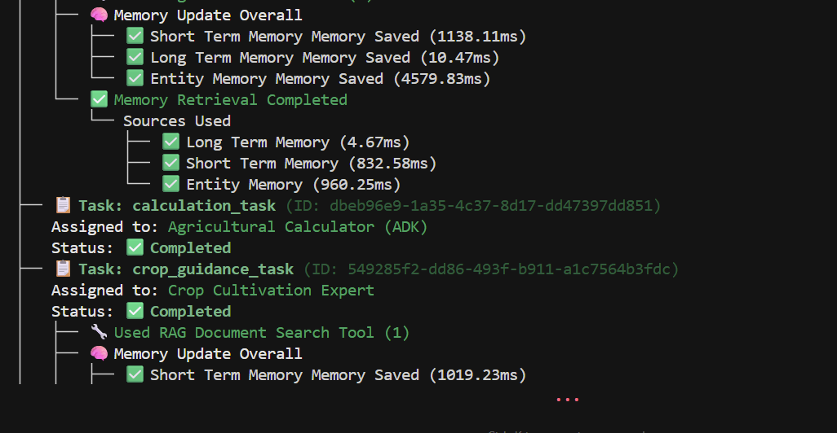
Fig 3. ADK Execution using A2A
Structured Output Generation:
All agent outputs are structured using Pydantic models ensuring type safety and validation. The Response Synthesizer combines outputs from multiple agents into coherent final responses with proper markdown formatting, source citations and confidence scores. The system generates both plain text and markdown versions with proper headings, lists, tables and source attribution.
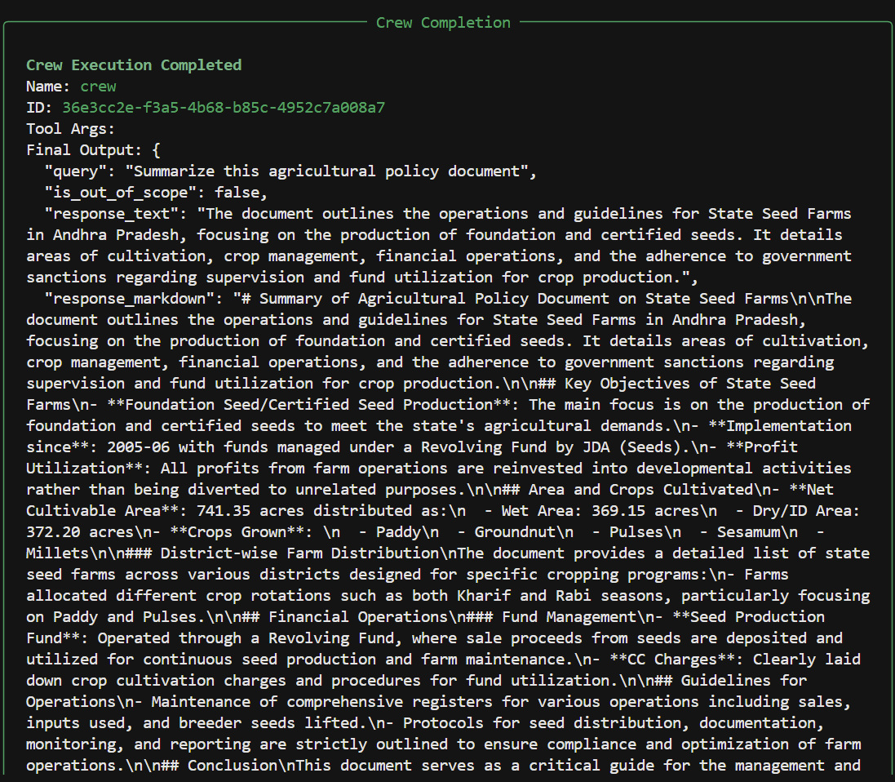
Fig 4. Structured Output Example Using Pydantic models
Monitoring and Execution Tracking:
The system provides execution tracking through the ExecutionTracker which monitors agent execution, tool usage and workflow flow. The React frontend displays this information showing which agents executed which tools were used and the execution sequence. This transparency enables users to understand how the system processes their queries and provides debugging capabilities for system optimization.
System Requirements Compliance:
The system meets all project requirements like context sharing through CrewAI memory, tool integration using MCP (Ollama Web Search and PDF MCP), structured output using Pydantic models, task monitoring through callback functions, A2A communication between CrewAI and ADK agents and framework usage (CrewAI as primary, ADK for calculator agent). The workflow visualization in the React frontend demonstrates compliance with these requirements, showing agent execution, tool usage, and cross-framework communication.
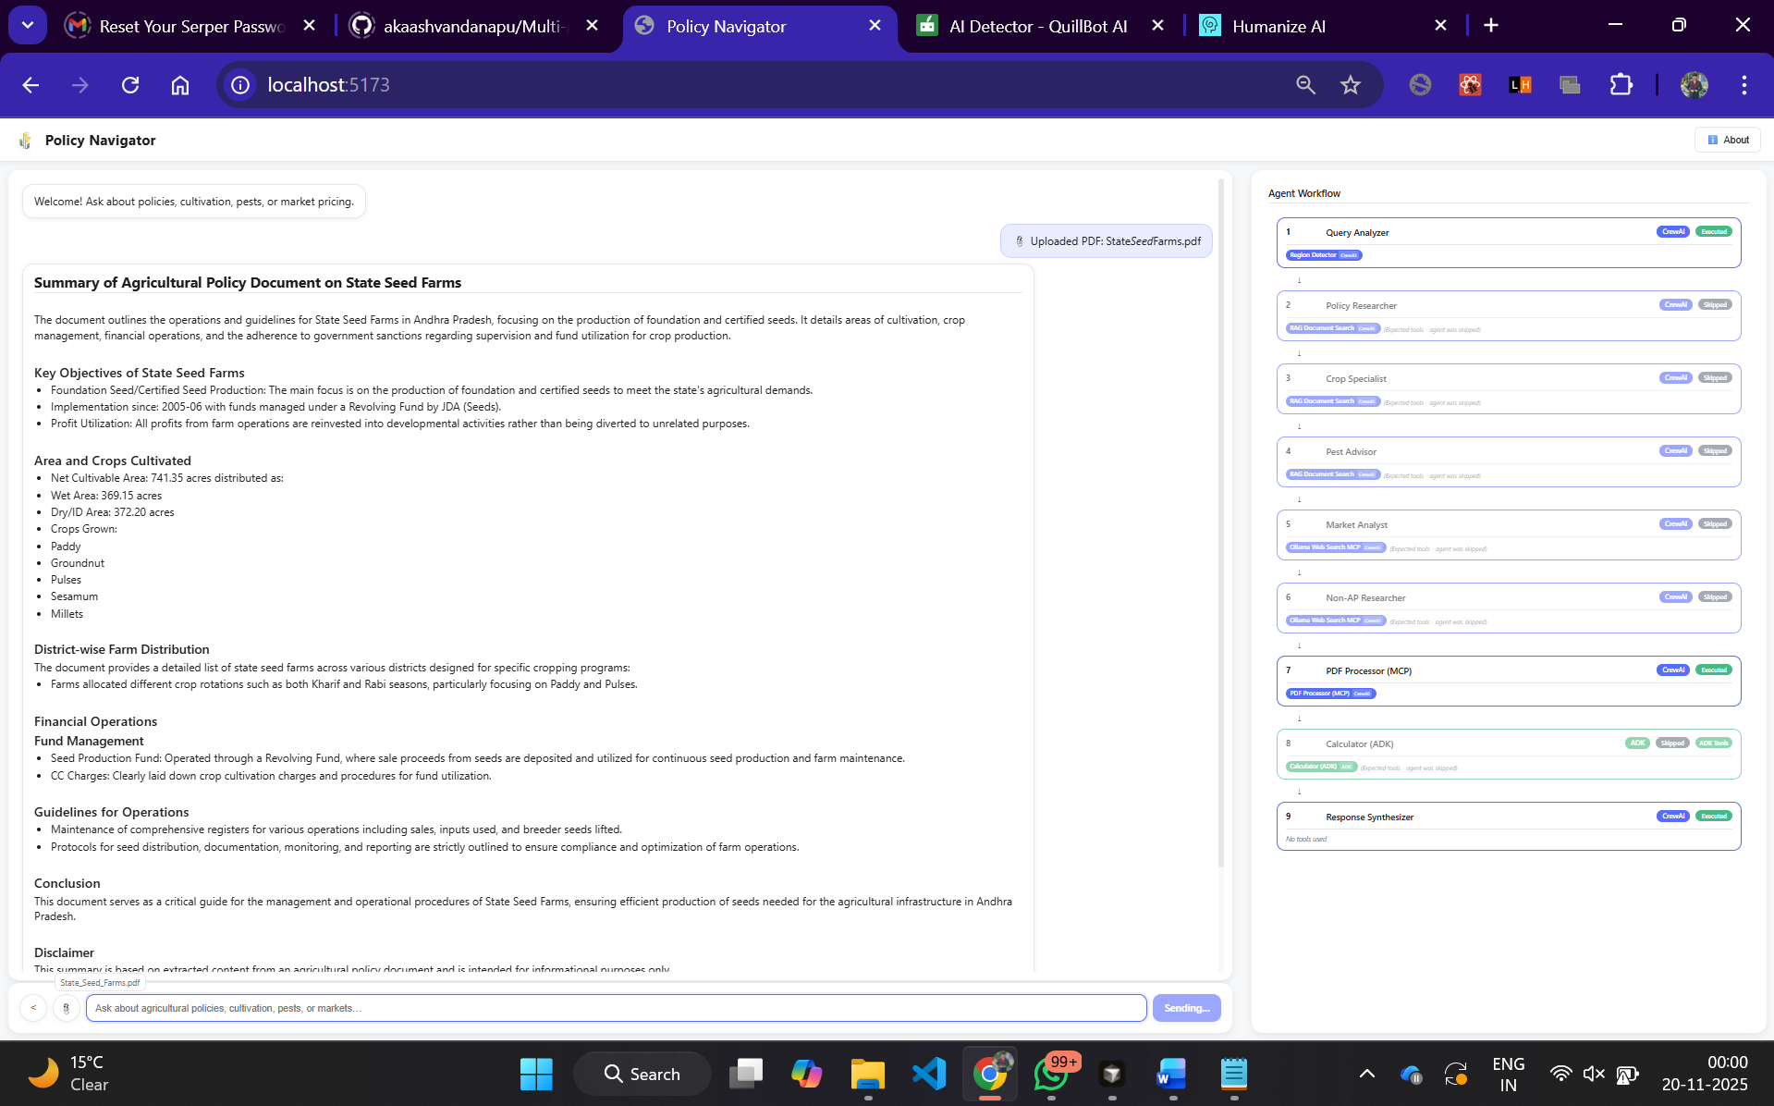
Fig 5. Developed a react front end using Flask API backend to make an interactive chatbot

Conclusion
The Policy Navigator system demonstrates a multi-agent architecture for agricultural policy navigation using CrewAI and ADK. The system integrates 9 specialized agents, RAG with ChromaDB, MCP servers for external tools and A2A communication for cross framework interoperability. The implementation shows that a modular and declarative approach enables efficient query routing, conditional task execution and context sharing between agents. The React frontend provides transparency into agent execution, tool usage and workflow flow supporting both end users and system debugging.
The system meets all project requirements including context sharing through CrewAI memory, tool integration via MCP (Ollama Web Search and PDF processing), structured output using Pydantic models, task monitoring through callbacks, A2A communication between CrewAI and ADK agents and dual framework usage. The architecture supports scalability and extensibility allowing new agents and tools to be added through configuration changes. Future work could explore additional agent specializations like enhanced RAG capabilities with larger document collections, integration of more MCP servers and performance optimizations for handling higher query volumes. The system provides a foundation for building domain specific multi-agent systems that combine structured knowledge retrieval with real time information access.

References
[1] Ke, Y., Yu, X., Du, H., Chapman, S., & Huang, H. (2025). Dynamic Orchestration of Multi-Agent System for Real-World Multi-Image Agricultural VQA. arXiv preprint arXiv:2509.24350.
[2] Lee, Y., et al. "GeoLLM-Squad: A geospatial copilot using multi-agent paradigm.”
[3] Shi, L., et al. "Pest MA: An LLM-based multi-agent system for pest control with validation agents."
[4] Kumar, A., et al. "Multi-agent expert system for agricultural production cycle monitoring and yield optimization."
[5] Zhang, Y., Liang, J., Chen, B., Deng, X., Zhang, Y., Xiong, Z., Pan, M., & Meng, X. (2025). Research Progress and Prospects of Multi-Agent Large Language Models in Agricultural Applications. Smart Agriculture, 1-15.
[6] Ankit, S. "Multi-agent collaborative framework integrating UAVs and UGVs for agricultural resource allocation."
[7] Pérez-Pons, M. E., et al. "Multi-agent system applications in precision agriculture: A comprehensive review."
[8] Obeidat, H., et al. "AI-driven agent communication in smart farming systems: Multi-agent integration for efficient data processing."
[9] Seo, J., & Lee, K. "Density-Driven Optimal Control framework for multi-UAV coordination in agricultural applications."
[10] Michael, R. "Swarm robotics and multi-agent systems in agriculture: Decentralized coordination for agricultural tasks."

Code Snippets
"""
================================================================================
SECTION 1: AGENTS CONFIGURATION AND IMPLEMENTATION
================================================================================
This file contains code snippets for agent definitions, configurations, and
implementation patterns used in the Policy Navigator system.
"""

# ============================================================================
# 1.1 Agent Configuration (YAML)
# ============================================================================
# File: src/policy_navigator/config/agents.yaml

"""
# CrewAI Agents Configuration
# All agents defined following CrewAI YAML format

query_analyzer:
role: "Query Understanding Specialist"
goal: "Analyze user queries to understand intent, extract entities, and determine which agents should handle the request"
backstory: |
You are an expert in natural language understanding with deep knowledge
of agricultural terminology. You can identify whether users are asking about policies,
crop cultivation, pest management, market prices, or general agriculture information.
You extract key entities like crop names, scheme names, locations, and pests.
You are precise and methodical in your analysis.
verbose: true
allow_delegation: false
max_iter: 3

policy_researcher:
role: "Agricultural Policy Expert"
goal: "Retrieve and explain agricultural schemes, policies, subsidies, and benefits from government documents"
backstory: |
You are an agricultural policy expert with comprehensive knowledge of
government schemes like PM-KISAN, PMFBY, crop insurance, seed distribution,
fertilizer subsidies, and rural development programs. You can clearly explain
eligibility criteria, benefits, and application processes. You always cite
your sources and provide accurate information.
verbose: true
allow_delegation: false
max_iter: 5

crop_specialist:
role: "Crop Cultivation Expert"
goal: "Provide comprehensive crop cultivation guidance including varieties, sowing, fertilization, irrigation, and best practices"
backstory: |
You are an agronomist with extensive experience in crop cultivation across
different regions of India. You understand local farming practices, soil
conditions, climate requirements, and can provide detailed guidance on
varieties, sowing schedules, fertilizer application, irrigation, and
harvesting practices. You provide practical, actionable advice.
verbose: true
allow_delegation: false
max_iter: 5

pest_advisor:
role: "Pest Control Advisor"
goal: "Identify pests and diseases, provide IPM strategies and control measures"
backstory: |
You are an entomologist and plant pathologist with expertise in Integrated
Pest Management (IPM). You can identify pests and diseases from descriptions,
recommend cultural, biological, and chemical control measures, and advise on
Economic Threshold Levels (ETL) and safe periods. You prioritize eco-friendly
solutions and always mention safety precautions.
verbose: true
allow_delegation: false
max_iter: 5

market_analyst:
role: "Market & Weather Analyst"
goal: "Provide current MSP, market prices, weather conditions, and agricultural announcements using Ollama Web Search MCP tool"
backstory: |
You are a market analyst specializing in agricultural commodities.
You track Minimum Support Prices (MSP), current market rates, weather patterns,
and government announcements affecting farmers.

CRITICAL: You MUST use the Ollama Web Search MCP tool (web_search) to find real-time information.
You NEVER generate market data, prices, or MSP values from memory - you ALWAYS
search for the latest information using the Ollama Web Search MCP tool first.
verbose: true
allow_delegation: false
max_iter: 5

calculator_agent:
role: "Agricultural Calculator (ADK)"
goal: "Perform agricultural calculations using ADK"
backstory: |
You are an ADK agent specialized in agricultural calculations.
You can calculate costs, yields, subsidies, and profits for farming operations.
You use Google Generative AI to provide accurate and detailed financial calculations
for agricultural queries.
verbose: true
allow_delegation: false
max_iter: 3
"""

# ============================================================================
# 1.2 Agent Implementation in CrewAI
# ============================================================================
# File: src/policy_navigator/crew.py

from crewai import Agent, Crew, Process, Task
from crewai.agent import BaseAgent
from crewai.crew import CrewBase
from crewai.task import TaskOutput
from typing import List

@CrewBase
class PolicyNavigatorCrew:
"""
Policy Navigator Crew - Main orchestration class
Organizes 9 specialized agents working collaboratively
"""

agents_config = 'config/agents.yaml'
tasks_config = 'config/tasks.yaml'

agents: List[BaseAgent]
tasks: List[Task]

# Query Analyzer Agent
@agent
def query_analyzer(self) -> Agent:
"""Query Understanding Agent"""
return Agent(
config=self.agents_config['query_analyzer'],
verbose=True,
tools=[region_detector_tool]
)

# RAG-Based Agents
@agent
def policy_researcher(self) -> Agent:
"""Agricultural Policy Expert Agent"""
return Agent(
config=self.agents_config['policy_researcher'],
verbose=True,
tools=[rag_tool]
)

@agent
def crop_specialist(self) -> Agent:
"""Crop Cultivation Expert Agent"""
return Agent(
config=self.agents_config['crop_specialist'],
verbose=True,
tools=[rag_tool]
)

@agent
def pest_advisor(self) -> Agent:
"""Pest Control Advisor Agent"""
return Agent(
config=self.agents_config['pest_advisor'],
verbose=True,
tools=[rag_tool]
)

# MCP-Based Agents
@agent
def market_analyst(self) -> Agent:
"""Market & Weather Analyst Agent"""
ollama_api_key = os.getenv("OLLAMA_API_KEY")

if ollama_api_key:
from policy_navigator.tools.ollama_websearch_tool import web_search, web_fetch
tools = [web_search, web_fetch]
else:
tools = []

return Agent(
config=self.agents_config['market_analyst'],
verbose=True,
tools=tools if tools else None
)

# Response Synthesizer
@agent
def response_synthesizer(self) -> Agent:
"""Response Synthesizer Agent"""
return Agent(
config=self.agents_config['response_synthesizer'],
verbose=True
)

# ============================================================================
# 1.3 Conditional Task Execution
# ============================================================================
# File: src/policy_navigator/crew.py

def get_query_analysis_from_tracker():
"""Get query_analysis_task output from execution tracker"""
from policy_navigator.callbacks.execution_tracker import get_tracker
tracker = get_tracker()
return tracker.query_analysis

def _check_condition_with_fallback(agent_id: str, output: TaskOutput, query_analysis=None) -> bool:
"""
Helper function to check if agent should run with fallback logic

Args:
agent_id: Agent ID to check (e.g., "pest_advisor")
output: TaskOutput from previous task
query_analysis: Optional pre-fetched query_analysis

Returns:
True if agent should run, False otherwise
"""
# First try: Use query_analysis from tracker
if query_analysis is None:
query_analysis = get_query_analysis_from_tracker()

if query_analysis:
required_agents = getattr(query_analysis, 'required_agents', [])
if not isinstance(required_agents, list):
required_agents = []

result = agent_id in required_agents
return result

# Fallback: Try to extract from previous task output
if output and hasattr(output, 'pydantic'):
from policy_navigator.models.schemas import QueryAnalysis
if isinstance(output.pydantic, QueryAnalysis):
required_agents = getattr(output.pydantic, 'required_agents', [])
if not isinstance(required_agents, list):
required_agents = []
result = agent_id in required_agents
return result

return False

def should_run_policy_research(output: TaskOutput) -> bool:
"""Check if policy_researcher agent should run"""
return _check_condition_with_fallback("policy_researcher", output)

def should_run_crop_guidance(output: TaskOutput) -> bool:
"""Check if crop_specialist agent should run"""
return _check_condition_with_fallback("crop_specialist", output)

def should_run_pest_management(output: TaskOutput) -> bool:
"""Check if pest_advisor agent should run"""
return _check_condition_with_fallback("pest_advisor", output)

"""
================================================================================
SECTION 2: TOOLS IMPLEMENTATION
================================================================================
This file contains code snippets for custom tools used by agents:
- RAG Tool (ChromaDB semantic search)
- Region Detector Tool
- MCP Integration Tools
"""

# ============================================================================
# 2.1 RAG Tool - ChromaDB Semantic Search
# ============================================================================
# File: src/policy_navigator/tools/rag_tool.py

from typing import Optional
from crewai.tools import tool
from policy_navigator.retrieval.vector_store import get_vector_store

@tool("RAG Document Search Tool")
def rag_tool(query: str, category: Optional[str] = None) -> str:
"""Search agricultural policy and crop information documents using RAG.

This tool searches through vectorized documents stored in ChromaDB to find
relevant information about policies, crops, pests, and agricultural practices.
Use this tool when you need to retrieve information from the document database.

Args:
query: Search query about policies, crops, or agricultural information.
Be specific about what you're looking for (e.g., "PM-KISAN scheme benefits",
"paddy cultivation practices", "pest management for cotton").
category: Optional category filter to narrow search scope.
Examples: 'Financial Schemes', 'Crop Cultivation Guides',
'Pest Disease Management', 'Soil Health', etc.
If not provided, searches across all categories.

Returns:
Formatted information with sources and relevance scores.
Each result includes the source document name, category, relevance score,
and relevant text excerpt.
"""
# Get vector store with default path (relative to project root)
import os
from pathlib import Path
project_root = Path(__file__).parent.parent.parent.parent
db_path = str(project_root / "chroma_db")
vector_store = get_vector_store(db_path=db_path)

# Search for relevant chunks
results = vector_store.search(
query=query,
top_k=5,
category_filter=category
)

if not results:
return f"No relevant information found for: {query}\n\nTry rephrasing your query or removing the category filter."

# Format results
output = f"**Search Results for:** {query}\n\n"

for idx, result in enumerate(results[:3], 1):
output += f"**Result {idx}:**\n"
output += f"Source: {result['source']}\n"
output += f"Category: {result['category']}\n"
output += f"Relevance Score: {result['score']:.2f}\n"
output += f"Content:\n{result['text'][:500]}"
if len(result['text']) > 500:
output += "..."
output += "\n\n"

if len(results) > 3:
output += f"\n**Total relevant documents found:** {len(results)}"

return output

# ============================================================================
# 2.2 Region Detector Tool
# ============================================================================
# File: src/policy_navigator/tools/region_detector.py

import json
from typing import Dict, List
from crewai.tools import tool

# Andhra Pradesh Districts
AP_DISTRICTS = [
"anantapur", "kadapa", "cuddapah", "kurnool", "chittoor", "krishna",
"guntur", "prakasam", "east godavari", "west godavari", "visakhapatnam",
"vizag", "vishakhapatnam", "srikakulam", "vizianagaram", "nellore"
]

# AP state variations
AP_VARIANTS = [
"andhra pradesh", "andhra", "ap", "ap state", "andhra pradesh state"
]

# Indian States (excluding Andhra Pradesh)
NON_AP_STATES = [
"telangana", "maharashtra", "karnataka", "tamil nadu", "kerala",
"odisha", "orissa", "west bengal", "bihar", "uttar pradesh", "up"
]

@tool("Region Detector Tool")
def region_detector_tool(query: str) -> str:
"""Detect if query mentions regions in Andhra Pradesh or other states/cities/districts.

This tool analyzes the query text to identify:
- Andhra Pradesh regions (districts, cities, state name)
- Non-AP regions (other Indian states, cities)
- Returns structured information about detected regions

Args:
query: User query text to analyze for region mentions.

Returns:
JSON string with region detection results:
{
"is_ap_region": bool,
"detected_regions": List[str],
"region_type": "ap" | "non_ap" | "mixed",
"ap_regions": List[str],
"non_ap_regions": List[str]
}
"""
query_lower = query.lower()

detected_ap_regions = []
detected_non_ap_regions = []

# Check for AP state name variations
for variant in AP_VARIANTS:
if variant in query_lower:
detected_ap_regions.append("Andhra Pradesh")
break

# Check for AP districts
for district in AP_DISTRICTS:
if district in query_lower:
formatted = ' '.join(word.capitalize() for word in district.split())
if formatted not in detected_ap_regions:
detected_ap_regions.append(formatted)

# Check for non-AP states
for state in NON_AP_STATES:
if state in query_lower:
if state in ["up", "mp", "hp", "j&k"]:
formatted = state.upper()
else:
formatted = ' '.join(word.capitalize() for word in state.split())
if formatted not in detected_non_ap_regions:
detected_non_ap_regions.append(formatted)

# Determine region type
has_ap = len(detected_ap_regions) > 0
has_non_ap = len(detected_non_ap_regions) > 0

if has_ap and has_non_ap:
region_type = "mixed"
is_ap_region = False
elif has_ap:
region_type = "ap"
is_ap_region = True
elif has_non_ap:
region_type = "non_ap"
is_ap_region = False
else:
# Default to Andhra Pradesh when no region is mentioned
region_type = "ap"
is_ap_region = True
if "Andhra Pradesh" not in detected_ap_regions:
detected_ap_regions.append("Andhra Pradesh")

# Combine all detected regions
all_detected = detected_ap_regions + detected_non_ap_regions

result = {
"is_ap_region": is_ap_region,
"detected_regions": all_detected,
"region_type": region_type,
"ap_regions": detected_ap_regions,
"non_ap_regions": detected_non_ap_regions
}

return json.dumps(result, indent=2)

# ============================================================================
# 2.3 Vector Store Implementation (ChromaDB)
# ============================================================================
# File: src/policy_navigator/retrieval/vector_store.py

import chromadb
from chromadb.config import Settings
from sentence_transformers import SentenceTransformer
from typing import List, Dict, Any, Optional

class VectorStore:
"""ChromaDB vector store for document retrieval"""

def __init__(self, db_path: str = "./chroma_db", collection_name: str = "policy_documents"):
"""Initialize vector store"""
self.db_path = Path(db_path)
self.collection_name = collection_name
embedding_model = get_embedding_model()
self.embedder = SentenceTransformer(embedding_model)

# Initialize ChromaDB client
self.client = chromadb.PersistentClient(
path=str(self.db_path),
settings=Settings(anonymized_telemetry=False)
)

# Get or create collection
self.collection = self.client.get_or_create_collection(
name=collection_name,
metadata={"hnsw:space": "cosine"}
)

def search(
self,
query: str,
top_k: int = 5,
category_filter: Optional[str] = None
) -> List[Dict[str, Any]]:
"""Search for similar documents using semantic search"""
# Generate query embedding
query_embedding = self.embedder.encode([query]).tolist()[0]

# Build where clause for filtering
where = None
if category_filter:
where = {"category": category_filter}

# Search in ChromaDB
results = self.collection.query(
query_embeddings=[query_embedding],
n_results=top_k,
where=where
)

# Format results
formatted_results = []
if results['documents'] and len(results['documents'][0]) > 0:
for idx in range(len(results['documents'][0])):
formatted_results.append({
'text': results['documents'][0][idx],
'source': results['metadatas'][0][idx]['source'],
'category': results['metadatas'][0][idx]['category'],
'score': 1 - results['distances'][0][idx] # Convert distance to similarity
})

return formatted_results

"""
================================================================================
SECTION 3: MCP SERVERS IMPLEMENTATION
================================================================================
This file contains code snippets for MCP (Model Context Protocol) servers:
- Ollama Web Search MCP Server
- PDF MCP Server
"""

# ============================================================================
# 3.1 Ollama Web Search MCP Server
# ============================================================================
# File: mcp_servers/ollama_websearch_mcp_server.py

from mcp.server.fastmcp import FastMCP
import httpx
import os
import asyncio
from pathlib import Path
from dotenv import load_dotenv

# Load environment variables
env_path = Path(__file__).resolve().parents[1] / ".env"
load_dotenv(env_path)

mcp = FastMCP("ollama-web-search")

API_KEY = os.getenv('OLLAMA_API_KEY')

if not API_KEY:
raise ValueError('OLLAMA_API_KEY environment variable is required')

async def make_api_request(url: str, payload: dict, max_retries: int = 3) -> dict:
"""Make API request with retry logic and error handling."""
for attempt in range(max_retries):
try:
async with httpx.AsyncClient(timeout=30.0) as client:
response = await client.post(
url,
headers={'Authorization': f'Bearer {API_KEY}'},
json=payload
)
response.raise_for_status()
return response.json()
except httpx.TimeoutException:
if attempt == max_retries - 1:
raise Exception(f"Request timed out after {max_retries} attempts")
await asyncio.sleep(2 ** attempt) # Exponential backoff
except httpx.HTTPStatusError as e:
if e.response.status_code == 429: # Rate limit
if attempt == max_retries - 1:
raise Exception("Rate limit exceeded. Please try again later.")
await asyncio.sleep(5 * (attempt + 1))
elif e.response.status_code >= 500: # Server error
if attempt == max_retries - 1:
raise Exception(f"Server error: {e.response.status_code}")
await asyncio.sleep(2 ** attempt)
else:
raise Exception(f"API error: {e.response.status_code} - {e.response.text}")
except Exception as e:
if attempt == max_retries - 1:
raise Exception(f"Request failed: {str(e)}")
await asyncio.sleep(2 ** attempt)

raise Exception("All retry attempts failed")

@mcp.tool()
async def web_search(query: str, max_results: int = 10) -> str:
"""Search the web using Ollama's web search API.

Args:
query: The search query string
max_results: Maximum number of results to return (default: 10, max: 20)

Returns:
Formatted search results as JSON string
"""
try:
# Validate and clamp max_results
max_results = max(1, min(max_results, 20))

# Make API request with retry logic
data = await make_api_request(
'https://ollama.com/api/web_search',
{'query': query, 'max_results': max_results}
)

# Parse and format the results
if 'results' in data and data['results']:
formatted_results = []
for i, result in enumerate(data['results'][:max_results], 1):
formatted_results.append({
'rank': i,
'title': result.get('title', 'No title'),
'url': result.get('url', 'No URL'),
'content': result.get('content', 'No content')[:500] + '...'
if len(result.get('content', '')) > 500
else result.get('content', 'No content')
})

return f"Search Results for: '{query}'\n\n" + "\n\n".join([
f"{result['rank']}. **{result['title']}**\n URL: {result['url']}\n Content: {result['content']}"
for result in formatted_results
])
else:
return f"Search completed for: '{query}'\n\nNo results found."

except Exception as e:
return f"Error performing web search: {str(e)}"

@mcp.tool()
async def web_fetch(url: str) -> str:
"""Fetch content from a web page using Ollama's web fetch API.

Args:
url: The URL of the webpage to fetch

Returns:
Formatted page content with title, content, and links
"""
try:
if not url.startswith(('http://', 'https://')):
return "Error: URL must start with http:// or https://"

data = await make_api_request(
'https://ollama.com/api/web_fetch',
{'url': url}
)

title = data.get('title', 'No title available')
content = data.get('content', 'No content available')
links = data.get('links', [])

formatted_response = f"**Page Title:** {title}\n\n**URL:** {url}\n\n**Content:**\n{content[:2000]}{'...' if len(content) > 2000 else ''}"

if links:
formatted_response += f"\n\n**Links Found:** {len(links)}\n" + "\n".join(f"- {link}" for link in links[:10])

return formatted_response

except Exception as e:
return f"Error fetching webpage: {str(e)}"

if __name__ == "__main__":
mcp.run(transport='stdio')

# ============================================================================
# 3.2 PDF MCP Server
# ============================================================================
# File: mcp_servers/pdf_mcp_server.py

from mcp.server.fastmcp import FastMCP
import PyPDF2
from pathlib import Path

mcp = FastMCP("pdf-extractor")

@mcp.tool()
def read_file(file_path: str) -> dict:
"""Read and extract text from a PDF file.

Args:
file_path: Path to the PDF file

Returns:
Dictionary with extracted text, page count, and metadata
"""
try:
file_path_obj = Path(file_path)

if not file_path_obj.exists():
return {
"success": False,
"error": f"File not found: {file_path}",
"text": "",
"page_count": 0
}

if file_path_obj.suffix.lower() != '.pdf':
return {
"success": False,
"error": f"File is not a PDF: {file_path}",
"text": "",
"page_count": 0
}

# Extract text from PDF
text = ""
page_count = 0

with open(file_path_obj, 'rb') as file:
pdf_reader = PyPDF2.PdfReader(file)
page_count = len(pdf_reader.pages)

for page in pdf_reader.pages:
text += page.extract_text() + "\n"

return {
"success": True,
"text": text,
"page_count": page_count,
"file_name": file_path_obj.name,
"file_path": str(file_path_obj),
"character_count": len(text)
}

except Exception as e:
return {
"success": False,
"error": f"Error reading PDF: {str(e)}",
"text": "",
"page_count": 0
}

if __name__ == "__main__":
mcp.run(transport='stdio')

"""
================================================================================
SECTION 4: A2A COMMUNICATION PROTOCOL
================================================================================
This file contains code snippets for Agent-to-Agent (A2A) communication:
- A2A Message Format
- StateManager Implementation
- ADK Agent Adapter
- Calculator Agent
"""

# ============================================================================
# 4.1 A2A Message Format
# ============================================================================
# File: src/policy_navigator/adk/adk_agent.py

from typing import Dict, Any, Optional, List
from pydantic import BaseModel

class A2AMessage(BaseModel):
"""
Message format for A2A (Agent-to-Agent) communication
Aligned with A2A Protocol standards for interoperability between CrewAI and ADK agents
"""
from_agent: str
"""Source agent identifier (e.g., 'calculator_agent', 'policy_researcher')"""
to_agent: str
"""Target agent identifier or broadcast target (e.g., 'crewai_agents', 'adk_agents')"""
message_type: str
"""Type of message: 'task_delegation', 'task_complete', 'data', 'status_update', 'capability_query'"""
content: Dict[str, Any]
"""Message payload containing task data, results, or context"""
timestamp: str
"""ISO format timestamp of message creation"""
conversation_id: Optional[str] = None
"""Optional conversation ID for tracking multi-turn interactions"""
status: Optional[str] = None
"""Message status: 'pending', 'processing', 'completed', 'failed'"""
capabilities: Optional[List[str]] = None
"""List of agent capabilities (for capability discovery)"""
response_required: bool = False
"""Whether this message requires a response from the recipient"""

# ============================================================================
# 4.2 StateManager Implementation
# ============================================================================
# File: src/policy_navigator/adk/adk_agent.py

class StateManager:
"""Manages shared state between CrewAI and ADK agents"""

def __init__(self):
import logging
self.logger = logging.getLogger(__name__)
self.state: Dict[str, Any] = {}
self.message_queue: list[A2AMessage] = []
self.logger.debug("StateManager initialized")

def update_state(self, key: str, value: Any) -> None:
"""Update shared state"""
self.state[key] = value
self.logger.debug(f"StateManager: Updated state key '{key}' (value type: {type(value).__name__})")

def get_state(self, key: str, default: Any = None) -> Any:
"""Get value from shared state"""
value = self.state.get(key, default)
if value is not None:
self.logger.debug(f"StateManager: Retrieved state key '{key}' (value type: {type(value).__name__})")
else:
self.logger.debug(f"StateManager: State key '{key}' not found, returning default")
return value

def add_message(self, message: A2AMessage) -> None:
"""Add message to A2A queue"""
self.message_queue.append(message)
self.logger.info(f"StateManager: Added A2A message from '{message.from_agent}' to '{message.to_agent}' (type: {message.message_type})")

def get_messages_for_agent(self, agent_id: str) -> list[A2AMessage]:
"""Get messages intended for a specific agent"""
messages = [msg for msg in self.message_queue if msg.to_agent == agent_id]
self.logger.debug(f"StateManager: Retrieved {len(messages)} message(s) for agent '{agent_id}'")
return messages

# Singleton instance
_state_manager = None

def get_state_manager() -> StateManager:
"""Get singleton StateManager instance"""
global _state_manager
if _state_manager is None:
_state_manager = StateManager()
return _state_manager

# ============================================================================
# 4.3 ADK Agent Base Class
# ============================================================================
# File: src/policy_navigator/adk/adk_agent.py

import os
try:
import google.generativeai as genai
ADK_AVAILABLE = True
except ImportError:
ADK_AVAILABLE = False

class ADKAgent:
"""
ADK Agent for A2A communication with CrewAI agents
This agent can be used alongside CrewAI agents for interoperability
"""

def __init__(self, agent_id: str = "adk_agent", model_name: Optional[str] = None):
"""Initialize ADK agent"""
self.agent_id = agent_id
self.model_name = model_name or os.getenv("ADK_MODEL", "gemini-pro")
self.state_manager = get_state_manager()

if ADK_AVAILABLE:
api_key = os.getenv("GOOGLE_API_KEY") or os.getenv("GEMINI_API_KEY")
if api_key:
genai.configure(api_key=api_key)
self.model = genai.GenerativeModel(self.model_name)
else:
self.model = None
else:
self.model = None

def process_message(self, message: A2AMessage) -> Dict[str, Any]:
"""Process a message from another agent (CrewAI or ADK)"""
# Store message in state
self.state_manager.add_message(message)

# Update shared state with message content
state_key = f"{message.from_agent}_output"
self.state_manager.update_state(state_key, message.content)

return {
"status": "processed",
"agent_id": self.agent_id,
"message_type": message.message_type
}

def send_message_to_crewai(self, to_agent: str, content: Dict[str, Any], message_type: str = "data") -> None:
"""Send a message to a CrewAI agent"""
from datetime import datetime

message = A2AMessage(
from_agent=self.agent_id,
to_agent=to_agent,
message_type=message_type,
content=content,
timestamp=datetime.now().isoformat()
)

self.state_manager.add_message(message)

# ============================================================================
# 4.4 Calculator Agent (Specialized ADK Agent)
# ============================================================================
# File: src/policy_navigator/adk/adk_agent.py

class CalculatorAgent(ADKAgent):
"""
ADK Agent specialized for agricultural calculations
Extends ADKAgent with calculator-specific functionality
"""

def __init__(self, agent_id: str = "calculator_agent", model_name: Optional[str] = None):
"""Initialize Calculator Agent"""
super().__init__(agent_id=agent_id, model_name=model_name)

def calculate_cost(self, area: float, crop: str, inputs: Optional[Dict[str, Any]] = None) -> Dict[str, Any]:
"""Calculate cost of cultivation using ADK model"""
# Base costs per hectare (in INR)
base_costs = {
"paddy": 45000, "rice": 45000, "maize": 35000, "cotton": 55000,
"groundnut": 40000, "redgram": 30000, "tur": 30000, "arhar": 30000
}

base_cost = base_costs.get(crop.lower(), 40000)
total_cost = base_cost * area

if inputs:
for value in inputs.values():
if isinstance(value, (int, float)):
total_cost += value * area

return {
"operation": "cost_estimation",
"crop": crop,
"area": area,
"base_cost_per_hectare": base_cost,
"total_cost": total_cost,
"additional_inputs": inputs or {}
}

def calculate_yield(self, area: float, crop: str, variety: Optional[str] = None) -> Dict[str, Any]:
"""Calculate expected yield"""
# Average yields per hectare (in kg)
yields = {
"paddy": 5500, "rice": 5500, "maize": 3500, "cotton": 500,
"groundnut": 2000, "redgram": 1200, "tur": 1200, "arhar": 1200
}

avg_yield = yields.get(crop.lower(), 3000)
total_yield = avg_yield * area

return {
"operation": "yield_calculation",
"crop": crop,
"variety": variety,
"area": area,
"yield_per_hectare": avg_yield,
"total_yield": total_yield
}

def perform_calculation(self, operation: str, values: Dict[str, Any]) -> str:
"""Perform agricultural calculation and format result"""
if operation == "cost_estimation":
result = self.calculate_cost(
area=values.get("area", 0),
crop=values.get("crop", ""),
inputs=values.get("inputs")
)
output = f"**Cost of Cultivation Calculation**\n\n"
output += f"Crop: {result['crop']}\n"
output += f"Area: {result['area']} hectares\n"
output += f"Base Cost per hectare: ₹{result['base_cost_per_hectare']:,}\n"
output += f"\n**Total Cost of Cultivation: ₹{result['total_cost']:,}**\n"
return output
# ... other operations (yield, subsidy, profit)
return "Calculation completed"

"""
================================================================================
SECTION 5: PYDANTIC MODELS FOR STRUCTURED OUTPUT
================================================================================
This file contains code snippets for Pydantic models used for structured outputs
from all agents in the Policy Navigator system.
"""

# ============================================================================
# 5.1 Query Analysis Model
# ============================================================================
# File: src/policy_navigator/models/schemas.py

from typing import List, Optional, Dict, Literal, Any
from pydantic import BaseModel, Field, field_validator

class QueryAnalysis(BaseModel):
"""Output schema for Query Understanding Agent"""

original_query: str = Field(..., description="The original user query")
query_type: Literal["policy", "cultivation", "pest", "market", "general", "document_upload", "out_of_scope"] = Field(
..., description="Classified type of query"
)
entities: Dict[str, List[str]] = Field(
default_factory=dict,
description="Extracted entities: crop names, schemes, locations, pests, diseases"
)
complexity: Literal["simple", "moderate", "complex"] = Field(
..., description="Query complexity level"
)
required_agents: List[str] = Field(
..., description="List of agent IDs required to answer this query"
)
is_ap_query: bool = Field(
default=True, description="Whether the query is about Andhra Pradesh"
)
detected_regions: List[str] = Field(
default_factory=list,
description="List of detected regions (states, cities, districts) in the query"
)
region_type: Literal["ap", "non_ap", "mixed"] = Field(
default="ap", description="Type of region detected"
)
is_out_of_scope: bool = Field(
default=False, description="Whether the query is completely out of scope (non-agricultural)"
)

@field_validator('entities')
@classmethod
def validate_entities(cls, v):
"""Ensure entities dict has expected keys"""
expected_keys = ['crop', 'scheme', 'location', 'pest', 'disease', 'region_limitation']
for key in expected_keys:
if key not in v:
v[key] = []
return v

# ============================================================================
# 5.2 Policy Response Model
# ============================================================================
# File: src/policy_navigator/models/schemas.py

class PolicyResponse(BaseModel):
"""Output schema for Policy Retrieval Agent"""

scheme_name: str = Field(..., description="Name of the policy/scheme")
description: str = Field(..., description="Detailed description of the scheme")
eligibility: List[str] = Field(
default_factory=list,
description="Eligibility criteria"
)
benefits: List[str] = Field(
default_factory=list,
description="Benefits provided by the scheme"
)
application_process: str = Field(
default="", description="How to apply for the scheme"
)
documents_required: List[str] = Field(
default_factory=list,
description="Documents needed for application"
)
source_documents: List[str] = Field(
default_factory=list,
description="Source PDF documents used"
)
confidence_score: float = Field(
..., ge=0.0, le=1.0,
description="Confidence score of the retrieval (0-1)"
)

# ============================================================================
# 5.3 Crop Guidance Model
# ============================================================================
# File: src/policy_navigator/models/schemas.py

class CropVariety(BaseModel):
"""Crop variety information"""
name: str = Field(..., description="Variety name")
description: str = Field(..., description="Characteristics and suitability")
season: Optional[str] = Field(None, description="Recommended season")

class SowingDetails(BaseModel):
"""Sowing details"""
sowing_time: str = Field(..., description="Best time for sowing")
spacing: str = Field(..., description="Row and plant spacing")
seed_rate: str = Field(..., description="Seeds per hectare")

class FertilizerSchedule(BaseModel):
"""Fertilizer application schedule"""
stage: str = Field(..., description="Growth stage")
npk: str = Field(..., description="NPK ratio or details")
details: str = Field(..., description="Application method")

class CropGuidance(BaseModel):
"""Output schema for Crop Cultivation Agent"""

crop_name: str = Field(..., description="Name of the crop")
varieties: List[CropVariety] = Field(
default_factory=list,
description="Recommended varieties with descriptions"
)
sowing_details: SowingDetails = Field(
..., description="Sowing timing, spacing, seed rate"
)
fertilizer_schedule: List[FertilizerSchedule] = Field(
default_factory=list,
description="Stage-wise fertilizer applications"
)
irrigation_schedule: List[str] = Field(
default_factory=list,
description="Irrigation timing and frequency"
)

# ============================================================================
# 5.4 Final Response Model
# ============================================================================
# File: src/policy_navigator/models/schemas.py

class FinalResponse(BaseModel):
"""Final structured output from Response Synthesizer"""

query: str = Field(..., description="Original user query")
is_out_of_scope: bool = Field(
default=False,
description="True if the query is out of scope (non-agricultural)"
)
response_text: str = Field(
..., min_length=100,
description="Plain text summary (minimum 100 characters, no markdown)"
)
response_markdown: Optional[str] = Field(
None,
description="Detailed markdown response with proper formatting"
)
agent_contributions: Dict[str, str] = Field(
default_factory=dict,
description="Summary of each agent's contribution"
)
sources: List[str] = Field(
default_factory=list,
description="All source documents and URLs"
)
confidence_score: float = Field(
..., ge=0.0, le=1.0,
description="Overall confidence (0-1)"
)
follow_up_questions: List[str] = Field(
default_factory=list,
description="Relevant follow-up questions (2-3 questions)"
)

@field_validator('response_markdown')
@classmethod
def validate_markdown(cls, v):
"""Validate markdown length if provided"""
if v is not None and len(v) < 200:
raise ValueError("response_markdown must be at least 200 characters if provided")
return v

"""
================================================================================
SECTION 6: GUARDRAILS AND MONITORING
================================================================================
This file contains code snippets for:
- Execution Tracking
- Monitoring Callbacks
- Guardrail Context Helpers
"""

# ============================================================================
# 6.1 Execution Tracker
# ============================================================================
# File: src/policy_navigator/callbacks/execution_tracker.py

from typing import Dict, Set, List, Optional, Any
from threading import Lock
from collections import defaultdict

class ExecutionTracker:
"""Thread-safe tracker for agents and tools used during execution"""

_instance = None
_lock = Lock()

def __new__(cls):
if cls._instance is None:
with cls._lock:
if cls._instance is None:
cls._instance = super().__new__(cls)
cls._instance._initialized = False
return cls._instance

def __init__(self):
if self._initialized:
return

with self._lock:
if self._initialized:
return

self.executed_agents: List[str] = [] # Preserve execution order
self.used_tools: Set[str] = set()
self.agent_tools: Dict[str, Set[str]] = defaultdict(set) # agent -> set of tools
self.query_analysis: Optional[Any] = None # Store query_analysis_task output
self._initialized = True

def reset(self):
"""Reset tracker for new execution"""
with self._lock:
self.executed_agents.clear()
self.used_tools.clear()
self.agent_tools.clear()
self.query_analysis = None

def store_query_analysis(self, query_analysis: Any):
"""Store query_analysis_task output for conditional task checks"""
with self._lock:
self.query_analysis = query_analysis

def track_agent(self, agent_name: str):
"""Track that an agent executed (preserves execution order)"""
with self._lock:
if agent_name not in self.executed_agents:
self.executed_agents.append(agent_name)
if agent_name not in self.agent_tools:
self.agent_tools[agent_name] = set()

def track_tool(self, agent_name: str, tool_name: str):
"""Track that a tool was used by an agent"""
with self._lock:
self.used_tools.add(tool_name)
self.agent_tools[agent_name].add(tool_name)
if agent_name not in self.executed_agents:
self.executed_agents.append(agent_name)

def get_executed_agents(self) -> List[str]:
"""Get list of executed agents (in execution order)"""
with self._lock:
return list(self.executed_agents)

def get_used_tools(self) -> List[str]:
"""Get list of used tools"""
with self._lock:
return sorted(list(self.used_tools))

def get_agent_tools(self) -> Dict[str, List[str]]:
"""Get dictionary of agent -> list of tools used"""
with self._lock:
return {
agent: sorted(list(tools))
for agent, tools in self.agent_tools.items()
}

# Global tracker instance
_tracker = ExecutionTracker()

def get_tracker() -> ExecutionTracker:
"""Get the global execution tracker instance"""
return _tracker

# ============================================================================
# 6.2 Monitoring Callbacks
# ============================================================================
# File: src/policy_navigator/callbacks/monitoring.py

from crewai.tasks.task_output import TaskOutput
from typing import Any, Dict

def step_callback(step: Dict[str, Any]) -> None:
"""
Callback function called after each step of every agent

Args:
step: Dictionary containing step information including:
- agent: Agent that executed the step
- task: Task being executed
- output: Step output
- iterations: Current iteration number
"""
try:
tracker = get_tracker()

# Extract agent role
agent_role = None
agent = None

if isinstance(step, dict):
agent = step.get('agent') or step.get('agent_role')
else:
agent = getattr(step, 'agent', None) or getattr(step, 'agent_role', None)

if agent:
if isinstance(agent, dict):
agent_role = agent.get('role') or agent.get('agent_role')
elif hasattr(agent, 'role'):
agent_role = agent.role

# Track agent execution
agent_id = _identify_agent_id(agent_role, task_desc, task)

if agent_id and agent_id not in ['Unknown', 'unknown_agent']:
tracker.track_agent(agent_id)

# Track tool usage if present
tool_calls = None
if isinstance(step, dict):
tool_calls = step.get('tool_calls') or step.get('actions')
else:
tool_calls = getattr(step, 'tool_calls', None) or getattr(step, 'actions', None)

if tool_calls:
if not isinstance(tool_calls, (list, tuple)):
tool_calls = [tool_calls]

for tc in tool_calls:
tool_name = None
if isinstance(tc, dict):
tool_name = tc.get('tool') or tc.get('name')
elif hasattr(tc, 'tool'):
tool_obj = tc.tool
tool_name = getattr(tool_obj, 'name', None)
elif hasattr(tc, 'name'):
tool_name = tc.name

if tool_name:
clean_tool_name = get_tool_display_name(tool_name)
tracker.track_tool(agent_id, clean_tool_name)

except Exception as e:
logger.error(f"Error in step_callback: {e}")

def task_callback(output: TaskOutput) -> None:
"""
Callback function called after the completion of each task
Also stores task outputs in StateManager for ADK agent access (A2A communication)

Args:
output: TaskOutput object containing task results
"""
try:
tracker = get_tracker()
task_desc = output.description[:100] if output.description else 'Unknown'
agent_role = output.agent if hasattr(output, 'agent') else 'Unknown'

# Track agent execution
agent_id = _identify_agent_id(agent_role, task_desc, None)

if agent_id and agent_id not in ['Unknown', 'unknown_agent']:
tracker.track_agent(agent_id)

# Store query analysis for conditional tasks
if hasattr(output, 'pydantic') and output.pydantic:
from policy_navigator.models.schemas import QueryAnalysis
if isinstance(output.pydantic, QueryAnalysis):
tracker.store_query_analysis(output.pydantic)

# Track tools from task output
if hasattr(output, 'tool_calls') and output.tool_calls:
for tool_call in output.tool_calls:
tool_name = None
if isinstance(tool_call, dict):
tool_name = tool_call.get('tool') or tool_call.get('name')
elif hasattr(tool_call, 'tool'):
tool_obj = tool_call.tool
tool_name = getattr(tool_obj, 'name', None)
elif hasattr(tool_call, 'name'):
tool_name = tool_call.name

if tool_name:
clean_tool_name = get_tool_display_name(tool_name)
tracker.track_tool(agent_id, clean_tool_name)

except Exception as e:
logger.error(f"Error in task_callback: {e}")

# ============================================================================
# 6.3 Guardrail Context Helpers
# ============================================================================
# File: src/policy_navigator/crew.py

def get_rag_task_context() -> str:
"""Get context for RAG-based tasks (policy, crop, pest)"""
return """Agricultural policy and crop information from Andhra Pradesh government documents and agricultural databases.
This includes schemes, policies, crop cultivation guides, and pest management information.
All information should be based on the RAG search results from the document database.
Outputs must be factual and directly supported by the retrieved documents."""

def get_web_search_task_context() -> str:
"""Get context for Ollama Web Search MCP tasks (market, non-AP)"""
return """Real-time information from Ollama Web Search MCP results including market prices, MSP, weather, and agricultural information.
Information is obtained from Ollama Web Search MCP and may vary in reliability.
Outputs should be based on the Ollama Web Search MCP results and include source URLs.
All claims must be supported by the search results provided."""

def get_pdf_task_context() -> str:
"""Get context for PDF processing tasks"""
return """Content extracted from uploaded PDF documents related to agricultural policies and Andhra Pradesh.
The PDF contains policy documents, scheme information, or agricultural guidelines.
Outputs must be based solely on the extracted PDF text content.
All information must be directly supported by the PDF content."""

def get_synthesis_task_context() -> str:
"""Get context for synthesis task"""
return """Comprehensive response synthesizing information from multiple specialized agents.
The response combines policy research, crop guidance, pest management, market information, and other relevant data.
All information in the synthesis must be supported by the outputs from previous tasks.
The response should accurately represent the information from source tasks without adding unsupported claims."""

# ============================================================================
# 6.4 Guardrail Configuration
# ============================================================================
# File: src/policy_navigator/guardrails/guardrail_config.py

import os
from crewai import LLM

class GuardrailConfig:
"""Configuration for hallucination guardrails"""

# Thresholds for different task types (0-10 scale)
THRESHOLDS = {
'rag_based': 7.0, # RAG-based tasks (policy, crop, pest)
'web_search': 6.5, # Ollama Web Search MCP tasks (market, non_ap)
'pdf_processing': 7.5, # PDF processing (document-based, high-stakes)
'synthesis': 7.0, # Synthesis task (multiple sources)
'query_analysis': 6.0, # Query analysis (lower priority)
}

@staticmethod
def get_threshold(task_type: str) -> float:
"""Get threshold for a task type"""
return GuardrailConfig.THRESHOLDS.get(task_type, 7.0)

@staticmethod
def get_guardrail_llm() -> LLM:
"""Get LLM instance for guardrail evaluation"""
from policy_navigator.config.llm_config import get_llm_instance

# Try to use PRIMARY LLM configuration
try:
llm = get_llm_instance(use_fallback=False, default_model=None)
return llm
except Exception:
pass

# Fallback to efficient models
openai_key = os.getenv("OPENAI_API_KEY")
if openai_key:
return LLM(model="gpt-4o-mini", api_key=openai_key)

return LLM(model="gpt-4o-mini")

def get_threshold_for_task(task_name: str) -> float:
"""Get appropriate threshold for a task"""
task_type_mapping = {
'policy_research_task': 'rag_based',
'crop_guidance_task': 'rag_based',
'pest_management_task': 'rag_based',
'market_info_task': 'web_search',
'non_ap_research_task': 'web_search',
'pdf_processing_task': 'pdf_processing',
'synthesis_task': 'synthesis',
}
task_type = task_type_mapping.get(task_name, 'rag_based')
return GuardrailConfig.get_threshold(task_type)

# ============================================================================
# 6.5 Guardrail Factory
# ============================================================================
# File: src/policy_navigator/guardrails/guardrail_factory.py

from crewai.tasks.hallucination_guardrail import HallucinationGuardrail

def extract_rag_context(tool_response: str) -> str:
"""Extract context from RAG tool response"""
if not tool_response or len(tool_response.strip()) < 50:
return "No relevant information found in RAG search results."

context_parts = []
if "**Result" in tool_response:
results = tool_response.split("**Result")
for result in results[1:]:
if "Content:" in result:
content = result.split("Content:")[1]
lines = content.split("\n")
content_lines = [line for line in lines
if not line.startswith("Source:")
and not line.startswith("Category:")]
context_parts.append("\n".join(content_lines).strip())
else:
context_parts.append(tool_response)

context = "\n\n".join(context_parts)
if len(context) > 3000:
context = context[:3000] + "..."

return context if context else "RAG search returned results but content extraction failed."

def create_rag_guardrail(
rag_tool_response: str,
task_name: str = "rag_based_task",
llm: Optional[LLM] = None
) -> HallucinationGuardrail:
"""Create guardrail for RAG-based tasks"""
context = extract_rag_context(rag_tool_response)
threshold = get_threshold_for_task(task_name)

if llm is None:
llm = GuardrailConfig.get_guardrail_llm()

return HallucinationGuardrail(
context=context,
llm=llm,
threshold=threshold
)

