Title

Almost is not perfect - Reward Positivity differences reflect the graded deviation from the optimal performance outcome
Anna Kabbeck
https://orcid.org/0009-0009-1800-306X
Rainer Düsing

Roman Osinsky
https://orcid.org/0000-0002-4282-4281

Abstract
Fast and efficient monitoring and evaluation of performance outcomes is essential for adaptive behavior in a constantly changing environment. In previous studies on performance monitoring, researchers have mainly relied on behavioral tasks with binary outcomes, i.e., correct or incorrect outcomes.
Across two studies, we examined differences in feedback-locked reward positivity (RewP) during a novel behavioral task that provides spatially graded performance feedback free of explicit accuracy labels.
Participants completed self-report measures of perfectionistic striving (PS) and perfectionistic concern (PC) and performed the task while EEG was recorded, with N = 58 participants in Study 1 and N = 65 participants in Study 2. Linear mixed-effects models tested differences in mean RewP amplitude across response outcomes and the moderation of perfectionism.
In Study 1, RewP amplitude decreased from the optimal outcome to increasingly suboptimal outcomes and then plateaued. PS moderated the RewP difference between the optimal and the largest‑error outcome.
Study 2 indicated a curvilinear amplitude profile: RewP was most positive for the optimal outcome, the amplitude decreasing progressively as outcomes deviated further from the optimum. The pattern was asymmetric, however, such that the amplitude differed from one adjacent outcome but not from the other. PC, but not PS, moderated the amplitude difference for the largest-error outcome.
The results indicate that the RewP varies with the evaluation of deviations from an internally defined performance optimum, rather than merely the objective correctness of an outcome. The mapping is not linear and depends on both task structure and perfectionism. This is the case even when the outcome is correct but suboptimal, and even when outcomes carry no explicit reward or punishment. However, the inconsistent effects of perfectionism across studies suggest that trait moderation depends on task structure.

Keywords: reward positivity; performance monitoring; feedback processing; deviation from optimum; perfectionism; event-related potentials

Introduction
To monitor performance, individuals must continuously evaluate their actions, detect deviations from intended goals, and adapt behavior accordingly (Fu et al., 2023). Performance outcome evaluation is the process that assesses the consequences of actions, such as correct versus incorrect responses, gains versus losses, and compares them to internal expectations or goals (Ullsperger et al., 2014).
In feedback paradigms, outcomes are evaluated relative to externally defined goals or performance standards. This comparison can produce reward prediction error (RPE) signals that encode whether an outcome is better or worse than expected and by how much. According to a prominent theory, an event-related potential (ERP) complex reflects the influence of dopaminergic RPE signals on activity in the medial frontal cortex (Holroyd & Coles, 2002).
A central ERP measure in the literature for feedback-based outcome evaluation is Reward Positivity (RewP), a frontocentral ERP component associated with feedback processing. The RewP is commonly interpreted as indicating positive reward-prediction error (RPE) and varies with outcome valence, reward magnitude, likelihood, and expectancy (Cohen et al., 2007; Sambrook & Goslin, 2015; Smillie et al., 2019; Talmi et al., 2013). Studies comparing RewP amplitudes in response to feedback of different valence show more positive-going RewP amplitudes for positive relative to negative outcomes (Proudfit, 2015; Tunison et al., 2019). The component peaks around 250 ms after feedback onset (Gu et al., 2010; Huang & Yu, 2014).
Most laboratory feedback paradigms reduce performance to binary categories, such as correct versus incorrect responses or monetary gains versus losses (Hajcak et al., 2006; Yeung & Sanfey, 2004). These designs are useful for isolating broad evaluative differences, but they provide limited information about response precision, i.e., how close the response is to the optimal outcome (Faßbender et al., 2023). In everyday behavior, outcomes often vary continuously in quality, and two responses classified as correct may nevertheless differ substantially in their distance from an optimum. Graded-feedback paradigms show that outcome-evaluation signals of the posterior midfrontal cortex (pMFC), a hub area of performance monitoring (Kirschner & Ullsperger, 2024), can scale with accuracy, error magnitude, and expectancy. Researchers developed tasks with neutral, positive, and negative outcomes represented in winning nothing, winning or losing money (Osinsky et al., 2018). Binary feedback has also been investigated with the additional variation of the timing of the reward (Rommerskirchen et al., 2021). Finer grading can be found in tasks where the magnitude of distinct errors increases gradually between hitting the target and missing the target by a small or large amount (Albrecht & Bellebaum, 2023). More continuous feedback is provided in tasks that distinguish between winning, losing, and losing very badly (Hassall et al., 2023; Yokota et al., 2019). Graded paradigms may consequently provide a more sensitive account of performance evaluation than simple correct–error contrasts.
Although previous feedback studies have incorporated graded outcomes, little attention has been given to whether the brain differentiates among multiple outcomes that all satisfy the task’s explicit correctness criterion but vary in precision. A response may therefore be correct without being optimal. In the present study, we developed and used a new behavioral task to address this distinction by including an optimal outcome and one or more suboptimal but still correct outcomes within the instructed target region. If the RewP reflects graded goal attainment or subjective outcome evaluation rather than binary correctness alone, the optimal outcome should elicit a more positive RewP than suboptimal outcomes within the same objectively correct region.
Graded sensitivity has so far been demonstrated mainly using paradigms that still communicate explicit outcome valence, leaving open whether comparable differentiation exists when valence must be inferred. Outcome feedback in monetary gambling tasks, doors task, or guessing tasks visually indicates whether participants earned or lost money on that trial, typically via symbolic cues (Foti et al., 2015; Hajcak et al., 2006; Rehbein et al., 2023). Such paradigms are well suited to study externally defined reward, but they make it difficult to determine whether feedback-locked activity also differentiates outcomes whose value must be inferred from an internally represented performance goal. Intrinsic reward can be experienced without external feedback carrying valence information: Monetary incentives enhance RewP amplitude, but they are not required to observe differentiation between outcomes (Tunison et al., 2019). Nevertheless, relatively little is known about how the RewP varies when feedback communicates only the spatial distance to a correct outcome, without explicit win-or-loss information.
A task with no explicit external valence is useful for testing whether feedback derives its value from internal evaluation. The present studies addressed this question using the CO-Task, a speeded forced-choice paradigm that provides graded response feedback without explicit rewards, punishments, or trial-wise accuracy labels. Participants were instructed to aim for a broad target region rather than a single marked optimum, allowing subjective evaluations of response precision to be examined.
Because the CO-Task requires participants to evaluate outcomes against an internally represented performance standard rather than an externally cued reward, individual differences in how such standards are set and applied are particularly relevant to outcome evaluation in this paradigm. Perfectionism might be a natural candidate moderator for graded, internally evaluated feedback: individuals may differ systematically in how strictly they define an 'optimal' outcome and how strongly they react to falling short of it.
In perfectionism research, most electrophysiological evidence on graded performance monitoring comes from the error-related negativity (ERN) rather than the RewP, since RewP studies on perfectionism remain scarce. This work shows that perfectionism dimensions moderate the degree to which the brain differentiates gradations of performance: personal standards perfectionism, reflecting an intrinsic motivation toward flawless performance, has been associated with greater sensitivity to graded error processing, whereas evaluative concerns perfectionism, reflecting fear of negative evaluation, is linked to a blunted differentiation between error types (Stahl et al., 2015). This suggests that perfectionism does not simply amplify overall error sensitivity. Whether a comparable moderation extends to the RewP, and specifically to graded distinctions among correct but suboptimal outcomes, remains largely untested.

Hypotheses
In this paper, we introduce the CO-Task, a new speeded, forced-choice task that allows subjective evaluation of performance correctness and deviations from an internal optimum. It includes graded-response regions (i.e., optimal, correct but not optimal, ambiguous, and clearly wrong) and feedback that follows the response, indicating the spatial distance to the optimal outcome, without explicit reward or precise instructions. In the first study, we explored the feasibility of the newly developed CO-Task for assessing subjective evaluation of graded response feedback and the effect of traits on differences in RewP amplitude between response outcomes. In the second study, we sought to overcome the limitations of Study 1. The study is the development of the paradigm, using a modified design and similar yet distinct experimental conditions. Our primary hypothesis was that the graded outcomes of the task would elicit systematic RewP differences, with the optimal outcome eliciting the most positive RewP and increasingly non‑optimal outcomes eliciting more negative‑going deflections. More specifically, if participants subjectively evaluate the magnitude of deviation from the optimum, RewP amplitudes should differ between the optimal outcome and each less-optimal outcome, including those within the objectively correct region. We further hypothesized that the dimensions of perfectionism would moderate these RewP differences.

Study 1

Methods

Participants
Participants were eligible for the study if they had normal or corrected-to-normal vision and reported no neurological or psychiatric disorders or relevant vision impairments. Individuals who were acutely under the influence of psychoactive substances or alcohol at the time of testing were excluded. A total of 65 individuals took part. Three participants had fewer than 20 trials per condition, and four were excluded because their amplitudes were classified as outliers using a ±2.5 SD criterion. The final sample comprised 58 participants, including 41 women, 16 men, and one participant identifying as diverse. The mean age was 22.57 years (SD = 3.68), ranging from 18 to 39 years. A total of 55 participants were students, 43 majored in psychology. 52 participants reported being right-handed or primarily right-handed. They received reimbursement for participation in the form of course credit.

General procedure
The study procedure comprised an online phase and a laboratory phase. Participants completed online measures assessing demographic variables, medically relevant statements, and personality traits. They then completed the computerized CO-Task in the laboratory within one month, during which EEG activity was recorded. Participants were informed about the study and gave informed consent both prior to the online assessment and again at the start of the laboratory session. The online assessment required approximately 1 hour, whereas the laboratory session lasted approximately 2.5 hours, as both phases included further tasks and questionnaires beyond those described in the paper.

Online questionnaires
When perfectionism is conceptualized as multidimensional, two independent higher-order dimensions can be identified: perfectionistic striving (PS) and perfectionistic concerns (PC, Stoeber & Otto, 2006). Perfectionism is commonly treated as a multidimensional construct, as confirmatory factor analyses in a large heterogeneous sample supported a six-factor, correlated model. Factor-analytic accounts converge on two broader higher-order dimensions: perfectionistic strivings and perfectionistic concerns (Stricker et al., 2019). Perfectionism was assessed online using the Mehrdimensionale Perfektionismus Skala (MPS-F; Altstötter-Gleich & Bergemann, 2006), a German version of the Multidimensional Perfectionism Scale (Frost et al., 1990). Two distinct factors correspond to PS (personal standards and organization), and two evaluate PC facets (concern over mistakes and doubts about action, Stricker et al., 2019). Frost-type subscales generally show acceptable to strong reliability, with reported subscale reliabilities often falling in the .70-.93 range, and reliability varying by sample characteristics (Altstötter-Gleich & Bergemann, 2006; Azevedo, 2017; Ha et al., 2010; Rice & Ashby, 2007). Each higher-order dimension was computed as the sum of 13 items, with responses given on a 6-point Likert scale ranging from “strongly disagree” to “strongly agree”.

CO-Task

Technical Setup and Stimuli
Participants sat approximately 60 cm from a 27-inch full high-definition monitor presenting in full-screen mode at 165 Hz at a resolution of 1920 × 1080 pixels in a dimly lit room. Stimulus-presentation software was PsychoPy v1.90.3, and responses were made with the MilliKey response box (Labhackers, model MH-5).
A fan-shaped target stimulus (Figure 1) was presented against a black background, centered horizontally and positioned 4.5° below fixation, occupying 24.7° × 12.6° of visual angle (width by height). A red pendulum, connected to the middle part of the fan, was shown superimposing the fan when in motion, with a 3.1° × 52.2° field. The fan was divided into seven sections. The central white section covered 25% of the fan, while the three sections to the left and right (each 12.5%) were shaded in progressively darker shades of gray with a gradient. This grayscale continuum was intended to make the categorical evaluation of intermediate outcomes less explicit. A red pendulum swung from one side of the display over the fan to the other; it subtended approximately 3.1° horizontally and 52.2° vertically. It started at the top, 11.25° to the left or right of the y-axis. Participants could stop the pendulum at 16 different positions, spaced 22.5° apart, by pressing a button on the response box in front of them.

Instructions and Procedure
Participants were instructed as follows: “Stop the pendulum on the fan. If possible, make the pendulum land on the light area.” This kind of instruction was also intended to create ambivalence in the evaluation process, as multiple outcomes fall into the correct category. They were instructed to stop it with the left button if the pendulum starts on the left-hand side, with the right button if it starts on the right-hand side, and not to press any button if it does not rotate.
The task consisted of four blocks, each lasting about 4 min, followed by a short break. It started with 10 practice trials. A total of 400 experimental trials were randomly assigned to four blocks, each containing 100 trials. Each trial consisted of four phases; see Figure 1 for visualization.
In the anticipation phase, a static image of the fan was shown at the start of each trial. The pendulum remained in the initial position for 0.250, 0.500, or 0.750 s in 30% of trials each. In the remaining 10%, the pendulum did not start to swing. After the anticipation phase, the response window began. In the response phase, the six trial types (two spinning directions × three initial position times) were randomized within each block. The pendulum remained at each orientation for a minimum of 0.012 s and a maximum of 0.042 s. The total trial duration therefore ranged from 0.454 s (0.250 s initial position time + 16 × 0.012 s per orientation + 0.012 s collision time) to 1.464 s (0.750 s initial position time + 16 × 0.042 s per orientation + 0.042 s collision time). If participants did not respond within the response time, they received a warning saying “Too late!”, and the instructions were displayed again until they deliberately clicked to continue. A button press stopped the pendulum and initiated the next phase. In experimental blocks 1 and 3, responses were not followed by response feedback; that is, the stimulus ended immediately after the response, and the intertrial phase began. Because these blocks lacked a visually distinct feedback period, they were excluded from feedback-locked analyses. In the feedback phase, responses in blocks 2 and 4 were followed by immediate feedback as a prolonged response-outcome presentation. In these trials, the fan and the pendulum were presented for an additional period of 0.500 s after the pendulum had been stopped at a specific location. No explicit reward or punishment was added, nor was any cumulative score or performance summary presented; participants were not shown a running total or end-of-block feedback, further minimizing the value assigned and focusing on subjective outcome evaluation rather than reward evaluation. In the intertrial phase, a blank screen appeared for 0.750 to 1.000 s before the next trial began. We adapted the time spent on each orientation to maintain a challenging but feasible task and to reduce confounding with time estimation (Maurer et al., 2022). The first experimental trial was conducted at 30 ms per orientation, and the speed for each subsequent trial was adjusted based on the response to the previous trial. After an outcome in the white region, the duration was reduced by 6 ms so that the pendulum moved faster on the next trial; after an outcome in the black region, the duration was increased by 6 ms. Durations ranged from 12 to 42 ms per orientation.
Figure 1
Procedure of the CO-Task in Study 1
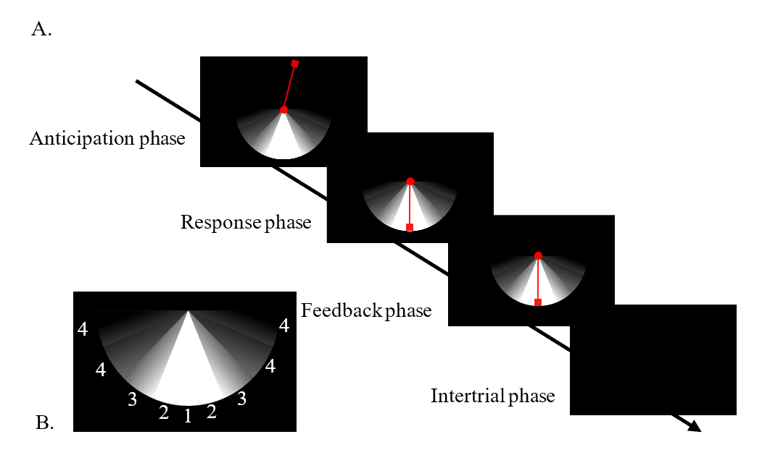
Note. Panel A shows the four trial phases of the CO-Task in block 2 or 4 in which responses were followed by response feedback. During the anticipation phase, a static pendulum was displayed. During the response phase, the pendulum moved counterclockwise until the participant responded. During feedback, the participant's response was displayed. A blank screen was presented during the intertrial interval. Panel B shows the response-outcome numbering used in the analyses; these numbers were not visible to participants.

Analyzed outcomes
As we were interested in a feedback-locked ERP, we analyzed only trials in blocks 2 and 4, since in blocks 1 and 3 responses were not followed by a visually distinct feedback period. Only correct button responses, i.e., congruent finger-to-spinning-direction outcomes, were analyzed. The minimum number of trials for each response outcome was set to 20, consistent with previous psychometric work demonstrating acceptable internal consistency of the RewP within 20 trials in healthy young adults (Levinson et al., 2017). Response conditions, which are the outcomes, did not differentiate between the left and right sides of the stimulus, nor between stopping the pendulum before or after the optimum area. Consequently, the mirrored sides of the fan were collapsed into the same condition. We assumed the center of the white target area to represent the optimal response outcome, as it was maximally distant from the objectively false black regions, whereas positions closer to the white–gray boundary were considered suboptimal despite still falling within the instructed target area, and that this graded distinction would be reflected in the RewP. Accordingly, outcome 1 represented the central, optimal position, and response outcome 2 represented suboptimal positions within the white target area. Both were correct according to the instructions. Outcome 3 comprised the gray positions immediately adjacent to the white target region. The two outer gray areas were grouped into outcome 4 because individual positions yielded too few trials for reliable averaging. Outcomes in the black areas were excluded because fewer than 20 epochs were available.

EEG recording and pre-processing
EEG hardware consisted of the actiCHamp Plus 64-channel amplifier with actiCAP slim active electrodes (Brain Products GmbH, Gilching, Germany), arranged according to the 10-10 electrode placement system. 63 recording electrodes were online referenced to FCz, with AFz as the ground electrode. The highest accepted electrode impedance threshold was 15 kΩ. Continuous EEG was recorded at 1,000 Hz using BrainVision Recorder (Version 1.21.0303; Brain Products GmbH). No notch filter was used. Recordings were preprocessed with the BrainVision Analyzer (v2.3.0, Brain Products GmbH), starting with downsampling to 250 Hz. Using Zero-Phase-Shift Butterworth filters, the low cutoff was set to 0.05 Hz and the high cutoff to 40 Hz, with a 48 dB/octave roll-off. Raw data inspection was performed semi-automatically, with parameters set to look for maximum voltage steps of 50 µV/ms, detect differences exceeding 500 µV at 1 s intervals, and set the lowest detectable activity to 0.5 µV at 100 ms intervals. Markings began 200 ms before and after artifacts. Re-referencing to the average reference electrode enabled the use of FCz as an additional sampling electrode. An Independent Component Analysis with the Infomax Restricted Biased algorithm (meaned slope) was applied semi-automatically to correct ocular artifacts, using 63 components across all data and all channels. Fp1 was the common reference for vertical EOG, whereas F7 and F8 served as horizontal activity channels. Components with total squared correlations above 20% were automatically deleted. The continuous data were then segmented from 200 ms before to 600 ms after response/feedback onset. After calculating the average for each channel, a Baseline Correction Transformation was applied 200-100 ms before the reaction, i.e., stopping the pendulum. The minimum accepted number of epochs per outcome condition was 20.

ERP components
In tasks with timely discrete response and feedback events, the RewP is typically observed about 250 ms after feedback onset (J. E. Glazer et al., 2018a; San Martín, 2012). In the CO-Task, however, the procedural structure of a single trial allowed for an evaluation of task performance even before the feedback stimulus. The response immediately stopped the visible pendulum and revealed its final position. Participants could therefore begin evaluating performance before the feedback onset (also compare Lange et al., 2023), which may have shifted or overlapped feedback-locked activity. Based on visual inspection of the grand-average difference waves and scalp distributions, mean amplitude was calculated at FCz from 100 to 200 ms after feedback onset (highlighted time frame in Figure 2). Inspection of condition differences across electrodes identified FCz as the most appropriate site to investigate the negativity in that time window (see the lower panel of Figure 2). Condition-specific amplitudes were retained for the mixed-effects analysis. The mean amplitude of outcome 1 was reported as the RewP. For difference scores, the Delta Reward Positivity (∆RewP) for each nonoptimal outcome was calculated as the amplitude of that outcome minus the amplitude of the optimal outcome; negative values therefore indicated an amplitude less positive than the optimal outcome. This method is recommended because other ERP components may confound the results (Holroyd & Krigolson, 2007).
Figure 2
Grand averages and difference waves at FCz of Study 1
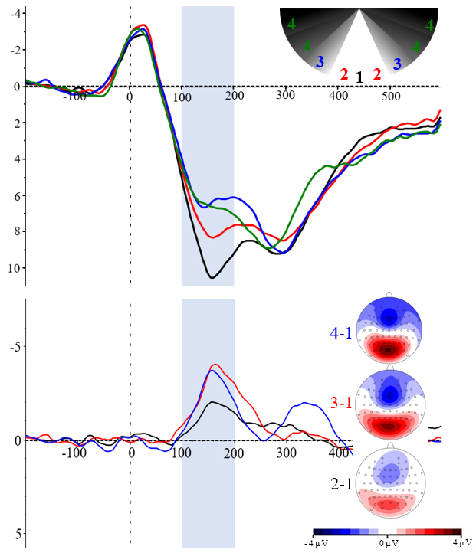
Note. Upper panel: Grand averages of response outcomes. Lower panel: Difference waves were calculated relative to the optimal response outcome at FCz. Colored heads show scalp topographies of outcome differences. In the highlighted area, 100-200 ms after the feedback onset, the mean values were calculated for the analysis. The y-axis is plotted with negative values upward. Amplitudes are expressed in microvolts (µV).

Statistical analysis
As indicated above, with outcome 1 as the reference level, we modeled the effects of outcomes 2, 3, and 4 as difference scores. The two perfectionism dimensions, PS and PC, were included as continuous predictors, along with their interactions with the outcomes. No higher-order interactions were tested. Both variables were z-standardized to facilitate interpretation and comparability of the regression coefficients. We fitted a linear mixed-effects model with random intercepts for participants to account for individual differences; random slopes were omitted because models including them failed to converge. Model assumptions were evaluated by inspecting residual normality, homoscedasticity, multicollinearity, and influence. The diagnostics indicated no major violations. Together, these results support the appropriateness of a mixed-effects modeling approach for data with repeated measures (Koerner & Zhang, 2017). Statistical tests were two-sided with α = .05. No values were missing from the analyzed variables. Estimated marginal means were calculated as pairwise comparisons with Tukey adjustment. Analyses were conducted in R using the integrated development environment RStudio (Version 2026.08.0). Packages used can be found in the online repository. Standardized β estimates of continuous predictors were fully z-standardized using the refit method. Estimates for outcome conditions were partially standardized and represent the SD change in amplitude per change in factor level. Julius AI (model 1.2 Max) was used to support English-language editing and code review. All content was reviewed and verified by the authors. It was not used to collect data or make autonomous analytic decisions.

Results

Descriptive statistics
Mean amplitudes were positive in all four conditions (M = 7.08, SD = 3.45). Amplitude became less positive from outcome 1 to 3, with a slight rebound for 4. Variability and standard error were similar across conditions. The mean range was 12.60 µV; outcome 1 had the widest range (13.43 µV), and outcome 3 had the narrowest range (11.88 µV). Descriptive statistics for the response conditions and perfectionism dimensions are reported in Table 1.

Table 1
Means, standard deviations, and ranges for independent variables in Study 1
 | M | SD | Range (min–max)
Outcome 1 | 8.88 | 3.28 | 2.37–15.81
Outcome 2 | 7.32 | 3.30 | 1.65–13.77
Outcome 3 | 5.96 | 3.18 | -0.28–11.58
Outcome 4 | 6.23 | 3.56 | 0.54–13.46
Perfectionistic striving | 53.50 | 12.01 | 30-76
Perfectionistic concern | 35.67 | 13.88 | 14-71
Note. Amplitudes are in µV.

Inferential statistics
The ∆RewP estimates for outcomes 2, 3, and 4 were all negative and significantly deviated from zero (p < 0.001). Relative to the optimal outcome, mean amplitude was significantly lower across all outcomes (see Table 2). Thus, the optimal outcome differed from every suboptimal outcome, supporting the hypothesis that feedback-locked amplitude was sensitive to deviations from the optimum.
Pairwise comparisons of estimated marginal means, evaluated at the mean levels of PS and PC, indicated that the difference between response outcomes 2 and 3 was significant (b = 1.35, SE = 0.22, t(165) = 6.28, p < .001), but not for 3 and 4 (b = -0.27, SE = 0.22, t(165) = -1.23, p = .608). All response outcomes therefore differed significantly in amplitude, except for outcomes 3 and 4. Hence, as expected, the results suggest a decrease in RewP with increasing distance from the optimum, which then levels off from outcome 3 onward, as depicted in Figure 4. This pattern supported graded outcome differentiation but not a strictly monotonic increase in the amplitude difference with increasing distance from the optimum.

Table 2
Fixed effects of outcomes and perfectionism dimensions on amplitude.
 | B | SE | 95% CI | df | t | p | β | 95% CI
Intercept | 8.88 | 0.42 | [8.06, 9.69] | 67.37 | 21.11 | < .001*** | 0.52 | [0.28, 0.76]
Outcome 2 | -1.56 | 0.22 | [-1.97, -1.15] | 165 | -7.25 | < .001*** | −0.45 | [−0.57, −0.33]
Outcome 3 | -2.91 | 0.22 | [-3.32, -2.50] | 165 | -13.53 | < .001*** | −0.84 | [−0.97, −0.72]
Outcome 4 | -2.65 | 0.22 | [-3.06, -2.23] | 165 | -12.30 | < .001*** | −0.77 | [−0.89, −0.64]
Perfectionistic striving | -0.48 | 0.46 | [-1.38, 0.41] | 67.37 | -1.05 | .298 | −0.14 | [−0.40, 0.12]
Perfectionistic concerns | -0.42 | 0.46 | [-1.31, 0.48] | 67.37 | -0.91 | .368 | −0.12 | [−0.38, 0.14]
Outcome 2 × Perfectionistic striving | -0.14 | 0.24 | [-0.60, 0.31] | 165 | -0.61 | .543 | −0.04 | [−0.18, 0.09]
Outcome 3 × Perfectionistic striving | -0.02 | 0.24 | [-0.47, 0.43] | 165 | -0.08 | .934 | −0.00 | [−0.14, 0.13]
Outcome 4 × Perfectionistic striving | -0.57 | 0.24 | [-1.03, -0.12] | 165 | -2.43 | .016* | −0.17 | [−0.30, −0.03]
Outcome 2 × Perfectionistic concerns | -0.04 | 0.24 | [-0.50, 0.41] | 165 | -0.18 | .856 | −0.01 | [−0.15, 0.12]
Outcome 3 × Perfectionistic concerns | 0.09 | 0.24 | [-0.37, 0.54] | 165 | 0.37 | .710 | 0.03 | [−0.11, 0.16]
Outcome 4 × Perfectionistic concerns | 0.11 | 0.24 | [-0.34, 0.56] | 165 | 0.46 | .644 | 0.03 | [−0.10, 0.17]

Note. B = unstandardized coefficient; SE = standard error; CI = confidence interval; df = degrees of freedom; β = standardized coefficient. Intercept is the mean of outcome 1. Unstandardized coefficients for the outcomes 2, 3, and 4 represent differences relative to the reference category outcome 1. N = 232 (58 participants). p < .05*, p < .001***.

At the optimal outcome, neither PS nor PC was significantly associated with amplitude. There was no main effect of either perfectionism dimension on the optimal outcome. PS did not moderate the contrasts for outcomes 2 or 3, but it significantly moderated the contrast between outcomes 4 and 1. That indicated a substantial increase in amplitude difference for participants scoring 1 SD above the mean score in PS, but only between the optimal response outcome and the response outcome that´s farthest from optimal (see Figure 3). Thus, higher PS was associated with stronger differentiation between the optimal outcome and outcome 4, but not with a general increase in differentiation across all nonoptimal outcomes. None of the outcome × PC interactions were significant; therefore, PC did not reliably moderate condition-related amplitude differences.
Estimated marginal means indicated that, accounting for the PS interaction, the difference between response outcomes 2 and 3 was significant (b = 1.23, SE = 0.32, t(165) = 3.84, p = .001), but not for 3 and 4 (b = 0.29, SE = 0.32, t(165) = 0.91, p = .801). Accounting for the PS interaction did not change the qualitative pattern of pairwise differences among the suboptimal outcomes.
Figure 3
Model-predicted amplitudes across outcomes as a function of perfectionistic strivings.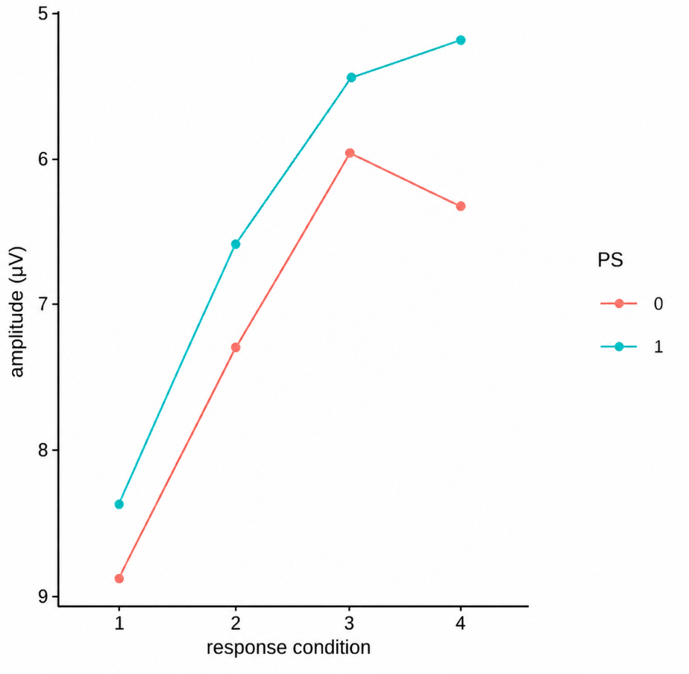
Note. Lines represent model-predicted amplitudes at selected levels of perfectionistic strivings. Perfectionistic concerns were held at the standardized mean (0).

The participant-level random-intercept variance was 8.91 (SD = 2.99), and the residual variance was 1.34 (SD = 1.16), corresponding to an adjusted intraclass correlation of .87. This indicated substantial between-participant variability in overall amplitude and supported the inclusion of a participant-specific random intercept.

Discussion
In Study 1, we examined subjective outcome evaluation using outcomes with varying deviation-from-optimum magnitudes and examined the moderating effects of perfectionism dimensions. Healthy adults completed a personality assessment and a performance task while an EEG was being recorded. We studied the differences in RewP amplitudes between the optimal outcome and adjacent outcomes and predicted that significant differences in RewP would be present and that outcome differentiation would vary with perfectionism. Results showed that RewP amplitudes varied with outcome accuracy, and that PS, but not PC, moderated the contrast involving the most nonoptimal outcome.
Outcome‑graded RewP in the ambivalent task
This pattern is consistent with evidence that feedback-locked ERPs vary not only with binary success or failure but also with the outcome magnitude and precision (Albrecht & Bellebaum, 2023; Sambrook & Goslin, 2015). The increase in amplitude difference, however, levels off at outcome 3. In other words, the amplitude approximated a value and basically stayed there. The plateau at response outcome 3 may indicate a non‑linear mapping of deviation-from-optimum magnitude to subjective evaluation. Similar results were reported in a study discriminating outcomes with high, medium, and low accuracy (Frömer et al., 2016), where they also reported a non-linear mapping. This plateau may indicate that neural differentiation is strongest near the optimum and diminishes once outcomes become clearly suboptimal. An alternative explanation is that conditions 3 and 4 are insufficiently distinct in subjective value, expectancy, visual properties, or trial frequency. The present results cannot distinguish among these explanations.
Internal reward properties and explicit reward value
The most intriguing and novel aspect of our findings is the RewP difference between objectively correct response outcomes that differ only in the deviation from the optimum. Outcomes 1 and 2 were both located within the instructed white target region, yet they differed significantly in RewP amplitude. The signal therefore distinguished the spatially optimal response from one that broadly satisfied the task instruction. The difference between the two outcomes within the white target region is compatible with the idea that participants evaluated response precision relative to an internal goal rather than relying exclusively on an explicit correct–incorrect label. Our results support the idea of Shaffer et al. (2025) and Tunison et al. (2019) that favorable performance feedback can elicit a RewP without monetary incentives, and the present task extends this logic to spatially graded outcomes. General reward properties are assigned internally and reflected in amplitude differences, and prolonged processing time may have allowed participants to evaluate their responses more critically. The results therefore suggest that the RewP may be sensitive to deviations from a task-specific optimum, rather than simply indexing the objective correctness of an outcome.
Perfectionism subscales and performance outcome evaluation
The main effect of PS at the optimal outcome was not significant. The dimension did not moderate the contrasts for outcome 2 or 3, but it did moderate the difference between the optimal outcome and outcome 4. Higher PS may therefore be associated with stronger neural differentiation when an outcome deviates substantially from the individual’s performance goal. PC was not associated with an amplitude change at the optimal outcome and did not moderate any condition contrast. This null pattern contrasts with evidence that persistent error-related rumination in high-evaluative-concern perfectionists reduces their ability to process errors deeply, thereby narrowing the difference between correct and wrong trials in that group compared to personal-standards perfectionism (Mattes et al., 2023). That study, however, did not investigate the RewP. The null pattern of Study 1 does not establish that PC is unrelated to performance monitoring; effects may depend on stronger evaluative threat, social evaluation, personal consequences, or other contexts that make concern over mistakes more salient.
PS and PC, higher‑order subscales of perfectionism, are sometimes labeled adaptive and maladaptive perfectionism (Stricker & Preckel, 2022). In a gambling task, individuals scoring high in adaptive perfectionism showed a less positive amplitude than maladaptive perfectionists, but only during error trials following a monetary loss (Isheqlou et al., 2023). These results suggest greater neural sensitivity to negative feedback in the adaptive subtype and an expectation bias toward poor outcomes in the maladaptive subtype. To our knowledge, this is the only study to date to use ERPs to explore neural mechanisms associated with perfectionism subtypes, stressing the need for additional research. Our results show that PS differentiated between the optimal area and the areas farthest from it. Hence, in accordance with previous studies, this suggests an expectation of perfection in performance on the part of the individual. But comparability might be limited. Isheqlou et al. (2023) reported differences in feedback-related negativity (FRN) between profile-defined perfectionism groups during monetary loss, whereas the present study examined continuous PS and PC scores during nonmonetary performance feedback. Differences in measurement, grouping, task incentives, and outcome type make the findings only indirectly comparable.
Temporal characteristics of the component
The early 100–200-ms latency observed relative to the conventional RewP interval may have several explanations. The response immediately stopped the visible pendulum and initiated the outcome display. Participants could therefore anticipate the stopping position before the nominal feedback onset, and response-related, motor, visual, and evaluative activity may have overlapped in the analyzed interval. These conclusions provide preliminary evidence that the CO-Task is sensitive to graded outcome quality, but the early latency limits a definitive interpretation in terms of the canonical RewP.

Limitations
Several limitations in Study 1 constrained its conclusions and motivated us to conduct Study 2. Response execution and outcome presentation were not temporally separated in Study 1. Study 2 addressed this limitation by inserting a recovery phase between the button press and the feedback display, therefore improving the separation of motor activity from outcome processing. Because the visible pendulum movement allowed participants to anticipate the final position, we concealed the movement during the response phase in Study 2. Participants therefore had to estimate when to stop the pendulum without continuous visual information about its position. Only blocks 2 and 4 provided feedback and were included in the ERP analysis, yielding 200 potentially usable trials out of the 400 available ones. Feedback availability was consequently confounded with block order. Restricting feedback to blocks 2 and 4 may represent a limitation, as the provision of feedback has been shown to influence overall ERP patterns (Bultena et al., 2020). The results indicated the need for additional outcomes in the white area to investigate the evaluation of correct but not optimal responses. The target region was redesigned for Study 2, allowing for more contrasts among correct but suboptimal outcomes.

Study 2
Study 2 was designed to resolve the limitations of Study 1. We increased the number of analyzable feedback trials, concealed pendulum motion during the response phase, inserted a brief recovery interval before feedback, and redesigned the stimulus. These changes reduced overlap between response-related and feedback-locked activity, limited advance visual prediction of the response outcome position, and permitted a finer-grained assessment of outcomes around the optimal position. Study 2 retained the central hypotheses from Study 1: RewP amplitude was expected to vary as a function of spatial deviation from the optimum, and perfectionism was expected to moderate these amplitude differences. Because outcomes immediately before and after the optimum were no longer combined, the analyses additionally tested whether neural outcome evaluation was symmetric around the optimum.

Methods

Participants
Participants in Study 2 met the same eligibility criteria as those in Study 1. 18 participants were excluded because fewer than 20 usable segments were available in at least one condition, and five more were excluded as amplitude outliers. The remaining 65 participants were young (M = 22.72, SD = 2.36), with the youngest being 19 and the oldest 29. 53 participants identified as women and 12 as men. Most participants were psychology students (n = 63), eight reported a different major, and 56 reported being right-handed or primarily right-handed. All participants received course credit.

General Procedure
The procedure followed Study 1, with two key exceptions. In Study 2´s laboratory session, only the CO-Task was conducted. The session lasted approximately 1.5 h.

Online questionnaires
As in Study 1, we applied the MPS-F.

CO-Task

Technical Setup and Stimuli
The technical setup was the same as in Study 1. The stimulus was redesigned to include more stopping positions within the correct region (see Figure 5). The new stimulus was now presented in the center. It subtended a visual angle of approximately 29.1° horizontally and, due to its shape, also 29.1° vertically. The pendulum covered approximately 1.25° × 28.8° of visual angle (horizontal × vertical). The fan was divided into three visually distinct areas: a white area, a gray area with a gradient, and a black area. The white area in the lower part of the fan extended 45° to either side of the y-axis. 45° to the left and right were covered by the gray area, and the upper half of the fan was black. The pendulum started at 157.5° or 205.5°, to the left and right of the y-axis, respectively. Swinging counterclockwise, it could stop at 112.5°, 72.0°, 54.0°, 36.0°, 18.0°, 0.0°, 342.0°, 324.0°, 306.0°, 288.0°, 247.5°, and 202.5°. Swinging clockwise, the order of these orientations was reversed.

Instructions and Procedure
Study 2 modified the instruction, feedback schedule, response display, and temporal sequence as follows. Participants received the single instruction, “If possible, make the pendulum land on the light area.”. Instructions were reduced to a single statement to narrow the range of possible interpretations while preserving the broad target goal.
The task still consisted of four blocks of 100 trials each. Unlike Study 1, every trial in every block was followed by response feedback, yielding 400 feedback trials rather than 200 without extending the total number of trials.
During the anticipation phase, a response before the pendulum began to move triggered a “Too early!” warning. The pendulum remained visible during this phase. During the response phase, the pendulum was not visible, thereby limiting visual information about the outcome. The minimum time at each orientation was again 0.012 s, but the maximum was now set to 0.060 s. Total trial duration ranged from 0.406 s (0.250 s initial position time + 12 × 0.012 s per orientation + 0.012 s collision time) to 1.530 s (0.750 s initial position time + 12 × 0.042 s per orientation + 0.042 s collision time). A button press initiated the recovery phase. During the recovery phase, only the fan was visible for 0.5 s. Feedback began 0.5 s after the response to reduce overlap between outcome-related activity and motor processes required to stop the pendulum. During the feedback phase, the final response outcome was displayed for 0.5 s. The brief display duration was intended to provide clearly visible feedback and enhance feedback processing (Faßbender et al., 2023). A blank screen lasting 1.000–1.250 s separated consecutive trials in the intertrial phase.
Analyzed outcomes
We analyzed every correct button press in each block. The white area contained the optimal outcome and multiple suboptimal outcomes. The optimal response was coded as outcome 1, stopping the pendulum before reaching the optimal outcome area corresponded to outcome -2, and stopping it right after the optimal outcome corresponded to outcome +2. Outcome +3 was also in the white area, but it was the furthest from the optimum. In the gray area, participants could land on two orientations, but only the one closer to the optimum (i.e., +4) yielded sufficient trials for averaging. The black-area orientations and every orientation that came before -2 were not used in the analysis because, again, they didn’t yield enough trials for averaging.
Figure 4
Procedure of the CO-Task in Study 2
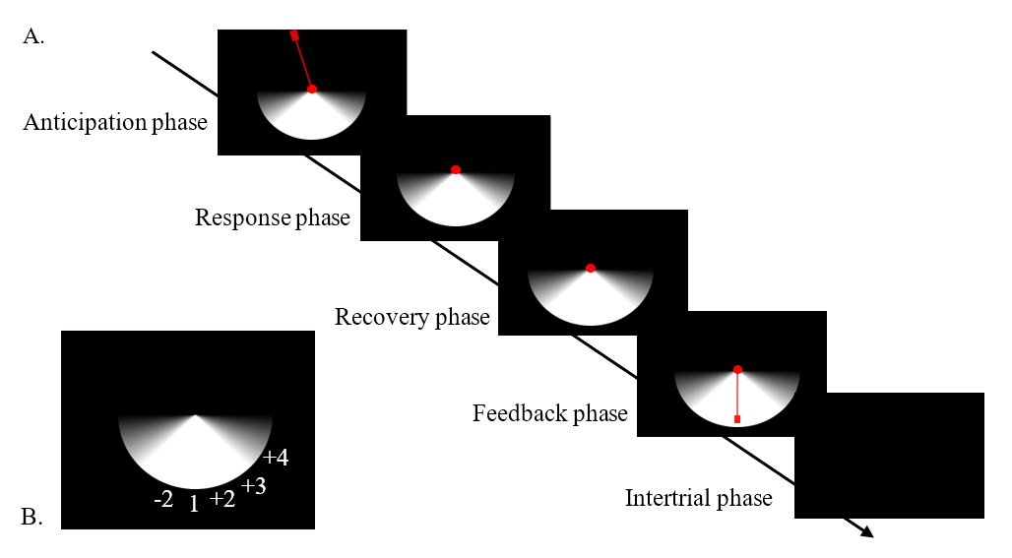
Note. Panel A shows the five trial phases of the CO-Task in any block. During the anticipation phase, a static pendulum was displayed. During the response phase, the pendulum moved counterclockwise until the participant responded, but it was not visible. In the recovery phase, the participant saw only the fan. During feedback, the participant's response was displayed. A blank screen was presented during the intertrial interval. Panel B shows the response-outcome numbering used in the analyses; these numbers were not visible to participants. They correspond to a trial in which the pendulum started on the left-hand side.

EEG and pre-processing
EEG acquisition and preprocessing followed the pipeline reported for Study 1. Continuous data were recorded from 63 scalp electrodes, downsampled to 250 Hz, filtered, inspected for artifacts, corrected for ocular activity using ICA, re-referenced to the average reference, and segmented relative to feedback onset. The minimum accepted number of artifact-free epochs was 20 per outcome condition.

ERP components
We analyzed the time window from 150 to 190 ms after feedback onset at electrode site Fz. We reported the absolute RewP for outcome 1 and the ∆RewP for outcomes -2, +2, +3, and +4, calculated as each outcome minus the optimal outcome. Outcome −2 represented a pre-optimum difference score, whereas outcomes +2, +3, and +4 represented post-optimum difference scores.
Figure 5
Grand-average and difference waves relative to the optimal response outcome at Fz in Study 2
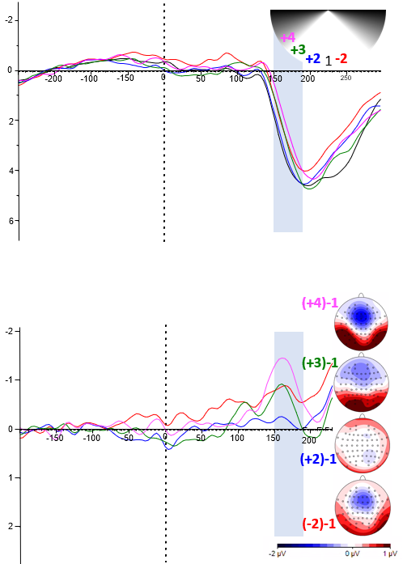
Note. Upper panel: Grand averages of response outcomes. Lower panel: Difference waves were calculated relative to the optimal response outcome at Fz. Colored heads show scalp topographies of outcome differences. In the highlighted area, 150-190 ms after feedback onset, the mean values were calculated for the analysis. The y-axis is plotted with negative values upward. Amplitudes are expressed in microvolts (µV).

Statistical analysis
A linear mixed-effects model was conducted to examine whether RewP amplitudes differed between conditions and the optimum, and whether perfectionistic striving (PS) and perfectionistic concern (PC) moderated these differences. Outcome was entered as a categorical predictor, with the optimal outcome serving as the reference category. PS and PC were z-standardized. The model included random intercepts for participants to account for individual differences in overall RewP amplitude.

Results

Descriptive statistics
Mean amplitudes of all five outcomes were positive (M = 2.92, SD = 2.31). As illustrated in Figure 7, the mean amplitudes followed a curvilinear pattern. Mean ERP amplitudes were positive-going from outcome -2 to 1, slightly more negative-going at outcome +2, and then gradually declined across outcomes +3 and +4. Mean ERP amplitudes across the five conditions ranged from 2.33 to 3.41 µV. Standard deviations were comparable (2.15–2.44 µV), indicating similar variability. The observed values spanned a broad range across conditions, from −2.80 µV to 9.65 µV. Participants showed substantial variability in both perfectionism dimensions (see Table 2).

Table 3
Means, standard deviations, and ranges for independent variables in Study 2
 | M | SD | Range (min–max)
Outcome -2 | 2.75 | 2.15 | -2.41–8.44
Outcome 1 | 3.41 | 2.44 | -1.25–9.47
Outcome +2 | 3.29 | 2.31 | -1.39–9.65
Outcome +3 | 2.84 | 2.27 | -1.83–7.64
Outcome +4 | 2.33 | 2.29 | -2.80–7.64
Perfectionistic striving | 46.12 | 8.30 | 18–65
Perfectionistic concern | 30.92 | 10.81 | 14–58
Note. Amplitudes in µV.

Inferential statistics
The model showed significant differences in RewP amplitudes across outcomes. Relative to the optimal outcome, outcomes -2, +3, and +4 showed significantly smaller RewP amplitudes. In contrast, outcome +2 did not differ significantly from the optimal outcome. This pattern indicated asymmetry around the optimum: the immediately preceding outcome differed from the optimum, whereas the immediately subsequent outcome did not.
Amplitudes were also less positive for the more distant post-optimum outcomes. Pairwise comparisons of estimated marginal means at the standardized means of PS and PC showed that outcome -2 elicited a significantly less positive amplitude than +2 (b = –0.54, SE = 0.18, t(248) = –2.94, (p = .029). Outcome +2 did not differ significantly from +3 (b = 0.46, SE = 0.18, t(248) = 2.49, p = .095), and the comparison between +3 and +4 was approaching significance (b = 0.51, SE = 0.18, t(248) = 2.75, p = .0501). Thus, the analyzed outcomes did not show a uniformly stepwise post-optimum decline; instead, they showed a more curvilinear response profile.
Neither PS nor PC showed a significant main effect on RewP amplitude at the optimal outcome. Regarding moderation effects, PS did not significantly affect the RewP differences between outcome conditions, as none of the interactions were significant (all p > .390). However, the interaction between the most non-optimal outcome (outcome +4) and PC was significant, suggesting that higher PC was associated with a stronger reduction in RewP amplitude for the largest-error outcome relative to the optimal outcome (see Figure 6 and Table 4). The remaining PC interactions were not significant (all p > .178). Higher PC was therefore associated with stronger differentiation of the most nonoptimal analyzed outcome, but not with reliable moderation of all graded outcome contrasts.
Comparisons with marginal means while factoring in the significant simple effect of PC showed that outcome -2 did not differ significantly from +2 (b = –0.61, SE = 0.26, t(248) = –2.33, p = .140), and +2 did not differ significantly from +3 (b = 0.56, SE = 0.26, t(248) = 2.13, p = .212). In contrast, the comparison between +3 and +4 reached significance (b = 0.88, SE = 0.26, t(248) = 3.35, p = .008). Thus, before and after the optimal area, the amplitude was the same for individuals scoring 1 SD higher than average in PC, whereas the two more distant post-optimum outcomes differed.
Figure 6
Model-predicted amplitudes across outcomes as a function of perfectionistic concern.
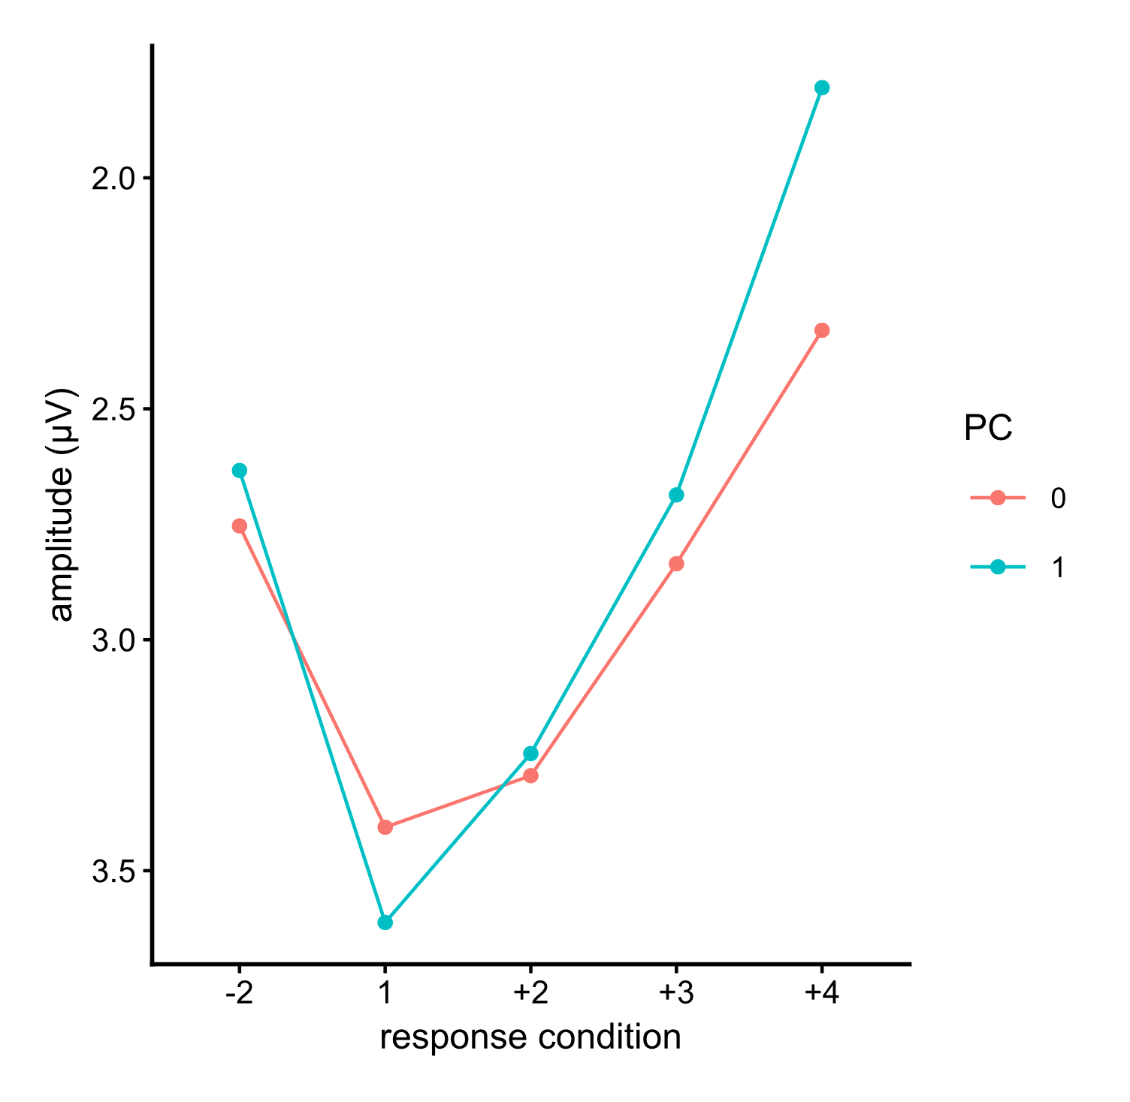
Note. Lines represent model-predicted amplitudes at selected levels of perfectionistic concerns. Perfectionistic strivings were held at the standardized mean (0).
Table 4
Fixed effects of outcome and perfectionism dimensions on amplitude.
 | B | SE | 95% CI | df | t | p | β | 95% CI
Intercept | 3.41 | 0.29 | [2.85, 3.96] | 88.17 | 11.90 | < .001*** | 0.21 | [-0.04, 0.45]
Outcome -2 | -0.65 | 0.18 | [-1.01, -0.30] | 248 | -3.55 | < .001*** | −0.28 | [−0.44, −0.13]
Outcome +2 | -0.11 | 0.18 | [-0.47, 0.24] | 248 | -0.61 | .545 | −0.05 | [−0.20, 0.11]
Outcome +3 | -0.57 | 0.18 | [-0.92, -0.22] | 248 | -3.10 | .002** | −0.25 | [0.40, −0.09]
Outcome +4 | -1.08 | 0.18 | [-1.43, -0.72] | 248 | -5.85 | < .001*** | -0.47 | [0.62, -0.31]
Perfectionistic striving | -0.14 | 0.29 | [-0.70, 0.43] | 88.17 | -0.47 | .639 | −0.06 | [−0.31, 0.19]
Perfectionistic concerns | 0.21 | 0.29 | [-0.36, 0.77] | 88.17 | 0.70 | .483 | −0.09 | [-0.16, 0.34]
Outcome -2 × Perfectionistic striving | 0.01 | 0.19 | [-0.35, 0.37] | 248 | 0.06 | .957 | 0.00 | [−0.16, 0.17]
Outcome +2 × Perfectionistic striving | 0.13 | 0.19 | [-0.23, 0.49] | 248 | 0.71 | .482 | 0.06 | [−0.10, 0.22]
Outcome +3 × Perfectionistic striving | -0.16 | 0.19 | [-0.52, 0.20] | 248 | -0.86 | .390 | −0.07 | [−0.23, 0.09]
Outcome +4 × Perfectionistic striving | 0.07 | 0.19 | [-0.29, 0.43] | 248 | 0.37 | .713 | 0.03 | [-0.13, 0.19]
Outcome -2 × Perfectionistic concerns | -0.33 | 0.19 | [-0.69, -0.04] | 248 | -1.73 | .084 | −0.14 | [−0.30, 0.02]
Outcome +2 × Perfectionistic concerns | -0.25 | 0.19 | [-0.62, 0.11] | 248 | -1.35 | .178 | -0.11 | [−0.27, 0.05]
Outcome +3 × Perfectionistic concerns | -0.36 | 0.19 | [-0.71, 0.01] | 248 | -1.87 | .060 | -0.15 | [−0.31, 0.01]
Outcome +4 × Perfectionistic concerns | -0.73 | 0.19 | [-1.09, -0.37] | 248 | -3.88 | < .001*** | -0.32 | [-0.48, -0.16]

Note. B = unstandardized coefficient; SE = standard error; CI = confidence interval; df = degrees of freedom; β = standardized coefficient. Intercept is the mean of outcome 1. Unstandardized coefficients for the outcomes -2, +2, +3, and +4 represent differences relative to the reference category 1. N = 325 participant-condition observations (65 participants). p < .05*, p < .001***.

The participant-level random-intercept variance was 4.23 (SD = 2.06), and the residual variance was 1.10 (SD = 1.05), corresponding to an adjusted intraclass correlation of .79. As in Study 1, this indicated substantial between-participant variability in overall amplitude and supported the inclusion of a participant-specific random intercept.

Discussion
Study 2 tested whether graded outcome differentiation persisted after reducing anticipatory information and separating the response from the feedback display. The optimal outcome elicited the most positive amplitude, and more distant post-optimum outcomes elicited less positive amplitudes. PS did not moderate any outcome contrast. PC moderated only the contrast between the optimal outcome and the most nonoptimal analyzed outcome. At the standardized means of PS and PC, the immediately preceding outcome differed from the optimum, whereas the immediately subsequent outcome did not. This difference was blunted when accounting for the significant simple effect of PC.
Outcomes −2 and +2 were both adjacent to the optimum but occurred on opposite sides of it. This asymmetry may be meaningful because reward expectations, subjective expectancy, and feedback can shape the feedback-locked signal (Hoy et al., 2021). It suggests that outcome evaluation depended on more than absolute spatial distance. A response made before reaching the optimum may have been evaluated as premature or as a missed opportunity, whereas a slightly late response may have retained more of the value assigned to the optimum. “Just a moment ago, I still had it” seems to be worse than “I just barely missed”, although people scoring high on perfectionistic concerns might not differentiate between outcomes in that way. The results might allude to results from studies on food-reinforcer devaluation that found no significant changes in RewP amplitude despite shifts in reward value (Shaffer et al., 2025). However, these interpretations are speculative and should be tested directly in future work.
The post-optimum profile was graded but not uniformly stepwise. Outcomes +2 and +3 did not differ significantly, and the condition comparison between +3 and +4 was not statistically significant at average trait levels. The data therefore supported a distinction between the optimum and more distant outcomes, but not a simple linear mapping in which each additional deviation yielded a proportional decrease in amplitude. This nonlinear pattern is consistent with evidence that feedback-locked activity is shaped by expectancy, contextual significance, as well as objective accuracy (Albrecht & Bellebaum, 2023; Hassall et al., 2023; Sambrook & Goslin, 2015), in addition to outcome valence.
Perfectionism and outcome differentiation
Higher PC was associated with a larger amplitude difference between the optimal outcome and outcome +4. The interaction was specific to the most nonoptimal condition, and the other PC interactions were not significant. Higher concern, therefore, appears to be linked to harsher evaluation of the worst outcomes.
A simple expectancy account yields a different prediction from the observed PC interaction. If people high in perfectionistic concerns expect deviations from the optimum, negative outcomes may produce smaller prediction errors and weaker feedback-locked differentiation. Prior work has suggested that higher perfectionistic striving may be accompanied by strong expectations of ideal performance, whereas higher perfectionistic concern may be associated with an expectation of falling short and, consequently, reduced neural differentiation of negative outcomes (Isheqlou et al., 2023). The selective PC effect in Study 2 doesn´t align cleanly with this account and, together with the different PS effect in Study 1, requires independent replication before adopting a trait-specific explanation.
Taken together, Study 2 reproduced the central finding that feedback-locked activity differentiated outcome quality, but it did not reproduce the perfectionism dimension involved in Study 1. The design changes therefore strengthen the evidence for outcome-related differentiation while also showing that the trait effects are not yet robust across task variants.

Limitation
Several limitations remained despite the design improvements. The 150–190-ms interval was still earlier than the conventional RewP latency, and Fz and the time window were selected from the collected data. Component identification, therefore, remained exploratory. Outcome probabilities were not experimentally balanced, and the design included only one analyzed position before the optimum but several after it. The apparent asymmetry may consequently reflect temporal position, response strategy, or outcome frequency in addition to subjective accuracy. Participant exclusion was substantial, reducing the recruited sample from 88 to 65 participants. Exclusion due to insufficient condition-specific epochs may have selected for participants with more consistent responding or cleaner EEG data, possibly limiting generalizability. Future versions of the task should be designed to yield sufficient trials for every outcome condition without relying on extensive post hoc exclusions. Despite these limitations, modifications of Study 1 allowed us to test whether graded outcome differentiation persisted under improved temporal and procedural control. Study 2 demonstrated that outcome-related amplitude differences remained after anticipatory visual information was reduced and response and feedback were temporally separated. It is a boundary-condition test showing that graded subjective evaluation survives improved temporal separation and reduced anticipatory information.

General discussion
Graded outcome evaluation
Across two versions of the CO-Task, the RewP varied with the quality of a graded performance outcome, even though the task provided no monetary incentive, no explicit trial-wise accuracy label, and no cumulative score. In both studies, the optimal outcome elicited the most positive mean amplitude, and clearly nonoptimal outcomes elicited lower amplitudes. The cross-study pattern supports the central proposal that performance monitoring is sensitive to more than a binary correct–incorrect distinction. This finding converges with previous literature.
Previous paradigms have distinguished neutral, rewarding, and punishing outcomes; manipulated reward timing; or presented feedback about progressively larger deviations from a target (Albrecht & Bellebaum, 2023; Hassall et al., 2023; Osinsky et al., 2018; Rommerskirchen et al., 2021; Yokota et al., 2019). These studies show outcome-related differentiation, but they do not imply a simple linear relation between objective distance and neural response. Less positive amplitudes are observed for negative compared to positive outcomes, with neutral feedback often falling in between or closer to negative (Funkhouser et al., 2020; Kreussel et al., 2012). Neutral or ambiguous feedback can also elicit the smallest RewP responses in monetary tasks (J. Glazer & Nusslock, 2022; Kreussel et al., 2012). Here, findings show that neutral feedback elicited a less positive amplitude than aversive feedback, which in turn was less positive than rewarding feedback (Teper & Inzlicht, 2014).
The non-linearity findings are being addressed and studied more in depth in our studies. The precise profile was not linear and differed between task versions. Study 1 showed a decline followed by a plateau, whereas Study 2 showed an asymmetric profile around the optimum and lower amplitudes for farther post-optimum outcomes. The plateau in Study 1 and asymmetry in Study 2 indicate that spatial distance from the optimum was not the only determinant of the signal. Categorical boundaries, whether the response occurred before or after the optimum, outcome probability, developing expectations, and task timing may all have contributed.
Because the exact response profile was context-dependent, consistent in conjunction with broader evidence that valence, expectancy, uncertainty, relevance, and component overlap (J. Glazer & Nusslock, 2022; J. E. Glazer et al., 2018a; Hassall et al., 2023; Peters et al., 2024; Sambrook & Goslin, 2015) jointly shape the RewP, the CO-Task should therefore be conceptualized as a measure of context-dependent, graded outcome evaluation instead of a direct neural readout of the magnitude of physical deviation from the optimum. The process underlying this pattern cannot be identified from the present data alone. Participants may have been surprised by a central stop position, may have treated it as the clearest goal-congruent outcome, or both. Consequently, the observed differences need not reflect a single value signal. Although the results are compatible with an internally assigned reward for spatially optimal responses, they do not establish that participants experienced the optimal position as rewarding. The instruction established an explicit preference for the light region, and amplitude differences could also reflect salience, visual differences, motor timing, or general goal congruence (Lau et al., 2026; Rommerskirchen et al., 2021; Springer et al., 2021). However, visual salience alone cannot explain the differences among outcomes within the white region, as those outcomes were visually equivalent with respect to region membership.
Internally guided evaluation without explicit external reward
The findings are consistent with evidence that favorable performance feedback can elicit a RewP without monetary reward (Tunison et al., 2019) and that it indexes better-than-expected or goal-attaining outcomes more generally (Cavanagh & Holroyd, 2026; Proudfit, 2015). In the CO-Task, participants evaluated the final position relative to an instructed goal rather than receiving an explicit win–loss cue. The task was not completely valence-free because the instruction identified the light region as preferable, consequently establishing an external goal that participants could internalize. The significant differences among outcomes within the white region suggest that participants represented an optimum more precisely than the broad instruction required. The results therefore suggest sensitivity to response precision and indicate that outcomes within a broadly correct region can be neurally differentiated. The RewP tracks graded goal congruence in the absence of explicit trial-wise evaluative labels and incentives.
Perfectionism as a moderator
In common frameworks of perfectionism, personal standards and organization index PS, whereas concern over mistakes and doubts about actions index PC (Stricker & Preckel, 2022). Concerns are more strongly associated with psychopathology, whereas strivings more often correspond to positive achievement features (DiBartolo et al., 2008; Stricker et al., 2019). Strivings align most with conscientiousness; concerns align most with neuroticism (Smith et al., 2019). Our results underscore the viewpoint that PS and PC are two distinct moderators of outcome evaluation rather than interchangeable “perfectionism” scores (Stoeber & Otto, 2006). ERP evidence remains limited and mixed. One study of a healthy sample found no significant link between perfectionism and ΔRewP (Muir et al., 2019). In a monetary gambling task, Isheqlou et al. (2023) reported differences in feedback-related negativity (FRN), the negative counterpart of the RewP (Miltner et al., 1997) among profile-defined perfectionism groups. However, such profiles do not map directly onto continuous PS and PC scores. Examining PS and PC dimensions continuously, as in this study, may therefore clarify whether perfectionism moderates neural differentiation among graded performance outcomes. Also, comparing PS and PC using results that measured adaptive and maladaptive perfectionism might be problematic because the implications depend on context. The findings about trait effects were selective and differed across studies. In Study 1, PS moderated the contrast between the optimum and the most suboptimal outcome, whereas PC did not moderate any contrast. In Study 2, PS did not moderate outcome differentiation, but PC moderated the contrast between the optimum and the most suboptimal outcome. Thus, neither perfectionism dimension showed a consistent moderating effect across both task versions; only the factor level involved in the simple effect was the same, and it was the least optimal one. This mixed pattern does not establish stable trait-specific neural signatures. Differences in task structure, temporal predictability, outcome distribution, and the definition of the largest-error condition may have changed which trait was most relevant in each study. Accordingly, Study 1 and 2 provides specific rather than comprehensive support for perfectionism-related moderation. The interactions occurred for the most non-optimal outcome contrast and should be replicated before they are interpreted as a stable individual-difference effect.
Ambivalence
Feedback-locked activity might reflect not only valence and expectancy but also ambivalence. Varying the degree of action correctness in tasks in several graded steps, ranging from an optimal, clear-cut outcome to the worst possible outcome, induces post-response ambivalence. Presenting several levels of response accuracy, from an optimal outcome to a clearly poor outcome, may induce post-response ambivalence without restricting perceptual information (Pailing & Segalowitz, 2004; Scheffers & Coles, 2000). The CO-Task was designed to introduce potential sources of ambivalence through its instructions, stimulus structure, and feedback display. The task instructions explicitly identified only part of the response space as preferable and left the value of other regions relatively unspecified. This design was supposed to create instructional ambiguity and allow subjective evaluation of the final outcome. The task was not entirely valence-free because the instruction established a preferred, though imprecisely defined, goal. It did, however, omit explicit trial-wise labels, rewards, and punishments, requiring participants to evaluate the outcome's value in relation to a goal, whether internal or external. Within the white region, the central position was designated as the optimal outcome. Stops within the white region but farther from the center, and then in the gray region, may have increased evaluative ambiguity and produced less positive amplitudes. Because stopping before and after the optimum also differed in response timing, ambivalence may not have been equivalent for pre- and post-optimum outcomes. Feedback, as a prolonged response outcome presentation, visually informs the participant only about the spatial closeness of the actual outcome to the optimal outcome, without assigning a valence to the response. The critical ambiguity is therefore evaluative rather than perceptual: participants can see where the response occurred, but must determine how to value a nonoptimal outcome. Ambivalence is common in everyday performance evaluation, making it important to understand how it shapes subjective judgments in the absence of explicit rewards and punishments. Future research should test subjective ambivalence directly rather than infer it solely from response outcomes or ERP amplitudes. Taken together, the results support the CO-Task as a promising tool for testing graded outcome evaluation with limited explicit feedback. Outcome-related differentiation was evident across both task variants, whereas the precise ERP profile and trait-moderation effects varied with design features.

Limitations
Several interpretative limitations apply across these studies. Both studies identified outcome-sensitive activity earlier than the conventional RewP interval. The early latency windows in both studies depart from the classic 200–350 ms RewP range. In Study 2, we reduced anticipatory visual information and inserted a recovery period, yet the selected interval remained early. This consistency suggests that the task reliably generated an early feedback-related signal, but it does not by itself establish that the signal was a temporally shifted RewP. Feedback-locked waveforms contain overlapping visual, motor, salience, expectancy, and evaluative processes, and their amplitude should not be interpreted as a process-pure measure of dopaminergic reward prediction error (Ullsperger et al., 2014). This makes latency-specific interpretation difficult without model-based separation (Kirsch et al., 2022). Also, because electrode and time-window selection were data-dependent in both studies, the risk of circular inference is increased. Modifications to design features such as ITI length, feedback timing, and information richness in instructions can alter neural activity, as shown in these studies, so null or inconsistent moderation effects should not be overinterpreted as evidence against trait sensitivity. No a priori power analyses were conducted. We therefore performed sensitivity analyses based on the final analytic samples to determine the minimum effect sizes detectable with 80% power using two-sided tests at α = .05. Sensitivity to condition × personality interactions was limited. The minimum detectable unstandardized interaction coefficients were ∣B∣=0.67 µV per standard deviation of the personality score in Study 1 and ∣B∣=0.53 µV per standard deviation in Study 2. After correction for all interaction terms, the corresponding thresholds increased to ∣B∣=0.84 µV and ∣B∣=0.68 µV, respectively. Thus, nonsignificant moderation effects should not be interpreted as strong evidence that perfectionistic strivings or concerns were unrelated to graded outcome evaluation.

Outlook

Insufficient trials prevented analysis of outcomes in black areas, which are intended to be seen as clearly wrong, and some positions had to be combined. Hence, the resulting analyses did not cover the complete range of possible deviation-from-optimum magnitudes. Controlling the frequencies of conditions might solve this problem. Feedback-related amplitude is sensitive to outcome frequencies (Holroyd et al., 2003). Because outcome frequency was not experimentally equated, effects of frequency, distance from the optimum, probability, and subjective salience may have been potentially confounded. Future versions of the task should manipulate outcome probabilities independently of spatial accuracy. An important unresolved question is whether the observed signal is best explained as graded goal congruence, positive goal-prediction error, broader subjective reward assignment, or a mixture of overlapping reward, surprise, and control signals, or a combination of these processes that current mean-based analyses cannot fully disentangle (Kirsch et al., 2022). Trial-level models could incorporate movement speed, outcome probability, previous-trial outcomes, and response timing to separate spatial error from expectancy and learning effects. Complementary analyses of other ERP components and time-frequency dynamics may help distinguish reward-prediction, salience, surprise, and cognitive-control accounts (J. E. Glazer et al., 2018b). The samples consisted primarily of young students, so broader samples are needed to establish generalizability. Anxiety, depressive symptoms, intolerance of uncertainty, and related traits could be measured as theoretically relevant moderators rather than treated automatically as exclusion criteria. Trait effects may emerge only when triggered by specific circumstances and task context. We did not explicitly employ a social context (Morawetz et al., 2014), social responsibility (Yokota & Naruse, 2022), or social evaluative feedback (Peters et al., 2024), which have been shown to enhance feedback-related potential. Also, no risk taking (van Noordt & Segalowitz, 2012) or cost of erroneous responses (Pailing & Segalowitz, 2004) was included. Other interesting independent variables are intolerance of uncertainty, depression (Gorka et al., 2015), and substance use disorders (Zhong et al., 2020). Although personalized approaches to perfectionism may be clinically valuable (Wegerer, 2024), the CO-Task cannot yet be used for clinical purposes. The reliability of its outcome measures has not been established, limiting the interpretation of main effects and interactions. Future studies should evaluate split-half reliability of outcome contrasts (Clayson et al., 2021; Kahveci et al., 2022). Confirmatory studies of perfectionism should be powered for interaction effects, test PS and PC as continuous dimensions and test whether moderation effects replicate before drawing conclusions about individual differences. Models that include interactions among perfectionistic subscales might be informative because individuals can score highly on both PS and PC simultaneously, as an fMRI study indicated (Barke et al., 2017).

Conclusion

In this paper, we presented the development and refinement of a task for investigating EEG markers of performance outcome evaluation. Across two studies, feedback-locked frontocentral activity differentiated an optimal response from several less optimal responses in the absence of explicit trial-wise accuracy labels; feedback conveyed only spatial proximity to an internal optimum. The relationship was graded but nonlinear and depended on task structure: Study 1 showed a decline followed by a plateau, whereas Study 2 revealed an asymmetric profile around the optimum, providing evidence that graded differentiation was not limited to the original response-feedback overlap. Perfectionism moderated the most nonoptimal outcome contrast in each study, but the relevant dimension differed across studies. These trait effects should therefore be regarded as preliminary rather than as evidence for stable PS- or PC-specific mechanisms. These findings support the CO-Task as a promising experimental paradigm for studying how the brain evaluates graded performance outcomes relative to an internalized, context-dependent goal. The results indicate that more differentiated outcome structures may better capture everyday performance evaluation and, consequently, may have higher ecological validity than binary outcome contrasts. The studies do not yet establish that the measured activity is a canonical RewP or that it specifically indexes subjective reward. Replication with independently defined ERP measures, direct manipulation checks, balanced outcome probabilities, and reliability assessment is required.

Impact statement
The CO-Task extends binary feedback paradigms by showing that feedback-locked frontocentral activity varies nonlinearly with graded distance from an internal performance optimum, even without explicit rewards, punishments, or trial-wise accuracy labels. Across two studies, the findings support the task’s feasibility for investigating subjective, context-dependent, graded evaluation of outcomes and suggest that perfectionism may shape neural differentiation of the most nonoptimal outcomes.

Acknowledgements
We thank all students who supported this study.

ORCHID
Anna Kabbeck: https://orcid.org/0009-0009-1800-306X

Data and code availability
RStudio packages, the PsychoPy script for the experimental task, and the pipeline for EEG data analysis can be found at https://github.com/akabbeck/Paper-repository-Almost-is-not-perfect-. For data accessibility, please contact the authors.

Funding statement
This research received no specific grant from any funding agency in the public, commercial, or not-for-profit sectors.

Conflict of interests
None.

Ethics approval

The ethics committee of Osnabrück University approved the study protocol.

CRediT statement
Anna Kabbeck: Conceptualization (equal); data curation; formal analysis (lead); investigation; methodology (lead); project administration (equal); resources (equal); software (lead); visualization; writing – original draft (lead); writing – review and editing (lead). Rainer Düsing: Formal analysis (supporting); methodology (supporting); software (supporting); validation (supporting); writing – review and editing (supporting). Roman Osinsky: Conceptualization (equal); funding acquisition; methodology (supporting); project administration (equal); resources (equal); supervision; validation (lead); writing – original draft (supporting); writing – review and editing (supporting).

Recommended Reviewers
Cameron D. Hassall, Olav Krigolson, Clay Holroyd

References
Albrecht, C., & Bellebaum, C. (2023). Slip or fallacy? Effects of error severity on own and observed pitch error processing in pianists. Cognitive, Affective, & Behavioral Neuroscience, 23(4), 1076–1094. https://doi.org/10.3758/s13415-023-01097-1
Altstötter-Gleich, C., & Bergemann, N. (2006). Testgüte einer deutschsprachigen Version der Mehrdimensionalen Perfektionismus Skala von Frost, Marten, Lahart und Rosenblate (MPS-F). Diagnostica, 52(3), 105–118. https://doi.org/10.1026/0012-1924.52.3.105
Azevedo, J. (2017). Confirmatory factor analysis of the Frost et al Multidimensional Perfectionism Scale-24 (F-MPS 24). Morressier. https://doi.org/10.26226/morressier.588f064fd462b8028d891a6e
Barke, A., Bode, S., Dechent, P., Schmidt-Samoa, C., van Heer, C., & Stahl, J. (2017). To err is (perfectly) human: Behavioural and neural correlates of error processing and perfectionism. Social Cognitive and Affective Neuroscience, 12(10), 1647–1657. https://doi.org/10.1093/scan/nsx082
Bultena, S., Danielmeier, C., Bekkering, H., & Lemhöfer, K. (2020). The Role of Conflicting Representations and Uncertainty in Internal Error Detection During L2 Learning. Language Learning, 70(S2), 75–103. https://doi.org/10.1111/lang.12401
Cavanagh, J. F., & Holroyd, C. B. (2026). The Reward Positivity signals a goal prediction error. Trends in Cognitive Sciences, 0(0). https://doi.org/10.1016/j.tics.2025.11.005
Clayson, P. E., Baldwin, S. A., & Larson, M. J. (2021). Evaluating the internal consistency of subtraction-based and residualized difference scores: Considerations for psychometric reliability analyses of event-related potentials. Psychophysiology, 58(4), e13762. https://doi.org/10.1111/psyp.13762
Cohen, M. X., Elger, C. E., & Ranganath, C. (2007). Reward expectation modulates feedback-related negativity and EEG spectra. NeuroImage, 35(2), 968–978. https://doi.org/10.1016/j.neuroimage.2006.11.056
DiBartolo, P. M., Li, C. Y., & Frost, R. O. (2008). How Do the Dimensions of Perfectionism Relate to Mental Health? Cognitive Therapy and Research, 32(3), 401–417. https://doi.org/10.1007/s10608-007-9157-7
Faßbender, L., Krause, D., & Weigelt, M. (2023). Feedback processing in cognitive and motor tasks: A meta-analysis on the feedback-related negativity. Psychophysiology, 60(12), e14439. https://doi.org/10.1111/psyp.14439
Foti, D., Weinberg, A., Bernat, E. M., & Proudfit, G. H [Greg H.] (2015). Anterior cingulate activity to monetary loss and basal ganglia activity to monetary gain uniquely contribute to the feedback negativity. Clinical Neurophysiology : Official Journal of the International Federation of Clinical Neurophysiology, 126(7), 1338–1347. https://doi.org/10.1016/j.clinph.2014.08.025
Frömer, R., Stürmer, B., & Sommer, W. (2016). The better, the bigger: The effect of graded positive performance feedback on the reward positivity. Biological Psychology, 114, 61–68. https://doi.org/10.1016/j.biopsycho.2015.12.011
Frost, R. O., Marten, P., Lahart, C., & Rosenblate, R. (1990). The dimensions of perfectionism. Cognitive Therapy and Research, 14(5), 449–468. https://doi.org/10.1007/BF01172967
Fu, Z., Sajad, A., Errington, S. P., Schall, J. D., & Rutishauser, U. (2023). Neurophysiological mechanisms of error monitoring in human and non-human primates. Nature Reviews. Neuroscience, 24(3), 153–172. https://doi.org/10.1038/s41583-022-00670-w
Funkhouser, C. J., Auerbach, R. P., Kujawa, A., Morelli, S. A., Phan, K. L., & Shankman, S. A. (2020). Social Feedback Valence Differentially Modulates the Reward Positivity, P300, and Late Positive Potential. Journal of Psychophysiology, 34(4), 255–267. https://doi.org/10.1027/0269-8803/a000253
Glazer, J., & Nusslock, R. (2022). Outcome valence and stimulus frequency affect neural responses to rewards and punishments. Psychophysiology, 59(3), e13981. https://doi.org/10.1111/psyp.13981
Glazer, J. E., Kelley, N. J., Pornpattananangkul, N., Mittal, V. A., & Nusslock, R. (2018a). Beyond the FRN: Broadening the time-course of EEG and ERP components implicated in reward processing. International Journal of Psychophysiology : Official Journal of the International Organization of Psychophysiology, 132(Pt B), 184–202. https://doi.org/10.1016/j.ijpsycho.2018.02.002
Glazer, J. E., Kelley, N. J., Pornpattananangkul, N., Mittal, V. A., & Nusslock, R. (2018b). Beyond the FRN: Broadening the time-course of EEG and ERP components implicated in reward processing. International Journal of Psychophysiology : Official Journal of the International Organization of Psychophysiology, 132(Pt B), 184–202. https://doi.org/10.1016/j.ijpsycho.2018.02.002
Gorka, S. M., Phan, K. L., & Shankman, S. A. (2015). Convergence of EEG and fMRI measures of reward anticipation. Biological Psychology, 112, 12–19. https://doi.org/10.1016/j.biopsycho.2015.09.007
Gu, R., Huang, Y.‑X., & Luo, Y.‑J. (2010). Anxiety and feedback negativity. Psychophysiology, 47(5), 961–967. https://doi.org/10.1111/j.1469-8986.2010.00997.x
Ha, J. H., Lee, S. M., & Puig, A. (2010). A reliability generalization study of the Frost Multidimensional Perfectionism Scale (F-MPS). Psychological Reports, 107(1), 95–112. https://doi.org/10.2466/03.09.20.PR0.107.4.95-112
Hajcak, G., Moser, J. S., Holroyd, C. B., & Simons, R. F. (2006). The feedback-related negativity reflects the binary evaluation of good versus bad outcomes. Biological Psychology, 71(2), 148–154. https://doi.org/10.1016/j.biopsycho.2005.04.001
Hassall, C. D., Yan, Y., & Hunt, L. T. (2023). The neural correlates of continuous feedback processing. Psychophysiology, 60(12), e14399. https://doi.org/10.1111/psyp.14399
Holroyd, C. B., & Coles, M. G. H. (2002). The neural basis of human error processing: Reinforcement learning, dopamine, and the error-related negativity. Psychological Review, 109(4), 679–709. https://doi.org/10.1037//0033-295x.109.4.679
Holroyd, C. B., & Krigolson, O. E. (2007). Reward prediction error signals associated with a modified time estimation task. Psychophysiology, 44(6), 913–917. https://doi.org/10.1111/j.1469-8986.2007.00561.x
Holroyd, C. B., Nieuwenhuis, S., Yeung, N., & Cohen, J. D. (2003). Errors in reward prediction are reflected in the event-related brain potential. NeuroReport, 14(18), 2481. https://doi.org/aspx
Hoy, C. W., Steiner, S. C., & Knight, R. T. (2021). Single-trial modeling separates multiple overlapping prediction errors during reward processing in human EEG. Communications Biology, 4(1), 910. https://doi.org/10.1038/s42003-021-02426-1
Huang, Y., & Yu, R. (2014). The feedback-related negativity reflects "more or less" prediction error in appetitive and aversive conditions. Frontiers in Neuroscience, 8, 108. https://doi.org/10.3389/fnins.2014.00108
Isheqlou, L. K., Soltanlou, M., Zarean, M., Saeedi, M. T., & Heysieattalab, S. (2023). Feedback-related negativity in perfectionists: An index of performance outcome evaluation. Behavioural Brain Research, 444, 114358. https://doi.org/10.1016/j.bbr.2023.114358
Kahveci, S., Bathke, A., & Blechert, J. (2022). Reaction Time Task Reliability Is More Accurately Computed With Permutation-Based Split-Half Correlations Than With Cronbach’s Alpha. https://doi.org/10.31234/osf.io/ta59r
Kirsch, F., Kirschner, H., Fischer, A. G., Klein, T. A., & Ullsperger, M. (2022). Disentangling performance-monitoring signals encoded in feedback-related EEG dynamics. NeuroImage, 257, 119322. https://doi.org/10.1016/j.neuroimage.2022.119322
Kirschner, H., & Ullsperger, M. (2024). THE MEDIAL FRONTAL CORTEX, PERFORMANCE MONITORING, COGNITIVE CONTROL, AND DECISION MAKING. Center for Open Science. https://doi.org/10.31234/osf.io/ytrxd
Koerner, T. K., & Zhang, Y. (2017). Application of Linear Mixed-Effects Models in Human Neuroscience Research: A Comparison with Pearson Correlation in Two Auditory Electrophysiology Studies. Brain Sciences, 7(3), 26. https://doi.org/10.3390/brainsci7030026
Kreussel, L., Hewig, J., Kretschmer, N., Hecht, H., Coles, M. G. H., & Miltner, W. H. R. (2012). The influence of the magnitude, probability, and valence of potential wins and losses on the amplitude of the feedback negativity. Psychophysiology, 49(2), 207–219. https://doi.org/10.1111/j.1469-8986.2011.01291.x
Lange, L., Kisker, J., & Osinsky, R. (2023). Midfrontal mechanisms of performance monitoring continuously adapt to incoming information during outcome anticipation. Neuroimage: Reports, 3(3), 100182. https://doi.org/10.1016/j.ynirp.2023.100182
Lau, K. J., Roach, B. J., Abram, S., Nicholas, S. C., Holroyd, C. B., Shamshiri, E. A., Paulus, M., Ford, J. M., Mathalon, D. H., & Fryer, S. L. (2026). Parsing Reward Processing Substages With Multimodal EEG-fMRI. Human Brain Mapping, 47(3), e70466. https://doi.org/10.1002/hbm.70466
Levinson, A. R., Speed, B. C., Infantolino, Z. P., & Hajcak, G. (2017). Reliability of the electrocortical response to gains and losses in the doors task. Psychophysiology, 54(4), 601–607. https://doi.org/10.1111/psyp.12813
Mattes, A., Mück, M., & Stahl, J. (2023). Perfectionism-related variations in error processing in a task with increased response selection complexity. Personality Neuroscience, 5, e12. https://doi.org/10.1017/pen.2022.3
Maurer, L. K., Joch, M., Hegele, M., Maurer, H., & Müller, H. (2022). Relevance of Predictive and Postdictive Error Information in the Course of Motor Learning. Neuroscience, 486, 77–90. https://doi.org/10.1016/j.neuroscience.2021.05.007
Miltner, W. H., Braun, C. H., & Coles, M. G. (1997). Event-related brain potentials following incorrect feedback in a time-estimation task: Evidence for a "generic" neural system for error detection. Journal of Cognitive Neuroscience, 9(6), 788–798. https://doi.org/10.1162/jocn.1997.9.6.788
Morawetz, C., Kirilina, E., Baudewig, J., & Heekeren, H. R. (2014). Relationship between personality traits and brain reward responses when playing on a team. PLOS ONE, 9(1), e87277. https://doi.org/10.1371/journal.pone.0087277
Muir, A. M., Carbine, K. A., Goodwin, J., Hedges-Muncy, A., Endrass, T., & Larson, M. J. (2019). Differentiating electrophysiological indices of internal and external performance monitoring: Relationship with perfectionism and locus of control. PLOS ONE, 14(10), e0219883. https://doi.org/10.1371/journal.pone.0219883
Osinsky, R., Holst, K., & Ulrich, N. (2018). When two become one: Electrocortical correlates of the integration of multiple action consequences. International Journal of Psychophysiology : Official Journal of the International Organization of Psychophysiology, 132(Pt B), 252–261. https://doi.org/10.1016/j.ijpsycho.2017.11.014
Pailing, P. E., & Segalowitz, S. J. (2004). The error-related negativity as a state and trait measure: Motivation, personality, and ERPs in response to errors. Psychophysiology, 41(1), 84–95. https://doi.org/10.1111/1469-8986.00124
Peters, A., Helming, H., Bruchmann, M., Wiegandt, A., Straube, T., & Schindler, S. (2024). How and when social evaluative feedback is processed in the brain: A systematic review on ERP studies. Cortex, 173(8), 187–207. https://doi.org/10.1016/j.cortex.2024.02.003
Proudfit, G. H [Greg Hajcak] (2015). The reward positivity: From basic research on reward to a biomarker for depression. Psychophysiology, 52(4), 449–459. https://doi.org/10.1111/psyp.12370
Rehbein, M. A., Kroker, T., Winker, C., Ziehfreund, L., Reschke, A., Bölte, J., Wyczesany, M., Roesmann, K., Wessing, I., & Junghöfer, M. (2023). Non-invasive stimulation reveals ventromedial prefrontal cortex function in reward prediction and reward processing. Frontiers in Neuroscience, 17, 1219029. https://doi.org/10.3389/fnins.2023.1219029
Rice, K. G., & Ashby, J. S. (2007). An efficient method for classifying perfectionists. Journal of Counseling Psychology, 54(1), 72–85. https://doi.org/10.1037/0022-0167.54.1.72
Rommerskirchen, L., Lange, L., & Osinsky, R. (2021). The reward positivity reflects the integrated value of temporally threefold-layered decision outcomes. Psychophysiology, 58(5), e13789. https://doi.org/10.1111/psyp.13789
Sambrook, T. D., & Goslin, J. (2015). A neural reward prediction error revealed by a meta-analysis of ERPs using great grand averages. Psychological Bulletin, 141(1), 213–235. https://doi.org/10.1037/bul0000006
San Martín, R. (2012). Event-related potential studies of outcome processing and feedback-guided learning. Frontiers in Human Neuroscience, 6, 304. https://doi.org/10.3389/fnhum.2012.00304
Scheffers, M. K., & Coles, M. G. H. (2000). Performance monitoring in a confusing world: Error-related brain activity, judgments of response accuracy, and types of errors. Journal of Experimental Psychology: Human Perception and Performance, 26(1), 141–151. https://doi.org/10.1037//0096-1523.26.1.141
Shaffer, L. S., Crowder, H. D., Kakalec, P. A., Duong, L. T., McDonald, C. G., & Thompson, J. C. (2025). The reward positivity is insensitive to reinforcer devaluation. BioRxiv : The Preprint Server for Biology. Advance online publication. https://doi.org/10.1101/2025.03.27.645774
Smillie, L. D., Jach, H. K., Hughes, D. M., Wacker, J., Cooper, A. J., & Pickering, A. D. (2019). Extraversion and reward-processing: Consolidating evidence from an electroencephalographic index of reward-prediction-error. Biological Psychology, 146, 107735. https://doi.org/10.1016/j.biopsycho.2019.107735
Springer, A., Ohlendorf, F., Schober, J., Lange, L., & Osinsky, R. (2021). Do food images as action outcomes evoke a reward positivity? Brain and Cognition, 154, 105804. https://doi.org/10.1016/j.bandc.2021.105804
Stahl, J., Acharki, M., Kresimon, M., Völler, F., & Gibbons, H. (2015). Perfect error processing: Perfectionism-related variations in action monitoring and error processing mechanisms. International Journal of Psychophysiology : Official Journal of the International Organization of Psychophysiology, 97(2), 153–162. https://doi.org/10.1016/j.ijpsycho.2015.06.002
Stoeber, J., & Otto, K. (2006). Positive conceptions of perfectionism: Approaches, evidence, challenges. Personality and Social Psychology Review : An Official Journal of the Society for Personality and Social Psychology, Inc, 10(4), 295–319. https://doi.org/10.1207/s15327957pspr1004_2
Stricker, J., Buecker, S., Schneider, M., & Preckel, F. (2019). Multidimensional Perfectionism and the Big Five Personality Traits: A Meta–Analysis. European Journal of Personality, 33(2), 176–196. https://doi.org/10.1002/per.2186
Stricker, J., & Preckel, F. (2022). Global Self-Esteem Differentially Predicts Multidimensional Perfectionism in Early Adolescents Two Years Later. The Journal of Early Adolescence, 42(2), 149–171. https://doi.org/10.1177/02724316211016069
Talmi, D., Atkinson, R., & El-Deredy, W. (2013). The feedback-related negativity signals salience prediction errors, not reward prediction errors. The Journal of Neuroscience : The Official Journal of the Society for Neuroscience, 33(19), 8264–8269. https://doi.org/10.1523/JNEUROSCI.5695-12.2013
Teper, R., & Inzlicht, M. (2014). Mindful acceptance dampens neuroaffective reactions to external and rewarding performance feedback. Emotion, 14(1), 105–114. https://doi.org/10.1037/a0034296
Tunison, E., Sylvain, R., Sterr, J., Hiley, V., & Carlson, J. M. (2019). No Money, No Problem: Enhanced Reward Positivity in the Absence of Monetary Reward. Frontiers in Human Neuroscience, 13, 41. https://doi.org/10.3389/fnhum.2019.00041
Ullsperger, M., Danielmeier, C., & Jocham, G. (2014). Neurophysiology of performance monitoring and adaptive behavior. Physiological Reviews, 94(1), 35–79. https://doi.org/10.1152/physrev.00041.2012
van Noordt, S. J. R., & Segalowitz, S. J. (2012). Performance monitoring and the medial prefrontal cortex: A review of individual differences and context effects as a window on self-regulation. Frontiers in Human Neuroscience, 6, 197. https://doi.org/10.3389/fnhum.2012.00197
Wegerer, M. (2024). Cognitive-Behavioral Treatment of Perfectionism: An Overview of the State of Research and Practical Therapeutical Procedures. Verhaltenstherapie, 34(1), 1–10. https://doi.org/10.1159/000532044
Yeung, N., & Sanfey, A. G. (2004). Independent coding of reward magnitude and valence in the human brain. The Journal of Neuroscience : The Official Journal of the Society for Neuroscience, 24(28), 6258–6264. https://doi.org/10.1523/jneurosci.4537-03.2004
Yokota, Y., & Naruse, Y. (2022). Effects of subjective and objective task difficulties for feedback- related brain potentials in social situations: An electroencephalogram study. PLOS ONE, 17(12), e0277663. https://doi.org/10.1371/journal.pone.0277663
Yokota, Y., Soshi, T., & Naruse, Y. (2019). Error-related negativity predicts failure in competitive dual-player video games. PloS One, 14(2), e0212483. https://doi.org/10.1371/journal.pone.0212483
Zhong, N., Chen, T., Zhu, Y., Su, H., Ruan, X., Li, X., Tan, H., Jiang, H., Du, J., & Zhao, M. (2020). Smaller Feedback-Related Negativity (FRN) Reflects the Risky Decision-Making Deficits of Methamphetamine Dependent Individuals. Frontiers in Psychiatry, 11, 320. https://doi.org/10.3389/fpsyt.2020.00320

