Software Project Management Plan

Fund My Way
12/05/2022

Team Members
Muhammad Arslan
Bilal Khan
Krutarth Lad
Muhammad Tayyab
Tyler Xiong

Document Control

Document Storage
This document is stored in a GitHub repository at: https://github.com/akabilalkhan/donation.git

Document Owner
Team Legend is responsible for developing and maintaining this document.
Table of Contents
1 Overview 4
1.1 Purpose and Scope 4
1.2 Goals and Objectives 4
1.3 Project Deliverables 5
1.4 Assumptions and Constraints 5
1.5 Success Criteria 6
1.6 Definitions 6
1.7 Evolution of the Project Plan 6
2 Startup Plan 6
2.1 Team Organization 6
2.2 Project Communications 7
2.3 Technical Process 7
2.4 Tools 7
3 Work Plan 7
3.1 Activities and Tasks 7
3.2 Release Plan/Iteration Plan 8
4 Control Plan 8
4.1 Monitoring and Control 8
5 Supporting Process Plans 8
5.1 Risk Management Plan 8
5.2 Configuration Management Plan 8
5.3 Verification and Validation Plan 9

Overview

1.1 Purpose and Scope
This project is part of a class assignment given by Commerce Bank. It is a web application that is used for donation purposes.

The web application allows users to login and setup their own fundraiser, track their donations, and view and donate to other user’s fundraisers.

Users would be able to donate and interact with other donation pages without signing up, but starting a self-fundraiser is limited to the signed-up users. We are not processing real transactions. A user’s guide will be provided.

1.2 Goals and Objectives
Project goals:
- Create a web application that deals with donations and current fundraisers.
- The web application should be easy to use and attractive to the target audience such as doners.
- Develop different web pages to give users more of the control and ease of access to the specific section.
- It should be secure platform since it deals with the payments and users’ data.
Project objectives:
- Users’ data should be saved and pulled from the database in backend.
- Provide an interface that users can use to add and update their data if they wish to.
- Create the homepage where fundraisers can be seen and interact by the users
- Users can create their own fundraiser and access to their own fundraiser page along with their profile settings.

Project Deliverables
The following items will be delivered to the customer on 12/5/2022:
- User’s Guide
- Architecture guide
- Test Plan

1.4 Assumptions and Constraints
- A prototype should be ready by 10/28/22.
- The web application must be built on a modern web development framework.
- The database must be open source.
- The application must be ready by 12/05/2022.

Success Criteria
- The goals set for each iteration should be achieved by the due date.
- All pages such as: Login page, Homepage, Individual Fundraiser page, Donation Form, User Profiles and Settings pages should be active.
- The web application should be in a working condition by Dec 05.

Definitions
Users-People who are interacting the web application
IDE-Integrated Development Environment
Iteration- a process where the design of a product or application is improved by repeated review and testing
GitHub: GitHub is an Internet hosting service for software development and version control using Git

Evolution of the Project Plan
- At the end of an iteration, the project progress was discussed and updated to include the actual effort for each completed task.
- Tasks were equally divided among the team members.
- All issues should be resolved by the end of iteration, related to that iteration, and start of other iteration.

Startup Plan

Team Organization
Team Leader: Team leader is responsible for creating the project plan (with input from those doing the work), managing risks, running the weekly team meeting, and providing monthly status reports to senior management.
Team Members (5): All members are primary responsible for coding and unit testing modules. They are also expected to take part in architecture planning and review meetings.

Project Communications
A chat group is set up to pass information among the members. GitHub is used to update the project success. Group meetings are arranged to plan the things ahead and assign tasks to the members.

Technical Process
This section describes the software development methodology or conventions the team agrees to live by. When following an organization standard process, this section will refer to the standard process and state any deviations that are planned for this project. In the absence of an organization standard process, this section will define planned phases, entry and exit criteria for each phase, major milestones, workflows, and other aspects of the proposed development process.

Tools
- Programming Language – JavaScript, TypeScript
- Version Control – source code and written artifacts will be stored in a GitHub repository.
- Build tools – VS Code is an IDE for this project.
- Automated testing – unit tests will be implemented with the ??? testing framework.

Work Plan

Activities and Tasks
Tasks | Task Name | Description | Effort Estimate | Actual Effort
1 | Project Plan | Finalize what platforms we will use for front-end and back-end | A week | A week
2 | Front-end/Back-end | Designed basic for all the pages for front-end and set spring boot application and database at the back end | A week | A weak
3 | Connecting | Connect front-end to the back end properly | A week | Three weeks
4 | Prototype | Focus on Prototype and have at least one page fully functioned | A week | A week
5 | Plan changed | Switched to different database and platform | A week | A week
6 | Authentication | Work on signed up users and admin authentication methods | A week | Two weeks
7 | Payments | Deal with dummy payments using stripe and connect to database | A week | Two weeks

Release Plan and Iterations
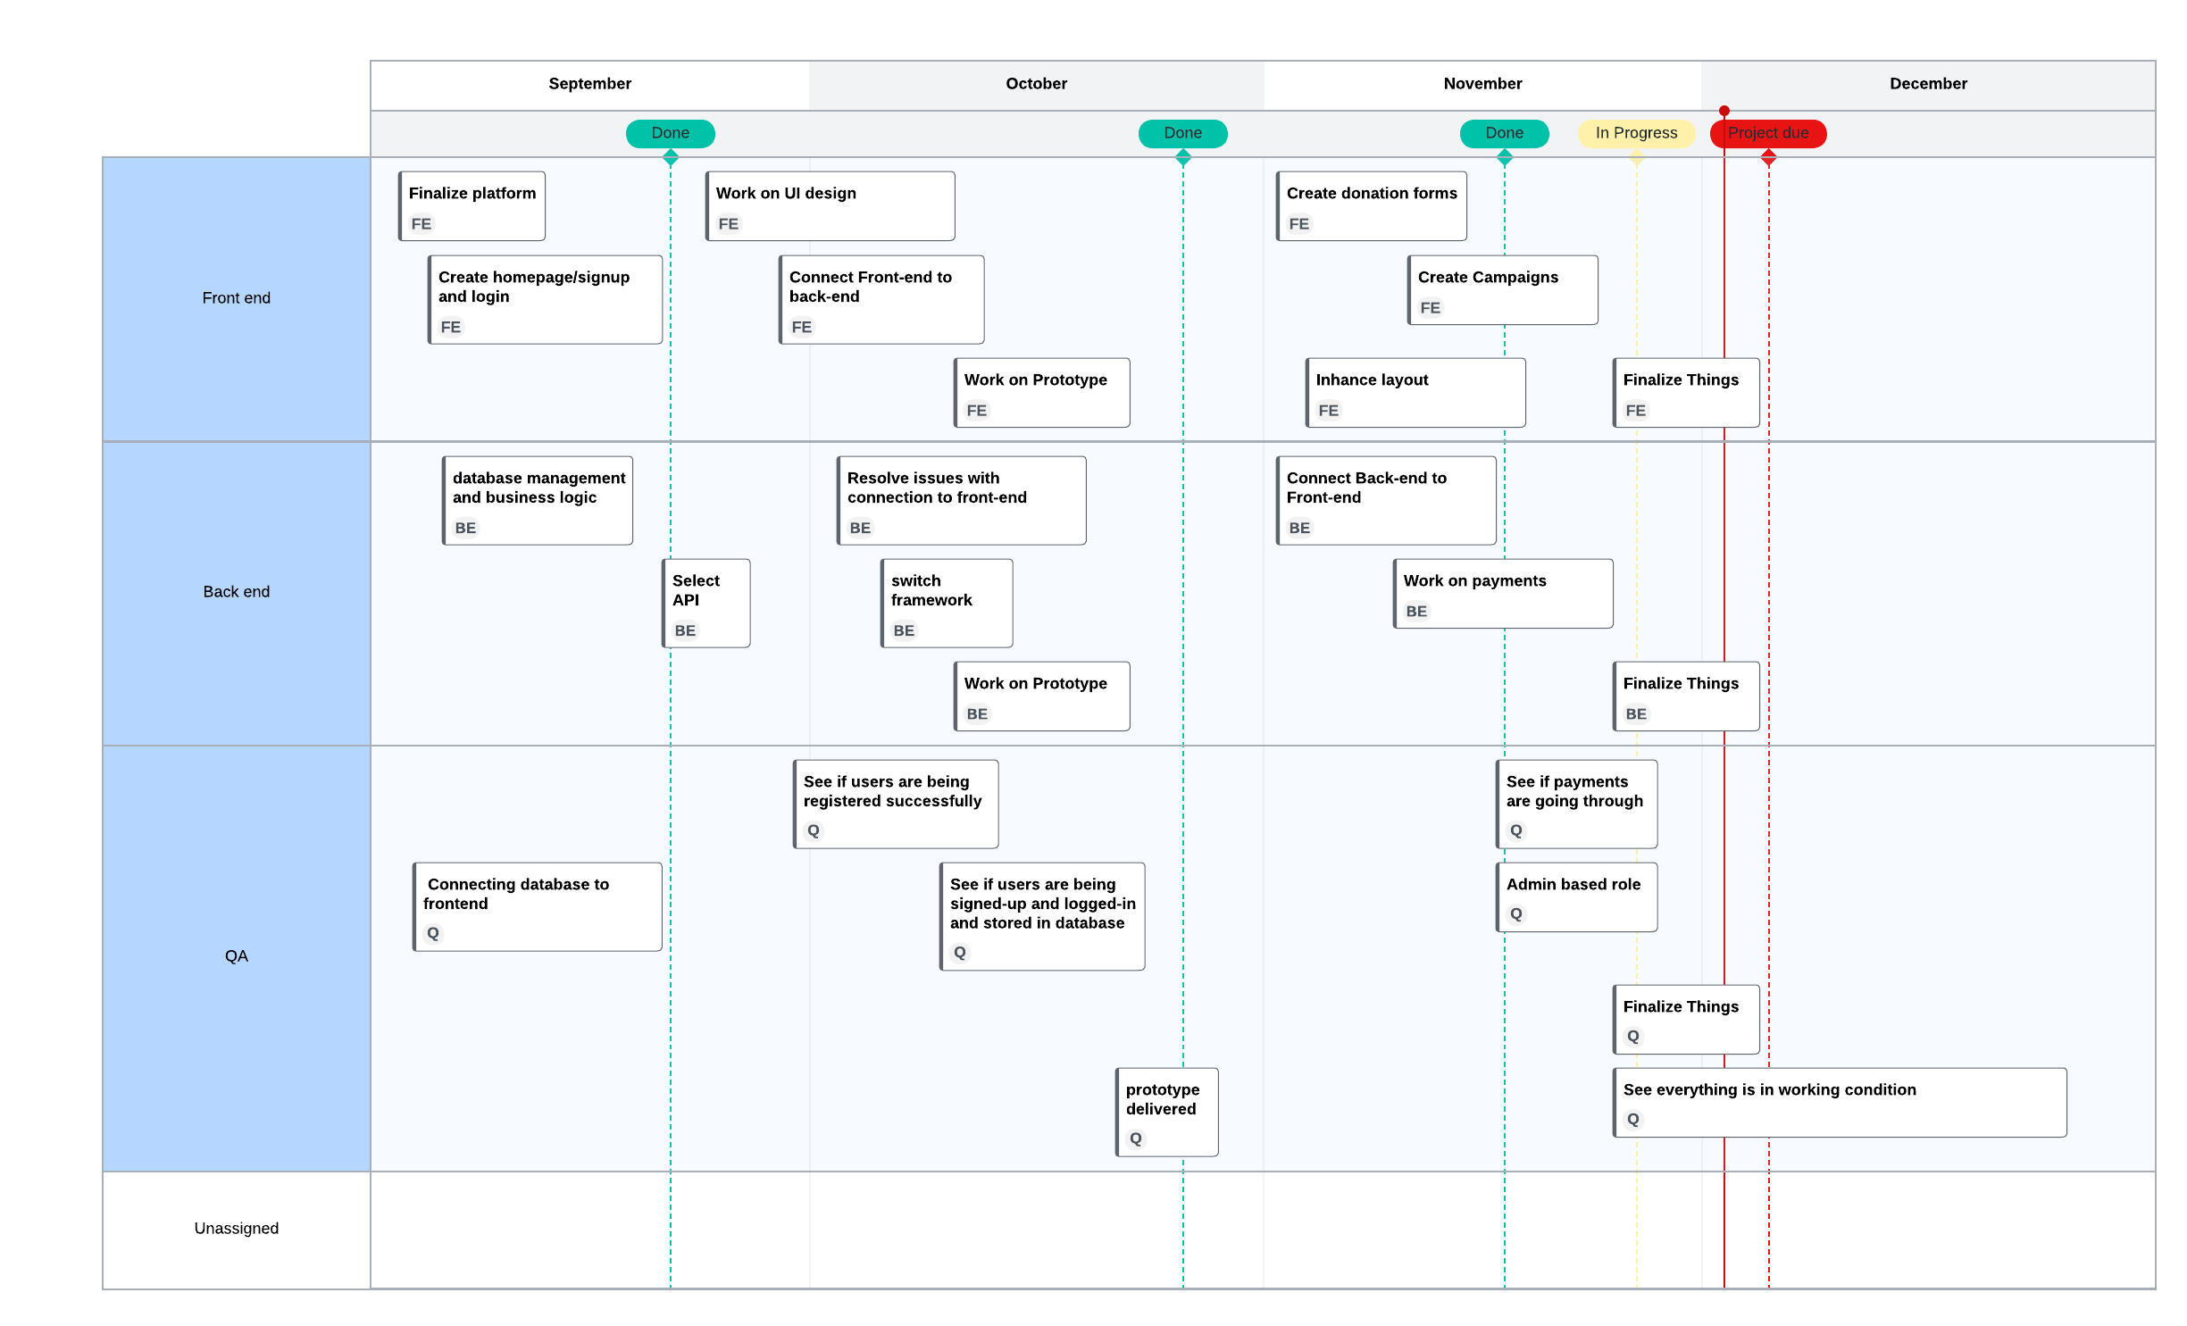

Control Plan

Monitoring and Control
Weekly – Meetings/GitHub: Project participants report status, progress, and potential problems. Participants update all their progress to the GitHub and look at the overall progress.
10/27/2022 – Prototype presentation. A one-on-one meeting with the stakeholders to get feedback on our progress
12/7/2022 – Final Presentation. An overview to the stakeholders and a walkthrough to our working application

Supporting Process Plans

Risk Management Plan
Levels | Intensity | Risks | Mitigations
10 |  | Project is not feasible within the given constraints | Make sure all requirements are met
9 | High | Switching platforms might hurt the production rate | Act only when the whole team is sure that it’s safe or better
8 |  | Not choosing the right technology | Based on requirements, figure out what technologies to use ahead of time
7 |  | Not meeting the deadlines | Manage time properly and stay ahead of time
6 |  | API issue with connection | Make sure if it’s compatible
5 | Medium | Testing issue | Clearly define test cases and do proper testing
4 |  | Lack of clarity | Define each step clearly and assure everyone understands it
3 |  | Low performance | Inspect everyone is doing their part right and on time
2 | Low | Compromising on design | Implement on design as soon as it’s possible
1 |  | Team member going dark | Have a good communication and plans to resolve any issue

Configuration Management Plan
- All work progress will be stored in a GitHub repository.
- All project (work products) items (documents, source code, test cases, program data, test data, etc.) will be stored in the repository but not all will be under change control.
- Items that are subject to change control will be considered baselined after a group review at the end of the life cycle phase during which they are created. Baselined here means that the product has undergone a formal review and can only be changed through the prescribed change control procedures.
- Group meetings will be held for any change and new ideas.

Verification and Validation Plan
All updates and progress details are given to the team leader on weekly basis and everything is stored in a GitHub repository so everyone knows where we are in terms of progress.

Product Acceptance Plan
The web application needs to be designed in a way that anyone, regardless of technical knowledge, should be able to understand and use it. Text should be clearly visible across desktop and mobile views. This includes font sizes, proper background colors for fonts, font colors, contrast etc. Users should have more control on their profile settings and limited access to other profiles.

