Team Term Project Progress Report
Team 10
1. Anzal Zia Khan
2. Anowarul Kabir
Code: https://github.com/akabiraka/cs584dm_project

Project and Data Selection

To look for a possible project idea we first go through several websites and blogs such as [1], [2] and [3] and so on. Finally we choose Diabetes 130-US hospitals [4] dataset from UCI data repository [1]. The primary goal of this dataset is to find Impact of HbA1c Measurement on Hospital Readmission Rates: Analysis of 70,000 Clinical Database Patient Records [5], where as our primary goal is to classify a patient as readmitted or not readmitted given that some diagnosis result and so on. There are several reasons for selecting this dataset. Such as:

1. The dataset is collected from 130-US hospitals and the number of individual row is 100000 where each row corresponds to one patient during encountering in the hospital, which makes this dataset as uniformly distributed.
2. The dataset is collected from real world situation which makes this dataset hard to find pattern.
3. The dataset contains many missing values which need to be cleaned. That is challenging as well as good for learning.
4. The diagnosis result for each patient is categorical which is not suitable for SVM or Deep Learning classifier. So we have to go through some data transformaion process.

Reminding these challenges, we look forward to attaining our goals by first cleaning the dataset. Before going into that we like to report some general information about the dataset which is taken from [4]. The dataset represents 10 years (1999-2008) of clinical care at 130 US hospitals and integrated delivery networks. It includes over 50 features representing patient and hospital outcomes. Information was extracted from the database for encounters that satisfied the following criteria.
(1) It is an inpatient encounter (a hospital admission).
(2) It is a diabetic encounter, that is, one during which any kind of diabetes was entered to the system as a diagnosis.
(3) The length of stay was at least 1 day and at most 14 days.
(4) Laboratory tests were performed during the encounter.
(5) Medications were administered during the encounter.
The data contains such attributes as patient number, race, gender, age, admission type, time in hospital, medical specialty of admitting physician, number of lab test performed, HbA1c test result, diagnosis, number of medication, diabetic medications, number of outpatient, inpatient, and emergency visits in the year before the hospitalization, etc.

Data Cleaning

As the dataset contains lots of missing values, we first go through cleaning process. We remove the following attributes shown in Table 1. Table 1 also describes the reasons behind it. We also check if any attribute has more than 30% instances are missing, we remove that attribute.

# | Attribute name | Attribute type | Reasons of removing
1 | encounter_id | nominal | adds no information in classification or clustering
2 | patient_nbr | nominal | adds no information in classification or clustering
3 | num_procedures | numerical | Corresponds to hospital procedures which has no relation with class attribute
4 | weight | numerical | 96.85% instances are missing
5 | payer_code | nominal | 39.55% instances are missing
6 | medical_specialty | nominal | 49.08% instances are missing
7 | discharge_disposition_id | nominal | adds no information in classification or clustering
8 | admission_source_id | nominal | adds no information in classification or clustering
9 | admission_type_id | nominal | adds no information in classification or clustering
Table 1: Attribute removal from classification task

If the missing instance percentage of any attribute is less 30% we fill up missing values using either mode or mean based on the type of the attribute. This fill up procedure is shown on Table 2.

# | Attribute name | Attribute type | Missing instances | Fill up process
1 | race | categorical | 2.23% | mode
2 | diag_1 | numerical | 0.02% | mean
3 | diag_2 | numerical | 0.35% | mean
4 | diag_3 | numerical | 1.39% | mean
Table 2: Fill up missing values of attributes

After removing the nine attributes we have forty attributes and one class attribute.

Data Description

In this chapter, we show data distribution, more specifically some attribute distribution to describe the nature of the data, class attribute values distribution, relations among attributes vs class attribute. To do that, we use data visualization technique such as histogram, scatter-plot and 3d-scatter plot. Table 3 shows full data distribution.

Number of instances | Number of attribute
101766 | 50 (without class attribute)
Table 3: Data distribution
Figure 1 shows some histograms on attribution data distribution. Note that these attributes do not belong to diagnosis result. From here we can conclude that some attribute are so skewed, e.g. race, max_glu_serum, A1Cresult etc which makes our classification tasks more difficult in the first guess.

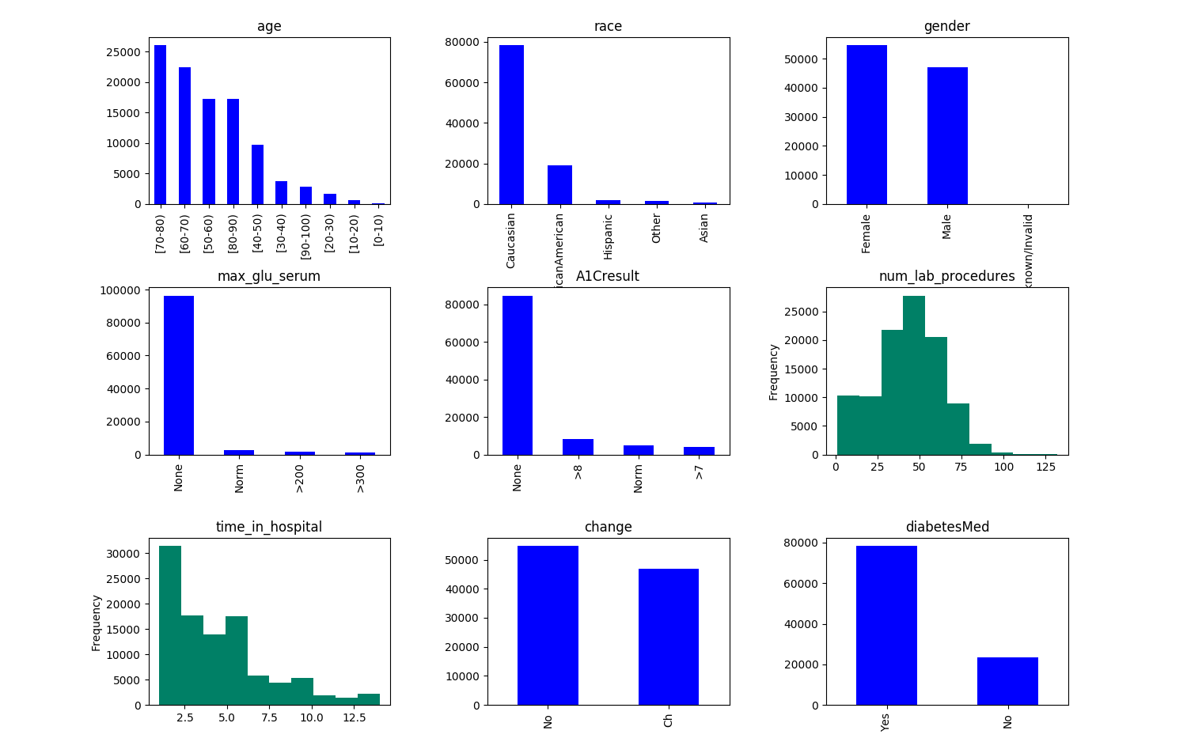Figure 1: Data distribution (blue:categorical, green:numerical)

Class attribute: Readmitted
- NO: if the patient was not readmitted into hospital.
- <30: if the patient was readmitted into hospital within 30 days from the encountering day of that patient.
- >30: if the patient was readmitted into hospital after 30 days from the encountering day of that patient.
In Figure 2, we show the class attribute distribution. Class attribute is fairly normally distributed. Although the number of NO examples are far more that <30 examples, however if we say >30 and <30 together represent YES, we can conclude it is normally distributed. Note that, we do not use >30 and <30 together in our work, instead they represent separate class.

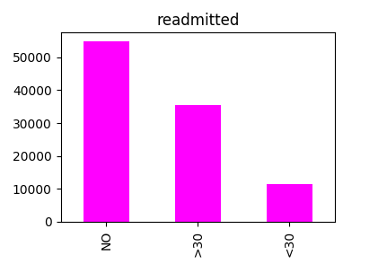Figure 2: Class attribute distribution

We try to find if there is any relation between num_lab_procedures and num_medications because we hypothesize that if number of lab procedures increase number of medications will increase and vice versa. To prove or disprove our hypothesis we draw scatter plot. As these attributes have different range of values, so we standardize them. Figure 3 shows scatter plot between num_lab_procedures and num_medications. From here we can not effectively say there are any relation between them.

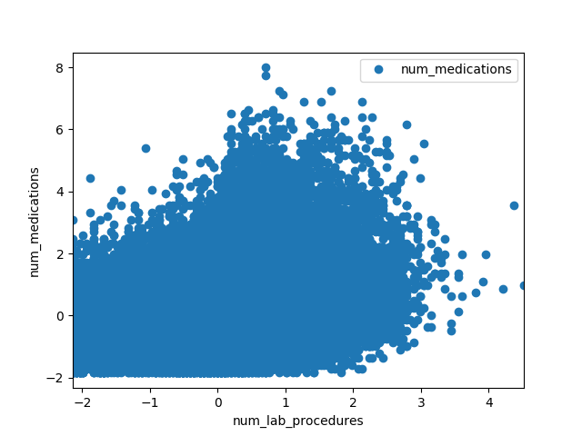Figure 3: Scatter plot between num_lab_procedures and num_medications

We try to find relation among number of different patients (such as in_patient, out_patient, emergency_patient) vs class attribute which is shown in Figure 4, but that does not seem to be so helpful. We also plot diag_1, diag_2, diag_3 in X, Y and Z-axis vs class attribute namely readmitted scatter plot so that we can see diagnosis relations with class attributes as well as among themselves, Figure 5 shows that. We assume that the number of instances is so big that visualization method is not helping so much. So from here we will directly go into classification task.
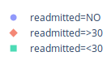

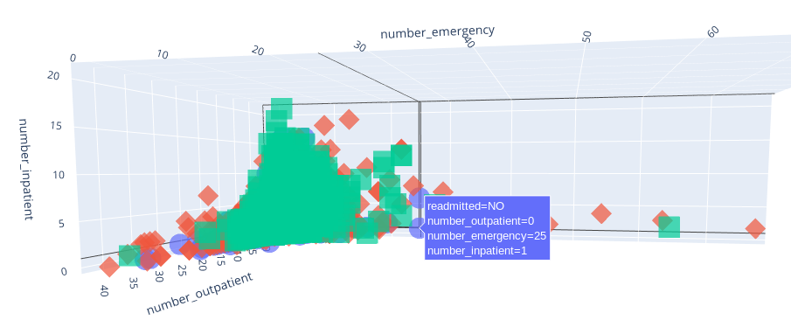Figure 4: In, out and emergency patient number vs Readmitted(class)
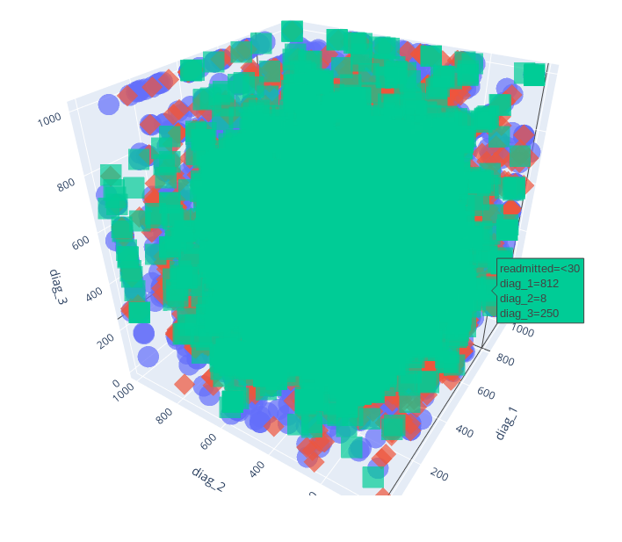Figure 5: diag_1, diag_2, diag_3 vs Readmitted(class)

We draw box plots class attribute (readmitted) vs num_diagnosis, num_lab_procedures and num_medications.

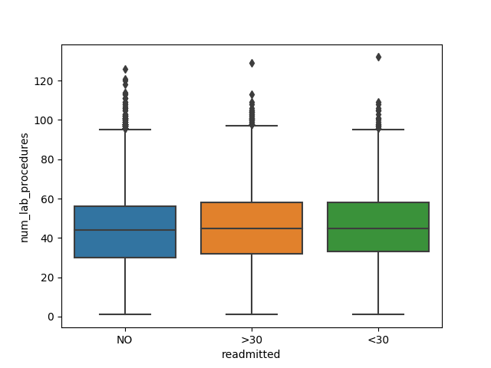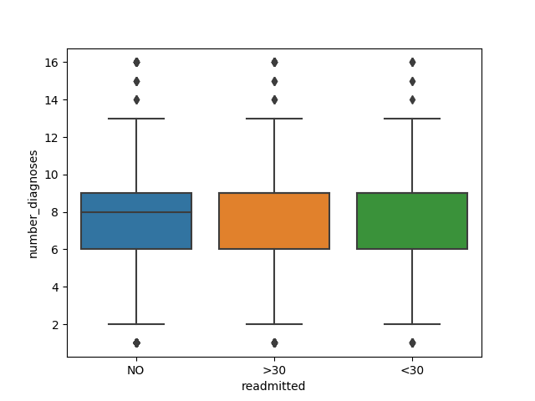

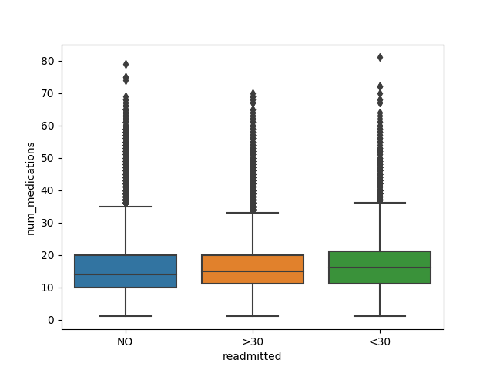

Figure: Box plots (readmitted vs num_lab_procedures, number_diagnosis and num_medications)

Decision Tree
a) Data Preprocessing: We have many features in our dataset which string values. We use label encoding to convert these labels into numeric form so as to make them machine-readable.
We divide the Dataset into training and test data by using the first 80000 records for training our model and the remaining 21700 records for test data.
b) 5-Fold Cross Validation: To evaluate different models we use 5-fold cross validation. We split our training set into 5 different subsets. We use 4 subsets to train our data and leave the last subset (or the last fold) as test data. We then average the model against each of the folds and then finalize our model.
We evaluate different models using 5-fold cross validation before finalizing our model.
c) Hyper Parameter Tuning: The Decision Tree has a lot of parameters that require tuning in order to derive the best possible model that reduces the generalization error as much as possible. We focused on 5 hyper parameters:
1) Max Depth: Maximum number of children nodes that can grow out of a Decision Tree until the tree is cut off. If set to 3, the tree will be cut off once 3 children nodes are used.
2) Min Samples Leaf: The minimum number of samples or data points that must be present inside the leaf node. If set to 0.04, it dictates that the tree should grow until the leaf nodes have at least 4% of the total samples in the data.
3) Splitting Criterion: The function used to measure the quality of a split. We have two functions in the scikit library i.e. “gini” for Gini Impurity and “entropy” for Information Gain.
4) Min Samples Split: Minimum number of samples required to split an internal node. When we increase this parameter, the tree becomes more constrained as it has to consider more samples to split a node.
5) Splitter: The strategy used to choose the split at each node. Supported strategies are “best” to choose the best split and “random” to choose the best random split.
Hyper Parameter Tuning Method
Grid Search: A very basic hyper parameter tuning method. We build a model for each combination of all the hyper parameter values provided, evaluating each model using 5-fold cross validation and selecting the architecture which produces the best results. The scoring metric used was accuracy.
We define our hyper-parameter space as follows:
grid_params = {
'criterion': ['gini','entropy'],
'splitter': ['best','random'],
'max_depth': [2,4,6],
'min_samples_leaf': [0.02, 0.04],
'min_samples_split': [0.2,0.5,0.8]
}
grid_object = GridSearchCV(estimator = dt, param_grid = grid_params, scoring = 'accuracy', cv = 5, n_jobs = -1)
We built models based on the above hyper-parameter space, evaluated each model using 5-fold cross validation and selected the parameter combination which produced the best results. The scoring metric used was accuracy.
d) Best Parameters Learned Using Grid Search: The best parameters learned using Grid Search are:
{'min_samples_split': 0.2, 'splitter': 'best', 'criterion': 'gini', 'max_depth': 2, 'min_samples_leaf': 0.04}
e) Accuracy of Model made with Best Parameters learned:
1) Accuracy of Model with Best Parameters (Hyper Parameter Tuning) using 5-fold cross validation:
Accuracy = 55.1 %
2) Accuracy of Model with Best Parameters (Hyper Parameter Tuning) on the Test Set:
Accuracy = 59.2 %

SVM(Support Vector Machines)

Data Preprocessing

Processed
Data
1-hot-encoded
Data
PCA

Raw Data
Clean Data

1-hot-encoded
Data
(categorical)
Processed
Data
PCA

Drawing 1: Data Processing procedure

While running SVM on our dataset, the first question comes into mind whether we should do SVM on categorical data. The answer is we should convert categorical data into numerical before running SVM [6]. As the feature values do not contains orders among them, we convert them first into 1-hot-encoding. So the dimension of the data is fueled up. To reduce the dimension we run PCA on it. Drawing 1 shows the procedure of data processing for SVM.

Table 4 shows how dimension of the data is first fueled up when we do 1-hot-encoding and then reduced down when we run PCA. Note that, we did two 1-hot-encoding to see how much the dimension is going to change. If we take only categorical attributes from cleaned dataset instead of taking all attributes the dimension can be reduced almost 11%. The intuition behind this is only diagnosis result should have more impact on class attribute and that is categorical. In Table 4, “Only categorical column” consists of all diagnosis result attributes, race, gender and age range.

Raw | Cleaned | 1-hot-encoded (taking all columns) | Keeping variance (σ ) | After PCA | Only categorical attributes | 1-hot-encoded (taking only categorical columns) | Keeping variance (σ ) | After PCA
101766, 50 | 101766, 40 | 101766, 2670 | .80 | 101766, 1888 | 101766,  33 | 101766,  2354 | .80 | 101766, 1666
101766, 50 | 101766, 40 | 101766, 2670 | .90 | 101766, 2204 | 101766,  33 | 101766,  2354 | .90 | 101766, 1941
101766, 50 | 101766, 40 | 101766, 2670 | .95 | 101766, 2381 | 101766,  33 | 101766,  2354 | .95 | 101766, 2098
Table 4: 1-hot-encoding and PCA on attributes for dimensionality reduction.

Subsampling technique

The dominating cost of running SVM iswhere in our case features>=1666 and observations=101766. So it is obvious that the running cost is very high so we follow subsampling technique in which for every dataset after running PCA we take .1%, 1% and 10% of the data and divide them into 20% test data and 80% train data, and find out if there is any significant increase of accuracy with the increase of data by 10 multitutde. So far our hyperparameter is keep_variance denoted by σ while running PCA and subsample_size denoted by n.

Table 5, 7 and 9 show mean accuracy, precision, recall and f1-score on the dataset that was produced by running PCA on all attributes while σ was 80%, 90% and 95% respectively. On the other hand Table 6, 8 and 10 shows 5-fold cross validation score on the dataset that was produced using same process.
σ | n | Data distribution | Support | Accuracy | Precision | Recall | f1-score
80% | .1% | Train: 81, 1888 | NO: 43  >30: 26  <30: 12 | 0.57 | 0.85 | 0.39 | 0.34
80% | .1% | Test: 21, 1888 | NO: 7  >30: 12  <30: 2 | 0.33 | 0.11 | 0.33 | 0.17
80% | 1% | Train: 814, 1888 | NO: 450  >30: 264  <30: 100 | 0.61 | 0.86 | 0.41 | 0.39
80% | 1% | Test: 204, 1888 | NO: 124  >30: 54  <30: 26 | 0.61 | 0.20 | 0.33 | 0.25
80% | 10% | Train: 8141, 1888 | NO: 4434  >30: 2857  <30: 850 | 0.61 | 0.86 | 0.43 | 0.42
80% | 10% | Test: 2036, 1888 | NO: 1098  >30: 731  <30: 207 | 0.53 | 0.32 | 0.33 | 0.25
Table 5: Accuracy, Precision, Recall and f1-score where σ=80% (all attributes)
σ | n | Data distribution | 1-fold | 2-fold | 3-fold | 4-fold | 5-fold
80% | .1% | 102, 1888 | 0.333 | 0.333 | 0.333 | 0.333 | 0.333
80% | 1% | 1018, 1888 | 0.330 | 0.330 | 0.333 | 0.333 | 0.330
80% | 10% | 10177, 1888 | 0.332 | 0.343 | 0.335 | 0.337 | 0.334
Table 6: 5-fold cross validation where σ=80% (all attributes)

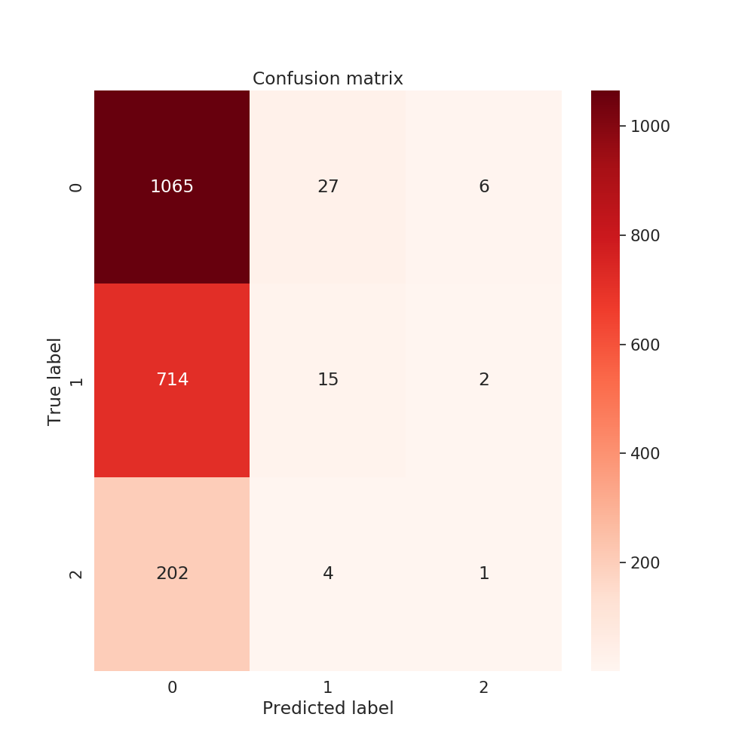Figure 6: σ=80%, n=10%
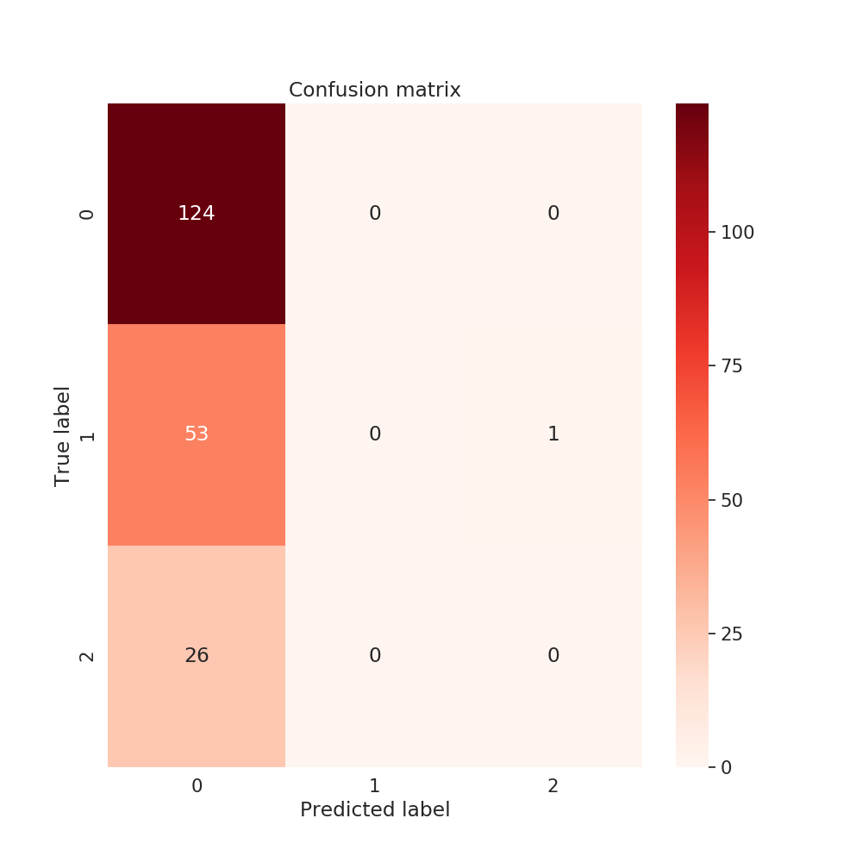Figure 7: σ=80%, n=1%
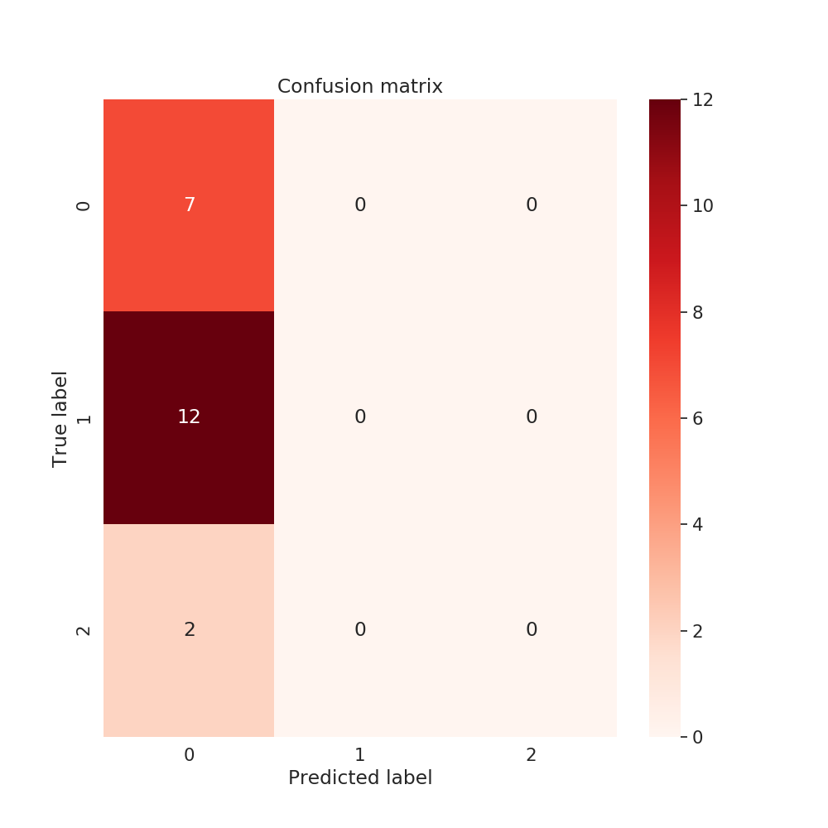Figure 8: σ=80%, n=.1%

σ | n | Data distribution | Support | Accuracy | Precision | Recall | f1-score
90% | .1% | Train: 81, 2204 | NO: 43  >30: 32  <30: 6 | 0.58 | 0.85 | 0.47 | 0.44
90% | .1% | Test: 21, 2204 | NO: 9  >30: 9  <30: 3 | 0.42 | .14 | .33 | .20
90% | 1% | Train: 814, 2204 | NO: 420  >30: 298  <30: 96 | .60 | .85 | .45 | .44
90% | 1% | Test: 204, 2204 | NO: 109  >30: 70  <30: 25 | .53 | .18 | .33 | .23
90% | 10% | Train: 8141, 2204 | NO: 4383  >30: 2858  <30: 900 | .61 | .86 | .44 | .43
90% | 10% | Test: 2036, 2204 | NO: 1075  >30: 745  <30: 216 | .52 | .33 | .33 | .25
Table 7: Accuracy, Precision, Recall and f1-score where σ=90% (all attributes)
σ | n | Data distribution | 1-fold | 2-fold | 3-fold | 4-fold | 5-fold
90% | .1% | 102, 2204 | 0.333 | 0.333 | 0.333 | 0.333 | 0.333
90% | 1% | 1018, 2204 | 0.333 | 0.324 | 0.338 | 0.330 | 0.333
90% | 10% | 10177, 2204 | 0.339 | 0.330 | 0.337 | 0.330 | 0.331
Table 8: 5-fold cross validation where σ=90% (all attributes)

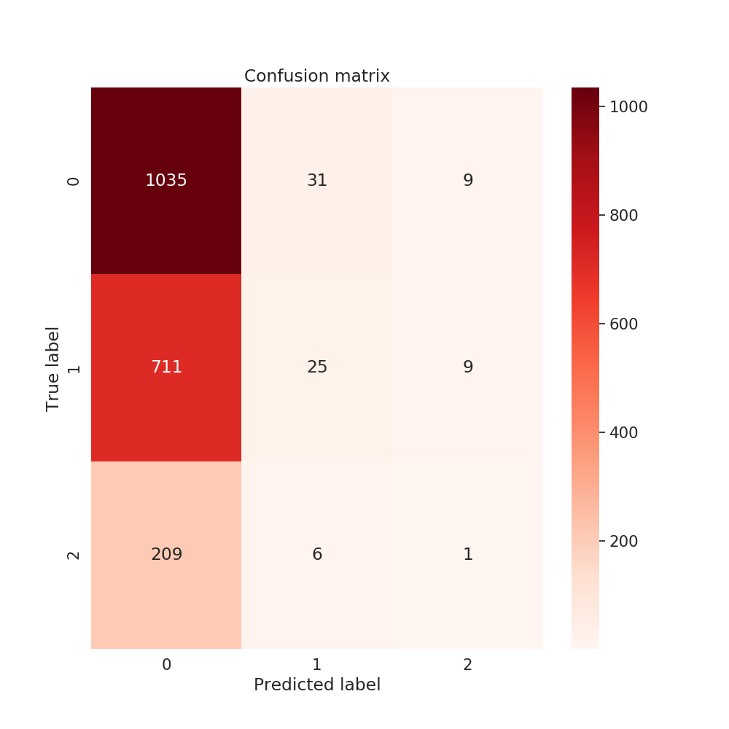Figure 9: σ=90%, n=10%
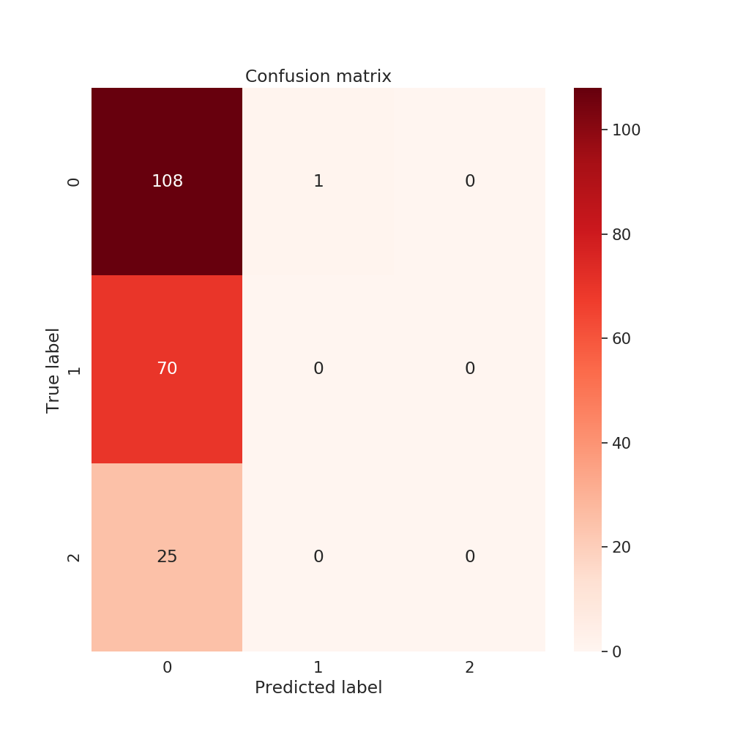Figure 10: σ=90%, n=1%
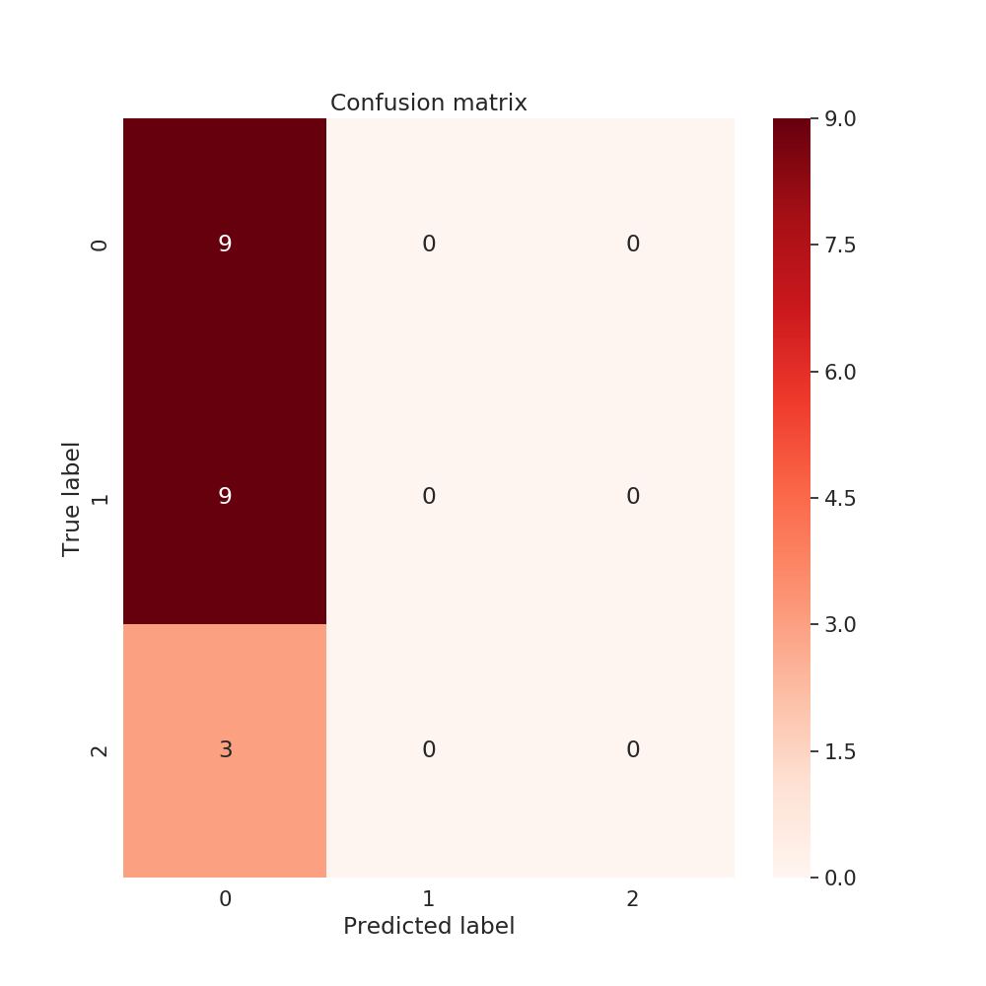Figure 11: σ=90%, n=.1%

σ | n | Data distribution | Support | Accuracy | Precision | Recall | f1-score
95% | .1% | Train: 81, 2381 | NO: 53  >30: 25  <30: 3 | .69 | .56 | .37 | .34
95% | .1% | Test: 21, 2381 | NO: 12  >30: 6  <30: 3 | .57 | .19 | .33 | .24
95% | 1% | Train: 814, 2381 | NO: 444  >30: 289  <30: 81 | .62 | .86 | .44 | .43
95% | 1% | Test: 204, 2381 | NO: 120  >30: 61  <30: 23 | .59 | .20 | .33 | .25
95% | 10% | Train: 8141, 2381 | NO: 4427  >30: 2859  <30: 855 | .61 | .85 | .43 | .41
95% | 10% | Test: 2036, 2381 | NO: 1095  >30: 719  <30: 222 | .53 | .31 | .33 | .25
Table 9: Accuracy, Precision, Recall and f1-score where σ=95% (all attributes)

σ | n | Data distribution | 1-fold | 2-fold | 3-fold | 4-fold | 5-fold
95% | .1% | 102, 2381 | 0.333 | 0.333 | 0.333 | 0.333 | 0.333
95% | 1% | 1018, 2381 | 0.330 | 0.333 | 0.330 | 0.342 | 0.330
95% | 10% | 10177, 2381 | 0.330 | 0.335 | 0.332 | 0.335 | 0.336
Table 10: 5-fold cross validation where σ=95% (all attributes)
Table 11 and 13 shows mean accuracy, precision, recall and f1-score on the dataset that was produced by running PCA on one-hot encoding of only diagnosis attributes while the minimum variance to keep was 80% and 90%. On the other hand Table 12 and 14 shows 5-fold cross validation score on the dataset that was produced using same process.
σ | n | Data distribution | Support | Accuracy | Precision | Recall | f1-score
80% | .1% | Train: 81, 1666 | NO: 40  >30: 30  <30: 11 | .56 | .84 | .45 | .41
80% | .1% | Test: 21, 1666 | NO: 14  >30: 4  <30: 3 | .67 | .22 | .33 | .27
80% | 1% | Train: 814, 1666 | NO: 420  >30: 298  <30: 96 | .58 | .85 | .42 | .39
80% | 1% | Test: 204, 1666 | NO: 124  >30: 62  <30: 18 | .60 | .20 | .33 | .25
80% | 10% | Train: 8141, 1666 | NO: 4354  >30: 2838  <30: 949 | .59 | .84 | .42 | .39
80% | 10% | Test: 2036, 1666 | NO: 1098  >30: 714  <30: 224 | .53 | .33 | .333 | .25
Table 11: Accuracy, Precision, Recall and f1-score on 80% explained variance PCA (diagnosis attributes)

σ | n | Data distribution | 1-fold | 2-fold | 3-fold | 4-fold | 5-fold
80% | .1% | 102, 1666 | 0.333 | 0.333 | 0.333 | 0.333 | 0.333
80% | 1% | 1018, 1666 | 0.337 | 0.324 | 0.333 | 0.330 | 0.327
80% | 10% | 10177, 1666 | 0.332 | 0.337 | 0.327 | 0.336 | 0.328
Table 12: 5-fold cross validation on 80% explained variance PCA (diagnosis attributes)

σ | n | Data distribution | Support | Accuracy | Precision | Recall | f1-score
90% | .1% | Train: 81, 1942 | NO: 49  >30: 25  <30: 7 | .68 | .88 | .52 | .53
90% | .1% | Test: 21, 1942 | NO: 9  >30: 9  <30: 3 | .43 | .14 | .33 | .20
90% | 1% | Train: 814 , 1942 | NO: 444  >30: 289  <30: 81 | .58 | .85 | .43 | .40
90% | 1% | Test: 204, 1942 | NO: 124  >30: 62  <30: 18 | .54 | .18 | .33 | .23
90% | 10% | Train: 8141, 1942 | NO: 4383  >30: 2858  <30: 900 | .61 | .85 | .43 | .42
90% | 10% | Test: 2036 , 1942 | NO: 1098  >30: 731  <30: 207 | .52 | .31 | .33 | .25
Table 13: Accuracy, Precision, Recall and f1-score on 90% explained variance PCA (diagnosis attributes)

σ | n | Data distribution | 1-fold | 2-fold | 3-fold | 4-fold | 5-fold
90% | .1% | 102, 1942 | 0.333 | 0.333 | 0.333 | 0.333 | 0.333
90% | 1% | 1018, 1942 | 0.337 | 0.327 | 0.330 | 0.333 | 0.333
90% | 10% | 10177, 1942 | 0.332 | 0.327 | 0.339 | 0.334 | 0.333
Table 14: 5-fold cross validation on 90% explained variance PCA (diagnosis attributes)

From the general, we decide to keep two dataset for further SVM parameter tuning that we call 95-pca-all and 90-pca-diag. Note that, 95-pca-all means the dataset which was produced by taking all attributes and keeping variance 95% while running PCA for dimensionality reduction. And 90-pca-diag means the dataset which was produced by taking only diagnosis result attributes and keeping variance 90% while running PCS for dimensionality reduction.

We decide to keep 95-pca-all to further SVM hyper-parameter tuning. We found the best accuracy for the following hyper-parameters.
SVC_params{
kernel: ‘poly’,
gamma: ‘scale’,
degree: 3,
shrinking: true
}

Using this hyper-parameters we get training accuracy=65% and test accuracy=58%.

Deep Learning
Finally we choose deep learning to do our classification task.
Preprocessing
In this task we do some preprocessing in our class variables. From Figure 2 we see that, the class attribute instances are highly skewed. So we take >30 and <30 as Yes attribute. Now the number of instances for each class attribute values almost close. We split the dataset into 60% train and 40% test. Since we found no use of validation data and did not use test data in training procedure, we did not make any validation split. As our dataset has mixture of categorical and numerical attribute values, we first do one-hot encoding of the categorical attributes. Now all the attribute instances are numerical but are in different range. So we standardize within normal distribution using scikit-learng StandardScaler[7].

Class attribute
instances
>30&<30
→ Yes

Numerical
attributes
Standardized
data
Clean Data
Processed
Data

1-hot-encoded
Of categorical
attributes

Drawing 2: Data Processing for NN

The dataset description is in Table-15.
Full | Traing-60% | Test-40% | Class Attribute
101766, 2361 | 61059, 2361 | 40707, 2361 | No, Yes(>30&<30)
Table 15: Dataset distribution for Neural Network
Network Architecture
We use the following network architecture and some changes to it to see if that has any significance on the output.

1
2
3
.
.
.
2361
Feature Vector
1
Some combination of BatchNorm, ReLU and Dropout layer
1
Some combination of BatchNorm, ReLU and Dropout layer
1
Some combination of BatchNorm, ReLU and Dropout layer
1
Some combination of BatchNorm, ReLU and Dropout layer
2
2
2
...
2
...
1
...
800
2
1

1600
...
400
100
2
32

Feature Vector
Linear layer
Linear layer
Linear layer
Linear layer
Linear layer
Output layer

Drawing 3: Network Architecture
As our features are flat, we did not use any convolutional layers. The data dimension is only reduced in the linear layer label, no reduction is conducted in BatchNorm, ReLU or Dropout layer. These three layers are basically used for regularization or penalty purposes. By using several combination of them and combination of other parameters such as learning rate, momentum and number of epoch the training procedure runs, we get different accuracy result on training and testing data. We will go through one by one and describe possible reasons.
Network 1
(classifier): Sequential(
(0): Linear(in_features=2361, out_features=1600, bias=True)
(1): BatchNorm1d(1600, eps=1e-05, momentum=0.1, affine=True, track_running_stats=True)
(2): Linear(in_features=1600, out_features=800, bias=True)
(3): BatchNorm1d(800, eps=1e-05, momentum=0.1, affine=True, track_running_stats=True)
(4): ReLU()
(5): Linear(in_features=800, out_features=400, bias=True)
(6): BatchNorm1d(400, eps=1e-05, momentum=0.1, affine=True, track_running_stats=True)
(7): ReLU()
(8): Linear(in_features=400, out_features=100, bias=True)
(9): BatchNorm1d(100, eps=1e-05, momentum=0.1, affine=True, track_running_stats=True)
(10): ReLU()
(11): Linear(in_features=100, out_features=32, bias=True)
(12): BatchNorm1d(32, eps=1e-05, momentum=0.1, affine=True, track_running_stats=True)
(13): ReLU()
(14): Linear(in_features=32, out_features=2, bias=True)
)

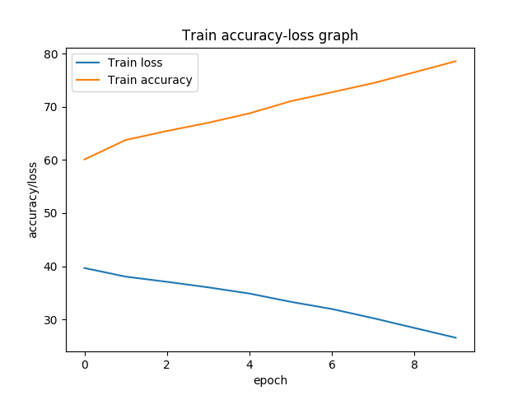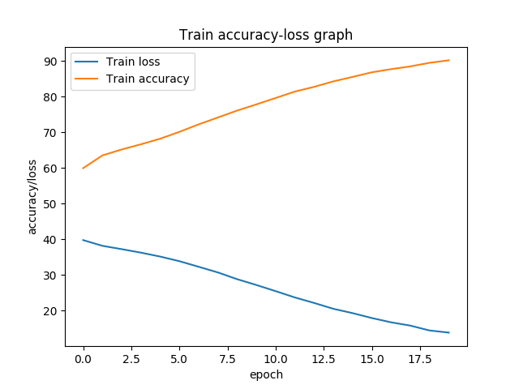

Figure 12: Loss-accuracy graph

We increase the epoch from 10 to 20 which significantly increase our training accuracy from 78% to 90%. But that does not improve our testing accuracy. From here we conclude that, by increasing the number of epochs we overfit the training data. So we induce more penalty by adding dropout layer.
We tried different learning rate and momentum but we found 0.01 and 0.9 works better and converges faster. We use cross entropy loss as our loss function and Stochastic Gradient Descent (SGD) as our optimizer. The test accuracy is reported in Table 16 for network-1.
Epoch | Learning rate | Momentum | Loss function | Optimizer | Test Accuracy
10 | 0.01 | 0.9 | Cross Entropy | SGD | 58%
20 | 0.01 | 0.9 | Cross Entropy | SGD | 60%
Table 16: Test accuracy on different hyper-parameters
Network 2

(classifier): Sequential(
(0): Linear(in_features=2361, out_features=1600, bias=True)
(1): BatchNorm1d(1600, eps=1e-05, momentum=0.1, affine=True, track_running_stats=True)
(2): Dropout(p=0.5, inplace=False)
(3): ReLU()
(4): Linear(in_features=1600, out_features=800, bias=True)
(5): BatchNorm1d(800, eps=1e-05, momentum=0.1, affine=True, track_running_stats=True)
(6): Dropout(p=0.5, inplace=False)
(7): ReLU()
(8): Linear(in_features=800, out_features=400, bias=True)
(9): BatchNorm1d(400, eps=1e-05, momentum=0.1, affine=True, track_running_stats=True)
(10): Dropout(p=0.5, inplace=False)
(11): ReLU()
(12): Linear(in_features=400, out_features=100, bias=True)
(13): BatchNorm1d(100, eps=1e-05, momentum=0.1, affine=True, track_running_stats=True)
(14): Dropout(p=0.5, inplace=False)
(15): ReLU()
(16): Linear(in_features=100, out_features=32, bias=True)
(17): BatchNorm1d(32, eps=1e-05, momentum=0.1, affine=True, track_running_stats=True)
(18): ReLU()
(19): Linear(in_features=32, out_features=2, bias=True)
)

Epoch | Learning rate | Momentum | Loss function | Optimizer | Test Accuracy
15 | 0.01 | 0.9 | Cross Entropy | SGD | 66%
20 | 0.01 | 0.9 | Cross Entropy | SGD | 66%
Table 17: Test accuracy on different hyper-parameters
This time we introduce dropout layer to induce more penalty to recover from penalty. We see from Figure 13, even we increase epoch the training accuracy does not increase that much and from Table 17 we can see the test accuracy is increased and not overfitted.

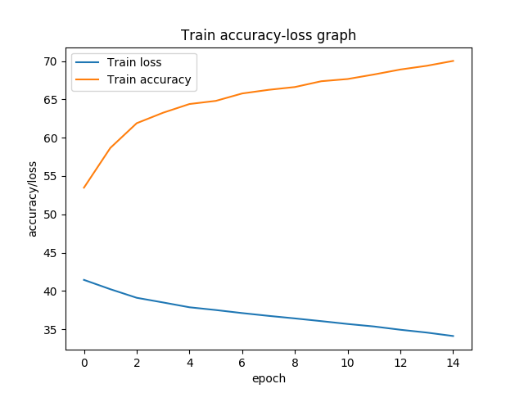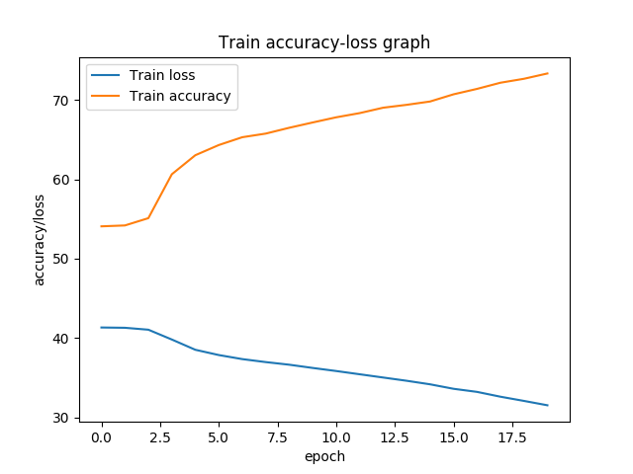

Figure 12: Loss-accuracy graph

Network 3

In our final network, we remove BatchNorm layer and keep dropout and relu to see how BatchNorm is affecting in our testing accuracy. We found the presence of these three together makes the best test accuracy so far.

(classifier): Sequential(
(0): Linear(in_features=2361, out_features=1600, bias=True)
(1): Dropout(p=0.5, inplace=False)
(2): ReLU()
(3): Linear(in_features=1600, out_features=800, bias=True)
(4): Dropout(p=0.5, inplace=False)
(5): ReLU()
(6): Linear(in_features=800, out_features=400, bias=True)
(7): Dropout(p=0.5, inplace=False)
(8): ReLU()
(9): Linear(in_features=400, out_features=100, bias=True)
(10): Dropout(p=0.5, inplace=False)
(11): ReLU()
(12): Linear(in_features=100, out_features=32, bias=True)
(13): ReLU()
(14): Linear(in_features=32, out_features=2, bias=True)
)

Epoch | Learning rate | Momentum | Loss function | Optimizer | Test Accuracy
30 | 0.01 | 0.9 | Cross Entropy | SGD | 63%
Table 18: Test accuracy on different hyper-parameters
We see dropout improves than batch norm but they both together works better. Figure 13 shows training loss and accuracy graph.
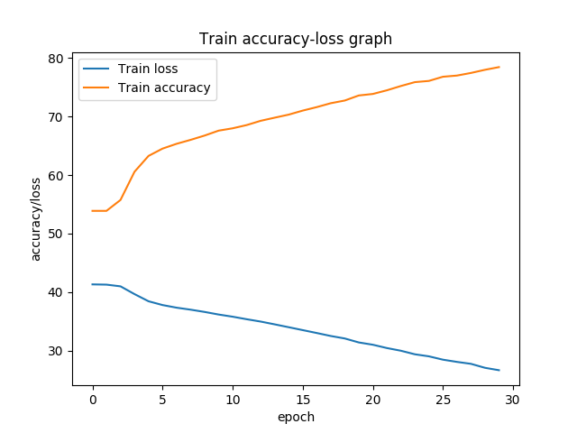
Figure 13: Loss-accuracy graph

From all these graph, one thing is very prominent and that is the loss of the learning is linear. We tried by increasing and decreasing hidden layers if that changes the loss function. But that does not help.
References:
1. https://archive.ics.uci.edu/ml/index.php
2. https://www.analyticsvidhya.com/blog/2018/05/24-ultimate-data-science-projects-to-boost-your-knowledge-and-skills/
3. https://www.dataoptimal.com/data-science-projects-2018/
4. https://archive.ics.uci.edu/ml/datasets/diabetes+130-us+hospitals+for+years+1999-2008
5. https://www.hindawi.com/journals/bmri/2014/781670/
6. https://www.quora.com/How-can-l-apply-an-SVM-for-categorical-data
7. https://scikit-learn.org/stable/modules/generated/sklearn.preprocessing.StandardScaler.html

