Report
Name: Anowarul Kabir
Date: 8th October, 2019

Data distribution
Number of attributes: 16
Train set: 7494
Test set: 3498
Missing rows/columns: No
Data cleaning: No

System architecture
Operating system: Ubuntu 18.04
Language and library used: Python 3.6, scikit-learn v0.21.3 DecisionTreeClassifier

Github link
The code can be found in the following github link: Link

Scores
The Table-1 shows accuracy, precision, recall based on several hyper-parameters such as criterion (gini, entropy), splitter (best, random), data-set (train, test), max-depth (none, 10). Best test accuracy is found on entropy, random, none (max-depth) combination. (Note that, max-leaf-nodes hyper-parameter makes the scores worse, that is why it is not mentioned). The green colored row shows the combination of the best accuracy score.

Model | Splitter | Data Set | Max-depth | Accuracy | Precision | Recall
Gini | Best | Train | None | 1.0 | 1.0 | 1.0
 | Best | Test | None | 0.917 | 0.921 | 0.917
 | Random | Train | None | 1.0 | 1.0 | 1.0
 | Random | Test | None | 0.913 | 0.913 | 0.912
 | Best | Train | 10 | 0.991 | 0.991 | 0.991
 | Best | Test | 10 | 0.909 | 0.914 | 0.909
 | Random | Train | 10 | 0.971 | 0.972 | 0.971
 | Random | Test | 10 | 0.900 | 0.901 | 0.903
Entropy | Best | Train | None | 1.0 | 1.0 | 1.0
 | Best | Test | None | 0.913 | 0.915 | 0.913
 | Random | Train | None | 1.0 | 1.0 | 1.0
 | Random | Test | None | 0.936 | 0.938 | 0.937
 | Best | Train | 10 | 0.996 | 0.996 | 0.996
 | Best | Test | 10 | 0.922 | 0.923 | 0.922
 | Random | Train | 10 | 0.982 | 0.983 | 0.982
 | Random | Test | 10 | 0.913 | 0.915 | 0.914
Table 1: Accuracy, Precision, Recall for different Decision Tree Model with hyper-parameters. Best accuracy found colored in green.
Table-2 shows 5-fold cross validation score on decision tree model.
Decision Tree(with below mentioned model) | 1st fold | 2nd fold | 3rd fold | 4th fold | 5th fold
Gini | 0.956 | 0.964 | 0.958 | 0.951 | 0.965
Entropy | 0.959 | 0.962 | 0.966 | 0.965 | 0.963
Table 2: 5-fold Cross Validation Score

Confusion matrix:
This section shows confusion matrix of corresponding Decision tree classifier with different hyper-parameters. The confusion matrix describes for which class the classifier is predicting wrong class label in a high degree. From the matrices, we can say the classifier is predicting wrong 1 vs. 7, 3 vs 5, 5 vs 9 and 4 vs. 9.

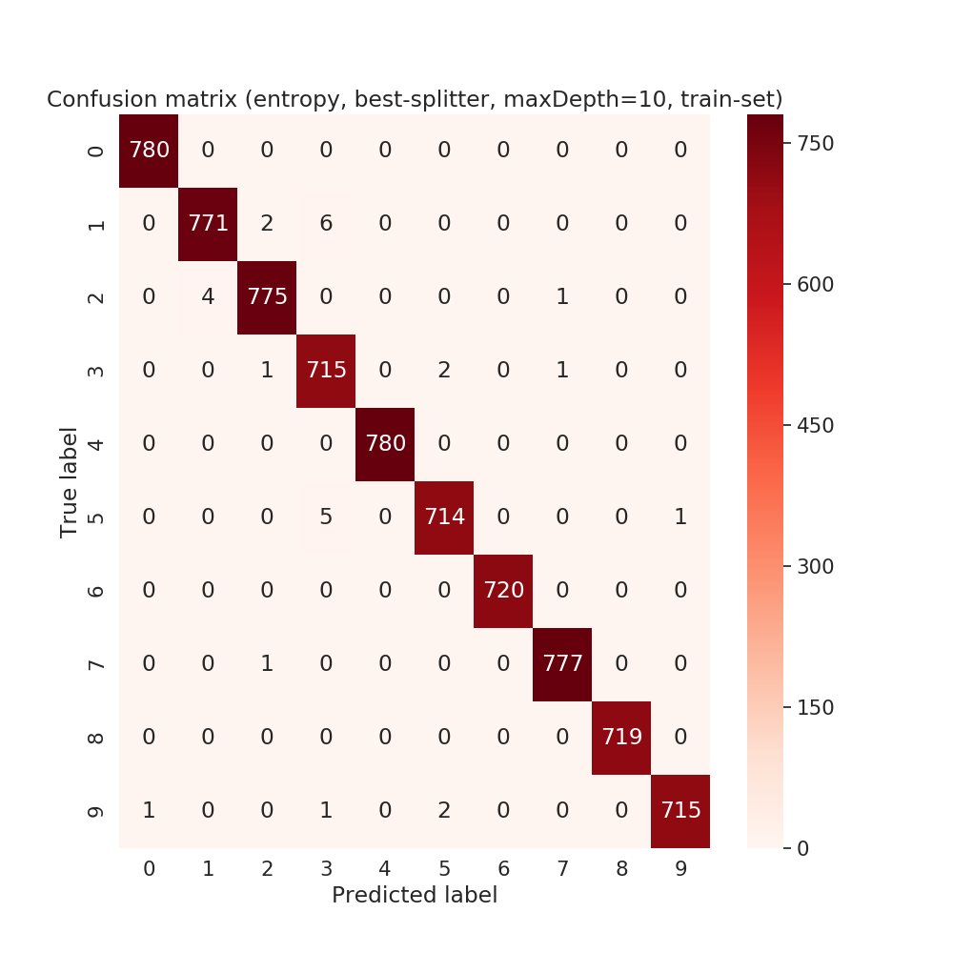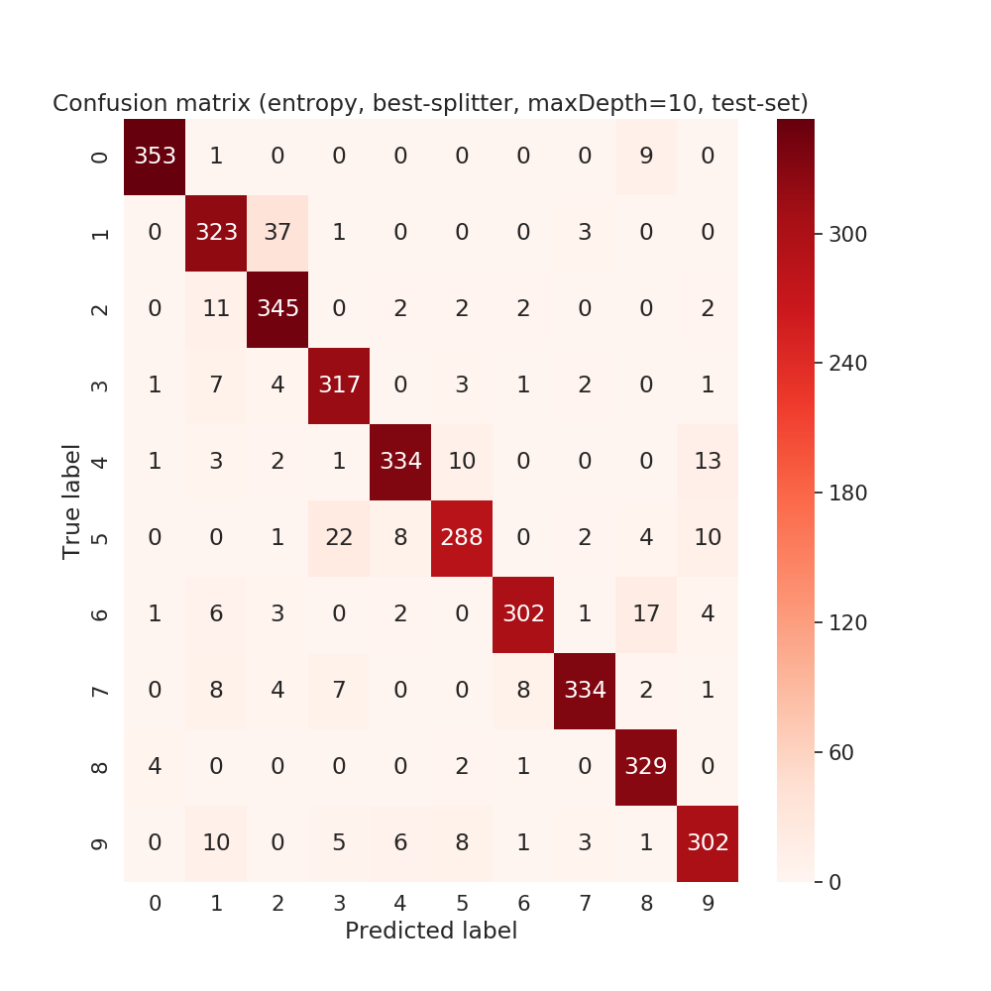

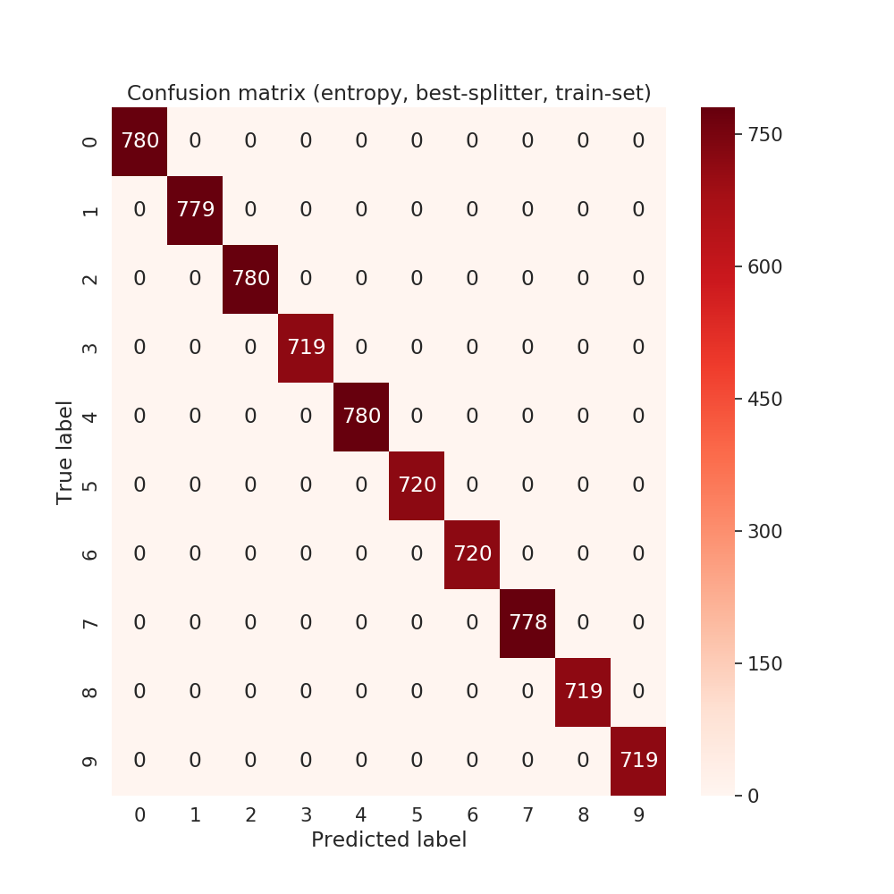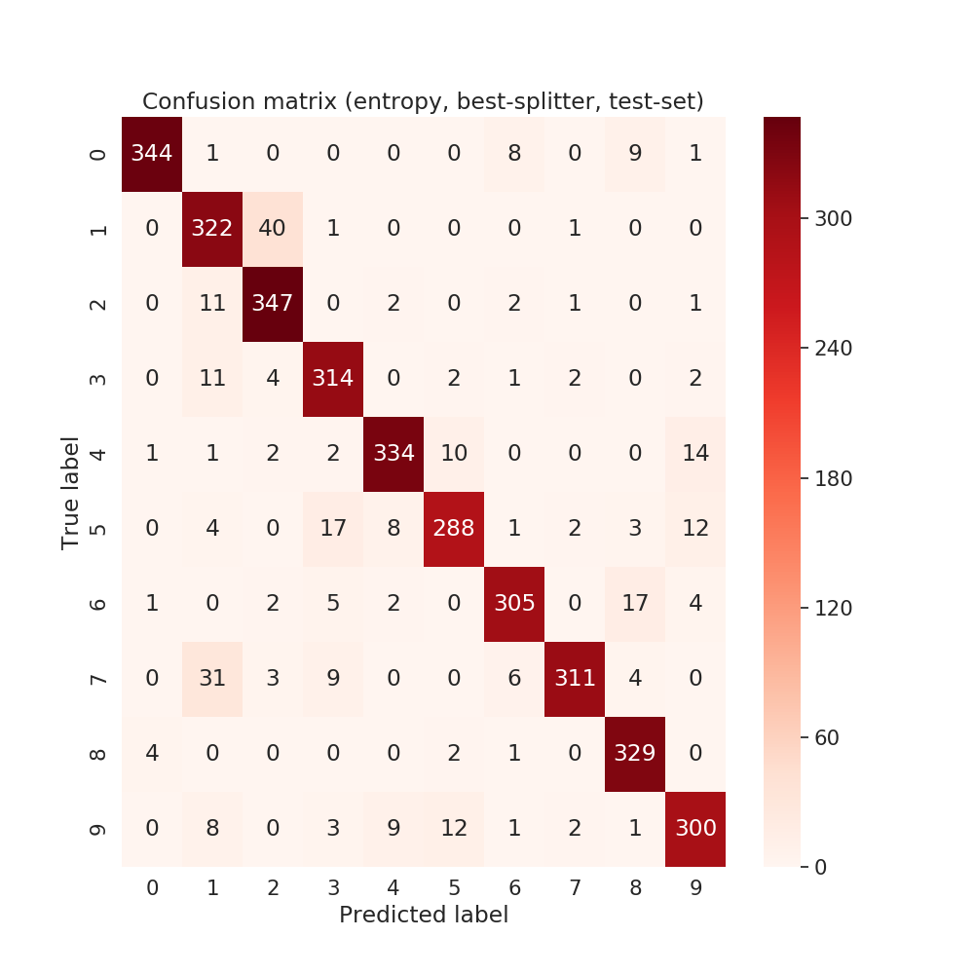

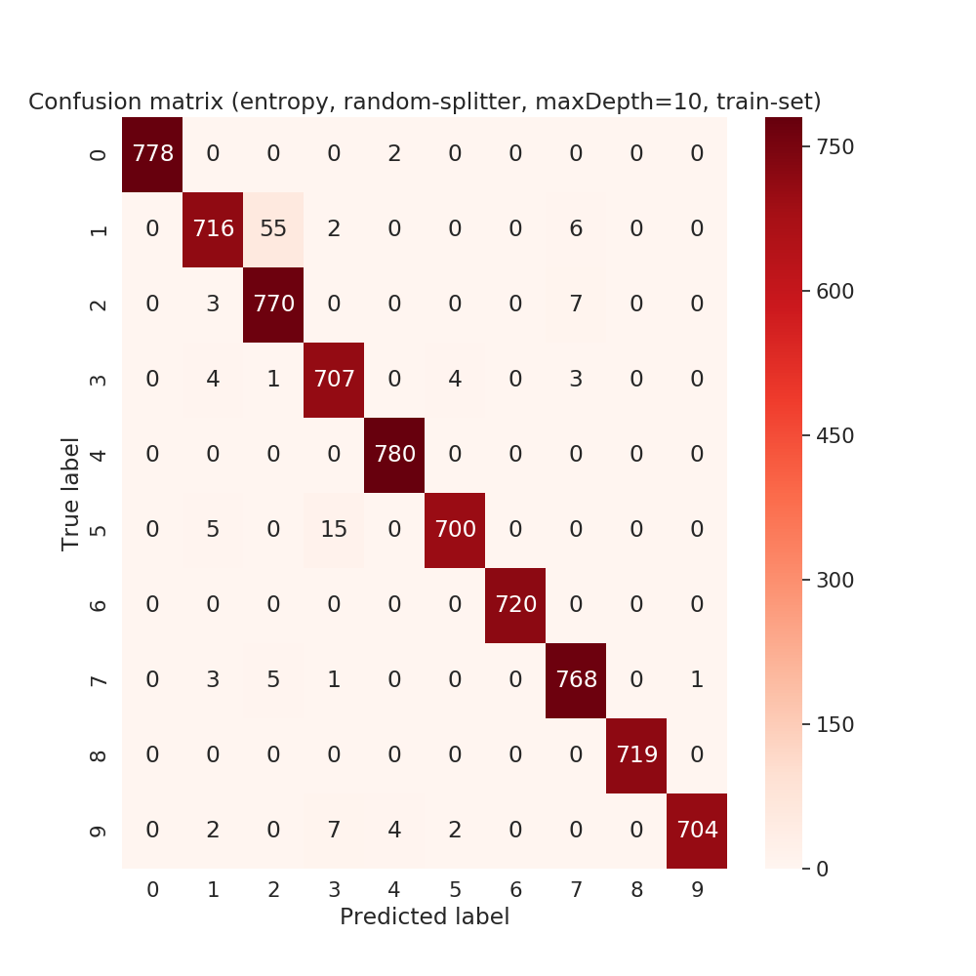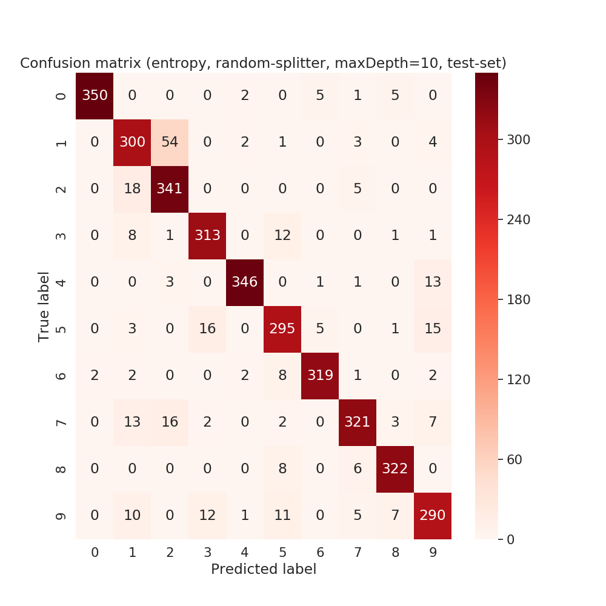

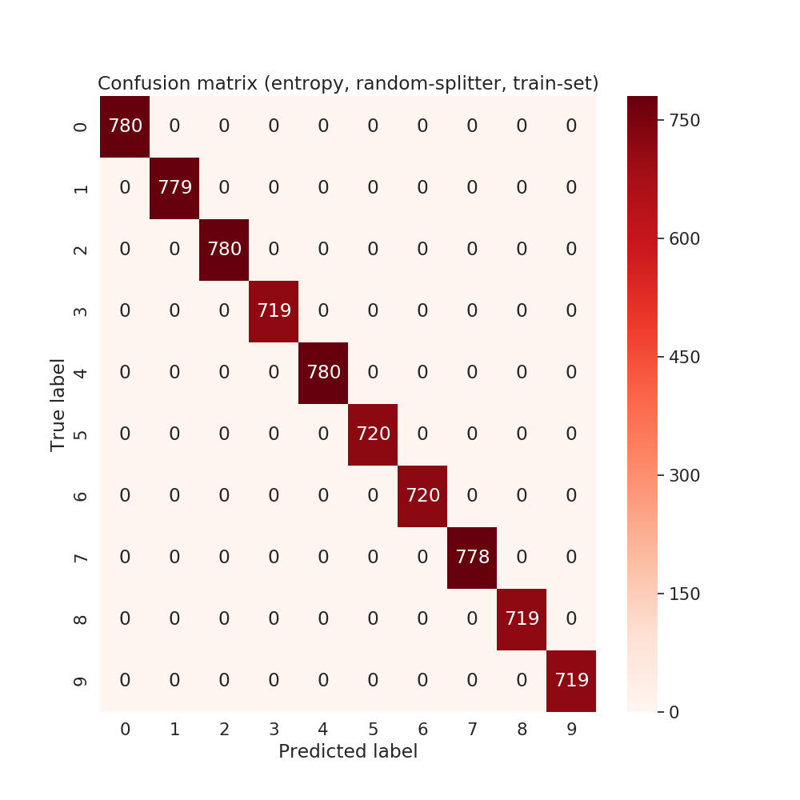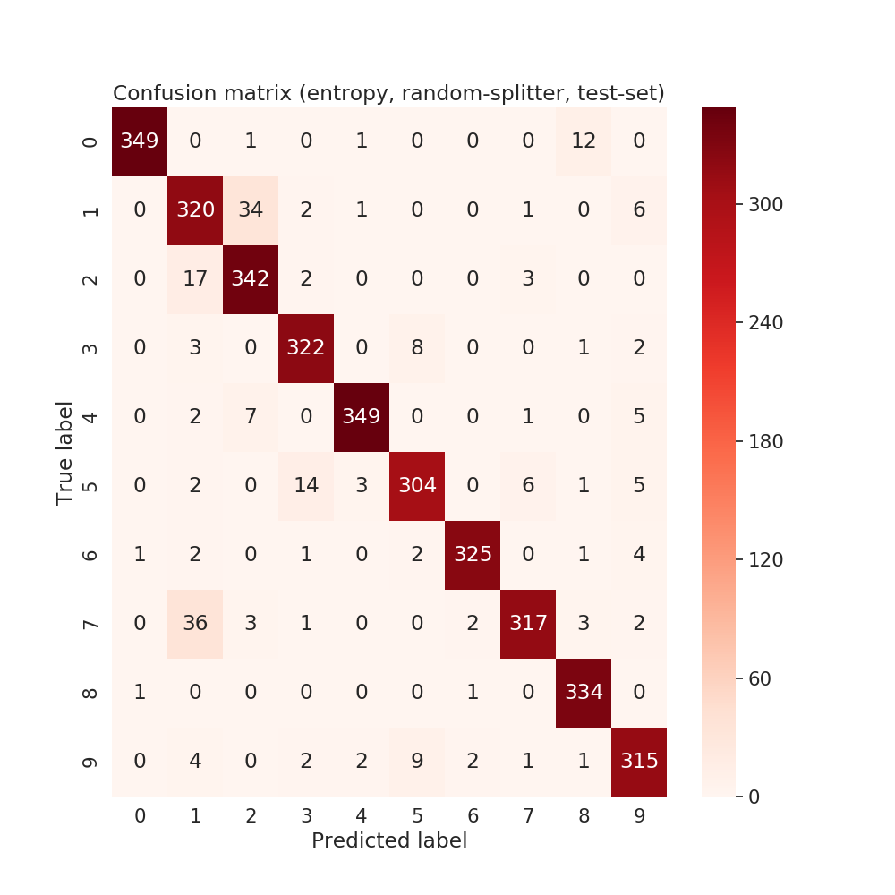

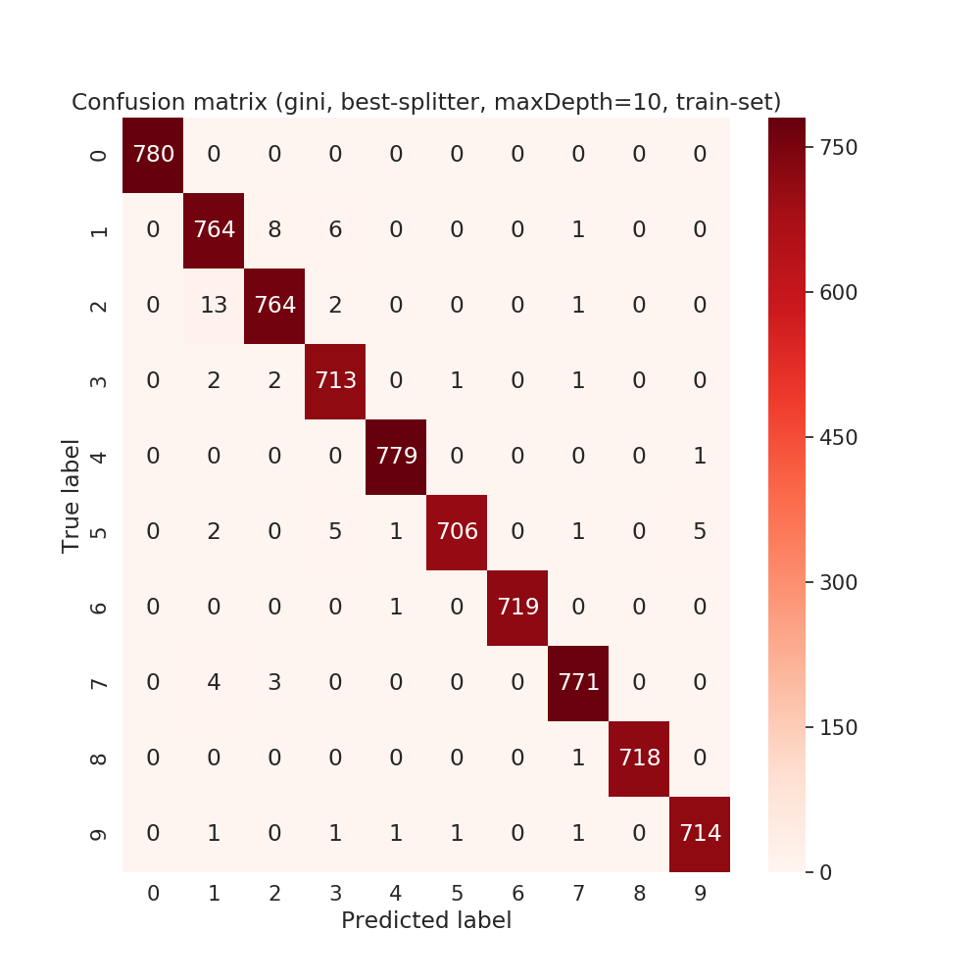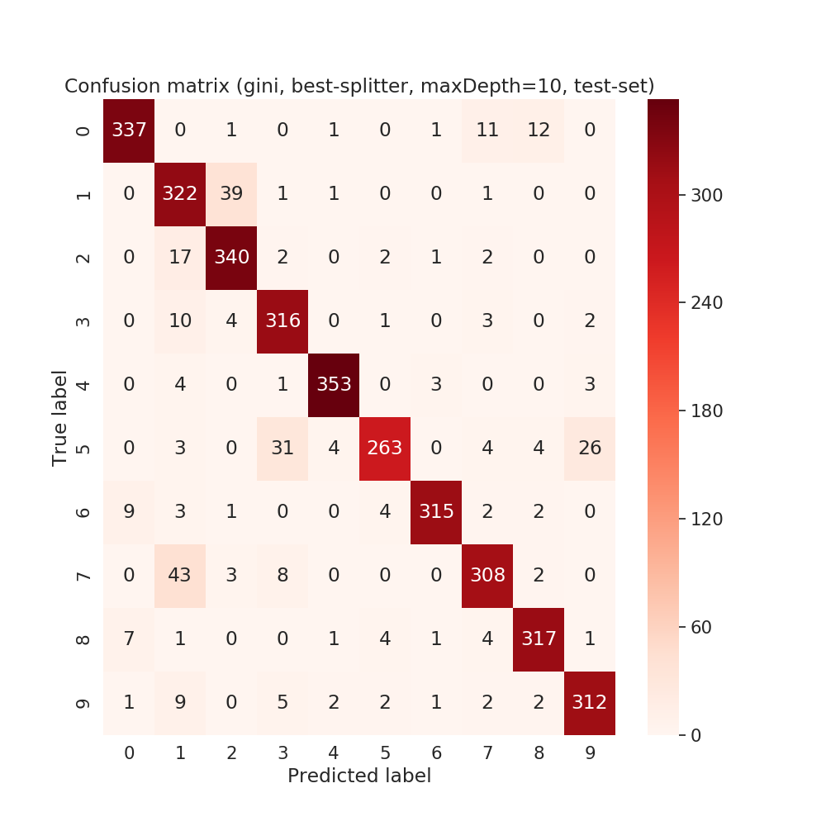

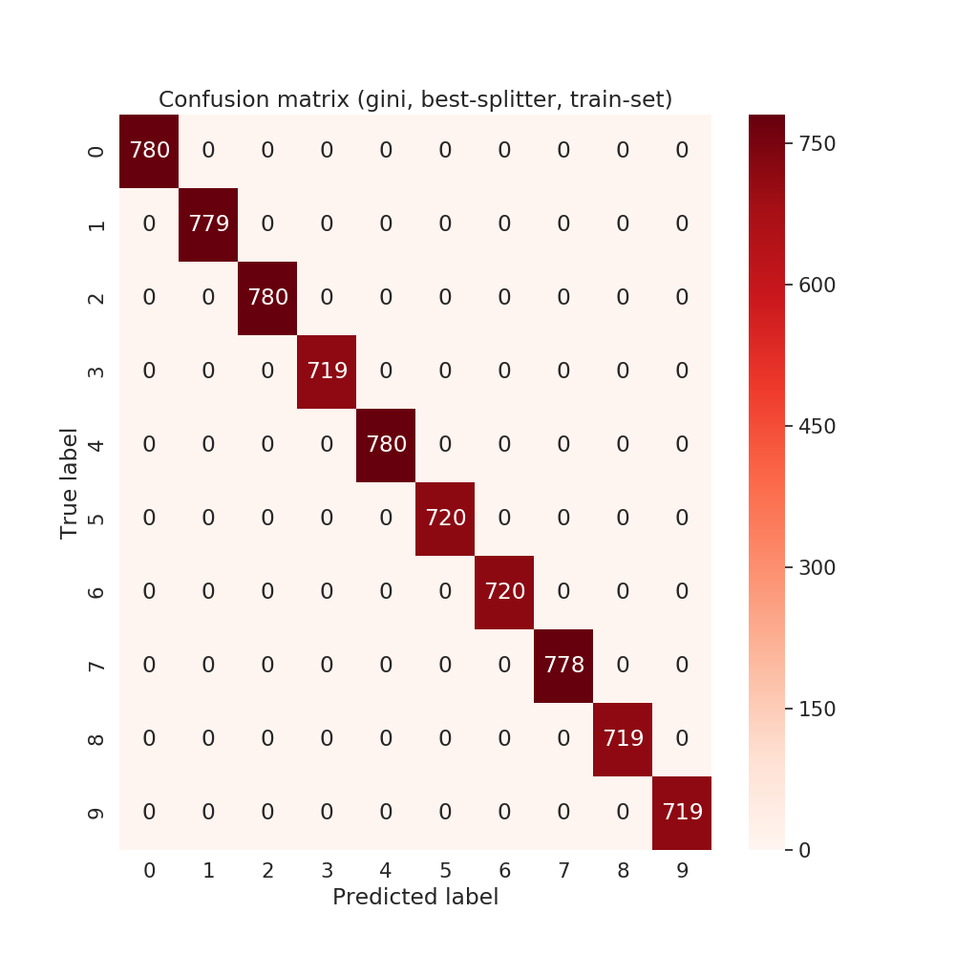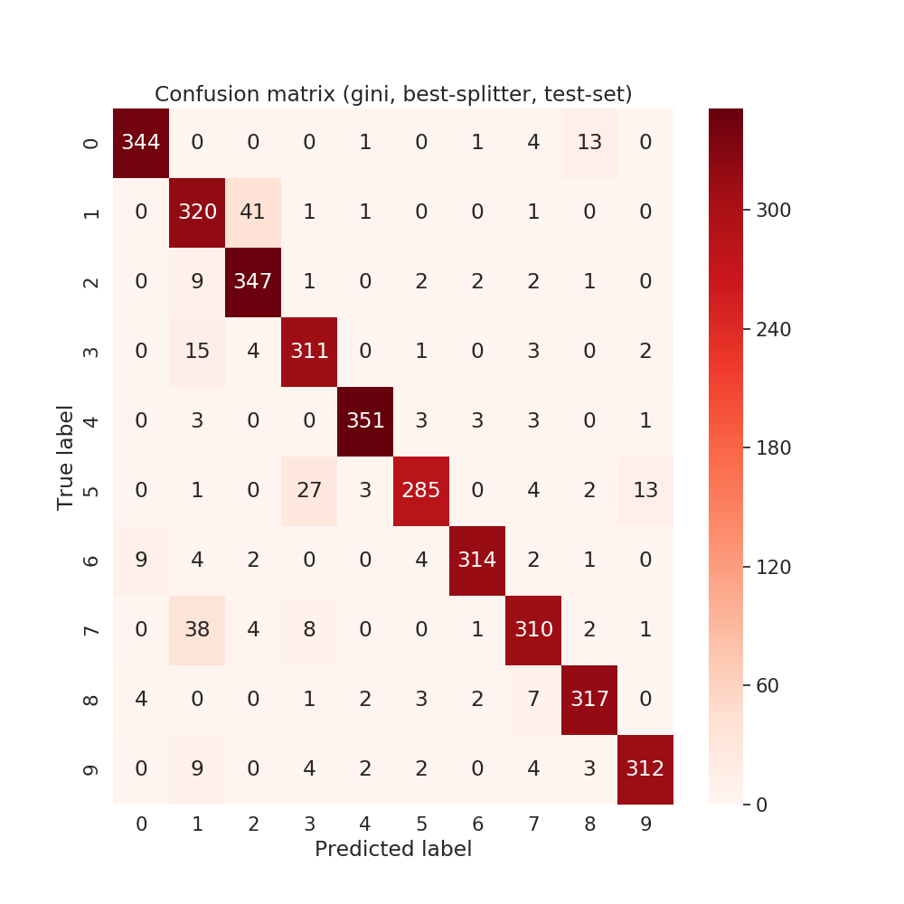

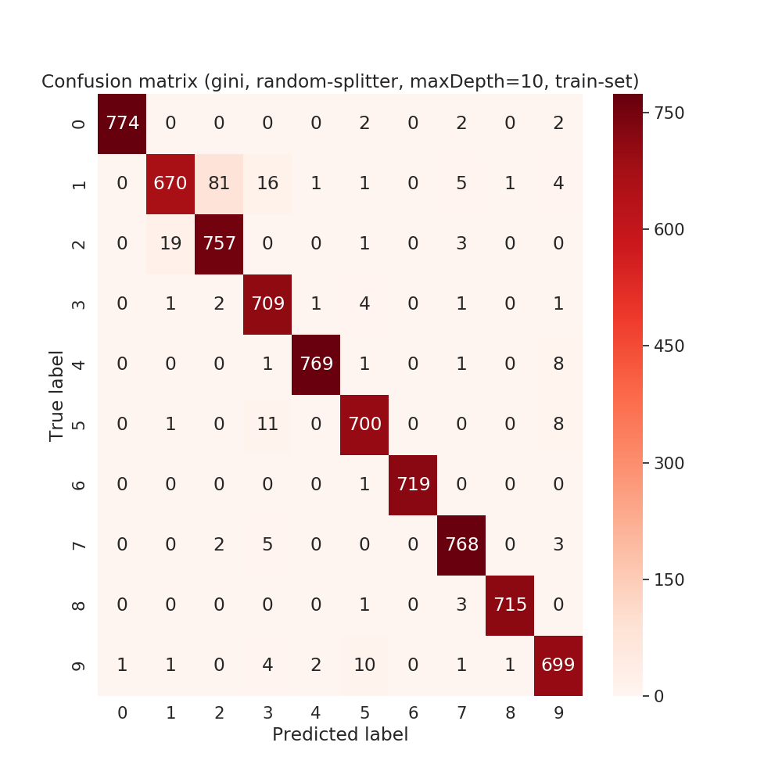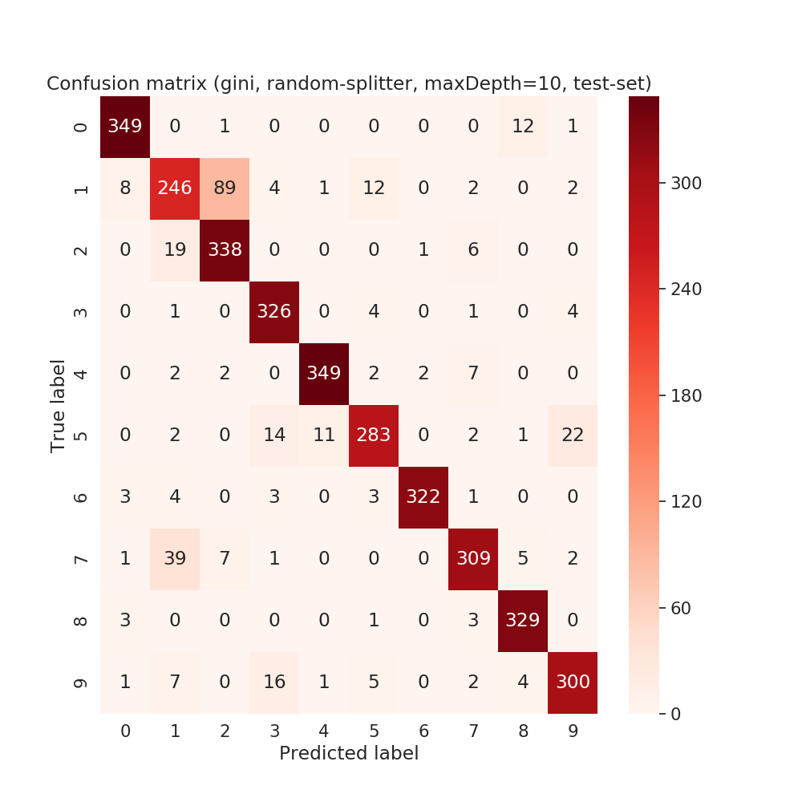

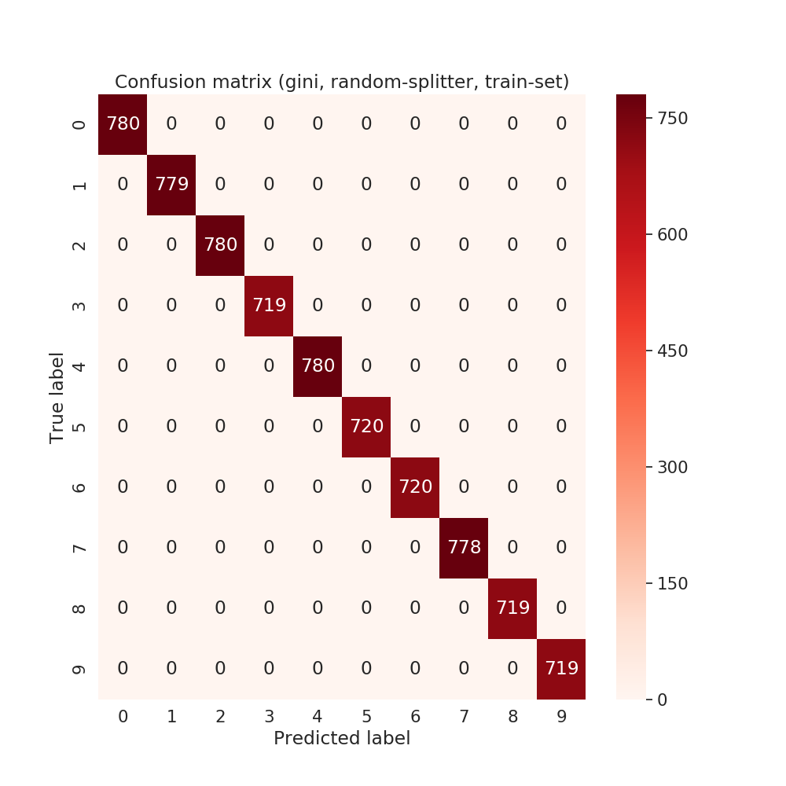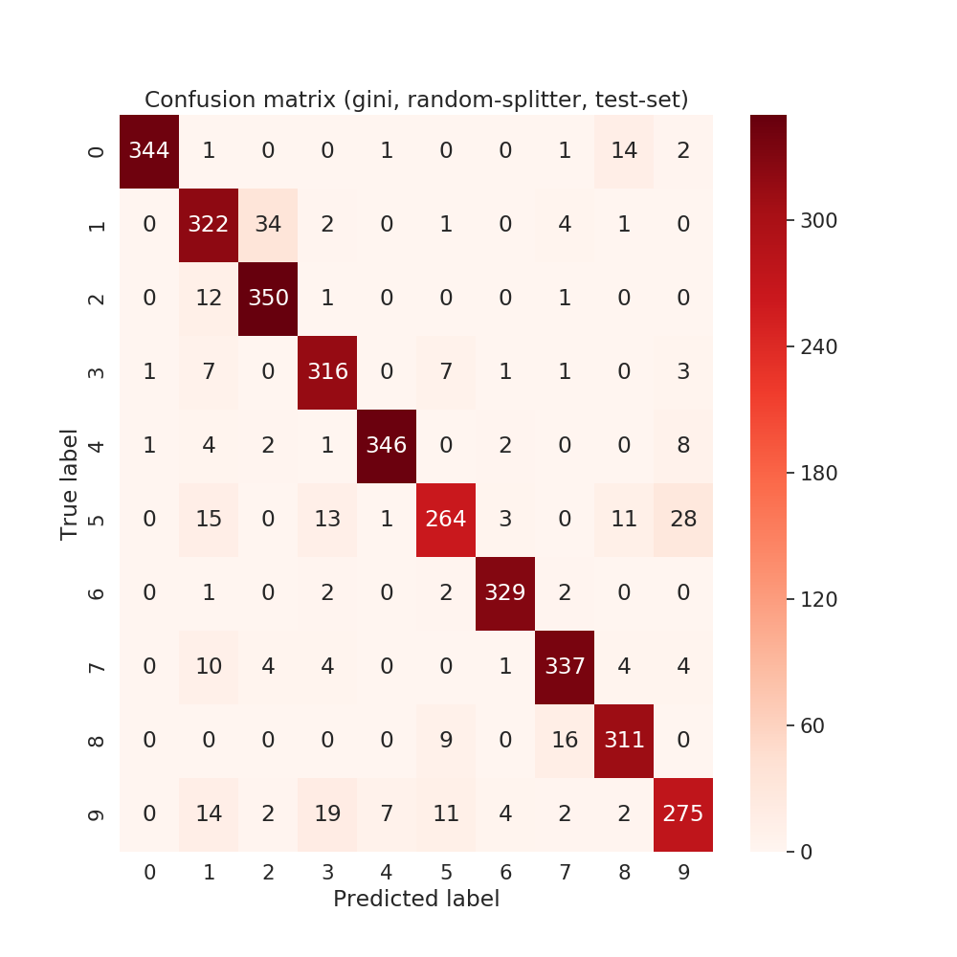

DM1.2

Data normalization
In Pen digit dataset, each image is 100x100 (gray scale), however in our MNIST each image 28x28 (gray scale) where as 20x20 is the actual container that contains the whole image. That is why we need to normalize the dimension of the image from 20x20 to 100x100. To do that, I leverage bilinear interpolation which is natural choice in compare to others (two other interpolation choices are cubic and nearest). Some examples from initial (28x28) and normalized image (100x100) of MNIST are as follows:

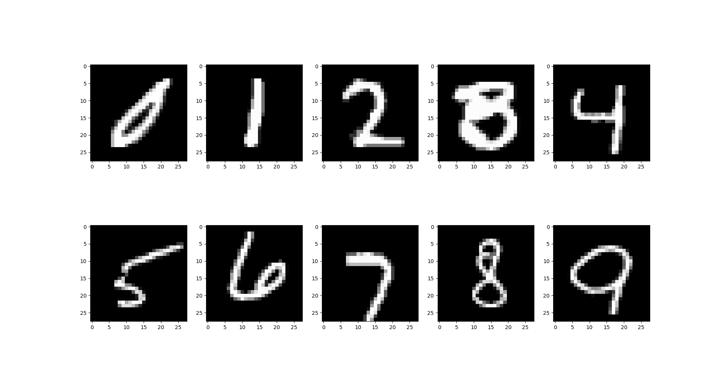IMAGE 1: MNIST (28X28)
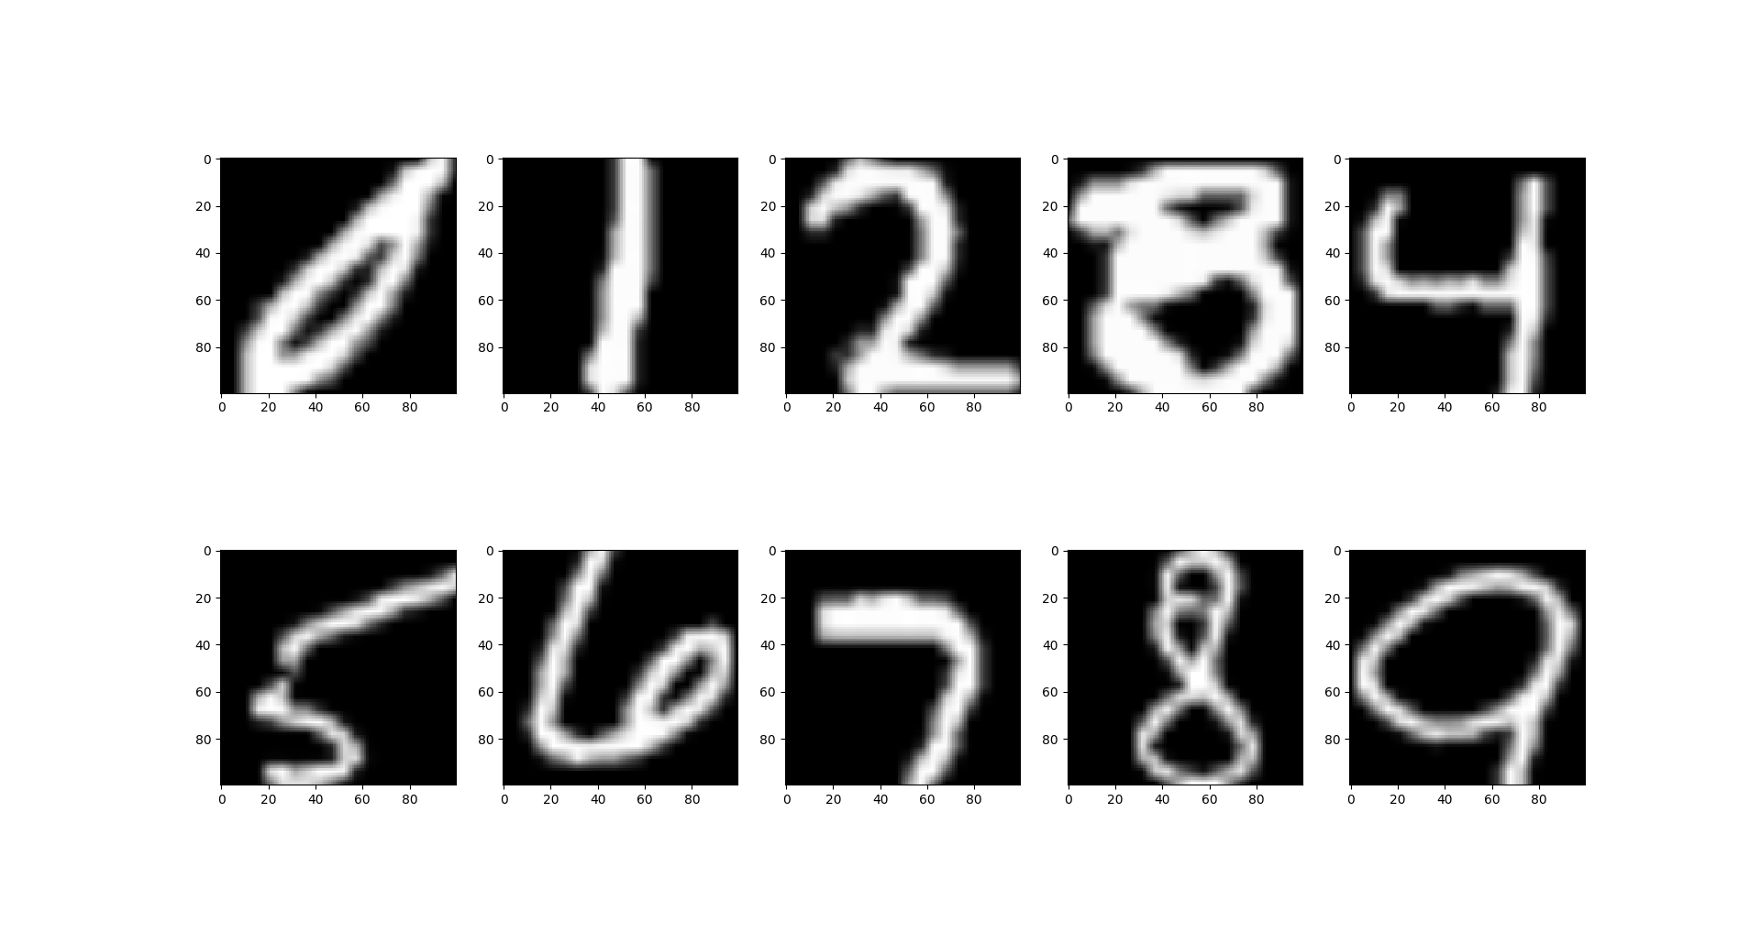IMAGE 2: Normalized (100x100)

Data Sampling
We need to sample 8 regularly spaced (x,y) coordinates along the trajectory of a digit. To do that, I follows several methods. The are as follows:

Sampling Method 1 (SM1):
1. Choose a uniformly random point (x, y) a
2. If the intensity value of a is 0 reject it
3. else keep a as a point
4. Start from step-1 until we get 8 such points
5. Start from step-1 until we sample 50 feature vector for each class

This random 8 points (x, y) are uniformly captured from 100x100 image grid. Since every point chosen from the grid (either accepted or rejected) is uniformly distributed, the accepted 8 points all together follow uniformly random distribution. There are no guarantee that the points are evenly spaced. Even the base Pen Digit [1] article does not describe how they resample such evenly spaced 8 points.
0
100
Sampling Method 2 (SM2):
1. Divide 100x100 image into 4 grids as like Drawing 1
0
Drawing 1: 4 Grid division
2. Select uniformly random two points (x1, y1, x2, y2)
100
75
50
25
in a grid such that the intensity value is not 0
3. Do step-2 for 4 grids such that we can sample 8 points
which are evenly spaces into 4 grids.
4. Start from step-1 until we sample 50 feature vector for
each class

In this method we can say, four pairs of points are evenly
spaced and uniformly randomly distributed.

Sampling Method 3 (SM3):
1. Divide 100x100 image into 4 grids as like Drawing 1
2. Select uniformly random two points (x1, y1, x2, y2)
in a grid such that the intensity value is not 0.
3. Maximize distance between (x1, y1) and (x2, y2) for some β times. Throughout this work I have used β=10.
4. Do step-2 and step-3 for 4 grids such that we can sample 8 points
5. Start from step-1 until we sample 50 feature vector for each class

Sampling Method 4 (SM4):
1. Divide 100x100 image into 4 grids as like Drawing 1
2. Find two points (x1, y1) and (x2, y2) for which intensity value is not 0 and the maximum distance is guaranteed. I call this as Sequential Search for two points that are located in the maximum distance corner of the grid
3. Do step-2 for 4 grids such that we can sample 8 points
4. Start from step-1 until we sample 50 feature vector for each class

This is the most slowest sampling method.

Table 3 shows accuracy, precision and recall score on sampled data which are sampled using SM1, SM2, SM3 and SM3.

Selected Model | Sampling Method | Accuracy | Precision | Recall
Gini (Best) | SM1 | 0.094 | 0.089 | 0.094
 | SM2 | 0.078 | 0.090 | 0.078
 | SM3 | 0.112 | 0.122 | 0.111
 | SM4 | 0.144 | 0.142 | 0.144
Gini (Random) | SM1 | 0.088 | 0.095 | 0.088
 | SM2 | 0.07 | 0.041 | 0.07
 | SM3 | 0.09 | 0.046 | 0.09
 | SM4 | 0.076 | 0.037 | 0.076
Entropy (Best) | SM1 | 0.094 | 0.068 | 0.094
 | SM2 | 0.1 | 0.076 | 0.1
 | SM3 | 0.1 | 0.183 | 0.1
 | SM4 | 0.128 | 0.111 | 0.128
Entropy (Random) | SM1 | 0.102 | 0.076 | 0.102
 | SM2 | 0.08 | 0.048 | 0.08
 | SM3 | 0.08 | 0.03 | 0.08
 | SM4 | 0.106 | 0.06 | 0.106
Table 3: Accuray, Precision & Recall on sampled data

Analysis:
In a obvious manner, the first question comes into mind why such low scores over the sampled data. To answer this question I read through the Preprocessing chapter of the Pen Digit [1] paper which consists of dynamic representation and static representation. In our work, we leverage dynamic representation which consists of normalization and resampling. Following normalization, we normalized 28x28 MNIST image to 100x100 image using bilinear interpolation which is natural interpolation method compared to nearest and cubic interpolation. So the issue resides in resampling methods. In the article [1] they have used spatial resampling method to collect evenly spaced 8 points through the arc of the digit. But they did not describe whether this resampling technique is manual or automatic. They did not describe any algoright on spatial resampling technique, instead they refer to other papers which I did not go through because of the scope of the assignment. Instead I followed some heuristic technique which can generate evenly spaced points which can be theoretically proved.

To push a little bit further, I resampled from the resampled data based on best recall scores. I took a set of data of a class for which SM methods generate best recall score. Which resampled data is taken on which SM method and what are the best recall score are shown in Table-4.

Class | Data size | Sampling Method (SM) | Best recall score on corresponding class only
0 | 50 | SM2 | 0.75
1 | 50 | SM4 | 0.36
2 | 50 | SM3 | 0.25
3 | 50 | SM2 | 0.12
4 | 50 | SM2 | 0.06
5 | 50 | SM4 | 0.18
6 | 50 | SM4 | 0.40
7 | 50 | SM4 | 0.44
8 | 50 | SM1 | 0.65
9 | 50 | SM8 | 0.39
Table 4: Best recall score using SMx
One important analysis is that if we take a look at the recall score of the class 2, 3, 4, 5; the corresponding recall score is very low in compared to others. From here we can conclude that these four classes are basically responsible for such low accuracy score.

Table-5 shows the final accuracy, precision and recall where we used the new resampled data and increased the accuracy more that by a factor of 2. The best accuracy is colored in green.

Model Selection | Best data (based on recall) | Accuracy | Precision | Recall
Gini (Best) | Best combination | 0.258 | 0.292 | 0.258
Gini (Random) | Best combination | 0.12 | 0.072 | 0.12
Entropy (Best) | Best combination | 0.244 | 0.210 | 0.244
Entropy (Random) | Best combination | 0.114 | 0.054 | 0.114

