Homework 3
Submitted by: Anowarul Kabir
G01146736
Site: http://mason.gmu.edu/~akabir4/cs682/
username: akabir4
pass: akabir4gmu135

Task 1:
This task involves to compute gray-level edges and color-level edges for all images in input directory named ‘ST2MainHall4’. To compute gray-level edges, each images are read as grayscale and edges are computed using Canny operator. The parameter used in Canny edge detection are as follows: min_Hysteresis_Thresholding=50, max_Hysteresis_Thresholding=180, L2gradient=True. Additionally to compute the gradients in both X and Y direction, I wrote a helper function named get_gradients(img) which returns derivative in horizontal direction (gx), derivative in vertical direction (gy), magnitudes (g) and orientation (theta) for each pixel. Figure 1 shows a grayscle image and corresponding canny edges.
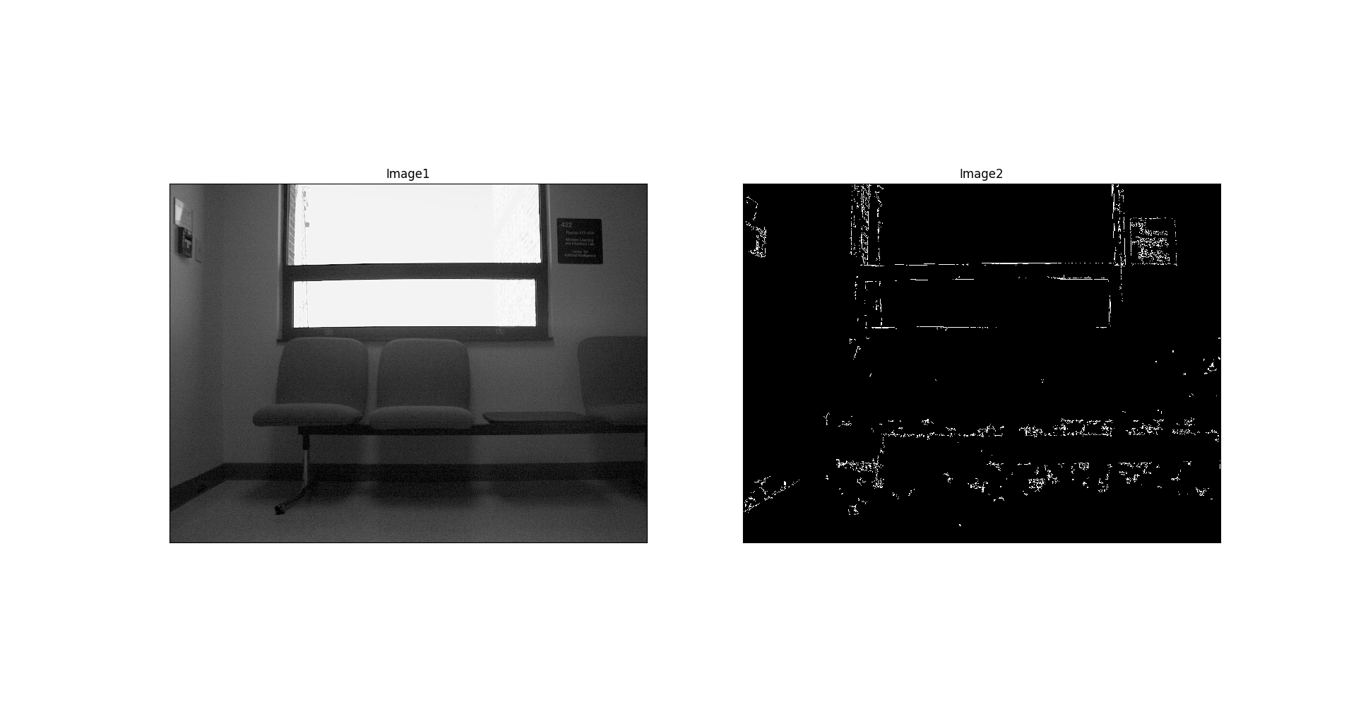Figure 1: Gray-level edges

To compute the color-level edges, each image is first separated by three channels and to compute channel wise edges, derivative in horizontal direction (gx), derivative in vertical direction (gy), magnitudes (g) and orientation (theta) for each pixel I wrote an helper function named get_channel_wise_edges(color_img, channel_index).

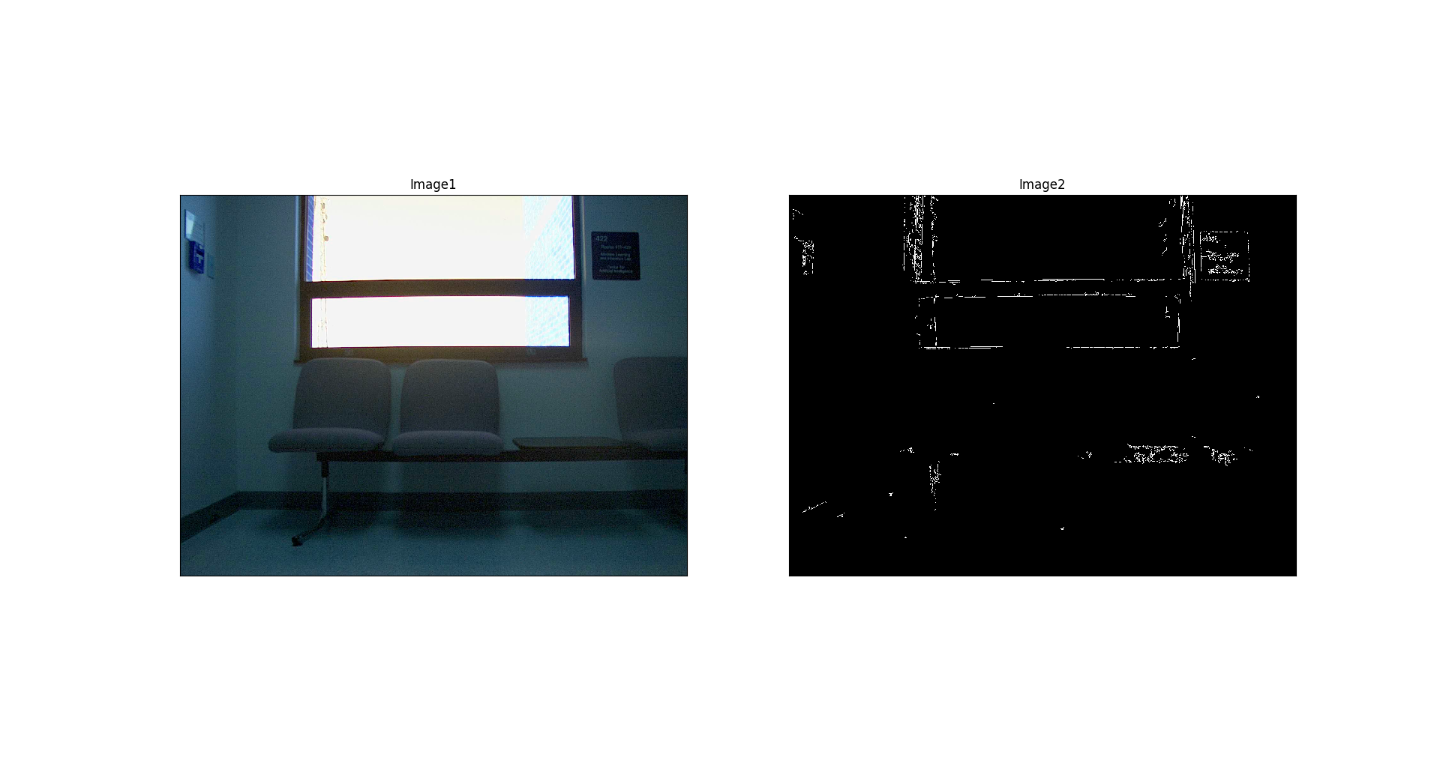Figure 2: Edges for blue channel

Figure 2, Figure 3 and Figure 4 show blue, green and red channel edges of an example color image.

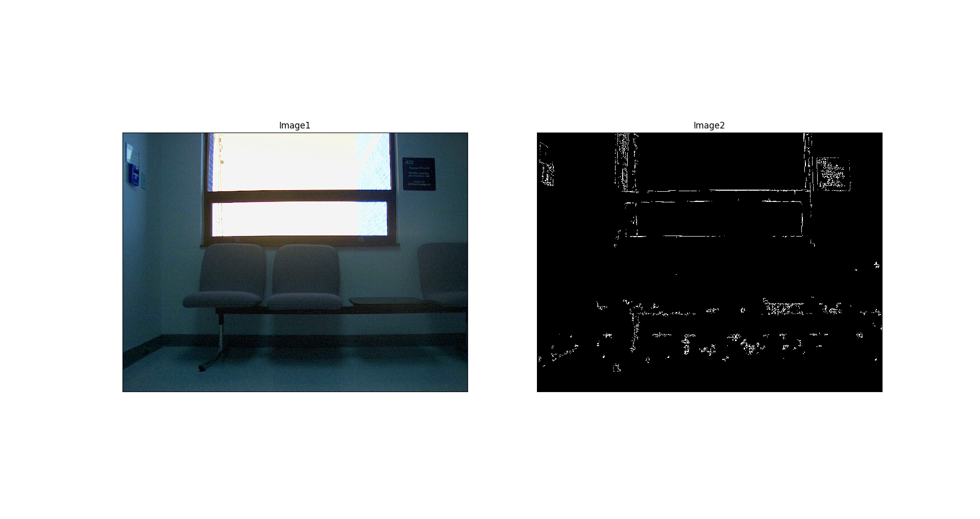Figure 3: Edges for green channel

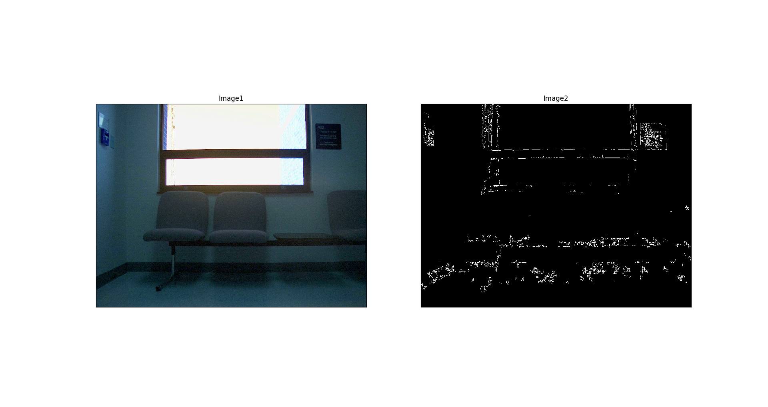Figure 4: Edges for red channel

Task 2: Gray edge histograms
I have computed derivative in horizontal direction (gx), derivative in vertical direction (gy), magnitudes (g) and angles (theta) for each pixel in compute_gray_label_edges(rgbimg) function. I divide the angles by 10 and convert the values into nearest integer, which leads to 36-bins. I compute two types of histograms for the angles.
1. Without considering magnitude value. Counting all edges using same value, for instance 1.
2. Considering magnitude value. For each angle, all corresponding magnitudes are summed up to compute contribution and plot that contribution as the value for the corresponding angles.
I scale these two histograms using min=1 and max=100 value. Figure 5 plots with scalling and Figure 6 illustrates without scaling.
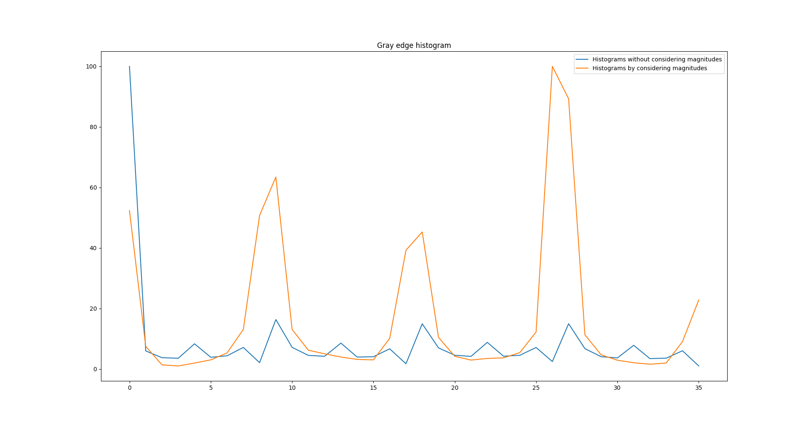Figure 5: Gray edge histograms (with scaling)

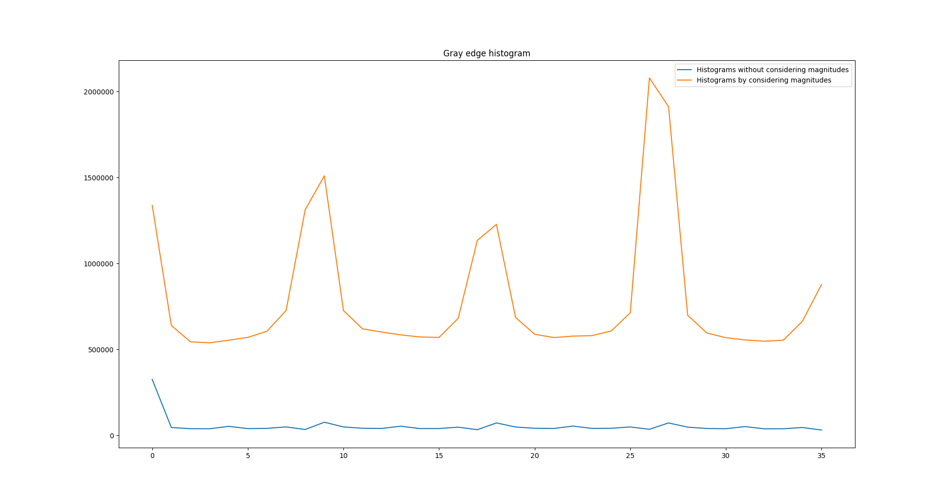Figure 6: Gray edge histograms (without scaling)

Task 3: Color edge histograms
Using channel wise gradients in both horizontal (gx) and vertical (gy) direction and given two equations, I calculate the magnitudes and angles. Using magnitudes and angles, I created two histograms as previous task with or without scaling. Figure 7 and 8 show color edge histograms using scaling and without scaling respectively.

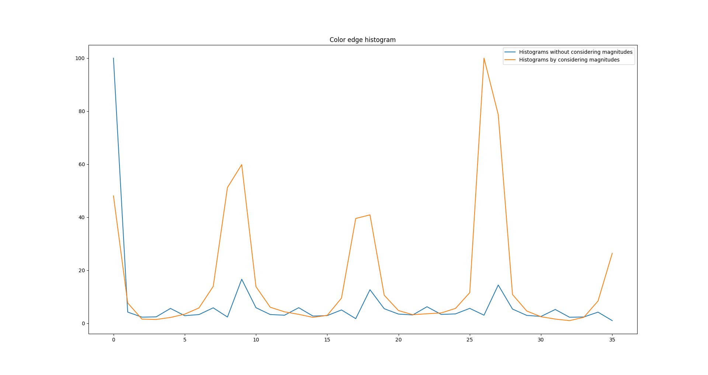Figure 7: Color edge histograms (with scaling)

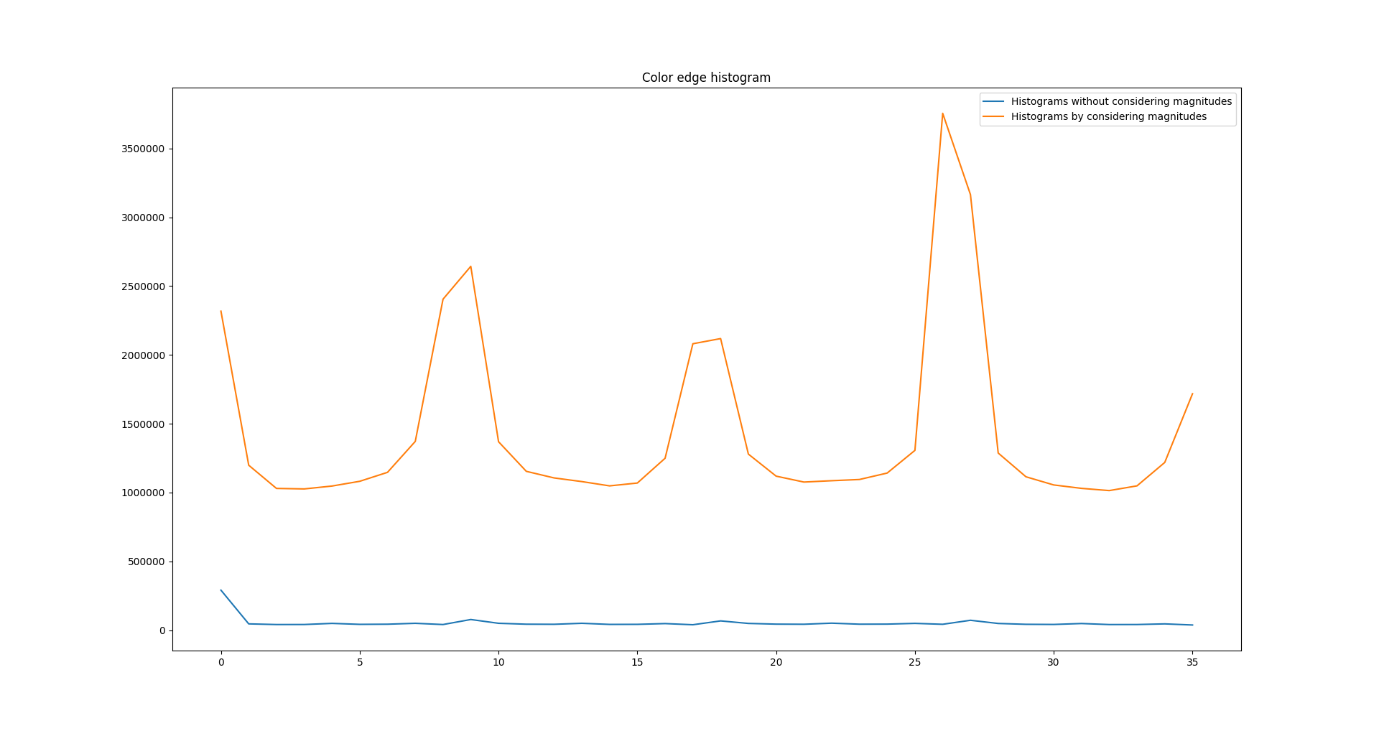Figure 8: Color edge histograms (without scaling)

Note that in Task-4 and 5, I have used scaled histograms by considering summation of magnitude values as contribution.

Task-4: Histogram distance function
Two given functions are implemented for histogram comparison namely hist_intersection(hist1, hist2) and chi_squared_measure(hist1, hist2).

Task-5: Histogram comparison
For all the gray and color images in the sequence, the edge histograms are computed first. Then these histograms are compared using histogram distance functions. The resulting distances are showing as heat map for all gray and color image pairs in Figure 9 and Figure 10 respectively.

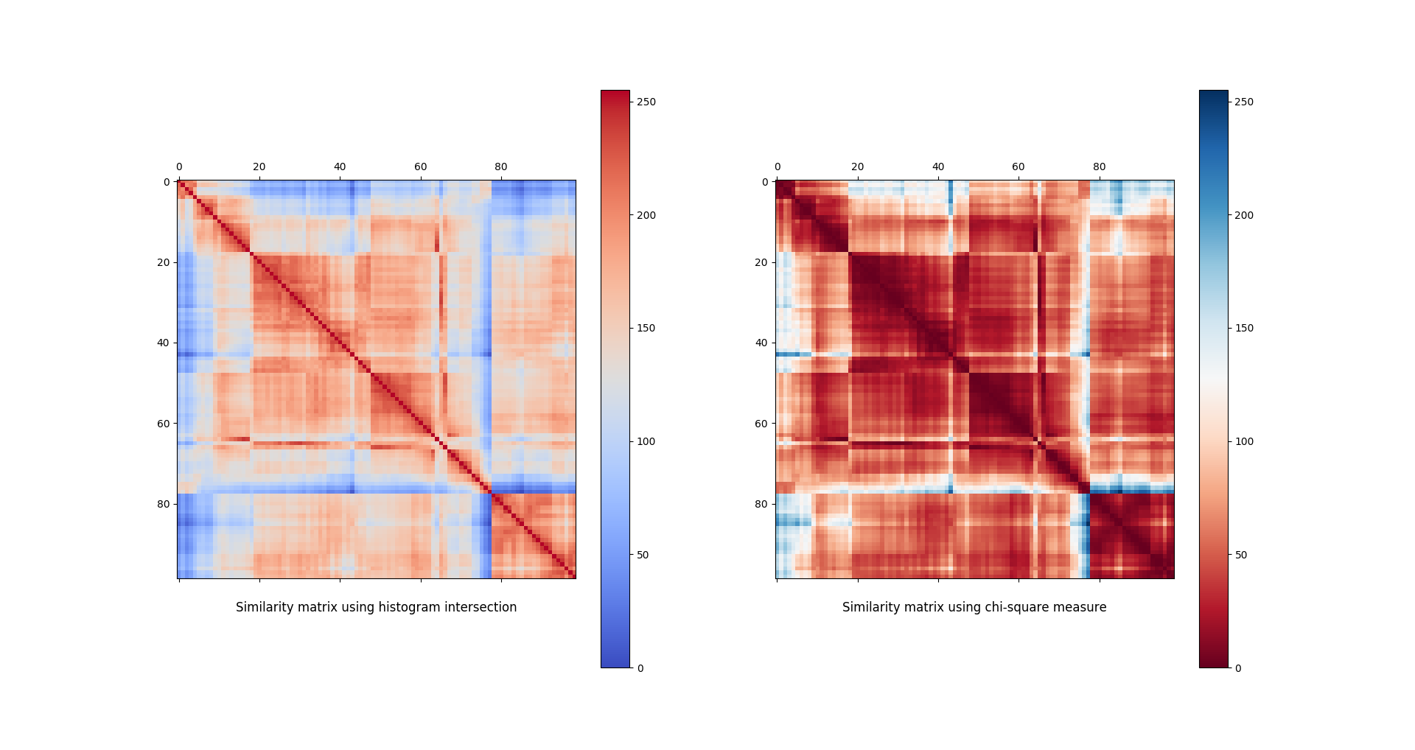Figure 9: All gray edge histogram comparison
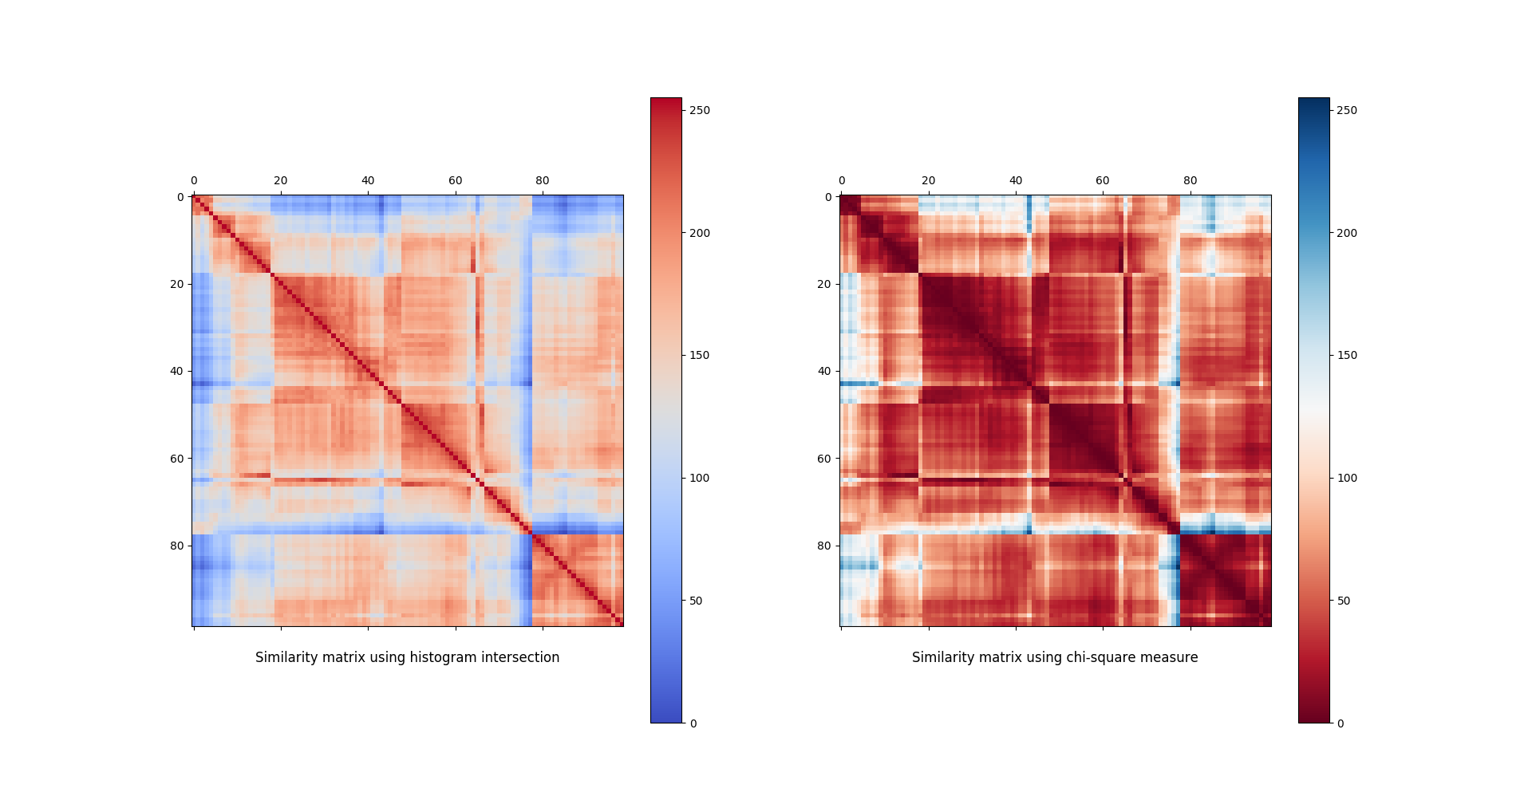Figure 10: All color edge histogram comparison

Extra credit:
Task 1: Usage of quiver function for visualizing gradients
Figure 11 shows original image and Figure 12 and 13 shows gradient visualization for grayscale and color image respectively

Figure 11: Original image

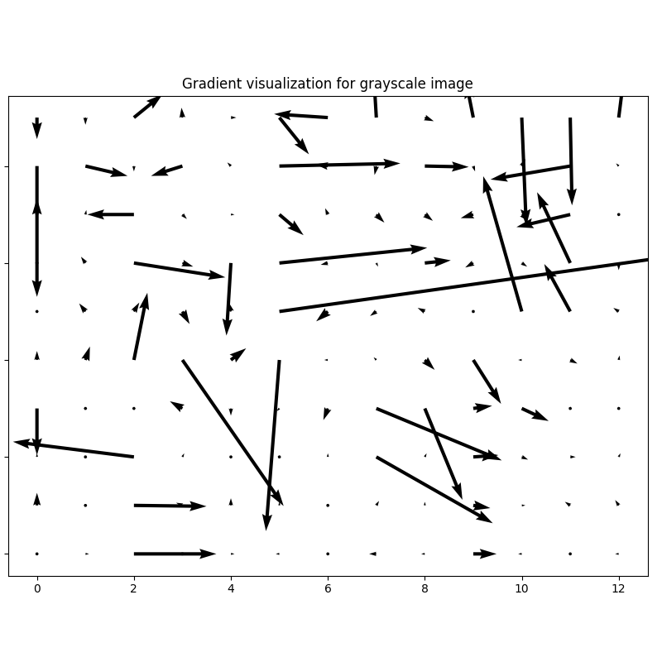Figure 12: Quiver visualization for gray image

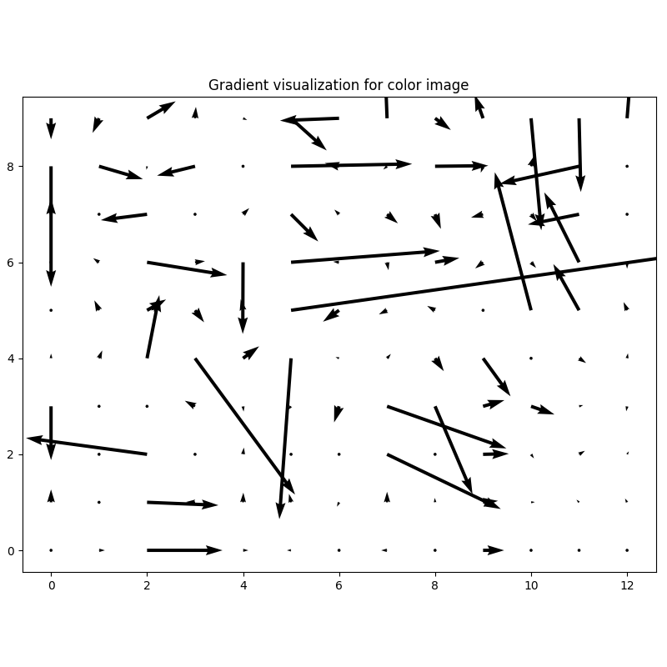Figure 13: Quiver visualization for color image

Task 2 and 3: Edge detection using eigenvalue and eigenvectors.
After following the given algorithm, I got the result as Figure 14.
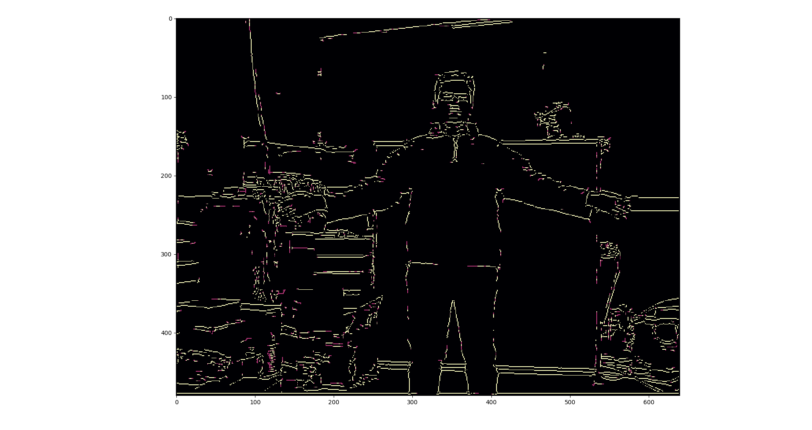Figure 14: Edges

