Homework 1
Website link: Click this link
Task 1: OpenCV installed
Task 2:
Figure 1 shows the task-2 related outputs: original image on the left, one color blue image in the middle and grascale image on the right. Each of these images dimension and size are 960x960 pixels and 86 kb respectively.

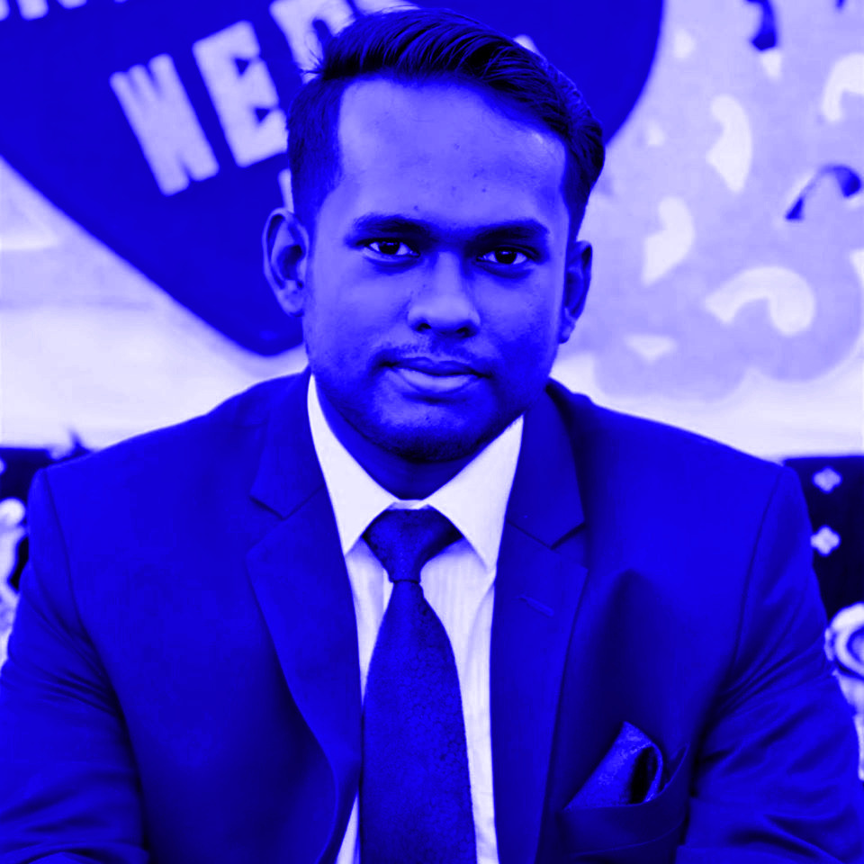

Figure 1: Original (left), one color blue image (middle), grayscale (right)

Task 3: Five transformations of the color and gray images
1. Blurring
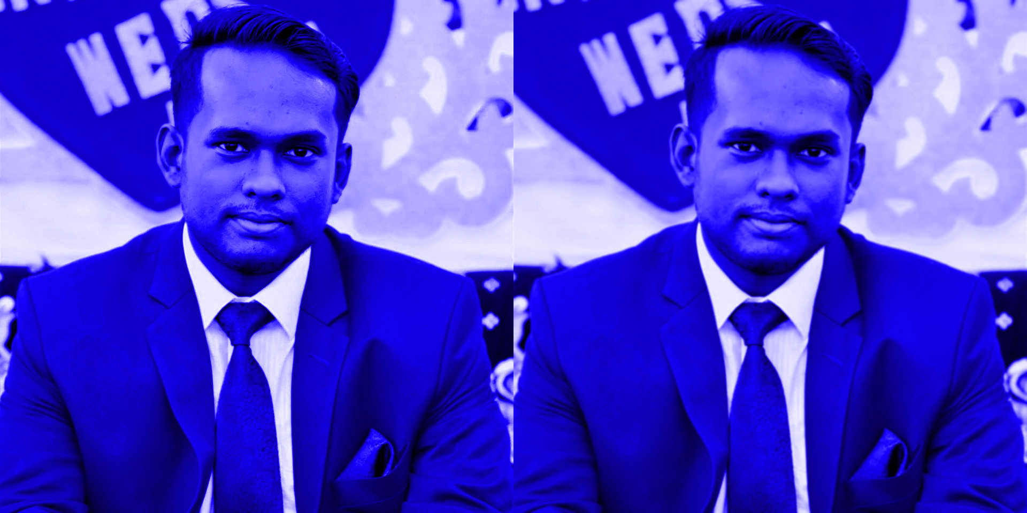



2. Rotation
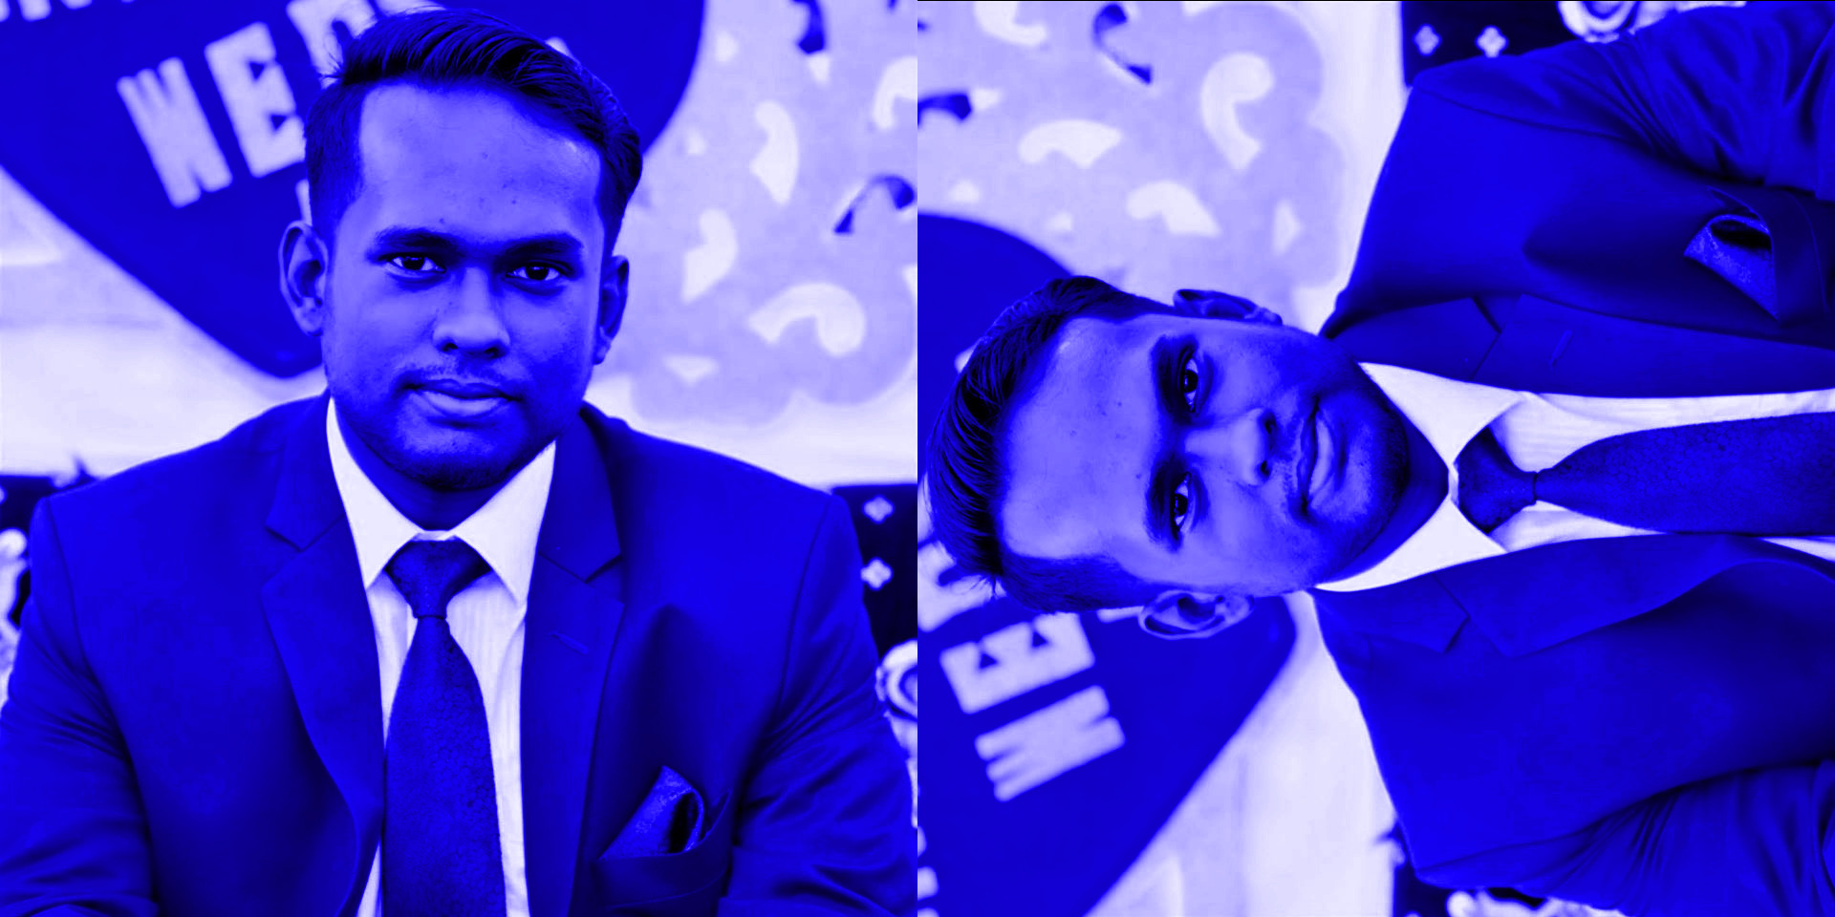


3. Affined


4. RGB to HSB and Gray to BGR



5. Plus/Minus operations:
First converted gray into bgr. Then I did the following operations:
Left: added one color and bgr images.
Middle: subtracted bgr image from one color image.
Right: subtracted bgr image from one color image, then added 100 with every pixels.

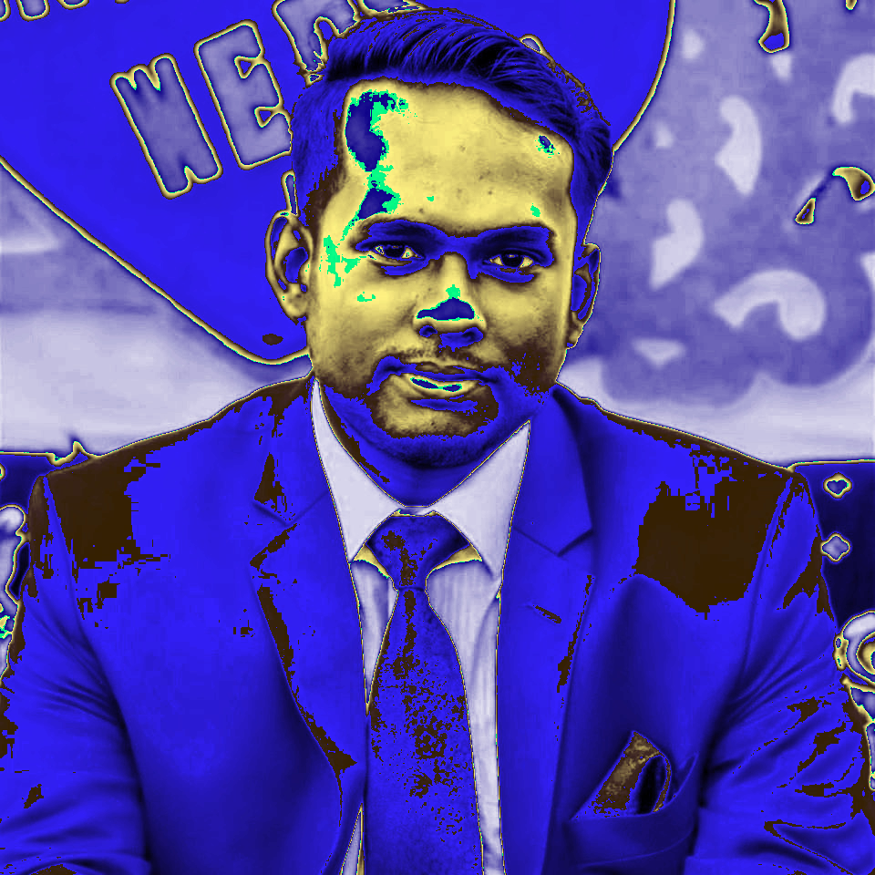

Task 4:
To build the gaussian pyramid of the image I used pyrDown function of OpenCV. In each iteration, the new layer is downsampled from the former. The iteration runs until there is one pixel left. The size of the image in each iteration are as follows.

Size: (960, 960, 3) → (480, 480, 3) → (240, 240, 3) → (120, 120, 3) → (60, 60, 3) → (30, 30, 3) → (15, 15, 3) → (8, 8, 3) → (4, 4, 3) → (2, 2, 3) → (1, 1, 3)

Size of the composite image: (960, 1920, 3). To build the composite image, a numpy matrix has been built using the height of the big image and width of the sum of width of the big and small images. Then the new image is constructed by copying the pixel values of the big and small image.

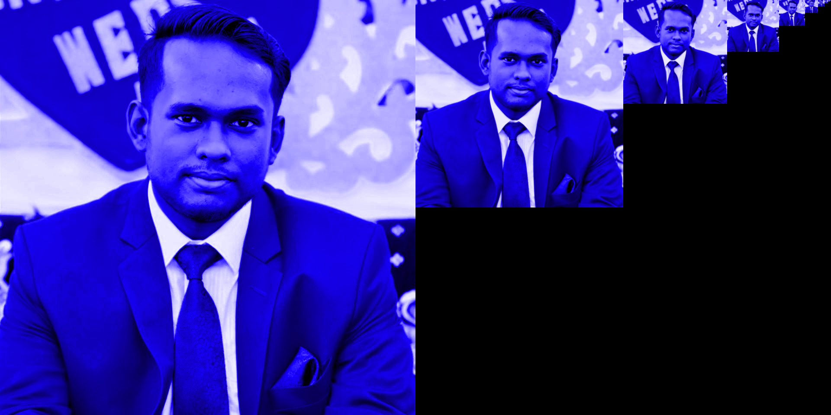

Task 5:
Ball on pitch detection in Cricket. There are some conditions for giving a batsman out as Leg Before Wicket (LBW). One of them are ball must be on pitch. To detect that, computer vision based application is now being used in the game. This link describes the conditions for an LBW.

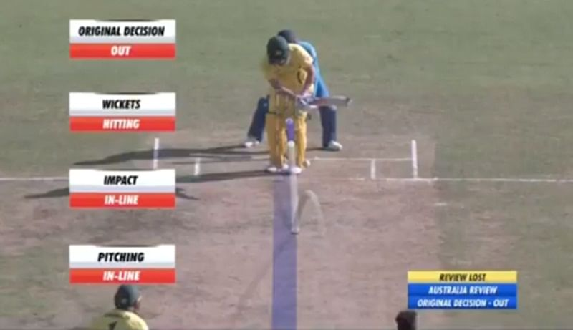Figure 1: Ball on pitch detection

