Name: Anowarul Kabir
Link: Click here
How to run: python solution.py

Task 1:
Problem1Solver computes all the required items and draw several images. As it is asked, I am showing outputs for two images (00000048.png, 00000173.png).
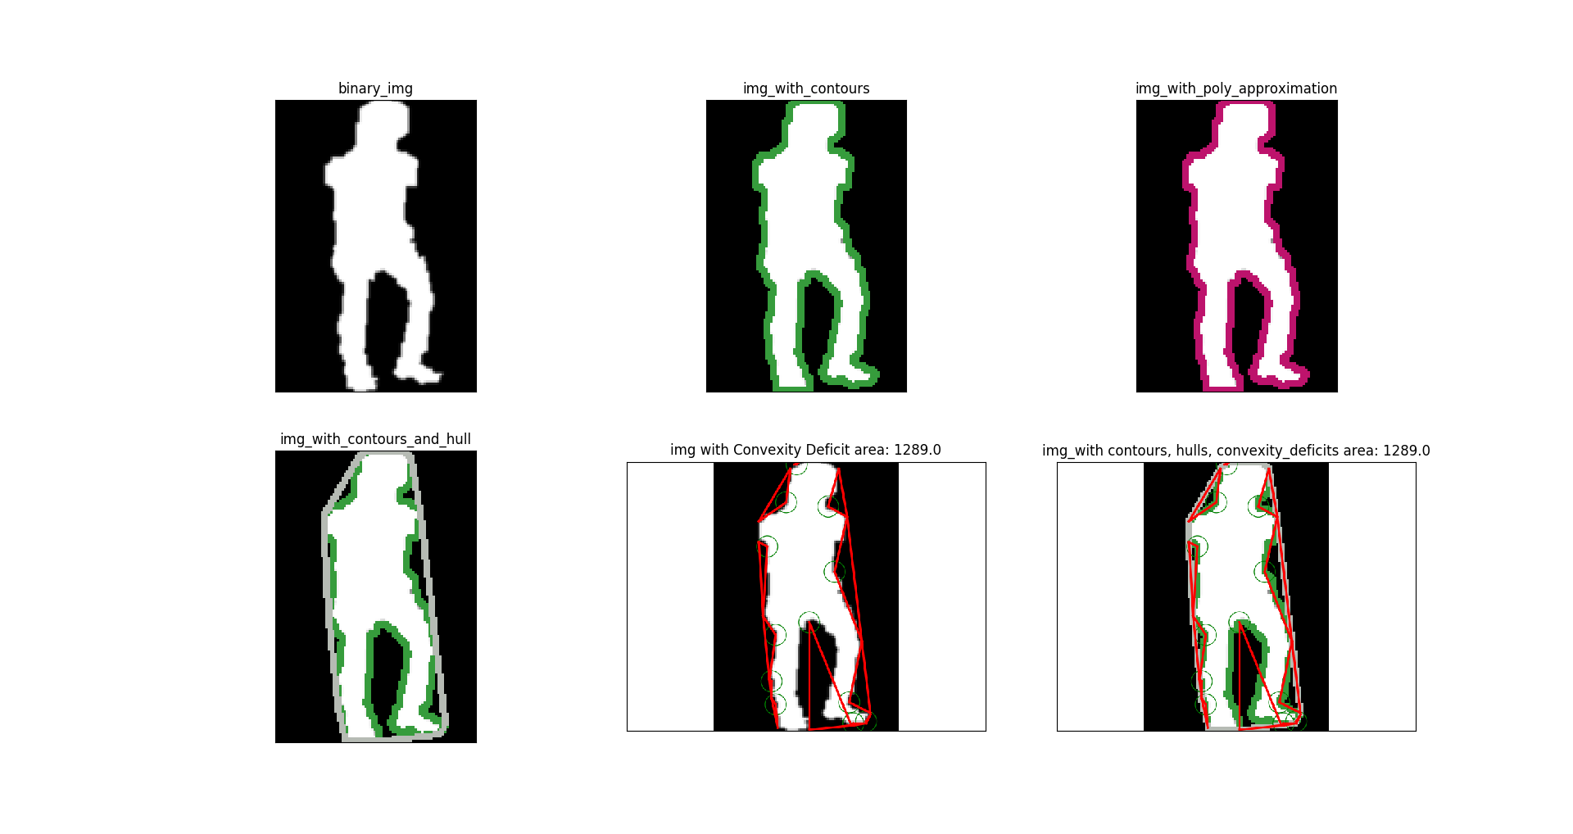Illustration 1: Computed Features for 00000048.png
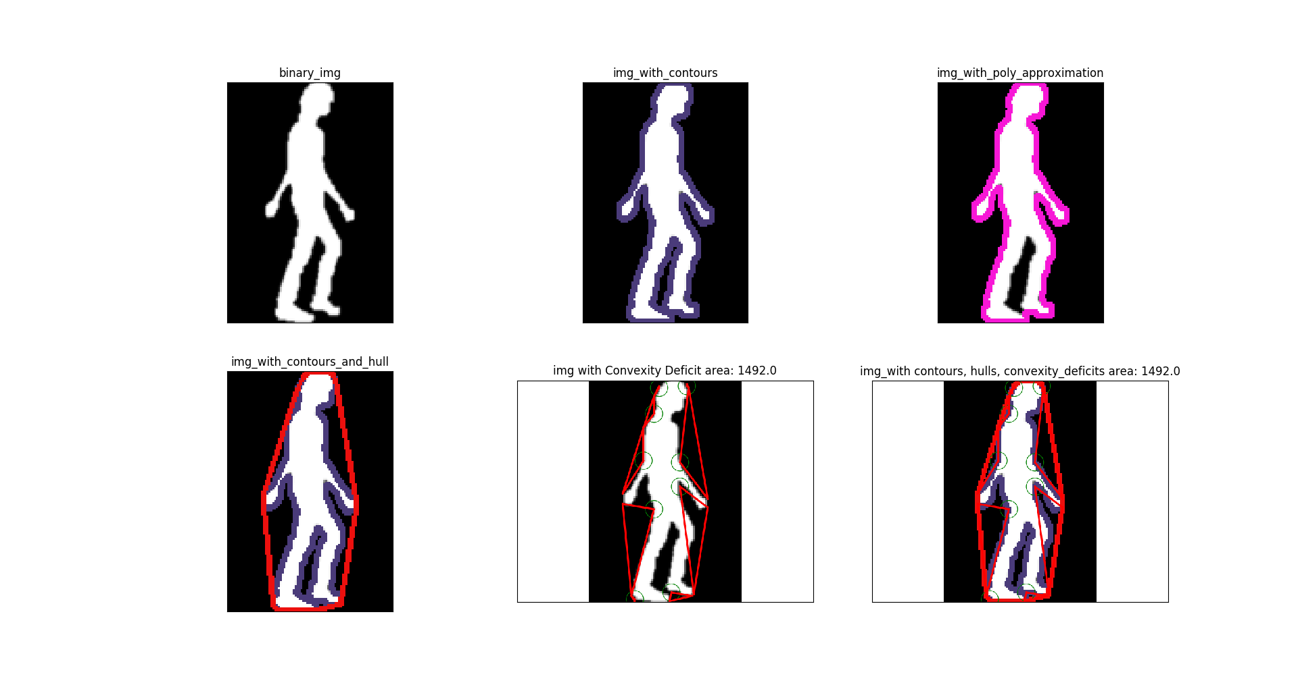Illustration 2: Computed features for 00000173.png

For 1st image: 00000048.png
original_area=3912.0, original_perimeter=471.9
hull_area=5283.0, hull_perimeter=318.1
Moments for Original image:
m00=3912.0, m10=175698.8, m01=245946.2, m20=8462461.2, m11=11257972.5, m02=20044319.5
Moments for Convex hulls:
m00=5283.0, m10=243768.0, m01=355255.2, m20=12104704.8, m11=16779098.8, m02=30213544.0

For 2nd image: 00000173.png
original_area=3141.0, original_perimeter=427.4
hull_area=4734.0, hull_perimeter=304.0
Moments for Original image:
m00=3141.0, m10=136383.5, m01=219155.2, m20=6174798.7, m11=9438432.7, m02=19120732.0
Moments for Convex hulls:
m00=4734.0, m10=207666.0, m01=327103.5, m20=9767028.8, m11=14105829.9, m02=27723658.8

Task 2:
Computed features for 10 images:

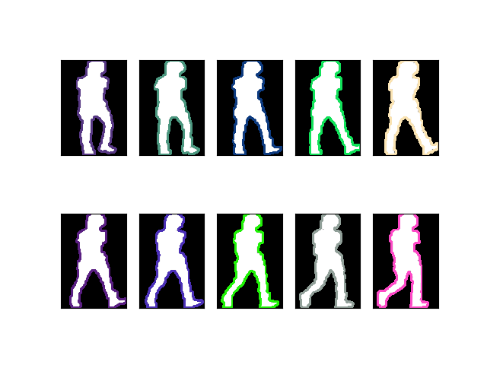Illustration 3: Computed contours for 10 images

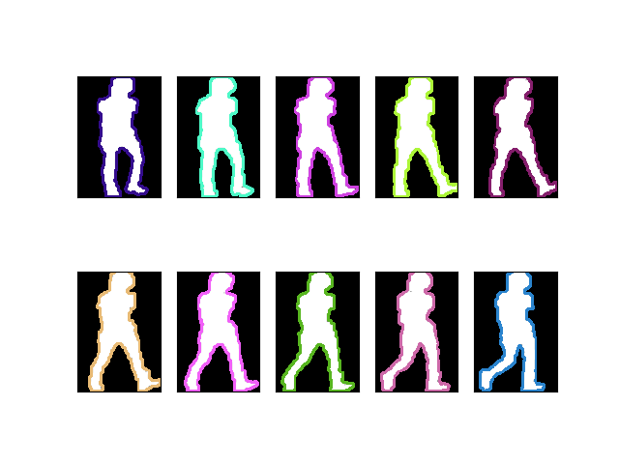Illustration 4: Polygonal approximation for 10 images
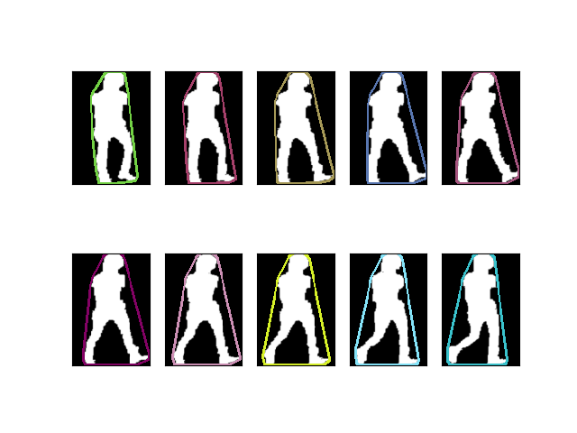Illustration 5: Computed convex hulls for 10 images

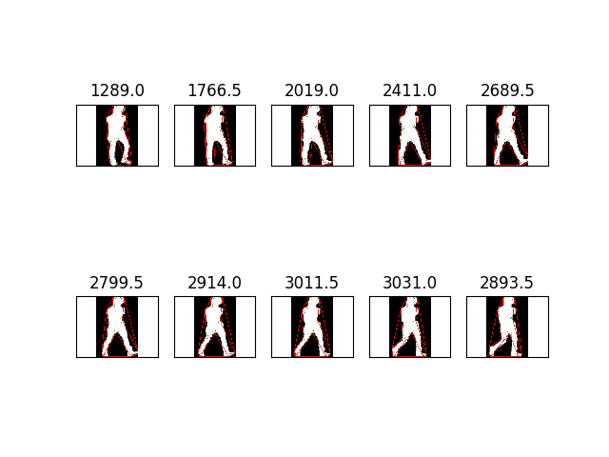Illustration 6: Computed convexity deficits with areas
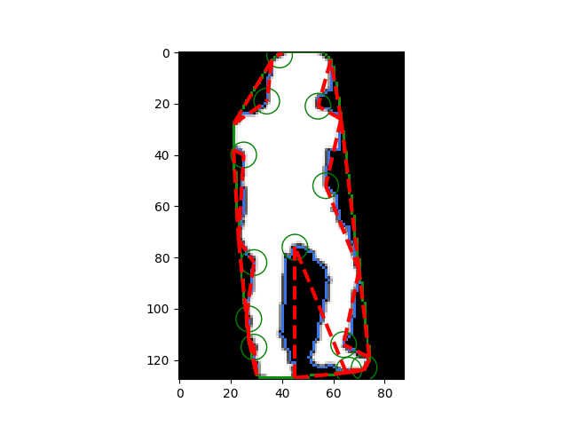Illustration 7: Sample Convexity deficits for 00000048.png
Task 3:
To solve this problem, I have used window size from 3 to 11. Output for each window size consists of four images:
1. Boundaries
2. Curvatures in respect with x and y coordinate values
3. Curvature hot map
4. Given image with curvature hot map
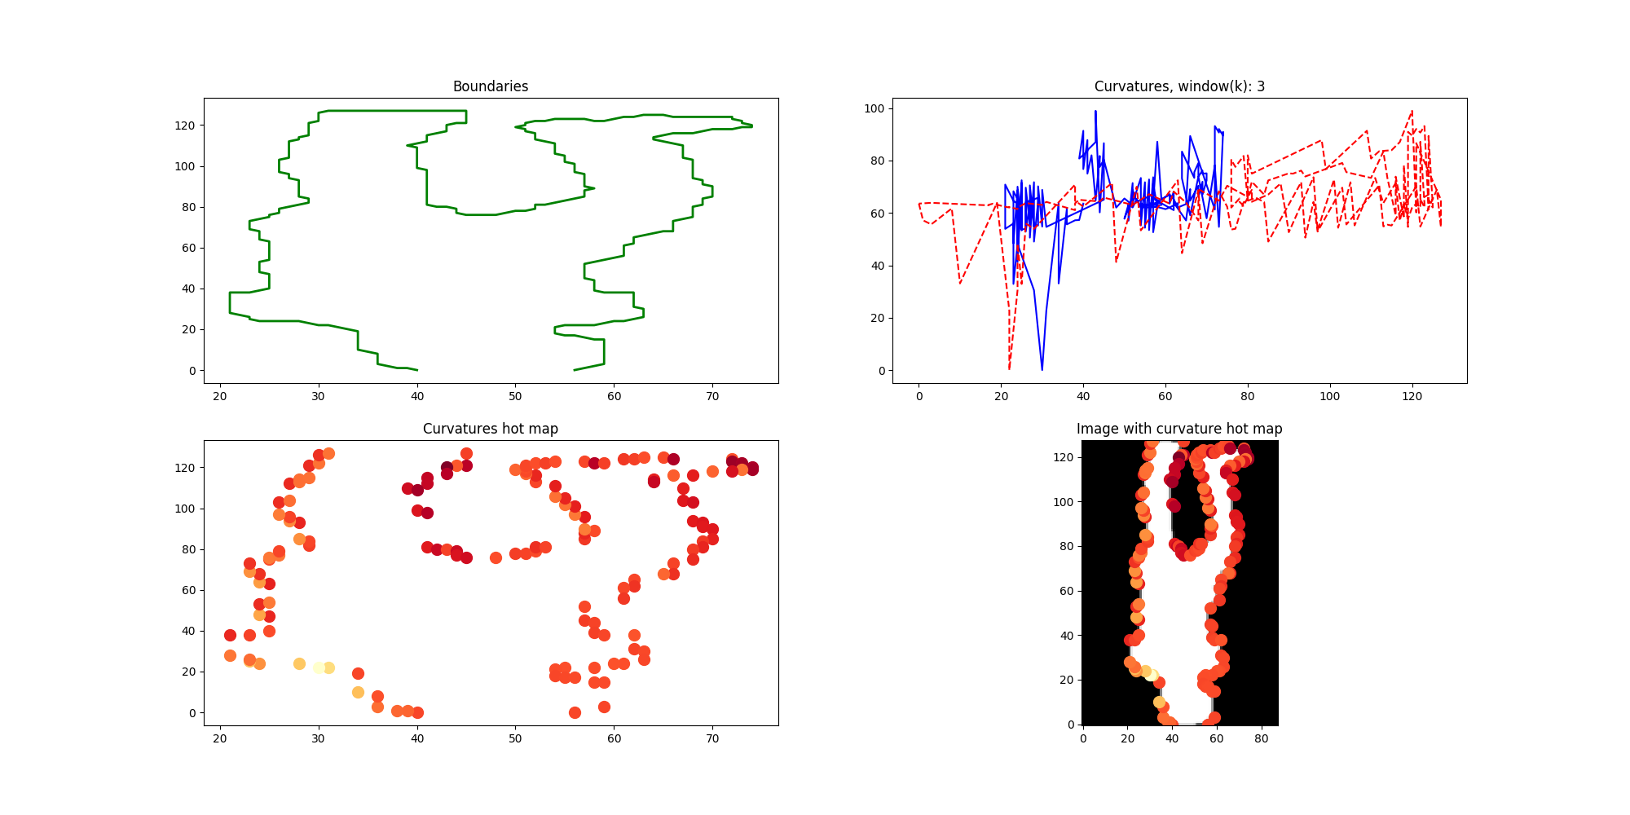Illustration 8: Window size: 3
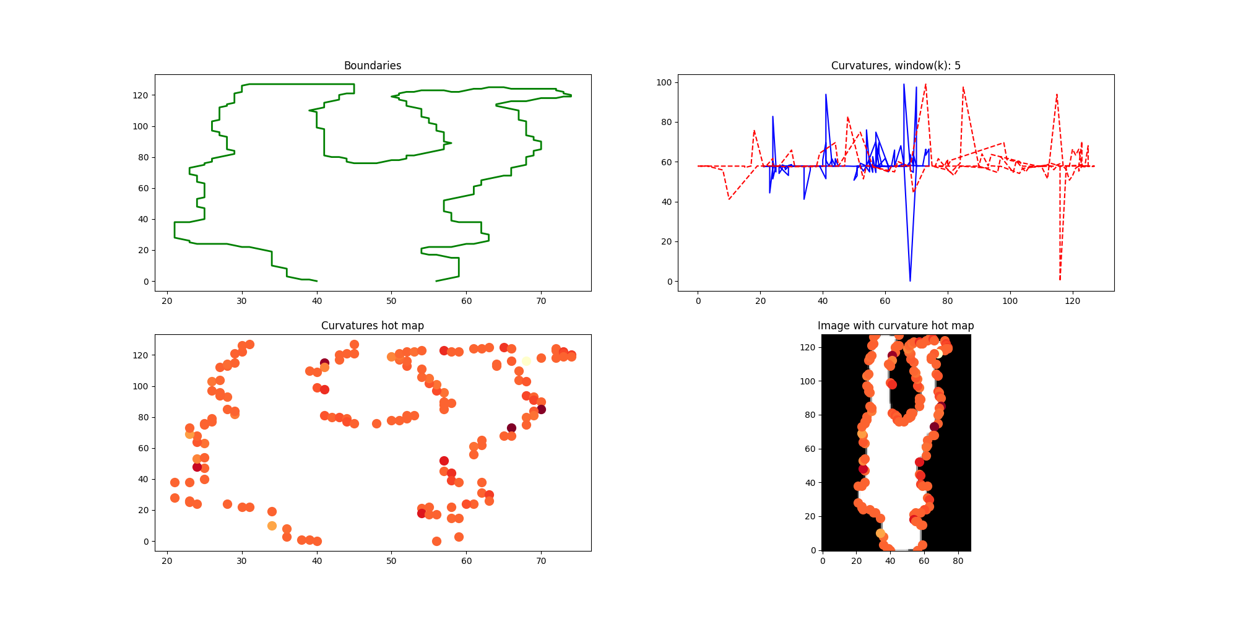Illustration 9: Window size: 5
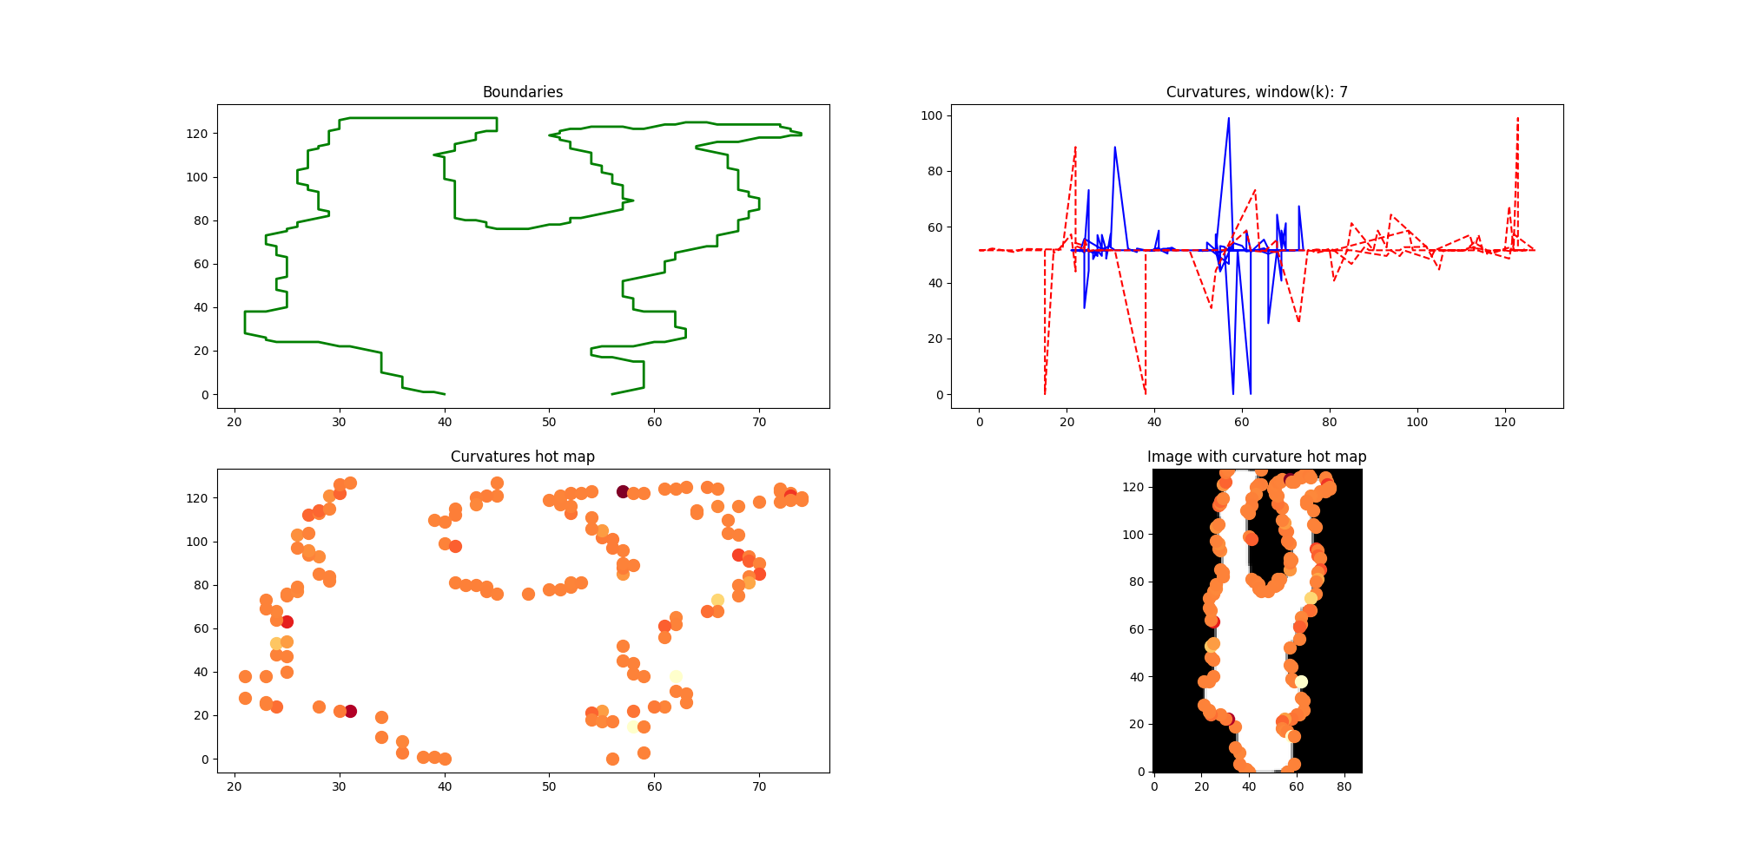Illustration 10: Window size: 7
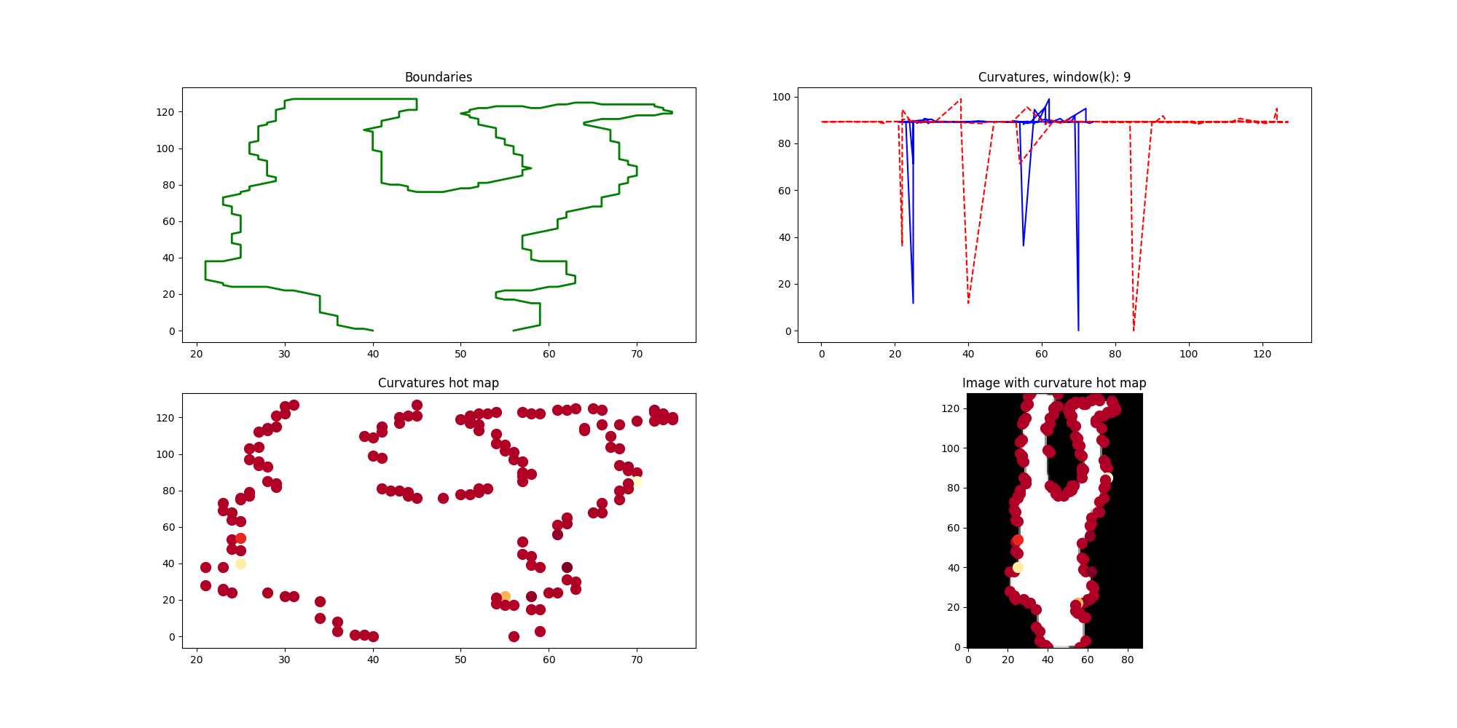Illustration 11: Window size: 9

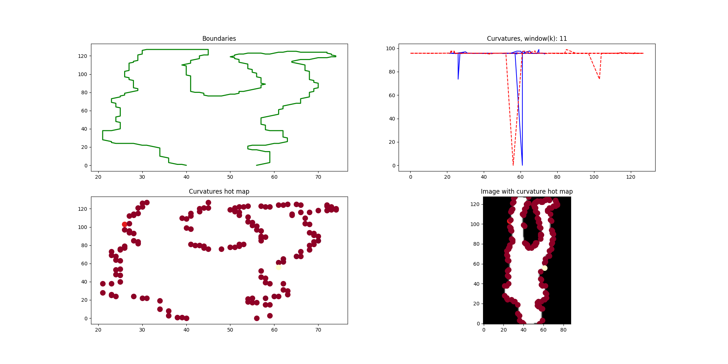Illustration 12: Window size: 11

Task 4:
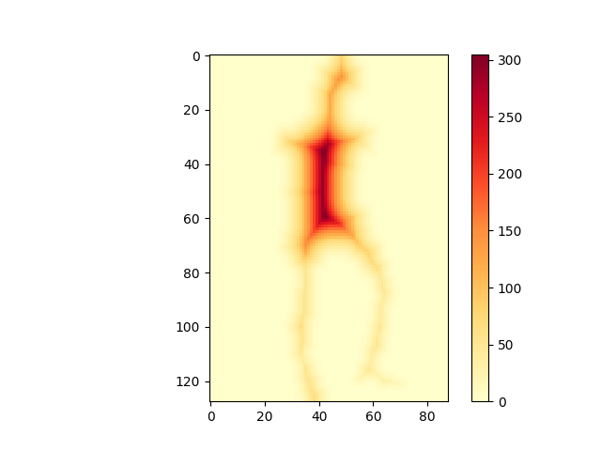Illustration 13: Distance transformation for 00000048.png
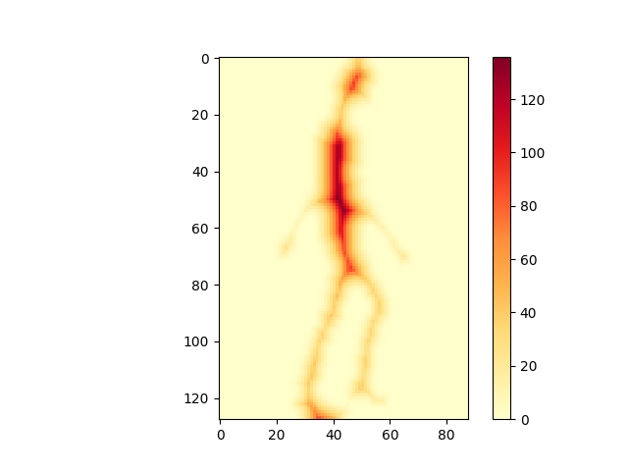Illustration 14: Distance transformation for 00000173.png
Task 5: chamfer matching
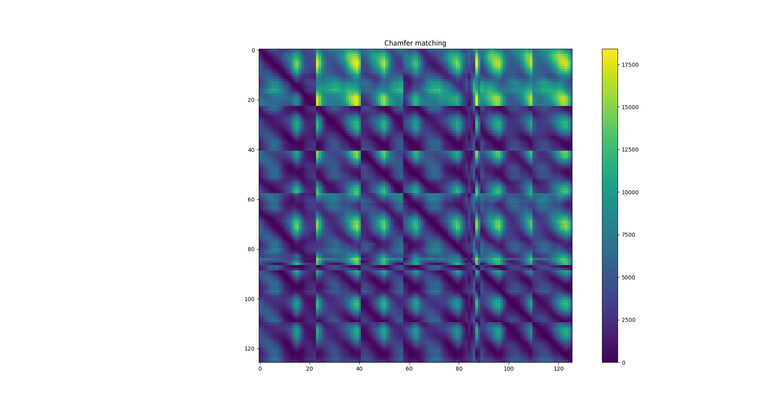Illustration 15: Chamfer mathing
Task 6:
From chamfer matching and convexity deficits images we can see that there is a periodicity. The curvature shows where the high and low curvature exists. And the possible joints are circled in Illustration 7. We can result convexity deficits far point as joint point. From this point we can segment the image using nearest neighbor or recursive labeling algorithms.

