DELLICS TRAVELS
— See the World —

Mobile Travel Booking Platform
Complete Product & Technical Documentation

Document Version 3.0 | Status: Production-Ready Specification
Prepared for Dellics Travels | August 2026

CONTACT INFORMATION
Dellics Travels · Tema Community 25, Devtraco Estate, Ghana
Phone: +233 55 205 4174 Email: info@dellicstravels.com
Business Hours: Monday to Saturday, 8:00 AM – 6:00 PM GMT

Table of Contents
1. Executive Summary
2. Competitive Research — Booking.com, Expedia, Trip.com, Skyscanner & Others
3. Brand & Visual Identity
4. Product Overview
5. User Roles & Permissions
6. Feature Architecture
7. Dellics Membership Packages
8. Phased Delivery Roadmap
9. Complete Technology Stack
10. System Architecture
11. Core Data Model
12. Payment Integration — Stripe
13. Security & Compliance
14. Non-Functional Requirements
15. Risk Register (Summary)
16. Workflow — End-to-End Operational Flows
17. Mobile App UI/UX Design

1. Executive Summary
Dellics Travels is a mobile-first travel booking platform that lets travelers search, compare, and book flights, hotels, car rentals, activities, bundled vacation packages, and destination eSIMs from a single app. The product draws on Booking.com — the world's largest travel platform with over 500 million annual bookings — as its primary benchmark for conversion optimization, inventory breadth, urgency merchandising, and loyalty engineering. Secondary insights from Expedia, Trip.com, Skyscanner, Hopper, Airalo, and others add advanced capabilities like dynamic packaging, price prediction, multi-modal transport search, and instant eSIM connectivity.
This document is the single source of truth for building Dellics Travels to a production-ready standard. It defines the competitive research behind the feature set, the visual identity derived from the Dellics Travels logo, the complete feature architecture split into MVP (ready-to-production) and later phases, the membership package structure, the full technology stack, system architecture, data model, Stripe-based payment integration, security posture, the end-to-end operational workflows that tie every feature together, and a complete mobile app UI/UX design (Section 17).
Scope of this release
The MVP defined in Section 6 is scoped to ship as a real, working production app: account creation, flight/hotel/package search and booking, Stripe checkout, trip management, price alerts, eSIM connectivity via Airalo, and a tiered membership system. Advanced supplier integrations (GDS/NDC direct airline contracts, white-label car rental APIs) are flagged as Phase 2/3 and are designed around third-party aggregator APIs (e.g. Duffel, Amadeus, RateHawk) so the MVP can launch without in-house airline contracts.

2. Competitive Research
Booking.com is the world's largest accommodation and travel booking platform, processing over 500 million bookings annually across hotels, homes, flights, car rentals, and attractions. Its scale, conversion-optimized UX, and Genius loyalty engine make it the single most important benchmark for Dellics Travels. Every other competitor in this section is evaluated as a secondary or tertiary reference that adds specific capabilities Booking.com does not own exclusively.

2.1 Booking.com (Primary Benchmark)
- Scale & Trust: 500M+ annual bookings, 28M+ total reported listings (hotels, homes, apartments, resorts), and operations in 200+ countries — the benchmark for search performance, inventory breadth, and checkout reliability at massive scale.
- Genius Loyalty Program: three-tier program (Genius Level 1–3) unlocking instant discounts, free breakfast, and room upgrades. Rewards are applied at checkout, not earned over time — reducing friction and increasing conversion.
- Urgency & Scarcity Merchandising: heavy use of real availability signals (“Only 2 rooms left at this price,” “Booked 12 times in the last 24 hours,” “In high demand”) and countdown timers on time-limited deals.
- All-in-One Inventory: hotels, vacation rentals, flights, car rentals, airport taxis, and attractions in a single platform — the “Homes” tab sits alongside hotels, giving apartments and villas first-class status.
- Flexible Search Patterns: “I don't know my dates yet” and “I'm traveling for work” toggles built into the search bar from the first screen, reducing drop-off for undecided travelers.
- Free Cancellation as Default: properties with free cancellation are heavily badged and filterable; cancellation policy is surfaced before checkout to reduce booking hesitation.
- Verified Reviews: only guests who completed a stay can leave a review. Properties display category sub-scores (cleanliness, staff, location, value for money, comfort, facilities) alongside the overall score.
- Property-First Mobile UX: optimized for thumb-scrolling through image galleries, map pins with price-per-night overlays, and one-tap saved-list creation.
- Deals & Secret Offers: member-only “Secret Deals” and mobile-only discounts that require login, incentivizing account creation before browsing.

2.2 Expedia
- One Key rewards program spanning flights, hotels, cars, and activities with points redeemable across the whole trip.
- “Bundle & Save” dynamic packaging engine that reprices a trip automatically as flight/hotel/car combinations change.
- Member-only prices unlocked simply by being signed in, encouraging account creation before browsing.
- Trip boards for collaborative planning — inviting others to view or contribute to an itinerary.

2.3 Trip.com
- All-in-one booking: flights, hotels, trains, car rentals, and attraction tickets in a single app, removing the need to switch platforms.
- Trip Planner: bookings are auto-organized into a timeline/itinerary view across the whole trip.
- Real-time alerts for flight delays, gate changes, and cancellations.
- Trip Coins loyalty program with a six-tier membership ladder (Silver → Black Diamond) unlocking lounge access, priority support, and travel credits.
- Bundle & Save: dynamically discounted flight + hotel packages shown alongside standalone results.
- Multi-currency and multi-language support for a global user base.

2.4 Skyscanner
- “Everywhere” search — enter only an origin and browse ranked destinations by price when the traveler has no fixed destination.
- Whole Month / flexible-date calendar view to surface the cheapest days to fly.
- Price Alerts that track a specific route/date and notify on any fare change, plus an app-exclusive “Drops” feed for 20%+ price drops.
- A persistent “Saved” list that groups saved flights/hotels into trip-based collections for comparison.
- Metasearch-style filtering by stops, airline, duration, and cabin class.

2.5 Priceline
- Express Deals / opaque discounted rates: unbranded hotel and flight deals at a lower price in exchange for details being revealed after booking.
- VIP loyalty program with cash-back-style rewards on every booking.
- Bundle savings that automatically apply an extra discount when a flight and hotel are booked together in one checkout.
- Free cancellation badges surfaced directly in search results to reduce booking hesitation.

2.6 Hopper
- AI price prediction (“buy now vs wait”) for flights and hotels, claimed up to 95% accurate, based on historical fare-trend modeling.
- Price Freeze: pay a small fee to lock today's fare for up to 14 days while the traveler decides.
- Price Watch: passive fare/rate monitoring with push notifications, independent of an active search session.
- Fintech-style protections bundled into checkout: Cancel For Any Reason, Disruption Rebooking, and a Price Drop Guarantee (refund the difference if the fare drops after booking).
- Mobile-only product design — every flow, including payment, is built for a phone screen first.

2.7 Google Flights
- Explore map: a world map of live fares from the traveler's home airport, filterable by interest (beach, outdoors, city) and trip length.
- Date Grid: a calendar matrix of departure × return dates, color-coded cheapest (green) to most expensive (red).
- Price Graph: a multi-week/month fare-trend chart for a fixed route, with a low/typical/high price indicator versus recent history.
- Multi-airport search (up to 7 origin/destination airports at once) and nearby-airport price comparison.

2.8 Airbnb & Vrbo
- Vacation rentals / homestays as a first-class inventory type alongside hotels — entire homes, private rooms, unique stays.
- Host-provided photo galleries, house rules, and amenity checklists (kitchen, wifi, parking, pool) shown before booking.
- Instant Book vs Request-to-Book distinction, with response-time badges for hosts.
- Guest-to-host in-app messaging thread scoped to a single reservation.

2.9 Agoda
- Aggressive urgency merchandising: “only 1 room left”, live countdown timers on deal prices.
- PointsMax loyalty currency redeemable across flights and hotels, stackable with member discounts.
- Cash-back-style instant discounts applied directly at checkout rather than earned over time.

2.10 TripAdvisor
- Aggregated, cross-platform reviews and a 1–5 bubble rating combining traveler photos, ranked “Travelers' Choice” badges, and category sub-scores.
- Destination forums and Q&A threads where travelers answer other travelers' questions before booking.
- Price-comparison panel showing the same hotel's rate across multiple OTAs side by side.

2.11 GetYourGuide & Klook
- Instant-confirmation activity bookings with a mobile e-ticket/QR voucher — no printing required.
- “Skip the line” and “Free cancellation up to 24 hours before” badges shown directly on activity cards.
- Curated destination guides that bundle top attractions, tours, and transport passes into a single “things to do” feed.

2.12 Rome2Rio
- Multi-modal journey search: a single query returns flight, train, bus, ferry, and drive options side by side with total door-to-door time and cost.
- Route visualization showing each leg of a multi-modal journey on one map.

2.13 Turo
- Peer-to-peer car sharing marketplace as an alternative to traditional rental-car counters, with host-owned vehicle listings, delivery-to-airport options, and per-trip insurance add-ons.

2.14 Kayak
- Fare-trend graphs (“buy now vs wait”) and a dedicated price-tracking hub kept separate from live search results.
- Multi-product search: flights, hotels, cars, and packages in one query.

2.15 Airalo (eSIM Marketplace)
- The leading standalone eSIM marketplace: instant-download data plans for 200+ countries and regions, activated by QR code with no physical SIM or store visit required.
- Plan structure travelers already recognize: Local (single country), Regional (multi-country), and Global plans, each sized by data allowance and validity window rather than voice/SMS bundles.
- A simple “How eSIM works” 3-step explainer (buy → scan → connect) shown at every purchase point, since eSIM is still an unfamiliar format for many travelers.
- Developer-friendly integration surface: Airalo exposes a REST API plus a Node.js-compatible Partner API SDK, making it the natural connectivity partner for Dellics's NestJS backend (Section 6.23).

2.16 Feature Synthesis — What Dellics Travels Adopts
Pattern | Primary Source | Dellics Implementation
All-in-one booking | Booking.com / Trip.com / Expedia | Flights, hotels, cars, activities, and packages in one app
Genius-style instant loyalty | Booking.com | Dellics Rewards points + tiered Membership Packages with instant perks (Sec. 7)
Urgency & scarcity merchandising | Booking.com / Agoda | Live availability counts, countdown timers, demand indicators on every result card (Sec. 6.20)
Free cancellation as default | Booking.com / Priceline | Cancellation-policy chip shown on every result and filterable before search
Homes & vacation rentals | Booking.com / Airbnb / Vrbo | Homestay inventory type alongside hotels (Sec. 6.17)
Verified reviews with sub-scores | Booking.com / TripAdvisor | Category sub-scores, verified-stay badge, Travelers' Choice badges (Sec. 6.21)
Member-only / Secret Deals | Booking.com / Expedia | Signed-in discount banner on flight & hotel results
Everywhere / flexible search | Skyscanner | “Inspire Me” destination search + Whole-Month calendar
Explore map + Date Grid + Price Graph | Google Flights | Interactive fare map, date-grid calendar, and fare-trend chart (Sec. 6.16)
Price Alerts & Drops | Skyscanner | Per-route fare tracking with push notifications
Price Prediction & Price Freeze | Hopper / Kayak | Book-now-vs-wait guidance + paid fare lock (Sec. 6.16)
Dynamic packaging | Expedia / Priceline / Trip.com | Flight+Hotel(+Car) bundles auto-discounted at checkout
Multi-modal transport search | Rome2Rio | Train/bus/ferry options alongside flights on select routes (Sec. 6.18)
Peer-to-peer car sharing | Turo | Host-listed vehicles as an alternative to counter rentals (Sec. 6.19)
Instant-confirmation activities | GetYourGuide / Klook | Mobile e-ticket, skip-the-line and free-cancellation badges (Sec. 6.22)
Instant eSIM connectivity | Airalo | QR-activated destination data plans sold in-app (Sec. 6.23)
Trip timeline / planner | Trip.com / Expedia trip boards | Unified itinerary hub per trip, shareable with companions

3. Brand & Visual Identity
Colors were extracted directly from the Dellics Travels logo (deep navy circle badge, orange aircraft mark, and clean white wordmark) and form the design token set for the app UI.

3.1 Color Palette
Token | Hex | Usage
Primary — Dellics Navy | #0A0060 | App bars, primary buttons, headers, nav background
Primary Dark — Ink Navy | #030067 | Splash screen, hero backgrounds, footers
Accent — Dellics Orange | #F4740D | CTAs, price highlights, badges, active states
Accent Tint — Sunrise | #FBD9BE | Chips, selected filter backgrounds, subtle highlights
Neutral — Cloud White | #FFFFFF | Cards, backgrounds, wordmark on navy
Neutral — Slate Text | #3A3A3A | Body copy on light backgrounds
Semantic — Confirm Green | #1E7A34 | Booking confirmed, free cancellation, success states
Semantic — Alert Amber | #B5540B | Price drop alerts, limited-availability warnings

3.2 Typography & Iconography
- Primary typeface: Poppins (headings, bold weights for pricing) with Inter for body text — both open-source, mobile-legible at small sizes.
- Iconography follows a rounded, 2px-stroke line style echoing the rounded aircraft silhouette in the logo.
- The circular badge mark (sun, mountains, aircraft) is reserved for splash screen, app icon, and empty-state illustrations — never resized below 32px.

3.3 Tone of Voice
- Confident and light — “See the World” tagline carries through in empty states and confirmation screens (“Packed and ready — see the world.”)
- Ghanaian-friendly defaults: GHS shown first for Ghana-based accounts, with instant toggle to USD/EUR/GBP.

4. Product Overview

4.1 Vision
Give travelers — starting with Ghana and expanding across West Africa — one trusted app to discover, compare, and book every part of a trip, with transparent pricing, real-time trip management, and a rewards system that pays back loyalty.

4.2 Platforms
- iOS and Android mobile apps (React Native) — primary product surface.
- Companion responsive web app (Next.js) for search/browse and account management, sharing the same backend.
- Admin/Ops web console for content, supplier, and support management.

4.3 Target Users
- Leisure travelers booking flights, hotel stays, and vacation packages.
- Business travelers needing fast rebooking, price tracking, and itinerary management.
- Budget/flexible travelers using Everywhere search and price alerts to decide where and when to go.

5. User Roles & Permissions
Roles are kept lean and permission boundaries explicit, consistent with the role-based architecture used across Dellics's other products.
Role | Access | Cannot Do
Traveler (Guest) | Search flights/hotels/packages, view prices, browse Inspire Me | Book, save trips, view member pricing
Traveler (Registered) | Full booking, Stripe checkout, trip management, price alerts, rewards | Access admin/ops tooling
Support Agent | View bookings, issue refunds within policy, respond to in-app chat | Edit content, change pricing, access supplier contracts
Content/Ops Admin | Manage destinations, packages, promotions, supplier catalog | Directly modify a customer's payment method
Super Admin | Full system access: roles, financial reconciliation, supplier API keys | N/A

6. Feature Architecture
Each module below is tagged Ready-to-Production (ships in MVP), Phase 2, or Phase 3. “Ready-to-Production” means the feature is scoped with a concrete data model, API, and UI flow in this document and can be built directly against the stack in Section 9.

6.1 Search & Discovery
[ READY-TO-PRODUCTION ]
- Unified search bar for Flights, Hotels, Packages, Cars, and Activities with tabbed results.
- “Inspire Me” Everywhere search: enter only origin + budget, browse ranked destinations by price (Skyscanner pattern).
- Whole-Month flexible calendar showing the cheapest days to fly/stay within a chosen month.
- Smart filters: stops, airline, cabin class, star rating, amenities, cancellation policy, price range.
- Map view for hotels and activities with cluster pins and price-per-night overlay.

6.2 Flights
[ READY-TO-PRODUCTION ]
- One-way, round-trip, and multi-city search via aggregator API (Duffel/Amadeus self-service in Phase 1).
- Seat class comparison, baggage allowance display, and fare rules shown before checkout.
- Real-time flight status: delay, gate change, and cancellation push notifications.
- Fare hold: reserve a fare for 30 minutes during checkout (soft reservation) before payment capture.

6.3 Hotels
[ READY-TO-PRODUCTION ]
- Hotel search with photos, amenities, guest reviews, and cancellation-policy chip on every card.
- Room-type comparison with per-night and total-stay pricing breakdown.
- Two-stage inventory: soft hold on selection, hard confirmation on successful payment (prevents double-booking).
- “Members-only price” banner for signed-in users (Expedia pattern).

6.4 Packages (Flight + Hotel Bundles)
[ READY-TO-PRODUCTION ]
- Dynamic packaging engine: selecting a flight and hotel for the same dates auto-applies a bundle discount at checkout.
- Pre-built curated packages (e.g. “Cape Coast Weekend”, “Dubai 5-Night Escape”) merchandised on the home screen.
- Package builder: add Car Rental or Activities to an existing Flight+Hotel bundle before final checkout.
- Single checkout and single confirmation/itinerary for the whole package, even though suppliers differ.

6.5 Car Rentals
[ PHASE 2 ]
- Aggregator-sourced car rental search (pickup/drop-off location, dates, vehicle class).
- Add-on to an existing flight or package booking from the trip itinerary screen.

6.6 Activities & Tours
[ PHASE 2 ]
- Bookable local experiences and attraction tickets, addable to any trip itinerary.
- Curated “Things to do” carousel per destination, sourced from a partner activities API.
- Instant-confirmation booking with a mobile e-ticket/QR voucher — no printing required (GetYourGuide/Klook pattern).
- “Skip the line” and “Free cancellation up to 24h before” badges shown directly on activity cards.

6.7 Trip Planner / Itinerary Hub
[ READY-TO-PRODUCTION ]
- All confirmed bookings for a trip (flight, hotel, package) auto-organized into a single chronological timeline.
- Offline-accessible itinerary (cached) with QR boarding-pass and e-voucher storage.
- Trip sharing: invite a companion to view (read-only) a trip itinerary via link.

6.8 Price Alerts & Fare Tracking
[ READY-TO-PRODUCTION ]
- Track a specific route/date or a whole destination; push notification on any fare change.
- “Drops” feed: daily digest of 20%+ price drops from the user's home airport.
- Saved list: bookmark flights/hotels into named trip collections for side-by-side comparison.

6.9 Dellics Rewards & Membership Packages
[ READY-TO-PRODUCTION ]
- Points earned on every completed booking, redeemable as trip credit.
- Tiered membership packages (Section 7) unlocking lounge partners, priority support, and bonus points.
- Referral program: both parties earn credit when a referred friend completes their first booking.

6.10 Payments & Checkout
[ READY-TO-PRODUCTION ]
- Stripe-powered checkout: cards, Apple Pay, Google Pay, and (Phase 2) mobile money via Stripe-supported local rails.
- Single checkout for multi-supplier packages using one PaymentIntent with itemized receipt.
- Saved payment methods (Stripe Customer + SetupIntent) for one-tap repeat booking.
- Automatic refunds routed through Stripe Refunds API according to each supplier's cancellation policy.

6.11 Notifications
[ READY-TO-PRODUCTION ]
- Push (FCM): booking confirmations, price alerts, flight status, check-in reminders.
- Email (transactional): itinerary, receipts, cancellation/refund confirmations.
- In-app notification center with read/unread state.

6.12 Reviews & Ratings
[ PHASE 2 ]
- Post-stay review prompts for hotels and activities, with photo upload.
- Verified-stay badge shown only for travelers who booked through Dellics.

6.13 Multi-Language & Multi-Currency
[ READY-TO-PRODUCTION ]
- English at launch; i18n-ready architecture (i18next) for French and further West African markets in Phase 2.
- Multi-currency display (GHS, USD, EUR, GBP, NGN) with live FX rates cached hourly; charge currency matches Stripe settlement currency.

6.14 Customer Support
[ READY-TO-PRODUCTION ]
- In-app live chat routed to Support Agents, with booking context auto-attached.
- Help Center with searchable FAQs and self-serve cancellation/refund flow.
- 24/7 support badge with defined SLA tiers by membership package (Section 7).

6.15 Account & Profile
[ READY-TO-PRODUCTION ]
- Email/phone + social sign-in (Google, Apple) via Supabase Auth.
- Traveler profile: passport/ID info for faster checkout (encrypted at rest), saved travelers for group bookings.
- Preference center: seat, meal, hotel amenity, and notification preferences.

6.16 Price Prediction, Price Graph & Price Freeze
[ READY-TO-PRODUCTION (HEURISTIC) / PHASE 2 (ML) ]
- Explore Map: interactive world map of live fares from the traveler's home airport, filterable by trip length and interest (beach, city, nature) — Google Flights pattern.
- Date Grid: calendar matrix of departure × return date combinations, color-coded cheapest to most expensive.
- Price Graph: fare-trend chart for a fixed route over the surrounding weeks/months, with a low / typical / high indicator versus recent history.
- Book-now-vs-wait guidance: at MVP, a rule-based heuristic compares the current fare to its own 90-day cached price history; a full ML prediction model (Hopper pattern) is a Phase 2 upgrade on the same data.
- Price Freeze (Phase 2): pay a small fee to lock a fare for up to 14 days, implemented as a separate Stripe PaymentIntent tied to a FareFreeze record with an expiry.

6.17 Vacation Rentals & Homestays
[ PHASE 2 ]
- Homestay/vacation-rental inventory (entire homes, private rooms) alongside hotels in the same Hotels search tab, sourced from a vacation-rental aggregator API.
- Host-provided photo gallery, amenity checklist, and house rules shown before booking (Airbnb/Vrbo pattern).
- Instant Book vs Request-to-Book distinction, with a host response-time badge.
- Guest–host in-app messaging thread scoped to a single reservation.

6.18 Multi-Modal & Ground Transport Search
[ PHASE 2 ]
- On applicable routes, search results show train, bus, and ferry options alongside flights with total door-to-door time and price (Rome2Rio pattern).
- Single map view visualizing each leg of a multi-modal journey.

6.19 Peer-to-Peer Car Sharing
[ PHASE 3 ]
- Host-listed vehicle marketplace as an alternative to counter car rentals (Turo pattern), with airport delivery options and per-trip insurance add-ons.

6.20 Deals, Urgency & Merchandising
[ READY-TO-PRODUCTION ]
- Live scarcity indicators on result cards — “only 2 rooms left”, “booked 12 times today” — driven directly from real supplier availability counts, never fabricated (Agoda/Booking.com pattern).
- Countdown timers on time-boxed promotional fares/rates.
- Home-screen deals carousel merchandising curated packages and last-minute price drops.

6.21 Community Reviews & Travel Q&A
[ PHASE 2 ]
- Category sub-scores (location, service, value, cleanliness) alongside the overall rating, not just a single star average (TripAdvisor pattern).
- “Travelers' Choice” style badges awarded algorithmically to top-rated properties/activities per destination.
- Destination Q&A threads where travelers can answer other travelers' questions ahead of booking.
- Builds on the core Reviews & Ratings module in Section 6.12.

6.22 Cross-Platform Price Comparison
[ PHASE 3 ]
- For hotel results, an optional panel showing the same property's rate across partner OTAs side by side, reinforcing Dellics as the trustworthy starting point for research even before booking (TripAdvisor pattern).

6.23 eSIM & Connectivity (Airalo-powered)
[ READY-TO-PRODUCTION ]
- In-app eSIM store: Local (single country), Regional (multi-country), and Global data plans, browsable by destination, data allowance, and validity window (Airalo pattern).
- Smart cross-sell: whenever a traveler books a flight or package to an international destination, a matching eSIM plan is surfaced on the confirmation screen and in the Trip Planner.
- Instant delivery: on successful Stripe payment, Dellics calls the Airalo Partner API to provision the eSIM and returns a QR code (LPA activation string) directly in-app — no physical SIM, no store visit, no shipping wait.
- Manual install fallback: the activation code is also shown as plain text for devices that can't scan a QR code from within the app.
- eSIM usage dashboard: data-remaining meter and validity countdown surfaced in the traveler's “My eSIMs” list (Section 6.15 / Profile).
- “How eSIM works” 3-step explainer shown at first purchase, since eSIM activation is still an unfamiliar format for many travelers.

7. Dellics Membership Packages
Inspired by Trip.com's tiered rewards and Expedia One Key, Dellics packages combine a free points program with two paid subscription tiers that bundle travel perks — distinct from trip packages (Section 6.4), which bundle flight+hotel for a single trip.
Package | Price | Key Benefits
Dellics Explorer  (Free) | GHS 0 | Earn 1 point/GHS 1 spent · Standard support · Price alerts · Saved trips
Dellics Voyager | GHS 60/mo  or GHS 600/yr | 1.5x points · Free cancellation on select fares · Priority support queue · 2 free seat-selection credits/mo
Dellics Elite | GHS 150/mo  or GHS 1,500/yr | 2.5x points · Airport lounge access (2 visits/yr via partner network) · 24/7 VIP support line · Free date-change on flights · Annual travel credit (GHS 200)
Implementation note
Membership packages are recurring Stripe Subscriptions (Stripe Billing) on the Traveler's Stripe Customer object, independent from one-off trip-package PaymentIntents used for bookings. Tier is stored on the user record and checked server-side (never client-side) before applying perks such as fee waivers or bonus points.

8. Phased Delivery Roadmap
Phase | Timeline | Delivers
MVP (Ready-to-Production) | Launch | Search & Discovery, Flights, Hotels, Packages, Trip Planner, Price Alerts, Explore Map/Date Grid/Price Graph, heuristic Price Prediction, Deals & Urgency merchandising, Rewards + Membership, eSIM Store (Airalo), Stripe Payments, Notifications, i18n foundation, Support
Phase 2 | Post-launch +3–6 months | Car Rentals, Activities & Tours, Vacation Rentals/Homestays, Multi-Modal Transport Search, ML-based Price Prediction + Price Freeze, Reviews & Ratings with Community Q&A, Mobile Money via Stripe local rails, French localization
Phase 3 | +6–12 months | Trip boards (collaborative planning), Peer-to-Peer Car Sharing, Cross-Platform Price Comparison, AI itinerary suggestions, direct airline NDC contracts, loyalty partner network expansion

9. Complete Technology Stack
Selected from the organization's reference architecture library for a mobile-first, production-ready travel platform. Choices favor React/TypeScript continuity with Dellics's other products, managed/serverless services for fast time-to-market, and free/low-tier eligibility with clear upgrade triggers.

9.1 Mobile & Web Frontend
Layer | Technology | Why
Mobile app | React Native + Expo | Single codebase for iOS/Android; native camera/GPS/push access for boarding passes & location search
State management | Zustand + TanStack Query | Lightweight client state; TanStack Query handles server-state caching for search results
Companion web app | Next.js 15 (App Router) + TypeScript | SEO-friendly marketing/search pages; shares API and design tokens with mobile
Styling | Tailwind CSS + shadcn/ui (web), NativeWind (mobile) | Consistent design tokens across web and native from one Tailwind config
Forms & validation | React Hook Form + Zod | Shared validation schemas between mobile checkout forms and backend API
Maps | Mapbox GL / React Native Mapbox | Branded, styleable maps for hotel/activity discovery

9.2 Backend
Layer | Technology | Why
API framework | NestJS (Node.js, TypeScript) | Modular, enterprise-grade structure for booking, payments, rewards, and admin domains
Database | PostgreSQL 16 via Supabase | ACID guarantees for bookings/payments; Row-Level Security for traveler data isolation
ORM | Prisma | Type-safe queries and versioned migrations shared across services
Cache / rate limiting | Upstash Redis | Search-result caching, price-alert de-duplication, API rate limiting
Background jobs | BullMQ (Redis-based) | Price-alert polling, itinerary email generation, fare-cache refresh
Scheduled tasks | Upstash QStash | Cron-style jobs: nightly FX rate refresh, membership renewal checks
Search | Typesense | Typo-tolerant destination/hotel/activity search-as-you-type
Travel content aggregation | Duffel API (flights), RateHawk / Amadeus (hotels) | Production-ready supplier aggregation without direct airline/hotel contracts at launch
Vacation rentals (Phase 2) | RateHawk homestay inventory / dedicated vacation-rental API | Adds Airbnb/Vrbo-style listings into the same Hotels search tab
Price intelligence | Rule-based heuristic on cached fare history (MVP) → Python FastAPI + scikit-learn microservice (Phase 2) | Powers Explore Map, Price Graph, and book-now-vs-wait guidance without ML infra at launch
eSIM connectivity | Airalo Partner API SDK (Node.js) | Official Node-compatible SDK over Airalo's REST API — provisions eSIMs and issues QR/LPA activation codes directly from the NestJS backend (Section 6.23)

9.3 Airalo Integration Approach
Airalo — the eSIM marketplace behind Section 6.23 — offers three integration paths. The comparison below is why Dellics uses the Partner API SDK rather than the raw REST API or the WooCommerce plugin.
Option | Fit for Dellics
1. REST API (build it yourself) | Most flexible, but means hand-rolling auth, retries, and response parsing inside NestJS — duplicate work the SDK already solves.
2. Partner API SDK (Node.js) | Selected. Airalo's official SDK is Node-compatible, drops directly into the existing NestJS backend, and ships with typed request/response handling — fastest path to production for a Node.js team.
3. WooCommerce Plugin | Built for a WordPress + WooCommerce storefront. Not applicable — Dellics has no WordPress layer, so this path is discarded.
Integration note
The eSIM Module (Section 10) wraps the Airalo Partner API SDK behind an internal EsimService in NestJS, so the rest of the backend (bookings, notifications, rewards) never calls Airalo directly — only through this one service boundary. This keeps a future swap to the raw REST API, or a second eSIM supplier, to a single-module change.

9.4 Payments, Media, Auth & Notifications
Layer | Technology | Why
Payments | Stripe (Payment Intents, Billing, Connect-ready) | Cards, Apple/Google Pay, subscriptions for membership packages, strong webhook reconciliation
Auth | Supabase Auth (email/phone + Google/Apple OAuth) | Row-Level Security ties directly to auth.uid(); consistent with Dellics's other products
Media storage | Cloudinary | Hotel/activity images, user-uploaded review photos, on-the-fly resizing for mobile
Transactional email | Resend | Itinerary, receipt, and refund emails with React Email templates
Push notifications | Firebase Cloud Messaging | Cross-platform push for price alerts and flight status
Bot & abuse protection | Arcjet | Protects search and auth endpoints from scraping/credential stuffing

9.5 Infrastructure, DevOps & Monitoring
Layer | Technology | Why
Frontend hosting | Vercel | Zero-config CI/CD and preview deployments for the Next.js web app
Backend hosting | Render | Managed NestJS API hosting with autoscaling and free-tier eligibility at launch
CI/CD | GitHub Actions | Automated test, lint, and deploy pipelines on every pull request
Error tracking | Sentry | Crash reporting for mobile app and backend with release-health tracking
Uptime monitoring | Uptime Kuma / Better Stack | Public status page and downtime alerting for booking-critical endpoints
Secrets | Doppler | Synced environment variables across dev, staging, and production

10. System Architecture
High-level component view (textual diagram):
React Native App (iOS/Android) + Next.js Web App
↓ HTTPS / REST+GraphQL-lite (NestJS)
API Gateway (NestJS) — Auth guard (Supabase JWT) → Domain Modules:
• Search Module → Typesense + cached supplier results (Redis)
• Booking Module → Duffel (flights) / RateHawk (hotels) → PostgreSQL (order ledger)
• Payments Module → Stripe (PaymentIntents, Billing, Webhooks)
• Rewards Module → PostgreSQL (points ledger) + BullMQ (accrual jobs)
• eSIM Module → Airalo Partner API SDK → QR/LPA code returned to app
• Notifications Module → FCM (push) + Resend (email)
↓
PostgreSQL (Supabase, RLS-enforced) + Upstash Redis (cache/queues) + Cloudinary (media)

- Two-stage reservation pattern for both flights and hotels: SOFT hold on selection (SERIALIZABLE transaction, short TTL) → HARD confirmation only after a Stripe PaymentIntent succeeds, preventing double-booking under concurrent demand.
- All supplier calls (Duffel/RateHawk) are wrapped with idempotency keys and retried via BullMQ on transient failure; webhook reconciliation confirms final booking state independent of client connectivity.
- The eSIM Module is isolated behind an EsimService interface so Airalo is the only module aware it's calling a third-party SDK — booking, payments, and rewards modules interact with eSIM purchases the same way they interact with any other Booking type.

11. Core Data Model
Entity | Key Fields | Notes
User | id, name, email, phone, role, membership_tier | RLS: a user can only read/write their own row unless role = admin
Trip | id, user_id, title, start_date, end_date | Container for all bookings in one itinerary
Booking | id, trip_id, type (flight/hotel/package/car/activity), status, supplier_ref | status: held → confirmed → completed / cancelled
Payment | id, booking_id, stripe_payment_intent_id, amount, currency, status | 1:1 with a Stripe PaymentIntent; webhook-driven status updates
Membership | id, user_id, tier, stripe_subscription_id, renews_at | Drives perk checks server-side
RewardsLedger | id, user_id, points_delta, reason, booking_id | Append-only ledger; balance is a derived sum
PriceAlert | id, user_id, origin, destination, target_price, status | Polled by scheduled job; triggers push on match
FareHistory | id, route_or_property, price, captured_at | Rolling 90-day cache powering Price Graph and prediction heuristic
FareFreeze | id, user_id, fare_ref, frozen_price, stripe_payment_intent_id, expires_at | Phase 2; separate PaymentIntent from the eventual booking payment
ESIMPlan | id, country_or_region, data_gb, validity_days, price, airalo_package_id | Cached copy of Airalo's package catalog, refreshed periodically
ESIMOrder | id, user_id, esim_plan_id, stripe_payment_intent_id, qr_code_url, iccid, status | status: pending → provisioned → active → expired; 1:1 with an Airalo order
Review | id, user_id, booking_id, rating, sub_scores, text, photos | Verified-stay badge requires a completed Booking reference

12. Payment Integration — Stripe
Stripe is the sole payment processor for Dellics Travels, handling both one-off trip bookings and recurring membership subscriptions.

12.1 Checkout Flow
- Traveler selects flight/hotel/package → backend creates a SOFT hold and a Stripe PaymentIntent scoped to the itemized total (in the traveler's selected currency).
- Mobile app renders Stripe's PaymentSheet (cards, Apple Pay, Google Pay) — card data never touches Dellics servers (PCI SAQ-A scope).
- On PaymentIntent success (client confirmation + server-side webhook confirmation, both required), the booking transitions from held to confirmed and supplier booking is finalized.
- On failure or 30-minute hold expiry, the soft hold is released back to inventory automatically via a scheduled job.

12.2 Membership Subscriptions
- Voyager/Elite tiers use Stripe Billing subscriptions tied to the traveler's Stripe Customer object.
- Tier changes (upgrade/downgrade/cancel) are driven by Stripe webhooks (customer.subscription.updated/deleted) — never by client-side state — to keep perk eligibility authoritative.

12.3 eSIM Purchases
- eSIM plans are one-off purchases: a single Stripe PaymentIntent per ESIMOrder, same PCI-minimized flow as flight/hotel checkout.
- On payment_intent.succeeded, the EsimService calls the Airalo Partner API SDK to provision the plan; the returned QR/LPA code and ICCID are written to the ESIMOrder record and pushed to the traveler in-app and by email.
- If Airalo provisioning fails after a successful charge, the order is flagged for automatic retry and, if still unresolved after 3 attempts, auto-refunded with a traveler notification — mirroring the package-leg failure handling in Section 16.3.

12.4 Refunds & Cancellations
- Refunds are issued via the Stripe Refunds API, amount computed from each supplier's cancellation policy (full, partial, or non-refundable fare).
- Elite-tier “free date-change” and Voyager “free cancellation on select fares” perks are enforced server-side against the Membership entity before a refund/change is permitted.
- eSIM orders are non-refundable once the Airalo package is provisioned (industry-standard for instant-delivery digital goods), consistent with Airalo's own policy — this is disclosed at checkout, before payment.

12.5 Webhooks Handled
Event | Action
payment_intent.succeeded | Confirm booking (or, for an ESIMOrder, trigger Airalo provisioning), finalize supplier reservation, send receipt email
payment_intent.payment_failed | Release soft hold, notify traveler, log failure reason
charge.refunded | Update Payment + Booking status, send refund confirmation email
customer.subscription.updated | Sync Membership.tier and renews_at
customer.subscription.deleted | Downgrade Membership to Explorer (free tier)
invoice.payment_failed | Trigger dunning email, flag membership as past_due

13. Security & Compliance
- PCI DSS scope minimized to SAQ-A: all card entry happens inside Stripe-hosted PaymentSheet/Elements; Dellics servers never receive raw card data.
- Row-Level Security (Supabase) enforced on every traveler-owned table (Booking, Payment, Trip, RewardsLedger, PriceAlert).
- JWT re-verification on every API request; short-lived access tokens with refresh rotation.
- Zod schema validation on all API boundaries; Helmet + Arcjet on public endpoints (search, auth) to block scraping and credential stuffing.
- Passport/ID fields (Section 6.15) encrypted at rest (application-layer AES-256), decrypted only for supplier submission at booking time.
- Stripe webhook signatures verified on every event; idempotency keys on all supplier and payment API calls to prevent duplicate charges/bookings.

14. Non-Functional Requirements
Category | Requirement
Performance | Search results render in under 2.5s on 4G; cached fare data served from Redis where possible
Availability | 99.5% uptime target for booking-critical endpoints (search, checkout, payments)
Scalability | Stateless NestJS API instances behind Render autoscaling; Postgres connection pooling via Prisma
Concurrency safety | SERIALIZABLE isolation on inventory holds to prevent double-booking under simultaneous demand
Offline support | Confirmed itineraries cached on-device for offline viewing (boarding passes, e-vouchers)
Accessibility | WCAG 2.1 AA target for the companion web app; native accessibility labels on mobile
Localization | i18next-ready string architecture from day one, even though only English ships at MVP

15. Risk Register (Summary)
Risk | Impact | Mitigation
Double-booking under concurrent demand | High | Two-stage soft/hard reservation + SERIALIZABLE transactions (Sec. 10)
Payment succeeds but supplier booking fails | High | Webhook-driven reconciliation job auto-refunds and alerts Support if supplier confirmation doesn't land within SLA
Stripe webhook downtime/delay | Medium | Booking remains ‘held’ with polling fallback via Stripe API until webhook catches up
Fare/rate change between search and checkout | Medium | Re-price confirmation step shown before final payment if supplier price has moved
Membership perk abuse (shared accounts) | Low | Perk redemption logged per Booking; anomaly flags reviewed by Ops
Currency/FX mismatch at settlement | Medium | Charge currency locked to Stripe settlement currency at PaymentIntent creation, not display currency

16. Workflow — End-to-End Operational Flows
These are the step-by-step operational flows that connect every module in Section 6 into a working product.

16.1 Onboarding & Authentication
- Traveler opens app → browses as Guest (search only, no member pricing).
- Traveler taps Sign Up → chooses email/phone or Google/Apple OAuth (Supabase Auth).
- On first sign-in, a User row and a free Dellics Explorer Membership row are created automatically.
- Traveler completes profile (name, phone, optional passport/ID for faster checkout).
- Session issued as a short-lived JWT + refresh token; RLS policies now scope all reads/writes to this user.

16.2 Flight Search & Booking
- Traveler enters origin/destination/dates (or taps Inspire Me for Everywhere search).
- Search Module queries Duffel aggregator API; results cached in Redis for repeat queries within the search session.
- Traveler filters/sorts, selects a fare → Booking Module creates a SOFT hold (30-min TTL) and a Stripe PaymentIntent.
- Traveler completes Stripe PaymentSheet (card/Apple Pay/Google Pay).
- On payment_intent.succeeded webhook: Booking Module finalizes the reservation with Duffel, Booking status → confirmed.
- Confirmation push + email sent; booking appears in the traveler's Trip Planner timeline.
- If payment fails or the 30-min hold expires first, the hold auto-releases and inventory returns to the pool.

16.3 Package (Flight + Hotel Bundle) Booking
- Traveler selects a flight, then is prompted ‘Add a hotel and save’ for matching dates/destination.
- Packaging engine reprices the combination, applying the bundle discount to a single order total.
- Optionally the traveler adds a Car Rental (Phase 2) or Activity (Phase 2) to the same package before checkout.
- A single Stripe PaymentIntent covers the full itemized package; on success, the Booking Module confirms each supplier leg (flight via Duffel, hotel via RateHawk) with independent idempotency keys.
- If one supplier leg fails after payment succeeds, the reconciliation job automatically refunds the failed leg's portion and notifies the traveler and Support Agent — the succeeded leg(s) remain booked.
- A single confirmation and itinerary entry is generated for the whole package.

16.4 Membership Package Upgrade
- Traveler opens Dellics Rewards → compares Explorer / Voyager / Elite → selects a paid tier.
- Backend creates/updates a Stripe Subscription on the traveler's Stripe Customer object.
- On customer.subscription.updated webhook, the Membership row's tier and renews_at are updated.
- Perks (bonus points multiplier, free cancellation, lounge access) become active immediately and are checked server-side on every relevant booking/refund action.
- On renewal failure (invoice.payment_failed), traveler is notified and given a grace period before automatic downgrade to Explorer.

16.5 Price Alert & Fare Tracking
- Traveler sets a Price Alert on a route/date or saves a search to a named trip collection.
- A scheduled BullMQ job polls the aggregator API for tracked routes on an interval.
- When the fare drops (or crosses the traveler's target price), a push notification and in-app alert are triggered.
- Tapping the alert deep-links directly into a pre-filled search/checkout flow for that fare.

16.6 eSIM Purchase & Activation
- Traveler opens the eSIM tab (directly, or via a cross-sell prompt on an international flight/package confirmation).
- Traveler selects a Local, Regional, or Global plan for their destination → backend creates an ESIMOrder and a Stripe PaymentIntent.
- Traveler completes Stripe PaymentSheet checkout.
- On payment_intent.succeeded, the EsimService calls the Airalo Partner API SDK to provision the plan; Airalo returns a QR/LPA activation code and ICCID.
- The QR code is displayed in-app immediately and emailed as a backup; ESIMOrder status moves to provisioned.
- Traveler scans the QR code (or enters the manual activation code) from their device's cellular settings — data activates automatically on arrival at the destination.
- ESIMOrder status moves to active on first network registration (via Airalo's status webhook) and the data-remaining meter in the traveler's “My eSIMs” list starts tracking usage.

16.7 Explore, Price Prediction & Price Freeze
- Traveler opens Explore Map → enters home airport only → map renders live fares to ranked destinations.
- Selecting a destination shows the Date Grid (cheapest date combinations) and Price Graph (fare trend for the route).
- The Price Intelligence service compares the current fare to its 90-day FareHistory cache and returns a Buy Now / Wait signal.
- If the traveler isn't ready to book, they may (Phase 2) pay a small fee to Price Freeze the fare — a FareFreeze record and its own Stripe PaymentIntent are created with a 14-day expiry.
- Booking within the freeze window honors the frozen price; on expiry, the FareFreeze simply lapses with no further charge.

16.8 Cancellation & Refund
- Traveler opens a booking in Trip Planner → taps Cancel/Change.
- System checks the fare's cancellation policy and the traveler's Membership perks (e.g. Voyager free cancellation on select fares).
- If eligible, the refund amount is computed and issued via the Stripe Refunds API; Booking status → cancelled.
- If not eligible for self-serve cancellation, the request routes to a Support Agent queue with full booking context attached.
- Refund confirmation email and push notification sent on charge.refunded webhook.

16.9 Post-Booking Trip Management
- All confirmed bookings for overlapping dates/destination auto-group into a single Trip in the itinerary timeline.
- Flight status updates (delay/gate change) push in real time via the airline aggregator's status webhook.
- Boarding passes and hotel vouchers are cached on-device for offline access.
- Traveler can share a read-only trip link with a companion, or invite them (Phase 3 Trip Boards) to collaborate.
- After trip completion, a review prompt (Phase 2) and Rewards points accrual are triggered automatically.

Document status
This specification is ready to drive MVP development directly: every Ready-to-Production feature in Section 6 has a corresponding data model entity (Section 11), API/webhook contract (Section 12), and operational workflow (Section 16).

17. Mobile App UI/UX Design
Twelve core screens, designed in the Dellics brand palette (Section 3) and modeled directly on the specific competitor patterns identified in Section 2. Every screen maps to a Ready-to-Production feature module in Section 6, so this section can be handed to design/engineering as the literal UI spec for the MVP build.
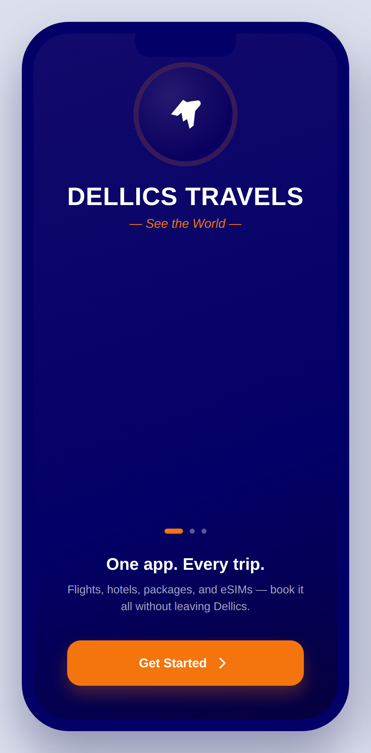  Splash & Onboarding  Brand-first launch screen that introduces the Dellics identity (Section 3 palette) before any functional UI — mirrors the mobile-first onboarding style of Hopper. | 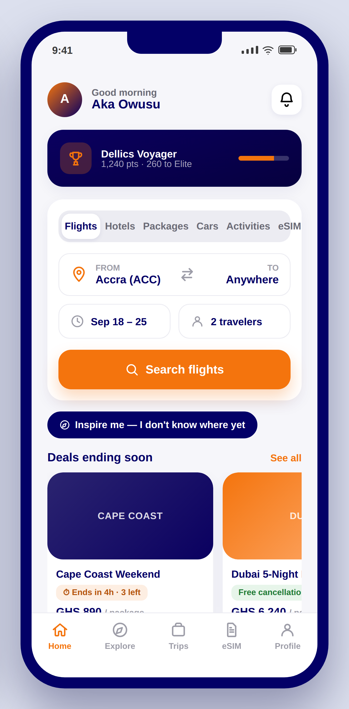  Home  Unified search tabs and “Inspire Me” entry point (Booking.com / Skyscanner), a membership progress banner, and an urgency-badged deals carousel (Booking.com / Agoda).

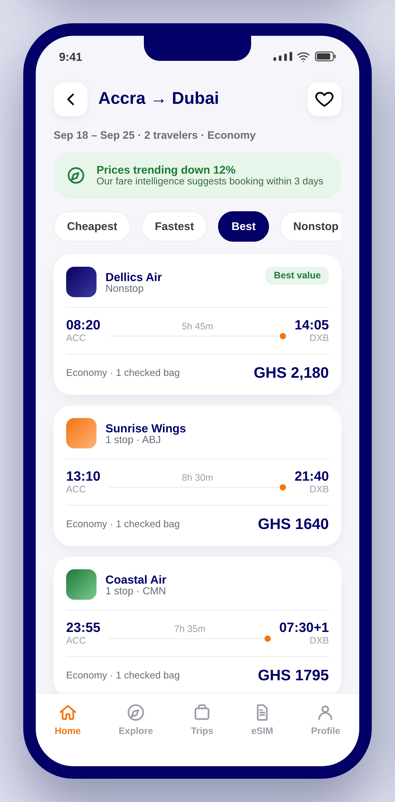  Flight Search Results  A Hopper/Kayak-style price-trend banner sits above a Skyscanner-style filter chip bar and flight list, surfacing buy-now-vs-wait guidance (Section 6.16) directly in results. | 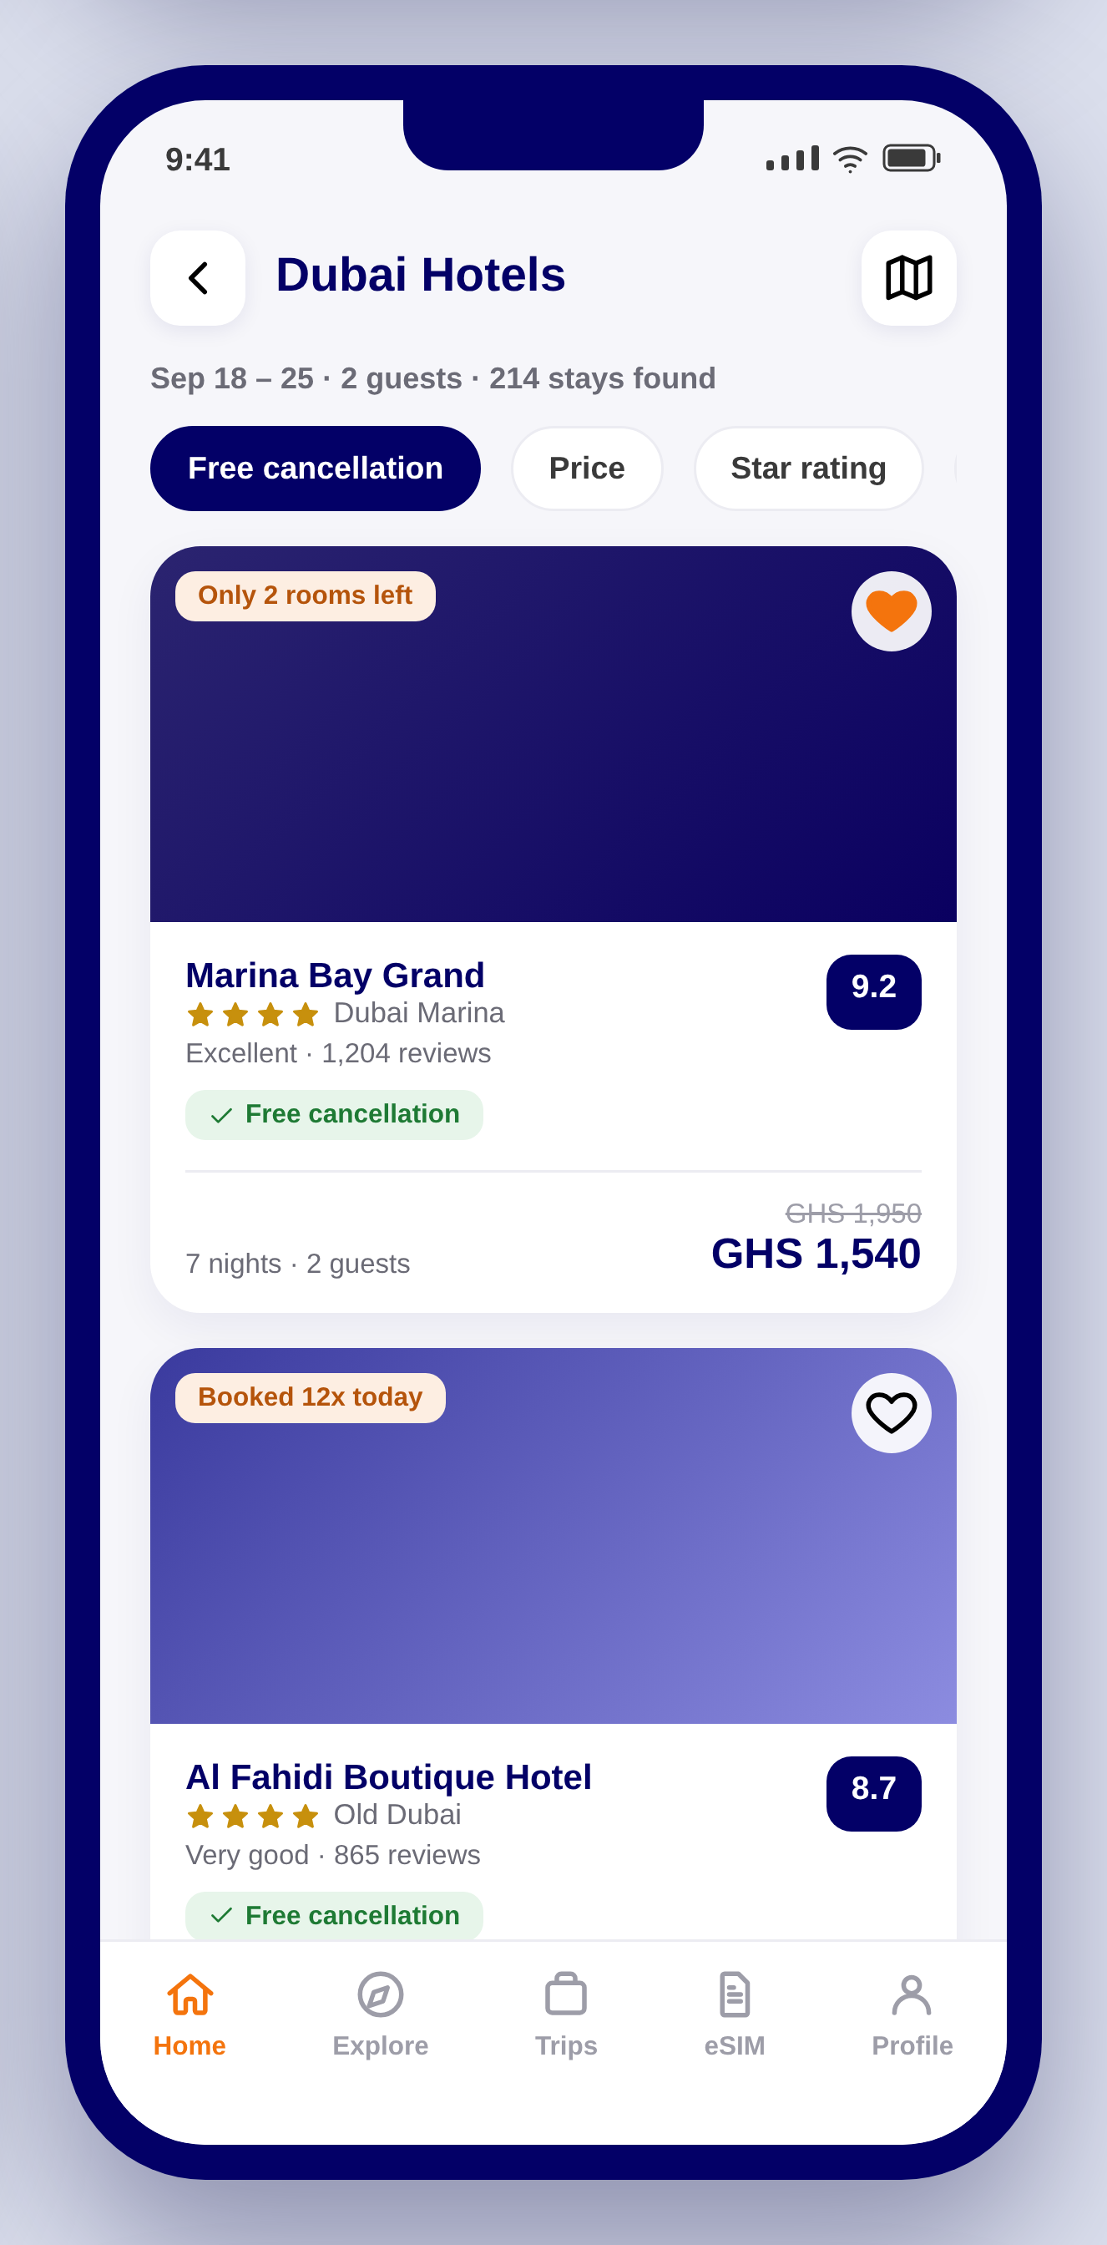  Hotel Search Results  Booking.com property cards: real-time scarcity badges (“Only 2 rooms left”), a review-score chip, and a free-cancellation badge shown by default (Section 6.20).

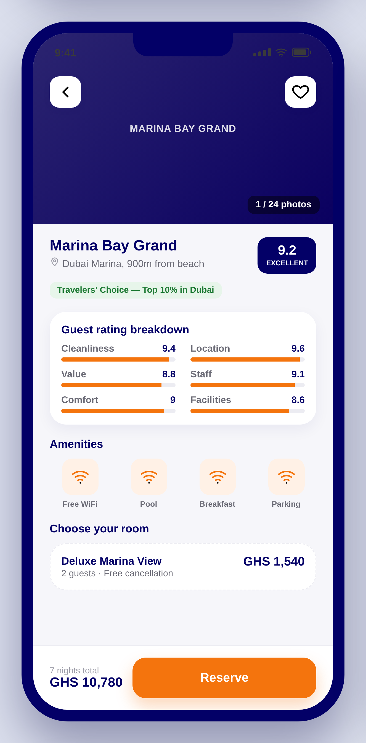  Property Detail  Booking.com's category sub-score breakdown (cleanliness, location, value…) plus a Travelers' Choice badge (TripAdvisor pattern, Section 6.21) and a sticky Reserve bar. | 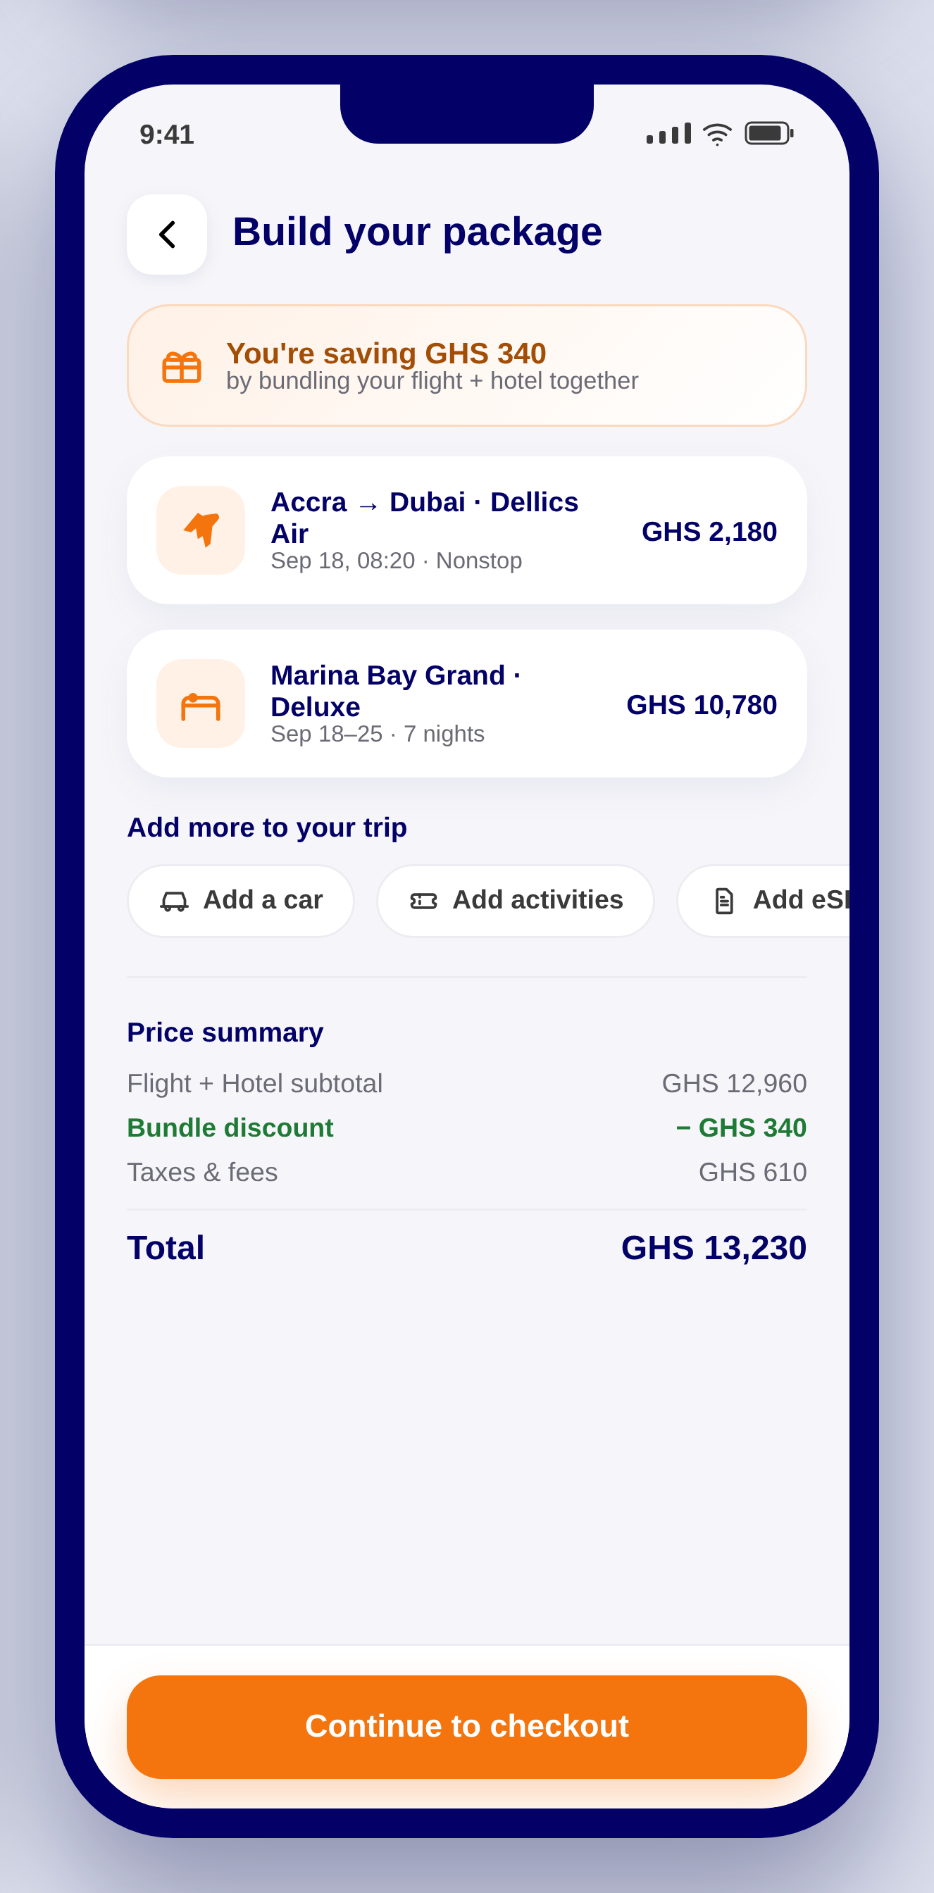  Package Builder  Expedia/Priceline-style dynamic bundle summary — the savings banner updates live as flight, hotel, car, and eSIM are combined into one package (Section 6.4).

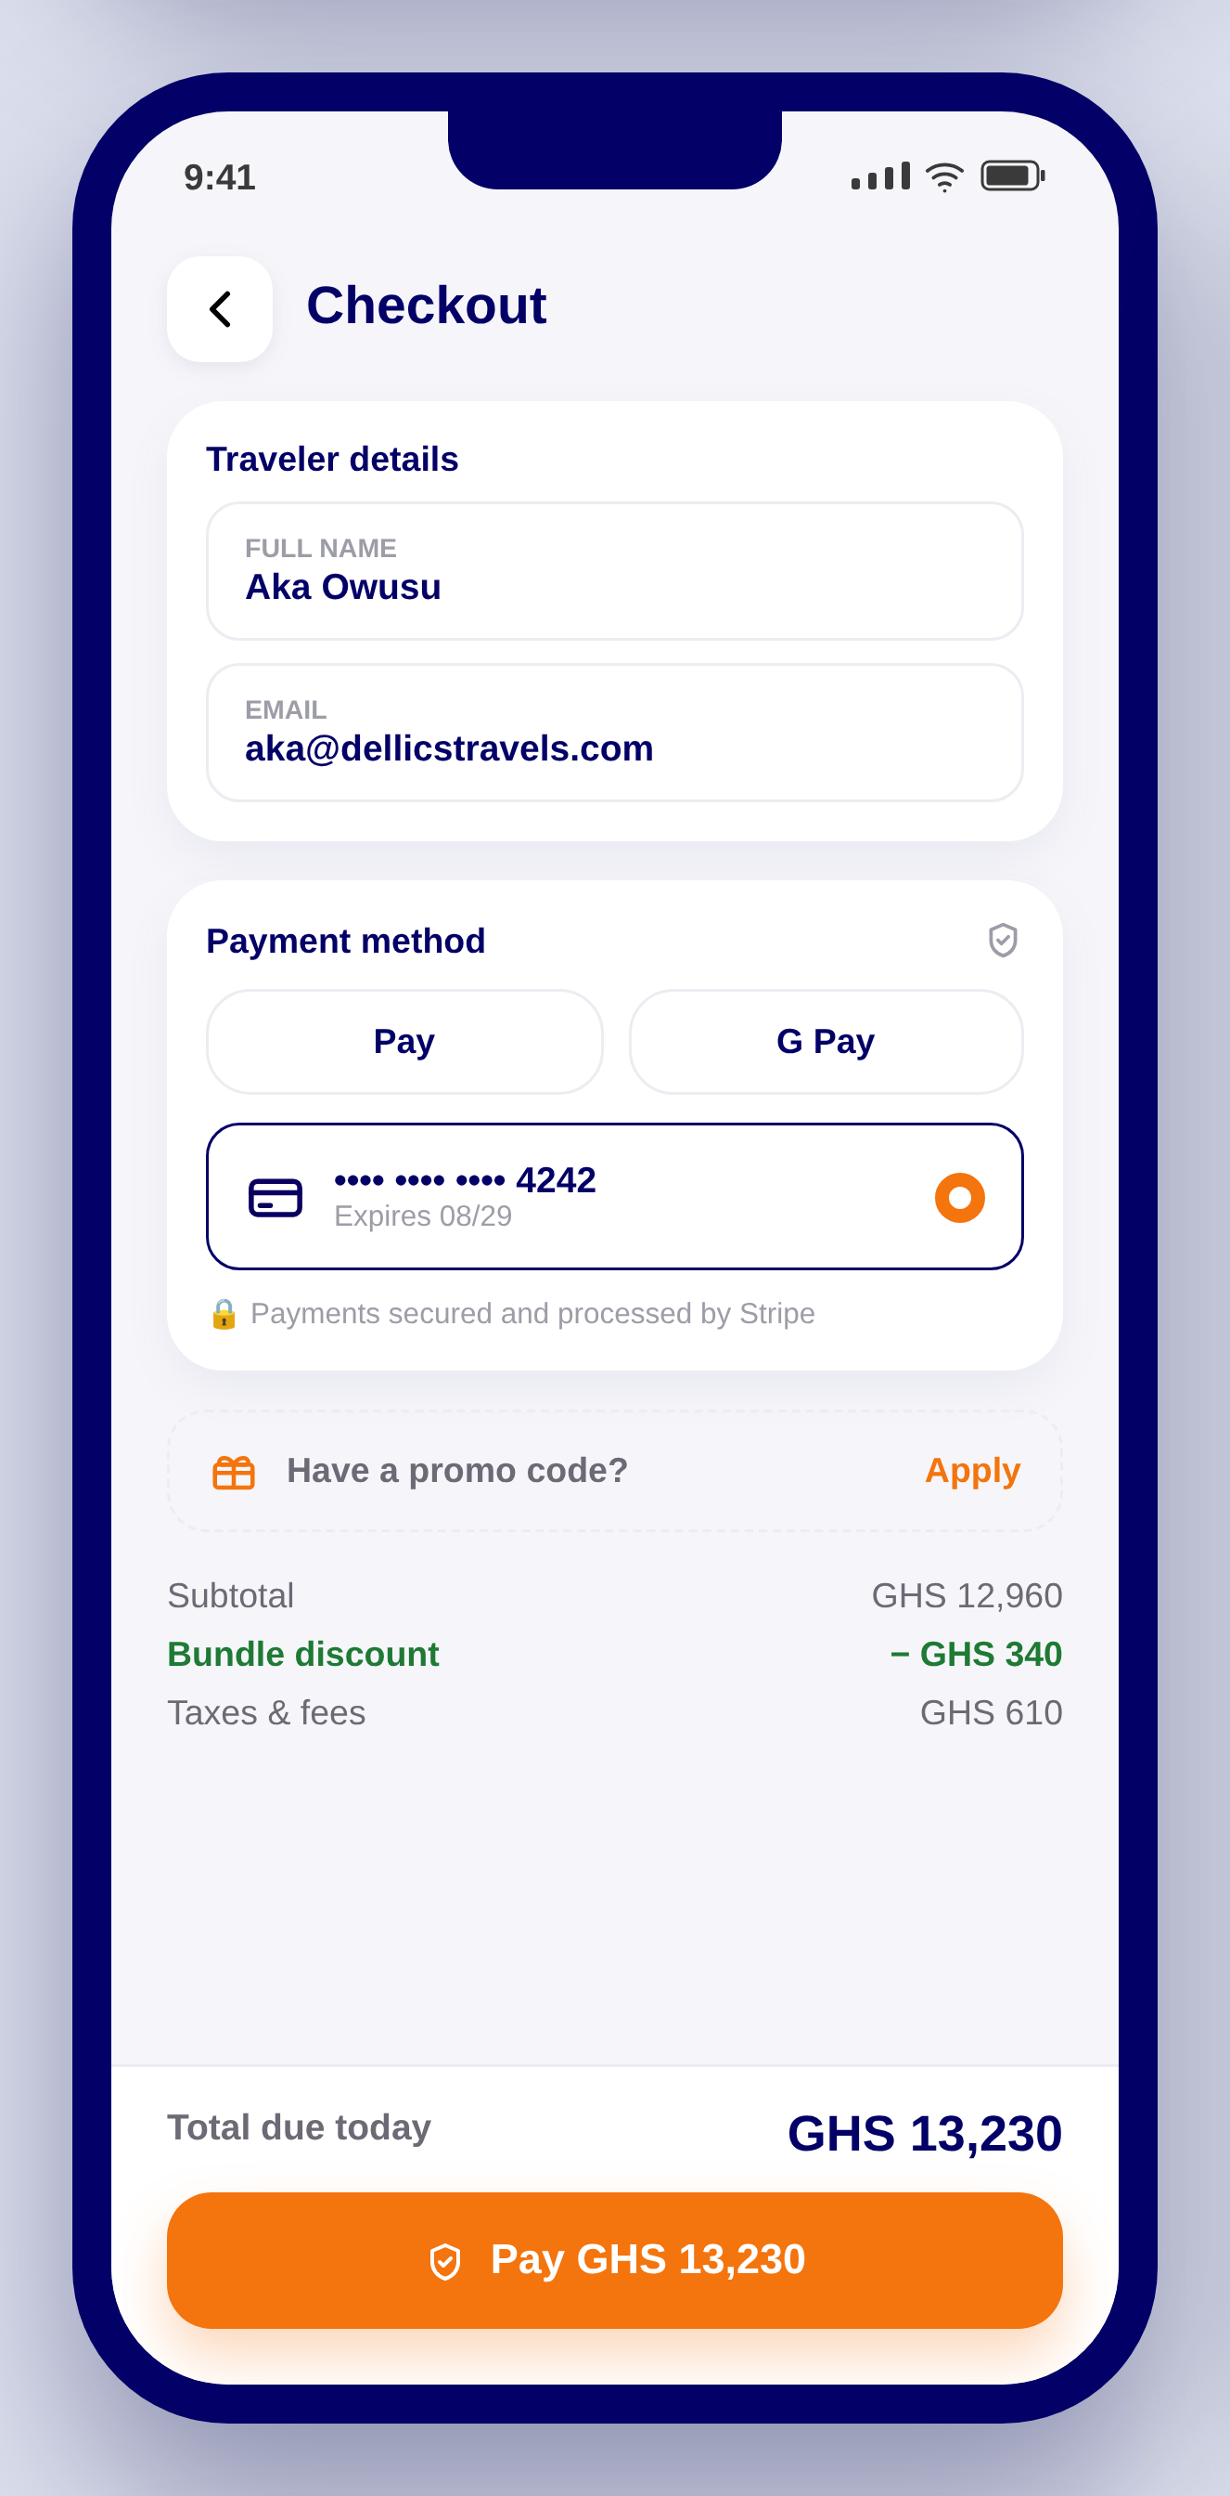  Checkout  Stripe PaymentSheet-style entry with saved card, Apple Pay / Google Pay, and an explicit “secured by Stripe” trust line (Section 12). | 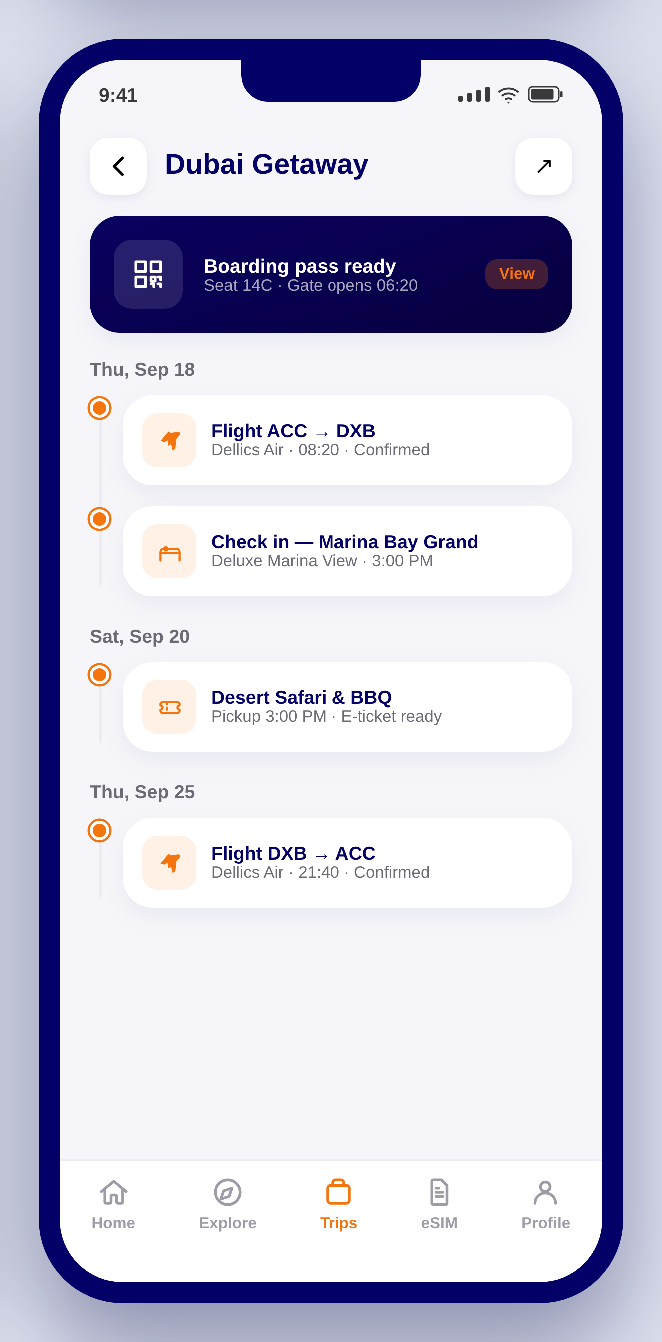  Trip Planner  Trip.com-style itinerary timeline that groups every booking type — flight, hotel, activity — into one chronological trip view, with the boarding pass pinned at the top (Section 6.7).

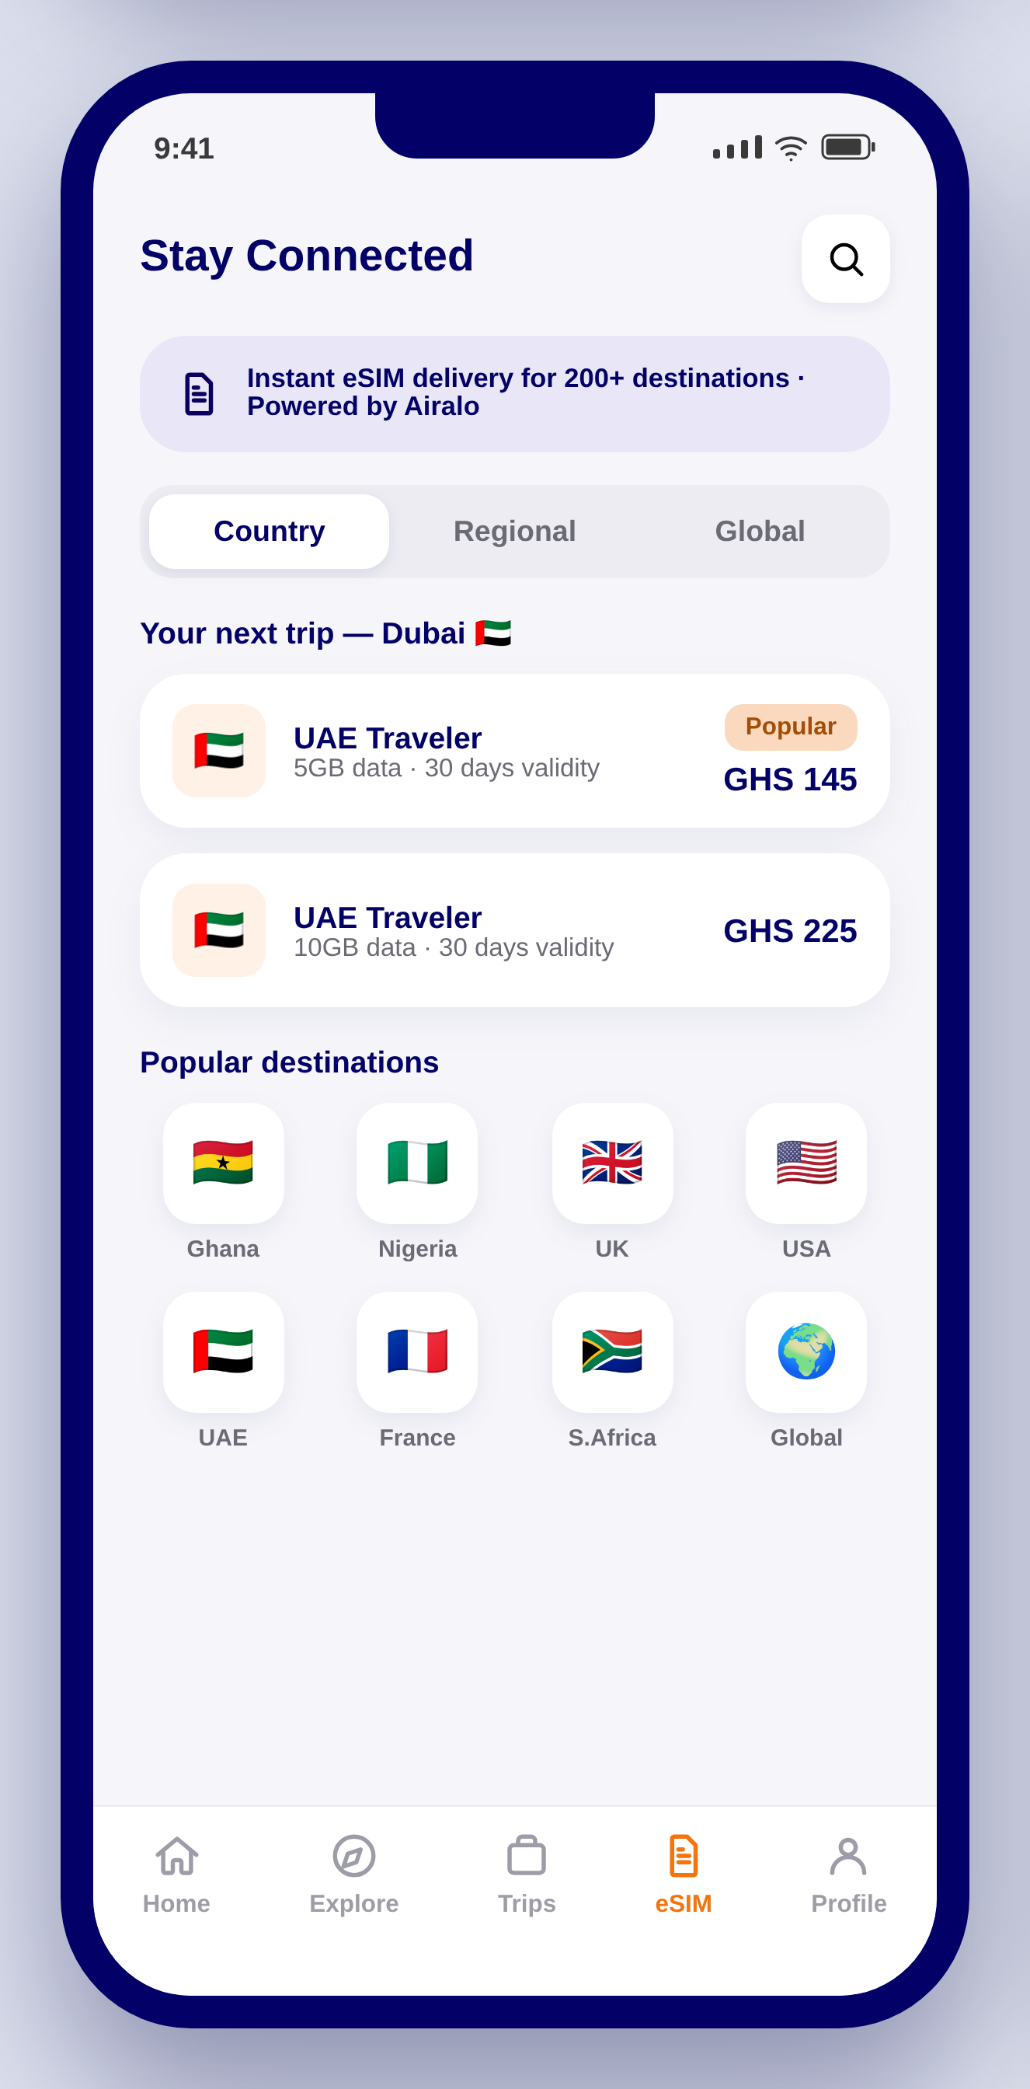  eSIM Store  Airalo's Local / Regional / Global plan structure, rebuilt in Dellics branding with a destination-matched cross-sell at the top (Section 6.23). | 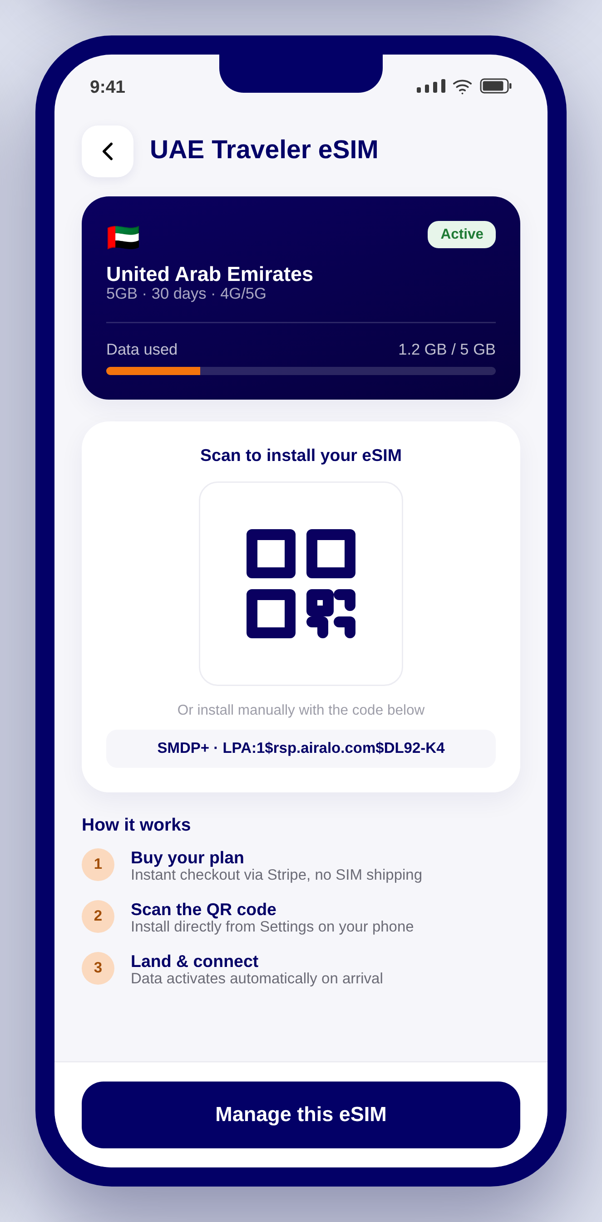  eSIM Activation  QR/LPA activation screen mirroring Airalo's install flow — the code shown here is issued live by the Airalo Partner API SDK on successful Stripe payment (Section 12.3).

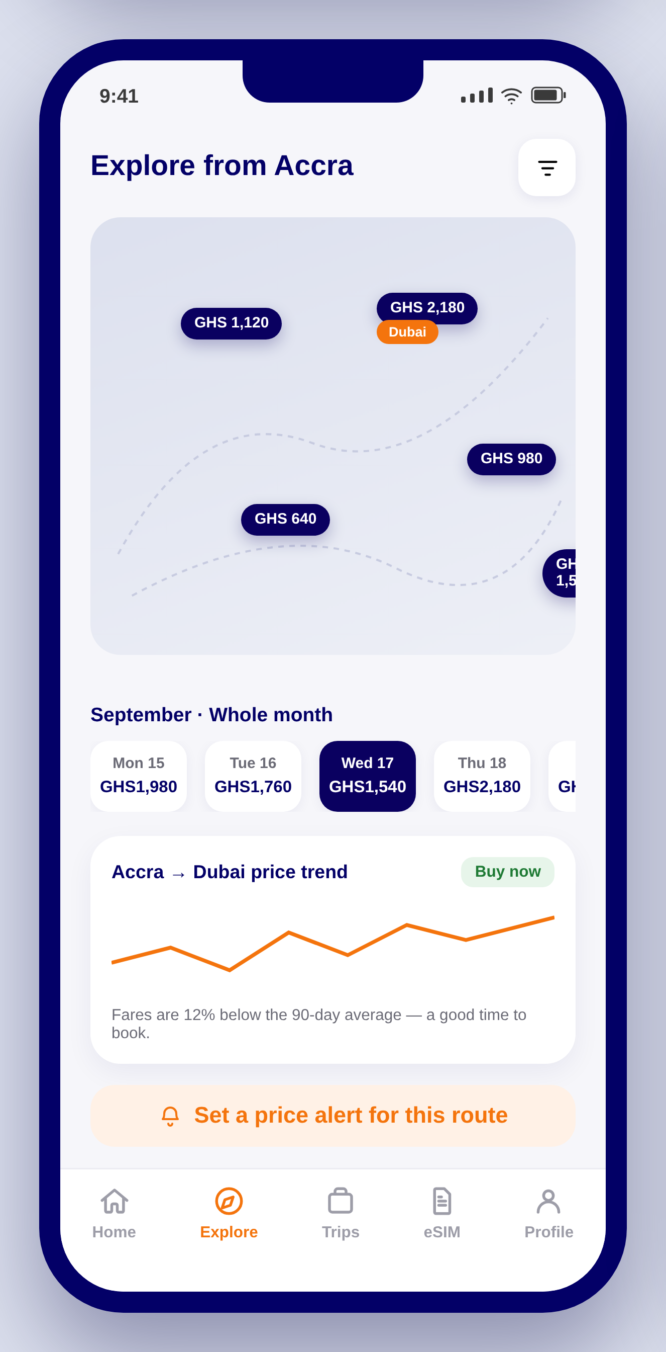  Explore Map  Google Flights' Explore Map and Date Grid combined with a Hopper-style price-trend chart and a one-tap “Set a price alert” action (Section 6.16). | 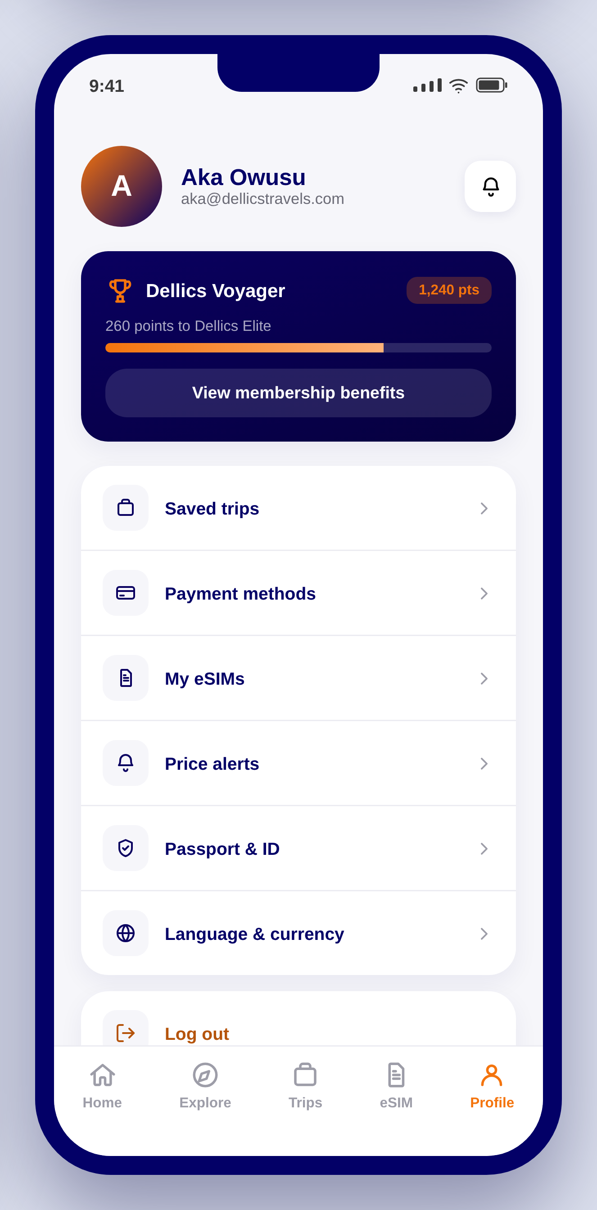  Profile & Membership  Membership tier progress bar (Section 7) with quick access to saved trips, payment methods, My eSIMs, and price alerts — Expedia One Key's unified account pattern.

Design-to-build handoff
Screens are built as a shared component system (status bar, app bar, bottom nav, card, chip, badge) styled from the Section 3 design tokens — the same structure a React Native/NativeWind implementation should follow, so this UI spec maps 1:1 onto the frontend stack in Section 9.1.

