UPSA ASSEMBLY PLATFORM
App Flow
How each of the seven roles moves through the system: navigation, journeys, state machines, approvals, notifications and what happens when things go wrong.
Project | UPSA Assembly Platform (UAP) — internal operations ERP
Document | App Flow
Version | 2.0 — Draft for UPSA review (internal-use scope)
Date | 3 October 2026
Prepared by | Codey Dev (Aka Brown), software & security
Prepared for | University of Professional Studies, Accra — Computer Assembly Unit
Colours follow UPSA’s published Navy Blue (Pantone 281C) and Gold (Pantone 1245C); hex values are screen approximations to confirm against UPSA’s brand guide.

Contents
01 How to read this document
02 Navigation by role
03 Core journeys
04 State machines
05 Notification matrix
06 Edge cases and error flows
07 A working day by role
08 Screen states and interaction rules

1. How to read this document
Section 2 shows what each role sees. Section 3 walks the main journeys, each with a diagram, ordered steps and the exceptions that branch off. Section 4 lists the legal status transitions that the database enforces. Sections 5 to 8 cover notifications, failure handling, daily rhythms and shared interaction rules.
Short code | Role
SA | Super Admin
MG | Management
PI | Procurement & Imports Officer
IS | Inventory & Sales Officer
FS | Finance & Service Officer
AT | Assembly Technician
QI | QC Inspector

2. Navigation by role
The sidebar shows only modules the user’s scopes allow. “Home” is the role’s landing screen (see the Design Brief).
Module | Screens | SA | MG | PI | IS | FS | AT | QI
Home | Role home, approvals inbox, notifications | ● | ● | ● | ● | ● | ● | ●
Procurement and imports | Suppliers, requisitions, POs, shipments, customs, charges, landed cost, supplier invoices, RMAs | ◐ | ◐ | ● | ◐ | ◐ | – | –
Inventory | Stock, ledger, goods receipts, transfers, adjustments, counts, reorder, lots and serials, labels | ◐ | ◐ | ◐ | ● | ◐ | ◐ | ◐
Production and quality | Assembly orders, board, unit workspace, tests, QC, rework, imaging, genealogy, defects | – | ◐ | – | ● | – | ● | ●
Sales and dispatch | Accounts, internal orders, reservations, dispatch and handover, returns | – | ◐ | – | ● | ◐ | – | –
Finance | Invoices, payments, expenses, budgets, journal, trial balance, periods | – | ◐ | – | – | ● | – | –
Service | Tickets, warranty register, serial lookup | – | ◐ | ◐ | ◐ | ● | ◐ | ◐
Reports | Reports hub, viewer, schedules | ◐ | ● | ◐ | ◐ | ● | – | ◐
Admin | Users, roles, approval rules, settings, import wizard, audit, API clients | ● | ◐ | – | – | – | – | –

● primary workspace ◐ read, limited or step-level access – hidden. Exact scopes are in the TDD permission matrix.

3. Core journeys

3.1 Requisition to purchase order
- Trigger: IS or PI raises a requisition manually, or the system creates one from a reorder alert or a production shortage (source recorded).
- Requisition is submitted; the approval rule engine matches action and amount. Below the limit it goes straight to PI; above it Management is notified.
- PI converts the approved requisition to a PO: picks the supplier (item-supplier prices and lead times are suggested), currency, incoterm, mode, expected dates. The system records the exchange rate and shows the estimated duty from HS codes.
- PO is submitted; approval by amount (Management). Rejection returns it to PI with the comment.
- On approval PI sends the PO (PDF by email); status becomes Sent, then Confirmed when the supplier acknowledges.
Exceptions: supplier on hold or blocked stops submission; a PO that pushes a supplier’s period total over the aggregate limit is flagged to Management; edits after approval create a new version and re-trigger approval.

3.2 Import: PO to landed cost
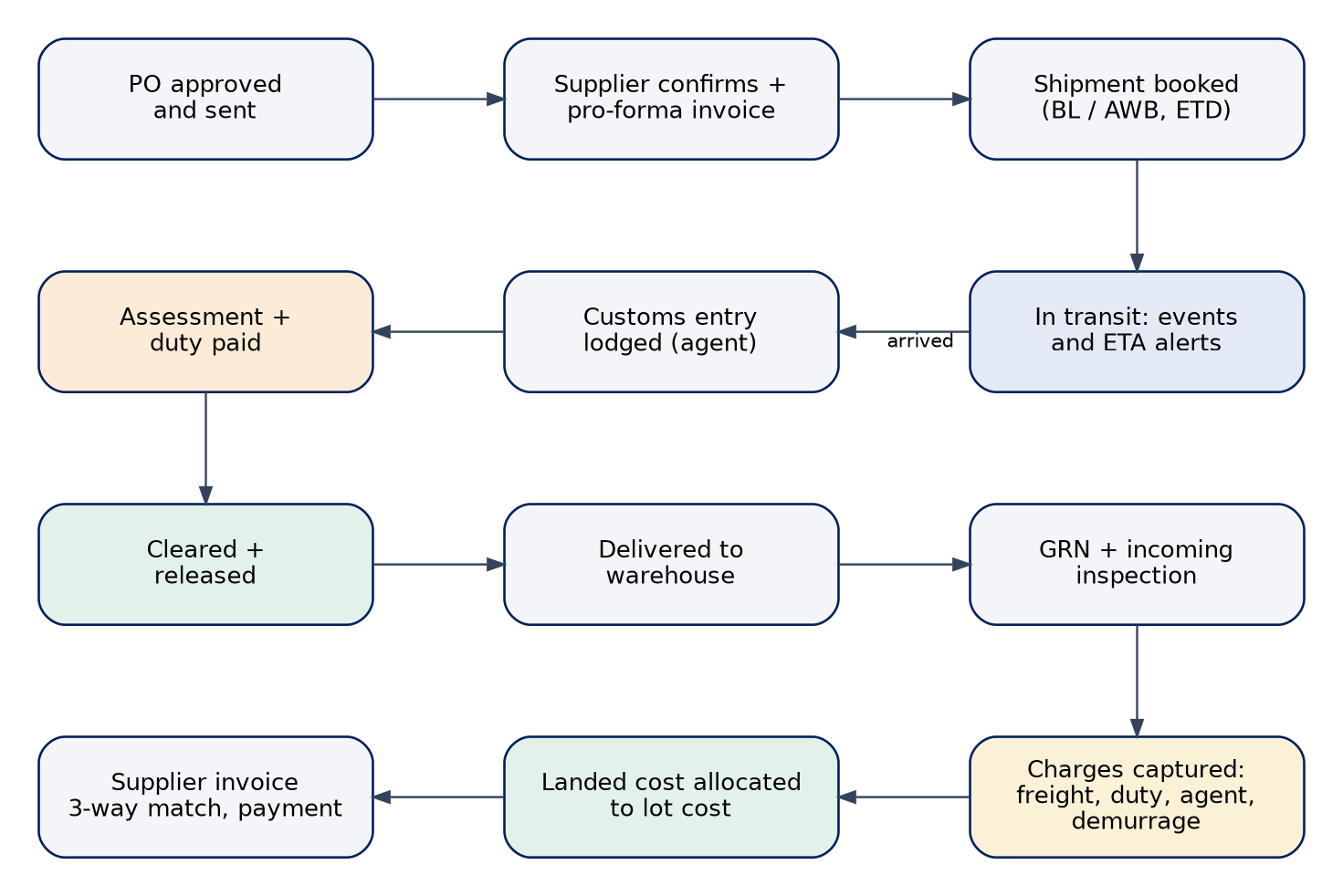
Figure 1 — Shipment and landed-cost journey
- PI creates a shipment (mode, BL or AWB, containers, carrier, forwarder, clearing agent, ports, ETD, ETA) and attaches PO lines being shipped; a PO can split across shipments and a shipment can carry several POs.
- PI records events as news arrives (departed, transhipped, arrived). If ETA slips by more than the configured days, Management and IS are notified.
- On arrival PI opens the customs entry: declaration number, regime, customs value, duty, VAT, levies and status. Uploads required documents; the checklist shows what is missing.
- PI enters charges as estimates and replaces them with actuals when agent and carrier invoices arrive; each charge has currency, rate, basis and a recoverable flag.
- After release, goods are delivered to the warehouse and IS receives them (journey 3.3).
- When charges are final, PI previews and posts the landed-cost run. Lot cost and moving-average cost update; FS sees the accrual and GL postings queue.
- Supplier invoice is matched three ways; FS records payments. The shipment closes when documents are complete and charges are actual.
Exceptions: customs query or hold sets the shipment to Held with owner and reason; a demurrage clock appears when free days are running out; late charges after posting create a landed-cost adjustment run; a closed period blocks reversal without Management approval.

3.3 Receiving and incoming inspection
- IS opens the expected receipt from the shipment or PO; the scan field is focused.
- For each line IS scans or keys quantity, lot number and component serials (required for CPU, motherboard, SSD, RAM).
- Damaged or wrong items are marked rejected with reason and photo and go to the quarantine location.
- If the item or supplier requires inspection, a QC Inspector records an incoming inspection (sample size, checklist, defects); a reject moves stock to quarantine.
- IS posts the receipt: ledger rows, lots and serials are written; PO and shipment lines update; variance against the PO is shown.
- Rejected quantities can open a supplier RMA for PI.
Exceptions: over-delivery needs a reason and PI confirmation; a duplicate serial is blocked with a link to the existing record; a partial receipt leaves the PO in Partly received.

3.4 Assembly, tests and quality control
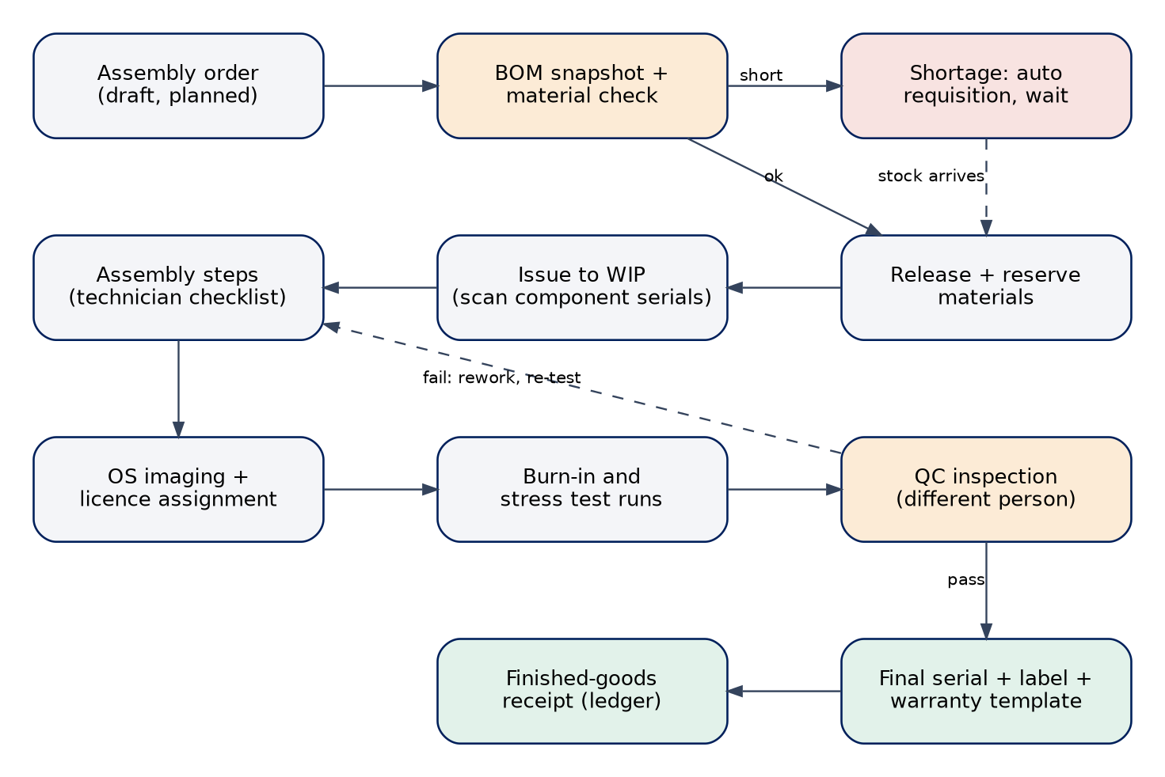
Figure 2 — From assembly order to finished goods
- IS creates an assembly order for stock or for an internal order; the BOM version and routing are snapshotted.
- The system checks materials including stock in transit. Shortages create a requisition and hold the order at Awaiting materials; the buildable view shows what limits the model.
- IS releases the order: materials are reserved, unit records are created, and IS issues parts to the WIP location by scanning component serials.
- The technician (AT) opens a unit, completes checklist steps in order, scans parts as installed and logs time; imaging and licence assignment follow where required.
- AT records tests (POST, burn-in, stress, battery, display, network, thermal) with logs.
- QI inspects the unit; the system blocks the inspector if they built it. Pass: final serial, cost snapshot, label and finished-goods receipt. Fail: defect codes and a rework order return the unit to the bench; re-inspection is required.
- When all units are complete the assembly order closes and yields, labour minutes and defects feed reports.
Exceptions: a faulty component found during build is replaced from stock (genealogy updated) and may open a supplier RMA; scrap needs approval above the limit; order on hold keeps reservations until released or cancelled.

3.5 Internal order to dispatch
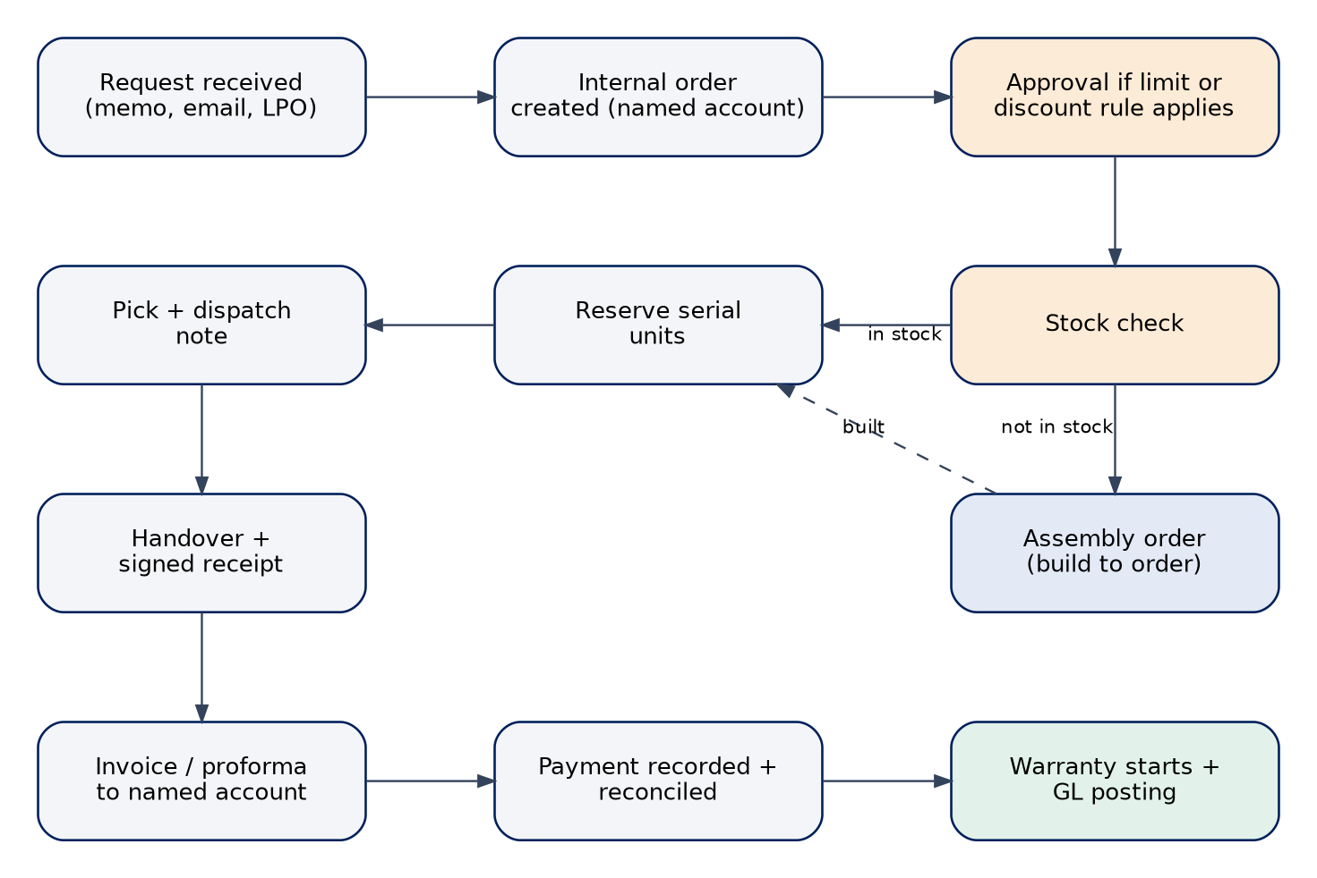
Figure 3 — Internal sales and dispatch
- IS creates an internal order for a named account (department, staff member, unit) with the source reference (memo, email, LPO), lines and required date. Prices come from the internal price list and are snapshotted when confirmed.
- Discounts or price overrides above the limit, or an account above its credit limit, trigger Management approval.
- The system checks stock. In-stock lines reserve specific serial units; out-of-stock lines can create an assembly order and show an expected ready date.
- When units are ready IS creates the dispatch note, picks, and dispatches. Partial dispatch is allowed.
- At handover IS records the recipient name, phone and signature or photo. Warranty starts on this event.
- FS issues the invoice or proforma, records payment and allocates it. Cost of sales posts to the ledger from the units’ actual cost.
Exceptions: a reserved unit that fails a late check goes back to QC hold and the order is re-reserved; a return is requested, approved by Management, inspected, restocked or quarantined, and credited.

3.6 Warranty claim and repair
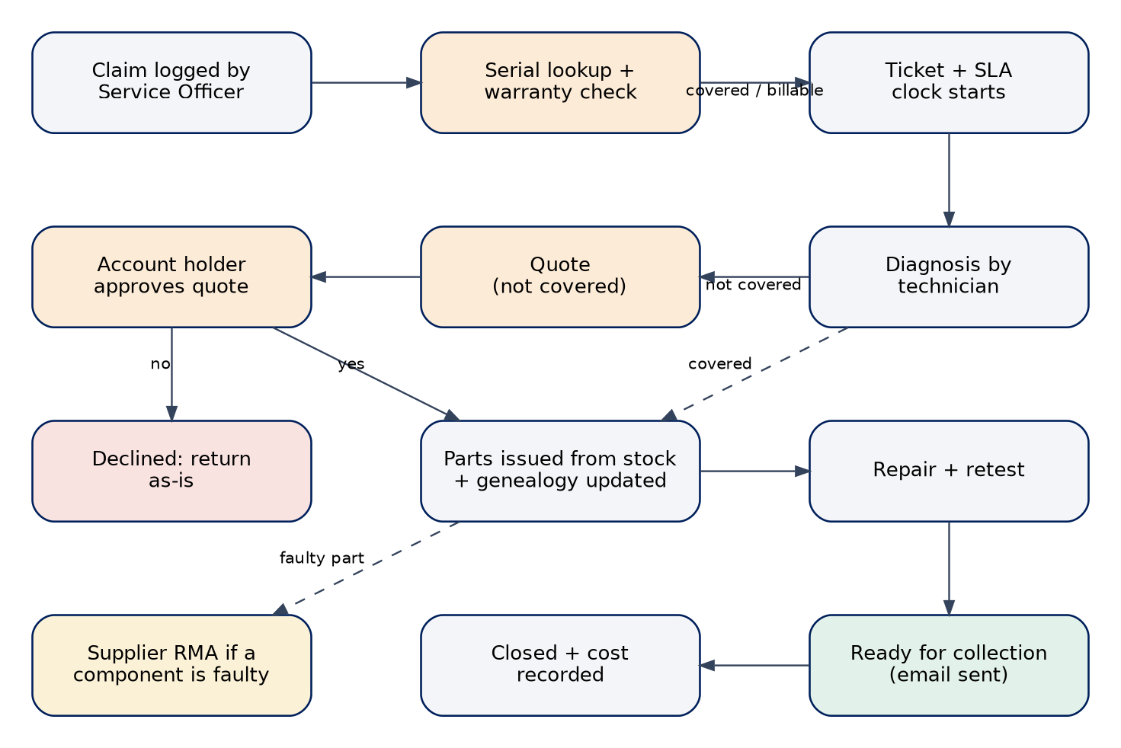
Figure 4 — After-sales service
- FS logs a claim or repair request by scanning or typing the unit serial. The system shows warranty status, genealogy and component supplier coverage.
- A ticket opens with priority and SLA clock; FS assigns an AT.
- AT diagnoses and records findings. If covered, parts are issued from stock and genealogy updated. If not covered, FS issues a quote to the account holder; approval is recorded.
- Parts are consumed (ledger rows linked to the ticket); AT repairs and retests; QI retests if the repair touched a controlled step.
- FS marks Ready for collection and the account contact is emailed; handover is recorded and the ticket closes with true cost (covered repairs post at zero charge).
- A faulty component still under supplier warranty opens a supplier RMA for PI.
Exceptions: goodwill cover for expired warranty needs Management approval; a loaner unit can be assigned; SLA breach alerts FS and Management.

3.7 Approvals
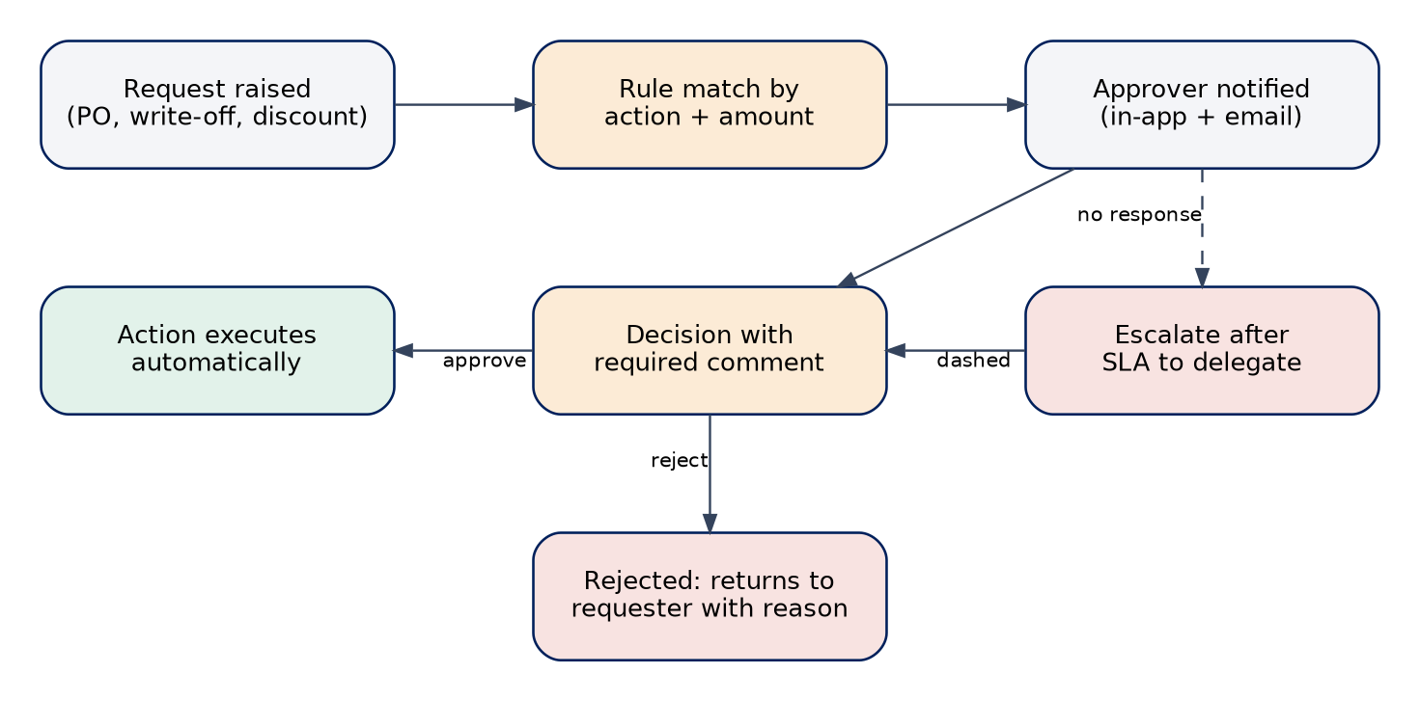
Figure 5 — Approval handling
- Rules are configured by action and amount: PO, stock write-off, discount or price override, refund, expense, supplier bank change, landed-cost reversal after close, period close.
- The requester cannot approve their own request; if no approver responds within the SLA the request escalates to the delegate named in the rule.
- Approving executes the action automatically (for example, the PO becomes Approved); rejecting returns it with the comment. Every decision is audited.
- Management can approve from a phone: the inbox and the detail view are designed for small screens.

3.8 Stock count and adjustment
- IS schedules a cycle count (by location, category or ABC class) or a full stock take; expected quantities are frozen from the ledger at the start.
- Counters enter quantities by scanning or keying; QI may witness high-value areas.
- Variances are listed with value; IS recommends reason codes.
- Variances above the limit go for Management approval; on approval an adjustment posts ledger rows and a GL entry.
- The count closes; accuracy figures feed the KPI.

3.9 Month-end close
- FS opens the close checklist: all receipts posted, landed-cost runs final, supplier invoices matched, payments allocated, adjustments approved, bank reconciliation done.
- The system flags open items by owner and notifies them.
- FS runs the trial balance and exports journals, invoices and payments for UPSA finance.
- FS requests the period close; Management approves; the period locks (closed).
- Corrections after close post in the current period; reopening needs Management approval and is audited.

3.10 Onboarding and data import
- SA invites a user by email with a role template; the user sets a password and enrols TOTP on first sign-in.
- SA can adjust scopes; Management is notified of any scope change.
- Data import wizard: choose a template (items, suppliers, accounts, BOMs, opening stock), upload Excel or CSV, review validation (row errors with reasons), commit; a batch can be rolled back until used.
- Opening stock is imported as ledger receipts to the correct locations, then verified by a supervised stock count.

4. State machines
Transitions not listed are rejected by database functions. Each transition records actor and time in the event timeline and audit log.

Purchase order
From | To | Who | Condition
draft | pending_approval | PI | Lines, supplier, currency, rate complete
pending_approval | approved / draft | MG | Approve, or reject with comment
approved | sent | PI | Email sent
sent | confirmed | PI | Supplier acknowledgement recorded
confirmed | partly_received / received | IS (via receipt) | Derived from posted receipts
received | closed | PI | Invoices matched
any open | cancelled | PI | No posted receipts; approval if above limit

Shipment
From | To | Who | Condition
booked | in_transit | PI | Departure event
in_transit | arrived | PI | Arrival date recorded
arrived | customs_processing | PI | Customs entry lodged
customs_processing | held | PI | Query or inspection hold with reason
customs_processing / held | cleared | PI | Duty paid; release recorded
cleared | delivered | IS / PI | Goods at warehouse
delivered | closed | PI | Receipt posted; documents complete; charges actual; landed cost posted

Requisition, internal order, assembly order
Object | Path
Requisition | draft → submitted → approved → converted · or rejected · or cancelled
Internal order | draft → pending_approval → approved → awaiting_build (optional) → ready → dispatched → completed · or cancelled
Assembly order | draft → planned → awaiting_materials ⇄ ready → released → in_progress → in_qc → completed · on_hold and cancelled from any open state

Ticket, RMA, invoice, count
Object | Path
Service ticket | received → diagnosing → (awaiting_approval) → (awaiting_parts) → in_repair → testing → ready_for_collection → closed · or declined
Supplier RMA | draft → submitted → authorised → shipped → credited or replaced → closed · or rejected
Invoice | draft → issued → part_paid → paid · overdue is derived · void with credit note
Stock count | planned → counting → review → posted · or cancelled
Fiscal period | open → soft_closed → closed (reopen needs approval)

5. Notification matrix
In-app and email only. Each user can switch email off per category except approvals and security.
Event | Recipients | Channel
Approval requested / decided / escalated | Approver; requester | In-app + email
Shipment ETA slips, held, arrived, released | PI, IS, MG | In-app + email
Demurrage free days ≤ 3 | PI, MG | In-app + email
Goods receipt posted with variance | PI, FS | In-app
Low stock or reorder suggestion | IS, PI | In-app + daily email digest
Landed-cost run posted | FS, MG | In-app
Assembly order blocked by materials | IS, PI | In-app
Unit ready for QC / rework returned | QI / AT | In-app
Order ready for dispatch; dispatched | IS; account contact (email) | In-app; email
Invoice issued; payment overdue | Account contact; FS | Email; in-app
Ticket assigned; SLA at risk or breached | AT; FS, MG | In-app + email
Warranty expiring in 30 days | FS | In-app
Scope change, new user, suspended user | MG | Email
Scheduled report ready | Requester | Email with signed link
Failed job or posting | SA | In-app + email

6. Edge cases and error flows
Situation | Behaviour
Two users edit the same document | Second save returns 412 with the latest version and a field-level diff to merge
Scan not found | Clear message with options: search manually, create item (if permitted), or report
Serial entered twice | Blocked; shows where the serial already lives
Receipt posted twice (double click or retry) | Idempotency key returns the first result; no duplicate ledger rows
Exchange rate missing for a date | Document cannot post; prompt to add a rate with source or choose the nearest approved rate
Closed period | Postings go to the current period with a banner; reversals need approval
Landed-cost charge arrives late | Adjustment run: remaining stock adjusts the average; consumed portion posts to variance
Landed-cost allocation would exceed the charge by rounding | Largest-remainder method guarantees equality
Reserved unit fails inspection | Reservation released, order flagged, IS offered substitutes
Approver unavailable | Escalates to delegate after the SLA; Management sees overdue approvals
Insufficient stock for issue | Issue blocked; shortage shown with in-transit quantities and a create-requisition shortcut
Supplier bank detail changed | Payments to that supplier are blocked until the change is verified and approved
Large export | Runs as a background job; user is notified and receives a signed link
Browser offline or connection lost | Unsaved form data is kept locally; a banner explains; nothing is posted until the server confirms
Session expiry or MFA failure | Redirect to sign-in preserving the target; repeated failures lock the account and alert SA
User without scope opens a link | 403 page naming the missing capability and how to request it

7. A working day by role
Role | Typical day
SA | Review failed jobs and security alerts; handle invitations and leavers; check backups and audit exceptions weekly
MG | Clear the approvals inbox; scan the home screen for delayed shipments, shortages and budget variance; review weekly KPIs and exceptions
PI | Chase shipments; update events and customs status; enter charges as invoices arrive; raise POs from approved requisitions; post landed-cost runs
IS | Receive goods; release and issue assembly orders; process internal orders and dispatches; run cycle counts; handle low-stock alerts
FS | Issue invoices; allocate payments; review service tickets and SLA; record expenses; prepare month-end
AT | Pick up the next unit from the queue; complete steps and tests; handle repairs assigned to them
QI | Inspect incoming goods and finished units; log defects; retest reworked units

8. Screen states and interaction rules
- Loading: skeleton rows for lists, spinner only inside buttons; blocking operations over one second show progress.
- Empty: each empty state explains why it is empty and offers the next action permitted for the role.
- Error: inline message with remedy and trace id; retry where safe.
- Saving documents: drafts autosave; posting actions need explicit confirmation showing what will be written (ledger rows, cost change, notifications).
- Destructive actions: void, cancel and reverse need a reason; irreversible ones need a second confirmation.
- Search: global search accepts serials, document numbers, supplier names and BL/AWB numbers; results grouped by type and filtered by the user’s scopes.
- Keyboard: Ctrl/Cmd+K command palette, / filter, G then letter to jump to a module, Esc closes drawers.
- Audit trail: every document has a timeline tab showing events and audit entries to users with the scope.

