TECHNICAL DESIGN DOCUMENT
Writer’s Personal Website
Architecture, security and delivery plan
Project | Writer’s Personal Website
Client | [Author Name] (author)
Prepared by | Codey Dev
Version | 1.0 (draft for client review)
Date | 13 October 2026
Status | Draft — assumptions flagged for confirmation

1. Context and constraints
This document describes how the requirements in the PRD are built. It follows a modular monolith: one Next.js application on Vercel, one Supabase project, and three small external services (Resend, Upstash QStash, Upstash Redis). There is no separate backend service; nothing here needs one.
Constraint | Consequence for the design
One author, low write volume, read-heavy public site | Pages are pre-rendered and cached; writes are rare and can invalidate cache on demand.
Free-tier first (NFR-COST-01) | Each service has a documented upgrade trigger (section 13). Nothing requires a paid plan at launch.
Weak devices and networks (NFR-PERF-01) | Server Components by default, almost no client JavaScript on reading pages, forms work without JavaScript.
Author is non-technical | Admin favours few, safe actions; publishing never needs a deploy.
Subscriber emails are personal data (NFR-PRIV-01) | Subscriber tables are closed to the public by database policy, not only by application code.

2. Architecture
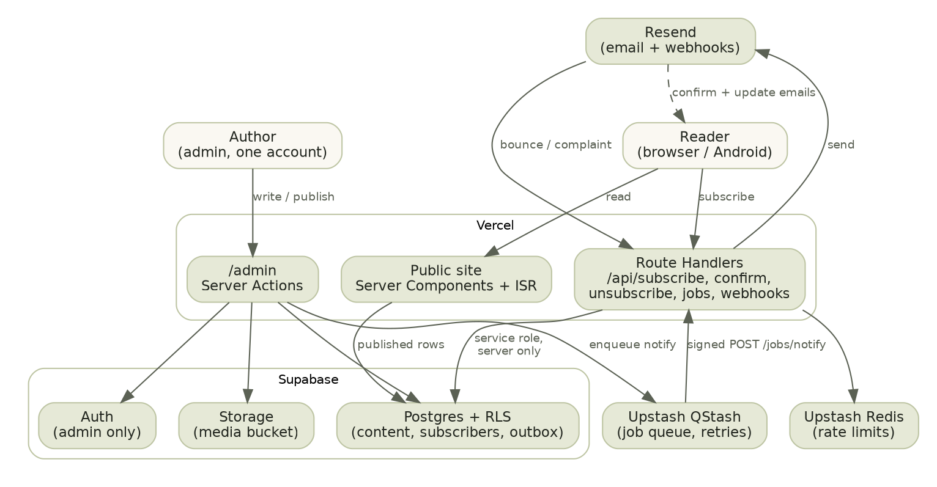
Component | Role | Notes
Next.js 15 (App Router), TypeScript strict | Public pages, admin UI, Route Handlers, Server Actions | Server Components by default; "use client" only for the subscribe form enhancement, share button and editor.
Tailwind CSS 4 + shadcn/ui (Radix) | Styling and accessible primitives | Public pages use custom components built on design tokens; shadcn is used mainly inside admin.
Supabase Postgres | Content, subscribers, notification outbox | Row Level Security on every table. Schema in the Backend Schema document.
Supabase Auth | Admin sign-in only | Email magic link or password plus optional TOTP. No public sign-up.
Supabase Storage | Cover images and About photo | Public-read media bucket; admin-only write; 2 MB cap; image types allow-listed.
Resend | Transactional and update emails; bounce and complaint webhooks | Sending domain with SPF, DKIM and DMARC.
Upstash QStash | Reliable background job with retries | Used for “send notification”. Signed requests verified on receipt.
Upstash Redis (ratelimit) | Rate limiting for public endpoints | Sliding window per IP and per email hash.
Vercel | Hosting, CDN, preview deployments, web analytics | Cookie-free analytics only.

3. Architecture decisions
Decision | Options considered | Choice and reason | Revisit when
One posts table for poems, stories, reflections and quotes | A table per type; one table with a kind column | One table with `kind`. The types share almost every field and every list/feed/notification query. Type-specific rules are enforced by CHECK constraints. | A type gains many unique fields.
Books in their own table | Reuse posts | Separate. Cover, status, link and ordering do not fit posts. | n/a
Body format | Rich-text JSON; Markdown; plain text | Markdown stored as text. Portable (export is trivial), small, safe to render with a sanitiser. Poems use a verse renderer instead of Markdown so line breaks are never lost. | Author finds Markdown hard; add a toolbar (still saves Markdown).
Public accounts | Reader accounts; token-based emails | No accounts. Matches the brief; subscribers act through signed links. | Comments or bookmarks are wanted.
Subscription consent | Single opt-in; double opt-in | Double opt-in to protect third parties’ addresses and sender reputation. | n/a
Publishing and caching | Fully dynamic; static with timed revalidation; static with on-demand revalidation | Static with on-demand revalidation (revalidateTag) from admin actions, plus a long timed fallback. Caching defaults changed in Next.js 15, so each data fetch declares its cache behaviour explicitly and this is verified against current Next.js docs at build time. | Content gets scheduled publishing.
Notification delivery | Send inside the publish request; Vercel Cron; QStash job | QStash job enqueued after the publish transaction commits. Retries with back-off, no long-running request, no cron frequency limits. | Volume exceeds free QStash allowance.
Notification trigger | Database trigger; application code | Database function `publish_post()` / `publish_book()` writes the status change and the outbox row in one transaction, so the email can never be lost or duplicated by a half-finished publish. | n/a
Admin data access | Service-role key everywhere; user session with RLS | User session with RLS for admin reads and writes. Service-role key is used only in subscribe, confirm, unsubscribe, job and webhook handlers, server-side. | n/a
Email provider | Resend; Postmark; SES | Resend for developer experience and a free tier suited to this volume. Verify current limits at build time. | List passes the free-tier daily cap.
Analytics | None; Vercel Web Analytics; Plausible | Vercel Web Analytics (cookie-free). Keeps cookie banners out of scope. | Author wants richer reports.

4. Routes and rendering
Route | Rendering | Access
/, /about | Static, revalidated on demand | Public
/poetry, /stories, /reflections, /quotes, /books | Static first page; further pages by search param ?cursor= rendered on demand and cached | Public
/poetry/[slug], /stories/[slug], /reflections/[slug], /quotes/[slug], /books/[slug] | generateStaticParams for published slugs; dynamicParams on; unknown slug returns 404 | Public
/subscribe/confirm, /subscribe/unsubscribe | Dynamic, noindex, token in query string | Anyone with the token
/privacy | Static | Public
/feed.xml, /sitemap.xml, /robots.txt | Generated, revalidated on demand | Public
/admin/** | Dynamic, no cache, noindex | Admin only
URL segments map to kind as: poem → poetry, story → stories, reflection → reflections, quote → quotes. Slugs are generated from the title on first save and then frozen so links never break; the author may edit a slug only before first publish.

5. Roles and permission matrix
Following the two-role pattern used across the portfolio, there are only Public and Admin. A subscriber is not a role: they hold a signed token for their own subscription and nothing else.
Resource | Public (anonymous) | Subscriber (token holder) | Admin
Published posts and books | Read | Read | Read, create, update, publish, unpublish, delete
Draft posts and books | None | None | Full (preview via signed-in session only)
Site settings, About | Read | Read | Update
Media files | Read by URL | Read by URL | Upload, replace, delete
Own subscription | Create (pending) via form | Confirm and unsubscribe with their own token | View, remove
Subscriber list | None | None | Read, remove, export
Notifications and deliveries | None | None | Read, retry failed
Email events (bounces) | None | None | Read
Enforcement is layered: (1) the route or action checks the admin session; (2) database RLS independently refuses non-admin access; (3) the service-role key never reaches the browser. All three must pass; any one failing means deny.

6. API specification

6.1 Conventions
- JSON over HTTPS. Request bodies validated with Zod; the same schema is used by the form and the server. Types are inferred from the schema; no any.
- Errors use the RFC 7807 problem format: { type, title, status, detail, code } with stable code values: VALIDATION_FAILED, RATE_LIMITED, TOKEN_INVALID, TOKEN_EXPIRED, UNAUTHENTICATED, FORBIDDEN, NOT_FOUND, CONFLICT, INTERNAL.
- Every request gets a request ID, logged and returned in the x-request-id header.
- Public forms work as plain HTML form posts when JavaScript is off (progressive enhancement); the handlers return a redirect in that case and JSON otherwise.

6.2 Public endpoints
Endpoint | Request | Responses | Controls
POST /api/subscribe | { email: string (RFC email, ≤254), website?: string } — website is a hidden honeypot and must be empty | 202 always, with the same body whether the address is new, pending or confirmed. 400 VALIDATION_FAILED. 429 RATE_LIMITED. | Limit 5 requests per IP per 10 minutes and 3 per email hash per day. A pending address gets a fresh confirm email at most once per hour. Honeypot hit returns 202 and does nothing.
POST /api/subscribe/confirm | { token: string } | 200 confirmed (or already confirmed). 410 TOKEN_EXPIRED. 404 TOKEN_INVALID. | Token is 32 random bytes, stored only as a SHA-256 hash, valid 48 hours, single use. Limit 20 per IP per hour.
POST /api/unsubscribe | Token in query ?t= (also accepts one-click body List-Unsubscribe=One-Click) | 200 always for a valid token; idempotent. 404 TOKEN_INVALID. | Token is id.HMAC computed on demand with a server secret, so every email can carry a working link without storing it. Constant-time comparison.
GET /feed.xml | — | RSS 2.0 of latest 30 published items | Cached, revalidated on publish.
The landing pages /subscribe/confirm and /subscribe/unsubscribe are GET pages that show a button; the button performs the POST. This is deliberate: mail scanners and link previewers fetch links automatically and must not confirm or cancel anyone.

6.3 Internal endpoints
Endpoint | Caller | Purpose | Authentication
POST /api/jobs/notify | QStash | Body { notificationId }. Creates deliveries and sends the emails. | QStash signature verified with current and next signing keys; reject otherwise. Returns 5xx if unsent deliveries remain so QStash retries.
POST /api/webhooks/resend | Resend | Bounces and complaints mark subscribers bounced or complained; event stored once. | Webhook signature verified; event ID de-duplicated by unique constraint.

6.4 Admin actions
Admin operations are Server Actions. Server Actions are public HTTP endpoints, so every action starts by loading the session, requiring admin, and validating input with Zod before touching data. All run as the signed-in user so RLS applies.
Action | Effect | After success
createPost, updatePost, deletePost | Write to posts. Slug frozen after first publish. | Revalidate affected tags only when status is published.
publishPost(id, notify) | Calls publish_post() (one transaction), then enqueues the QStash job if notify is true. | Revalidate home, section index, detail page, feed, sitemap.
unpublishPost(id) | Sets status to draft. Keeps published_at, so a later republish keeps its original date and does not re-notify. | Revalidate as above.
createBook, updateBook, publishBook, deleteBook | Same pattern for books. | Revalidate books tags.
updateSiteSettings | Updates the singleton settings row. | Revalidate home and About.
uploadImage | Uploads to media using the admin session; validates type, size and alt text. | Returns storage path.
removeSubscriber(id) | Hard delete (erasure). | —
retryFailedDeliveries(notificationId) | Re-enqueues the notify job; only failed rows are retried. | —
GET /admin/subscribers/export.csv | Admin-only streamed CSV (email, status, dates). | Logged.

Subscribe schema (reference)
import { z } from "zod";

export const subscribeSchema = z.object({
email: z.string().trim().toLowerCase().email().max(254),
website: z.string().max(0).optional(), // honeypot: must stay empty
});
export type SubscribeInput = z.infer<typeof subscribeSchema>;

7. Subscription and notification pipeline
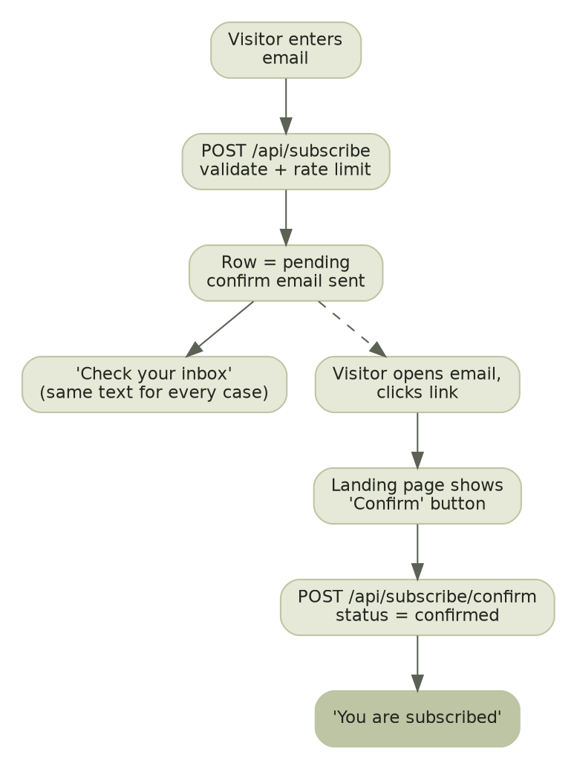
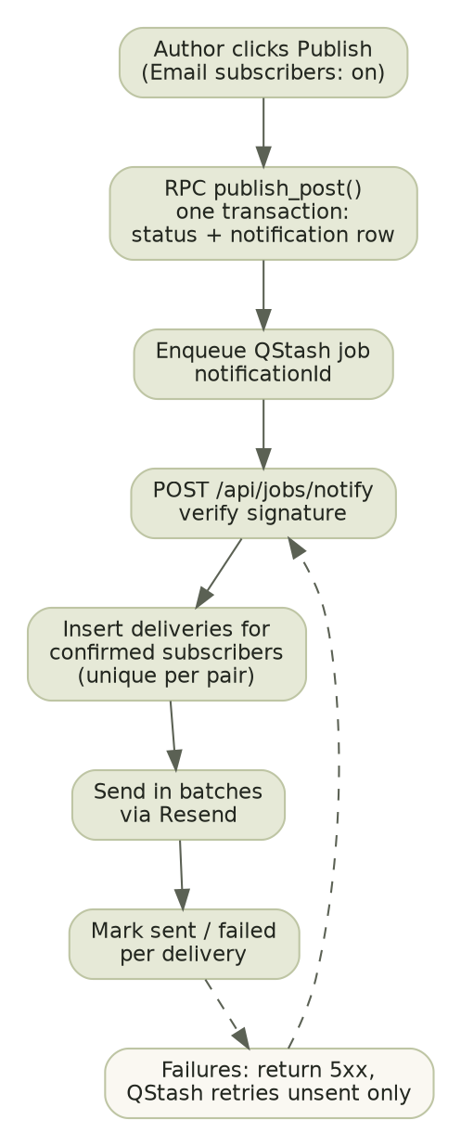

7.1 Idempotency and ordering
- notifications has a unique constraint on post_id and on book_id: a piece can have only one notification, ever. Publishing again changes nothing (FR-NTF-02).
- notification_deliveries has a unique constraint on (notification_id, subscriber_id). The job inserts rows with ON CONFLICT DO NOTHING, so a retry cannot double-create, and it only sends rows still queued or failed.
- The recipient set is fixed when the job first runs: confirmed subscribers at that moment. Someone who confirms later does not receive older pieces.
- Sends go out in batches (provider batch limit is 100 per call; verify at build time). After each batch, delivery rows are updated before the next batch starts.
- If the provider rejects with a rate-limit or server error, the job stops and returns 503; QStash retries with back-off and the job resumes from the unsent rows.
- Each email includes: sender identity, title, preview by kind, link to the piece, link to unsubscribe, List-Unsubscribe and List-Unsubscribe-Post headers, and a plain-text part.

8. Threat model
Method: for each trust boundary, what could go wrong, how likely it is for a small personal site, and the control. Likelihood: High, Medium, Low.
# | Threat | Likelihood | Control
T1 | Bot floods subscribe form to spam confirm emails or burn the email quota | High | IP and email rate limits, honeypot, one confirm email per address per hour, generic responses, double opt-in. Upgrade path: Cloudflare Turnstile.
T2 | Someone signs up another person’s address (harassment) | High | Double opt-in means no updates without the owner’s click; only one confirm email per hour.
T3 | Attacker learns who is subscribed by probing the form | Medium | Identical response and similar timing for every case; subscriber table unreadable to the public.
T4 | Mail scanners auto-click confirm or unsubscribe links | High | Links open a landing page; state changes only on a POST from the button.
T5 | Forged or guessed tokens | Low | 32-byte random confirm tokens stored hashed with expiry; HMAC unsubscribe tokens with constant-time compare; rate limits.
T6 | Admin account takeover | Medium | Admin-only auth, strong password or magic link, optional TOTP (recommended and set up at handover), short sessions, HttpOnly Secure SameSite cookies, rate limit on login, no public sign-up (disabled in Supabase settings).
T7 | Stored XSS through post body, About text or book fields | Medium | Markdown rendered through a sanitising pipeline (no raw HTML), strict CSP, links forced rel="noopener noreferrer". Poems rendered as text nodes.
T8 | Service-role key leaked to browser or logs | Low | Key only in server environment variables, never prefixed NEXT_PUBLIC_, secret scanning in CI, never logged.
T9 | Forged webhook or job request | Medium | Signature verification (Resend, QStash); reject if invalid; event de-duplication.
T10 | Broken access control on admin actions (Server Actions are public endpoints) | Medium | Every action re-checks admin; RLS is the second wall; tests call each action unauthenticated and as a non-admin and expect denial.
T11 | Malicious file upload | Low | Admin only; type allow-list, 2 MB cap, served from a separate storage origin, no SVG.
T12 | Email header injection or open redirect via inputs | Low | Emails built from validated fields only; redirects only to fixed internal paths.
T13 | Dependency or supply-chain compromise | Medium | Lockfile, Dependabot, npm audit in CI, pinned CI actions, minimal dependencies.
T14 | Data loss (deleted post, bad migration) | Medium | Backups, forward-only migrations with rollback plan, Markdown export, soft confirmation before delete.

8.1 Baseline controls
- Security headers: HSTS, X-Content-Type-Options: nosniff, frame protection (frame-ancestors 'none'), Referrer-Policy: strict-origin-when-cross-origin, a Content-Security-Policy that allows only own origin, Supabase storage and Vercel analytics.
- CSRF: Server Actions use the framework origin check; API POSTs that act on cookies are not used for public endpoints.
- No custom cryptography; token hashing with SHA-256, HMAC-SHA256 and the platform’s auth provider.
- Secrets only in Vercel and Supabase settings; separate values for preview and production; debug off in production; fail closed on any error in an authorisation check.
- Dependency audit and secret scan on every pull request.

9. Performance design
Concern | Design
Budgets | Mobile LCP < 2.5 s, INP < 200 ms, CLS < 0.1, TTFB under about 0.8 s, JavaScript per route under about 170 KB gzipped, fonts under 300 KB (WOFF2, Latin subset).
Reading pages | Statically generated and served from the CDN; no client data fetching; no JavaScript needed to read.
Images | next/image with AVIF/WebP, explicit width and height, lazy-loaded below the fold, LCP image preloaded. Covers are resized on upload limits (2 MB).
Fonts | Self-hosted via next/font, font-display: swap, one text family plus one small UI family, variable fonts subset to Latin.
Queries | Keyset (cursor) pagination on (published_at, id) backed by partial indexes; list queries select only needed columns, never body_md.
Verification | Lighthouse mobile on Home, a poem, a story and the books page before launch; record before/after; Vercel real-user data after launch.

10. Failure modes and degradation
Failure | Effect | Behaviour / recovery
Supabase unavailable | Cannot write; new pages cannot render | Cached static pages keep serving; admin shows an error; no data is lost.
Resend outage or rate limit | Emails delayed | Job returns 503, QStash retries; deliveries stay queued; author sees backlog on Notifications screen.
QStash outage at publish time | Notification row exists but job not enqueued | Publish still succeeds; notification stays pending; Notifications screen shows “not sent” with a Send now action which re-enqueues.
Author double-clicks Publish | Possible double request | Second call finds status not draft and returns conflict; no second notification.
Bounce or complaint spike | Sender reputation risk | Webhook marks subscribers; bounced and complained addresses are never emailed again; alert if complaint rate rises.
Redis unavailable | Rate limiter cannot decide | Subscribe fails closed for new sign-ups (shows try-again message); reading is unaffected.
Revalidation fails after publish | Public site shows stale content | Long timed fallback revalidation (1 hour) bounds staleness; admin shows a warning.
Bad deploy | Broken site | Instant rollback to previous Vercel deployment; database migrations are backward compatible (expand, backfill, contract).

11. Observability
- Logs: structured JSON with request ID, route, outcome and duration. Never log email addresses, tokens or secrets (log a short hash of the email if needed).
- Errors: an error tracker on free tier (for example Sentry) for server and client; alert to the developer on new error types.
- Business signals (read from the database, shown on the admin dashboard): subscribers by status, confirmations per week, last notification result, failed deliveries.
- Alerts to the developer: notification failure rate above 5% of a batch; job retries above 3 for one notification; webhook signature failures; uptime check failing for 2 minutes from an external free monitor.
- Real-user performance: Vercel Speed Insights or equivalent.

12. Testing strategy
Level | Tool | What is covered
Unit | Vitest | Verse and Markdown renderers (line breaks, stanzas, sanitising), slug generator, token functions, Zod schemas, cursor encoding, email template builders.
Integration | Vitest against a local Supabase | RLS: anonymous cannot read drafts or subscribers; admin can. publish_post is transactional and idempotent. Subscribe/confirm/unsubscribe state machine. Job resumes after a simulated provider failure without duplicates.
End to end | Playwright (Chromium, plus mobile viewport) | Subscribe → confirm → receive publish email (mail sandbox) → unsubscribe. Admin login → write → preview → publish → appears publicly. Each admin action unauthenticated returns denial.
Accessibility | axe-core in Playwright, manual screen-reader pass | All public templates; keyboard-only run of subscribe flow.
Performance | Lighthouse CI, k6 on subscribe endpoint | Budgets from section 9; subscribe rate limit behaves under burst.
Definition of done for any change: types and lint pass, tests pass (a failing test first for every bug fix), accessibility basics checked, loading, empty and error states present.

13. Environments, configuration and upgrade triggers

13.1 Environments
Environment | Purpose | Data
Local | Development with local Supabase | Seed data only
Preview (per pull request) | Review changes | Separate Supabase project or branch; test email sink
Production | Live site | Real data; daily backups

13.2 Configuration (names only; values live in the host)
Variable | Scope | Purpose
NEXT_PUBLIC_SUPABASE_URL, NEXT_PUBLIC_SUPABASE_ANON_KEY | Public | Browser and server Supabase client (RLS-protected)
SUPABASE_SERVICE_ROLE_KEY | Server only | Subscribe, confirm, unsubscribe, jobs, webhooks
RESEND_API_KEY, RESEND_WEBHOOK_SECRET, MAIL_FROM | Server only | Sending and webhook verification
QSTASH_TOKEN, QSTASH_CURRENT_SIGNING_KEY, QSTASH_NEXT_SIGNING_KEY | Server only | Enqueue and verify jobs
UPSTASH_REDIS_REST_URL, UPSTASH_REDIS_REST_TOKEN | Server only | Rate limiting
UNSUBSCRIBE_HMAC_SECRET | Server only | Unsubscribe tokens
NEXT_PUBLIC_SITE_URL | Public | Canonical URLs, email links

13.3 Free-tier upgrade triggers
Service | Free tier suits | Upgrade when
Resend | Small list, a few posts a month (verify current daily and monthly caps) | A single publish would exceed the daily cap, or deliveries regularly take over 15 minutes.
Supabase | Content, small list, a few images | Database or storage near the plan limit, or the project’s inactivity pause becomes a problem. Check that the project is not paused before launch.
Vercel | Static-heavy site | Bandwidth or function usage near the limit, or commercial use rules require a paid plan. Check current terms for the intended use.
Upstash | A few jobs and rate-limit calls a day | Daily message or command cap approached.

14. Requirement traceability
Requirement | Where it is built
FR-HOME-01, FR-ABOUT-01, FR-LIST-01, FR-READ-01/02, FR-QUOTE-01, FR-BOOK-01 | Section 4 routes; posts, books, site_settings tables; verse and Markdown renderers (section 12)
FR-SUB-01/02/03 | Section 6.2 endpoints; section 7 flow; subscribers table; threat T1–T5
FR-NTF-01/02/03 | Section 6.4 publishPost; section 7; notifications, notification_deliveries; Notifications admin screen
FR-ADM-01–07 | Section 5 matrix; section 6.4 actions; Supabase Auth and RLS; threats T6, T10, T11
FR-FEED-01, FR-SEO-01, FR-SHARE-01 | Section 4 generated routes; Next.js metadata API; Web Share API
NFR-PERF-01 | Section 9
NFR-SEC-01, NFR-PRIV-01 | Sections 5, 8; Backend Schema RLS
NFR-REL-01 | Section 7.1; schema unique constraints
NFR-OPS-01, NFR-COST-01 | Sections 10, 11, 13

