APP FLOW
Writer’s Personal Website
Screens, journeys and what happens at every step
Project | Writer’s Personal Website
Client | [Author Name] (author)
Prepared by | Codey Dev
Version | 1.0 (draft for client review)
Date | 13 October 2026
Status | Draft — assumptions flagged for confirmation

1. Purpose
This document describes how people move through the site: which screens exist, who can see them, and what happens in each journey, including the unhappy paths. It uses the requirement IDs from the PRD.

2. Sitemap
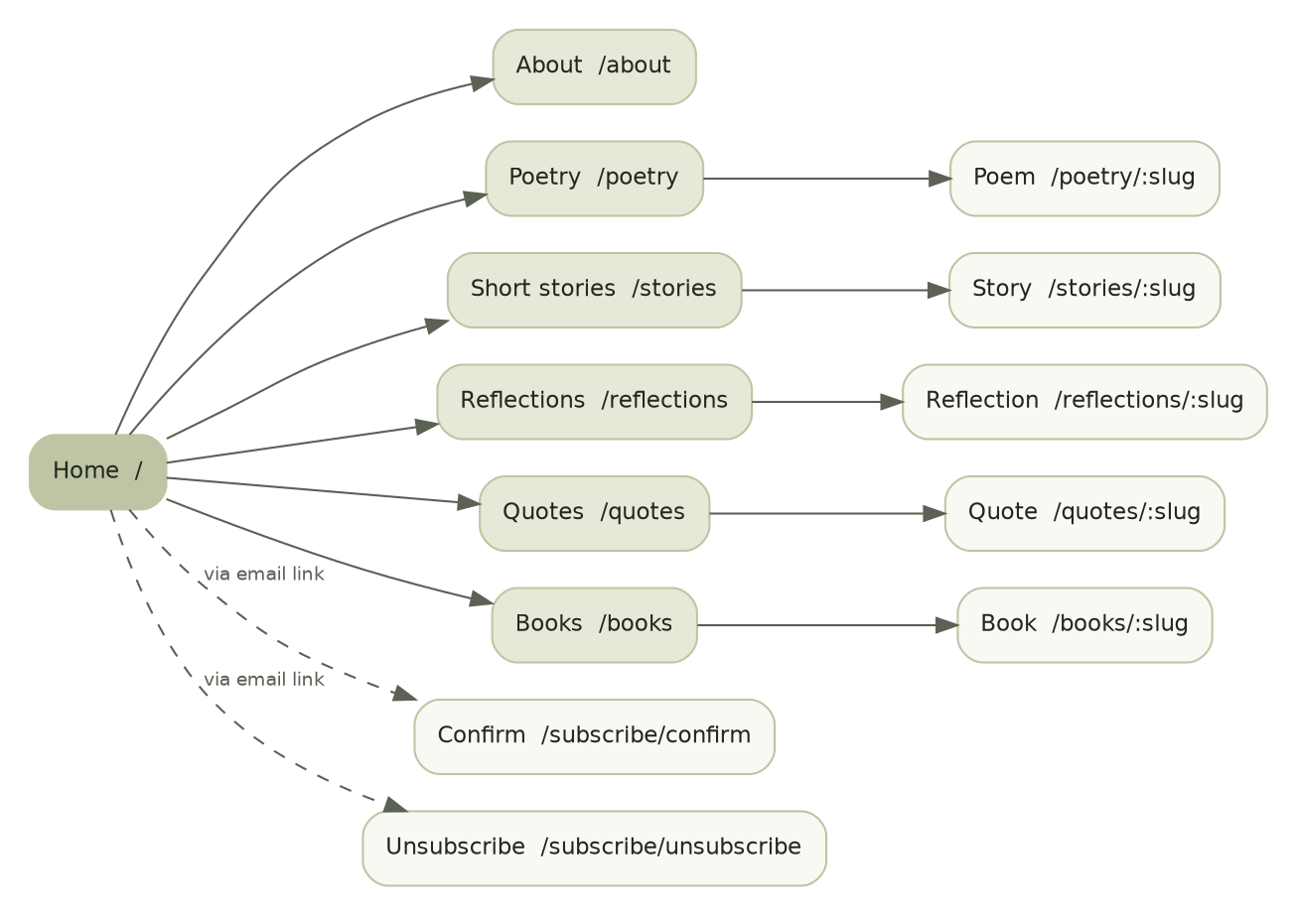

2.1 Public screens
Screen | Route | Purpose | Requirement | Index?
Home | / | Introduce the author, subscribe, show recent writing | FR-HOME-01 | Yes
About | /about | Photo, bio, contact and follow links | FR-ABOUT-01 | Yes
Poetry index / poem | /poetry, /poetry/:slug | Browse and read poems | FR-LIST-01, FR-READ-01/02 | Yes
Stories index / story | /stories, /stories/:slug | Browse and read short stories | FR-LIST-01, FR-READ-01 | Yes
Reflections index / reflection | /reflections, /reflections/:slug | Browse and read reflections | FR-LIST-01, FR-READ-01 | Yes
Quotes index / quote | /quotes, /quotes/:slug | Browse and share quotes | FR-LIST-01, FR-QUOTE-01 | Yes
Books index / book | /books, /books/:slug | See books and follow external link | FR-LIST-01, FR-BOOK-01 | Yes
Confirm subscription | /subscribe/confirm?token=… | Press a button to confirm | FR-SUB-02 | No
Unsubscribe | /subscribe/unsubscribe?t=… | Press a button to unsubscribe | FR-SUB-03 | No
Privacy notice | /privacy | Explain what is collected and why | NFR-PRIV-01 | Yes
Not found / error | any | Human message, links home | — | No

2.2 Admin screens (author only)
Screen | Route | Purpose | Req.
Login | /admin/login | Sign in | FR-ADM-01
Dashboard | /admin | Subscriber counts, latest notification result, drafts, shortcuts to write | FR-NTF-03
Writing list | /admin/posts | All posts filtered by type and status | FR-ADM-02
Editor | /admin/posts/new?kind=…, /admin/posts/:id | Write, save draft, preview, publish, unpublish, delete | FR-ADM-02/03
Books | /admin/books, /admin/books/new, /admin/books/:id | Manage books and covers | FR-ADM-04/06
About and settings | /admin/about | Site title, tagline, bio, photo, contact, social links | FR-ADM-05/06
Subscribers | /admin/subscribers | Counts, search, remove, export CSV | FR-ADM-07
Notifications | /admin/notifications | Delivery results per piece, retry failed, send now | FR-NTF-03

3. Reader journeys

3.1 Discover and read
Step | Reader does | System does | If something goes wrong
1 | Opens a shared link to a piece, or the Home page. | Serves the pre-rendered page from the CDN. | Unknown or draft slug: 404 page with links to sections.
2 | Reads. On a poem, line breaks and stanzas are preserved. | No JavaScript needed. | Slow network: text appears first; images load later without shifting layout.
3 | Reaches the end: sees subscribe prompt, share, previous and next. | Previous/next computed within the same section by date. | First or last piece: only one link shows.
4 | Taps Share. | Opens the native share sheet or copies the link. | Unsupported browser: copy link with visible “Copied”.
5 | Opens a section index, scrolls, taps Older. | Loads the next page by cursor. | End of list: Older link not shown. No items: friendly empty state.

3.2 Subscribe (no account)
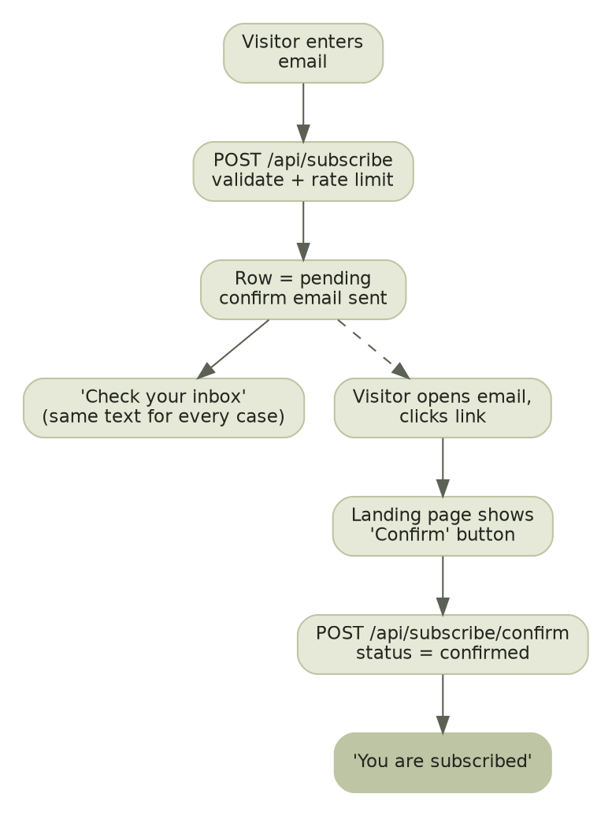
Step | Visitor does | System does | Alternative outcomes
1 | Types email into the form (Home, end of piece or footer) and presses Subscribe. | Validates in the browser and again on the server. | Invalid email: inline error, nothing sent. Honeypot filled (bot): generic success shown, nothing done.
2 | — | Rate-limit check, then creates a pending record (or reuses an existing one) and sends a confirmation email. | Rate limit hit: message “Too many tries”. Provider failure: error message and nothing saved as confirmed.
3 | Sees “Almost there. Check your inbox…” | Returns the same message whether the address is new, pending or already confirmed. | JavaScript off: page reloads with the same message.
4 | Opens the email and taps the link. | — | Email not received: visitor may submit again (one confirm email per hour per address).
5 | Lands on “Confirm your subscription” and presses Confirm. | Verifies token, marks confirmed, records time. | Expired (48 h): “Link expired” with a form to request a new one. Invalid or used: neutral message and link home. Already confirmed: “You are already subscribed”.
6 | Sees “You are subscribed.” | Subscriber is included in future notifications only. | —

3.3 Receive an update
Step | Event | Outcome
1 | Author publishes a piece with “Email subscribers” on. | A notification is recorded in the same database transaction as the publish.
2 | Background job runs within moments. | Each confirmed subscriber gets one email: title, preview or full text by type, link to the site, unsubscribe link.
3 | Subscriber taps the link. | The piece opens on the site (Journey 3.1, step 2).
4 | Delivery problem (provider limit, temporary error). | Job retries automatically; unsent emails go out later; the author sees the backlog on the Notifications screen.
5 | Address bounces or the recipient marks spam. | Provider webhook marks that subscriber; they are never emailed again.

3.4 Unsubscribe
Step | Subscriber does | System does | Alternative outcomes
1 | Taps “Unsubscribe” in an email, or uses their mail app’s built-in unsubscribe button. | Mail app button: one-click POST handled immediately and silently. Link: opens the unsubscribe page. | Invalid link: neutral message.
2 | Presses Unsubscribe on the page. | Marks unsubscribed with a timestamp. Safe to repeat. | Already unsubscribed: same confirmation.
3 | Sees “You have been unsubscribed” with a Subscribe again link. | No further emails. | —

4. Author journeys

4.1 Sign in
Step | Author does | System does | If something goes wrong
1 | Opens /admin. | No session: redirect to /admin/login. | —
2 | Enters email and signs in (magic link or password, plus code if two-step is on). | Verifies identity and checks the account is on the admin list. | Wrong details: generic “Could not sign in”. Too many attempts: temporary lockout message. Signed in but not admin: “Not allowed” and sign-out.
3 | Lands on the dashboard. | Shows counts and latest notification status. | Session expired later: returned to login, draft safe locally and on server.

4.2 Write and publish a piece
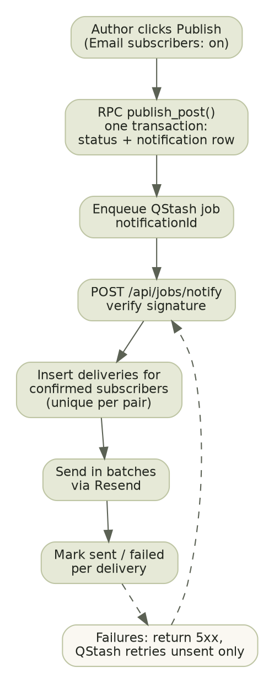
Step | Author does | System does | If something goes wrong
1 | Taps New and chooses a type (poem, story, reflection, quote). | Opens the editor with fields for that type. | —
2 | Writes the title and text. | Autosaves a draft every few seconds; shows “Saved”. | Offline or save fails: “Not saved” warning stays visible and text is kept in the page; leaving the page warns.
3 | Taps Preview. | Shows the piece in the public layout with a draft banner. | —
4 | Taps Publish. | Shows a confirmation: title, number of confirmed subscribers, “Email subscribers” switch. | Missing required field: blocked with message.
5 | Confirms. | Publishes and records the notification in one transaction, refreshes public pages, queues the emails. | Already published: message, nothing repeated. Queue unavailable: piece is live, notification marked “not sent” with Send now.
6 | Opens Notifications. | Shows sent, failed and pending counts for that piece. | Failures: Retry failed.

4.3 Edit, unpublish or delete
Action | Result
Edit a published piece and save | Public page updates within a minute. No email is sent.
Unpublish | Piece disappears from lists, feed and sitemap; its URL shows 404. Original date and “already emailed” status are kept.
Republish | Returns with its original date. No email is sent again.
Delete | Asks the author to confirm by typing the title or pressing a named confirm button; removes the piece permanently.

4.4 Books, About and images
- Books: create, upload cover (alt text required), set status and link, publish; reorder by an order number.
- About and settings: edit text and links; replace the photo (alt text required); changes show publicly within a minute.
- Upload errors: wrong type or over 2 MB shows a plain-language message and nothing is stored.

4.5 Subscribers and notifications
Task | Flow
See who follows | Subscribers screen shows counts for confirmed, pending, unsubscribed and bounced, and a searchable list.
Remove someone on request | Select subscriber, confirm by name; the record is permanently erased.
Export | Download CSV (email, status, dates). The action is logged.
Retry or send now | Notifications screen: Retry failed re-queues only unsent emails; Send now re-enqueues a notification whose job never started.

5. Screen state inventory
Every data-driven screen must design and test these states before it is complete.
Screen | Loading | Empty | Error | Other
Home | Static; no spinner | Intro + subscribe + “The first piece is on its way” | Generic error page | —
Section index | Static; next page shows “Loading…” text link state | Empty-section message | Inline “Could not load more. Try again.” | End of list
Piece / book | Static | n/a | 404 | Draft (admin preview banner)
Subscribe form | Button “Sending…”, disabled | n/a | Invalid, rate-limited, server error | Pending confirmation
Confirm / unsubscribe | Button “Working…” | n/a | Invalid, expired | Already done
Admin lists | Skeleton rows | “Nothing yet” + primary action | Retry banner | Filtered-empty
Editor | Skeleton | New blank form | Save failed banner | Saved, saving, unsaved
Notifications | Skeleton | “No notifications yet” | Retry banner | Pending, partial, done, failed

6. Navigation rules
- The header is identical on every public page; the current section is underlined.
- The subscribe form appears on Home, at the end of every piece and in the footer. It never appears as a pop-up or overlay.
- Every email link goes to a stable canonical URL on the site; piece URLs never change after first publish.
- The admin area is not linked from the public site. The author bookmarks /admin.
- After every admin action the author lands back where they were, with a short confirmation message.

