|  |
| --- |
| Close-up image showing the leaf-sides of two oversized books side-by-side on a bookshelf, with additional books in soft focus background |
| Binance API Website  Requirements & Specification Document |
| |  |  |  | | --- | --- | --- | | Artem F. | 11/2/21 | Freelancer Project | |

# Overview of program interface

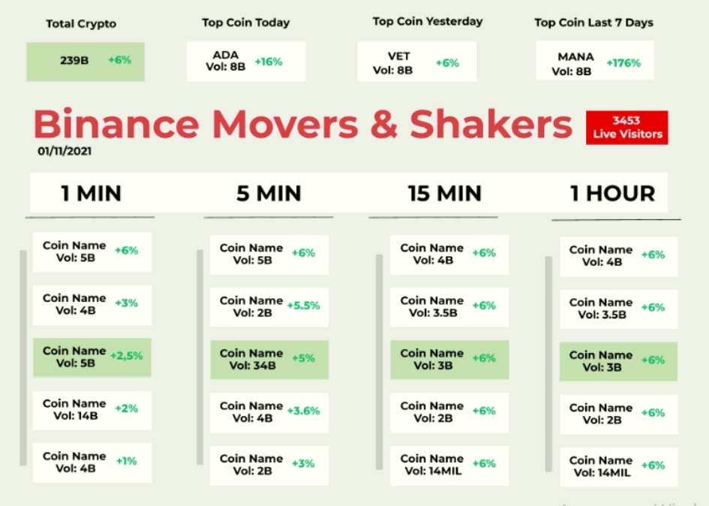

# Requirement Specification

## Dashboard

#### Total Crypto

Total Crypto volume in BTC

#### Top Coin Today

Top Coin name & volume today

#### Top Coin Yesterday

Top Coin name & volume yesterday

#### Top Coin 7 days

Top Coin name & volume 7 days

## Movers & Stakes

#### 1 MIN

Shows the lastest orders done in one minute.

Display its name & volume & increase percent.

#### 5 MIN

Shows the lastest orders done in 5 minutes.

Display its name & volume & increase percent.

#### 10 MIN

Shows the latest orders done in 10 minutes.

Display its name & volume & increase percent.

#### 1 HOUR

Shows the lastest orders done in 10 minutes.

Display its name & volume & increase percent.

# Implementation

## API Integration

Main API I’m gonna use is GET /api/v3/allOrders (HMAC SHA256)

| **Name** | **Type** | **Mandatory** | **Description** |
| --- | --- | --- | --- |
| symbol | STRING | YES |  |
| orderId | LONG | NO |  |
| startTime | LONG | NO |  |
| endTime | LONG | NO |  |
| limit | INT | NO | Default 500; max 1000. |
| recvWindow | LONG | NO | The value cannot be greater than 60000 |
| timestamp | LONG | YES |  |

## 3.2 API Integration