|  |
| --- |
| Close-up image showing the leaf-sides of two oversized books side-by-side on a bookshelf, with additional books in soft focus background |
| Binance API Website  Requirements & Specification Document |
| |  |  |  | | --- | --- | --- | | Artem F. | 11/2/21 | Freelancer Project | |

# Overview of program interface

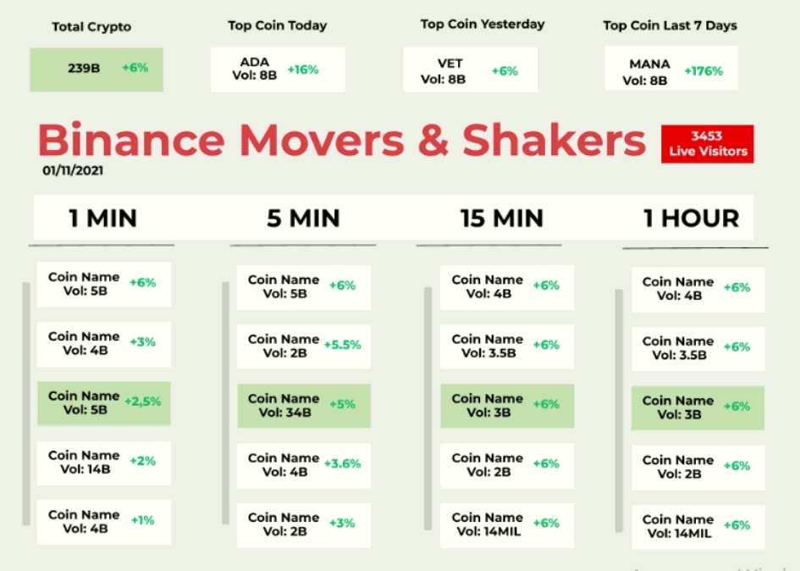

# Requirement Specification

## Data Research and Core Function

#### Specification

Research relevant Binance platform API,

Build network communication library to get data from the platform via API

#### Estimation

Required time : 3 hours,

Budget : 45 $

## Main Functionalities

#### Specification

Reference : Following will be implemented based-on getting data via Binance platform API.

Get the trading volume of 7 days of each BTC product,

Get today total volume(**Total Crypto, percentage**),

Get the coin name of BTC product of top trading volume(**Top Coin Today, percentage**),

Get the coin name of BTC product of top trading volume of yesterday(**Top Coin Yesterday, percentage**),

Get the coin name of BTC product of top trading volume of last 7 Days (**Top Coin 7 Days, percentage**),

Get all coin names of each BTC product and calculate the trading volume of each BTC product of 1Hours (**1 HOUR**),

Get the same of 15 Min, 5 Min, 1Min (**15 Min, 5Min, 1Min**),

#### Estimation

Required time : 18 hours

Budget : 270$

# Timeline

## Project Release Date

05/11/2021, Thursday

## Total budget

315$

