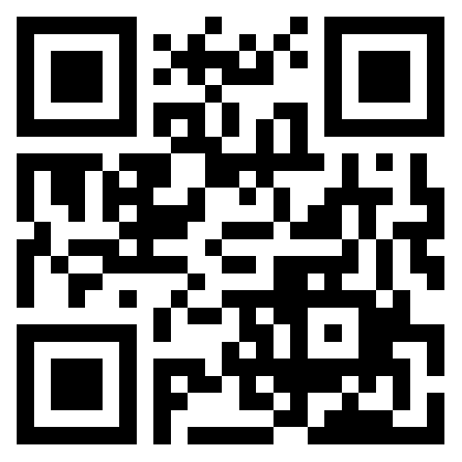

**Adam Kadane**

**11 Candlewood Rd.; Lynnfield, MA 01940**

**Home: 781 334 2868 or Cell: 781 724 4343**

Email: [akadane87@gmail.com](mailto:akadane87@gmail.com)

Portfolio: <http://akadane87.carbonmade.com/>

*Graphic Designer skilled in multiple technologies with agency experience and client management*

**Summary of Qualifications**

Broad background in agency services for a wide variety of clients including design, layout, and production of both digital graphics and print media, along with photography, web design and social media. Experience with creative development, pitch development and account management.

**Employment History**

***Free Lance Graphic Designer (***2014-Present)

- Various projects for multiple clients.

- Work includes, but is not limited to logo design, identity/branding, fashion/apparel materials, promotional materials, digital assets, web design consulting, and digital photography.

- (HTTP Hood, Lynnfield MA): Product Mockup, Label Design, and Package Design for Food, Food Service, Food Retail, and Super Market

- (Buyer Advertising, Newton MA): Logo Design, Print Ads, Micro Sites, Responsive Landing Pages, Banner Ads, for health care professional Services and retail.

***Digital Producer*** (ChamberPG, Salem, MA; 2012-2013)

* Member of pitch development and presentation team; developed and presented social media plans.
* Produced magazine and Chamber of Commerce promotional publications.
  + Produced advertisements and generated placements for over 100 businesses; designed all layout, wrote copy and managed all client review.
  + Produced and designed all cover art and photography; managed all client services including content interviews, deadlines and approvals.
* TV commercial production
  + Member of creative team—concept/script development and copywriting.
  + Designed and produced digital graphic elements.
  + Assisted with all onsite camera operation, lighting, shot layout and audio production.
  + Worked with onscreen camera personnel and performed on-camera as required.
* Google AdWord Banner Ad Campaigns + YouTube PreRoll Campaigns
  + Performed all account management duties and assisted in business acquisition.
  + Produced all banner ads and static/animated digital assets for YouTube.
  + Managed campaigns through Google AdWords; tracked analytics using Google Analytics.
  + Managed and executed tie-ins with customer web properties.
* Integrated campaign development for automotive retail
  + Managed and produced monthly graphic content for TV commercials, website, banner ad and YouTube campaigns integrated with sales events.
  + Produced template layouts to maximize efficiency and turn around time, while maintaining originality.
  + Obtained approvals on original content under client corporate marketing brand standards.
  + Produced point-of-sale promotional materials—design, copywriting, production management.

***Manager*** (Kitty O’Shea’s, Boston, MA; 2012-2012)

* A full service eating a drinking establishment.
* Managed inventory and front of the house.

***Marketing Intern*** (Gazelle, Boston, MA; 2011-2012)

* Managed entire social media network.
* Produced all product photography for e-commerce site and print ads.
* Acquired and distributed promotional materials.
* Marketing Department member of Employee Communication Team.
* Worked as a Customer Service Rep, as required.

**Technical Skills**

* Digital imaging, illustration, advanced photography and postproduction, graphic design for digital and print, corporate and brand identity design, web design
* Proficient in CS6 Creative Suite: Photoshop, Illustrator, InDesign, Dreamweaver, LightRoom, Bridge. Also, certificates in HTML + CSS, Acrobat X Pro, Google AdWords, QuarkXPress, Microsoft Office

**Education**

* Lynn University, Boca Raton, FL; B.S. Graphic Design, Minor: Photography (2006-2012). Received Academic Honors.

− Lawrence Academy; Groton, MA (2002-2006)