Item Purchase Code:  
7e842c36-7cbe-4647-8093-a4ef9f586f2d  
  
Purchase Date:  
2022-06-07 05:43:12 UTC

I have found many issues in yesterday purchase,

kind of Full of Bugs in main modules

1.  I find one basis & important validation is missed - in Numeric Field Like Price, Qty, Discount, Tax...i can ENTER TEXT/STRING - why you missed this?

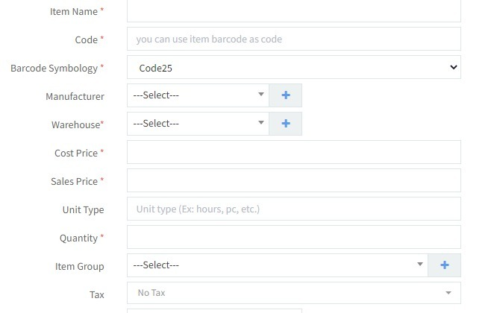

2.  Item Insert UI and upload excel are not matching the fields - how i can upload same format as in the UI ?

- check excel sheet

3. i added few custom fields, but those are not storing the values entered. and not even display what i entered

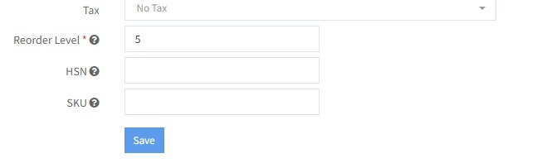

4. also the Warehouse also, i have purchased 6 items to the warehouse, but when i go to PosSales - warehouse is not selectable and it displays 1 item  

-  purchased and paid in full by cash

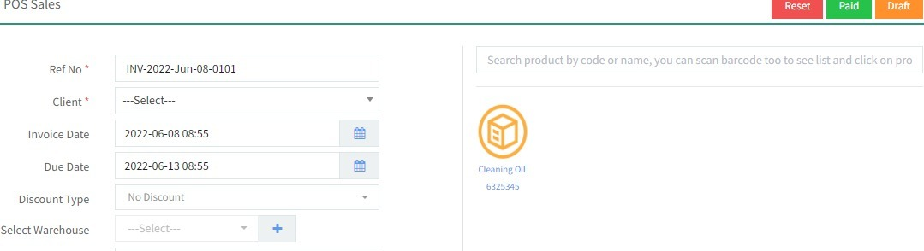  
ware house is disabled

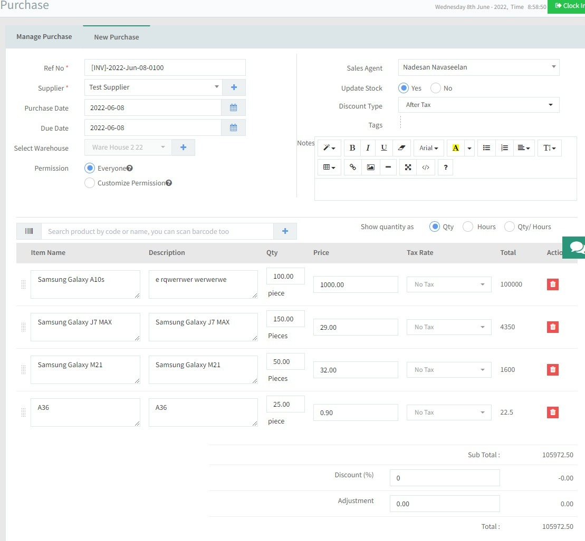

- for sales user - not displaying the warehouse

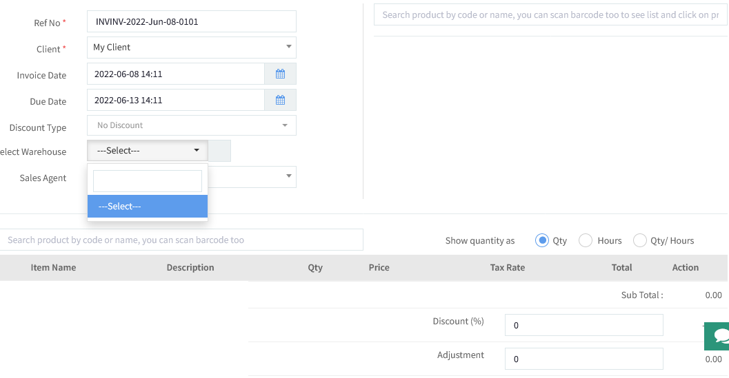

5. another issue - Creating new user - selected warehouse and saved - seems its also not saved in DB and not retrieved

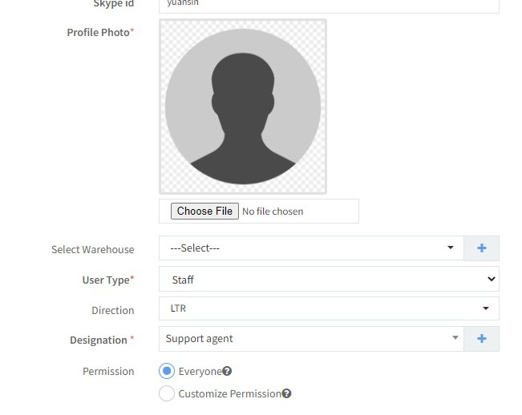

6. click GO button and see in Overtime & Provident Fund - buggy :D

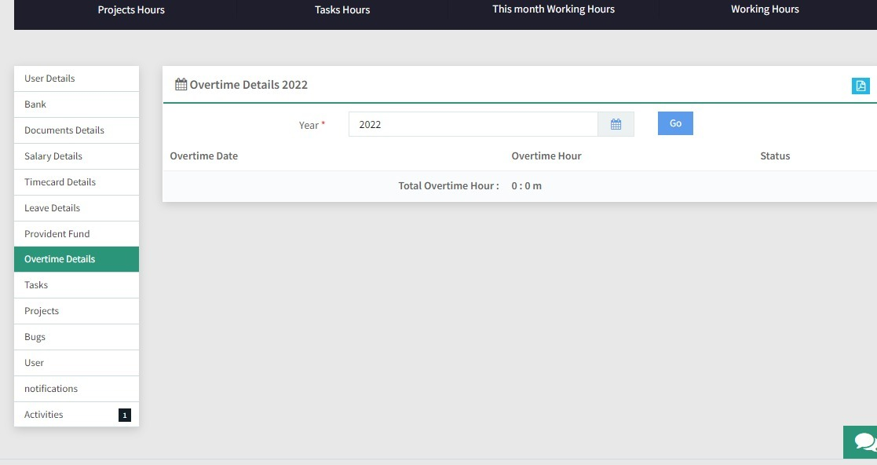

i am not able to go forward with these critical issues

7. if you click on the listed item's icon. its not adding to the cart. please check that also

