**课程编号：C0800000012**

**程序设计基础实验报告**



|  |  |  |  |  |
| --- | --- | --- | --- | --- |
| **姓名** | **高志斐** | **学 号** | | **20175132** |
| **班级** | **3** | **指 导 教 师** | | **李丹程** |
| **实验名称** | **程序设计基础实验** | | | |
| **开设学期** | **2017-2018第一学期** | | | |
| **开设时间** | **第8周——第17周** | | | |
| **报告日期** | **2017/12/26** | | | |
| **评定成绩** |  | | **评定人** |  |
| **评定日期** |  |

**东北大学软件学院**

实验五：查找与排序程序设计

1. **实验目的**

掌握查找与排序算法；编辑和运行 Python 程序。实验要求采用查找与排序算法进行程序设计，给出程序设计流程图或伪代码，并使用 Python 代码编程实现，且编写实验报告。

1. **问题分析与程序设计**
2. **伪代码**

Declare Studentname[5] As String  
Declare Sum[3],Average[3] As Float  
Declare score,total As Float  
Declare k As Integer  
Declare i,count As Integer  
For(i=0,i<5,i++)  
  Write “Please enter a student’s name”  
  Input Studentname[i]  
  For(i=0,i<3,i++)  
Write”Please enter a student’s score:”  
Input score  
Set total += score  
  End For  
Set Average[i] = total/3  
Set Sum[i] = total  
Set total = 0  
End For  
For(count=0,count<4,count++)  
  For(i=0,i<4,i++)  
If Sum[i]<Sum[i+1] Then  
 Set  Sum[i],Sum[i+1]=Sum[i+1],Sum[i]  
 Set  Studentname[i],Studentname[i+1]=Studentname[i+1],Studentname[i]  
 Set  Average[i],Average[i+1]=Average[i+1],Average[i]  
End If  
  End For  
End For  
For(k=0,k<5,K++)  
  Write Studentname[k]+Sum[k]+Average[k]  
End For

1. **python代码**

Studentname = []

Sum = []

Average = []

TempSum = 0

for i in range(5):

Studentname.append(str(input("Please enter a student's name")))

for count in range(3):

Tempscore = float(input("Please enter the student's score"))

TempSum += Tempscore

Average.append(float(TempSum/3))

Sum.append(TempSum)

TempSum = 0

for count in range(4):

for i in range(4):

if Sum[i]<Sum[i+1]:

Sum[i],Sum[i+1]=Sum[i+1],Sum[i]

Studentname[i],Studentname[i+1]=Studentname[i+1],Studentname[i]

Average[i],Average[i+1]=Average[i+1],Average[i]

k = 0

for k in range(5):

print("Studentname:",Studentname[k],"\t","Totalscore:",Sum[k],"\t","Averagescore:",Average[k])

**2.伪代码**

Declare array[14] As Integer  
Declare count,k,Temp As Integer  
For(k=0,K<15,K++)  
  Write”Pelase enter elem:”   
  Input array[k]  
End For  
For(count=0,count<14,count++)  
  For(k=o,k<14,k++)  
If array[k]>array[k+1] Then  
Set Temp = array[k]  
Set array[k+1] = array[k]  
Set array[k] = Temp  
End If  
  End For  
End For  
Declare Mid,Low,High,Found As Integer  
Decalre Number As Integer  
Set Low = 0  
Set High = 14  
Set Found = 0  
Write”Please enter the number you want to find:”  
Input Number  
While (Low<=High) AND (Found = 0)  
  Set Mid = Int((Low+High)/2)  
  If Number = array[Mid] Then  
Set Found = 1  
  End If  
  If Number > array[Mid] Then  
    Set Low = Mid+1  
  End If  
  If Number < array[Mid] Then  
Set High = Mid  
  End If  
End While  
If Found = 1 Then  
  Write “The number is”+Mid+”th”  
Else  
  Write “Not found”  
End if

1. **python代码**

array = []

for k in range(15):

array.append(int(input("Please enter an integer:\n")))

for count in range(14):

for i in range(14):

if array[i]>array[i+1]:

array[i],array[i+1]=array[i+1],array[i]

Low = 0

High = 14

Found = False

number = int(input("Please enter the integer you want to find:\n"))

Mid = int((Low+High)/2)

while Low<=High and not Found:

Mid = int((Low+High)/2)

if number > array[Mid]:

Low = Mid+1

if number < array[Mid]:

High = Mid-1

if number == array[Mid]:

Found = True

if Found == True:

print("This number is number",Mid,"element of the array")

if Found == False:

print("not found")

**四、实验结果总结**

**1**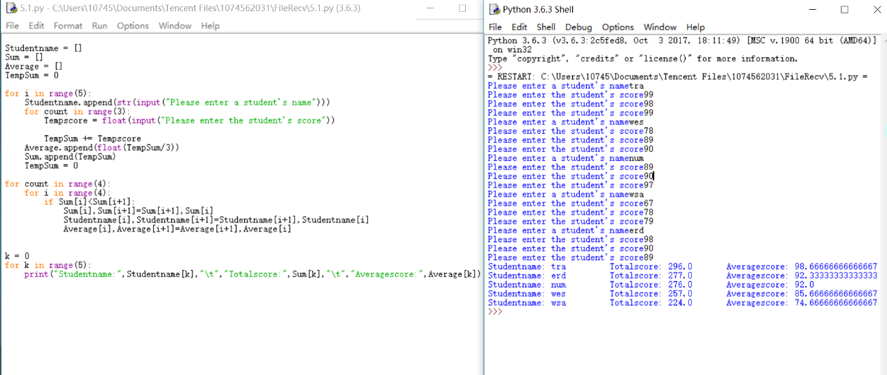

2.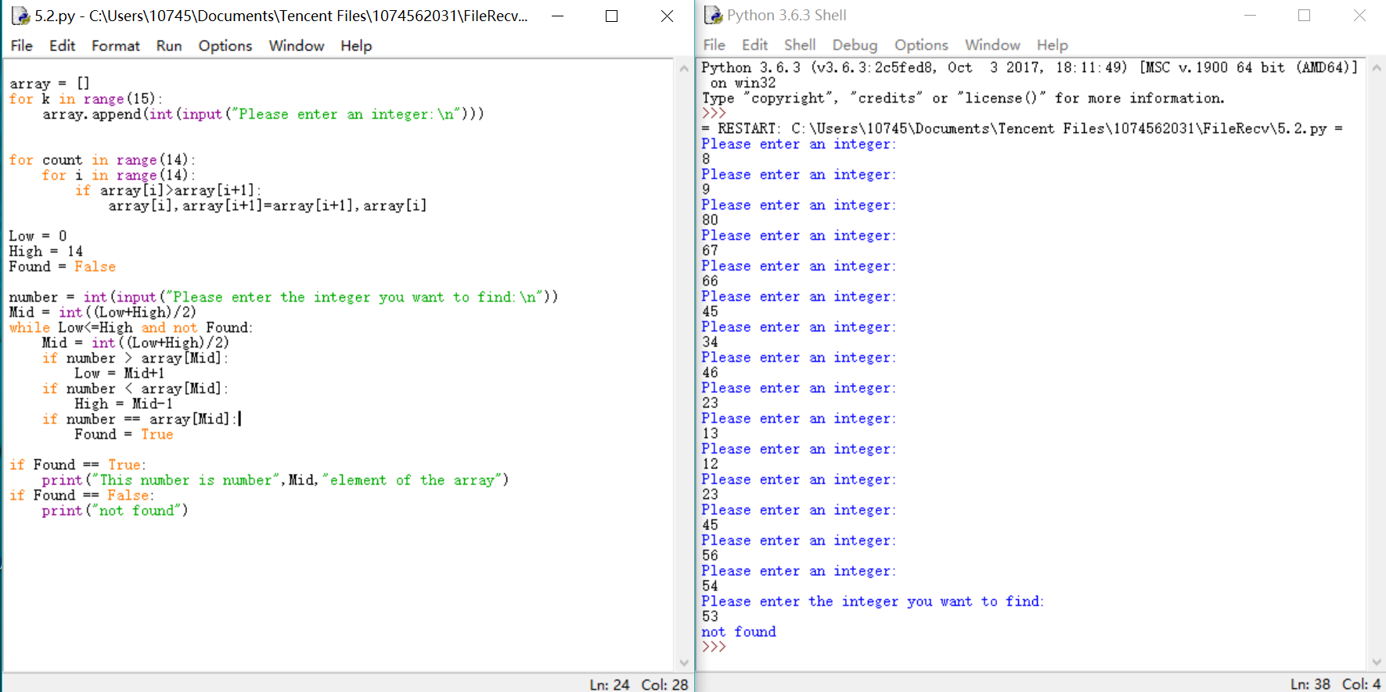

**五、创新的部分**

**六、对实验的意见与建议**

**实验六：模块化程序设计**

1. **伪代码**

Len = Length_Of(Array)  
Function average(Sum) As Float  
  Set average = Sum/Len  
End Function  
Function judge(n) As Integer  
  Declare k As Integer  
  For(k=0,k<Len,k++)  
If Array[k]<average Then  
  Set n += 1  
End If  
  End For  
End Function  
Function result(n,m)  
  Write”The average is:”+average  
  Write “The amount of number which is greater than or equal to the average is:”+good  
End Function  
Main  
  Declare Len,Sum,i,good As Integer  
  Declare Array[300] As Integer  
  Write”Please enter a positive number:”  
  Input elem  
  Set i = 0  
  Set Sum = 0  
  Set good = 0  
  While elem != -1  
Set Array[i] = elem  
Set Sum+=elem  
elem = 0  
Write”Please enter a positive number again(enter -1 to end)”  
Input elem  
  End While  
  Set Aver = average(Sum)   
  Set good= judge(good)  
End Program  
**1.python代码**

def average(Sum):

return Sum/len(array)

def judge(n):

for i in range(len(array)):

if array[i]>=aver:

n += 1

return n

def result(n,m):

print("The average number is:",n)

print("The amount of number which is greater than or equal to the average is :",good)

array = []

Sum = 0

Big = 0

Temp = float(input("Please enter a positive number:"))

while Temp!= -1 and Temp>=0:

Sum += Temp

array.append(Temp)

Temp = float(input("Please enter a positive number(enter -1 to end):"))

aver = average(Sum)

good = judge(Big)

result(aver,good)

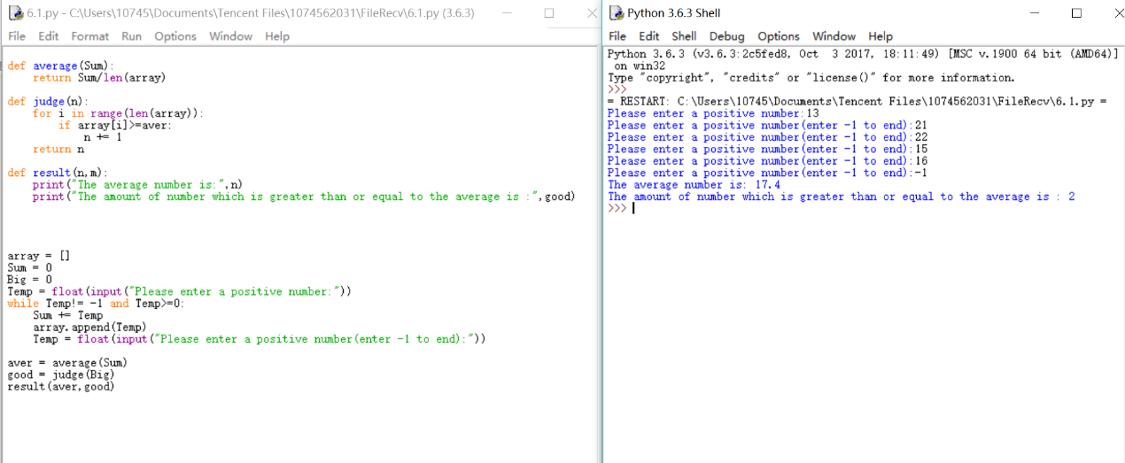

1. **伪代码**

Declare Number1,Number2.Number3 ,Result,Circle,Temp As Integer  
Function common divisor(Number1,Number2)  
  Set Circle = 1  
  While (Number1//2=0) AND (Number2//2=0)  
Number1=Number1/2  
Number2=Number2/2  
Circle += 1  
  End While  
  While Number1!=Number2  
If Number1>Number2 Then  
  Set Temp = Number1-Number2  
  Set Number1 = Temp  
End If  
If Number1<Number2 Then  
  Set Temp = Numebr2-Number1  
  Set Number2 = Temp  
End If  
Set common divisor = Temp*Circle  
End Function  
Write “Please enter the first number:”  
Input Number1  
Write “Please enter the second number”  
Input Number2  
Set Result = common divisor (Numebr1,Number2)  
Write”Their maximum common divisor is:”+Result

**2.python代码**

##This program is used to calculate the largest common divisor of two numbers

def main():

a = int(input("Please enter the first number:"))

b = int(input("Please enter the sceond number:"))

c = commondivisor(a,b)

print("The largest common divisor of this two numbers is:",c)

def commondivisor(a,b):

circle = 1

while (a%2==0) and (b%2==0):

a = a/2

b = b/2

circle = circle*2

while a != b:

if a > b:

Temp = a-b

a = Temp

if a < b:

Temp = b-a

b = Temp

return Temp*circle

main()

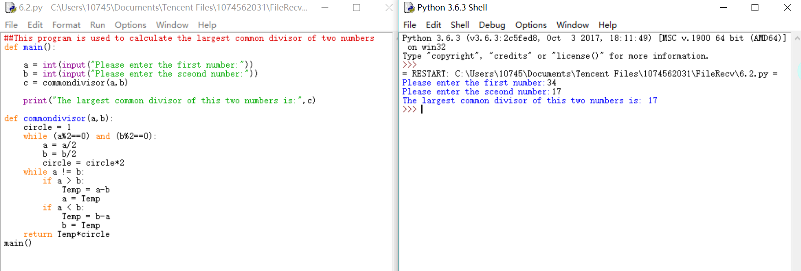

**实验七: 数据文件程序设计**

**伪代码**

**Declare samelastname_number ,count,find as integer**

**Newname = open("name","w")**

**write"Please enter the customer's lastname:"**

**write "Enter 0 to end "**

**set count = 0**

**set lastname = str(input())**

**if lastname != "0":**

**write "Please enter his\her firstname:"**

**set firstname = str(input())**

**Lastname = []**

**while lastname != "0":**

**set count += 1**

**Lastname.append(lastname)**

**Str = firstname+lastname+"\n"**

**Newname.writelines(Str)**

**write"Please enter the customer's lastname:"**

**write "Enter 0 to end "**

**lastname = str(input())**

**if lastname != "0":**

**write "Please enter his\her firstname:"**

**firstname = str(input())**

**Newname.close()**

**write "Do you want to find a name?"**

**write "Enter yes to find,enter no to end"**

**response = str(input("Please enter you response:\n"))**

**response = response.lower()**

**set find = 0**

**Newfile = open("name","r")**

**Set samelastname_number =0**

**Findname = str(input("Please enter the lastname:\n"))**

**while (response == "yes") and (find<count):**

**samelastname = Newfile.readline()**

**if Findname == Lastname[find]:**

**print(samelastname.rstrip("\n"))**

**samelastname_number += 1**

**set find += 1**

**Newfile.close()**

**if samelastname_number == 0:**

**write”Not found”**

**else:**

**write"The amount of customers who have the same lastname is:",samelastname_number**

**end if**

**python代码**

**Newname = open("name","w")**

**print("Please enter the customer's lastname:")**

**print("Enter 0 to end ")**

**count = 0**

**lastname = str(input())**

**if lastname != "0":**

**print("Please enter his\her firstname:")**

**firstname = str(input())**

**Lastname = []**

**while lastname != "0":**

**count += 1**

**Lastname.append(lastname)**

**Str = firstname+lastname+"\n"**

**Newname.writelines(Str)**

**print("Please enter the customer's lastname:")**

**print("Enter 0 to end ")**

**lastname = str(input())**

**if lastname != "0":**

**print("Please enter his\her firstname:")**

**firstname = str(input())**

**Newname.close()**

**print("Do you want to find a name?")**

**print("Enter yes to find,enter no to end")**

**response = str(input("Please enter you response:\n"))**

**response = response.lower()**

**find = 0**

**Newfile = open("name","r")**

**samelastname_number =0**

**Findname = str(input("Please enter the lastname:\n"))**

**while (response == "yes") and (find<count):**

**samelastname = Newfile.readline()**

**if Findname == Lastname[find]:**

**print(samelastname.rstrip("\n"))**

**samelastname_number += 1**

**find += 1**

**Newfile.close()**

**if samelastname_number == 0:**

**print('Not found')**

**else:**

**print("The amount of customers who have the same lastname is:",samelastname_number)**

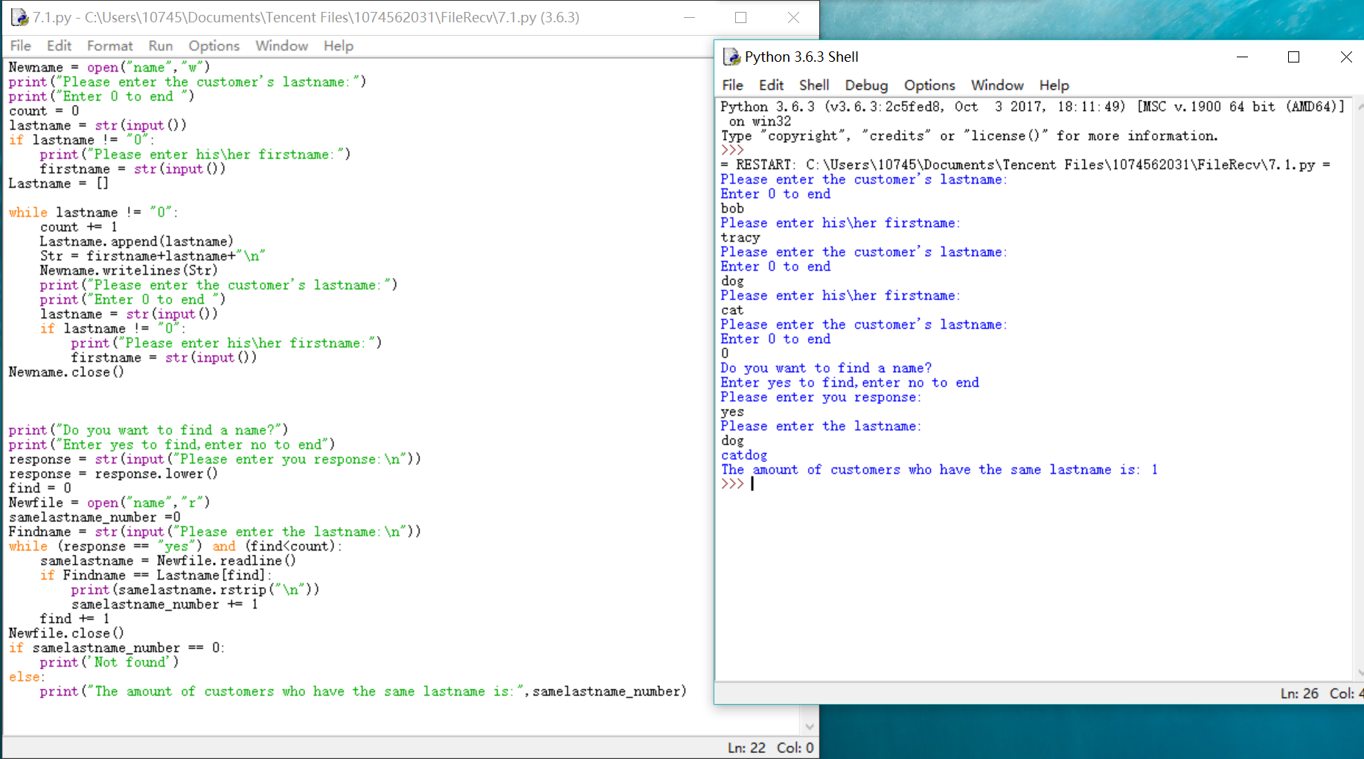

**实验八：面向对象程序设计**

**伪代码**

Class Sum_work

Declare self.hours,self.salary As Ingeter

Subprogram __init__( self,man_hours,hourly_pay)

Set self.hours = man_hours

Set self.salary = hourly_pay

End Subprogram

Subprogram total_wages(self)

Function self.hours * self.salary As Ingeter

End Function

End Subprogram

Subprogram setTime(self,man_hours)

Set self.hours = man_hours

End Subprogram

Subprogram setSalary(self,hourly_pay)

Set self.salary = hourly_pay

Main

Declare num As Ingeter

Write "The number of the employees:"

Input num

Call statistic(num)

End program

Subprogram statistic

Declare salary[num] As Ingeter

Declare a, man_hours,hourly_pay,count As Ingeter

For(a=0;a<num;a++)

Write "Enter the man_hours and hourly_pay of employee %d sperated with space."+a

Input man_hours,hourly_pay

Declare total As New Sum_work

Set salary[a]= total.total_wages()

End For

Set count=Sum_Of(salary)

Call judge(num,salary,count)

End Subprogram

Subprogram judge

Declare b As Ingeter

For(b+0;b<num;b++)

If salary[b]*num>=count

Write "Employee %d can get the reward."+b

Write "The total salary of employee %d is:"+b+salary[b]

Else

Write "Employee %d can not get the reward."+b

Write "The total salary of employee %d is:"+b+salary[b]

End IF

End For

End Subprogram

**Python代码**

**class Sum_work:**

**def __init__(self,man_hours,hourly_pay):**

**self.hours = man_hours**

**self.salary = hourly_pay**

**def total_wages(self):**

**return self.hours * self.salary**

**def setTime(self,man_hours):**

**self.hours = man_hours**

**def setSalary(self,hourly_pay):**

**self.salary = hourly_pay**

**import sum_work**

**def main():**

**num = int(input("The amount of the employees:"))**

**statistic(num)**

**def statistic(num):**

**salary = []**

**for a in range(num):**

**print("Enter the hours and hourly_pay of employee {0} sperated with space.".format(a))**

**man_hours,hourly_pay = map(float,input().split())**

**total = sum_work.Sum_work(man_hours,hourly_pay)**

**salary.append(total.total_wages())**

**count = sum(salary)**

**judge(num,salary,count)**

**def judge(num,salary,count):**

**for b in range(num):**

**if salary[b]*num >= count:**

**print("Employee {0} can get the reward.".format(b))**

**print("The total salary of employee {0} is:".format(b),salary[b])**

**else:**

**print("Employee {0} can not get the reward.".format(b))**

**print("The total salary of employee {0} is:".format(b),salary[b])**

**main()**

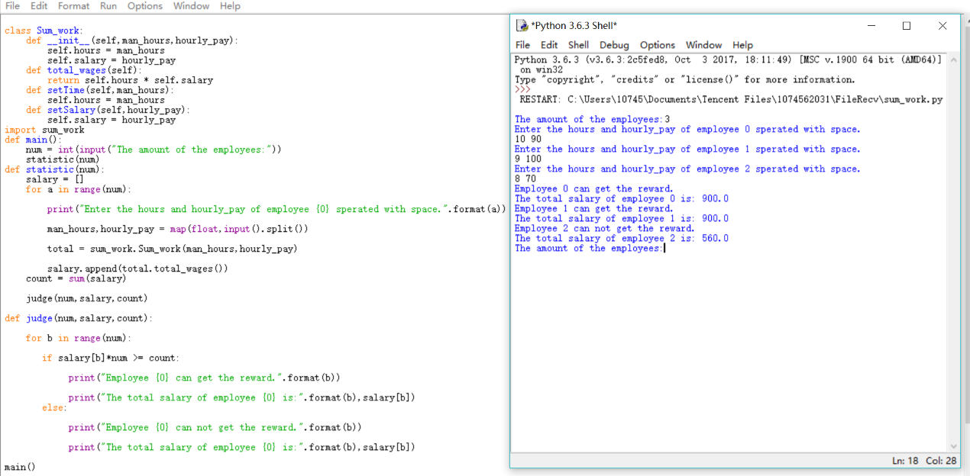

评价表格（每份实验报告只需一份评分表）

|  |  |
| --- | --- |
| 考核标准 | 得分 |
| （1）正确理解和掌握实验所涉及的概念和原理（20%）； |  |
| （2）按实验要求合理设计程序执行流程（20%）； |  |
| （3）能编程实现设计的程序流程，运行结果正确（20%）； |  |
| （4）认真记录实验数据，原理及实验结果分析准确（20%）； |  |
| （5）实验过程中，具有严谨的学习态度和认真、踏实、一丝不苟的科学作风（5%）； |  |
| （6）所做实验具有一定的创新性（5%）； |  |
| （7）实验报告规范（10%）。 |  |