**课程编号：C0809000012**

**Computer Programming**

**Fundamentals Experiment Report**



|  |  |  |  |  |
| --- | --- | --- | --- | --- |
| **Name** | 王龙 | **Student number** | | 20175271 |
| **Class** | 软英1701 | **Tutor** | | Ying Liu |
| **Semester** | 2017-2018 Fall Semester | | | |
| **Experiment Title** | Experiment 1 Selection StructuresExperiment 2 Repetition Structures | | | |
| **Experiment Date** | 2017-11-13 | | | |
| **Score** |  | | **Grader signature** |  |
| **Date of grading** |  |

Software College of Northeastern University

**Experiment Title**

**(For example: Experiment 1 Selection Structures)**

**一、Experiment purpose**

1. **Design a program promoting a message to ask users to input a number, if the number is bigger than zero then output ‘Positive’, if the number is smaller than zero then output ‘Negative’, if the number is equal to zero then output ‘Zero’.**
2. **Design a program to calculate the tax according to user’s input. The following table lists the relative data. To be sure to include incorrect checking in your program avoiding to input negatives.**

|  |  |  |
| --- | --- | --- |
| income | | tax |
| start | end |  |
| 0 | 50000 | 5% above 0 |
| 50000 | 100000 | 7% 2500+5000 |
| 100000 | …… | 9% 6000+100000 |

1. **Design a program to input a message including year, month and day and judge what day it is in this year. (For example, 2000, March 1st is the 61th in the year of 2000, 31+29+1=61.)**

**(1) Design a program to calculate the sum of 5 integers from user’s input, and print the result to console. Modify the previous program by asking user how many integers do you want to sum, if the number is bigger than 10 then ask user to input it again, else calculate the sum and print the result.**

**(2) Implement the following function: print out a prompt message asking users to input a line of characters, and get how many letters, space letter, numbers and other characters are included.**

**(3) There is a pair of rabbits, and they would give birth to another pair of rabbits in the third month, and the new pair of the rabbits would give birth to another pair in the third month counting from their birthday, if all of these rabbits would not die, how many rabbits are there in the 20th month.**

**The list of the numbers of rabbits is: 1,1,2,3,5,8,13,21,……**

**二、Experiment contents and steps**

**实验一**

1)

Write “Enter a number:”

Input number

If number=0 Then

Write”Zero”

Else

If number>0 Then

Write “Positive”

Else

Write “Negative”

End If

End If

(2)

Declare Income As Float

Declare tax as eval

Write “Please enter the income.”

Input Income

If Income>=0

If Income<=50000 Then

Set Tax=Income*0.05

Else

If Income<=100000 Then

Set Tax=2500+0.07*(Income-50000)

Else

Set Tax=6000+0.09*(Income-100000)

End If

End if

Write “Your tax is” +Tax

Else

Write “please enter number that is positive”

End if

(3)

Declare Year As Integer

Declare Month As Integer

Declare Day As Integer

Set Monthdays1=[31,29,31,30,31,30,31,31,30,31,30,31]

Set Monthdays2=[31,28,31,30,31,30,31,31,30,31,30,31]

Write “Please enter the year number:”

Input Year

Write “Please enter the month number:”

Input Month

Write “Please enter the day number:”

Input Day

If( (Year%4==0)and(Year%100!=0))or(Year%400==0) Then

For(i=1;i<Month;i++)

Set Days+=Monthdays1[i]

End For

Else

For(i=1;i<Month;i++)

Set Days+=Monthdays2[i]

End For

End If

Set Days+=Day

Write Year,Month,Day + “is the”+Days+“th day of the year.”

**实验二**

(1)

I

For(i=1;i<=5;i++)

Write “Please enter a number:”

Input num

Set sum+=num

End For

II

Declare n As Integer

Declare num As Integer

Write “How many Integers do you want to sum:”

Input n

While n>10

Write “Please choose less than 10 integers:”

Input n

End While

For(i=1;i<=5;i++)

Write “Please enter a integer:”

Input num

Set sum+=num

End For

Write “The summation of the integers is”+ sum

(2)

Write “Please enter a string.”

Input ST

Set number = 0

Set letter = 0

Set space = 0

Set other = 0

Set n = length_of(srting)

Set i = 0

While i < n

i+=1

Set a = to_ascii(string[i])

If (a>=65 and a<=90)or(a>=97 and a<= 122) Then

Set letter += 1

Else

If a>=48 and a<=57 Then

Set number += 1

Else

If a == 32 Then

Set space += 1

Else

Set other += 1

End If

End If

End If

End While

Write “There are”+ letter +“letters in the string.”

Write “There are”+ number +“numbers in the string.”

Write “There are”+ space +“spaces in the string.”

Write “There are”+ other +“other charactors in the string”

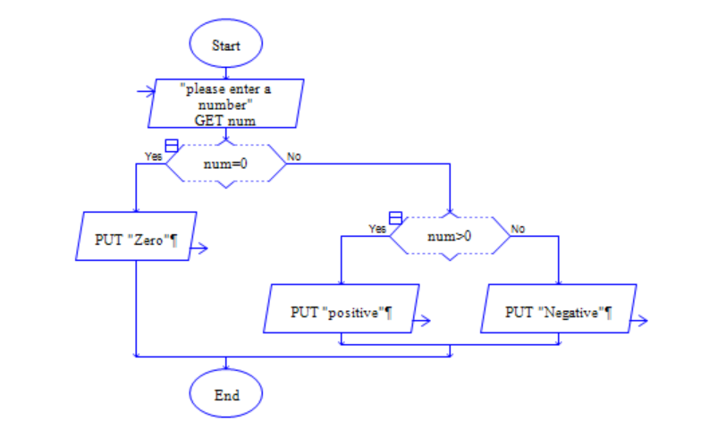

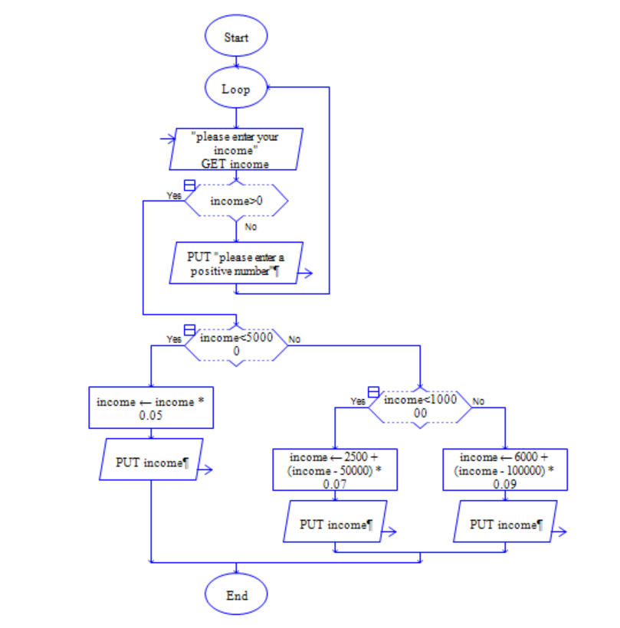

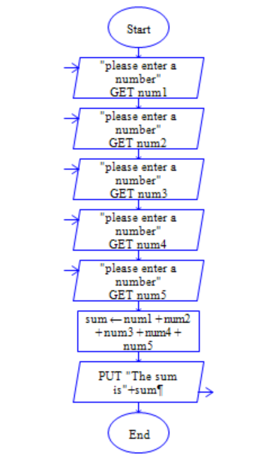

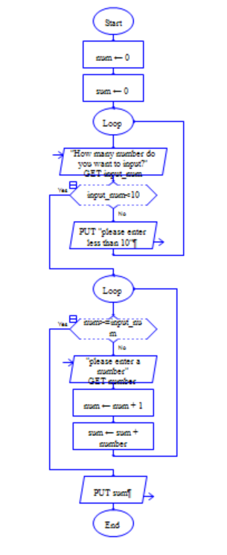

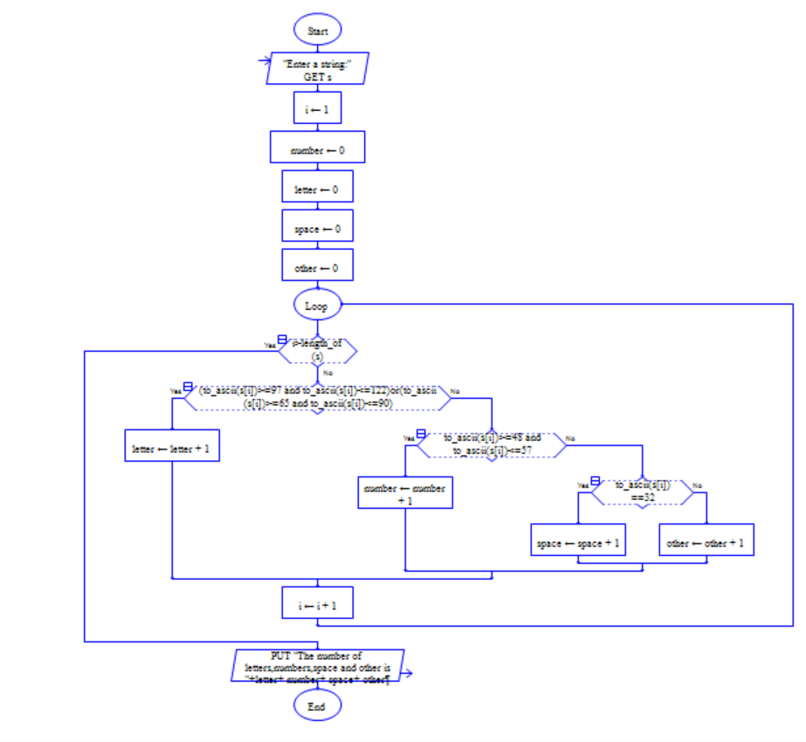

**三、Experiment process and analysis**

**I don’t know how to translate the characters into ascii in python.Then I find the correct ways.**

**I have found out that if we suppose users to enter a number but users input a other thing,the program would be error,and I find the solution in 2.1 in python.**

**四、Experimental conclusion**

1.1 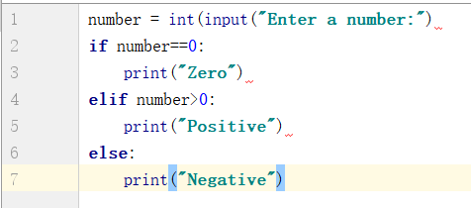

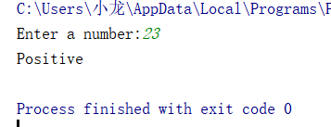

1.2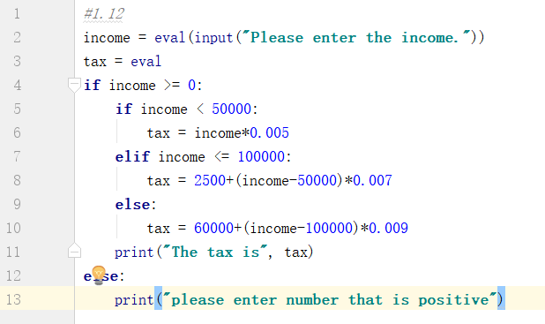

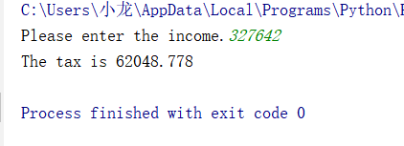

1.3 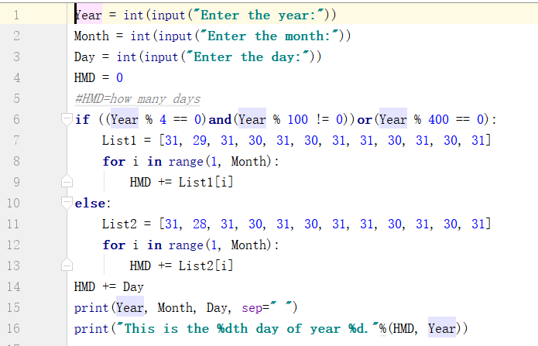

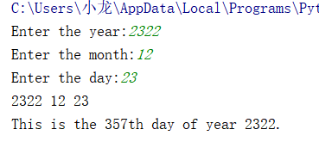

2.1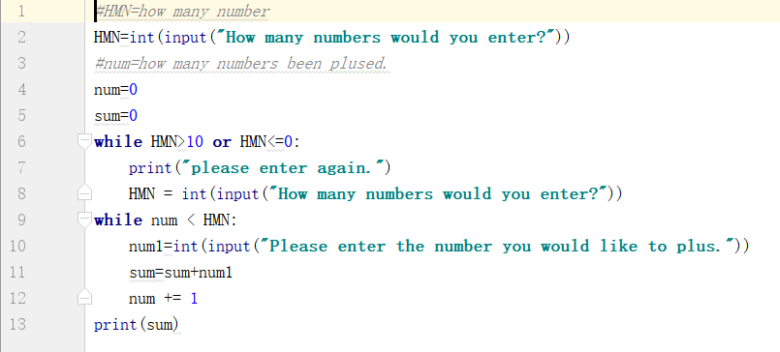

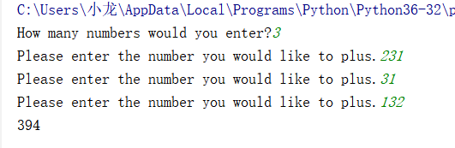

2.2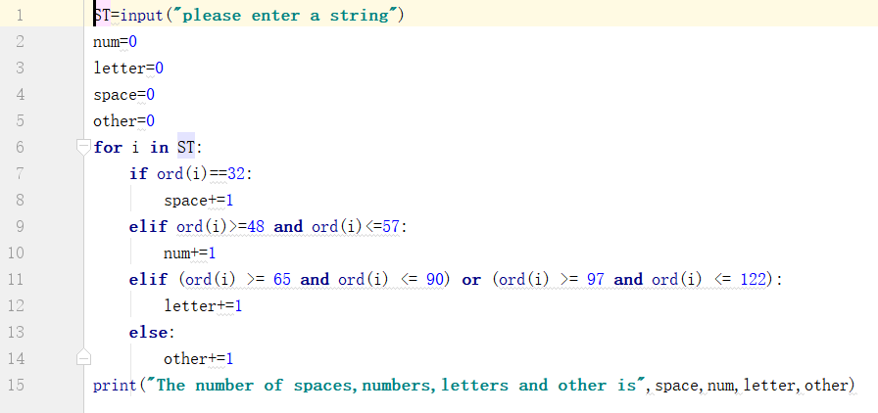

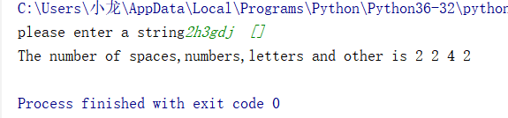

2.3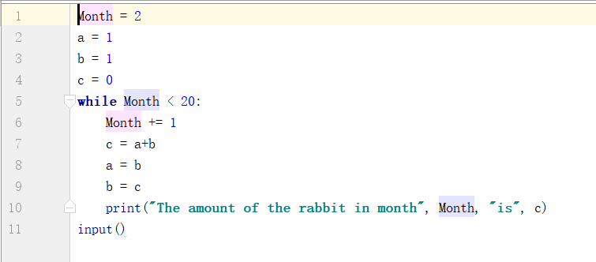

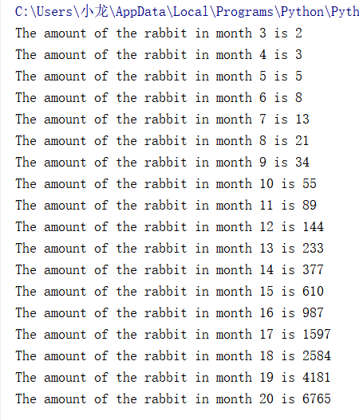

**五、Creativity part**

**六、Advices and suggestions**

JUST BE PATIENT

Evaluation Table（Every experiment needs one table）

|  |  |
| --- | --- |
| Evaluation Criterion | Score |
| （1）Understand and master the related concepts correctly （20%）； |  |
| （2）Design the programming flow according to requirements reasonably（20%）； |  |
| （3）Edit and run the program correctly（20%）； |  |
| （4）Record experiment’s data, process and results correctly（20%）； |  |
| （5）To be conscientious and diligent in the experiment（5%）； |  |
| （6）To be innovative with your design（5%）； |  |
| （7）Satisfied with standard（10%）。 |  |