**课程编号：C0800000012**

**程序设计基础实验报告**



|  |  |  |  |  |
| --- | --- | --- | --- | --- |
| **姓名** | **王文浩** | **学 号** | | **20175168** |
| **班级** | **1703** | **指 导 教 师** | | **李丹程** |
| **实验名称** | **程序设计基础实验** | | | |
| **开设学期** | **2017-2018第一学期** | | | |
| **开设时间** | **第8周——第17周** | | | |
| **报告日期** | **11月28日** | | | |
| **评定成绩** |  | | **评定人** |  |
| **评定日期** |  |

**东北大学软件学院**

实验一：选择结构程序设计

1.1

一，掌握选择结构

二,问题分析与程序设计

Pseudocode

// This programe is judge positive and negative

Write”This program is used to judge a number is Positive or Negative”

Declare Number As Float

Input Number

//start to judge

If Number < 0 Then

Write”Negative”

End If

If Number > 0 Then

Write”Positive”

End If

If Number = 0 Then

Write”Zero”

End If

Raptor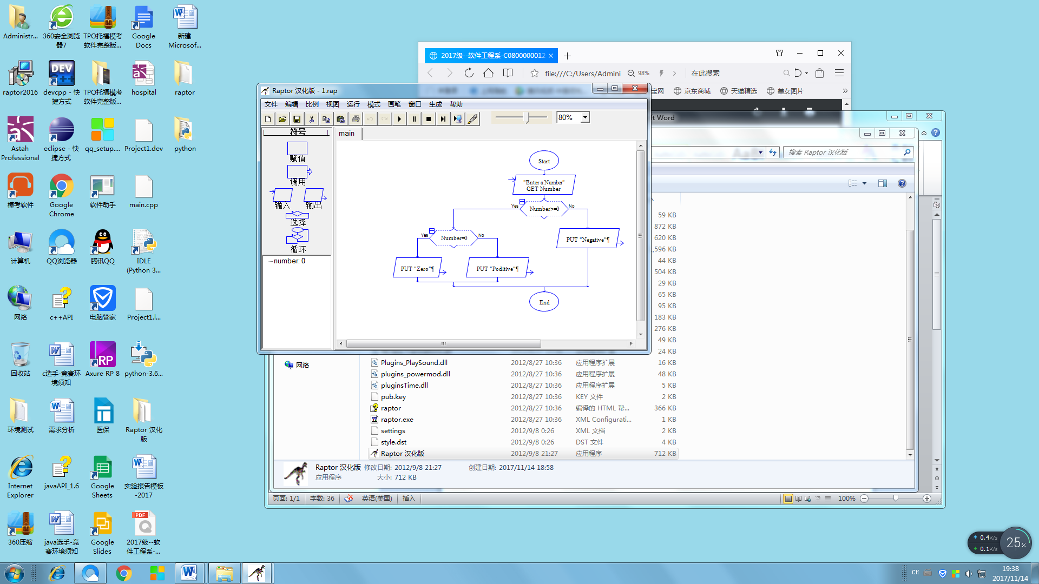

三，Python代码

Python

##The program is used to judge a Number is Positive or Negative

#Input a number

Number = int(input("Enter a number:"))

if Number<0:

print("The number is:Negative")

if Number>=0:

if Number==0:

print("The number is:Zero")

if Number!=0:

print("The number is:Positive ")

四，实验结果总结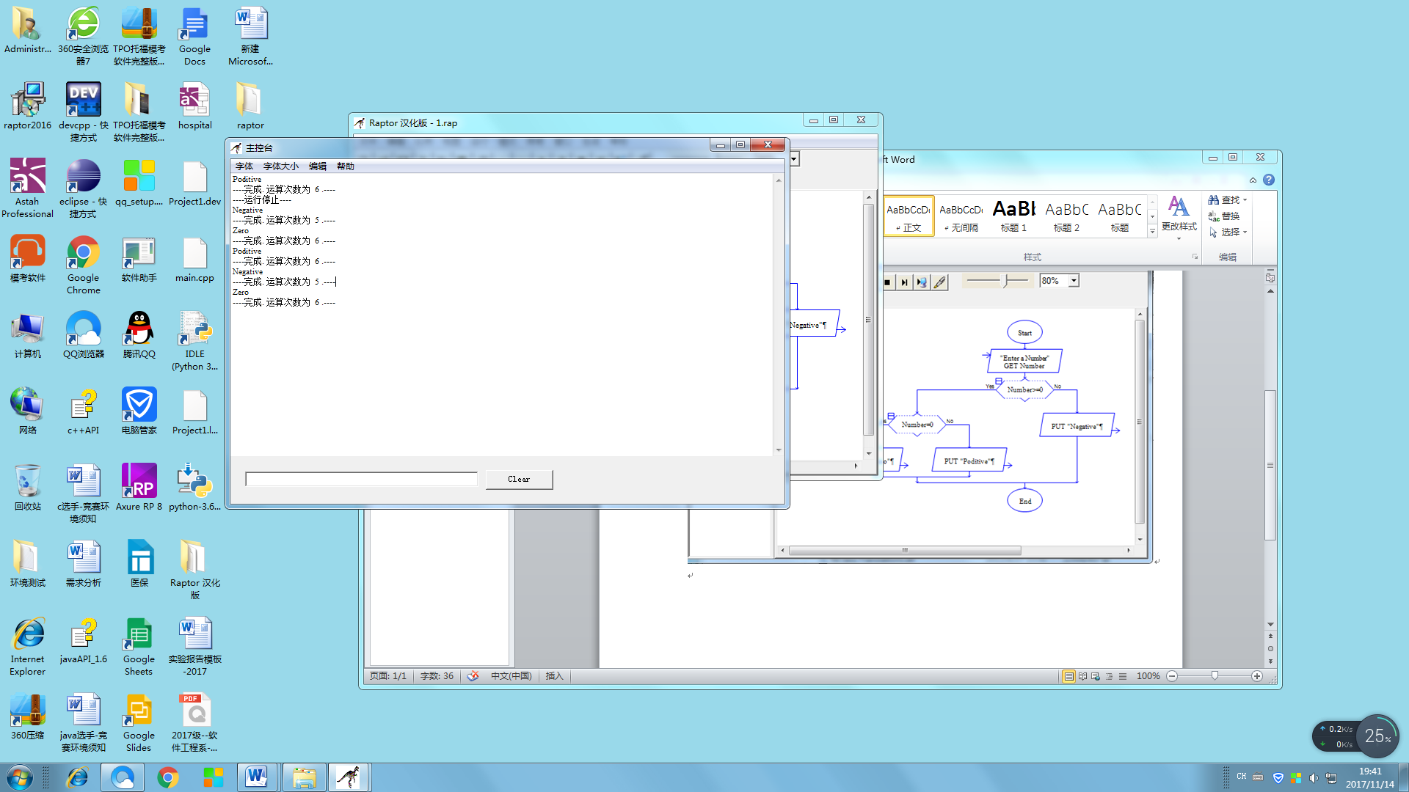

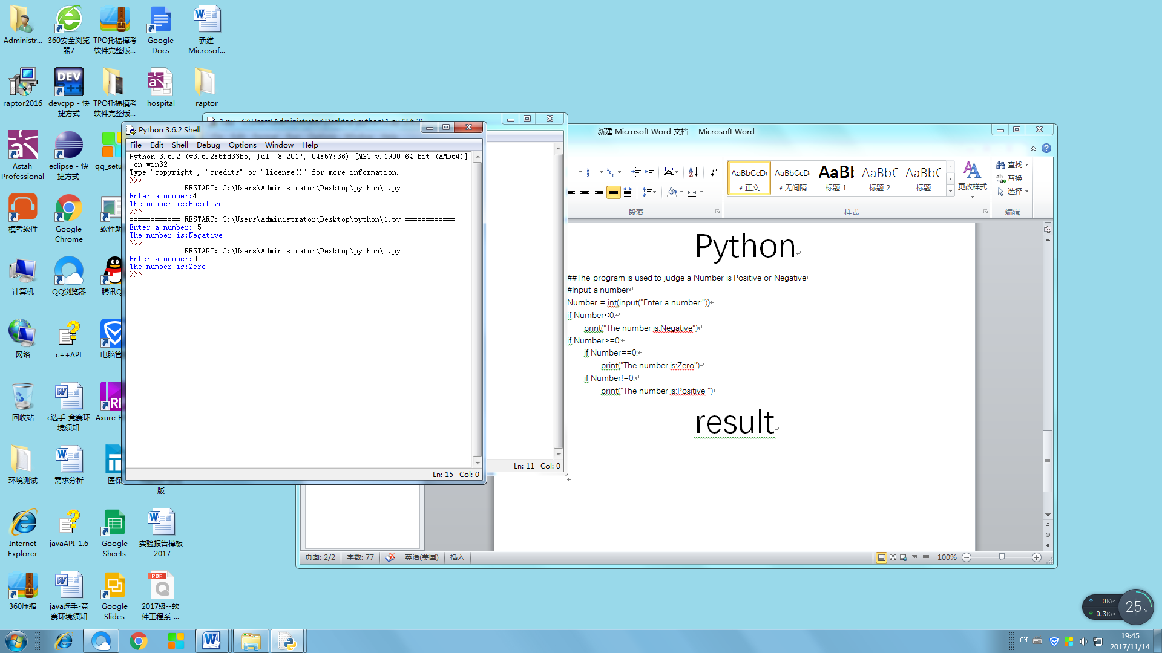

1.2

一，对选择结构进一步掌握

二，问题分析与设计

//calculate a counter’s tax

Declare Accrued_TaxAs Float

Declare Tax As Float

Input Accrude_Tax

If Accrude_Tax<0 Then

Write “The Accrued_Tax is Negative”

End if

If Accrued_Tax>=0 AndAccrued_Tax<=50000 Then

Set Tax=Accrued*0.05

Write”Tax”

End If

If Accrued_Tax>50000 AndAccrued_Tax<=100000 Then

Set Tax=2500+(Accrued_Tax-5000)*0.07

Write”Tax”

End If

If Accrued_Tax>10000 Then

Set Tax=(Accrued_Tax-10000)*0.09+6000 Then

Write “Tax”

End If

Raptor

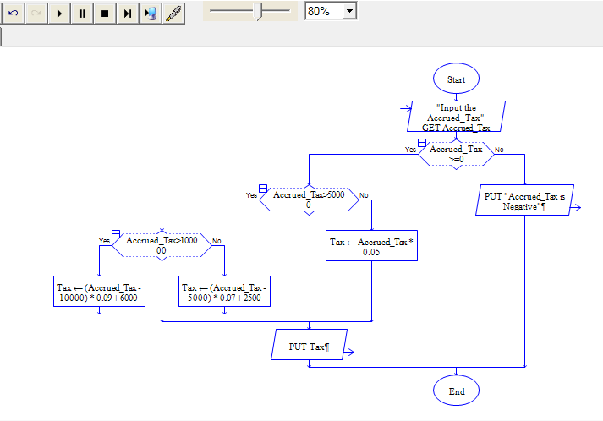

三，Python代码及结果

Python

##The program is used to calculate Tax

#输入你的应征税收入

Accrued_Tax = eval(input("The Accrued_Tax is:"))

#如果输入是负数，则是无效的

ifAccrued_Tax<0:

print("The Accrued_Tax is Negative")

#计算有效的所得税

if (Accrued_Tax>=0 and Accrued_Tax<=50000):

Tax = Accrued_Tax*0.05

print("The Tax is:",Tax)

if(Accrued_Tax>50000 and Accrued_Tax<=100000):

Tax = (Accrued_Tax-50000)*0.07+2500

print("The Tax is:",Tax)

if(Accrued_Tax>100000):

Tax = (Accrued_Tax-100000)*0.09+6000

print("The tax is:",Tax)

四，实验结果总结

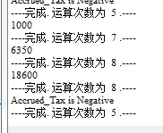

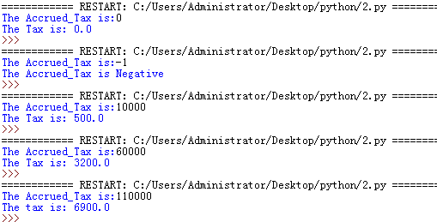

实验2

实验二：循环结构程序设计

2.1

一，掌握循环结构用法

//add five number

Write”Enter five number to calculate sum”

Declare a,b,c,d,e As Float

Input a

Input b

Input c

Input d

Input e

Set sum = a+b+c+d+e

Wrint sum

修改后

//calculate many number to add

Declare total,num,number As Float

Write”Please enter number that you want to calculate”

Input num

//stop to enter number>10

While num>10

Write”Please enter a num again”

Input num

End Whlie

Write”Enter the number”

Input number

For(count=1,count<=num,count++)

Set total += number

Write”Please enter next number”

Input number

End For

Write total

Raptor及结果

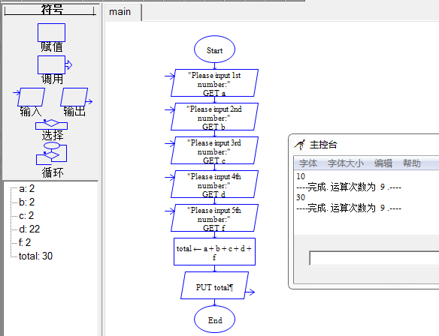修改后

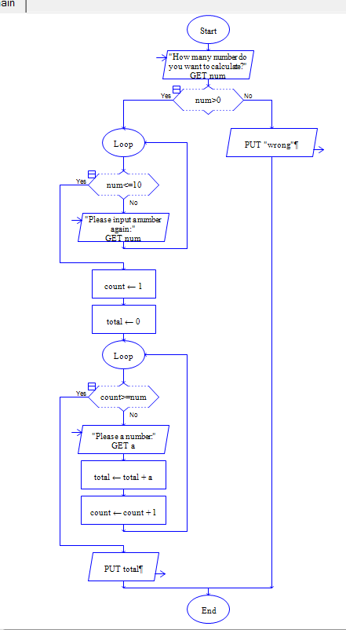

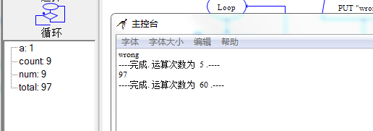

三，python代码及结果

Python及结果

##计算五个数的和

#请输入五个数字

a = float(input("1st:"))

b = float(input("2nd:"))

c = float(input("3rd:"))

d = float(input("4th:"))

f = float(input("5th:"))

total = a+b+c+d+f

print("The total is:”,total)

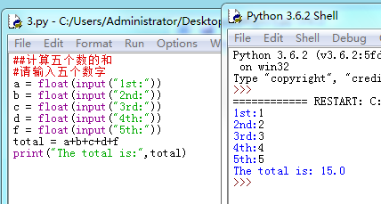

修改后

##这个程序是计算累加数的

#请输入你想要累加数字的个数

num = int(input("How many number do you want to calculate:"))

#如果个数小于等于0，则程序不允许

if(num<=0):

print("wrong")

#如果输入想计算累加的数字个数大于10，则重新输入,否则则进行计算

total = 0

if(num>0):

while (num>10):

num = eval(input("Please input a num again:"))

for count in range (num):

number = eval(input("Please a number:"))

total = total+number

print("The total is:",total)

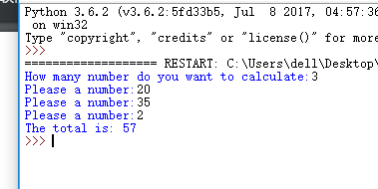

2.2

一，**接触循环并熟练掌握选择结构**

二，**问题分析与程序设计**

**//calculate a string how many alphabet,figure,blank,other**

**Declare alp_num,fig_num,bla_num,oth_num,i,len As Integer**

**Declare n Integer**

**Decalre Str[n] As String**

**Write”Please enter how long the string”**

**Input n**

**//enter the string once one elem**

**For(K=1,K<=n,K++)**

**Write”Please enter the string once a alphabet”**

**Input[K]**

**End For**

**Set i = 1**

**Set len = length_Of(Str)**

**//the loop is judge the string**

**For(i,i<=len,i++)**

**If Str[i]>=0And Str[i]<=9 Then**

**fig_num += 1**

**End If**

**If (Str[i]>=A And Str[i]<=Z) Or (Str[i]>=a And Str[i]<=z) Then**

**Alp_num += 1**

**End If**

**If Str[i] ==’ ’ Then**

**Bla_num += 1**

**Else**

**Oth_num +=1**

**End If**

**End For**

**Write “The alphabet is:”+alp_num**

**Write “The number is:”+fig_num**

**Write “The blank is:”+bla_num**

**Write “The other is”+oth_num**

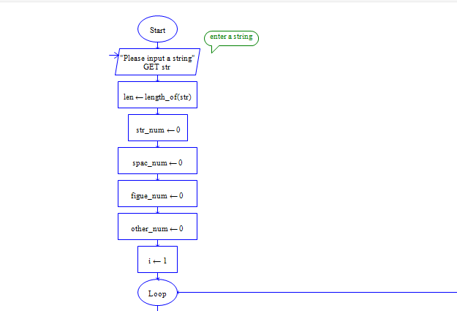

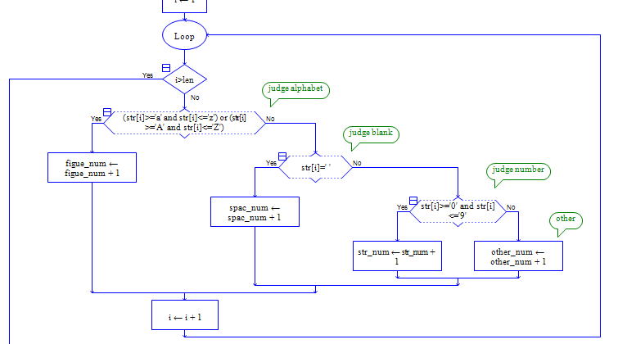

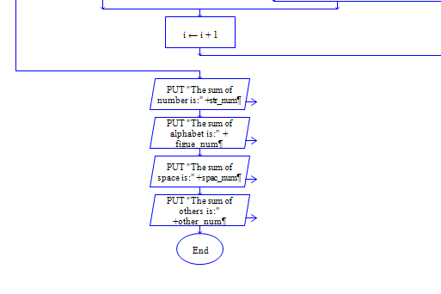

Python

##用来计算一行字符串中有几个英文字母，数字，空格和其他

oStr = str(input("Please input a string:"))

str_num = 0

spac_num = 0

figue_num = 0

other_num = 0

#循环体测试

for strs in oStr:

if strs.isalpha():

str_num +=1

elif strs.isdigit():

figue_num +=1

elif strs == " ":

spac_num +=1

else:

other_num +=1

print("英文字母有:",str_num)

print(" 数字有:",figue_num)

print(" 空格有:",spac_num)

print(" 其他有:",other_num)

四，实验结果总结

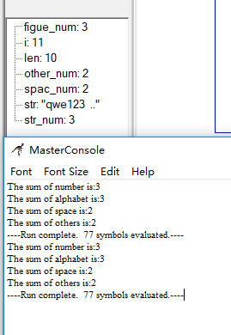

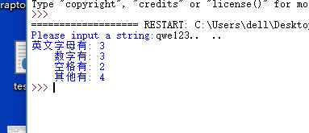

实验三

3.1

一，对嵌套循环的初步掌握

二，问题分析与程序设计

伪代码

Declare Num_class,Num_student As Interge

Write”Please enter number of class”

Input Num_class

Write”Please enter number of student”

Input Num_student

For(count=1,count<=Num_class,count++)

While Num_student>50

Write”Wrong”

Write”Please enter a number again”

Input Num_student

End While

//n可以是任意你想要输入的学生的个数

Declare name[n] As String

Declare score[n] As Float

For(count=0,count<Num_student,count++)

Write”Please enter a student name”

Input name[count]

Write”Please this student score”

Input score[count]

End For

Set k = 0

For(k,k<count,k++)

Write name[k]+score[k]

End for

Raptor

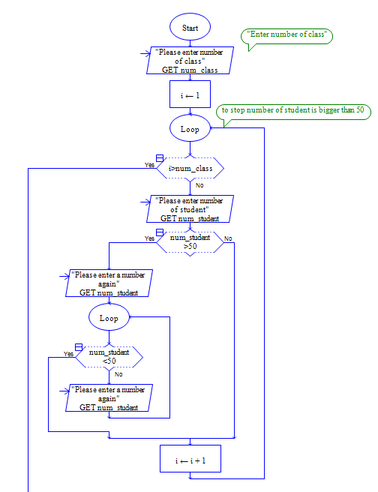

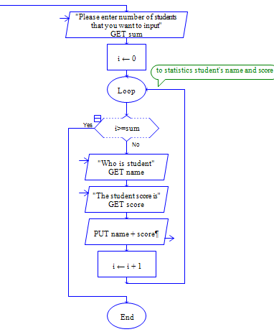

三，Python代码及结果

Python

##统计50名内学生成绩

#输入班级数目和学生数目

num_class = int(input("Please enter class number:"))

for i in range (num_class):

num_student = int(input("Please enter student number:"))

while num_student > 50:

print("Wrong") #若学生人数大于50，则错误

num_student = int(input("Please enter a number again:"))

#统计各个学生及其成绩

Name = []

Score = []

count = 0

print("Please enter student\'name:(input\'*\' to end)")

TempName = input()

print("Please enter this student\'score:")

TempScore = float(input())

#输入学生名字及其成绩

while TempName != "*":

Name.append(TempName)

Score.append(TempScore)

count += 1

print("Enter next student\' name:(input\'s*\'to end)")

TempName = input()

if TempName != "*":

print("Enter this student\'score:")

TempScore = float(input())

#输出学生的名字及其成绩

K = 0

while K < count:

print(Name[K],Score[K])

K += 1

三，实验结果总结

3.1

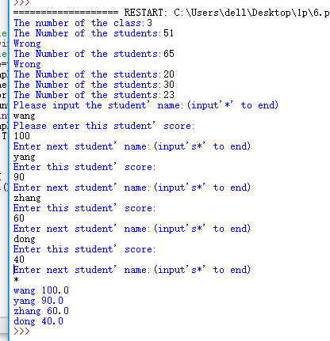

3.2

一，对嵌套循环的进一步掌握

二，问题分析与程序设计

Declare number As integer

Write “Please enter a number”

Input number

For(count=1,count<=number,count=count+2)

If number = 1 Them

Write “*”

End If

If number//2=0 Then

Write “ ”

End If

If number//2=0 Then

Write “*”*number

End If

End For

Raptor

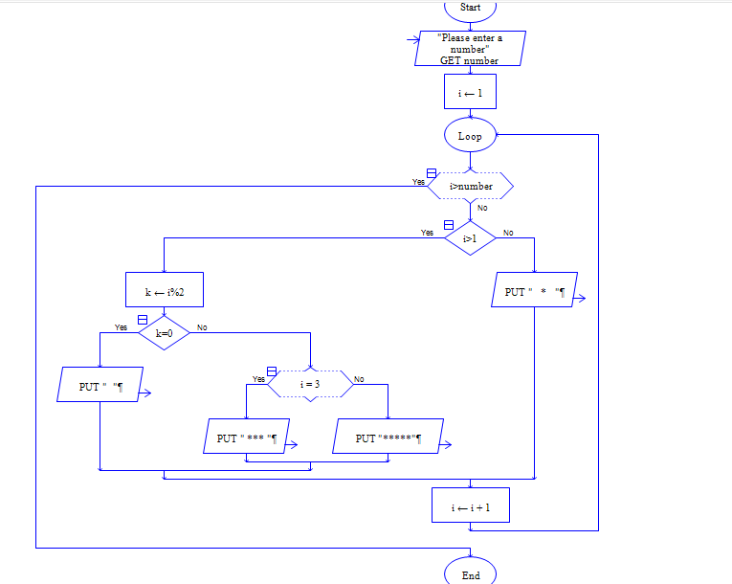

三，python代码及结果

Python及结果

Number =int(input("Please enter a number:"))

b=Number

if Number >=1:

print("*".center(b))

for a in range (2,Number+1):

if a%2 == 1:

print(("*"*a).center(b))

elif a%2==0:

print("")

四，实验结果总结

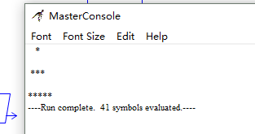

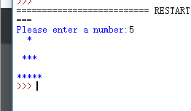

实验4

4.1

一，初步掌握数组

二，问题的分析与程序设计



Declare Score[30] As Float

Declare Name[30] As String

Declare Up60,UP90 As integer

Set Up60 = 0

Set Up90 = 0

For(K=0,K<30,K++)

Write “Please enter a name”

Input Name[K]

Write “Please enter a score”

Input Score[K]

If Score[K]>60 Then

Up60 += 1

If Score[K]>90 Then

Up90 += 1

Write Name[K]+Score[K]

Write “The score up 60”+Up60

Write “The score up 90”+Up90

三，python代码及结果

Python及结果

##统计30名学生英语成绩并统计60和90分以上人数

English_Score=[]

TempName=[]

Forty_up=0

Ninety_up=0

#输入学生名字和成绩

for count in range(30):

TempName.append(input("Please enter a student\'s name:\n"))

TempScore=float(input("Please enter a score:\n"))

TempName.append(TempScore)

English_Score.append(TempName)

TempName=[]

#统计60，90分以上人数

if TempScore >60:

Forty_up +=1

if TempScore>90:

Ninety_up+=1

print(English_Score)

print("六十分以上者:",Forty_up)

print("九十分以上者:",Ninety_up)

四，实验结果总结

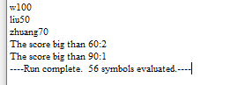

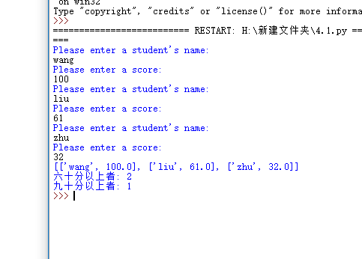

###########作3组意思意思################################