**课程编号：C0800000012**

**程序设计基础实验报告**



|  |  |  |  |  |
| --- | --- | --- | --- | --- |
| **姓名** | **高志斐** | **学 号** | | **20175132** |
| **班级** | **3** | **指 导 教 师** | | **李丹程** |
| **实验名称** | **程序设计基础实验** | | | |
| **开设学期** | **2017-2018第一学期** | | | |
| **开设时间** | **第8周——第17周** | | | |
| **报告日期** | **2017/12/13** | | | |
| **评定成绩** |  | | **评定人** |  |
| **评定日期** |  |

**东北大学软件学院**

实验一：选择结构程序设计

**一、实验目的**

了解所使用的计算机系统和在该系统上如何进行程序设计；掌握选择结构的程序设计方法；编辑和运行 Python 程序。实验要求采用选择结构进行程序设计，给出程序设计流程图或伪代码，并使用 Python 代码编程实现，且编写实验报告。

**二、问题分析与程序设计**

1.伪代码

Declare Number As Float

Write”input a number

Input number

If number≥0

If number==0 then

Print”zero

Else

Print”positive

Else

Print”negative”

End If

RAPTOR流程图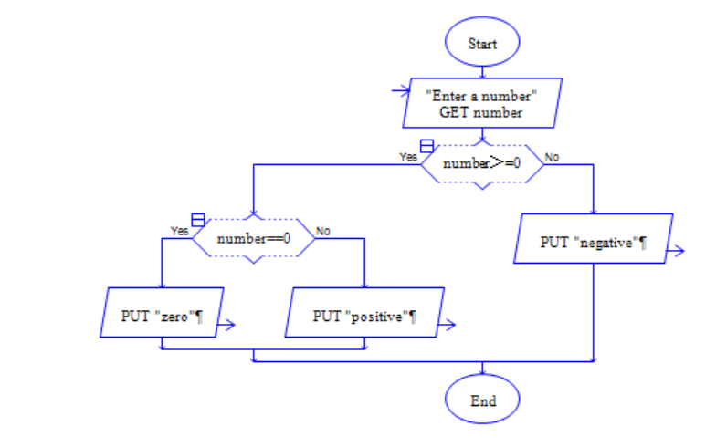

2.伪代码

Declare Taxable income As Float

Declare Tax Rate As Float

Declare Tax As Float

Write”input Taxable income

Input Taxable income

If Taxable income＜0 Then

Write”You can not input a negative number”

If (Taxable income≥0)AND（Taxable income≤50000）Then

Set Tax Rate=0.05

Set Tax= Taxable income* Tax Rate

Else

If (Taxable income＞50000)AND(Taxable income≤100000)

Set Tax Rate=0.07

Set Tax=2500+( Taxable income-50000)* Tax Rate

Else

Set Tax Rate=0.09

Set Tax=6000+( Taxable income-100000)* Tax Rate

End If

End If

Print Tax

RAPTOR流程图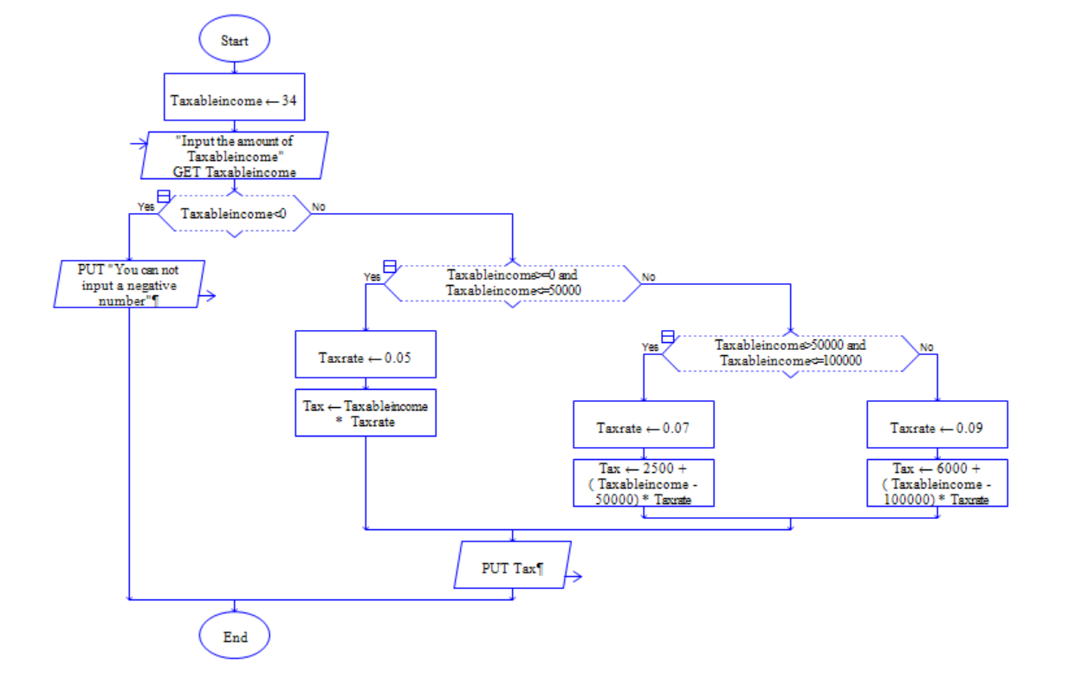

**三、实现过程与测试结果分析**

1.Python代码

#This is a program to judge whether a number is positive or negative or zero

number = int(input("Enter a number:"))

#input the number you want to judge

if (number>=0):

if (number==0):

print("Zero")

else:

print("Positive")

else:

print("Negative")

2.Python代码

#This program is used to calculate tax

Taxableincome=int(input("Enter the Taxableincome:"))

#Get the user’s Taxable income

if Taxableincome<0:

print("You can not input a negative number")

#Prevent the user from inputing a negative number mistakenly

if Taxableincome>=0 and Taxableincome<=50000:

Tax_Rate=0.05

Tax=Taxableincome*Tax_Rate

#Calculate the tax

else:

if Taxableincome>50000 and Taxableincome<=100000:

Tax_Rate=0.07

Tax=2500+(Taxableincome-50000)*Tax_Rate

else:

Tax_Rate=0.09

Tax=6000+(Taxableincome-100000)*Tax_Rate

print(Tax)

**四、实验结果总结**

**1.**

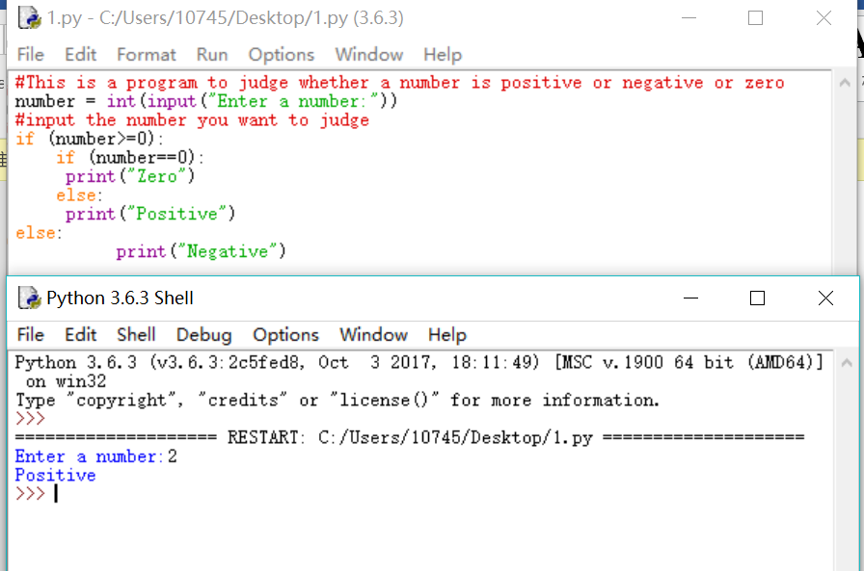

2.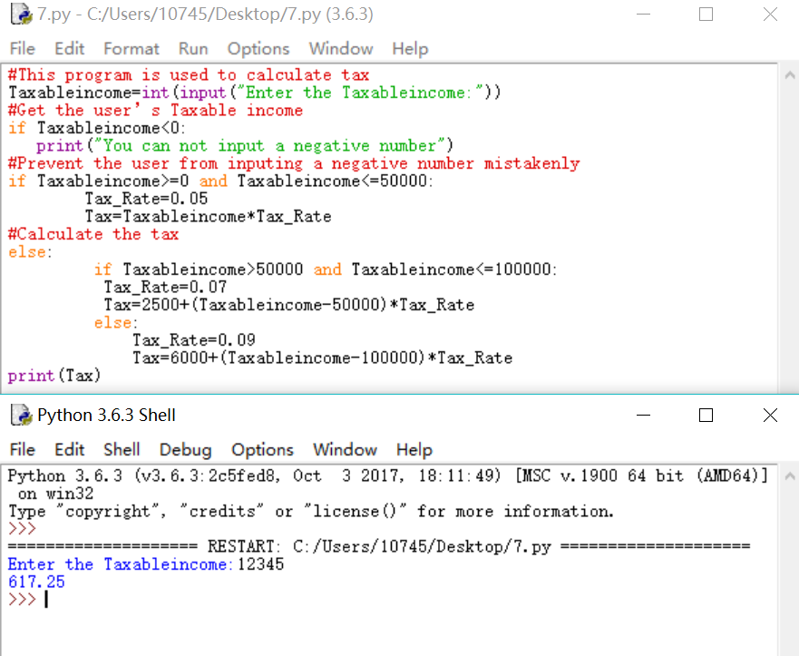

**五、创新的部分**

暂无

**六、对实验的意见与建议**

通过本次实验，我更加熟练地掌握了选择结构。

评价表格（每份实验报告只需一份评分表）

|  |  |
| --- | --- |
| 考核标准 | 得分 |
| （1）正确理解和掌握实验所涉及的概念和原理（20%）； |  |
| （2）按实验要求合理设计程序执行流程（20%）； |  |
| （3）能编程实现设计的程序流程，运行结果正确（20%）； |  |
| （4）认真记录实验数据，原理及实验结果分析准确（20%）； |  |
| （5）实验过程中，具有严谨的学习态度和认真、踏实、一丝不苟的科学作风（5%）； |  |
| （6）所做实验具有一定的创新性（5%）； |  |
| （7）实验报告规范（10%）。 |  |

实验二：循环结构程序设计

**一、实验目的**

掌握循环结构的程序设计方法；编辑和运行 Python 程序。实验要求采用循环结构进行程序设计，给出程序设计流程图或伪代码，并使用 Python 代码编程实现，且编写实验报告。

**二、问题分析与程序设计**

1.伪代码

Declare Sum As Integer

Declare Count As Integer

Declare Number As Integer

Set Count=1

Set Sum=0

Repeat

Write “Enter an integer:”

Input Number

Set sum=sum+Number

Set count=count+1

Until Count=6

Write”The sum is“+Sum

修改后伪代码

Declare Sum As Integer

Declare Count As Integer

Declare Number As Integer

Declare Amount As Integer

Set Count=0

Set Sum=0

Repeat

Write“the amount of numbers you want to sum is”

Input Amount

If Amount.〉10

Write”It‘s too many,the amount of the number must<=10,please enter again”

Until Amount<=10

Repeat

Write “Enter an integer:”

Input Number

Set sum=sum+Number

Set count=count+1

Until Count= Amount

Write”The sum is“+Sum

1. Rapter流程图

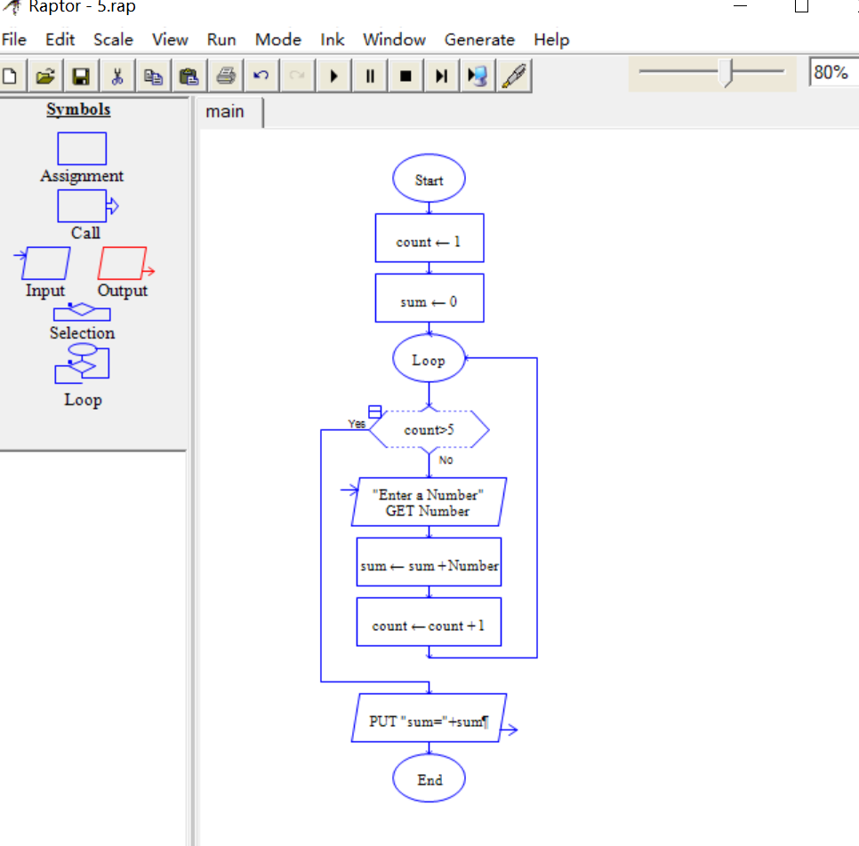

修改后流程图

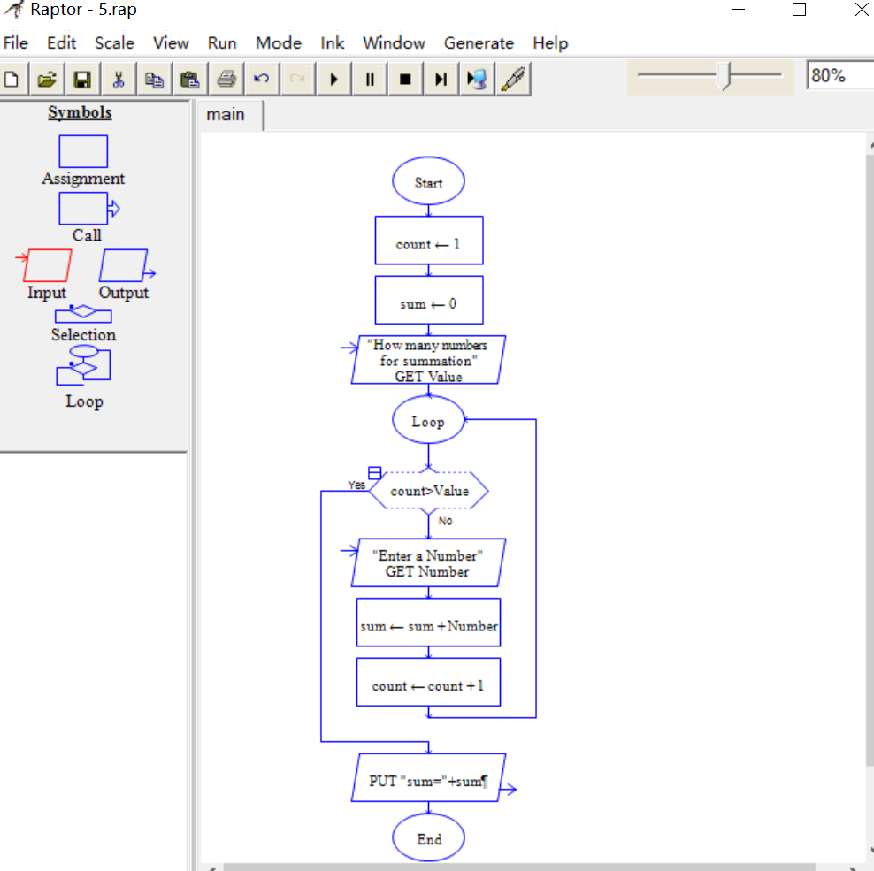

2.伪代码

Write “Please enter a string.”

Input ST

Set number = 0

Set letter = 0

Set space = 0

Set other = 0

Set n = length_of(srting)

Set i = 0

While i < n

i+=1

Set a = to_ascii(string[i])

If (a>=65 and a<=90)or(a>=97 and a<= 122) Then

Set letter += 1

Else

If a>=48 and a<=57 Then

Set number += 1

Else

If a == 32 Then

Set space += 1

Else

Set other += 1

End If

End If

End If

End While

Write “There are”+ letter +“letters in the string.”

Write “There are”+ number +“numbers in the string.”

Write “There are”+ space +“spaces in the string.”

Write “There are”+ other +“other charactors in the string”

1. Rapter



**三、实现过程与测试结果分析**

1.Python代码

# -*- coding:utf-8 -*-

count=1

sum=0

while(1):

if count>5:

break

else:

number = int(input("Enter a number:"))

sum=sum+number

count+=1

print("Sum="+str(sum))

修改后Python代码

#-*- coding:utf-8 -*-

count=1

sum=0

numberCount=int(input("How many numbers for summation :"))

while(1):

if count>numberCount:

break

else:

number = int(input("Enter a number:"))

sum=sum+number

count+=1

print("Sum="+str(sum))

2.Python代码

ST=input("please enter a string")

num=0

letter=0

space=0

other=0

for i in ST:

if ord(i)==32:

space+=1

elif ord(i)>=48 and ord(i)<=57:

num+=1

elif (ord(i) >= 65 and ord(i) <= 90) or (ord(i) >= 97 and ord(i) <= 122):

letter+=1

else:

other+=1

print("The number of spaces,numbers,letters and other is",space,num,letter,other)

**四、实验结果总结**

**1：**

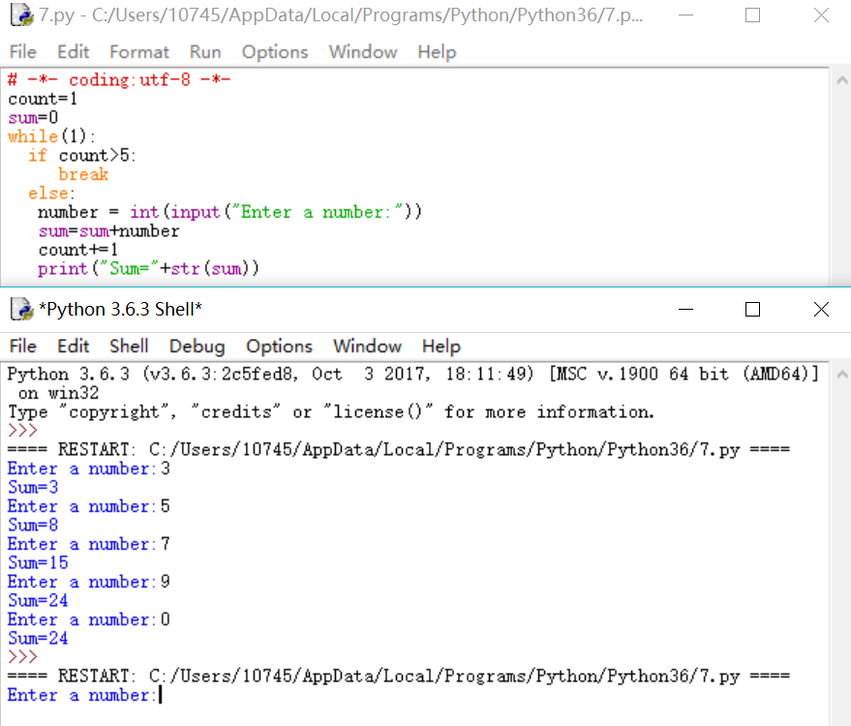

修改后

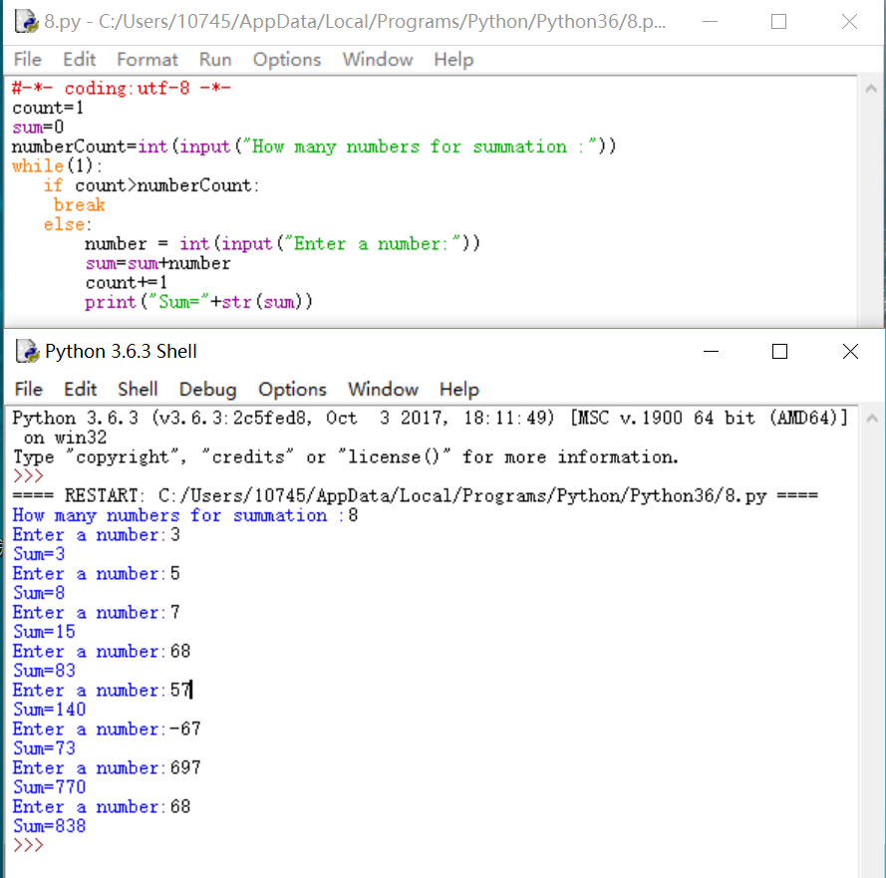

2.

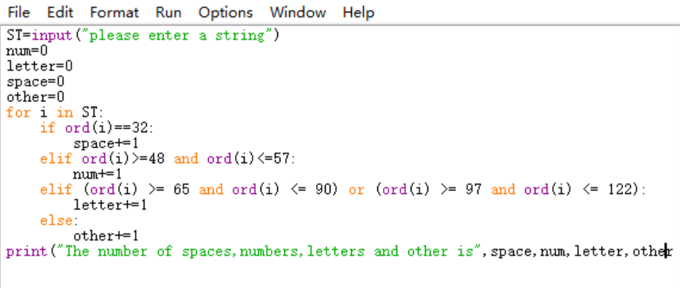

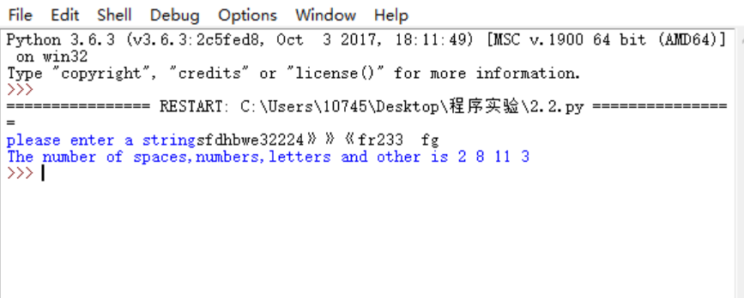

实验三：嵌套循环结构程序设计

**一、实验目的**

了解嵌套循环结构的程序设计方法；编辑和运行 Python 程序。实验要求采用嵌套循环结构进行程序设计，给出程序设计流程图或伪代码，并使用 Python 代码编程实现，且编写实验报告。

**二、问题分析与程序设计**

1.伪代码

Declare classnumber As Integer

Declare studentnumber As Integer

Declare name[n] As String

Declare score[n] As Float

Write”Please enter the number of classes”

Input classnumber

Write”Please enter the number of students”

Input studentnumber

For(count=1,count<=classnumber,count++)

While studentnumber>50

Write”Wrong”

Write”Please enter a new number”

Input studentnumber

End While

For(count=0,count<studentnumber,count++)

Write”Please enter a student’s name”

Input name[count]

Write”Please this student’s score”

Input score[count]

End For

Set k = 0

For(k,k<count,k++)

Write name[k]+score[k]

End for

Raptor流程图



Python代码

classnumber=int(input("Please enter the number of classes :"))

for i in range (classnumber):

studentnumber = int(input("Please enter the number of the students:"))

while studentnumber>50:

print("Wrong")

studentnumber = int(input("Please enter a new number:"))

Name = []

Score = []

count = 0

print("Please enter a student'name:(input '*' to end)")

TempName = input()

if TempName !="*":

print("Please enter this student's score:")

TempScore = float(input())

Name.append(TempName)

Score.append(TempScore)

count+=1

print("Enter the next student' name:(input '*' to end)")

TempName = input()

if TempName !="*":

print("Enter this student'score:")

TempScore = float(input())

K = 0

while K<count:

print(Name[K],Score[K])

K+=1

2.伪代码

Declare number As integer

Write “Please enter a number”

Input number

For(count=1,count<=number,count=count+2)

If number = 1 Then

Write “*”

End If

If number//2=0 Then

Write “ ”

End If

If number//2=1Then

Write “*”*number

End If

End For

Rapter

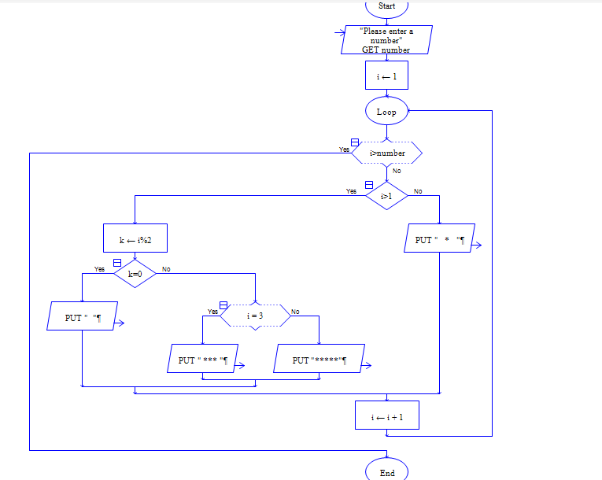

Python

Number =int(input("Please enter a number:"))

b=Number

if Number >=1:

print("*".center(b))

for a in range (2,Number+1):

if a%2 == 1:

print(("*"*a).center(b))

elif a%2==0:

print("")

**三、实现过程与测试结果分析**

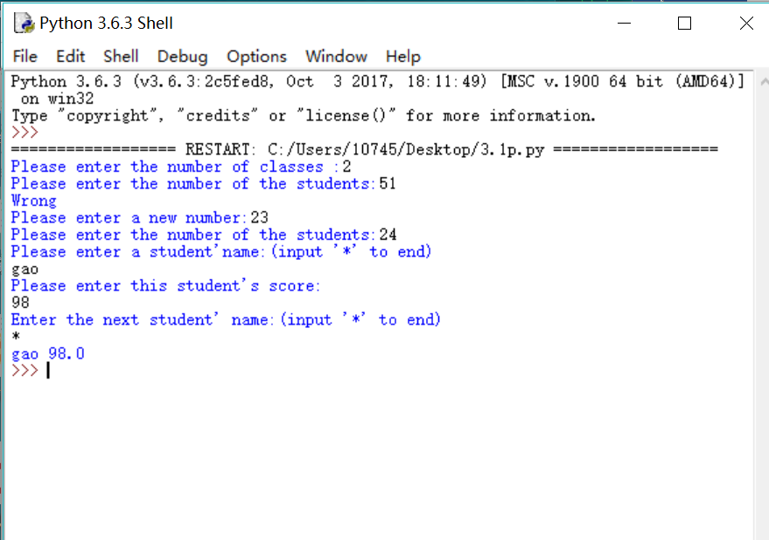

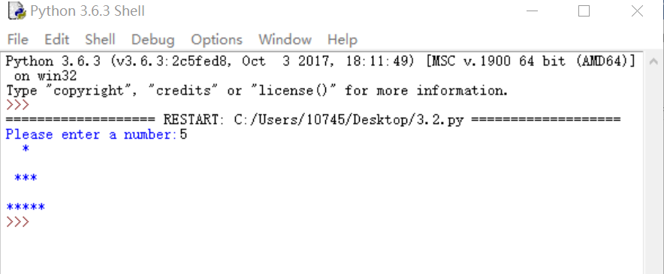

实验四数组程序设计

1. 伪代码

Declare Score[30] As Float

Declare Name[30] As String

Declare score60plus As integer

Declare score90plus As integer

Set score60plus = 0

Set score90plus = 0

For(K=0,K<30,K++)

Write “Please enter a name”

Input Name[K]

Write “Please enter a score”

Input Score[K]

If Score[K]>60 Then

score60plus += 1

If Score[K]>90 Then

score90plus += 1

Write Name[K]+Score[K]

Write “The number of students who get 60+ is”+ score60plus

Write “The number of students who get 90+ is”+ score90plus

Raptor



Python

EnglishScore=[]

TempName=[]

sixtyplus=0

ninetyplus=0

for count in range(30):

TempName.append(input("Please enter a student's name:\n"))

TempScore=float(input("Please enter a score:\n"))

TempName.append(TempScore)

EnglishScore.append(TempName)

TempName=[]

if TempScore >60:

sixtyplus+=1

if TempScore>90:

ninetyplus+=1

print(EnglishScore)

print("The number of students who get 60+ is:",sixtyplus)

print("The number of students who get 90+ is:",ninetyplus)

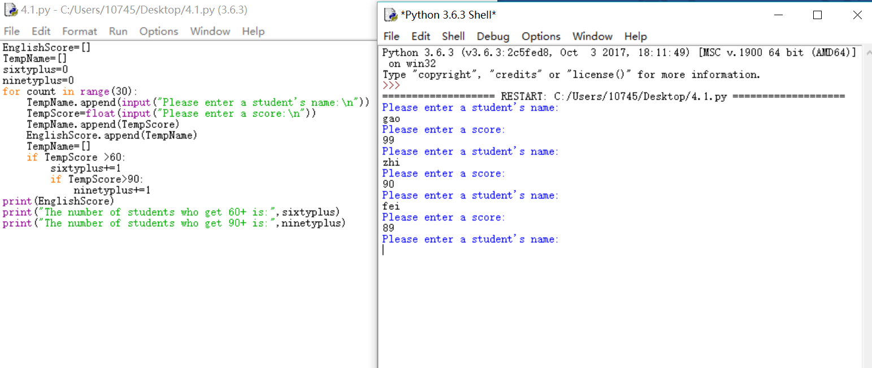

1. 伪代码

Declare str1,str2 as string

Write"Please enter string1"

input str1

Write"Please enter string2"

Input str2

If len(str1)>len(str2)

Print(“the length of string1> the length of string2”

If len(str1)<len(str2)

Print(“the length of string1< the length of string2”)

Else

Print(“the length of string1=the length of string2”)

Print(“the addition of the two string is”,str1+str2)

Print(“the copy of str1 is”,str1)

Print(“the copy of str2 is”,str2)

Raptor



Python

str1=input("input a string")

str2=input("input a string")

if len(str1)>len(str2):

print("the length of string1> the length of string2")

if len(str1)<len(str2):

print("the length of string1< the length of string2")

else:

print("the length of string1=the length of string2")

print("the addition of the two string is",str1+str2)

print("the copy of str1 is",str1)

print("the copy of str2 is",str2)

