***Use Terminal***

# 

# **Install Java 8**

Download java 8 :

**sudo apt install openjdk-8-jre-headless**

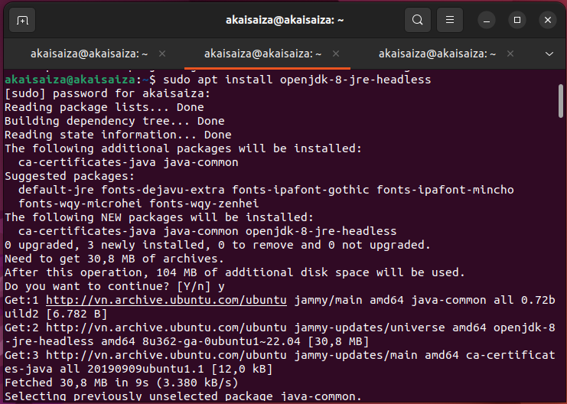

~$ sudo apt install openjdk-8-jdk-headless -y

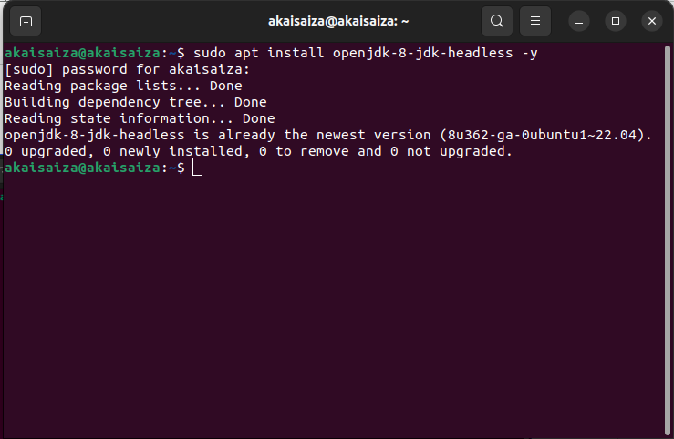

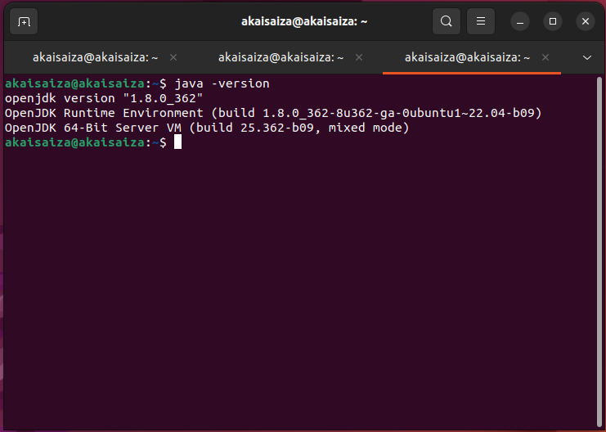

# **Install Netbeans 16**

Download :

<https://drive.google.com/file/d/1gCCeFRyh2LElcOkzmxb3jUcBR5oTkboV/view?usp=sharing>

Setup netbean

**sudo dpkg -i * file name\***

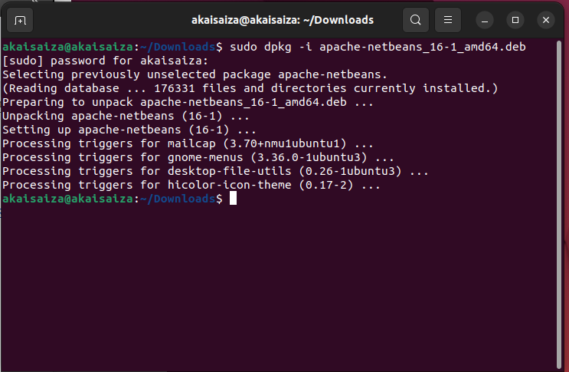

# 

# 

# 

# 

# 

# **Install Tomcat 9 and Setup on Netbeans 16**

**Step 1 :**

Link setup :<https://linuxhint.com/install_apache_tomcat_server_ubuntu_2204/>

Start **Step 3: Check the availability of Apache Tomcat package**

**Step 2 :**

Next **Add to NetBean**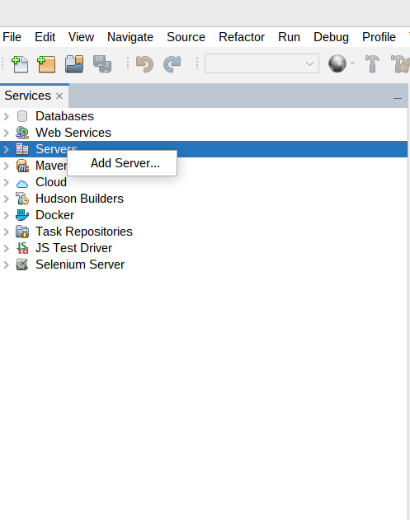

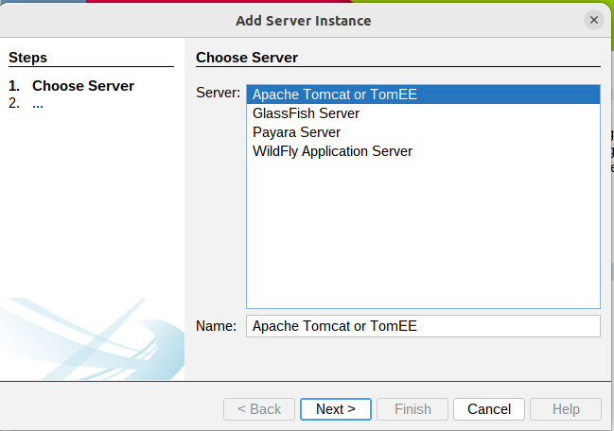

Copy and Paste : “**/usr/share/tomcat9”**

if no error :

you need enter username ,password

Ex :

username : admin

password : admin

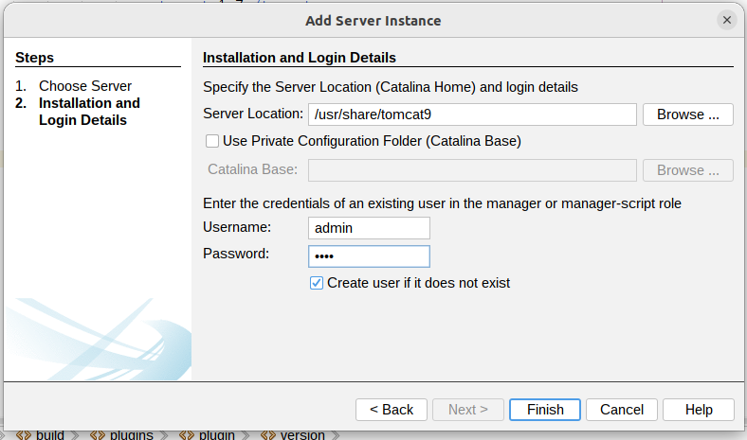

If you encountered error “The <CATALINA_HOME>/conf/server.xml can’t be read.”

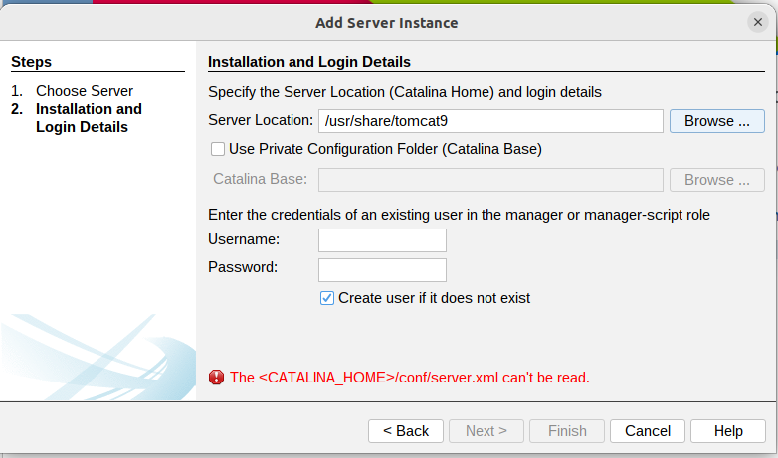

You need to do the following steps

**Step 4 :**

**sudo chown -R *user account* *direction\***

**2 direction you need to change permission:**

* /etc/tomcat9
* /usr/share/tomcat9

**Ex :**

* user account : akaisaiza

sudo chown -R akaisaiza /etc/tomcat9

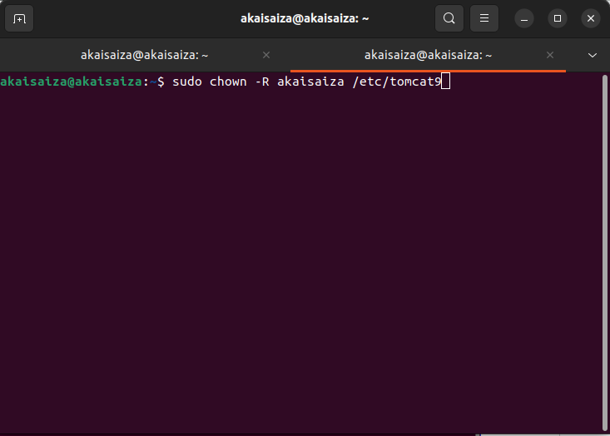

sudo chown -R akaisaiza /usr/share/tomcat9

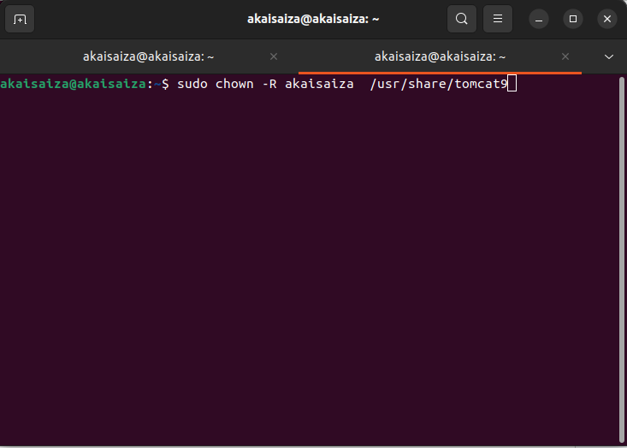

Note : Chown là chữ viết tắt của “change owner” – đổi chủ sở hữu.

**Step 3:**

**ln -s /etc/tomcat9 /usr/share/tomcat9/conf**

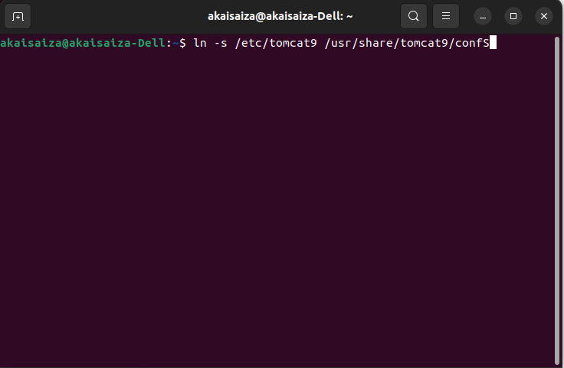

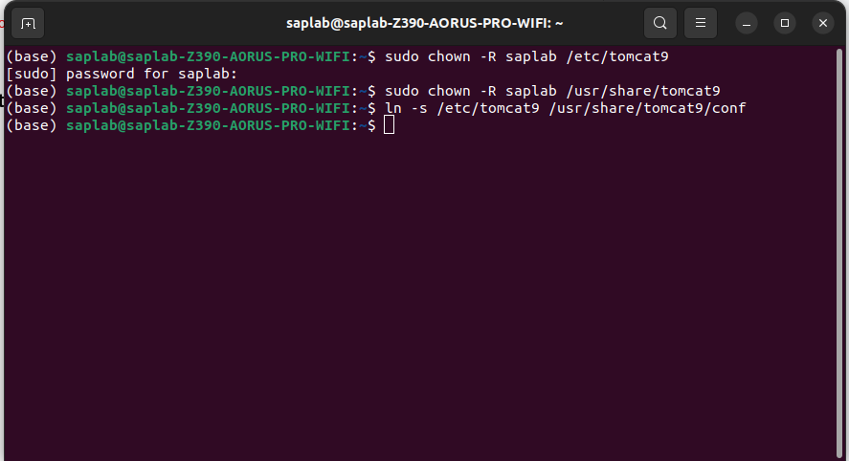

Note :

you need stop tomcat before run tomcat in netbean by using command:

sudo systemctl stop tomcat9

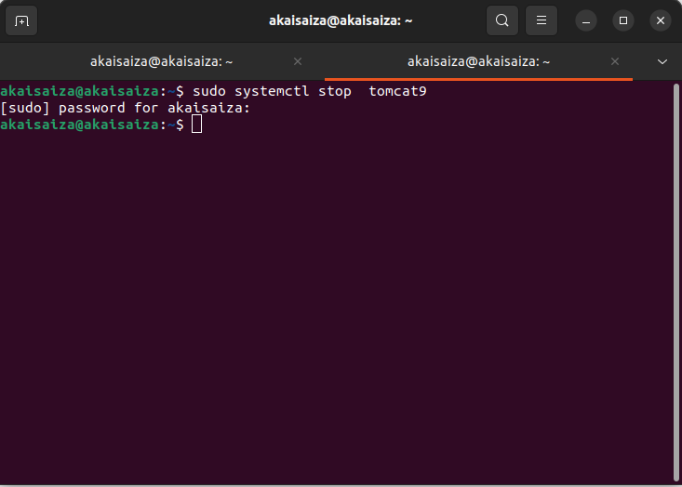

**Go back to step 1**

# **Run first project with maven**

(if you done all step above)

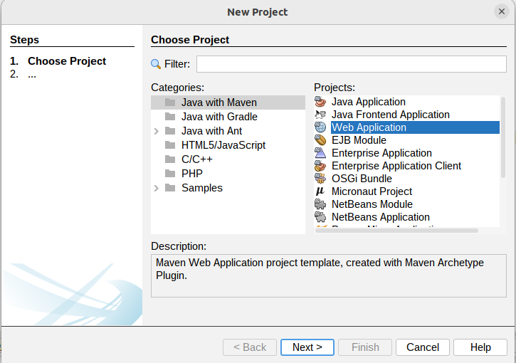

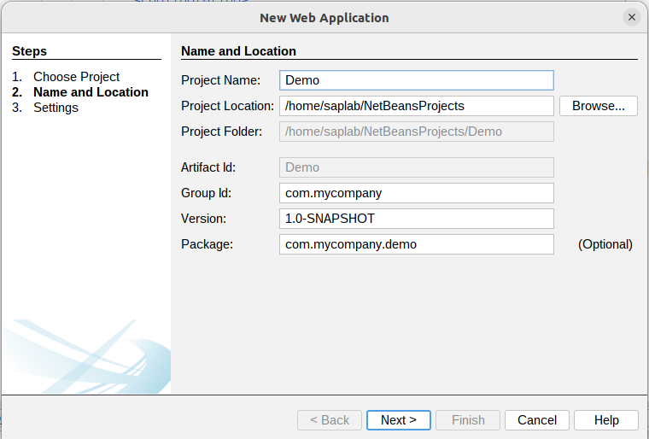

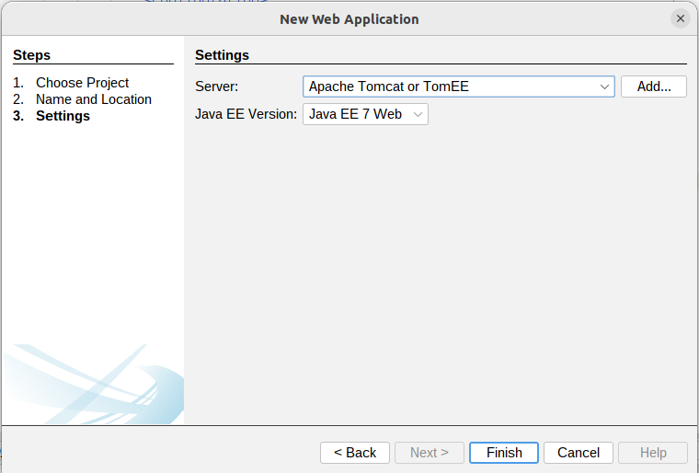

Next you run project :

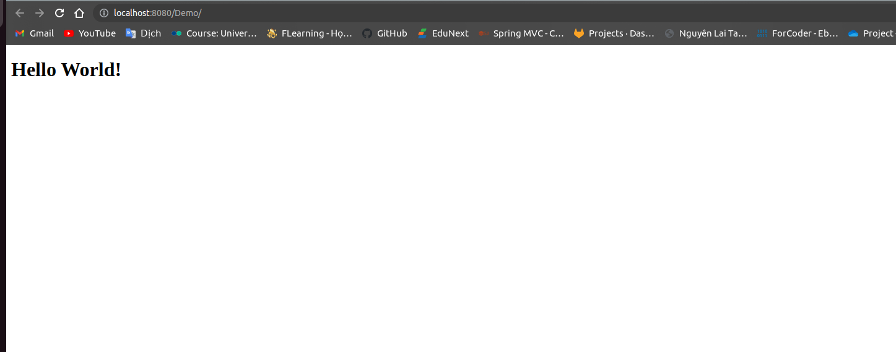

If you encountered this error

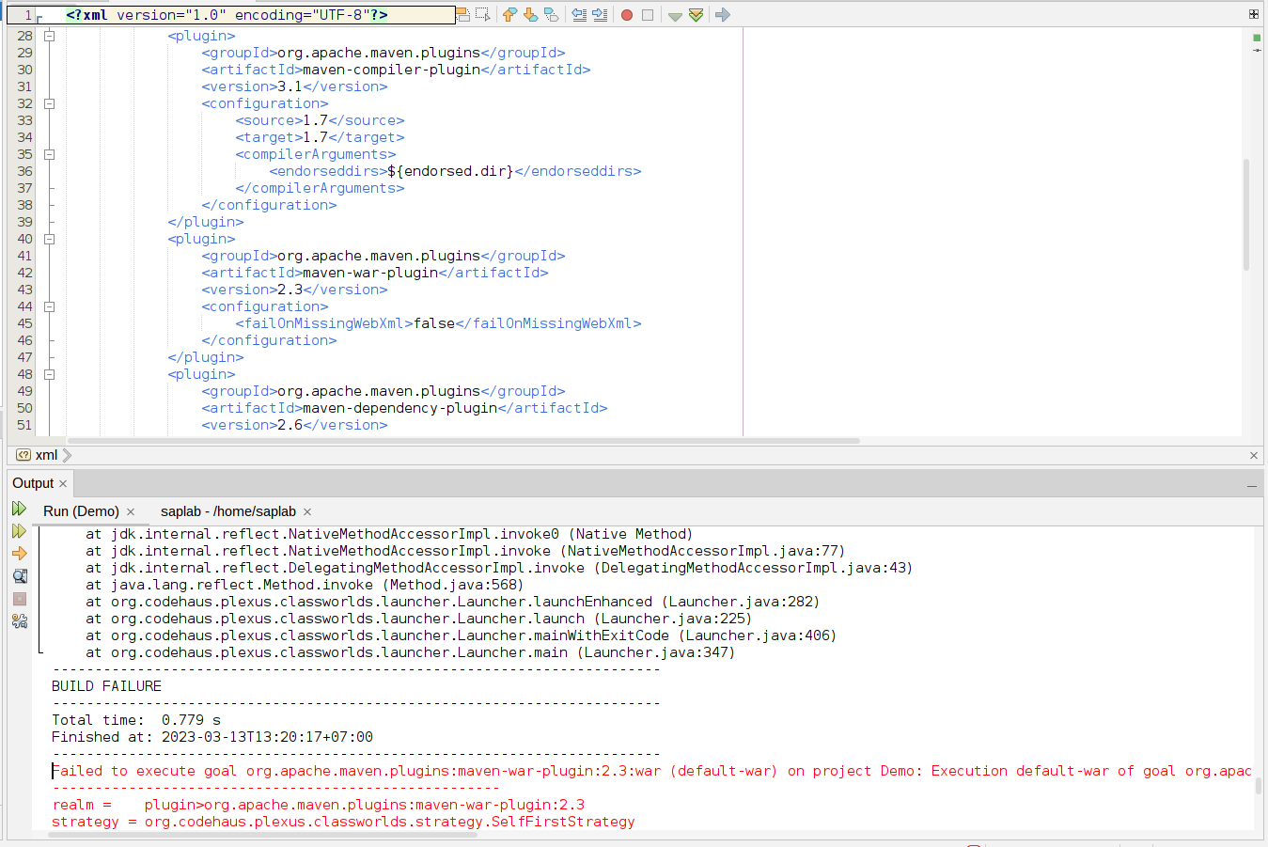

you need edit version of maven in file **pom.xml**

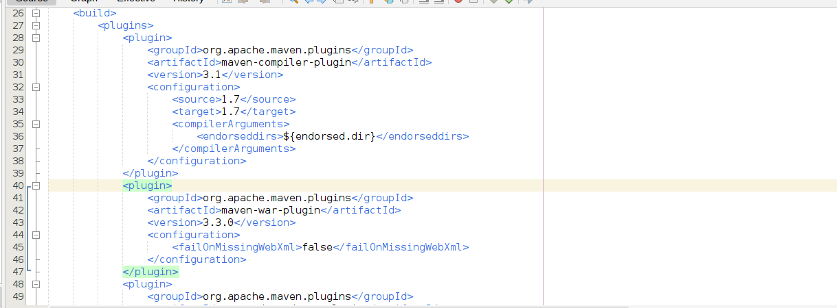

**Success!**