**Pet Health Monitoring System using AI**

By Aryan Kakran

**1. Problem Statement**

Many pet owners struggle with detecting early signs of health issues in their pets. Since pets cannot communicate discomfort directly, owners often miss subtle behavioural cues that indicate underlying health problems, leading to late diagnoses and more serious conditions. This problem is compounded in households where pets are left unattended for long periods, making continuous monitoring impossible. An AI-based pet health monitoring system aims to address this by using machine learning algorithms to analyze the pet's behaviour and identify potential health issues before they become severe.

**2. Market/Customer/Business Need Assessment**

The pet care industry is booming, with more people willing to spend on advanced technologies to care for their pets. According to the American Pet Products Association, the pet industry in the U.S. alone generated over $100 billion in 2022. Pet owners, particularly those with elderly pets or pets with chronic health conditions, are increasingly looking for technological solutions to monitor their pets' health and well-being. Small businesses like pet clinics, veterinary startups, and companies offering pet insurance would benefit from such a monitoring system to provide better services and reduce healthcare costs through early intervention.

**3. Target Specifications and Characterization**

* **Target Users**: Pet owners (especially those with senior or sick pets), veterinarians, pet insurance companies.
* **Pet Types**: Cats, dogs, rabbits, and other common household pets.
* **Customer Characteristics**: Primarily urban pet owners who have full-time jobs and cannot monitor their pets during the day, elderly owners who struggle with monitoring, and veterinarians looking for data-driven insights into pet health.

**4. External Search (online information sources/references/links)**

* Research articles on pet behaviour analysis using machine learning.
* Veterinary studies that focus on early diagnosis based on behavioral patterns.
* Competitive products like pet health wearables or behaviour analysis tools.

**5. Benchmarking Alternate Products (Comparison with Existing Products/Services)**

Several wearable devices, such as Whistle and Fit Bark , provide basic tracking for activity and sleep. However, they do not offer advanced predictive health monitoring through machine learning, limiting their functionality to tracking rather than proactive health management. Existing solutions mostly rely on tracking steps or location but do not integrate other behavioural metrics, nor do they predict potential health issues.

|  |  |  |  |
| --- | --- | --- | --- |
| Feature | AI-Powered Pet Health Monitoring | FitBark | Whistle |
| Activity Tracking | Yes | Yes | Yes |
| Health Issue Prediction | Yes | No | No |
| Real-Time Alerts | Yes | No | No |
| Monitoring Multiple Behaviors | Yes | No | No |

**6. Applicable Patents**

* Patent US20170000090A1: Pet Health Monitoring and Analysis.
* Patent WO2016171896A1: Intelligent pet monitoring system.
* Patent US9357921B2 : Wearable health monitoring system
* Frameworks like TensorFlow and PyTorch, commonly used in machine learning, are open-source, allowing for flexibility in development.

**7. Applicable Regulations**

* **Data Protection**: Must comply with local and international regulations regarding data privacy (e.g., GDPR) since sensitive data about pets and their owners will be collected and Analyzed.
* **Animal Welfare**: The product must comply with regulations ensuring that no harm or discomfort is caused to the pets during the data collection process (e.g., Animal Welfare Act).
* **Wearable Devices**: Compliance with electronics and wireless device regulations.

**8. Applicable Constraints**

* **Space**: The monitoring devices need to be lightweight and unobtrusive for the pet to wear comfortably.
* **Budget**: The solution must be affordable for average pet owners to adopt.
* **Expertise**: Developing machine learning models for behavioural analysis requires a team skilled in data science, veterinary medicine, and software development.

**9. Business Model (Monetization Idea)**

* **Subscription Model**: Offer a monthly subscription for continuous health monitoring and data analysis, with different pricing tiers based on features (e.g., basic activity monitoring vs. full health prediction).
* **Hardware Sales**: Sell the monitoring device (wearable collar) separately or bundled with the subscription.
* **Veterinary Partnerships**: Collaborate with veterinary clinics to provide them with insights into their clients’ pets, offering a B2B model for clinics.
* **Insurance Integration**: Partner with pet insurance companies, offering them predictive analytics to reduce claims through early interventions.

**10. Concept Generation**

The idea originated from the increasing demand for technology-driven pet care solutions and the limitations of existing wearable devices, which lack predictive health capabilities. The concept of monitoring various pet behaviours such as eating, sleeping, and activity levels, and using machine learning to predict potential health risks, fills a gap in the market.

**11. Concept Development**

The AI-based pet health monitoring system consists of a wearable collar equipped with sensors to track various pet behaviours (e.g., activity levels, sleep patterns, food intake). The data collected is sent to an AI system, which uses machine learning algorithms to Analyze the behaviour and predict potential health risks. Alerts are sent to the pet owner’s mobile app or veterinarian if any irregularities are detected, enabling early intervention.

**12. Final Product Prototype (Abstract) with Schematic Diagram**

Prototype Overview

* Wearable Device: A lightweight, sensor-equipped collar for pets.
* Mobile App: Real-time health insights and notifications sent to pet owners and veterinarians.
* Cloud-Based AI System: Analyze data using machine learning models to predict health risks.

**Schematic Diagram**

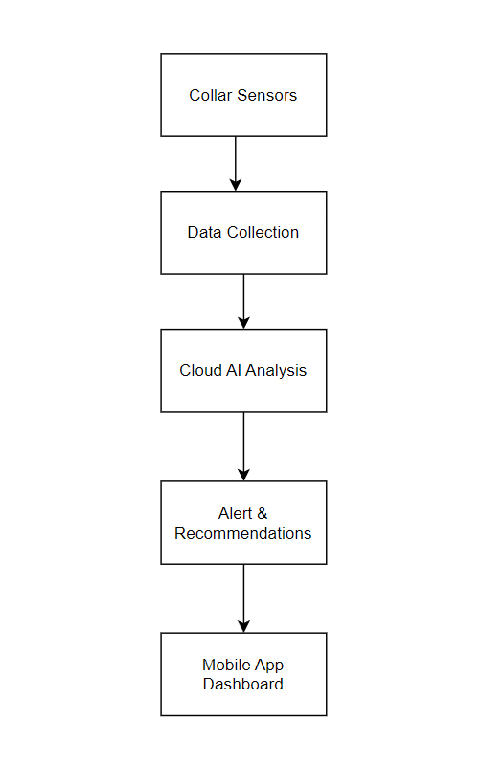

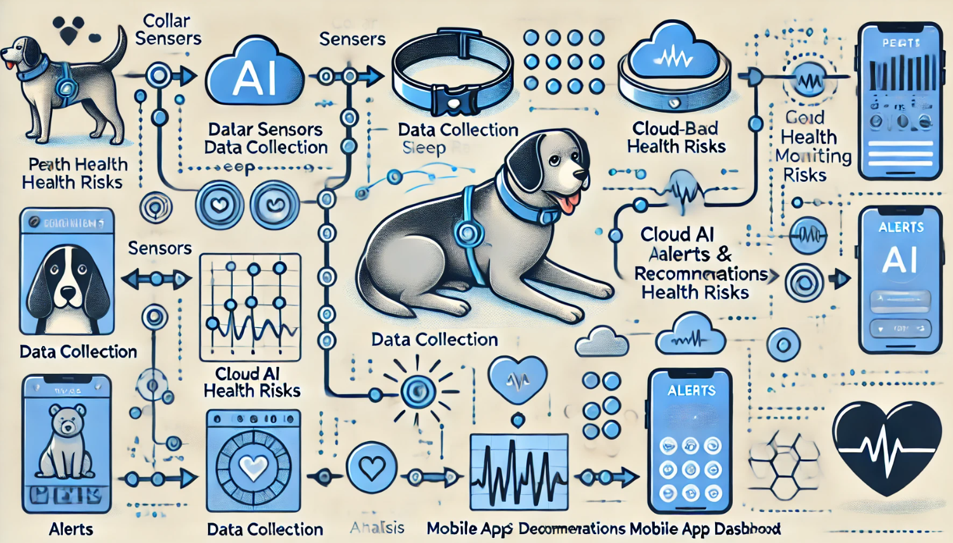

**13. Product Details**

The system collects behavioural data (e.g., sleep, activity, eating habits) using a wearable device and uploads it to a cloud server, where machine learning models analyze it. The AI predicts potential health issues and sends alerts to the owner or veterinarian.

**Data Sources**

Data is collected via sensors embedded in the collar, including accelerometers, temperature monitors, and heart rate sensors.

**Algorithms, Frameworks, Software**

Machine learning algorithms like Random Forest and LSTM (Long Short-Term Memory) will be used for predictive analysis. Python-based frameworks like TensorFlow, Keras, and scikit-learn will be leveraged.

**Team Required to Develop**

* Data Scientists
* Software Developers
* Veterinary Advisors
* Product Designers

**14. Conclusion**

The AI-based pet health monitoring system presents a unique solution for pet owners and veterinarians, offering real-time insights and predictive analytics to detect potential health problems early. By using machine learning to analyze pet behaviour, the system not only provides peace of mind for pet owners but also reduces the cost of healthcare through preventive care. With the growing interest in tech-driven pet care solutions, this product has significant market potential.

**15.Reference**

* <https://www.optisolbusiness.com/portfolio/ai-ml-based-pet-health-monitoring-system>
* <https://medium.com/@jam.canda/revolutionizing-pet-care-with-ai-smart-health-monitoring-systems-4e04eebb2b1b>
* Wearable health monitoring system

<https://patents.google.com/patent/US9357921B2/en>

* Wearable health monitoring system

<https://patents.google.com/patent/US9357921B2/en>

* Intelligent pet monitoring system

<https://patents.google.com/patent/WO2016171896A1/en>

* Pet Health Monitoring and Analysis

<https://patents.google.com/patent/US20170000090A1/en>

* <https://hastingsvet.com/early-health-issue-detection-tips-for-pet-owners-of-all-kinds/>