Additional points to be noted in the use of SAP2

- If Windows 2000 is used, instead of clicking on view results icon 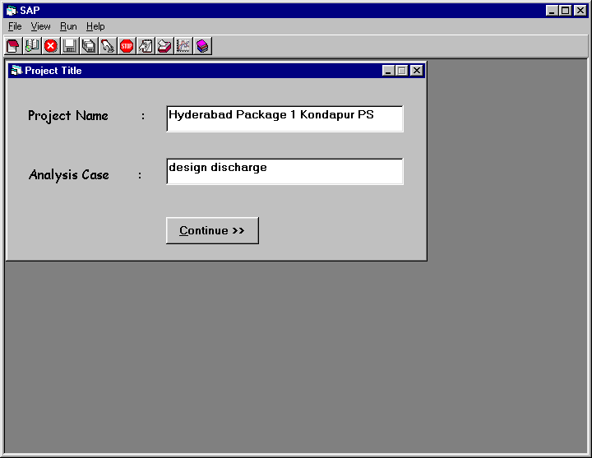 on menu, open c:\iisc\sap2.res file using notepad. And instead of clicking on view graph icon on the menu, directly open the sap2.xls file from the desk top. Thereafter, all the macros in sap2.xls will be available for the plots.

- The Type A project option is provided essentially to provide a transition for the users of the first version of SAP2. It is preferable to start using Type B project option early, as it provides considerable flexibility in using the software.

- In designing surge protection system, all the air valves should not be considered in surge analysis. The air valves may not function as ideal vacuum breakers and hence design based on air valves should be taken up with caution. In general, when design based on air valves alone is proposed, it may be necessary to verify that the surge picture will not be severe even if the air valves fail to function as vacuum breaker.

- Whenever the minimum head profile indicates pressures below –10 m over a stretch, water column separation analysis is necessary for determining the maximum head profile. Analysis must be repeated considering water column separation effect at different critical locations.

- When analysis is done with water column separation effect at one or two locations as allowed in SAP2, the minimum head profile has no relevance and hence the minimum head profile may be removed from the plot (prepared from macros with short cut key ctrl + g etc.) and only the maximum head profile may be retained for such cases.

