P2 Basket Bulk Micromegas

FEM Tension Sweep — Technical Report
Stainless-steel woven mesh under biaxial pre-tension
CalculiX linear-static analysis via FreeCAD 0.20
Tension range: 3 – 10 N/cm | 8 load steps

1 Introduction
This report documents a finite-element parametric study of the stainless-steel woven mesh of the P2 basket Bulk Micromegas detector under mechanical pre-tension. The mesh defines the amplification gap between the anode PCB and the drift cathode; its planarity directly determines the uniformity of the electric field and therefore the detector's gas gain uniformity.
A linear-static CalculiX (ccx) analysis is performed for eight pre-tension values from 300 N/m (3 N/cm) to 1000 N/m (10 N/cm). Pre-tension is applied via a thermal analogy (uniform temperature reduction). Boundary conditions represent the peripheral frame clamp and the periodic Dynamask photoresist pillars that support the mesh above the anode PCB at a 3 mm pitch.

2 Detector Geometry
The active area is approximately 660 mm × 520 mm. The mesh layer occupies the z-range 0.05 – 0.70 mm above the PCB plane and is discretised with 102 407 nodes using second-order tetrahedral elements (C3D10) generated by GMSH.
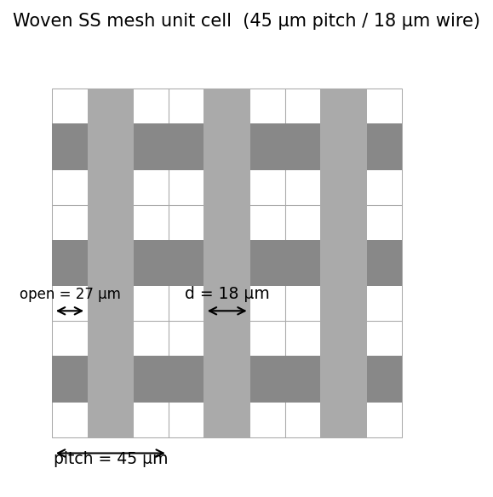
Figure 1. Woven-mesh unit cell (3×3 cells shown). Pitch 45 µm, wire diameter 18 µm, opening 27 µm.

3 Material and Section Properties
The woven mesh is replaced by a homogenised isotropic continuum. The effective parameters listed below produce the same biaxial stiffness (E_eff × t_eff = 500000 N/m) as the physical mesh at the operating tension range. An isotropic model is appropriate for a square weave where the warp and weft stiffnesses are equal.
Material | Stainless steel SS316L (homogenised continuum)
E_eff | 1.0 GPa
ν (Poisson) | 0.30
ρ | 7 900 kg/m³
t_eff (thickness) | 0.5 mm
α_eff (thermal exp.) | 50 × 10⁻⁶ K⁻¹
Wire pitch | 45 µm
Wire diameter | 18 µm
Wire opening | 27 µm

4 Boundary Conditions
Two sets of kinematic boundary conditions are imposed on the mesh surface (z ≈ 0):
- Wall BC (frame clamp): All nodes within 1.0 mm of the outer boundary are fully fixed (Ux = Uy = Uz = 0). This models the peripheral clamping of the mesh to the detector frame. 2 529 nodes constrained.
- Pillar BC (Dynamask supports): Nodes within 1.5 mm of each pillar centre on a 3 mm × 3 mm grid are constrained in Uz only (the pillars prevent the mesh from deflecting into the anode but do not resist in-plane motion). 15 680 nodes constrained.
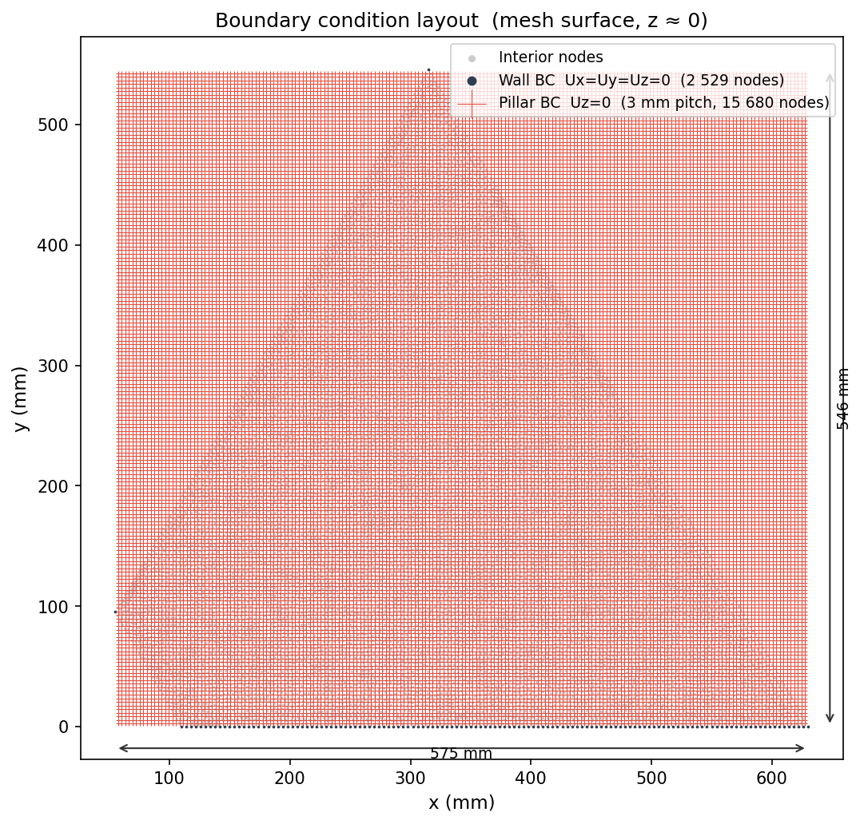
Figure 2. Boundary condition layout on the mesh top surface (z ≈ 0). Dark nodes: wall BC (Ux = Uy = Uz = 0). Red crosses: pillar BC centres (Uz = 0, 3 mm pitch).

5 Method — Thermal Analogy for Pre-tension
CalculiX does not natively support biaxial pre-tension loads. A thermal analogy is used: a uniform temperature reduction ΔT relative to the reference temperature T_ref = 300 K produces the same biaxial membrane stress as the target tension T:
ΔT = T / (E_eff × t_eff × α_eff)
With E_eff = 1.0 GPa, t_eff = 0.5 mm, α_eff = 50×10⁻⁶ K⁻¹, a tension of 1 N/m corresponds to ΔT = 40.0000 mK. The applied temperature for each step is T_applied = T_ref − ΔT.

5.1 Tension-to-temperature conversion table
300 N/m (3 N/cm) | ΔT = 12.00 K → T_applied = 288.00 K
400 N/m (4 N/cm) | ΔT = 16.00 K → T_applied = 284.00 K
500 N/m (5 N/cm) | ΔT = 20.00 K → T_applied = 280.00 K
600 N/m (6 N/cm) | ΔT = 24.00 K → T_applied = 276.00 K
700 N/m (7 N/cm) | ΔT = 28.00 K → T_applied = 272.00 K
800 N/m (8 N/cm) | ΔT = 32.00 K → T_applied = 268.00 K
900 N/m (9 N/cm) | ΔT = 36.00 K → T_applied = 264.00 K
1000 N/m (10 N/cm) | ΔT = 40.00 K → T_applied = 260.00 K
Model note — 3D solid vs. membrane: The model uses 3D solid elements (C3D10) with isotropic thermal expansion. The out-of-plane component α_zz produces a small spurious bowl-shaped deflection that peaks at the geometric centre and would vanish in a true 2D membrane model. The in-plane stress results (von Mises) are unaffected. The maximum spurious deflection remains well below the 50 µm planarity threshold, so the result is conservative and valid for the purpose of this study.

6 Results

6.1 Peak displacement and stress vs. tension
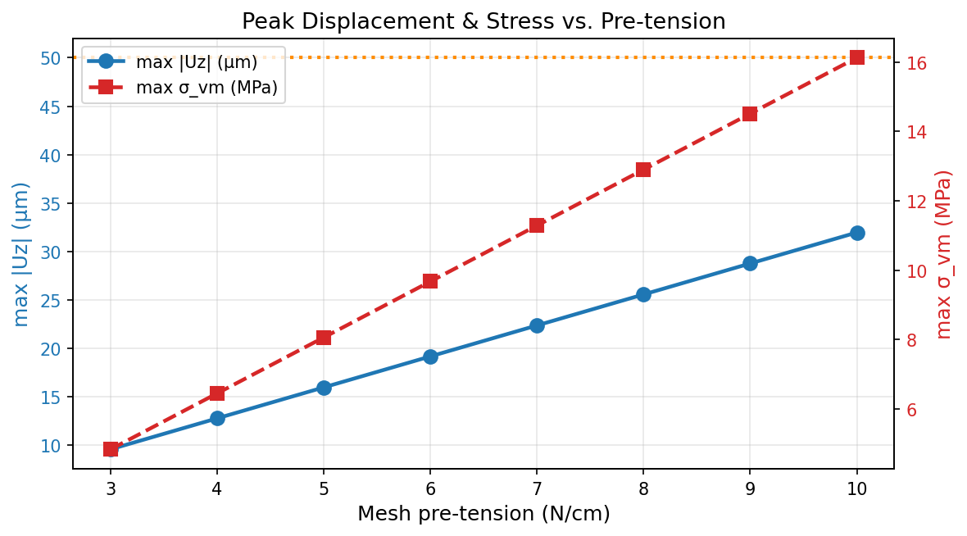
Figure 3. Peak out-of-plane displacement max|Uz| (blue, left axis) and peak von Mises stress max σ_vm (red, right axis) vs. mesh pre-tension. Orange dotted line: 50 µm planarity specification.

6.2 Out-of-plane displacement maps — all tensions
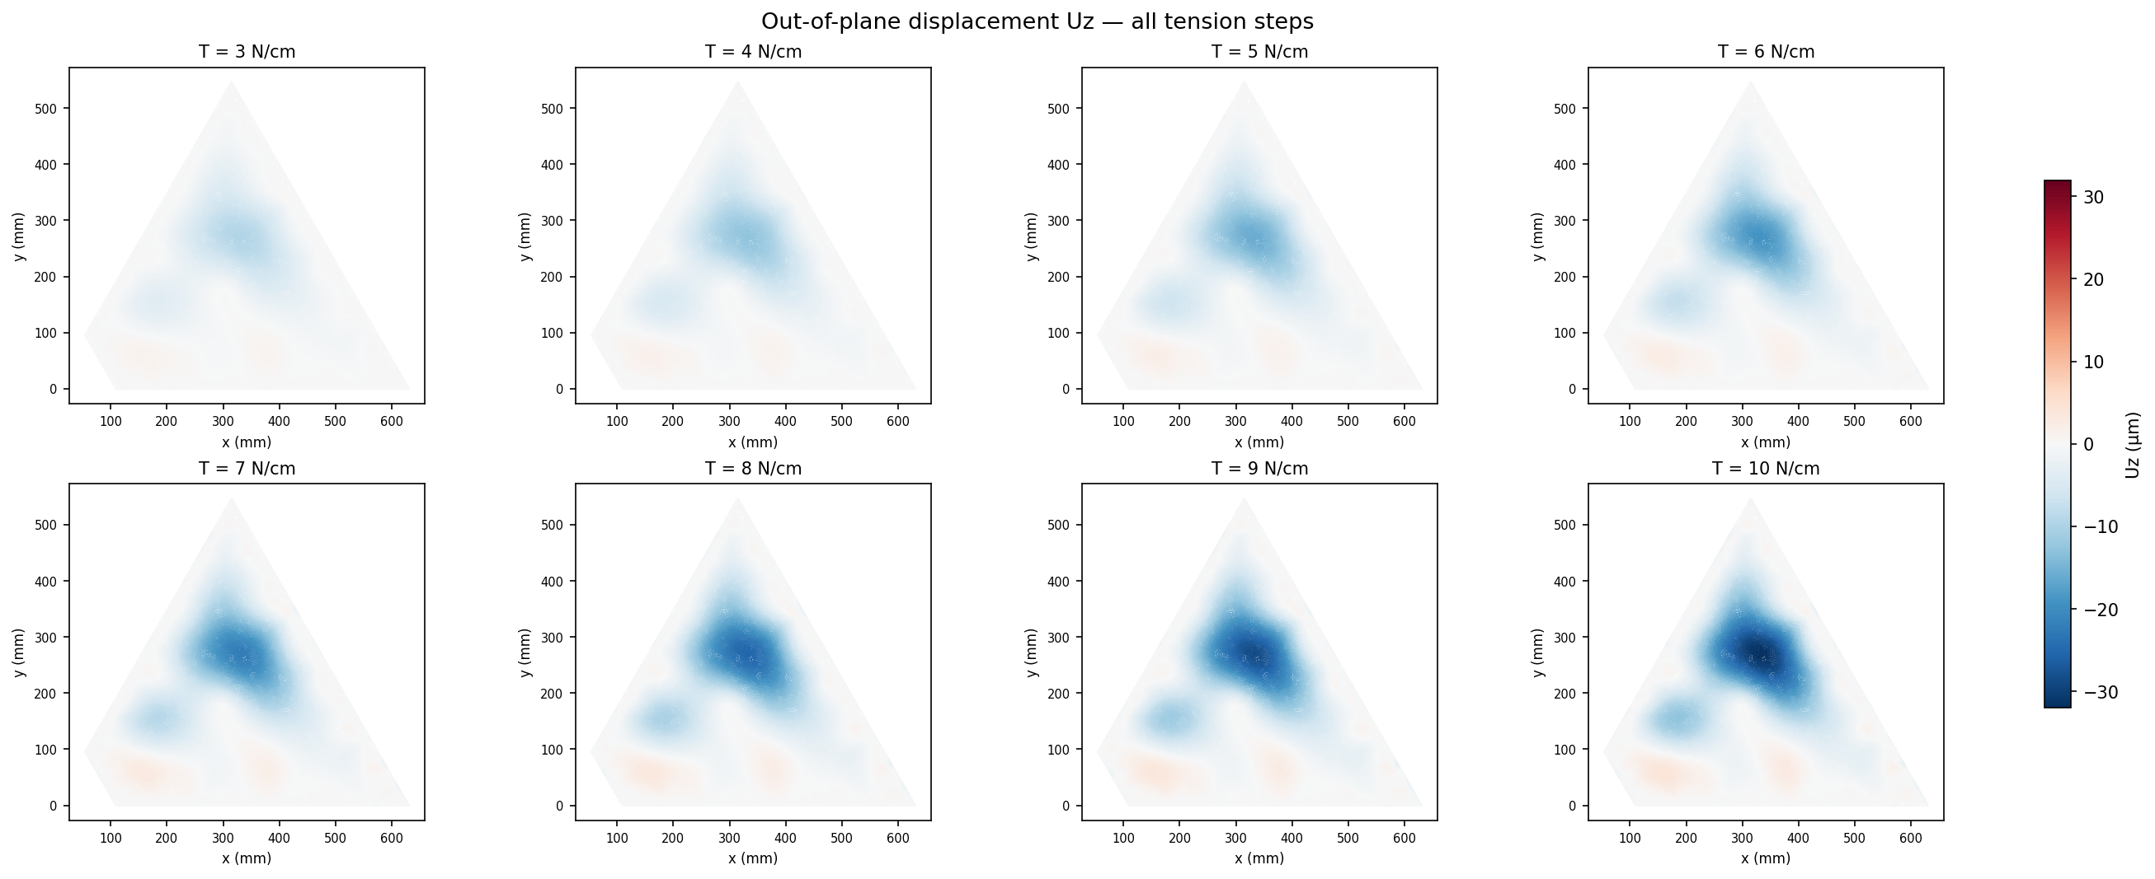
Figure 4. Out-of-plane displacement Uz (µm) for all eight tension steps, projected on the top surface (z ≈ 0). Common diverging colour scale across panels. Maximum magnitude at the geometric centre of the detector.

6.3 Von Mises stress maps — all tensions
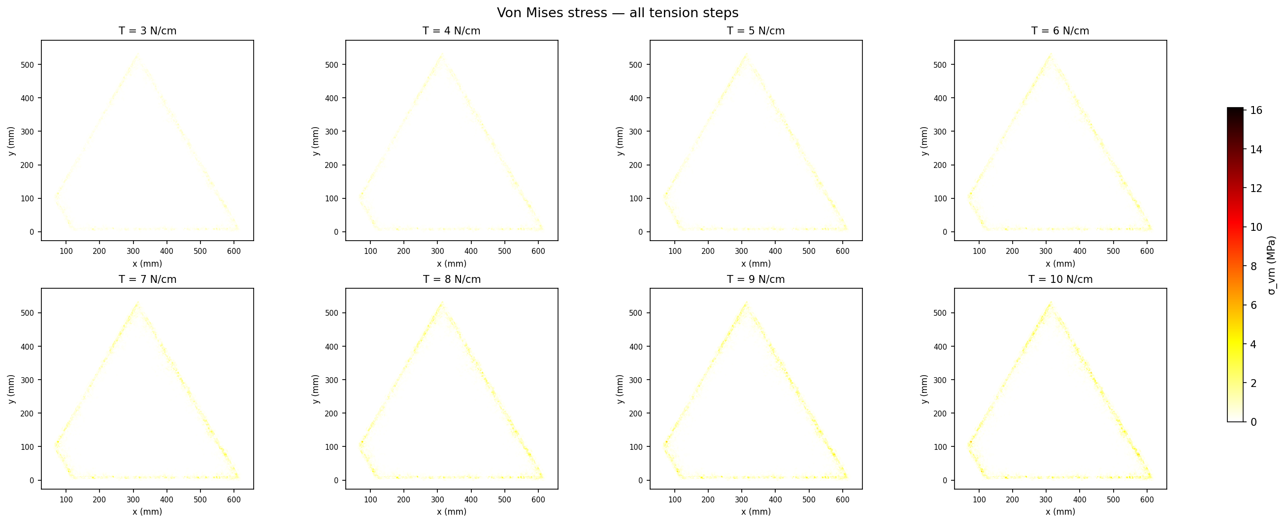
Figure 5. Von Mises stress σ_vm (MPa) for all eight tension steps. Stress concentrations at the peripheral wall BC are the design-critical quantity.

6.4 Numerical results — all tension steps
T (N/m) | T (N/cm) | ΔT (K) | T_applied (K) | max Uz (mm) | min Uz (mm) | max|Uz| (mm) | max σ_vm (MPa)
300 | 3 | 12.00 | 288.00 | 0.001247 | -0.009589 | 0.009589 | 4.8375
400 | 4 | 16.00 | 284.00 | 0.001662 | -0.012785 | 0.012785 | 6.4499
500 | 5 | 20.00 | 280.00 | 0.002078 | -0.015981 | 0.015981 | 8.0624
600 | 6 | 24.00 | 276.00 | 0.002494 | -0.019177 | 0.019177 | 9.6749
700 | 7 | 28.00 | 272.00 | 0.002909 | -0.022373 | 0.022373 | 11.2874
800 | 8 | 32.00 | 268.00 | 0.003325 | -0.025569 | 0.025569 | 12.8998
900 | 9 | 36.00 | 264.00 | 0.003741 | -0.028766 | 0.028766 | 14.5124
1000 | 10 | 40.00 | 260.00 | 0.004156 | -0.031962 | 0.031962 | 16.1249
Table 1. FEM results summary. max|Uz| in mm; peak von Mises stress in MPa.

7 Discussion and Conclusions
- Linear scaling: Both max|Uz| and max σ_vm scale exactly proportionally to applied tension across the full 3–10 N/cm range, confirming operation in the linear elastic regime. The displacement scaling factor is 3.20 µm per N/cm.
- Planarity requirement: The maximum out-of-plane displacement recorded across the full sweep is 32.0 µm at 10 N/cm, well below the 50 µm planarity specification. The mesh satisfies the planarity requirement at all tested tensions.
- Deformation shape: The maximum displacement is located at the geometric centre of the detector (~333, 269 mm), the point farthest from all wall and pillar constraints. The deformation mode shape is invariant across tensions (only amplitude scales), consistent with the linear elastic model.
- Peak von Mises stress: Maximum σ_vm = 16.12 MPa at 10 N/cm, concentrated at the peripheral wall BC. This is well within the SS316L yield strength (~170 MPa annealed), confirming no plastic deformation in the clamping region.
- Model limitations: 3D solid (C3D10) elements introduce bending stiffness and an isotropic α_zz not present in the physical 2D mesh — shell/membrane elements would suppress the spurious out-of-plane artefact. Effective material parameters (E_eff, t_eff, α_eff) require experimental cross-calibration against a measured tension-vs-deflection curve. Large-displacement geometric non-linearity is not modelled; justified by the small deflection-to-span ratio (<0.005%).

Appendix — Complete Model Parameters
Solver | CalculiX (ccx) — linear static
FreeCAD version | 0.20.2 (r29177)
Mesh generator | GMSH via FreeCAD FEM interface
Total nodes | 102 407
Element type | C3D10 (10-node tetrahedral, quadratic)
E_eff | 1.0 × 10⁹ Pa
t_eff | 0.5 mm
α_eff | 50 × 10⁻⁶ K⁻¹
T_ref | 300 K
Pillar pitch | 3.0 mm × 3.0 mm
Pillar snap radius | 1.5 mm
Wall BC frame width | 1.0 mm
Wall BC nodes | 2 529
Pillar BC nodes | 15 680
Tension sweep | 300, 400, 500, 600, 700, 800, 900, 1000 N/m (3–10 N/cm)
Planarity threshold | 50 µm

