Week 2: Dynamic and Informative Visualizations using R
Entry-Level Internship Submission | Titanic Passenger Dataset

1. Objective
The objective of this task was to communicate meaningful insights from a public dataset using multiple types of visualizations in R. The focus was on selecting suitable graph types, explaining why each visualization was used, and presenting findings in a way that a non-technical audience can understand.

2. Dataset Overview
The Titanic passenger dataset was continued from Week 1 to maintain a consistent analytical workflow. The dataset contains 891 passenger records and variables including survival outcome, passenger class, sex, age, number of siblings/spouses, number of parents/children, fare, and port of embarkation. Before visualization, the same basic cleaning approach from Week 1 was applied: the Cabin column was removed because most values were missing, missing Age values were replaced with the median, and missing Embarked values were replaced with the most frequent category.

3. Visualization Strategy
Different chart types were selected because each answers a different question. Histograms were used to study distributions, boxplots to identify unusual values, bar charts to compare categories, scatter plots to examine relationships between two numerical variables, line charts to show changes across ordered groups, and a correlation matrix to summarize numerical relationships.

4. Visualization 1: Age Distribution
ggplot(data, aes(x = Age)) +
geom_histogram(binwidth = 5) +
labs(title = "Distribution of Passenger Age", x = "Age", y = "Number of Passengers")
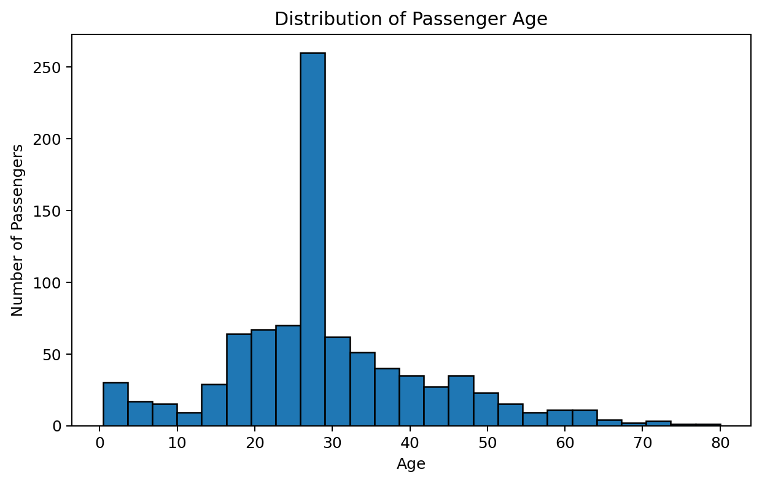
A histogram was selected because Age is a numerical variable and the graph makes it easy to see where passenger ages are concentrated. The distribution shows that the dataset contains many young adults, while the number of passengers decreases at higher ages. This visualization provides useful context before comparing age with other variables.

5. Visualization 2: Fare Distribution and Potential Outliers
ggplot(data, aes(y = Fare)) +
geom_boxplot() +
labs(title = "Distribution and Potential Outliers in Fare", y = "Fare")
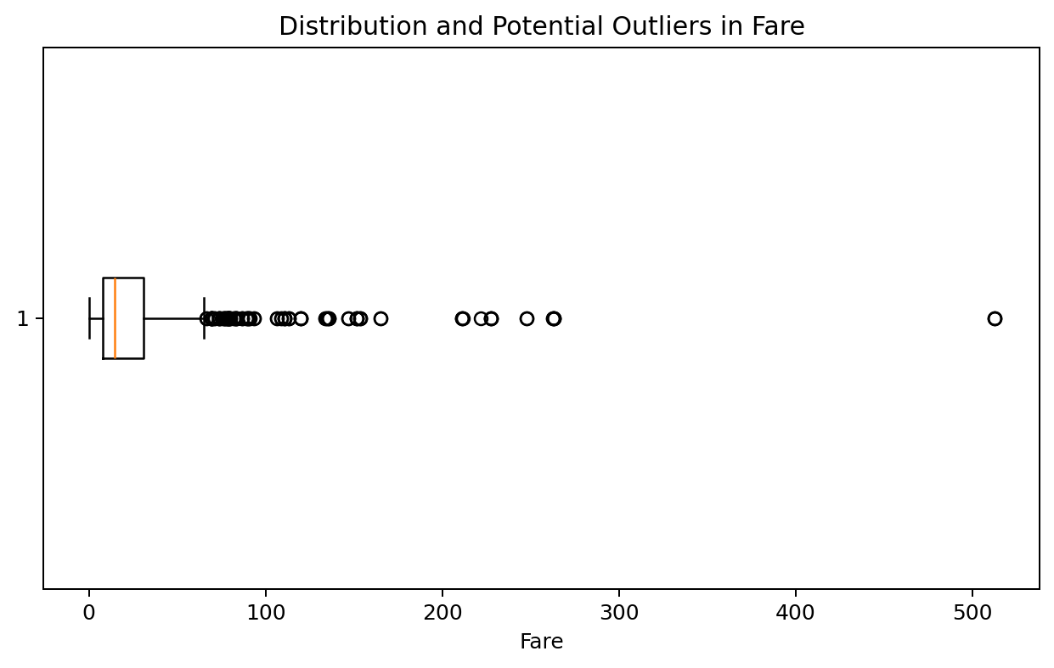
A boxplot was chosen because it clearly displays the median, spread, and unusually high observations. The plot shows a strongly right-skewed distribution with several high fares. These values were not automatically removed because they may represent genuine first-class ticket prices rather than errors.

6. Visualization 3: Survival Rate by Sex
sex_summary <- aggregate(Survived ~ Sex, data = data, mean)
sex_summary$SurvivalRate <- sex_summary$Survived * 100
ggplot(sex_summary, aes(x = Sex, y = SurvivalRate)) +
geom_col() + labs(title = "Survival Rate by Sex")
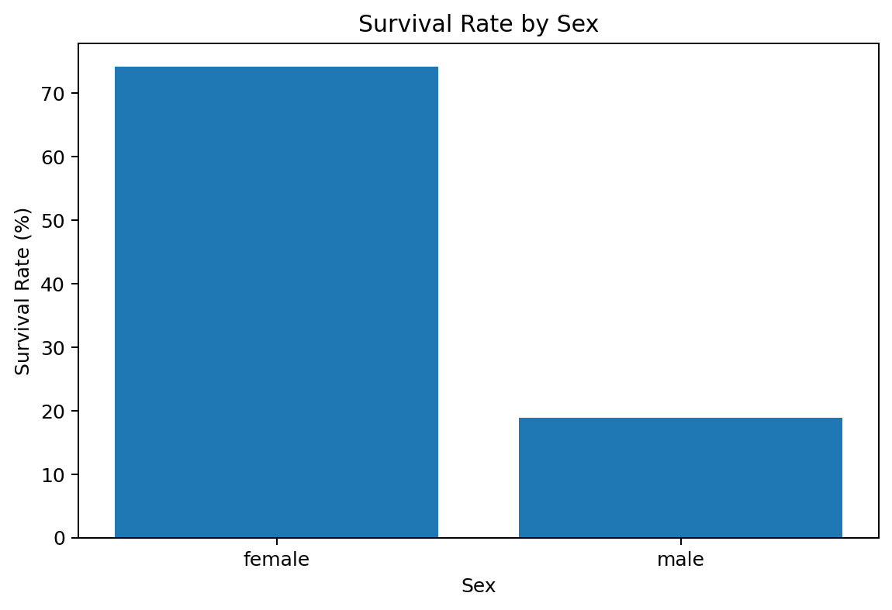
A bar chart was appropriate because Sex is categorical and the purpose is to compare two groups. The observed survival rate was approximately 74.2% for female passengers and 18.9% for male passengers. The large difference makes sex one of the most visually important variables associated with survival.

7. Visualization 4: Survival Rate by Passenger Class
class_summary <- aggregate(Survived ~ Pclass, data = data, mean)
class_summary$SurvivalRate <- class_summary$Survived * 100
ggplot(class_summary, aes(x = factor(Pclass), y = SurvivalRate)) +
geom_col() + labs(title = "Survival Rate by Passenger Class")
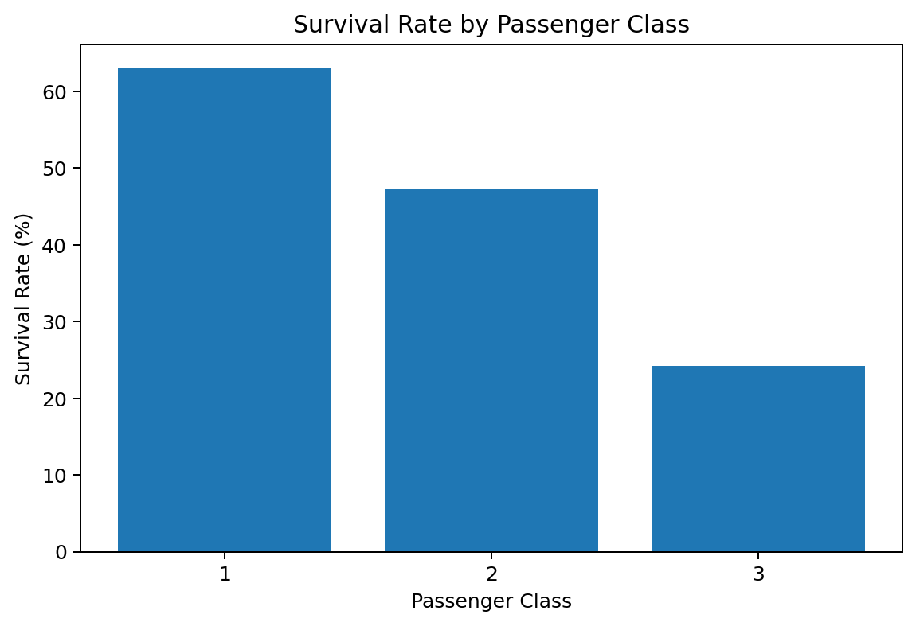
The bar chart compares the three passenger classes. First class had the highest observed survival rate (63.0%), followed by second class (47.3%) and third class (24.2%). This pattern suggests that passenger class was associated with the likelihood of survival.

8. Visualization 5: Age and Fare by Survival Outcome
ggplot(data, aes(x = Age, y = Fare, color = factor(Survived))) +
geom_point(alpha = 0.6) +
labs(title = "Age and Fare by Survival Outcome", color = "Survived")
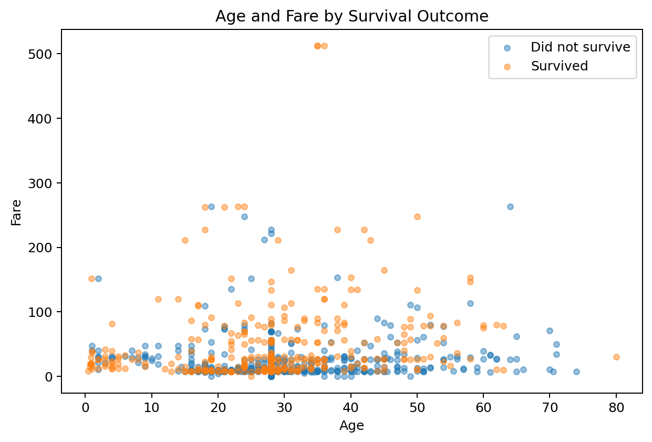
A scatter plot was selected to examine the joint relationship between two numerical variables, Age and Fare, while using color to represent survival outcome. The plot shows substantial overlap between the two outcomes, meaning that Age and Fare alone do not perfectly separate survivors from non-survivors. However, the graph helps reveal clusters and extreme fare values.

9. Visualization 6: Survival Rate Across Age Groups
data$AgeGroup <- cut(data$Age, breaks = c(0,12,18,30,45,60,80), include.lowest = TRUE)
age_summary <- aggregate(Survived ~ AgeGroup, data = data, mean)
age_summary$SurvivalRate <- age_summary$Survived * 100
ggplot(age_summary, aes(x = AgeGroup, y = SurvivalRate, group = 1)) +
geom_line() + geom_point()
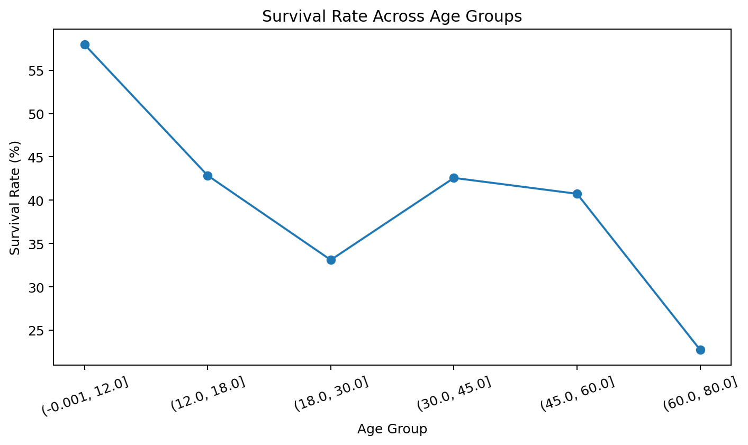
A line chart was used after converting the continuous Age variable into ordered age groups. This makes it easier to compare how survival changes across age ranges. The chart is descriptive rather than proof of causation, but it provides a simple view of differences across groups.

10. Visualization 7: Correlation Matrix
numeric_data <- data[, c("Survived","Pclass","Age","SibSp","Parch","Fare")]
cor_matrix <- cor(numeric_data)
round(cor_matrix, 2)
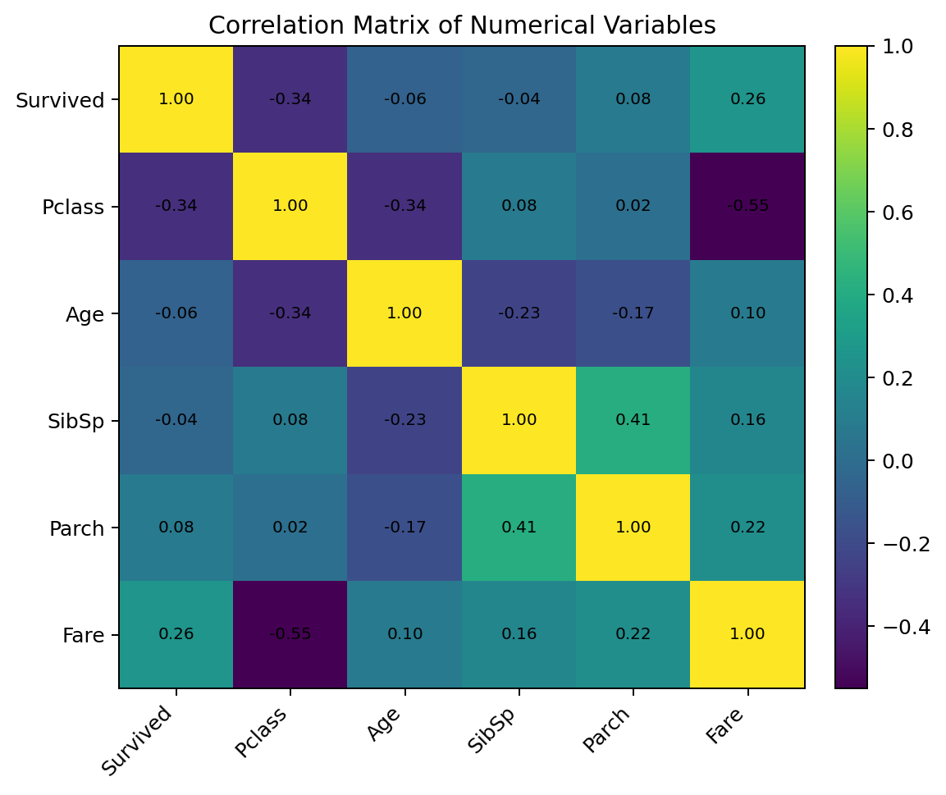
The correlation matrix summarizes linear relationships among selected numerical variables. It is useful for quickly identifying positive and negative associations. In this dataset, Pclass shows a negative association with Fare and survival because the class numbering runs from 1 for first class to 3 for third class. Correlation was used as an exploratory tool and does not establish causation.

11. Key Insights
- The passenger population contained a large concentration of young adults.
- Fare had a right-skewed distribution with several high but potentially valid observations.
- Female passengers had a substantially higher observed survival rate (74.2%) than male passengers (18.9%).
- First-class passengers had the highest observed survival rate (63.0%), while third-class passengers had the lowest (24.2%).
- Age and Fare provided useful descriptive information, but neither variable alone was sufficient to clearly predict survival.
- Using multiple visualization types gave a broader understanding than relying on a single graph.

12. Conclusion
This task demonstrated how visualization can turn a cleaned dataset into an understandable analytical story. Multiple chart types were used because each was selected for a specific purpose. The strongest descriptive patterns were related to sex and passenger class, while the distribution charts helped identify the shape of Age and Fare. The visual findings also provide a foundation for the statistical testing and predictive modeling performed in Week 3.

13. Complete R Code
# Week 2: Dynamic and Informative Visualizations using R
# Dataset: Titanic passenger dataset
library(ggplot2)
data <- read.csv("titanic.csv", stringsAsFactors = FALSE)
# Basic cleaning to make the dataset ready for visualization
data$Cabin <- NULL
data$Age[is.na(data$Age)] <- median(data$Age, na.rm = TRUE)
mode_embarked <- names(sort(table(data$Embarked), decreasing = TRUE))[1]
data$Embarked[is.na(data$Embarked)] <- mode_embarked
data$Sex <- as.factor(data$Sex)
data$Embarked <- as.factor(data$Embarked)
# 1. Histogram: Age distribution
ggplot(data, aes(x = Age)) +
geom_histogram(binwidth = 5, fill = "steelblue", color = "white") +
labs(title = "Distribution of Passenger Age",
x = "Age", y = "Number of Passengers")
# 2. Boxplot: Fare distribution
ggplot(data, aes(y = Fare)) +
geom_boxplot(fill = "orange") +
labs(title = "Distribution and Potential Outliers in Fare", y = "Fare")
# 3. Bar chart: Survival rate by sex
sex_summary <- aggregate(Survived ~ Sex, data = data, mean)
sex_summary$SurvivalRate <- sex_summary$Survived * 100
ggplot(sex_summary, aes(x = Sex, y = SurvivalRate, fill = Sex)) +
geom_col() +
labs(title = "Survival Rate by Sex", y = "Survival Rate (%)")
# 4. Bar chart: Survival rate by passenger class
class_summary <- aggregate(Survived ~ Pclass, data = data, mean)
class_summary$SurvivalRate <- class_summary$Survived * 100
ggplot(class_summary, aes(x = factor(Pclass), y = SurvivalRate,
fill = factor(Pclass))) +
geom_col() +
labs(title = "Survival Rate by Passenger Class",
x = "Passenger Class", y = "Survival Rate (%)")
# 5. Scatter plot: Age vs Fare
ggplot(data, aes(x = Age, y = Fare, color = factor(Survived))) +
geom_point(alpha = 0.6) +
labs(title = "Age and Fare by Survival Outcome",
color = "Survived")
# 6. Line chart: Survival rate by age group
data$AgeGroup <- cut(data$Age,
breaks = c(0, 12, 18, 30, 45, 60, 80),
include.lowest = TRUE)
age_summary <- aggregate(Survived ~ AgeGroup, data = data, mean)
age_summary$SurvivalRate <- age_summary$Survived * 100
ggplot(age_summary, aes(x = AgeGroup, y = SurvivalRate, group = 1)) +
geom_line() +
geom_point() +
labs(title = "Survival Rate Across Age Groups",
x = "Age Group", y = "Survival Rate (%)") +
theme(axis.text.x = element_text(angle = 25, hjust = 1))
# 7. Correlation matrix (base R)
numeric_data <- data[, c("Survived","Pclass","Age","SibSp","Parch","Fare")]
cor_matrix <- cor(numeric_data)
round(cor_matrix, 2)

References
Data Science Dojo. Titanic dataset: https://github.com/datasciencedojo/datasets/blob/master/titanic.csv

