Week 3: Statistical Analysis and Predictive Modeling using R
Entry-Level Internship Submission | Titanic Passenger Dataset

1. Objective
The objective of this task was to move beyond descriptive analysis and apply statistical testing and predictive modeling. The analysis used the Titanic dataset to test selected hypotheses, examine assumptions and relationships, build a classification model, and evaluate its predictive performance.

2. Dataset Identification and Rationale
The Titanic dataset was selected because the target variable, Survived, has two possible outcomes: survived (1) or did not survive (0). This makes the dataset suitable for a binary classification model. It also contains a useful combination of numerical and categorical predictor variables. The cleaned version from Week 1 was used so that the workflow remained consistent across the internship tasks.

3. Hypothesis Testing
A Welch two-sample t-test was used to compare the mean Fare paid by survivors and non-survivors.
# H0: Mean fare is the same for survivors and non-survivors.
# H1: Mean fare is different for survivors and non-survivors.
t.test(Fare ~ Survived, data = data)
Using the cleaned dataset, the test produced a very small p-value (p = 2.7e-11). At a 5% significance level, the null hypothesis would be rejected. The result indicates a statistically significant difference in the mean Fare between the two survival groups. This does not mean that Fare alone caused survival; Fare may also be related to passenger class and other factors.

4. Distribution and Assumption Check
set.seed(42)
shapiro.test(sample(data$Age, 500))
A Shapiro-Wilk test was performed on a reproducible sample of 500 Age observations. The result was W = 0.953, p = 1.43e-11. The purpose was to check whether the age data closely followed a normal distribution. For large real-world datasets, statistical tests can be sensitive to small deviations, so the distribution should also be interpreted using visual inspection rather than relying on a single test.

5. Correlation Analysis
numeric_data <- data[, c("Age","Fare","SibSp","Parch","Pclass")]
cor(numeric_data, method = "spearman")
The Spearman correlation between Age and Fare was 0.126 (p = 0.000163). This indicates a weak monotonic relationship. Spearman correlation was useful because Fare is strongly skewed and contains high values.

6. Predictive Model Selection
A logistic regression model was selected because the target variable, Survived, is binary. Logistic regression estimates the probability that a passenger belongs to the survival class based on predictor variables.
model <- glm(Survived ~ Pclass + Sex + Age + SibSp + Parch + Fare + Embarked,
data = train_data, family = binomial)
The predictors were passenger class, sex, age, family-related variables, fare, and embarkation port. The data was split into 80% training data and 20% testing data using a fixed random seed for reproducibility. The split was stratified so that the survival proportion remained similar across the two sets.

7. Model Evaluation
Metric | Test-set Result
Accuracy | 0.804
Precision | 0.793
Recall | 0.667
F1-score | 0.724
ROC-AUC | 0.845
The 5-fold cross-validation accuracy scores had a mean of 0.794 with a standard deviation of 0.017. Cross-validation was included to check whether the model's performance was reasonably stable across different subsets of the dataset.

8. Confusion Matrix
prob <- predict(model, test_data, type = "response")
pred_class <- ifelse(prob >= 0.5, 1, 0)
confusionMatrix(as.factor(pred_class), test_data$Survived)
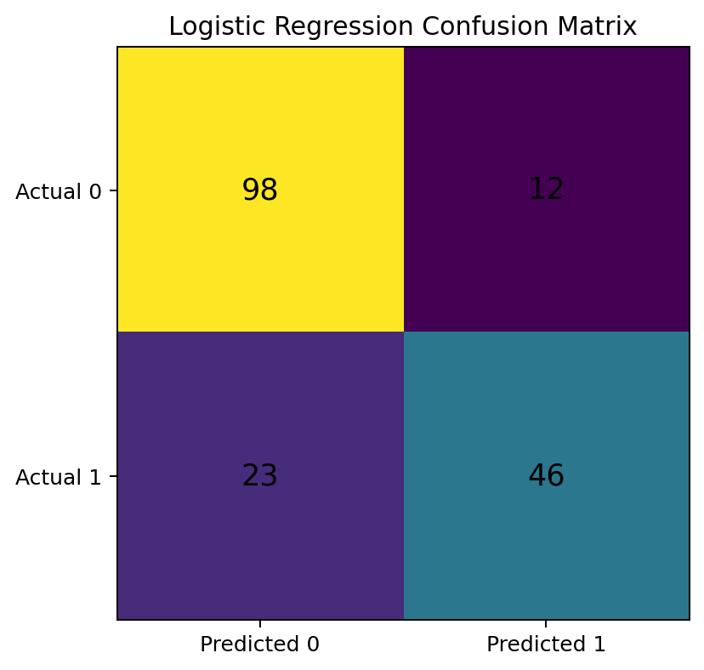
The confusion matrix shows 98 true negatives, 12 false positives, 23 false negatives, and 46 true positives. Accuracy alone was not treated as sufficient, so precision, recall, F1-score, and ROC-AUC were also reported.

9. ROC Curve and AUC
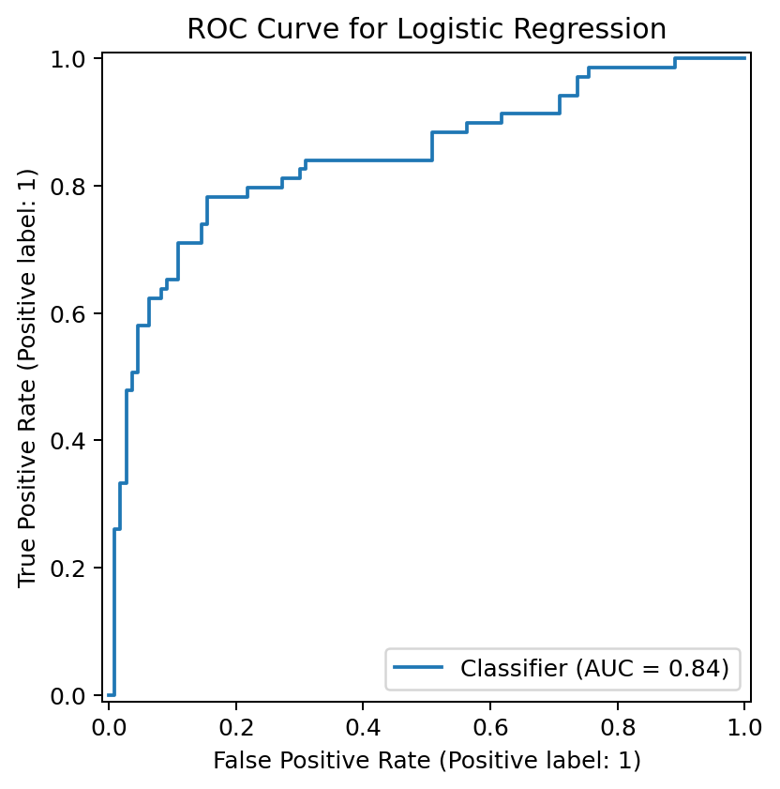
The ROC curve evaluates the model across different classification thresholds. The test-set ROC-AUC was 0.845. A value closer to 1 indicates better discrimination, while 0.5 would indicate performance close to random classification.

10. Predicted Probability Distribution
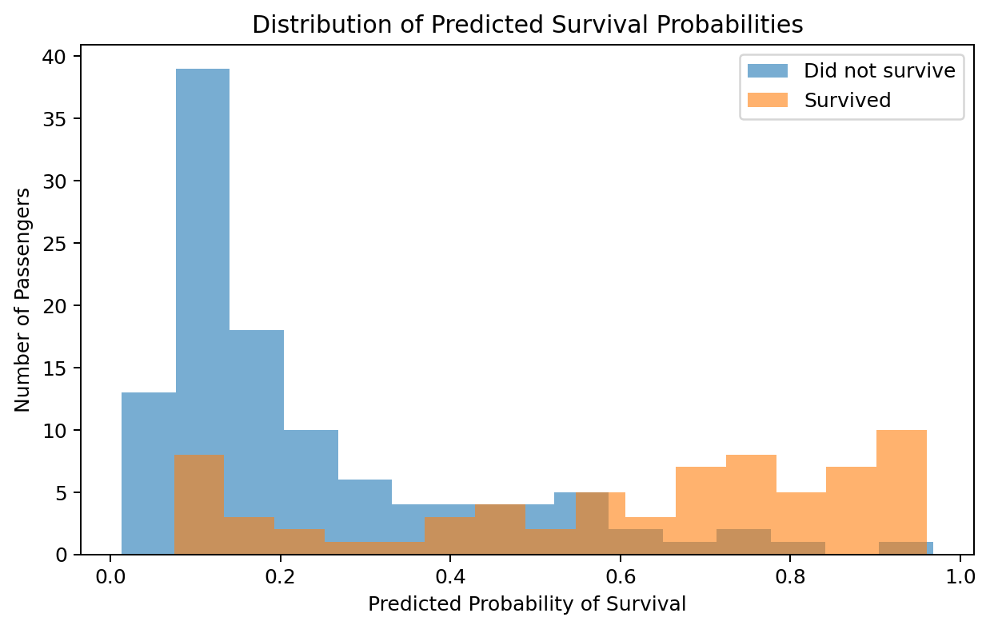
This chart shows how the model assigned survival probabilities to the two actual outcome groups. Some overlap remains, which is expected because the available variables do not completely explain the survival outcome.

11. Model Diagnostics and Interpretation
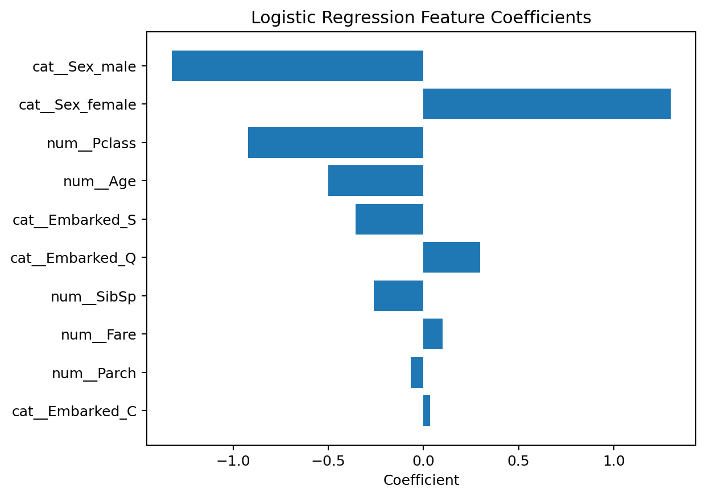
The coefficient chart provides a high-level view of the direction and relative strength of the transformed model features. Positive and negative coefficients should be interpreted in relation to the reference categories and the other variables in the model. The results support the earlier exploratory finding that variables such as sex and passenger class contain useful predictive information.

12. Model Strengths
- The target variable was appropriate for binary classification.
- Both numerical and categorical predictors were included.
- The data was evaluated using a separate test set.
- Multiple performance metrics were reported instead of accuracy alone.
- 5-fold cross-validation was used to check model stability.
- ROC-AUC and a confusion matrix provided additional diagnostic information.

13. Potential Improvements
- Engineer additional features such as title extracted from passenger names or family size.
- Investigate interaction effects, such as sex combined with passenger class.
- Compare logistic regression with decision trees, random forests, or gradient boosting.
- Perform hyperparameter tuning for alternative models.
- Use additional diagnostics and calibration analysis.
- Validate the final approach on an independent dataset if available.

14. Conclusion
The Week 3 analysis demonstrated a complete entry-level predictive analytics workflow: preparing the dataset, testing a hypothesis, checking distributional assumptions, exploring correlations, splitting the data, building a logistic regression model, applying cross-validation, and evaluating performance. The model achieved useful predictive performance but was not perfect, which is realistic for a small historical dataset. The analysis also showed the importance of combining statistical evidence with practical interpretation.

15. Complete R Code
# Week 3: Statistical Analysis and Predictive Modeling using R
# Dataset: Titanic passenger dataset
# Install packages if required:
# install.packages(c("caret", "pROC"))
library(caret)
library(pROC)
data <- read.csv("titanic.csv", stringsAsFactors = FALSE)
# Data preparation
data$Cabin <- NULL
data$Age[is.na(data$Age)] <- median(data$Age, na.rm = TRUE)
mode_embarked <- names(sort(table(data$Embarked), decreasing = TRUE))[1]
data$Embarked[is.na(data$Embarked)] <- mode_embarked
data$Sex <- as.factor(data$Sex)
data$Embarked <- as.factor(data$Embarked)
data$Survived <- as.factor(data$Survived)
# 1. Hypothesis test
# H0: Mean fare is the same for survivors and non-survivors.
# H1: Mean fare is different for survivors and non-survivors.
t.test(Fare ~ Survived, data = data)
# 2. Normality check
shapiro.test(sample(data$Age, 500))
# 3. Correlation
numeric_data <- data[, c("Age","Fare","SibSp","Parch","Pclass")]
cor(numeric_data, method = "spearman")
# 4. Train/test split
set.seed(42)
index <- createDataPartition(data$Survived, p = 0.80, list = FALSE)
train_data <- data[index, ]
test_data <- data[-index, ]
# 5. Logistic regression model
model <- glm(Survived ~ Pclass + Sex + Age + SibSp + Parch + Fare + Embarked,
data = train_data, family = binomial)
summary(model)
# 6. Predicted probabilities and classes
prob <- predict(model, test_data, type = "response")
pred_class <- ifelse(prob >= 0.5, 1, 0)
pred_class <- as.factor(pred_class)
# 7. Confusion matrix
confusionMatrix(pred_class, test_data$Survived)
# 8. ROC and AUC
roc_obj <- roc(as.numeric(as.character(test_data$Survived)), prob)
plot(roc_obj)
auc(roc_obj)
# 9. 5-fold cross-validation
control <- trainControl(method = "cv", number = 5)
cv_model <- train(Survived ~ Pclass + Sex + Age + SibSp + Parch + Fare + Embarked,
data = data, method = "glm", family = "binomial",
trControl = control)
cv_model

References
Data Science Dojo. Titanic dataset: https://github.com/datasciencedojo/datasets/blob/master/titanic.csv

