Week 4: Comprehensive Data Analysis Reporting and Presentation
Final Integrated Report | Titanic Passenger Dataset

Executive Summary
This final report integrates the data cleaning, visualization, statistical analysis, and predictive modeling work completed across the previous three weeks. The analysis used the Titanic passenger dataset as a consistent case study. The overall objective was to demonstrate an end-to-end data analysis workflow in R: starting with raw data, improving data quality, exploring patterns visually, testing statistical relationships, and developing a predictive model. The final findings show clear descriptive differences in survival by sex and passenger class, while the predictive model demonstrates that combining multiple variables can produce useful survival predictions.

1. Introduction
Data analysis is most useful when technical processing and business interpretation are connected. A dataset may contain valuable information, but missing values, inconsistent formats, unsuitable scales, and poorly chosen visualizations can reduce the quality of the conclusions. This project therefore followed a step-by-step workflow from data preparation to communication of findings.

2. Dataset and Analytical Scope
The analysis used the publicly available Titanic passenger dataset containing 891 records and 12 original variables. Important variables included Survived, Pclass, Sex, Age, SibSp, Parch, Fare, and Embarked. The dataset was suitable because it contains a mixture of numerical and categorical data and also includes missing values. The same dataset was used throughout all four weeks so that the work developed progressively rather than treating each task as an unrelated exercise.

3. Data Preparation and Cleaning (Week 1)
The first stage focused on understanding the raw data and preparing it for analysis. Functions such as str(), summary(), dim(), and missing-value checks were used to inspect the dataset. The Age variable contained 177 missing values, Cabin contained 687 missing values, and Embarked contained 2 missing values.
- Cabin was removed because approximately 77% of the values were missing.
- Missing Age values were replaced with the median age.
- Missing Embarked values were replaced with the most frequent category.
- Duplicate rows were checked as a standard data-quality step.
- Potential Fare outliers were identified using the IQR method and retained when they appeared to be valid observations.
- Age and Fare were demonstrated using min-max normalization.
- Categorical variables were converted to factors for analysis.
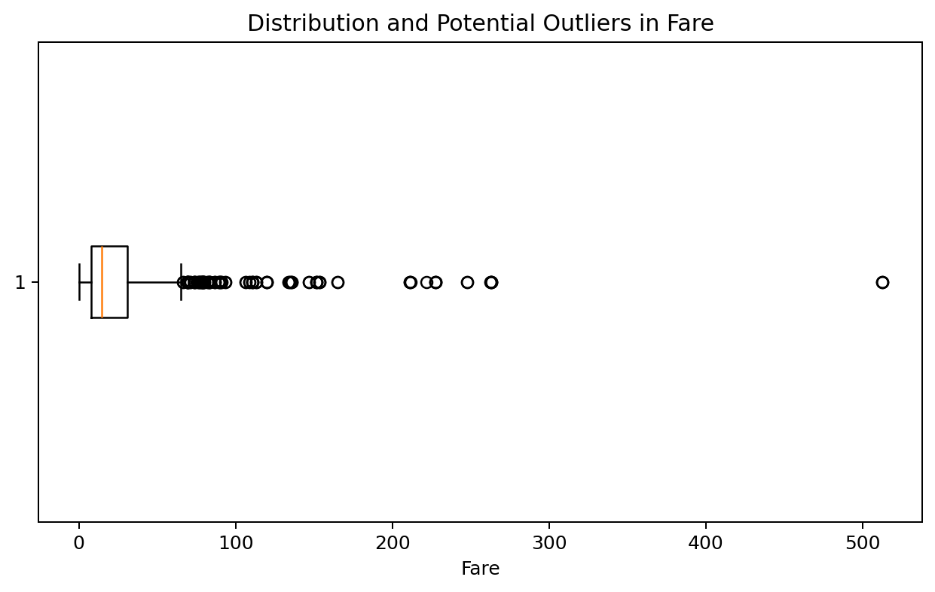
The Fare boxplot illustrates why outlier detection requires judgment. Several high values were identified, but removing them automatically would have discarded potentially genuine first-class fares. This was an important lesson: data cleaning should improve quality without unnecessarily deleting meaningful variation.

4. Exploratory Visualization (Week 2)
The second stage used multiple visualization types to communicate patterns to both technical and non-technical audiences. A histogram was used for Age, a boxplot for Fare, bar charts for categorical comparisons, a scatter plot for Age and Fare, a line chart for ordered age groups, and a correlation matrix for numerical relationships.
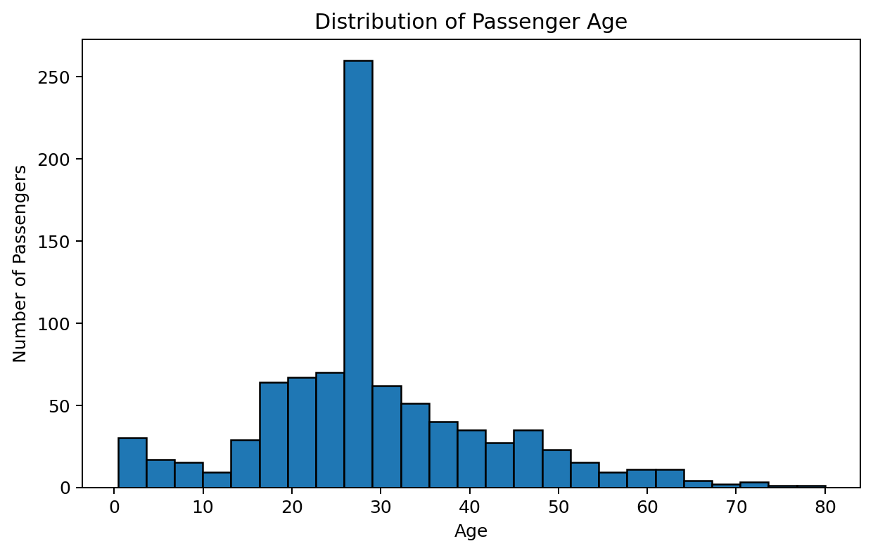
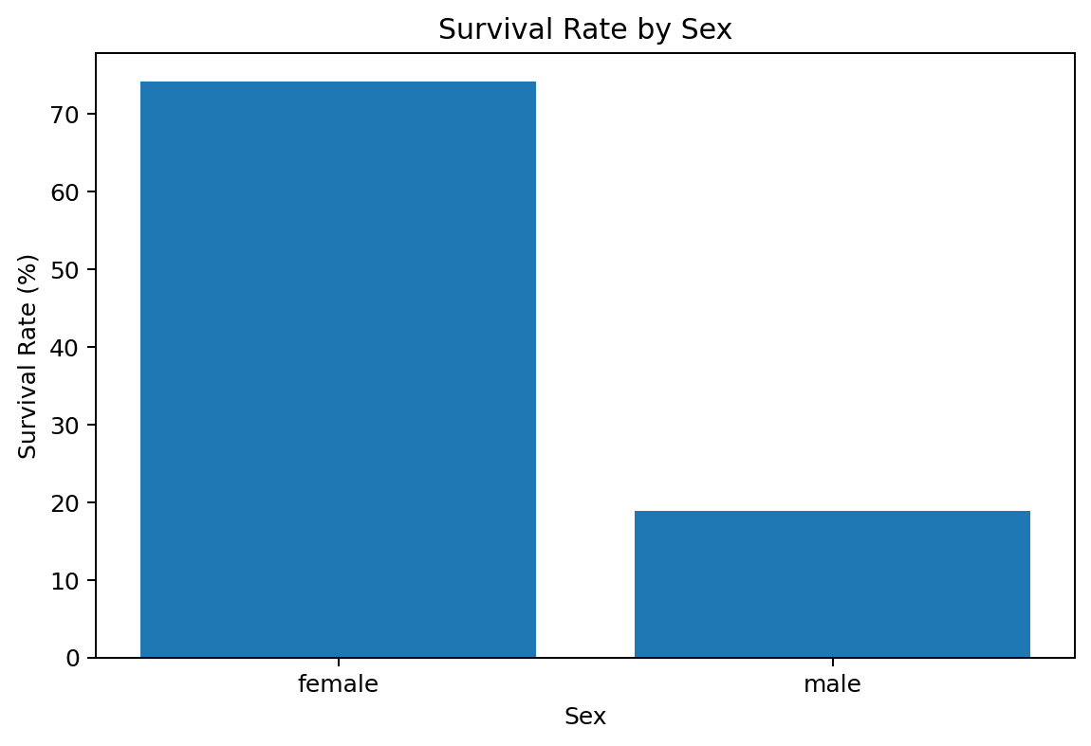
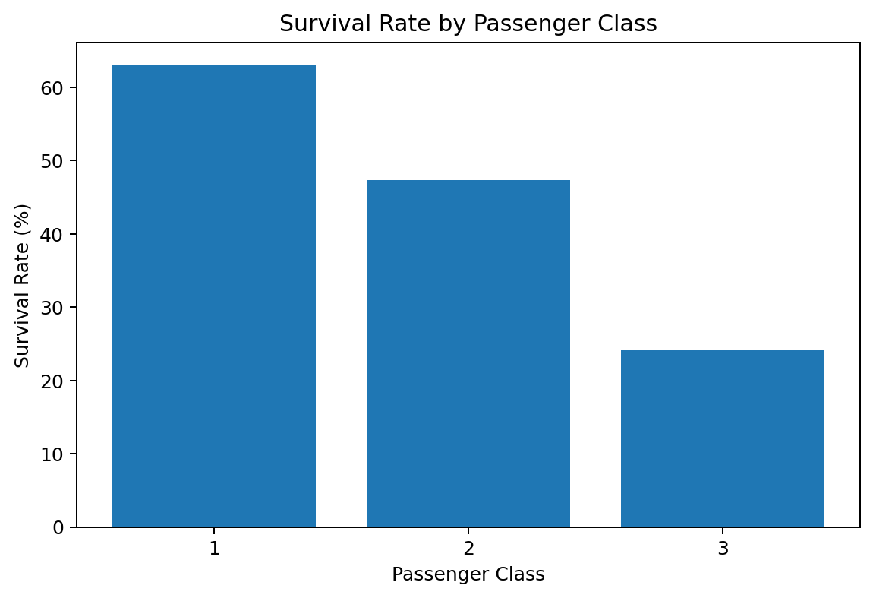
The strongest descriptive findings were the survival differences by sex and passenger class. Female passengers had an observed survival rate of approximately 74.2% compared with 18.9% for male passengers. Survival was also highest in first class (63.0%) and lowest in third class (24.2%). These visual patterns motivated further statistical and predictive analysis.

5. Statistical Analysis (Week 3)
The third stage added statistical testing to determine whether selected patterns were supported by evidence rather than visual observation alone. A Welch t-test compared Fare between survivors and non-survivors. The resulting p-value was very small, indicating a statistically significant difference in mean Fare between the two groups at a conventional 5% significance level.
A Shapiro-Wilk test was also demonstrated on a reproducible sample of Age values (W = 0.953, p = 1.43e-11), while Spearman correlation was used to examine the relationship between Age and Fare. These procedures highlighted the importance of checking assumptions and selecting methods that fit the characteristics of the data.

6. Predictive Modeling (Week 3)
A logistic regression model was developed to predict the binary survival outcome. The predictors included passenger class, sex, age, family-related variables, fare, and embarkation port. The dataset was split into training and test sets, and 5-fold cross-validation was used to assess stability.
Metric | Result
Accuracy | 0.804
Precision | 0.793
Recall | 0.667
F1-score | 0.724
ROC-AUC | 0.845
The mean 5-fold cross-validation accuracy was 0.794. These results indicate that the model captured useful patterns but still made errors, which is expected because survival is influenced by factors not fully represented in the dataset.
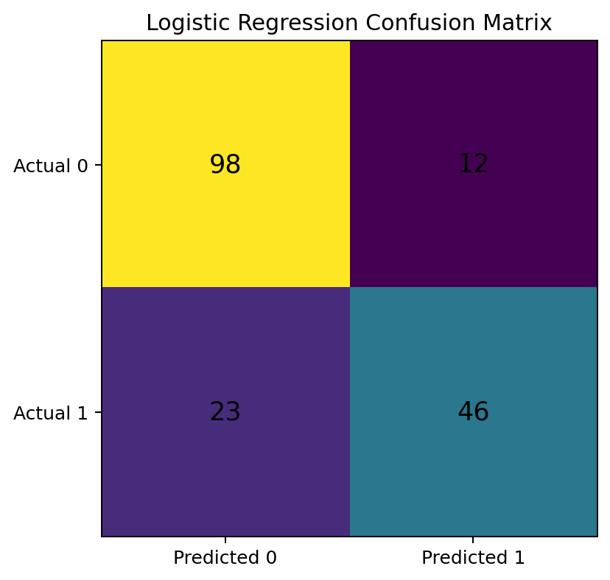
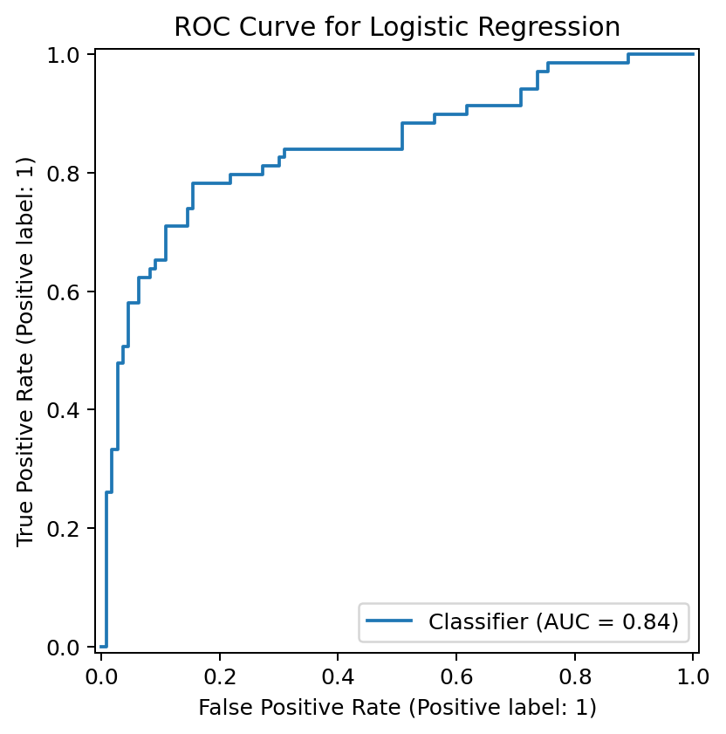

7. Integrated Results and Discussion
When the three stages are viewed together, a clear analytical progression emerges. Data cleaning made the dataset suitable for analysis. Visualization revealed strong descriptive patterns. Statistical testing provided evidence for selected group differences. Finally, predictive modeling combined multiple variables to estimate survival probability.
- Sex was one of the strongest descriptive indicators associated with survival.
- Passenger class was also strongly associated with survival outcomes.
- Fare differed significantly between survival groups, but its relationship with survival should not be interpreted as purely causal.
- Age showed useful distributional patterns but was not sufficient on its own to predict survival.
- A multivariable model performed better than relying on any single visualization or variable.

8. Practical and Business Implications
Although the Titanic dataset is historical and not a modern business dataset, the workflow has direct relevance to practical analytics. In a business setting, a similar process could be used to understand customer retention, patient outcomes, product demand, employee attrition, or service quality. The important principle is to move from raw data to reliable decisions through careful cleaning, exploratory analysis, statistical validation, and predictive modeling.

9. Challenges and Lessons Learned
- Missing data requires a justified strategy; there is no single method that is correct for every variable.
- Outliers should be investigated rather than automatically deleted.
- The choice of chart should match the type of question being asked.
- Correlation and statistical significance do not establish causation.
- Model accuracy alone is not enough; precision, recall, F1-score, ROC-AUC, and confusion matrices provide additional context.
- A simple interpretable model can be valuable as a baseline before trying more complex algorithms.
- Clear documentation is essential so that a non-technical audience can understand what was done and why.

10. Future Directions
- Create additional features such as family size and passenger title.
- Compare logistic regression with tree-based models.
- Perform hyperparameter tuning and model calibration.
- Explore interaction effects between sex, passenger class, and fare.
- Create an interactive dashboard using R Shiny or another visualization tool.
- Apply the same end-to-end workflow to a larger real-world dataset.

11. Final Conclusion
This final project demonstrates a complete entry-level data analysis workflow in R. Beginning with a raw public dataset, the work addressed missing values, variable types, potential outliers, normalization, and encoding. Exploratory visualizations then identified important patterns, particularly differences in survival by sex and passenger class. Statistical analysis provided additional evidence for group differences, and a logistic regression model demonstrated how multiple variables can be combined to make predictions. The project highlights that effective data analysis is not only about writing code or producing charts. It also requires selecting appropriate methods, checking assumptions, interpreting results carefully, and communicating findings clearly.

12. Key R Workflow
# Week 4: Comprehensive Data Analysis Reporting and Presentation
# This script integrates the main workflow from Weeks 1, 2 and 3.
# Load data
data <- read.csv("titanic.csv", stringsAsFactors = FALSE)
# WEEK 1: DATA CLEANING
data$Cabin <- NULL
data$Age[is.na(data$Age)] <- median(data$Age, na.rm = TRUE)
mode_embarked <- names(sort(table(data$Embarked), decreasing = TRUE))[1]
data$Embarked[is.na(data$Embarked)] <- mode_embarked
data$Sex <- as.factor(data$Sex)
data$Embarked <- as.factor(data$Embarked)
# Check outliers
boxplot(data$Fare, main = "Fare Distribution")
# WEEK 2: VISUALIZATION
library(ggplot2)
ggplot(data, aes(x = Age)) +
geom_histogram(binwidth = 5) +
labs(title = "Age Distribution")
sex_summary <- aggregate(Survived ~ Sex, data = data, mean)
sex_summary$SurvivalRate <- sex_summary$Survived * 100
ggplot(sex_summary, aes(x = Sex, y = SurvivalRate)) +
geom_col() +
labs(title = "Survival Rate by Sex")
# WEEK 3: PREDICTIVE MODEL
library(caret)
set.seed(42)
index <- createDataPartition(as.factor(data$Survived), p = 0.80, list = FALSE)
train_data <- data[index, ]
test_data <- data[-index, ]
model <- glm(Survived ~ Pclass + Sex + Age + SibSp + Parch + Fare + Embarked,
data = train_data, family = binomial)
prob <- predict(model, test_data, type = "response")
pred_class <- ifelse(prob >= 0.5, 1, 0)
confusionMatrix(as.factor(pred_class), as.factor(test_data$Survived))

References
Data Science Dojo. Titanic dataset: https://github.com/datasciencedojo/datasets/blob/master/titanic.csv

