Week 1: Data Cleaning and Preliminary Analysis with R
Entry-Level Internship Submission | Titanic Dataset
This report documents the selection, cleaning, preprocessing and preliminary exploratory analysis of the Titanic passenger dataset using R. The work is intentionally kept at an entry-level level and focuses on understanding the basic data-analysis workflow.

1. Objective
The objective of this task was to select a public dataset containing numerical and categorical variables, identify data-quality issues, clean and transform the data, and perform preliminary exploratory analysis using R.

2. Dataset Selection and Overview
The Titanic dataset was selected because it contains a mixture of numerical variables (Age, Fare, SibSp and Parch) and categorical variables (Sex and Embarked), along with missing values. The dataset contains 891 passenger records and 12 columns. The public dataset is available from the Data Science Dojo GitHub dataset repository and is also commonly used in Kaggle’s Titanic competition.
Dataset source: https://github.com/datasciencedojo/datasets/blob/master/titanic.csv
Variable | Description | Type
Survived | 0 = No, 1 = Yes | Numerical / binary
Pclass | Passenger class (1, 2, 3) | Numerical / categorical
Sex | Passenger sex | Categorical
Age | Age in years | Numerical
SibSp | Siblings/spouses aboard | Numerical
Parch | Parents/children aboard | Numerical
Fare | Passenger fare | Numerical
Cabin | Cabin number | Categorical
Embarked | Port of embarkation | Categorical

3. Importing the Dataset in R
data <- read.csv("titanic.csv", stringsAsFactors = FALSE)
head(data)
The first few rows were checked to confirm that the dataset loaded correctly.

4. Initial Data Inspection
The functions str() and summary() were used to understand the structure of the dataset and obtain descriptive statistics.
str(data)
summary(data)
dim(data)
Key observation: The dataset contains 891 rows and 12 columns. Age has 177 missing values, Cabin has 687 missing values and Embarked has 2 missing values.
Column | Missing Values | Action Taken
Age | 177 | Median imputation
Cabin | 687 | Dropped due to very high missingness
Embarked | 2 | Mode imputation

5. Data Cleaning Process

5.1 Removing a Column with Excessive Missing Values
Cabin had 687 missing values out of 891 records, which is approximately 77%. Since most values were missing, the column was removed for this entry-level preliminary analysis.
data$Cabin <- NULL

5.2 Handling Missing Age Values
Age is a numerical variable. The median age was 28 years, so missing Age values were replaced with the median. Median imputation was chosen because it is less affected by extreme values than the mean.
data$Age[is.na(data$Age)] <- median(data$Age, na.rm = TRUE)

5.3 Handling Missing Embarked Values
Embarked is a categorical variable. The most frequent value was S (Southampton), so the two missing values were replaced with the mode.
mode_embarked <- names(sort(table(data$Embarked), decreasing = TRUE))[1]
data$Embarked[is.na(data$Embarked)] <- mode_embarked

5.4 Removing Duplicate Rows
sum(duplicated(data))
data <- data[!duplicated(data), ]
Duplicate records were checked as a standard cleaning step. No duplicate passenger rows were identified.

6. Outlier Detection
Outliers were checked for the Fare variable using the Interquartile Range (IQR) method. Fare was retained because high fares may represent genuine first-class tickets rather than data-entry errors.
Q1 <- quantile(data$Fare, 0.25)
Q3 <- quantile(data$Fare, 0.75)
IQR_value <- IQR(data$Fare)
lower_bound <- Q1 - 1.5 * IQR_value
upper_bound <- Q3 + 1.5 * IQR_value
outliers <- data[data$Fare < lower_bound | data$Fare > upper_bound, ]
boxplot(data$Fare, main = "Fare Outlier Check")
For Fare, Q1 = 7.9104, Q3 = 31.0000 and the IQR = 23.0896. The upper IQR threshold was 65.6344. The method identified 116 observations outside the IQR range. These were kept because they can be valid observations.
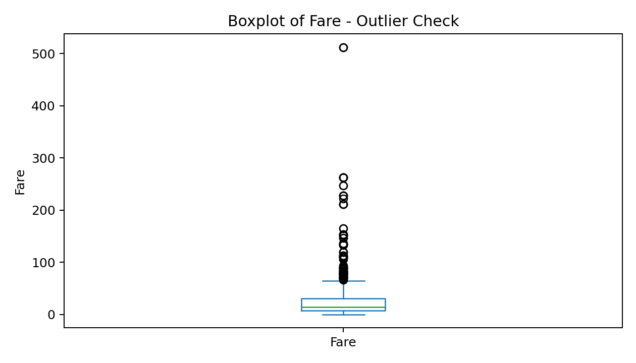

7. Normalization of Numerical Variables
Min-max normalization was demonstrated for Age and Fare so that the values are scaled between 0 and 1. This is useful when variables with different scales are used together in later analysis or modelling.
normalize <- function(x) {
(x - min(x)) / (max(x) - min(x))
}
data$Age_Normalized <- normalize(data$Age)
data$Fare_Normalized <- normalize(data$Fare)

8. Encoding Categorical Variables
Sex and Embarked were converted into categorical factors. For an entry-level analysis, factor conversion is sufficient. Dummy variables can also be created if the cleaned dataset is later used for a machine-learning model.
data$Sex <- as.factor(data$Sex)
data$Embarked <- as.factor(data$Embarked)
# Example of dummy encoding
sex_dummy <- model.matrix(~ Sex - 1, data = data)
embarked_dummy <- model.matrix(~ Embarked - 1, data = data)

9. Exploratory Data Analysis

9.1 Descriptive Statistics
Variable | Mean | Median | Minimum | Maximum
Age (before imputation) | 29.70 | 28.00 | 0.42 | 80.00
Fare | 32.20 | 14.45 | 0.00 | 512.33
SibSp | 0.52 | 0.00 | 0 | 8
Parch | 0.38 | 0.00 | 0 | 6
summary(data[, c("Survived", "Pclass", "Age", "SibSp", "Parch", "Fare")])

9.2 Age Distribution
hist(data$Age, breaks = 25, main = "Age Distribution",
xlab = "Age", col = "lightblue")
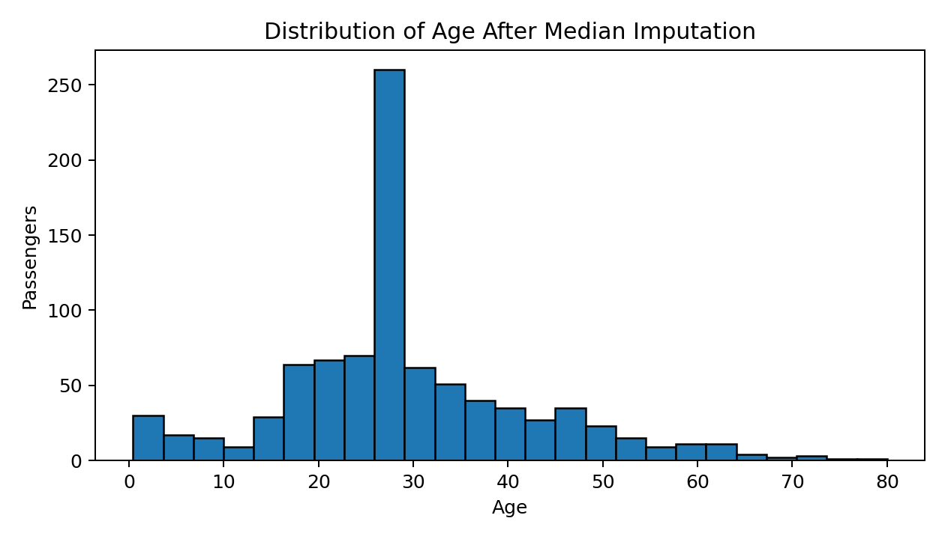
The passenger ages were concentrated mainly among young adults, with fewer passengers at the higher age range.

9.3 Survival Rate by Sex
survival_by_sex <- aggregate(Survived ~ Sex, data = data, FUN = mean)
survival_by_sex$Survived <- survival_by_sex$Survived * 100
barplot(survival_by_sex$Survived, names.arg = survival_by_sex$Sex,
ylab = "Survival Rate (%)", main = "Survival Rate by Sex")
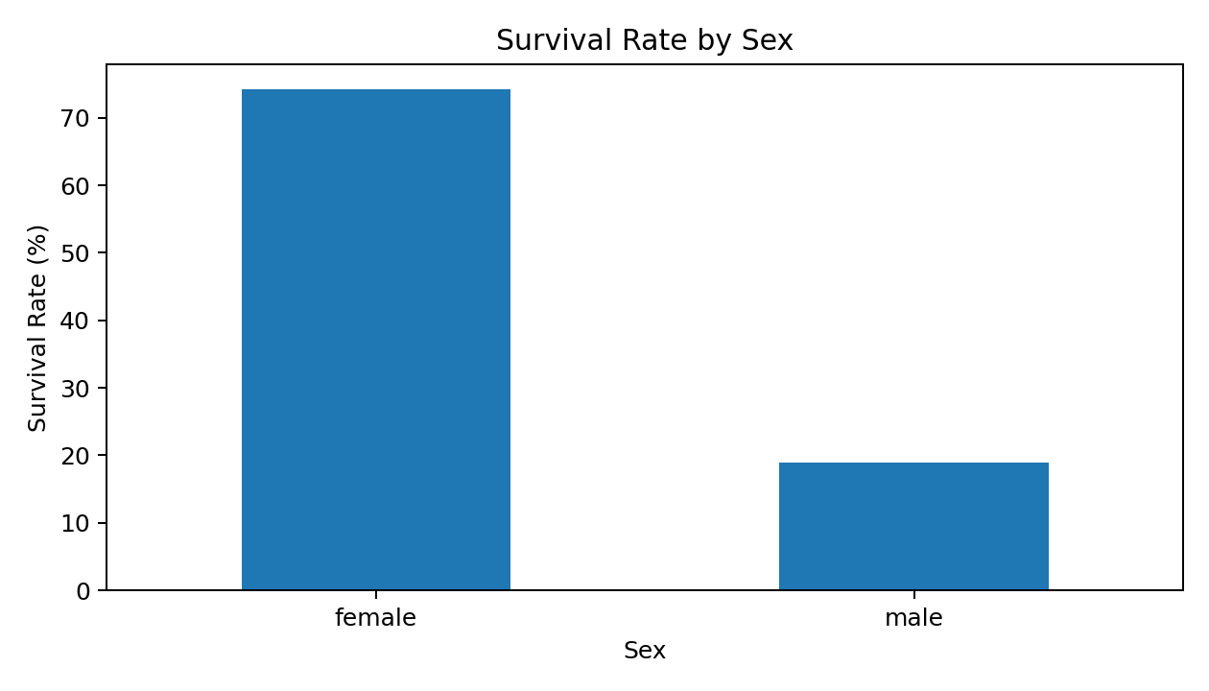
Female passengers had a survival rate of approximately 74.2%, compared with approximately 18.9% for male passengers. Sex therefore showed a strong relationship with survival in this dataset.

9.4 Survival Rate by Passenger Class
survival_by_class <- aggregate(Survived ~ Pclass, data = data, FUN = mean)
survival_by_class$Survived <- survival_by_class$Survived * 100
barplot(survival_by_class$Survived, names.arg = survival_by_class$Pclass,
ylab = "Survival Rate (%)", main = "Survival Rate by Passenger Class")
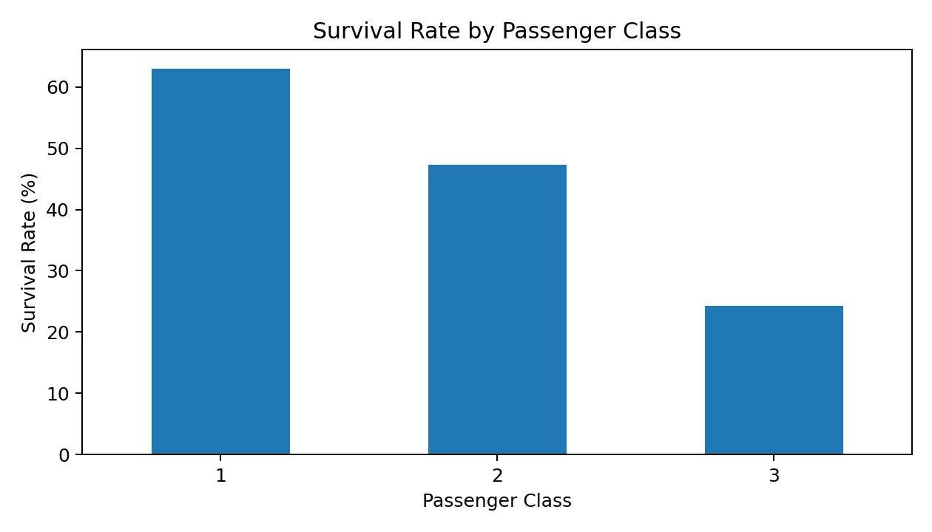
First-class passengers had the highest survival rate (about 63.0%), followed by second class (47.3%) and third class (24.2%).

10. Correlation Analysis
Correlation was calculated for selected numerical variables. Categorical variables were not included directly in the basic correlation matrix.
numeric_data <- data[, c("Survived", "Pclass", "Age", "SibSp", "Parch", "Fare")]
cor_matrix <- cor(numeric_data, use = "complete.obs")
round(cor_matrix, 2)
Relationship | Correlation | Initial Interpretation
Survived vs Pclass | -0.34 | Moderate negative relationship
Survived vs Fare | 0.26 | Weak-to-moderate positive relationship
Pclass vs Fare | -0.55 | Higher class number generally linked to lower fare
SibSp vs Parch | 0.42 | Moderate positive relationship

11. Initial Insights
- The dataset required meaningful cleaning because of missing values and different variable types.
- Cabin was removed because approximately 77% of its values were missing.
- Age was completed using median imputation, while Embarked was completed using the most frequent category.
- Fare contained high-value observations identified by the IQR method, but they were retained because they may be genuine passenger fares.
- Female passengers had a substantially higher observed survival rate than male passengers.
- Passengers in first class had a higher survival rate than passengers in second and third class.
- Passenger class had a negative correlation with survival and fare, while fare had a positive correlation with survival.

12. Conclusion
This preliminary analysis completed the main data-cleaning and exploratory-analysis requirements for Week 1. The dataset was inspected, missing values were handled, a highly incomplete column was removed, potential outliers were identified, numerical variables were normalized and categorical variables were encoded. Basic descriptive statistics, visualizations and correlations provided initial insights into the dataset. This cleaned dataset can be used for more advanced analysis or predictive modelling in a future task.

13. R Code – Complete Beginner-Level Script
# Week 1 - Data Cleaning and Preliminary Analysis with R
# 1. Load dataset
data <- read.csv("titanic.csv", stringsAsFactors = FALSE)
# 2. Initial inspection
head(data)
str(data)
summary(data)
dim(data)
colSums(is.na(data))
# 3. Remove Cabin because of too many missing values
data$Cabin <- NULL
# 4. Handle missing values
data$Age[is.na(data$Age)] <- median(data$Age, na.rm = TRUE)
mode_embarked <- names(sort(table(data$Embarked), decreasing = TRUE))[1]
data$Embarked[is.na(data$Embarked)] <- mode_embarked
# 5. Check duplicates
sum(duplicated(data))
data <- data[!duplicated(data), ]
# 6. Outlier detection for Fare
Q1 <- quantile(data$Fare, 0.25)
Q3 <- quantile(data$Fare, 0.75)
IQR_value <- IQR(data$Fare)
lower_bound <- Q1 - 1.5 * IQR_value
upper_bound <- Q3 + 1.5 * IQR_value
outliers <- data[data$Fare < lower_bound | data$Fare > upper_bound, ]
boxplot(data$Fare, main = "Fare Outlier Check")
# 7. Normalize Age and Fare
normalize <- function(x) (x - min(x)) / (max(x) - min(x))
data$Age_Normalized <- normalize(data$Age)
data$Fare_Normalized <- normalize(data$Fare)
# 8. Encode categorical variables
data$Sex <- as.factor(data$Sex)
data$Embarked <- as.factor(data$Embarked)
# 9. Visualizations
hist(data$Age, breaks = 25, main = "Age Distribution", xlab = "Age")
survival_by_sex <- aggregate(Survived ~ Sex, data = data, FUN = mean)
survival_by_class <- aggregate(Survived ~ Pclass, data = data, FUN = mean)
# 10. Correlation
numeric_data <- data[, c("Survived", "Pclass", "Age", "SibSp", "Parch", "Fare")]
round(cor(numeric_data, use = "complete.obs"), 2)

References
Data Science Dojo. Titanic dataset (public dataset repository): https://github.com/datasciencedojo/datasets/blob/master/titanic.csv
Kaggle. Titanic: Machine Learning from Disaster – data description and data dictionary: https://www.kaggle.com/competitions/titanic/data

