|  |
| --- |
| California State University, San Bernardino |
| **Department of Computer Science**  **And Engineering**  {AlgorithmA}; 2010  logo_CS455 |
|  |
| **User’s Manual** |
| **CSE 455, Inc.** |

CEO: Dr. Concepcion

Project Manager: Patrick O’Connor

Assistant Managers: Danny Vargas and Abdelrahman Kamel

Documentation Team: Erick Behr, Tyler Cannon,

Charles Korma, Kathleen Daugherty

|  |
| --- |
|  |

Table of Contents

[1. Introduction - 3 -](#_Toc256712511)

[1.1 Who is CSE 455, Inc.? - 3 -](#_Toc256712512)

[1.2 What is AlgorithmA 2010? - 3 -](#_Toc256712513)

[2. Server Documentation - 3 -](#_Toc256712514)

[2.2 ClockingIT - 3 -](#_Toc256712515)

[2.3 JavaScript - 4 -](#_Toc256712516)

[2.4 Bugzilla - 4 -](#_Toc256712517)

[2.5 Subversion (SVN) - 4 -](#_Toc256712518)

[2.6 LAMP - 4 -](#_Toc256712519)

[2.7 SVN to Web root - 5 -](#_Toc256712520)

[3. Server Diagrams - 5 -](#_Toc256712521)

[3.2 Deployment Diagram - 5 -](#_Toc256712522)

[3.3 Deployment Server Diagram - 6 -](#_Toc256712523)

[3.4 Class Diagram of PbMan and jsAnim - 6 -](#_Toc256712524)

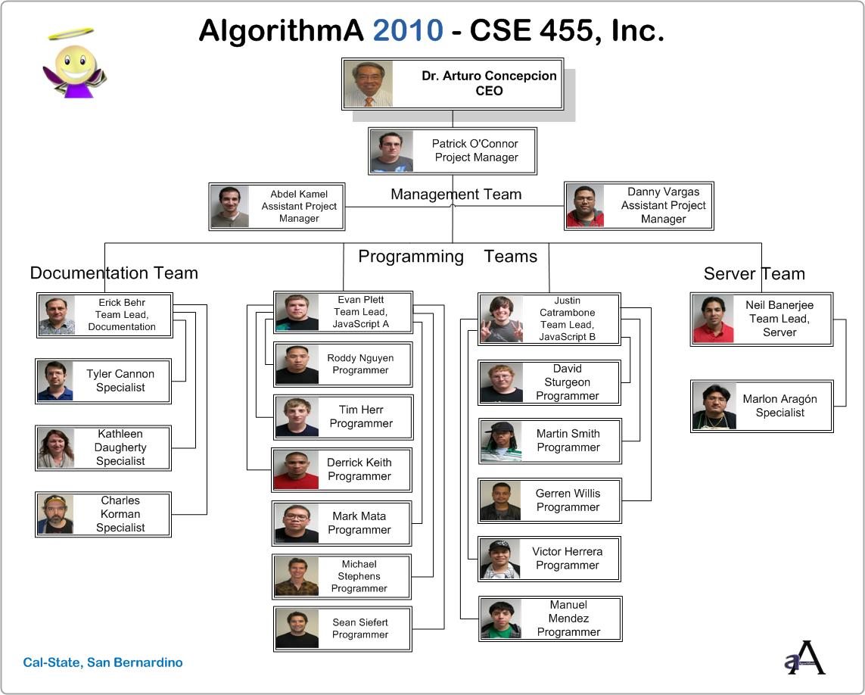

CSE 455, Inc.

# Introduction

### 1.1 Who is CSE 455, Inc.?

CSE 455, Inc is a fictitious software development company focused to develop educational software for the academic community in Computer Science. This software company is managed by a CEO, a Program Manager, two Assistant Managers, four Team Leads and a group of competent programmers highly qualified in several high-level computer languages.

### 1.2 What is AlgorithmA 2010?

AlgorithmA 2010 is a dedicated website for students of Computer Science to learn the foundation of programming, mathematical algorithms, data structures, and design patterns. This framework is taught in the first two classes of the Computer Science B.S. and B.A. degree programs. AlgorithmA 2010 is a learning tool for these students to help them understand how these mechanisms work in software. AlgorithmA is structured in a way to give its user a detailed account of how an algorithm or data structure works. The walkthroughs go line-by-line and show, using a graph, what happens when each line executed. This design shows what the algorithm actually does and in what sequence. AlgorithmA 2010 is structured in a way to give its user a detailed account of how an Algorithm or a Data Structure works. Using a graph, each line of pseudo code is highlighted as it is executed. Parts of the graph are highlighted as the code is executed as well. This design shows what the algorithm actually does and in what sequence.

AlgorithmA 2010 is a continuation of the CSE 455 class at California State University, San Bernardino. AlgorithmA first started in 1991. It has gone through yearly iterations that have included updating, adding new algorithms, and reengineering code to more update software design. For 2010 AlgorithmA is being updated from Java to JavaScript. At least 20 animations are being redesigned including the sorts, search and data structures. The end goal is to have republished this on the open source.

# Server Documentation

## ClockingIT

ClockingIT is a project management site with the emphasis of scheduled tasking, milestones, and personnel tracking. Its main purpose is to organize large amounts of people using management created tasks and assignments. Users are notified of new tasks and are given reminders by email of a due task. ClockingIT has user accounts and allows management to track project members and separate tasks amongst individual groups or the whole team. There were for main groups that were made for the four teams: the two programming teams, server team, and documentation team. You can access the AlgorithmA team ClockingIT at [algodev.clockingit.com](file:///C:\Users\Admin\AppData\Local\Microsoft\Windows\Temporary%20Internet%20Files\Content.Outlook\Z70DZXKB\algodev.clockingit.com).

## JavaScript

JavaScript is an object-oriented scripting language which looks similar to Java but easier to use. JavaScript takes advantage of becoming integrated component of a web browser. This allows for a dynamic website and enhanced user interface. All AlgorithmA 2010 animations are done in JavaScript with some coding standards to make it easier to read, debug, and create new ones. JsAnim and PbMan are the libraries that are currently being used to produce these animations. PbMan is a library created by Danny Vargas who used the jsAmin libraries and modified it. New functions such as the swap function were added to this library. This allowed more standardized coding as all programmers used the same libraries that are more specific to the AlgorithmA programming needs. A class diagram showing how PbMan and jsAnim work together is shown in 3.5. More details on jsAnim can be found at <http://jsamin.com>. Examples of JavaScript and the libraries can be found <http://algodev.clockingit.com/project_files/list/13325>.

## Bugzilla

Bugzilla is an open sourced defect tracking system. It is used to send in faults that are found within the project. All team members are to send in reports of any bug/fault they find to Bugzilla. The faults are stored and tracked. Each fault can be checked out from the database and fixed by a member of the team assigned to fixing it. Once it is fixed the fault is closed out showing that it has been completed. This helps ensure no more than one person is fixing the same fault at the same time and that the faults are not fixed again though they were already fixed. You can access Bugzilla with your login and password at <https://bug.algodev.ias.csusb.edu:8443/>.

## Subversion (SVN)

SVN is an open sourced revision control system. This allows for old versions of a project to be stored as the project progresses. It allows rolls backs and finding old or overwritten files from the previous versions. It also shows the development of the project and changes made within each revision. Copies of the project files may be checked out and changed with a user login. The new versions are to be uploaded by a team lead to create a new revision with some slight documentation telling what was changed. Instructions on how to login, checkout, and upload to AlgorithmA’s SVN can be found at <http://algodev.clockingit.com/project_files/list>. You can also view the latest revision or the old AlgorithmA site from the trunk folder at <http://algodev.ias.csusb.edu:8080/svn/trunk/>.

For Windows users, a download may be required to use SVN. TortoiseSVN is the main client used for 2010. It is easily found for download and is found on the open source.

## LAMP

This is a guide to install the AlgorithmA package to a CentOS machine. This is not how you set up a development server. This requires a few things to be installed already. Using the yum command you can install all of these. You can use yum –y install <insert commands> to install MySQL, Apache and all the other required items. Next you will need to use the CHKCONFIG command to set both http and MySQL during startup. You will need to restart you database server and HTTPD by using the service <command name> restart. You will then import the data from the other database into the database using MySQL –u root < <database>.sql. Copy the AlgorithmA folder to the web root by first making a new directory and then copying it over. AlgorithmA should now be installed and time to load up a browser and check it out.

## SVN to Web root

A 'cron' job was set up to do a SVN update that would periodically update web live folders and therefore to sync with the SVN HEAD. This allows new revisions to be seen on the AlgorithmA website every ten minutes. The ten minutes are synced to run for example at 7:00, 7:10, 7:20 and so forth. Any revisions made between those times must wait until the update runs again before being able to view it live. Only the most recent revision will be seen at the time of the update as SVN only points to the last one much like a stack.

# Server Diagrams

## Deployment Diagram



## Deployment Server Diagram



## Class Diagram of PbMan and jsAnim

This class diagram is a representation of how PbMan and jsAnim work together to form the library used to create the animations for AlgorithmA.

