Parallel Computers : Project 1

Group members
- Abdelrahman Kamel (ak883)
- Hee Jung (hr99)

Optimization methods

- Loop ordering
- Copy optimization (transposition of A & fringe optimization)
- SSE Vector instructions
- GCC Compiler Optimization flags
- C annotations (aligned & restrict keywords)
- Blocking

Explanations

Blocking was also utilized as an optimization method. We increased our block size, which increased our performance by a noticeable amount. The main concept was borrowed from blocking-dgemm.c which was provided in the project package.
Changing our compiler flags to include optimization for XMM instructions boosted performance. We have several flags set, but the major flags that seem to have a major impact on performance are the O3, funroll-all-loops and mfpmath=sse. Other flags that seem to have a slight but not major increase are the ffast-mathand ftree-vectorize.
We also followed the c coding style guide suggested by PhiPAC and ATLAS. Instead of making the matrices element value to be stored to register, we made local variables for them so that expensive use of register is avoided. This slightly improved the performance of our code.
Transposed Copy optimization method is also used in our code. For the column-major array A, we copied and transformed it into a row-major array transformed_A. This allows more sequential access to the array A during the computation as A gets accessed row by row while B gets accessed column by column. This also prevented the associativity conflicts thus making the access to the matrices much faster via increased number of cache hits for all the matrices whose sizes are powers of 2.
As per the ordering of the for-loops per index (e.g. i, j, k), we ordered them in j, i, k order (out-most to inner-most order) in order to make the array access sequential rather than random. This was possible due to the transposing of the given matrix A thus striding through A and B at the same time in the inner most loop. On the other hand, we could stride through the matrix C by incrementing i while holding j with the same value by placing the j for-loop as the outer most.
For the matrices whose sizes are smaller than or equal to 318, we did not make a new copy of the given matrix in an aligned address space because that generated too much overhead. However, we created an array of size two with the address aligned to 16 bit to perform SSE instruction, thus performing two floating point operations at each loop via XMM registers. This improved our performance.
But the most effective was the use of Fringe Copy Optimization method along with SSE instructions. For SSE instructions, we had to create a new copy of the given matrices with the address to be aligned by 16-bit. For that, the best way to make a copy is to make sure the copied matrix fits in and fills in the entire L2 cache to ease the address alignment restriction. Also, for such a big matrix, it is a good idea to create the aligned matrix address space only once by declaring it as ‘static’, which is included in our code at the start of do_block.
Now, to talk more about how we utilized SSE instructions to our benefit, we loaded two consecutive double values in the copied matrix at once to XMM register and interleaved multiplications and additions using SSE instructions. This decreased the number of floating-point operations performed in total by half since two such operations are performed at once in one clock cycle. This has led our code’s performance, for matrices whose size is greater than 318, to be much faster. In fact, the bigger the matrix becomes, faster the operations were performed. For the matrices whose size is 769, the speed went beyond ~2000 Mflops/s.
We also used C annotations to denote to the compiler that in our code we ensure there will be no aliasing between pointers. This annotation used the restrict keyword. Another annotation used was the aligned attribute which makes sure that the variables are aligned in memory to the size we have set (eg. 16). This is needed for some SSE instructions to be preformed.
A notable compiler flag we used is the funroll-all-loops which is a bit different than the one suggested in the notes. The one in the notes which is funroll-loops preforms optimization or loops whose number of iterations can be determined at compile time or run time. Funroll-all-loops preforms optimization on all loops which in general slows down performance but in our case it actually increased performance.
Sizes that have been tested were 32, 36, 128, 181, 256, and 512. The highest results where obtained by using a block size of 256

.

Results
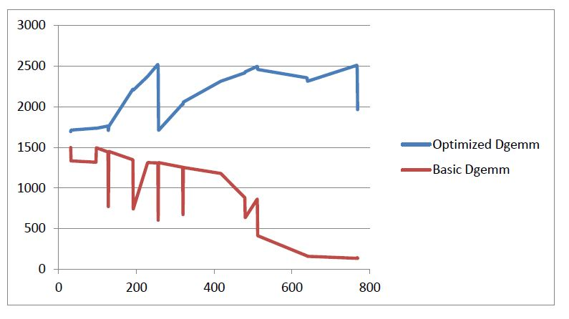
compute-0-4.local
Compiler: /share/apps/local/bin/gcc
Options: -mfpmath=sse -ftree-vectorize -O3 -funroll-all-loops -ffast-math
Description: Hee and Abdel’s dgemm.

Size: 31 mflop/s: 1695.13
Size: 32 mflop/s: 1712.98
Size: 96 mflop/s: 1735.75
Size: 97 mflop/s: 1735.2
Size: 127 mflop/s: 1762.85
Size: 128 mflop/s: 1709.46
Size: 129 mflop/s: 1758.34
Size: 191 mflop/s: 2216.89
Size: 192 mflop/s: 2203
Size: 229 mflop/s: 2372.53
Size: 255 mflop/s: 2520.16
Size: 256 mflop/s: 2463.86
Size: 257 mflop/s: 1708.67
Size: 319 mflop/s: 2034.22
Size: 320 mflop/s: 2026.79
Size: 321 mflop/s: 2057.74
Size: 417 mflop/s: 2313.92
Size: 479 mflop/s: 2416.48
Size: 480 mflop/s: 2428.59
Size: 511 mflop/s: 2496.67
Size: 512 mflop/s: 2458.08
Size: 639 mflop/s: 2355.86
Size: 640 mflop/s: 2313.52
Size: 767 mflop/s: 2509.48
Size: 768 mflop/s: 2457.73
Size: 769 mflop/s: 1964.92

