**App guide info for CMZ TD-Series**

**Job setup:**

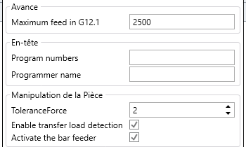

Max feedrate for polar coordinate interpolation



Force detection value for transfer (G38 Z-7.5 **Q2** F500)



Force detection value for transfer. (G38 Z-7.5 **Q2** F500)



Opens and closes chucks at the start and end of the program.

**Operations:**

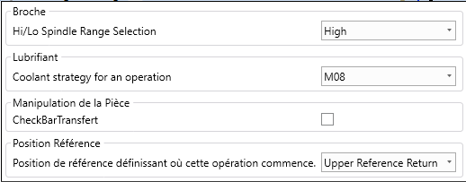

Store tool in high or low position.



Adds an M40 code to the tool approach to check for stock in the spindle.