ATI Water Monitor App: User Manual
Entry, automatic calculation, automatic saving to the Google Sheet and comparison with other ATIs

1. What the app does
ATI Water Monitor is a smartphone app for recording the water level of the FP (Farmers' Practice) plot and the 3F4D+MD plot. When you save, the data are sent automatically to the shared Google Sheet prepared by the teacher, through a Google Form. The dashboard shows the data kept in the sheet, not only the data on the phone. You can compare your ATI with the other ATIs in graphs.
Step | What happens
1. Enter | Students enter water level, irrigation, rain, fertilizer, pesticide and tiller counts in the app. Water level, irrigation and so on are calculated automatically.
2. Sent automatically | When you save (for example "Save entry"), the data are sent to the shared sheet a few seconds later. No pasting is needed.
3. Show and compare | The dashboard and the Compare tab show the data in the sheet. You can compare your ATI with the other ATIs in graphs.
Saving to the Google Sheet is required. "Save entry" cannot be pressed until the app is connected to the sheet.

2. Teacher setup (Google Form and shared sheet)
The administrator (for example a teacher) does this once. All ATIs that want to compare use the same form and the same sheet.
- Make the form: create a new Google Form with these four questions, in this order, with exactly these names: ATI (short answer), Updated (short answer), Summary (short answer), Data (paragraph). Keep the names exactly, including capital letters. Do not make them "Required".
- In the form settings, turn OFF "Require sign-in", "Limit to 1 response" and "Collect email addresses" (so that students can send without signing in). Keep the form open for responses.
- Form link: open the "︙" menu at the top right > "Get pre-filled link". In the four questions, type ATI, UPDATED, SUMMARY and DATA (the question names in capital letters). Press "Get link" > "Copy link".
- Make the sheet: in the form, open the "Responses" tab and press "Link to Sheets" to create the response sheet.
- Compare link: in that sheet, open "File > Share > Publish to web". Choose the response tab ("Form Responses 1") instead of "Entire document", choose the format "Comma-separated values (.csv)" and press "Publish". Copy the link shown.
- Connect the app: in the app, open Share > Google Sheet connection and paste the form link and the compare link. Press "Create class setup link" to make one link, and send that link to the students. When a student opens it, both links are filled in automatically.
Note: Anyone who knows the form link can send data, so give it to the students only. Anyone who knows the compare link can read the data (water level, irrigation and so on; no farmer names). To stop publishing, press "Stop publishing" on the "Publish to web" screen. If rows are deleted by mistake, restore them with "File > Version history".
How the sheet grows: Every save adds one row (about 2-3 KB). Only the newest row of each ATI is used. You may delete old rows from time to time (never the newest row of an ATI). If the sheet becomes large, you can make another tab "Latest": write ATI, Updated, Summary, Data in A1:D1, put =SORTN(SORT('Form Responses 1'!B2:E,2,FALSE),9999,2,1,TRUE) in A2, and publish that tab instead. (This formula is not verified. Try it first.)

3. How students use it

3.1 The first time
- Open the "class setup link" from the teacher in Chrome on the phone. This connects the app to the shared sheet. In Chrome, choose "Add to Home screen" to start the app from an icon.
- Setup tab: enter ATI name*, place*, sowing date*, seedling age at transplanting*, and TP and b* of FP and 3F4D+MD (* = required). While a required item is empty, or the app is not connected to the sheet, "Save entry" in the Entry tab cannot be pressed.
- Schedule tab: planned dates appear automatically. Enter the date you actually did the work in "Actual".
How to read m, TP and b: see the figure below. m = tape reading at the water surface, TP = tape reading at the top of the pipe, b = height of the pipe top above the ground (measured with another scale). Water level = m − TP + b. A negative value means the water is below the ground.
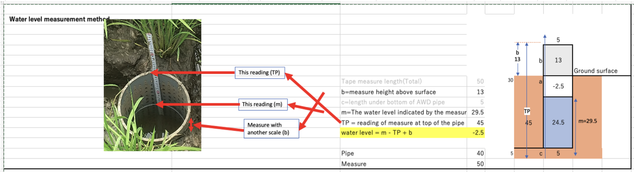
Figure: how to measure the water level (example: m = 29.5, TP = 45, b = 13 gives a water level of −2.5 cm)

3.2 Every day
- Entry tab: choose the date and enter the tape reading (m) of FP and 3F4D+MD. The water level is calculated for you. If you irrigated, choose "Yes" and enter the readings before and after irrigation.
- "Save entry" becomes active when all required items (*) are filled and the values are in range. Missing items are shown in red under the button.
- After saving, the data are sent to the sheet automatically a few seconds later. The line above the dashboard shows the state.
Message | Meaning and what to do
Not yet sent | Not sent yet. It is sent automatically when the phone is online. You can also press "Send now".
Sent. Waiting for the sheet… | Sent. The sheet needs a few minutes to show it. Wait.
Saved in Google Sheet | The sheet has it. This is the normal state.
Sent, but the sheet does not show it yet | Not in the sheet after 20 minutes. Check the form link and press "Send now".
You can enter and save in the field without internet. The data stay on the phone for a while and are sent when the phone is online again.
Input | Required items
Setup | ATI name, place, sowing date, seedling age, TP and b (both plots)
Entry (water level) | Date, m of FP, m of 3F4D+MD. If irrigation is "Yes": the readings before and after irrigation of that plot
Field records: fertilizer | Date, plot, at least one fertilizer amount (kg)
Field records: pesticide | Date, plot, type, chemical name
Field records: tillers | Date, plot, tiller counts of all 5 hills (whole numbers). The value used is the mean of the 2nd, 3rd and 4th largest
Re-measure TP and b | Plot, date, TP, b

3.3 Correcting entries
- Water-level entry: press ✎ in the Entries list, change the values and press "Save entry" again (the same date is overwritten). ✕ deletes the day.
- Fertilizer, pesticide, tillers, TP and b: press ✎ in the list, change the values and press "Update". Press "Cancel" to stop.
- After a correction the new version is also sent automatically. In the sheet, the newest version of the same ATI is used.

3.4 Continuing on a new phone
- Open the class setup link. In Share > Restore from the sheet, type the ATI name (exactly as in the sheet) and press "Restore from sheet". The data in the sheet come back to that phone.

4. Comparing with other ATIs (Compare tab)
- The Compare tab reads all ATIs in the sheet when the app opens. Press "Refresh from sheet" to read again. Tick the ATIs you want to see.
- Your own ATI is drawn with thick lines. The x axis is days after transplanting (DAT).
- Graphs: total irrigation and saving (FP vs 3F4D+MD), cumulative irrigation, water level, tiller number.
- "View" switches the display. "Overlay" draws all ATIs in the same graph. "Each ATI" shows a separate panel with water-level and cumulative-irrigation graphs for every ATI. It also works without data of your own (for example when a teacher looks at all ATIs).
- To see how Compare looks without connecting to the sheet, use "Try with demo data" in Setup (demo ATIs also appear in Compare). Nothing is sent in the demo.

5. Demo, backup and other points
- Demo: "Try with demo data" in Setup opens the app with example data. Nothing is saved or sent. Press "Exit demo" at the top to leave.
- Backup: The master copy is the sheet. The phone also keeps a copy until it has been sent. You may also use "Export file (JSON)" in Share from time to time.
- View-only link: "Create link" in Share makes a link that shows only the dashboard.
- Language: The button at the top right switches English and Bengali. The Bengali is a draft and needs checking.

6. Notes and limits
- Each ATI name must be unique. The same name is treated as the same ATI.
- Each send puts all data of that ATI into one row (not a difference). "Updated" in the sheet is U plus a number for the time of sending; the app fills it in. Do not change it, the header row or the column names.
- If the same ATI is used on two phones, the version saved last is the newest in the sheet. Press Refresh to load the newest before entering data.
- Verified: the app's calculations equal the original Excel values; required-item checks, corrections, demo, sending to the form and restoring/loading from the sheet (with mock data in place of Google, including two simulated phones).
- Not verified: sending to a real Google Form, loading the published CSV, behaviour on real phones, correctness of the Bengali. Test with the first ATI before handing it out.

