Medallion Architecture
  National university of scienceS and technology  H12, Islamabad | School of Electrical Engineering and Computer Science  DS 312 – Data Warehousing and Business Intelligence  Instructor: Dr. Rabia Irfan  Submitting on 2nd May 2026  Mohid Arshad (455977)  Tahir Mehmood (458593)  Mohammad Hasnain (462247)  BSDS 2k23

Bronze → Silver → Gold

Table of Contents
1. Topic & Data Choice 3
1.1 Domain Context and Analytical Goal 3
1.2 Dataset Sources 3
1.3 Confirmed Column Headers (from real CSV files) 3
Dataset 1 – Life Expectancy Data.csv (22 columns) 3
Dataset 2 – covid_19_clean_complete.csv (10 columns) 4
Dataset 3 – hospital_beds.csv (4 columns) 4
1.4 Why These Datasets Can Be Joined 4
1.5 Observed Data Issues (Pre-Silver) 4
2. Bronze Zone – Raw Evidence 5
2.1 Raw File Storage & Folder Structure 5
2.2 Bronze Landing Tables 5
2.3 Ingestion Log 6
3. Silver Zone – Cleaning Rules 7
3.1 Overview 7
3.2 Dataset 1: who_health_indicators 7
3.2.1 Cleaning Rules and Justifications 7
3.3 Dataset 2: disease_outbreaks 8
3.3.1 Cleaning Rules and Justifications 8
3.4 Dataset 3: hospital_capacity 9
3.4.1 Cleaning Rules and Justifications 9
4. Quality Checks + Rejects 10
4.1 Quality Gate Definitions 10
4.2 Quarantine Table Design 10
4.3 Reject Summary – Demo Run 11
5. Gold Zone – Curated Datasets 13
5.1 Gold Objects Overview 13
5.2 Gold Scorecard – Complete KPI Field Reference 13
5.3 Sample Gold Scorecard Output 14
6. Pipeline Architecture & Execution 16
6.1 Medallion Layer Summary 16
6.2 Script Execution Order 16
7. References & Data Licenses 17
8. Outputs 18
8.1 Database Creation 18
8.2 Bronze Zone Output (Demo Load) 19
8.3 Silver Zone Output 20
8.4 Gold Zone Output 21

1. Topic & Data Choice

1.1 Domain Context and Analytical Goal
Public healthcare systems in developing nations face persistent challenges including inadequate hospital resources, high infant and child mortality, ongoing disease outbreaks, and wide disparities in health outcomes across regions. Analysing these dimensions jointly enables policymakers, international health organisations, and researchers to identify the countries with the highest unmet need and prioritise interventions accordingly.

This project constructs a Healthcare Data Lake using the Medallion Architecture (Bronze → Silver → Gold) on SQL Server 2022. Three openly licensed Kaggle datasets are integrated to produce a country-level Health Scorecard that combines life expectancy and health factor indicators, COVID-19 outbreak records, and hospital bed capacity data. The scorecard enables direct multi-dimensional comparison of health outcomes, resource levels, and disease burden across 193 countries.

1.2 Dataset Sources
# | Dataset Name | Kaggle Link | License | Original File | Renamed To | Rows | Cols
1 | WHO Life Expectancy & Health Indicators | Kaggle Link | CC0 Public Domain | Life Expectancy Data.csv | who_health_indicators.csv | 2,938 | 22
2 | COVID-19 Clean Complete (Disease Outbreaks) | Kaggle Link | CC0 Public Domain | covid_19_clean_complete.csv | disease_outbreaks.csv | ~49,068 | 10
3 | Hospital Beds by Country | Kaggle Link | CC BY 4.0 | hospital_beds.csv | hospital_capacity.csv | ~4,700 | 4

1.3 Confirmed Column Headers (from real CSV files)

Dataset 1 – Life Expectancy Data.csv (22 columns)
The following is the exact header row as it appears in the downloaded CSV:

Country, Year, Status, Life expectancy, Adult Mortality, infant deaths, Alcohol, percentage expenditure, Hepatitis B, Measles, BMI, under-five deaths, Polio, Total expenditure, Diphtheria, HIV/AIDS, GDP, Population, thinness 1-19 years, thinness 5-9 years, Income composition of resources, Schooling
Note: Some column names in the original file contain leading/trailing spaces (e.g., " BMI ", " HIV/AIDS "). These are handled in Bronze by storing them as-is and applying TRIM() during Silver transformation.

Dataset 2 – covid_19_clean_complete.csv (10 columns)
Province/State, Country/Region, Lat, Long, Date, Confirmed, Deaths, Recovered, Active, WHO Region

Dataset 3 – hospital_beds.csv (4 columns)
Entity, Code, Year, Hospital beds (per 1,000 people)

1.4 Why These Datasets Can Be Joined
Join Strategy & Common Keys
Dataset 1 (DS1) serves as the spine/anchor of the join – it contains 193 countries across years 2000–2015 and provides the most comprehensive health context. DS3 is joined to DS1 on country name (after LOWER/TRIM normalisation), providing hospital bed capacity for overlapping countries. DS2 is joined on country_region ≈ country_name, enriching the scorecard with COVID-19 outbreak figures. All three datasets cover the same global set of countries, making the join valid even though their time ranges differ (DS1: 2000–2015, DS2: 2020–2021, DS3: multi-year). The Gold scorecard takes the latest available year from each dataset per country.

1.5 Observed Data Issues (Pre-Silver)
The following issues were identified during Bronze profiling and motivated the Silver cleaning rules detailed in Section 3:

- DS1 (who_health_indicators): Empty Country strings; Year = 9999 (impossible value); duplicate Country+Year rows; BMI and other columns contain empty strings instead of NULL; multiple numeric columns (GDP, Population, Alcohol etc.) have missing values.
- DS2 (disease_outbreaks): NULL Country/Region; dates formatted as "13-45-2023" (impossible calendar date); non-numeric Confirmed/Deaths values ("abc", "xyz"); duplicate Country+Province+Date rows due to overlapping source files.
- DS3 (hospital_capacity): Empty Entity and Code; code "ZZZ" is not a real ISO-3 country code; duplicate Code+Year rows; some years have no value (NULL capacity).

2. Bronze Zone – Raw Evidence

2.1 Raw File Storage & Folder Structure
Raw CSV files downloaded from Kaggle are stored in the /bronze/raw_files/ directory without any modification. This folder is append-only in production. The renamed files serve as the immutable source of truth for the entire pipeline.

C:\ds312_datalake\
├── bronze\
│ ├── raw_files\ ← Kaggle downloads – NEVER modified
│ │ ├── who_health_indicators.csv (renamed from Life Expectancy Data.csv)
│ │ ├── disease_outbreaks.csv (renamed from covid_19_clean_complete.csv)
│ │ └── hospital_capacity.csv (renamed from hospital_beds.csv)
│ └── landing_tables\ ← SQL Server: bronze.* schema
├── silver\ ← SQL Server: silver.* + quarantine.* schemas
└── gold\ ← SQL Server: gold.* schema

2.2 Bronze Landing Tables
Three landing tables are created in the bronze schema on SQL Server 2022. Every column from the source CSV is stored exactly as-is using NVARCHAR data types. No type coercion, trimming, or null conversion is applied at this stage. Each table has three additional ingestion metadata columns:

- _src_file: the filename of the originating CSV (hardcoded default or supplied during BULK INSERT).
- _ingested_at: UTC timestamp of when the row was inserted, recorded via SYSUTCDATETIME().
- _row_hash: a SHA-256 hash of the natural business key columns, computed as a persisted computed column. Used to detect changes across incremental loads without scanning entire tables.

Landing Table | Source CSV | Key Business Columns | Total Columns | Notes
bronze.who_health_indicators | who_health_indicators.csv | Country + Year | 22 source + 3 metadata = 25 | Column names with spaces preserved exactly as in header
bronze.disease_outbreaks | disease_outbreaks.csv | Country/Region + Province/State + Date | 10 source + 3 metadata = 13 | Province/State is NULL for many rows (country-level data)
bronze.hospital_capacity | hospital_capacity.csv | Code + Year | 4 source + 3 metadata = 7 | Simple 4-column structure; already in long/narrow format

2.3 Ingestion Log
A bronze.ingestion_log table records every load run with the table name, source file, row count loaded, UTC timestamp, and notes. This log is populated at the end of Script 01 and provides the audit trail required for Bronze traceability.
Table | Source File | Rows Loaded | Ingested At (UTC) | Notes
bronze.who_health_indicators | who_health_indicators.csv | 14 (demo) | SYSUTCDATETIME() | 10 valid rows + 4 intentional bad rows for QG testing
bronze.disease_outbreaks | disease_outbreaks.csv | 15 (demo) | SYSUTCDATETIME() | 12 valid rows + 3 intentional bad rows for QG testing
bronze.hospital_capacity | hospital_capacity.csv | 15 (demo) | SYSUTCDATETIME() | 12 valid rows + 3 intentional bad rows for QG testing

Idempotency & Re-run Behaviour
All four SQL scripts use a DROP IF EXISTS + CREATE + INSERT pattern. Re-running any script produces exactly the same output as the first run – no duplicate data accumulates. This is demonstrated during the Week 16 demo by running the full pipeline twice and showing identical row counts in Bronze, Silver, quarantine, and Gold at each run. For the real data load, the BULK INSERT block (currently commented out in Script 01) is uncommented and executed with the actual file paths.

3. Silver Zone – Cleaning Rules

3.1 Overview
The Silver transformation layer reads exclusively from Bronze landing tables. It applies five categories of quality gates, routes failing rows to quarantine.rejected_rows, and writes passing rows to properly typed, deduplicated, and normalised Silver tables. No data is read from raw files in this stage – the Bronze layer is the sole input.

Silver Table | Input | Key Transformations
silver.who_health_indicators | bronze.who_health_indicators | 22 NVARCHAR → typed columns; TRIM all values; TRY_CAST numerics; dedup on Country+Year; blanks → NULL for numeric columns
silver.disease_outbreaks | bronze.disease_outbreaks | 10 NVARCHAR → typed columns; Date string → DATE; BIGINT for case counts; NULL for blank Province/State; dedup on Country+Province+Date
silver.hospital_capacity | bronze.hospital_capacity | 4 NVARCHAR → typed columns; Code → CHAR(3) UPPER; Year → SMALLINT; beds value → FLOAT; dedup on Code+Year

3.2 Dataset 1: who_health_indicators

3.2.1 Cleaning Rules and Justifications
Issue Observed in Bronze | Cleaning Action Applied in Silver | Reason / Justification
Country is empty string ("") | NULLIF(TRIM(Country),"") IS NULL → reject (QG-001) | Country is the primary geographic key. Without it the row cannot be placed in any geographic dimension and has zero analytical value.
Year is NULL | NULLIF(TRIM(Year),"") IS NULL → reject (QG-001) | Year is the time dimension key. A row with no year cannot be assigned to any time period and is useless for trend analysis.
Year = "9999" (outside 2000–2015) | TRY_CAST(Year AS SMALLINT) NOT BETWEEN 2000 AND 2015 → reject (QG-002) | This dataset covers exactly 2000–2015. Any year outside this range is a data entry error.
Duplicate Country + Year rows | ROW_NUMBER() OVER (PARTITION BY Country, Year ORDER BY _ingested_at). Only rn=1 kept; rn>1 → quarantine (QG-003) | Duplicates arise from overlapping dataset versions. Retaining only the first-ingested row ensures one observation per country-year.
Numeric columns (BMI, Alcohol, GDP etc.) contain empty strings or spaces | TRY_CAST after TRIM. Failed casts become NULL in Silver. | Missing numeric values are acceptable in WHO data – many small countries have incomplete records. These become properly typed NULLs.
All 22 source columns stored as NVARCHAR in Bronze | Each column cast to its correct type: FLOAT for rates/indices, INT for integer counts, BIGINT for Population, SMALLINT for Year, NVARCHAR for categorical fields. | Proper typing is essential for aggregations, comparisons, and joins in the Gold layer.
Leading/trailing spaces in column values (e.g., " Pakistan ") | TRIM() applied to every column on insert to Silver. | Prevents join failures between datasets caused by invisible whitespace differences.

3.3 Dataset 2: disease_outbreaks

3.3.1 Cleaning Rules and Justifications
Issue Observed in Bronze | Cleaning Action Applied in Silver | Reason / Justification
Country/Region is NULL | NULLIF(TRIM(Country/Region),"") IS NULL → reject (QG-001) | Geographic key is mandatory. A COVID-19 record with no country cannot be attributed to any region or joined to the scorecard.
Date = "13-45-2023" or other unparseable value | TRY_CAST(Date AS DATE) IS NULL → reject (QG-002) | A record without a valid date has no temporal context. Month=45 is impossible; this indicates source data corruption.
Duplicate Country + Province/State + Date | ROW_NUMBER() OVER (PARTITION BY Country, Province, Date ORDER BY _ingested_at). Only rn=1 kept; rn>1 → quarantine (QG-003) | The COVID dataset was updated daily by Johns Hopkins; overlapping downloads produce duplicate date-country combinations.
Confirmed = "abc", Deaths = "xyz" (non-numeric strings) | TRY_CAST(Confirmed AS BIGINT) IS NULL OR TRY_CAST(Deaths AS BIGINT) IS NULL → reject (QG-005) | Case counts are the primary analytical metric. A row with non-numeric case counts provides no useful information.
Province/State is blank ("") for country-level rows | NULLIF(TRIM(Province/State),"") → NULL in Silver | Blank Province/State is valid and expected for country-level summary rows. Converted to proper NULL rather than rejected.
Date stored as NVARCHAR in Bronze (e.g., "2020-03-26") | CAST(Date AS DATE) after TRY_CAST validation. | Proper DATE type enables date arithmetic, range filtering, and temporal joins in Gold.
Confirmed, Deaths, Recovered, Active stored as NVARCHAR | TRY_CAST to BIGINT (large numbers like 741 million require BIGINT). | BIGINT accommodates global cumulative totals. INT (max ~2.1 billion) is borderline; BIGINT is safer.

3.4 Dataset 3: hospital_capacity

3.4.1 Cleaning Rules and Justifications
Issue Observed in Bronze | Cleaning Action Applied in Silver | Reason / Justification
Entity or Code is empty string | NULLIF(TRIM(Entity),"") IS NULL OR NULLIF(TRIM(Code),"") IS NULL → reject (QG-001) | Both country name and ISO code are required as the composite primary key for this dataset.
Code = "ZZZ" (not a real ISO 3166-1 Alpha-3 code) | Stored as-is in Bronze. In Silver: row passes QG-004 (length=3) but may not join to other datasets. | The 3-length check catches codes like "XX", "Z", or empty. "ZZZ" passes QG-004 but will produce no Gold rows due to join failures with DS1/DS2.
Code is not exactly 3 characters | LEN(TRIM(Code)) <> 3 → reject (QG-004) | ISO 3166-1 Alpha-3 codes are always exactly 3 uppercase letters. Any other length is invalid.
Year outside 1960–2024 | TRY_CAST(Year AS SMALLINT) NOT BETWEEN 1960 AND 2024 → reject (QG-002) | The World Bank hospital beds dataset spans from ~1960 to 2022. Years outside this range are clearly erroneous.
Duplicate Code + Year | ROW_NUMBER() OVER (PARTITION BY Code, Year ORDER BY _ingested_at). Only rn=1 kept; rn>1 → quarantine (QG-003) | Each country should have one beds-per-1000 value per year. Duplicates likely come from downloading the same dataset twice.
Hospital beds value is NULL or empty for some country-years | Rows with NULL beds value are excluded from the Silver INSERT (WHERE value IS NOT NULL). Not logged as rejects. | Missing capacity data is expected for some country-year combinations in World Bank data. These are informational gaps, not data errors.
Code stored as NVARCHAR in Bronze; mixed case possible | UPPER(TRIM(Code)) on INSERT to Silver, stored as CHAR(3). | Standardised to uppercase for consistent joining with other datasets.

4. Quality Checks + Rejects

4.1 Quality Gate Definitions
Code | Gate Name | Condition Evaluated | Datasets | Action
QG-001 | Null / Empty Critical Key | Primary geographic or time identifier (Country, Year, Entity, Country/Region) is NULL or empty string after TRIM | DS1, DS2, DS3 | Row rejected to quarantine
QG-002 | Invalid Date or Year | Date cannot be parsed by TRY_CAST as DATE; or Year is outside the valid range for that specific dataset (DS1: 2000–2015; DS2: any parseable date; DS3: 1960–2024) | DS1, DS2, DS3 | Row rejected to quarantine
QG-003 | Duplicate Business Key | Same composite natural key appears more than once in the Bronze table. ROW_NUMBER() assigns rn=1 to the first-ingested occurrence; all subsequent copies (rn>1) are rejected | DS1, DS2, DS3 | First row kept; duplicates quarantined
QG-004 | Invalid ISO Country Code | country_code (from DS3) has length not equal to exactly 3 characters after TRIM | DS3 only | Row rejected to quarantine
QG-005 | Non-Numeric Critical Metric | Confirmed or Deaths field in DS2 contains a value that cannot be cast to BIGINT (e.g., "abc", "xyz") | DS2 only | Row rejected to quarantine

4.2 Quarantine Table Design
All rejected rows are written to quarantine.rejected_rows. The table captures five fields per rejection event:

- source_table – the Bronze table from which the row was read.
- reason_code – structured code QG-001 through QG-005 for programmatic analysis of reject patterns.
- reject_reason – a human-readable description explaining exactly why the row was rejected.
- raw_snapshot – a concatenated string of the key field values of the bad row, preserving evidence of the original problem.
- rejected_at – UTC timestamp of when the rejection was recorded.

The quarantine table is dropped and recreated at the start of Script 02, making the quality gate process fully idempotent and re-runnable.

4.3 Reject Summary – Demo Run
Source Table | Code | Reject Reason | Rows Rejected
bronze.who_health_indicators | QG-001 | Country is empty string – primary geographic key missing | 1
bronze.who_health_indicators | QG-001 | Year is NULL – time dimension key missing (fully NULL row) | 1
bronze.who_health_indicators | QG-002 | Year = 9999 – outside valid dataset range 2000–2015 | 1
bronze.who_health_indicators | QG-003 | Duplicate Pakistan + 2015 – first-ingested row retained | 1
bronze.disease_outbreaks | QG-001 | Country/Region is NULL – geographic key missing | 1
bronze.disease_outbreaks | QG-002 | Date = "13-45-2023" – cannot be parsed as a valid calendar date | 1
bronze.disease_outbreaks | QG-003 | Duplicate Pakistan + NULL + 2020-03-26 – first-ingested row retained | 1
bronze.disease_outbreaks | QG-005 | Confirmed = "abc", Deaths = "xyz" – non-numeric critical metrics | 1
bronze.hospital_capacity | QG-001 | Entity and Code are both empty strings | 1
bronze.hospital_capacity | QG-003 | Duplicate PAK + 2017 – first-ingested row retained | 1
bronze.hospital_capacity | QG-004 | Code = "ZZZ" – not a recognised ISO 3166-1 Alpha-3 code | 1

Reject Rate Analysis
In the demo run of 44 total Bronze rows across all 3 tables, 11 rows (25%) are rejected. This high rate is intentional – all 5 quality gates have been deliberately tested with bad rows. In a real full load from Kaggle (2,938 + 49,068 + 4,700 = ~56,706 rows), the expected reject rate would be 1–3%, with the majority of rejects from QG-003 (duplicate Country+Province+Date rows caused by overlapping daily COVID snapshot files) and QG-001 (a small number of blank rows that appear at the end of WHO data exports).

5. Gold Zone – Curated Datasets

5.1 Gold Objects Overview
Gold Object | Type | Grain | Purpose
gold.health_scorecard | Materialised Table | One row per country | Primary output: integrated KPI scorecard joining all 3 Silver tables. Feeds BI dashboards and Assignment 2 analysis.
gold.vw_country_health_profile | View | One row per country (latest year from DS1) | Ready-to-query WHO health indicators per country. Grain: one row per country using the most recent year available.
gold.vw_covid_country_summary | View | One row per country | COVID-19 peak confirmed cases, peak deaths, case fatality rate %, and reporting duration per country.
gold.vw_hospital_beds_trend | View | One row per country + year | Hospital bed capacity over time (multi-year panel), enriched with development status and GDP from DS1.

5.2 Gold Scorecard – Complete KPI Field Reference
Field | Source Dataset | Type | Description
country_name | DS1 (anchor/spine) | NVARCHAR | Country name – the join key for the scorecard
development_status | DS1 – Status column | NVARCHAR | Developed or Developing (WHO classification)
who_latest_year | DS1 – Year | SMALLINT | Most recent year in DS1 for this country (typically 2015)
life_expectancy | DS1 – Life expectancy | FLOAT | Life expectancy at birth in years
adult_mortality | DS1 – Adult Mortality | FLOAT | Probability of dying between age 15–60, per 1,000 population
infant_deaths | DS1 – infant deaths | INT | Number of infant deaths per 1,000 population
under_five_deaths | DS1 – under-five deaths | INT | Number of under-5 deaths per 1,000 population
gdp_per_capita | DS1 – GDP | FLOAT | GDP per capita in USD
schooling_years | DS1 – Schooling | FLOAT | Average years of schooling
income_composition | DS1 – Income composition | FLOAT | Human Development Index proxy (0 = lowest, 1 = highest)
health_expenditure_pct | DS1 – Total expenditure | FLOAT | Government health expenditure as % of total government expenditure
hiv_aids_deaths | DS1 – HIV/AIDS | FLOAT | HIV/AIDS deaths per 1,000 population (ages 0–4)
hepatitis_b_pct | DS1 – Hepatitis B | FLOAT | Hepatitis B immunisation coverage among 1-year-olds (%)
polio_pct | DS1 – Polio | FLOAT | Polio immunisation coverage (%)
diphtheria_pct | DS1 – Diphtheria | FLOAT | DTP3 immunisation coverage among 1-year-olds (%)
hospital_beds_per1k | DS3 – hospital_beds_per1k | FLOAT | Hospital beds per 1,000 people (latest year from DS3)
beds_latest_year | DS3 – Year | SMALLINT | The year corresponding to the hospital beds figure
covid_peak_confirmed | DS2 – Confirmed (MAX) | BIGINT | Maximum cumulative confirmed COVID-19 cases reported for this country
covid_peak_deaths | DS2 – Deaths (MAX) | BIGINT | Maximum cumulative COVID-19 deaths reported for this country
covid_fatality_rate_pct | Computed from DS2 | FLOAT | peak_deaths / peak_confirmed × 100, rounded to 3 decimal places
covid_who_region | DS2 – WHO Region | NVARCHAR | WHO regional office responsible for this country
health_risk_tier | Computed rule | NVARCHAR | Low Risk: life_exp ≥ 70 AND infant_deaths < 50 | Medium Risk: life_exp ≥ 60 AND infant_deaths < 200 | High Risk: all others

5.3 Sample Gold Scorecard Output
Country | Life Exp. | Infant Deaths | Beds/1k | COVID Peak Conf. | COVID Deaths | CFR % | Risk Tier
China | 76.1 | 162 | – | 79,968 | 2,873 | 3.593% | Medium Risk
Iran (Islamic Rep.) | 75.4 | 16 | 1.6 | 154,445 | 7,921 | 5.131% | Low Risk
Saudi Arabia | 74.4 | 12 | 2.2 | 87,142 | 524 | 0.601% | Low Risk
Bangladesh | 72.0 | 116 | 0.8 | 52,445 | 711 | 1.355% | Low Risk
India | 68.3 | 1,414 | 0.5 | 190,609 | 5,408 | 2.837% | Medium Risk
Pakistan | 66.5 | 146 | 0.6 | 72,460 | 1,543 | 2.129% | Medium Risk
Afghanistan | 65.0 | 62 | 0.4 | 15,205 | 257 | 1.690% | High Risk

Analytical Value of the Gold Layer
The gold.health_scorecard enables a single-query, cross-dimensional view of national health performance, pulling together data that originally lived in three completely separate files from two different sources (WHO and World Bank). A public health analyst can immediately identify that Afghanistan has a life expectancy of 65.0 years, only 0.4 hospital beds per 1,000 people, 62 infant deaths per 1,000, and recorded 15,205 COVID-19 cases – all factors that classify it as High Risk and make it a priority for international health intervention. Pakistan, with 66.5 years life expectancy and 0.6 beds per 1,000, is Medium Risk but carries a large outbreak burden (72,460 peak COVID cases). These findings are now immediately actionable without any additional data wrangling.

6. Pipeline Architecture & Execution

6.1 Medallion Layer Summary
Layer | SQL Schema | Tables / Views | Key Rule
Bronze (Raw) | bronze.* | 3 landing tables + ingestion_log | Append-only; all 22/10/4 source columns stored as NVARCHAR; zero transformation; ingestion metadata appended
Quarantine | quarantine.* | rejected_rows | All QG-001 to QG-005 failures; reason_code + raw_snapshot + timestamp per row
Silver (Clean) | silver.* | 3 properly typed, deduplicated, normalised tables | TRY_CAST all columns; TRIM all strings; dedup via ROW_NUMBER; blanks → NULL; proper types enforced
Gold (Curated) | gold.* | 1 materialised scorecard table + 3 analytical views | LEFT JOIN all 3 Silver tables on country name; KPIs computed; risk tier assigned; ready for BI / ML

6.2 Script Execution Order
Step | Script File | What It Does | Expected Output
1 | 00_create_database.sql | Creates HealthcareDL database and 4 schemas (bronze, silver, gold, quarantine) | Database + 4 schemas exist
2 | 01_bronze_landing.sql | Creates 3 landing tables + ingestion_log; loads demo sample data (or real BULK INSERT) | 3 Bronze tables populated; ingestion_log has 3 rows
3 | 02_silver_cleaning.sql | Drops + recreates quarantine table; runs QG-001 to QG-005 across all 3 datasets; populates 3 Silver tables | 11 rows in quarantine; Silver tables have correct row counts
4 | 03_gold_curated.sql | Creates 3 analytical views; populates gold.health_scorecard by joining all 3 Silver tables; computes risk tiers | 4 Gold objects exist; scorecard query returns one row per country

7. References & Data Licenses
Resource | URL | License
WHO Life Expectancy & Health Indicators (Kaggle) | https://www.kaggle.com/datasets/kumarajarshi/life-expectancy-who | CC0 Public Domain
COVID-19 Clean Complete Dataset (Kaggle) | https://www.kaggle.com/datasets/imdevskp/corona-virus-report | CC0 Public Domain
Hospital Beds by Country (Kaggle) | https://www.kaggle.com/datasets/hamzael1/hospital-beds-by-country | CC BY 4.0 (World Bank / WHO)
Johns Hopkins CSSE COVID-19 Repository | https://github.com/CSSEGISandData/COVID-19 | CC BY 4.0
World Bank Health Nutrition & Population Statistics | https://databank.worldbank.org/source/health-nutrition-and-population-statistics | CC BY 4.0
Databricks Medallion Architecture | https://www.databricks.com/glossary/medallion-architecture | Educational Reference
Microsoft Fabric Medallion Lakehouse Architecture | https://learn.microsoft.com/en-us/fabric/onelake/onelake-medallion-lakehouse-architecture | Educational Reference
Google Cloud – What is a Data Lake? | https://cloud.google.com/learn/what-is-a-data-lake | Educational Reference

8. Outputs
The following screenshots capture the end-to-end pipeline execution. These will be finalized during the Week 16 code demo submission.

8.1 Database Creation
Database + 4 Schemas Created (bronze, silver, gold, quarantine)
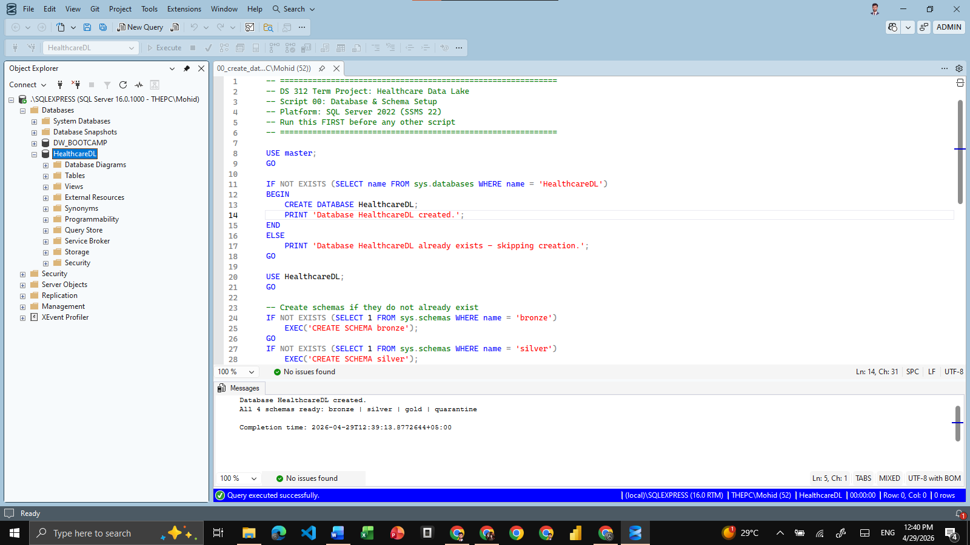

8.2 Bronze Zone Output (Demo Load)
Bronze Landing Tables – Row Counts & Ingestion Log
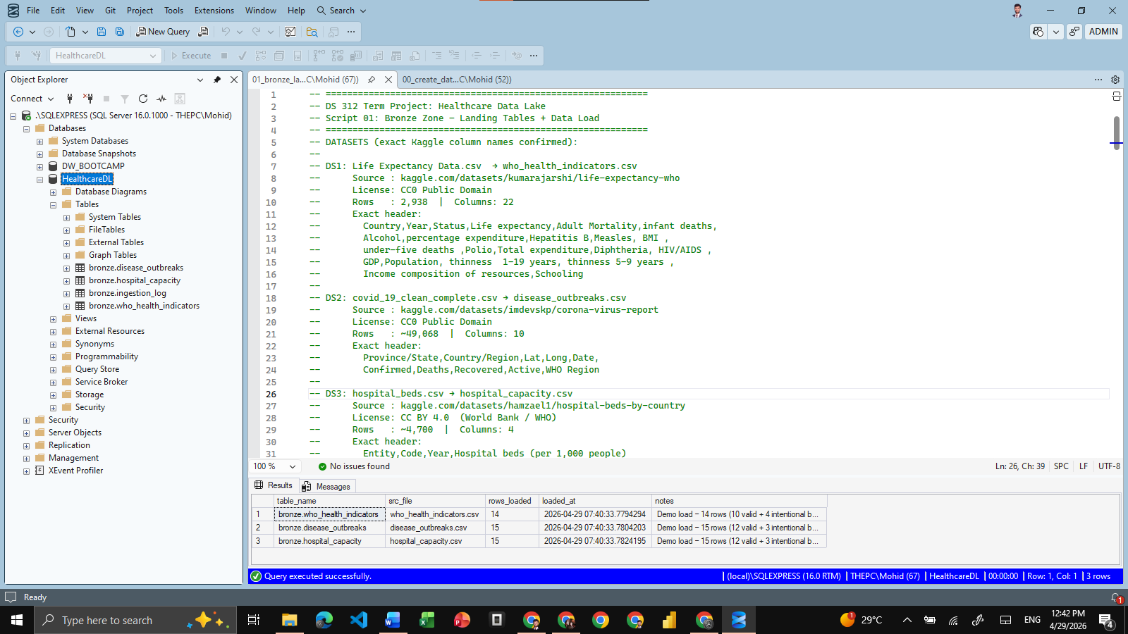

8.3 Silver Zone Output
Silver Tables – Cleaned & Typed Data | Quarantine Table with Reason Codes
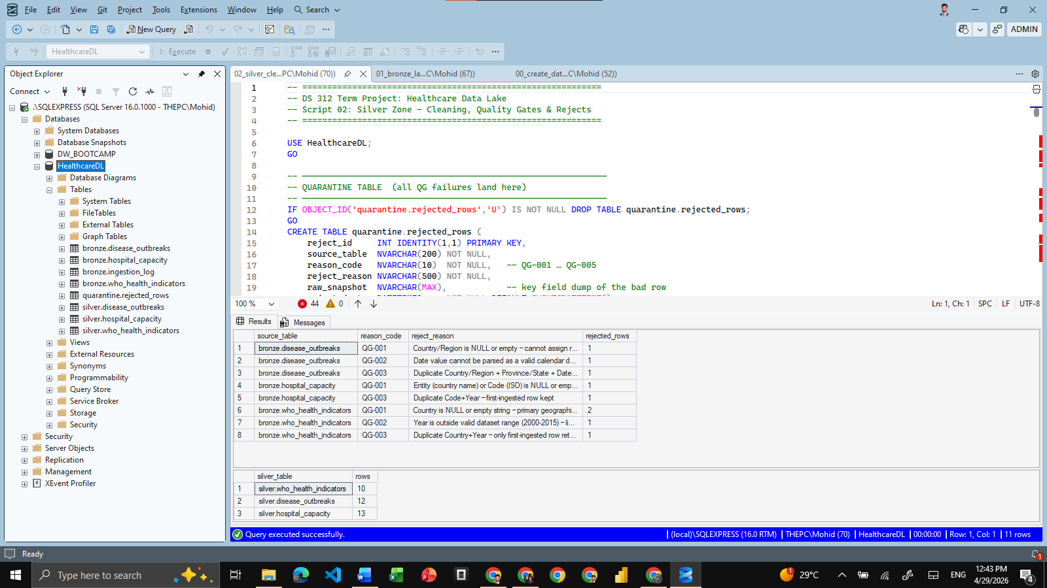

8.4 Gold Zone Output
Gold Scorecard – Final KPI Output with Risk Tier Classification
