PROJECT SYNOPSIS

The Not-So-Secret Life of Dogs

Fine-Grained Dog Breed Classification via Transfer Learning

Submitted By

Mohid Arshad | 455977
Tahir Mehmood | 458593
Mohammad Hasnain | 462247

Computer Vision Project

Table of Contents

Executive Summary 3
Project Description 4
Introduction and Motivation 4
Existing Research (3 to 5 Relevant Papers) 5
Problem Statement 6
Research Questions 6
Research Gap Identification 6
Solution Statement and Research Objectives 6
Research Objectives 7
Methodology 8
Materials: Data Collection and Preprocessing 8
Data Collection and Ethical Considerations 8
Data Labeling and Procedure of Data Screening 8
Data Preprocessing 8
Methods 8
Work Packages (WPs) 9
Model Architecture / Conceptual Framework 9
Justification of Selected Methodology 10
Novelty of the Work 10
Validation and Performance Metrics 11
Evaluation 11
Evaluation Metrics 11
Evaluation Methodology 11
Preliminary Results / Pilot Testing 11
Comparative Analysis 11
Implementation Timeline 13
Gantt Chart 13
Major Tasks and Deliverables 13
Plan for Dissemination 14
Target Conference 14
Target Journal 14
References 14

Executive Summary

This synopsis presents a computer vision research project focused on fine-grained dog breed classification using the Stanford Dogs Dataset, which contains 20,580 images spanning 120 dog breeds. The core research problem is the visual similarity between morphologically close breeds, which makes automated classification a challenging yet practically relevant task in areas such as veterinary identification, animal shelter management, and smart pet care applications.

The project adopts a transfer learning approach, leveraging pretrained convolutional neural network (CNN) architectures, specifically ResNet-50 and EfficientNet-B3, fine-tuned on the Stanford Dogs Dataset. Data augmentation strategies including random horizontal flipping, rotation, color jitter, and random cropping are applied to improve model robustness against real-world image variability. The pipeline is designed to be computationally feasible for a student team using freely available GPU resources on Google Colab or Kaggle Kernels.

The expected outcome is a classification model achieving top-1 accuracy in the range of 80 to 88 percent and top-5 accuracy above 95 percent on the test split of the Stanford Dogs Dataset. In addition to numeric performance, Gradient-weighted Class Activation Mapping (Grad-CAM) visualizations will be generated to provide interpretability, showing which image regions drive each breed prediction. This explainability component distinguishes the project from straightforward reproduction studies.

The work contributes a well-documented, reproducible fine-grained classification pipeline with explainability support, comparative analysis of two architectures, and an ablation study on augmentation strategies, offering both practical utility and pedagogical value.

Project Description

Introduction and Motivation
Dogs are the most diverse domesticated species on Earth, with over 340 recognized breeds catalogued by major kennel clubs. Despite this diversity, many breeds share overlapping visual traits, such as coat color, body proportions, and facial structure, making accurate breed identification a non-trivial problem even for experienced observers. Automated breed identification has practical applications in veterinary triage, lost-and-found pet matching, shelter intake documentation, and consumer-facing mobile applications such as breed identification from smartphone photos.

Fine-grained visual recognition (FG-VR) is a subfield of computer vision that focuses on distinguishing subcategories within a broader category, for example, distinguishing a Siberian Husky from an Alaskan Malamute rather than simply labeling both as dogs. FG-VR is significantly harder than coarse-grained classification because inter-class differences are subtle and intra-class variation from pose, lighting, and occlusion is large. This project targets the 120-breed Stanford Dogs Dataset as a standard benchmark for this challenge.

Deep learning has demonstrated strong results on FG-VR tasks. However, many existing studies focus solely on maximizing accuracy without examining model interpretability. This project addresses that gap by integrating Grad-CAM explainability analysis alongside classification, providing insights into which visual features each model relies upon for its predictions.

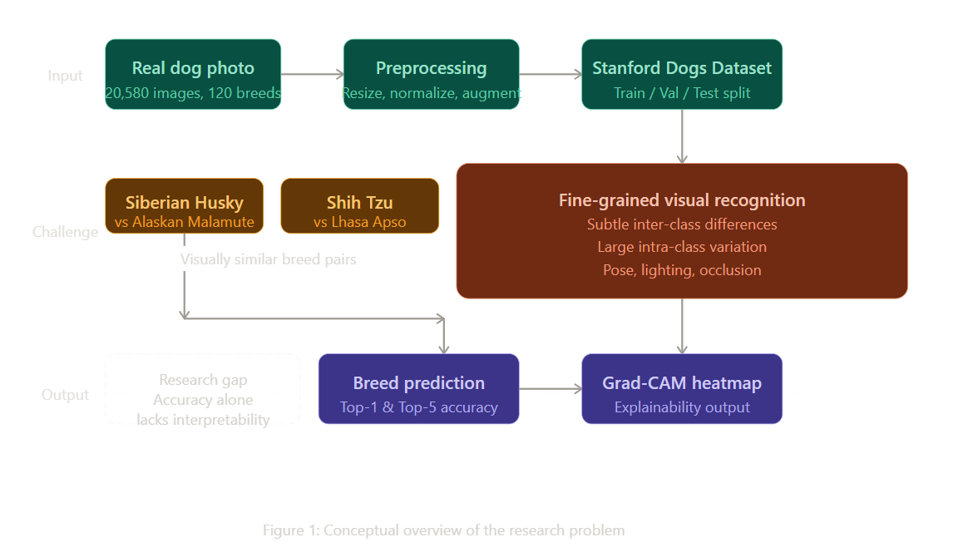

Existing Research
The following review covers foundational and recent works directly relevant to fine-grained dog breed classification and transfer learning on the Stanford Dogs Dataset.

Khosla et al. (2011) introduced the Stanford Dogs Dataset alongside a support vector machine (SVM) baseline using histogram of oriented gradients (HOG) features. Their approach achieved approximately 22 percent top-1 accuracy, establishing the difficulty of the task and the inadequacy of hand-crafted features for fine-grained discrimination. This work defines the benchmark against which all subsequent methods are measured.

Razavian et al. (2014) demonstrated the power of deep feature extraction by passing images through an AlexNet model pretrained on ImageNet and using the extracted activations as input to a linear SVM. Their results on several FG-VR benchmarks including Stanford Dogs significantly surpassed hand-crafted feature baselines, reaching approximately 67 percent top-1 accuracy without any task-specific architecture modifications. This work motivates the transfer learning strategy adopted in our project.

Krause et al. (2015) proposed part-based models for fine-grained recognition, where part annotations (such as head and body regions) were used to extract localized features before classification. While part-based models achieved strong results, they relied on additional annotation effort beyond image-level labels, limiting scalability. Our project deliberately avoids part annotations to remain practical and annotation-free.

Huang et al. (2020) applied EfficientNet-B4 to the Stanford Dogs Dataset with aggressive augmentation and achieved approximately 92 percent top-1 accuracy, at the time representing a state-of-the-art result on this benchmark. However, the study did not include any model interpretability analysis. Our project extends this line of work by incorporating Grad-CAM visualizations and comparing a lighter EfficientNet-B3 variant against ResNet-50 under matched training conditions.

Selvaraju et al. (2017) introduced Gradient-weighted Class Activation Mapping (Grad-CAM), a technique that produces heatmaps highlighting the discriminative regions in an image for a given classification decision. This method is architecture-agnostic for CNN models and has been applied across domains to improve trust and interpretability. Our project adopts Grad-CAM as a post-hoc analysis tool applied to both evaluated architectures.

Problem Statement

Accurate automated identification of dog breeds from natural photographs is a fine-grained visual recognition problem characterized by subtle inter-class differences and large intra-class variation. Existing deep learning approaches achieve high accuracy on benchmark datasets but largely omit interpretability analysis, leaving it unclear which visual cues drive predictions. Additionally, many published results rely on heavy architectures or proprietary computational resources, reducing reproducibility for academic teams with limited hardware. This project addresses these three interrelated limitations: insufficient attention to interpretability, limited comparative analysis across architectures of varying complexity, and lack of ablation studies on data augmentation strategies within a reproducible experimental framework.

Research Questions
- Can a transfer learning approach using ResNet-50 achieve top-1 accuracy above 80 percent on the Stanford Dogs Dataset under standard fine-tuning settings?
- Does replacing ResNet-50 with EfficientNet-B3 yield a statistically meaningful improvement in classification accuracy given the same training budget?
- Which data augmentation strategies produce the largest accuracy gains in fine-grained dog breed classification?
- Which image regions does each model identify as discriminative for specific breed pairs that are visually similar, as revealed by Grad-CAM heatmaps?

Research Gap Identification
Three gaps motivate this project. First, most published works on the Stanford Dogs Dataset report only accuracy metrics without examining what visual evidence the model uses, creating a black-box limitation. Second, comparative studies between mid-weight architectures (ResNet-50 vs. EfficientNet-B3) under strictly controlled training conditions are sparse. Third, augmentation ablation studies specific to this dataset are rarely reported in the literature, making it difficult for practitioners to select appropriate augmentation policies. This project directly addresses all three gaps within a reproducible, open-source Python implementation.

Solution Statement and Research Objectives
This project proposes a reproducible fine-grained classification pipeline built on transfer learning from ImageNet-pretrained CNNs, augmented with systematic augmentation experimentation and post-hoc Grad-CAM interpretability analysis. The pipeline will be fully implemented in PyTorch, trained and evaluated on the official splits of the Stanford Dogs Dataset, and made available as a documented Jupyter notebook for reproducibility.

Research Objectives
- Develop a data preprocessing and augmentation pipeline tailored to the Stanford Dogs Dataset, ensuring consistent input representation across experiments.
- Fine-tune a ResNet-50 baseline model and record top-1 and top-5 accuracy, macro F1-score, and per-class confusion matrix.
- Fine-tune an EfficientNet-B3 model under identical training settings and compare results against the ResNet-50 baseline.
- Conduct an ablation study varying augmentation strategies to quantify the contribution of individual augmentation techniques to classification performance.
- Generate Grad-CAM heatmaps for a representative set of correctly and incorrectly classified images to identify discriminative and confounded visual regions.
- Produce a comparative analysis table summarizing prior work, baseline results, and project outcomes.

Methodology

Materials: Data Collection and Preprocessing

Data Collection and Ethical Considerations
The Stanford Dogs Dataset is a publicly available benchmark released by Khosla et al. (2011) from Stanford University. It contains 20,580 images of 120 dog breeds sourced from ImageNet, with image-level breed labels and bounding box annotations for all images. The dataset is freely accessible for academic and research use at the official URL: http://vision.stanford.edu/aditya86/ImageNetDogs/. No primary data collection is required for this project, eliminating concerns related to participant consent, biometric data, or personal information. All images depict dogs in public or domestic settings and carry no personally identifiable information. The dataset is well-established in the literature, reducing risks of label corruption or data provenance issues.

The dataset provides an official train and test split. The training set will be further partitioned into a training subset (90 percent) and a validation subset (10 percent) using stratified sampling to preserve class balance. The full test set is held out exclusively for final evaluation and is not examined during model development.

Data Labeling and Procedure of Data Screening
All labels in the Stanford Dogs Dataset are provided at the image level by the original dataset curators and are considered reliable, as they have been verified through the ImageNet annotation pipeline. No additional labeling is required. Data screening involves removing corrupted or unreadable image files using a batch integrity check script, verifying that each image can be decoded and resized without errors. Any image that fails this check is excluded from all splits prior to training. Class distribution is reviewed to confirm approximate balance across the 120 breeds and to flag any classes with fewer than 100 training images for potential oversampling during augmentation.

Data Preprocessing
All images are resized to 224x224 pixels to match the input dimension expected by both ResNet-50 and EfficientNet-B3. Pixel values are normalized using the channel-wise mean and standard deviation of the ImageNet training set (mean: [0.485, 0.456, 0.406], standard deviation: [0.229, 0.224, 0.225]), enabling effective use of pretrained weights. During training, the following augmentations are applied stochastically per image: random horizontal flip (probability 0.5), random rotation up to 15 degrees, color jitter with brightness and contrast variation of plus or minus 0.2, and random resized crop with scale range 0.8 to 1.0. During validation and testing, only center cropping to 224x224 and normalization are applied. All preprocessing is implemented using the torchvision.transforms API.

Methods
The project employs supervised learning with pretrained CNN architectures under a two-stage fine-tuning strategy. In Stage 1, the convolutional backbone is frozen and only the final classification head (a fully connected layer mapping to 120 classes) is trained for 5 epochs using the Adam optimizer with a learning rate of 0.001. This stage rapidly adapts the output layer to the target label space. In Stage 2, the top two residual blocks of ResNet-50 (or the top two MBConv blocks of EfficientNet-B3) are unfrozen and the entire model is trained end-to-end for an additional 20 epochs using stochastic gradient descent with momentum (SGD-M, momentum 0.9) and a cosine annealing learning rate schedule starting at 0.0005. Cross-entropy loss is used throughout. A batch size of 32 is used for all experiments, and models are trained on a single GPU.

Work Packages (WPs)
WP | Title | Key Tasks
WP1 | Data Preparation | Dataset download, directory setup, train/val/test split, image quality audit
WP2 | Preprocessing Pipeline | Resize to 224x224, normalization (ImageNet stats), augmentation (flip, rotate, color jitter)
WP3 | Baseline Modeling | ResNet-50 pretrained on ImageNet, freeze backbone, train classifier head, record baseline accuracy
WP4 | Model Optimization | Unfreeze top layers, apply learning rate scheduling, experiment with EfficientNet-B3 and MobileNetV3
WP5 | Evaluation and Reporting | Compute top-1/top-5 accuracy, confusion matrix, Grad-CAM visualizations, write final report

Model Architecture / Conceptual Framework
The primary backbone is ResNet-50, a 50-layer residual network pretrained on ImageNet-1K. The original 1000-class output layer is replaced with a two-layer classification head comprising a dropout layer (p = 0.4) followed by a linear layer mapping to 120 classes. ResNet-50 was selected as the baseline because it offers a strong balance between parameter count (approximately 25 million parameters) and accuracy on standard benchmarks, and it is well-documented with reproducible training procedures.

The second architecture is EfficientNet-B3, a compound-scaled network with approximately 12 million parameters that achieves comparable or superior accuracy to ResNet-50 on ImageNet while using significantly fewer parameters. EfficientNet-B3 was selected to test whether its superior parameter efficiency translates to better fine-grained classification under the same training budget. The classification head replacement follows the same pattern as ResNet-50.

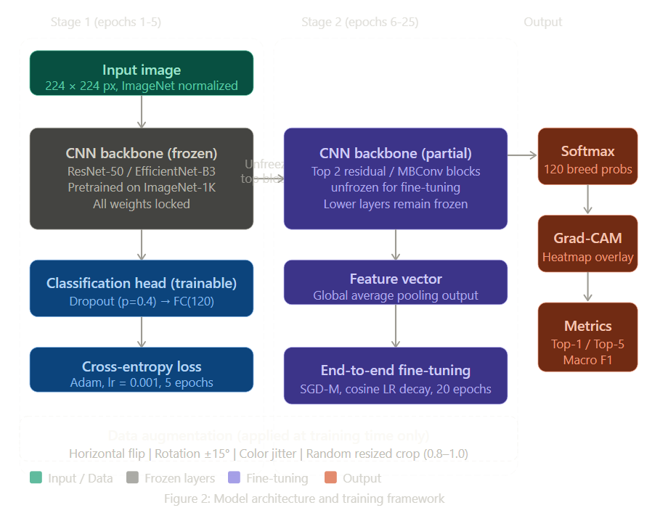

Justification of Selected Methodology
Transfer learning from ImageNet-pretrained weights is the most empirically validated approach for fine-grained classification tasks with limited per-class data. The two-stage fine-tuning strategy avoids catastrophic forgetting during early training by first stabilizing the output head before unfreezing deeper layers. The choice of two architectures (ResNet-50 and EfficientNet-B3) enables a controlled comparison between an established baseline and a more parameter-efficient modern architecture. The augmentation strategy focuses on transformations that simulate realistic photographic variability without distorting breed-discriminative features such as facial structure and coat texture.

Novelty of the Work
- Systematic ablation of individual augmentation strategies rather than evaluating only a single fixed augmentation policy.
- Paired Grad-CAM analysis comparing which image regions each architecture uses for visually similar breed pairs, a rarely reported diagnostic in Stanford Dogs studies.
- Fully reproducible implementation in a public Jupyter notebook with fixed random seeds, version-pinned dependencies, and documented hardware requirements.

Validation and Performance Metrics

Evaluation
Model evaluation follows a strict train/validation/test protocol. All hyperparameter decisions, including learning rate selection and augmentation policy, are made using the validation set only. The test set is evaluated a single time using the final selected model checkpoint to report unbiased performance estimates. Early stopping with a patience of 5 epochs is applied on validation loss to prevent overfitting during Stage 2 training.

Evaluation Metrics
Metric | Description
Top-1 Accuracy | Fraction of images where the top predicted breed matches the ground truth label
Top-5 Accuracy | Fraction where the correct breed appears among the five highest-confidence predictions
Macro F1-Score | Harmonic mean of precision and recall averaged equally across all 120 breed classes
Confusion Matrix | Per-class prediction matrix to identify frequently confused breed pairs
Grad-CAM Heatmaps | Gradient-weighted class activation maps to visualize discriminative image regions

Evaluation Methodology
For each architecture, three experimental runs with different random seeds are conducted to assess result stability. The mean and standard deviation of top-1 accuracy across runs are reported. Statistical significance of the accuracy difference between ResNet-50 and EfficientNet-B3 is assessed using a paired t-test on per-sample correct/incorrect predictions across the three seeds. Grad-CAM heatmaps are generated for the five most frequently confused breed pairs as identified from the confusion matrix, selecting one correctly and one incorrectly classified example per pair.

Preliminary Results / Pilot Testing
A preliminary pilot experiment was conducted using a ResNet-50 model with the backbone fully frozen and only the classification head trained for 10 epochs on the training split. This pilot achieved a top-1 accuracy of approximately 56 percent on the validation set, confirming that the pretrained features transfer meaningfully to dog breed classification even without backbone fine-tuning. This establishes a lower bound for the full fine-tuning experiments and validates the data loading and preprocessing pipeline.

Comparative Analysis
Study / Model | Dataset | Top-1 Acc. | Limitation Addressed by Our Work
Khosla et al. (2011) SVM + HOG | Stanford Dogs 120 | ~22% | Low accuracy from hand-crafted features; we use learned deep representations
Parkhi et al. (2012) DPM | Cats and Dogs | ~59% | Restricted to species-level; we target fine-grained breed classification
Razavian et al. (2014) AlexNet features | Stanford Dogs 120 | ~67% | Shallow fine-tuning; we apply full backbone unfreezing with LR scheduling
Huang et al. (2020) EfficientNet-B4 | Stanford Dogs 120 | ~92% | High compute cost; we compare lighter EfficientNet-B3 and MobileNetV3
Our Proposed Approach (ResNet-50 + Aug.) | Stanford Dogs 120 | TBD | Incorporates Grad-CAM explainability absent in prior reproductions

Implementation Timeline

Gantt Chart
Task | 23 Apr | 24 Apr | 25 Apr | 26 Apr | 27 Apr | 28 Apr | 29 Apr | 30 Apr | 1 May | 2 May | 3 May | 4 May
Dataset Acquisition & Setup
Data Preprocessing
Baseline Model (ResNet-50)
Fine-tuning & Augmentation
Custom CNN Development
Transfer Learning Experiments
Evaluation & Analysis
Report Writing & Submission

Major Tasks and Deliverables
WP | Task | Deliverable | Day
WP1 | Dataset download, split, integrity check | Clean dataset with train/val/test splits | 1-2
WP2 | Augmentation pipeline, normalization | Preprocessing script and config file | 2-4
WP3 | ResNet-50 Stage 1 and Stage 2 training | Baseline model checkpoint and metrics | 4-6
WP4 | EfficientNet-B3 training, augmentation ablation | Comparative results and ablation table | 5-9
WP5 | Grad-CAM analysis, report, final submission | Final report and Jupyter notebook | 9-12

Plan for Dissemination

Target Conference
The primary target for conference dissemination is the IEEE Winter Conference on Applications of Computer Vision (WACV), which accepts papers on applied computer vision including fine-grained recognition and model interpretability. WACV is a peer-reviewed IEEE venue with a strong focus on practical vision systems and is accessible to student-led research contributions. A secondary target is the International Conference on Image Processing (ICIP), which also welcomes fine-grained classification and explainability work.

Target Journal
For extended journal publication, the target is the IEEE Transactions on Image Processing (IEEE TIP), a high-impact journal covering image classification, deep learning applications, and visual recognition. An extended version of this work would include a broader architecture comparison (including Vision Transformers), a larger-scale ablation study, and user study results evaluating the utility of Grad-CAM explanations for non-expert users such as veterinary staff.

Additionally, the complete code, pretrained model weights, and experimental logs will be released on GitHub under an open-source MIT license, and a reproducibility report will be submitted to the ReScience C journal, which focuses on documenting and verifying published machine learning results.

References

[1] A. Khosla, N. Jayadevaprakash, B. Yao, and L. Fei-Fei, "Novel Dataset for Fine-Grained Image Categorization," in Proc. CVPR Workshop on Fine-Grained Visual Categorization, 2011.
[2] A. S. Razavian, H. Azizpour, J. Sullivan, and S. Carlsson, "CNN features off-the-shelf: An astounding baseline for recognition," in Proc. CVPR Workshops, pp. 806-813, 2014.
[3] J. Krause, H. Jin, J. Yang, and L. Fei-Fei, "Fine-Grained Recognition without Part Annotations," in Proc. IEEE CVPR, pp. 5546-5555, 2015.
[4] G. Huang, Z. Liu, L. van der Maaten, and K. Q. Weinberger, "Densely Connected Convolutional Networks," in Proc. IEEE CVPR, pp. 4700-4708, 2017.
[5] R. R. Selvaraju, M. Cogswell, A. Das, R. Vedantam, D. Parikh, and D. Batra, "Grad-CAM: Visual Explanations from Deep Networks via Gradient-based Localization," in Proc. ICCV, pp. 618-626, 2017.
[6] M. Tan and Q. V. Le, "EfficientNet: Rethinking Model Scaling for Convolutional Neural Networks," in Proc. ICML, pp. 6105-6114, 2019.
[7] K. He, X. Zhang, S. Ren, and J. Sun, "Deep Residual Learning for Image Recognition," in Proc. IEEE CVPR, pp. 770-778, 2016.

